****

Concordia Institute for Information Systems Engineering (CIISE)

‍‍Concordia University

**INSE 6130: Operating Systems Security**

**Project Report**

**Implementing Recent Attacks and Security Application on Containers**

**Submitted to:**

Dr. Suryadipta Majumdar

**Dated: April 20th, 2022**

|  |  |  |
| --- | --- | --- |
|  | **Student Name** | **Student ID** |
| 1 | Mohit Balu | 40221594 |
| 2 | Bikramjeet Singh | 40192900 |
| 3 | Harpreet Kaur | 40190384 |
| 4 | Nithya Sri Bommakanti | 40220572 |
| 5 | Milanpreet Kaur | 40204741 |
| 6 | Gouresh Chauhan | 40194834 |
| 7 | Srividya Poshala | 40192542 |
| 8 | Rabiatou Oubbo Modi | 40155873 |

**Table Of Contents**

Introduction 3

Planning and Preparation 6

Setting Up the Environment 6

Attack Scenarios 7

Attack 1 Implementation 7

Attack 1 Execution 7

Attack 1 Defense 8

Attack 2 Implementation 9

Attack 2 Execution 10

Attack 2 Defense 10

Defense Mechanisms 10

Implementation 10

Application 10

Team Member’s Contributions 10

Challenges Faced: 13

Future Scope 13

References 14

Appendix 15

# Introduction

Over the last few years, the use of virtualization technologies has been increased dramatically. This makes the demand for efficient and secure virtualization solutions more obvious. There are two main types of virtualization solutions: container-based and hypervisor that have emerged in the market. Docker, which is a container-based virtualization platform, was introduced in 2013, to solve the time-consuming and costly process of application development and service delivery. It provides a lightweight and efficient virtual environment and separates the applications into their containers, where they share the resources, however, interacts with the operating system independently. As virtualization is becoming mainstream, the security concerns pertaining to it are also coming to the surface.

In this project, we have emphasized on Docker environment, its possible attack vectors, and defense mechanisms against its vulnerabilities, knowing the fact that the working of other containerized environments is similar to that of Docker.

This project report mentions the planning, preparation, and development of the following:

1. Implementation of the attack scenarios,
2. Exploitation of the vulnerabilities implemented in the attack scenarios,
3. Implementation of the defense mechanisms against the vulnerabilities,
4. And the execution of the whole project.
5. **Implementation of the attack scenarios:**

We have developed two attack scenarios in which we have a Docker environment running on a system, and few components of the Docker environments (such as Docker registry, Docker Images, Docker containers, and Docker Engine) are running with security misconfigurations or with known vulnerabilities. We have tried to keep the scenarios as close to a typical real-world Docker environment running on a system in some organization.

1. **Exploitation of the vulnerabilities implemented in the attack scenarios:**

Assuming the role of an adversary, we have enumerated the system and exploited the vulnerabilities as in aforementioned attack scenarios. We also have chained different vulnerabilities to reach the goal of controlling the host operating system or exfiltrating the data from the database, more of which have been discussed in the “Attack Scenarios Section” of this report. During the execution of both the attacks, we have used Kali Linux as an attacker’s system and different open-source tool such as Nmap, Curl, Netcat, Docker Client to achieve our goal.

We have included following vulnerabilities as the part of our attack scenarios:

* + 1. Unprotected Docker Registry
    2. Sensitive Information Leakage in Image Manifest
    3. Docker Socket Mounted inside Docker Container
    4. Excessive Capabilities
    5. Components with Known Vulnerabilities (CVE-2019-5736)
    6. Missing Signature Verification

1. **Implementation of the defense mechanisms against the vulnerabilities:**

As the defenders of the Docker environment, implemented in Part (I), we have developed several python scripts, using different libraries, and few manual implementations, to mitigate or remediate those vulnerabilities; eventually making the attacker unable to discover or exploit them. Our python scripts interact with Docker environment using “Docker SDK for Python” to make necessary detections or changes in order to successfully defend the environment from an adversary. The specific details of the implementation have been discussed in the “Defense Mechanisms” part of this report however following is the list of security mechanisms that we have implemented:

* + 1. Image Manifest Scanner
    2. Capabilities Checker
    3. Docker Socket Detector
    4. Signature Implementation
    5. Registry Authentication
    6. IP Based filtering

1. **The execution of the whole project:**

Since the planning phase of this project, we have used a private repository on GitHub to share the ideas, resources, and documents. We have used the Zoom meetings and Group Study Rooms at Webster library to collaborate and discuss the ideas during the whole duration of the project.

We have regularly documented the steps of implementation on our GitHub repository to keep track of the things and to have the version control over code that we were developing to automate the steps. (Figure 1)

All above mentioned work have been thoroughly discussed in the specific sections of this report.

We believe that we have implemented and exploited fairly good number of vulnerabilities in this project, and we have been successful in achieving our attack goals by chaining those vulnerabilities. At the same time, we also have achieved both the detection and prevention of attacks with our implementations in defense mechanisms, therefore, we are targeting the bonus points for the evaluation of this project report.

# Planning and Preparation

Our planning and preparation for the project implementation included several courses of actions, a few of which were decided before we started with the project and a few of them were figured out during the course of the project. The list is as following, but not limited to:

1. Learn Docker basics and read user guides from Docker official documentation (docs.docker.com)
2. Complete Docker courses on Udemy to get a hands-on idea of the docker environment and commonly used commands.
3. Learn about the latest common vulnerabilities (CVEs) in the containerized environments and common security misconfigurations.
4. Complete “The Docker Rodeo” lab on tryhackme.com to get a hands-on idea of exploiting vulnerabilities in the docker environment.
5. Read published papers and conference materials about container security to get in-depth knowledge of the specific vulnerabilities.
6. Document all the illustrations, learnings, and findings on our private project repository on GitHub.
7. Participate in the weekly recurring meeting to discuss the ideas and actions plans.
8. Discuss the challenges faced during the working of the project and try to figure out the solutions or the workarounds.

**Attackers vs Defenders:**

In the beginning, we divided our team of 8 members in two parts namely attackers and defenders. The attackers decided to implement the vulnerabilities and perform the exploitation whereas the defenders decided to work on detection and prevention of the attacks.

As we were going through different security misconfigurations and known vulnerabilities in Docker environment, we decided to chain multiple vulnerabilities to mimic real-world attack scenarios on Docker environment instead of exploiting a single or two vulnerabilities independently.

For defending the system from attacks, we planned to implement some automated solutions that can interact with Docker Engine, therefore, Python programming language was used because of its familiarity with all of the team members.

**Getting started with the Implementation:**

A handful of ideas and solutions were tried before we could figure out the common working conditions for our project on every member’s local system. We ended up with setting the local environment as discussed in the next section of the report, that we found best suited for our project.

# Setting Up the Environment

Before starting the implementation of attack and defense mechanisms, we decided to set up the environment on our local machine inside virtual environments and collaborate on GitHub for sharing the implementation steps and key-points through a private repository. GitHub is a collaboration tool used by software developers to work on a single project without the need to share a common network. It helps to manage a large collection of documents and regularly updates them.

We installed Ubuntu operating system on the hypervisor (as our host OS) for hosting the docker environment, to contain the vulnerable components inside the virtual environment only.

# Attack Scenarios

## Attack 1 Implementation

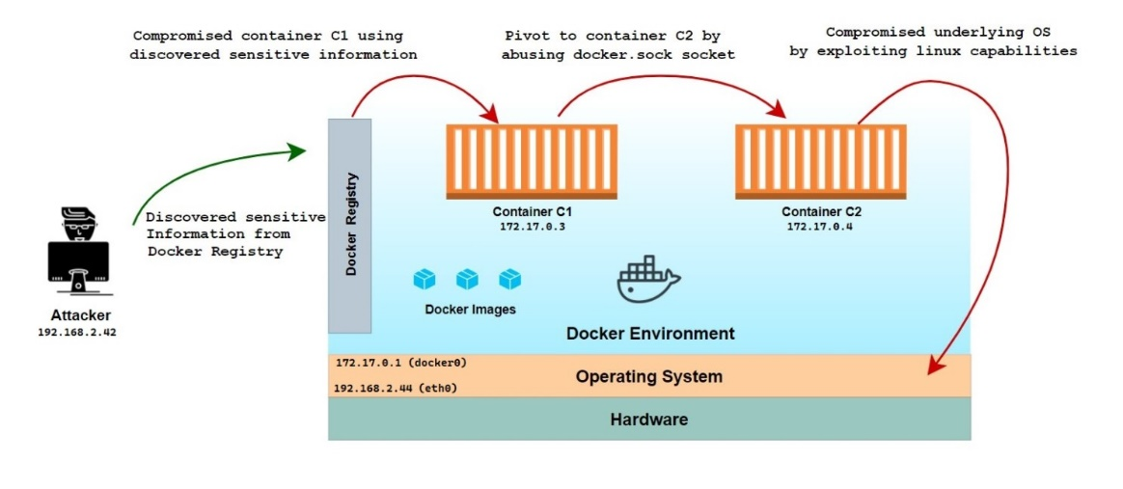

**Docker Registry:**

A Docker registry is a distribution system for Docker images. There will be different images, and each may contain multiple tags and versions. By default, the registry runs on port 5000 without authentication and TLS.

**Docker Socket:**

docker.sock is a socket file used for communication from the docker engine API or the CLI to run commands on the system through the docker daemon. The two most used sockets are, Unix sockets – which are used when processes want to communicate locally; so, they are faster, and on the other hand, the TCP sockets are used to communicate via the internet or network. The exposed docker socket is exploited by the attacker by using docker-engine API to download any custom image hosted by him or her on the victim machine and use it for his or her benefit by mounting file system on the docker container image.

## Attack 1 Execution

**Compromising Container C1**

A Docker Environment is running in an organization, and it has several images and a few containers running. It also has a docker registry service running on port 5000 for developers to access the status of images and containers.

An attacker (or an adversary) is in the same network as the system on which the docker engine is installed (say Ubuntu). S(he) does not have access to the target Ubuntu system (it’s very secure) however S(he) could see that there is a docker environment in the network as the docker registry can be accessed on port 5000. The docker registry itself does not pose any serious security risk as it does not allow the user to create, delete or publish images (unless it is writable). The objective of the attacker is to find and exploit the vulnerabilities in the docker environment (if any) and eventually gain access to the underlying Ubuntu operating system.

**Compromising Container C2**

Container C1 is already compromised which has docker.sock file mounted at /var/run/docker.sock. This can be leveraged to communicate with the docker engine and get access to other running containers.

To communicate with Docker Engine using docker. sock, 'docker' command-line tool should be installed however we are assuming that installation for the 'docker' command line is blocked due to security reasons. So, we will be using Unix socket to communicate with Docker Engine.

**Compromising Underlying Operating System [Goal]**

Sometimes containers need to be run with extra privileges to perform some operations on the host operating system itself. These containers are run with —a privileged flag which adds some special capabilities to the running container, however, it is not considered a best practice for the security of the system. Any user (or attacker) having access to the container can easily elevate his/her access to the underlying operating system.

As remediation of the above issue, containers are run with the specific capability (whichever is needed) instead of running it as a privileged container (which possesses all the capabilities). These capabilities can be listed with the capsh --print command.

In this attack scenario, Container C2 is also running with the capability SYS_ADMIN. SYS_ADMIN capability allows the container to perform system administration operations such as quotactl, mount, umount, swapon, swapoff, sethostname, and setdomainname. Although not running a container as a privileged one, decreases the security risk however these specific capabilities can also be exploited by issuing some commands and access to the underlying operating system can be gained.

## Attack 1 Defense

To Defend the vulnerabilities that are present in attack 1, we have implemented python SDK for docker scripts. First, we have designed the security measures according to the vulnerabilities that are present in the attack scenario. In this, we have decided to implement five scripts. From which two scripts we have implemented and currently we are working on three defense mechanism scripts.

1. **Designing security Measures according to vulnerabilities present in attack scenario 1: [*WORKING*]:**
   * + Implement a python script to detect (and generate an alert) if any of the running docker containers is mounting docker. sock socket file.
     + Implement a python script to detect (and generate an alert) if any of the docker containers are running with unnecessary capabilities which can be abused by an adversary.
     + Implement a python script to generate an alert when someone logins via SSH to the docker container from an unidentified IP address.
2. **Implemented Defense Mechanism for first attack scenario: [*COMPLETED*]**
   * + We have implemented docker SDK for python, to defend the first part of the attack. In this script, it detects if any information (such as PASS, KEY, APIKEY, TOKEN) is being disclosed in the manifest file of the images on the Docker registry.
     + We have implemented the HTTP authentication for the docker registry to protect the registry service from being accessed by unauthorized users.
3. **Monitoring tools we are working on to detect the vulnerabilities in the docker: [*WORKING*]**
   * + We are also working on monitoring tools: Docker bench and Clair. We are analyzing both tools and will finalize which will detect the vulnerabilities more efficiently.
4. **Future Deliverables: [Planning to implement]**
   * + We are planning to design a security application that consists of all the defense scripts.

*Further, we will be working on implementing a second attack scenario and expect to work out the defense mechanism for it.*

## Attack 2 Implementation

We have designed the scenario for our attack 2. The preliminary idea is that the attacker tries to exploit the web application for the credit reporting organization which stores all information related to the credit card of the users.

Below is the diagram for the idea of the exploit.

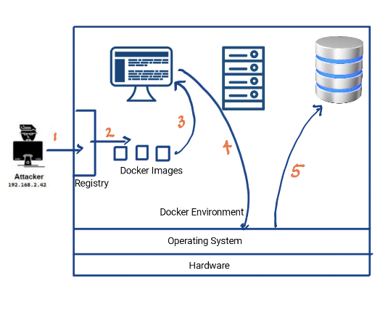

The idea for the exploit is divided into 5 parts as explained below:

1. The attacker discovers the unprotected registry is writable and writes his own malicious image.
2. An adversary then pushes that image to the registry with runC exploit.
3. Legitimate user starts the container executing the runC exploit along with it.
4. Gets access to the host Operating system (Docker-engine).
5. The attacker tries to access the container hosting database to get sensitive info

## Attack 2 Execution

## Attack 2 Defense

We will design the security measures according to vulnerabilities present in attack scenario 2 as we have done in scenario 1 and we will implement the defense scenario related to this particular attack.

# Defense Mechanisms

## Implementation

## Application

# Team Member’s Contributions

Each Member has put equal contributions to the project. Everyone has read the paper and attended the meetings regularly to attain a better understanding of the project. The background research has been done by everyone and the understanding was discussed.

**Member’s Individual Contributions:**

**Attack Scenario 1 Vulnerabilities:**

1. Unprotected Docker registry service
2. Sensitive information disclosure in image manifests
3. Abusing exposed docker socket inside the container (docker.sock)
4. Abusing SYS_ADMIN Linux capability inside the container.

|  |  |  |
| --- | --- | --- |
|  | Sub Tasks | Contribution |
| 1. | Reading about different known vulnerabilities and misconfigurations in the Docker environment. | All |
| 2. | Designing Attack Scenario 1 by chaining different vulnerabilities as per real world context. | Mohit Balu,  Nithya Sri Bommakanti,  Harpreet Kaur |
| 3. | Prerequisites for Attack Scenario 1 (Installing specific versions and implementing misconfigurations). | Gouresh Chauhan,  Rabiatou Oubbo Modi |
| 4. | Performing attack on the environment including initial compromise, pivoting to other containers, docker escape, host OS compromise. | Mohit Balu,  Milanpreet Kaur,  Bikramjeet Singh |
| 5. | Documentation of development of Attack Scenario and attack steps on common Github repo. | Harpreet kaur,  Srividya Poshala |

**Attack Scenario 2 Vulnerabilities:**

1. Unprotected Docker registry service
2. CVE-2019-5736 (runC docker escape exploit)

**Sub-Tasks:**

|  | Sub Tasks | Contribution |
| --- | --- | --- |
| 1. | Designing Attack Scenario 2 by chaining a known vulnerability (CVE-2019-5736) and unprotected registry service. | Mohit Balu,  Bikramjeet Singh,  Harpreet kaur |
| 2. | Figuring out pre-requisites and compatibility of different docker components' versions (Docker Engine, Docker Client, containerd, runc) required for the implementation of runC vulnerability. | Gouresh Chauhan,  Rabiatou Oubbo Modi |
| 3. | Implementation of Attack Scenario 2. | Bikramjeet Singh,  Mohit Balu,  Nithya Sri Bommakanti |
| 4. | Documentation of Attack Scenario 2. | Srividya Poshala. Milanpreet Kaur |

**Defense Tasks:**

|  | Defense Tasks | Contribution |
| --- | --- | --- |
| 1. | Designing security Measures according to vulnerabilities present in Attack Scenerio1 & 2 | Milanpreet Kaur,  Mohit Balu,  Bikramjeet Singh |
| 2. | Implemented defense mechanism using Python SDK for docker. | Milanpreet Kaur,  Srividya Poshala. |
| 3. | Working on monitoring tools to detect the vulnerabilities | Gouresh Chauhan,  Rabiatou Oubbo Modi |
| 4. | Planning to design a framework for the security application. | Nithya Sri Bommakanti,  Harpreet kaur |
| 5. | Documentation of security measures | Harpreet kaur,  Milanpreet Kaur,  Srividya Poshala |

# Challenges Faced:

1. We have faced some challenges while working on this project. One challenge was that team members were not familiar with docker. We spent some time familiarizing ourselves with it and learning it.
2. Many articles on the internet guide about a running container with docker. sock and Unix sockets but commands for functioning containers using docker.sock and Unix sockets were a challenge to figure out. Anyhow, docker-engine API documentation came to our rescue for the challenge we were facing.
3. Another challenge was to find a working exploit with a reverse shell, to gain access to the operating system. All of the available writeups were limited to running the 'ps aux' command to prove the control over OS. We tried to modify the exploit to gain the reverse shell on OS, and we almost managed to run it, unfortunately, ended up with a 'broken pipe' as soon as the first command was executed on the reverse shell. After several attempts to fix it, the final solution was to go ahead with a bind shell written in python to make it work.
4. Faced compatibility issues of Virtual machines Ubuntu with the Mac M1 and Windows 11.
5. We struggled to figure out such vulnerability in docker components, which would let us do initial compromise of the environment and also further allow us to pivot to other containers or to perform docker escape.

Compromising initially by uploading malicious images would have given us access to the container itself however escaping from that container would have been very difficult, unless the container is intentionally run with some potential misconfiguration by a legitimate user, which is the least likely scenario in the real world.

Similarly, to implement the docker escape scenario, we would have required access to an already running container with some misconfiguration, which was possible by compromising some explicitly installed applications on the docker container. In the end, we figured out that an attacker outside the docker environment can do an initial compromise by pushing malicious image (with runC exploit) into an unprotected docker registry and at the same time perform docker escape through runC exploit and get access to the host OS.

# Future Scope

1. **I**mplementing the remaining defense mechanisms for Attack 1.
2. Need to do the documentation of Attack Scenario 2.
3. Need to implement remaining defense mechanisms for Attack 1.
4. Working on an implementation of a detection tool for the vulnerabilities.
5. Need to design security measures & implement those defense mechanisms for Attack 2.

# References

[1] “Docker Desktop overview,” *Docker Documentation*, Mar. 14, 2022.<https://docs.docker.com/desktop/> (accessed Mar. 15, 2022).

[2] “Docker Engine API v1.41 Reference.”<https://docs.docker.com/engine/api/v1.41/> (accessed Mar. 15, 2022).

[3] “Examples using the Docker Engine SDKs and Docker API,” *Docker Documentation*, Mar. 14, 2022.<https://docs.docker.com/engine/api/sdk/examples/> (accessed Mar. 15, 2022).

[4] “How To Run Docker In Docker Container [3 Methods Explained],” Jun. 25, 2021.<https://devopscube.com/run-docker-in-docker/> (accessed Mar. 15, 2022).

[5] Atucom, “Smallest Python Bind Shell.”<https://blog.atucom.net/2017/06/smallest-python-bind-shell.html> (accessed Mar. 15, 2022).

[6] “TryHackMe | Cyber Security Training,” *TryHackMe*. [https://tryhackme.com](https://tryhackme.com/) (accessed Mar. 15, 2022).

[7] Anton, “Understanding Docker container escapes,” *Trail of Bits Blog*, Jul. 20, 2019.<https://blog.trailofbits.com/2019/07/19/understanding-docker-container-escapes/> (accessed Mar. 15, 2022).

[8]”TryHackMe | The Docker Rodeo” *TryHackMe. The Docker Rodeo.* [https://tryhackme.com](https://tryhackme.com/)

# Appendix