Applied Robotics Laboratory: Conveyor Tracking
Hardware Overview and Documentation

Mechanical Setup
CAD is handed in seperately and includes all 3D-Printed parts (STL/STEP).

PLC Setup

Wiring
Component | Usage | Notes
EK1100 | EtherCAT
EL2911 | Safety
EL7411 | BLDC Drive Conveyor
EL7411 | BLDC Drive Conveyor
EL1014 | Digital Input: Hall Sensor
EL2008 | Digital Outputs: R/G LED | On old setup: ENC simulation via pulsing digital outputs
EL2521 | Encoder Simulation Output to DSQC377 | Axis Slave of EL7411

All connections are broken out:
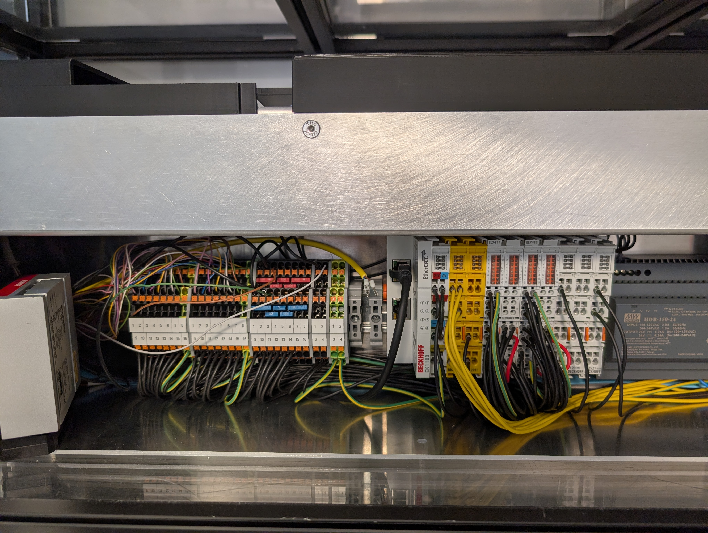
Conveyor 1
Conveyor 2
24V / GND
X3

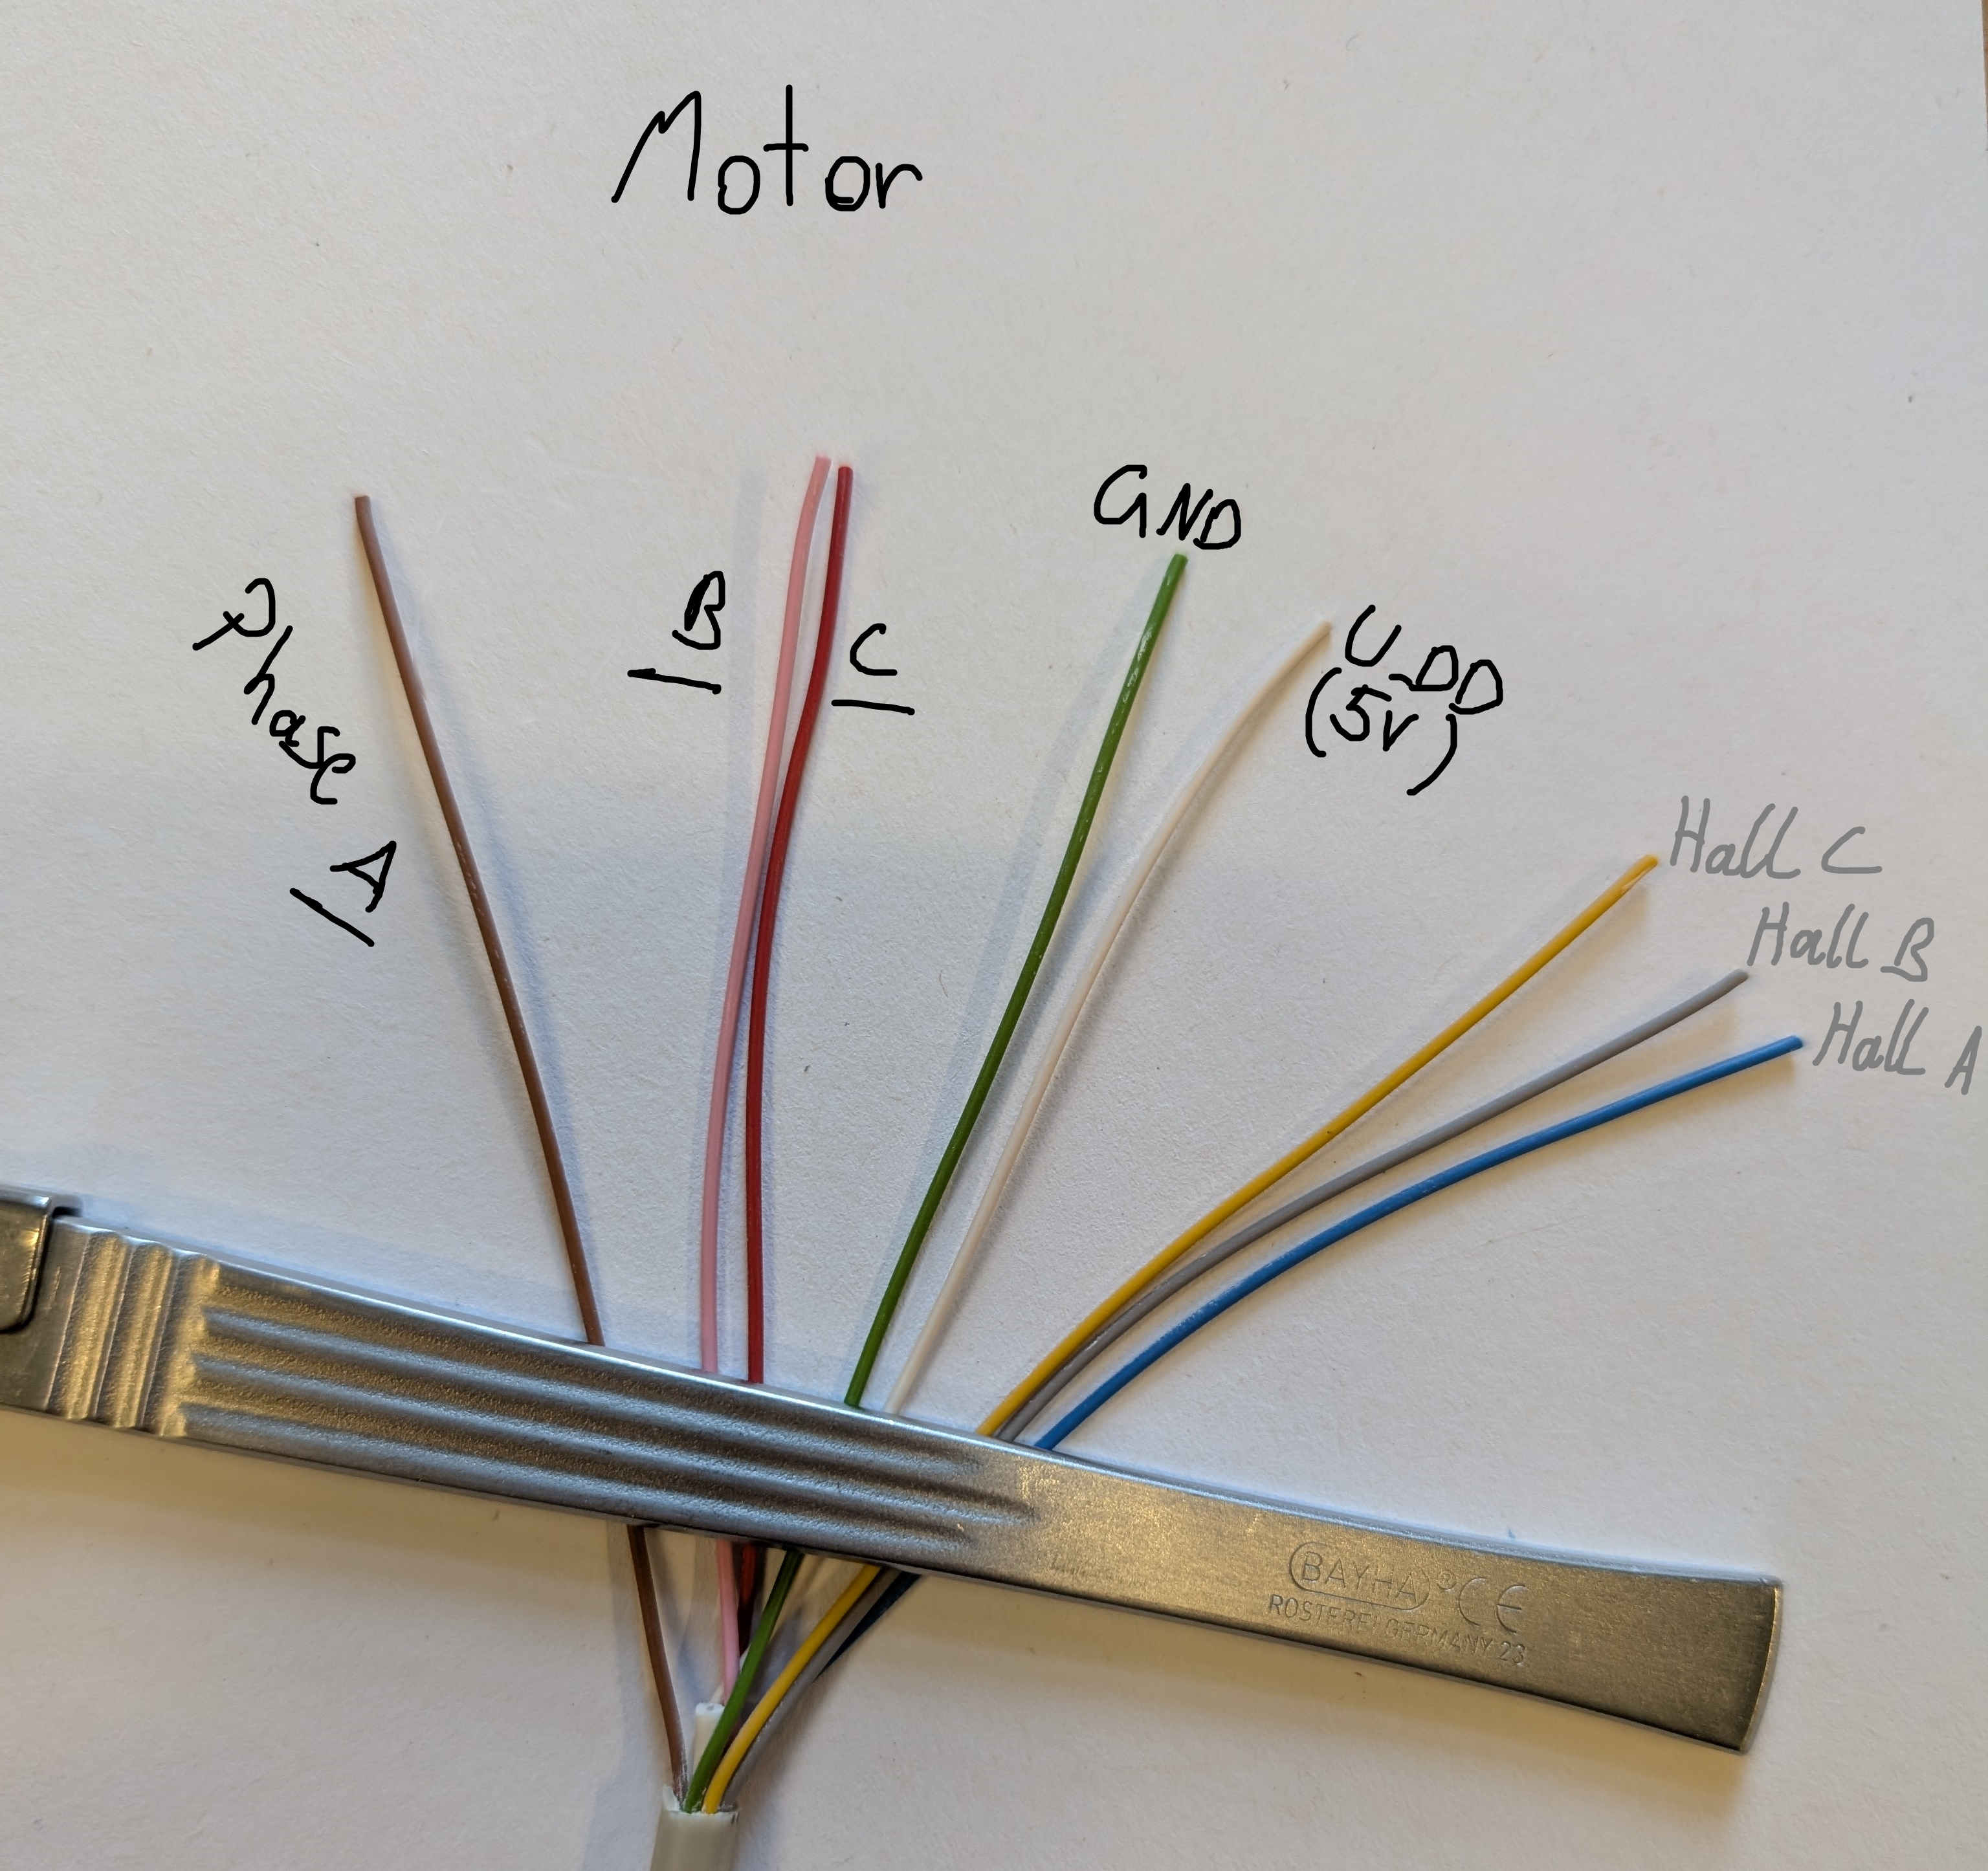
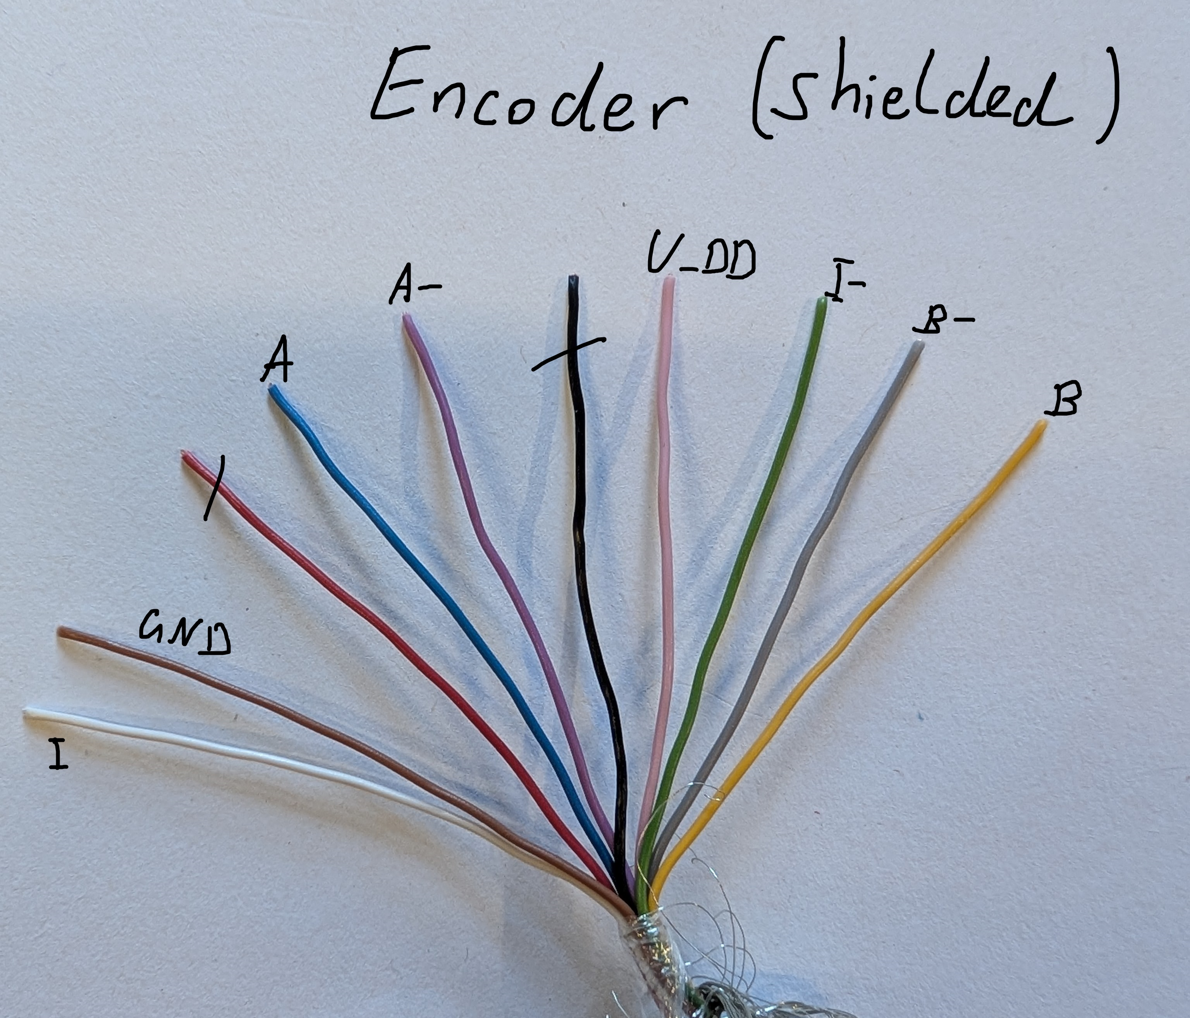

Encoder Channel A, B and C (or I) must all be connected to EL7411.
The Hall Sensor of the motor is not required but still has been connected.
Only minor changes have been made to the electrical system after the first EPLAN was made. It might be useful to update the EPLAN to represent the current state.

The Terminal Assignment can be seen on the next page.

Electrical Signals PLC → Robot

M12 5-Pin Connector for ENC and TRIG signal → Conveyor Tracking
Pin | Usage
1 | EncA
2 | EncB
3 | GND 0V
4 | None
5 | +LS TRIG
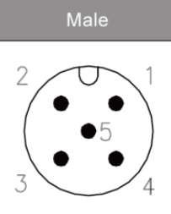
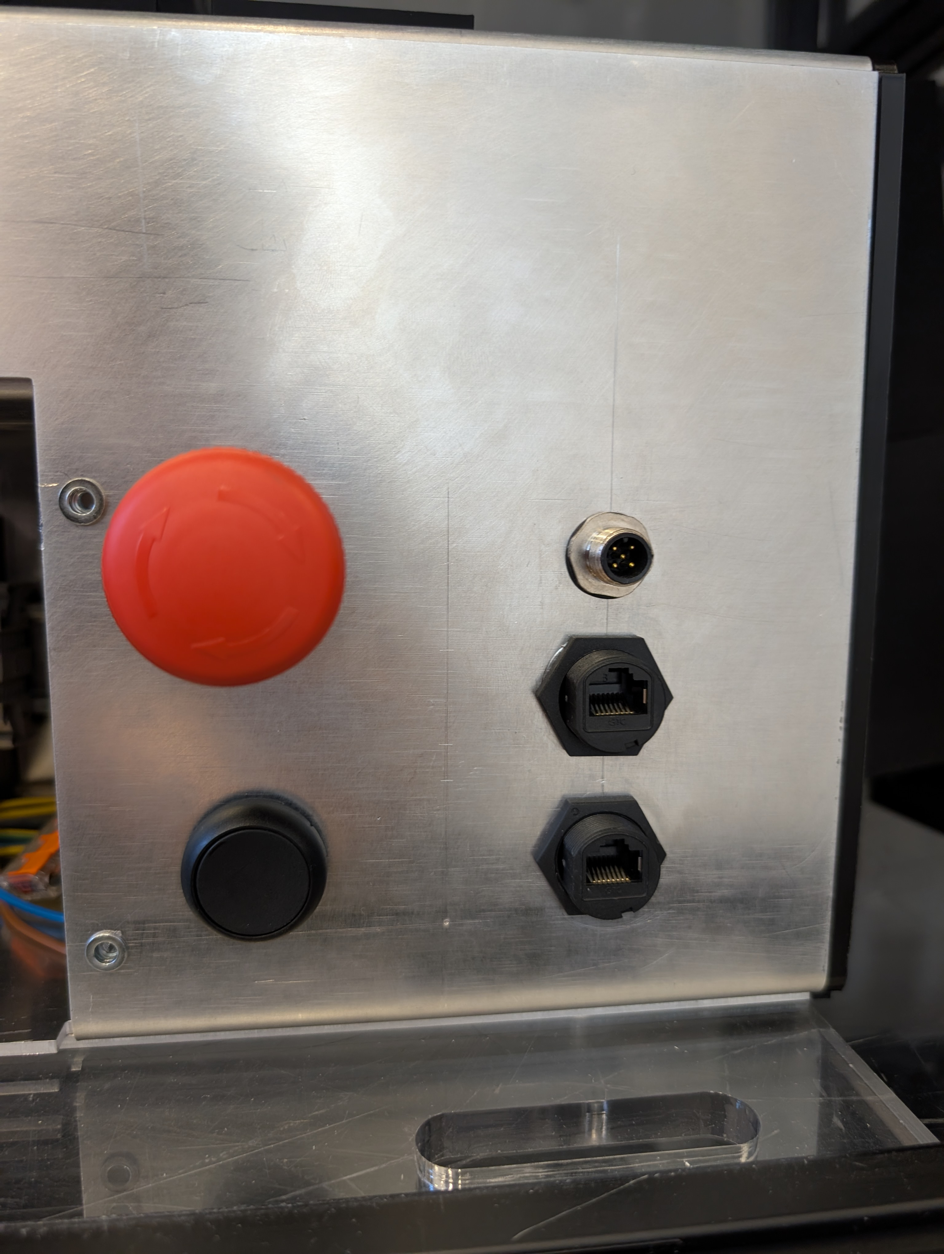
See ABB Document 3HAC050991-001 (Application Manual Conveyor Tracking) for detailed description on the DSQC377 card. Here is an overview of the electrical connections.
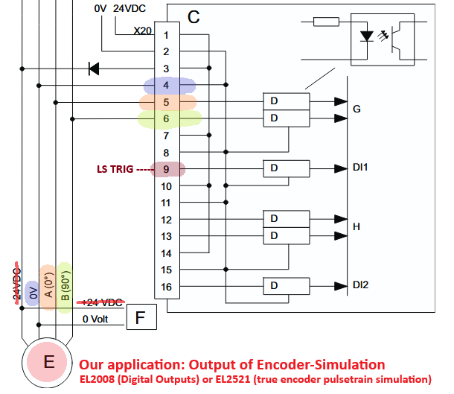

Network Connection PLC → Robot
PROFINET – use PN-Backups of Robot controllers
SPS_67 only connects to robot ...67 Wi-Fi, and SPS_68 only to ...68.
Both PLC have the static IP address 192.168.125.5 → each in the respective network. If you want to connect to the PLC via remote desktop, set your own adapter IP settings to automatic and the Wi-Fi router will give you the right address via DHCP. If you use manual addresses, use 192.168.125.XXX but not .5!
Adapter settings are automatic for PROFINET and EtherCAT – no static addresses!

Encoder Signal generation from PLC to Robot
On SPS_67, the EL2521 is used (not yet finally working in the program) to generate a 24V pulse (encoder) signal from the speed of the EL7411 Camera_Axis.
On SPS_68, the EL2008 Digital Output card is used to generate a 24V pulse signal with the delegated task and Main_Encoder program.
Both have the same purpose: Generate a 24V encoder signal for the DSQC377 (ABB Conveyor Tracking) to process. The DSQC377 needs a minimum level of 18V but the encoder in the conveyors is TTL 5V. The solution with EL2521 is the correct, recommended way to solve this issue. Using digital outputs is only a temporary workaround.

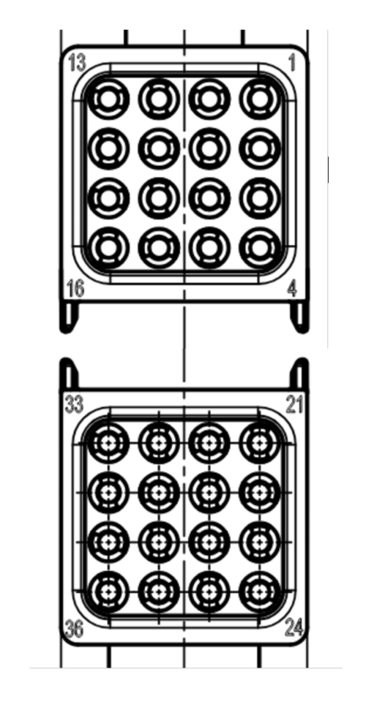
HARTING
On the old setup, the two modules are seperate and a connection is established using the HARTING industrial connector. The “Han Gelenkrahmen Plus” frame holds 4 “Han Domino” cubes. Power transmission for the camera, power and signal for the light barrier (LS) sensor and all signals for the camera conveyor are routed via two “Han Domino HD” cubes – each with 16 pins, so a total of 32 pins is available on the HARTING connector. Conveniently, the 16-pin cubes have labels 1-16 and 21-36 for each pin, as visible on the image. The pin occupation is as follows:
HARTING Pin Occupation
Pin | Usage
1-10 | Encoder (passthrough, wires see chapter 2.1)
11 | +24V (for LS and Camera)
12 | +Out LS (Trig)
13 | GND 0V
14 | -
15 | -
16 | -
21-28 | Motor (passthrough, wires see chapter 2.1)
29-36 | -

Ethernet for the COGNEX camera is passed through the HARTING connector as well.

SCHMALZ
Both Vacuum generators were delivered with cables attached. SCHMALZ uses JST-PA style (RS: 476-6805) connectors. The original cables were removed and a short cable for the quick-change electrical passthrough was soldered to a JST-PA connector. This was done so that the original SCHMALZ cables don’t need to be cut. The wiring can be seen here:
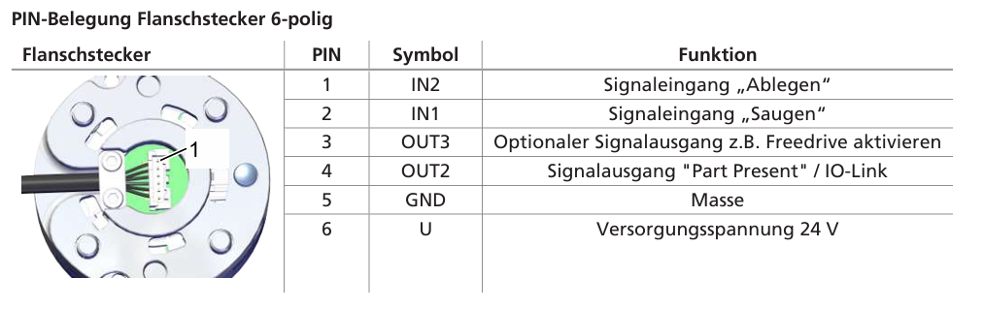
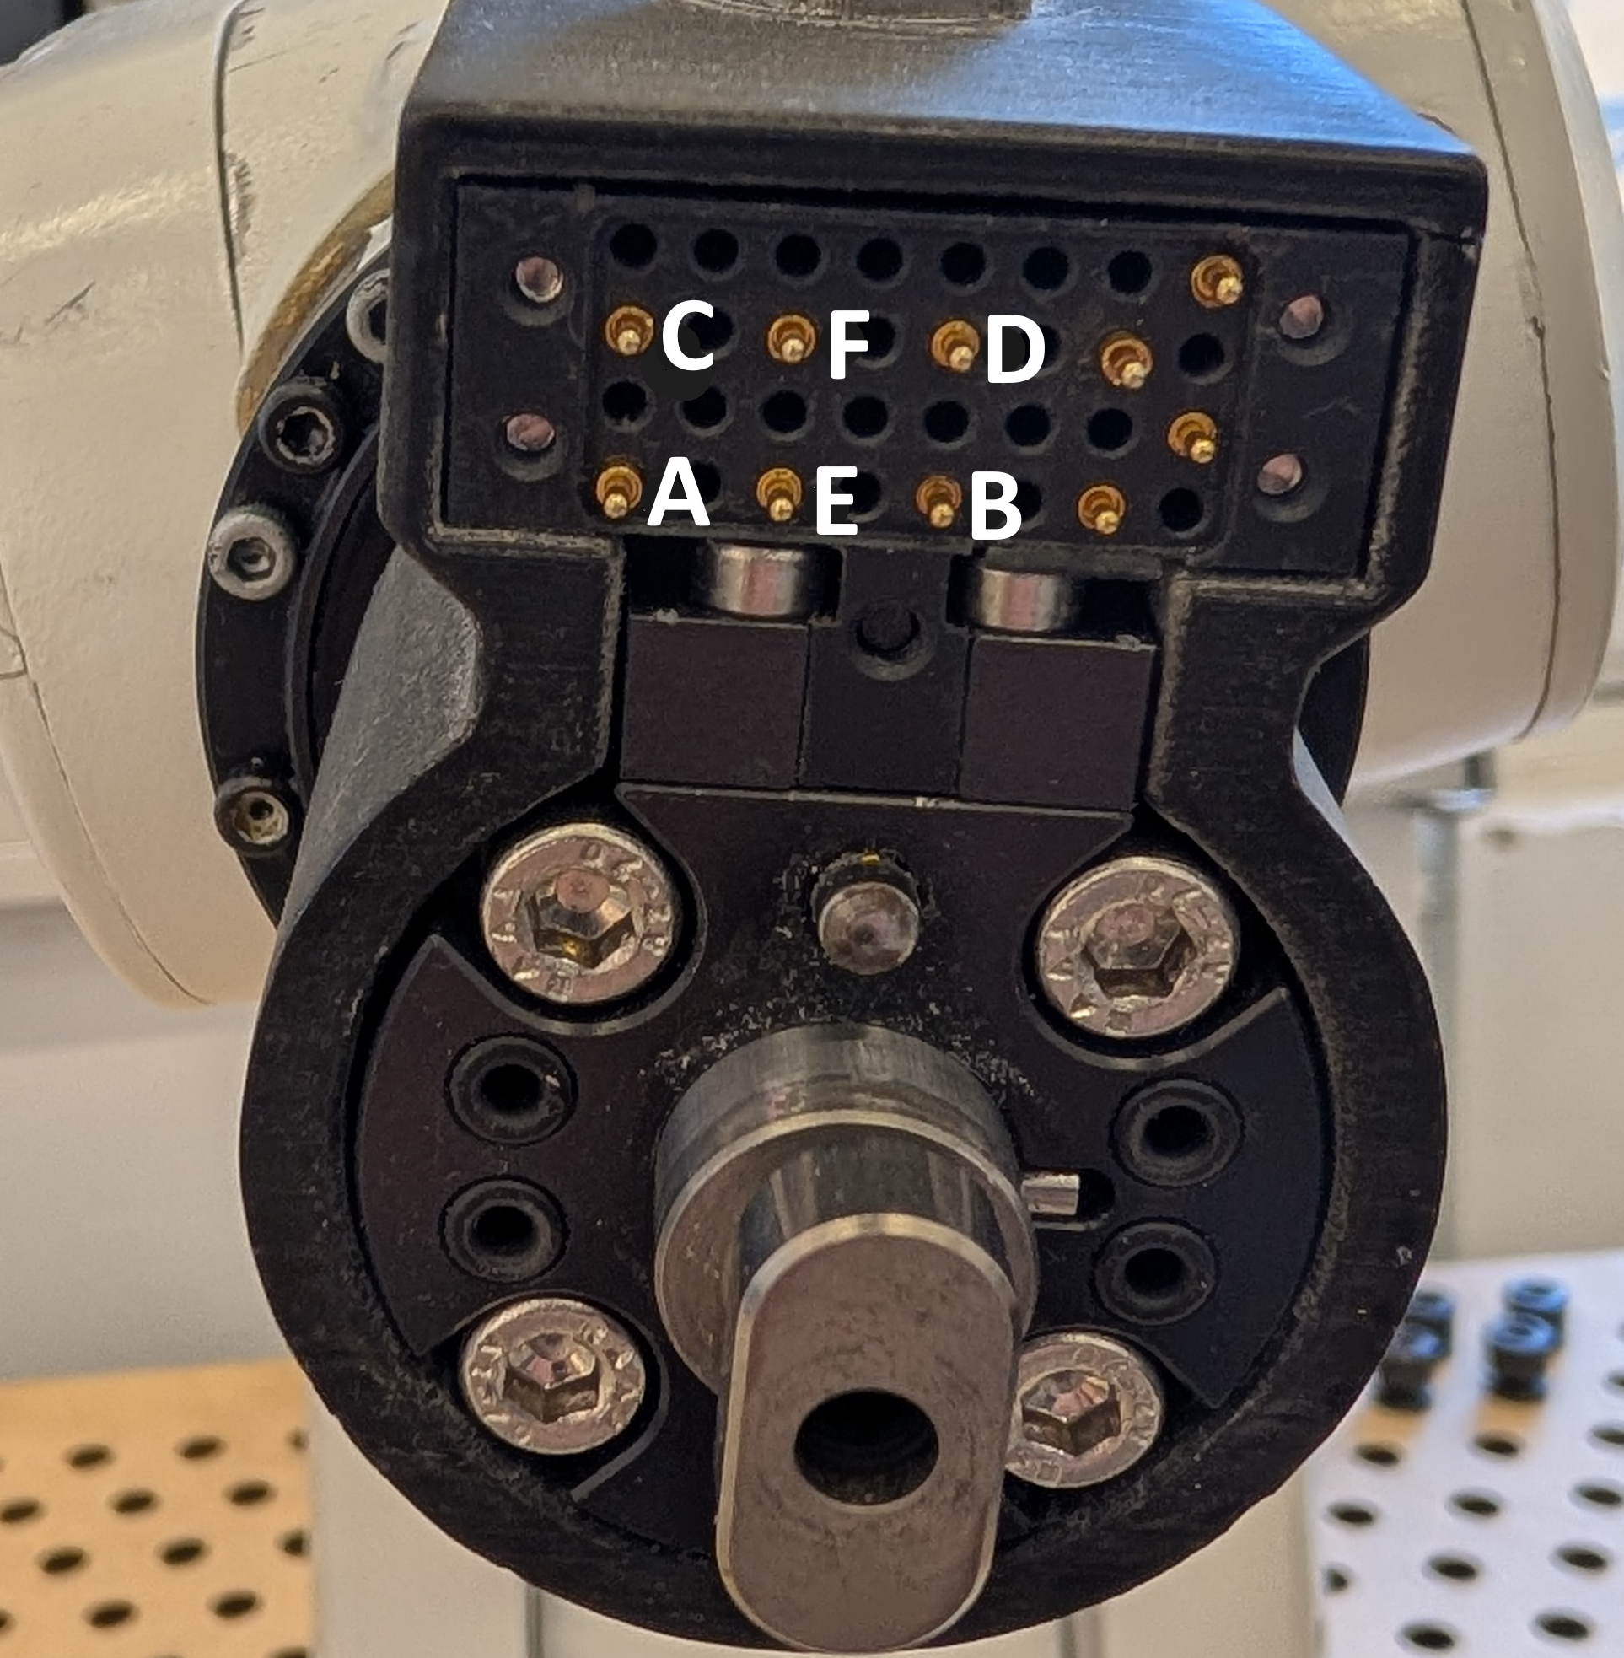
The connections must match the pins of the quickchange system on the robot. See the yellow folder in the lab office for a detailed layout of the quickchanger.
SCHMALZ Quickchange Pins
Quickchange Pin | Function
A | +24V
B | DO1 (DO07)
C | GND 0V
D | DO2 (DO08)
E | DI1 (DI07?)
F | DI2 ?

Watch out! The pins on the receiving end of the quick changer are mirrored!

The vacuum grippers are type SFB1 10 SI-55 M5-AG

COGNEX
The camera tower is detachable from the base. The camera is connected via a CCB-M12X12FS-05 cable to the breakout wago clips inside the camera tower.
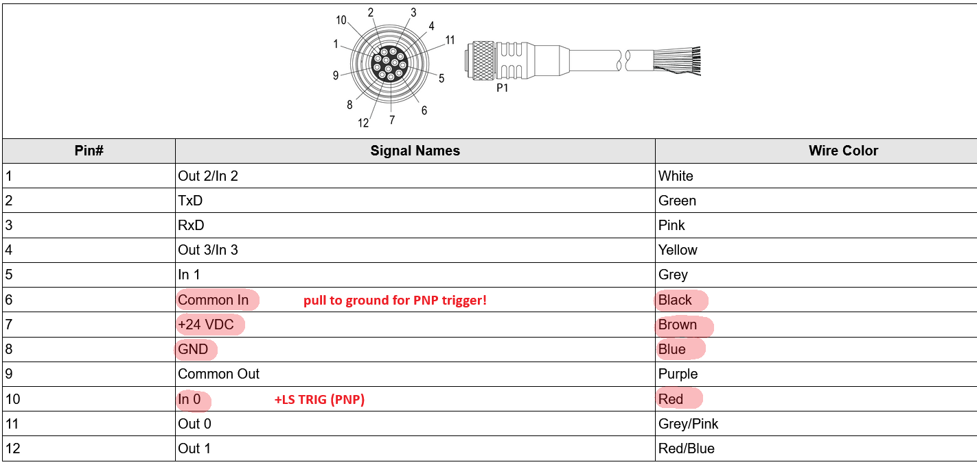

Important: Look closely at the label of the COGNEX cable, there are different models with different wire colors!!!
At the bottom of the camera tower, as well as at the base, an A-coded M12 8 pin connector is used to pass through the electrical connections for the camera:
COGNEX Cable → Camera Tower
Function | Cognex Cable | M12x8 Pin Cable | M12x8 Pin
+24V | Brown | Brown | 2
GND 0V | Blue + Black | Blue | 7
+LS TRIG | Red | Yellow | 4

M12 8 pin connector matches to the camera tower base which has labeled wires and connects via Wago clips to the rest of the system from above.

Ethernet for the camera is passed through the whole system down into the Wi-Fi router of the robot! The robot uses its native network protocol for communication with the camera.

Bill of Materials
The following table gives an overview of important, specifically sourced components used. It does not claim to be complete and many of the components used and not listed are normally in stock at the MCI robotics lab.

Name | Usage in Component Group | Count per Setup | RS Number or Manufacturer Part Number
Festo Light Barrier | Camera Tower Base | 1 | SOOD-TB-R-PN
Eaton LED R/G | Part-Conveyor Cover | 1 | 180799 M22-FLED-RG
Eaton Push Button | Main | 1 | M22S-D-S 216591
Eaton E-Stop Twist Release | Main | 1 | 263467 M22-PVT
MeanWell 24V 6.25A PSU | Main | 1 | HDR-150-24
RS PRO RJ45-Coupler Panelmount Straight | Main | 2 | 111-6746
RS PRO RJ45-Coupler Panelmount 90° | Camera Tower Base, Camera Tower | 2 | 111-6747
RS PRO M12 5-pin Male Connector Panelmount | Main | 1 | 877-1154
RS PRO M12 8-Pin Male Connector Panelmount | Camera Tower Base | 1 | 208-0595
RS PRO M12 8-Pin Female Connector Panelmount | Camera Tower | 1 | 208-0582
RS PRO M12 8-Pin Male Connector for Cable | Connection Cable Camera Tower | 1 | 208-0570
RS PRO M12 8-Pin Female Connector with open Cable | Connection Cable Camera Tower | 1 | 206-7628
Assemtech Inductive Sensor | Main | 1 | 866-2628
Vacuum Gripper | SCHMALZ | 2 | SFB1 10 SI-55 M5-AG

