

Ben-Gurion University of the Negev
Faculty of Engineering Science
School of Electrical and Computer Engineering
Dept. of Electrical and Computer Engineering

Fourth Year Engineering Project
Final Report
Drones Over Cellular

p-2025-149 | Project number:
Omer Madmon (213438138) | Student:
Prof. Omer Gurewitz | Supervisor:
omermad@post.bgu.ac.il | Email for contact
27.7.2025 | Submitting date

Table of Contents
2 Abstract 4
3 Introduction 5
3.1 Motivation and Background 5
3.2 Project Objectives 5
3.3 Survey of Existing Solutions 5
3.4 Rationale for Chosen Approach 6
4 Spec Sheet 6
4.1 System Overview 6
4.2 Technology Involved 7
4.3 Work Stages 8
4.4 Potential Applications 8
4.5 System Performance 8
5 Approach & Design 9
5.1 Architectural Overview 9
5.2 Hardware Components & Specifications 10
5.2.1 Drone Platform 10
5.2.2 Raspberry Pi Zero 2W 10
5.2.3 Cellular Module 11
5.3 Physical Hardware Integration 12
5.3.1 Power and Boot 13
5.3.2 Data and Control Wiring 13
5.3.3 Antenna Placement 14
5.3.4 Module Mounting 14
5.3.5 Preserved Drone Sensors 14
5.4 Network Architecture 14
5.4.1 Network Overview 14
5.4.2 NAT Barrier 15
5.4.3 Central Relay Server 15
5.4.4 WireGuard VPN 16
5.5 Software Architecture & Implementation 17
5.5.1 Main Software Tools Used 17
5.5.2 Control Station Software 18
5.5.3 Raspberry Pi Software 19
5.5.4 Central Relay Server 20
5.5.5 WireGuard Configuration 20
6 Final Acceptance Tests of the Product 21
6.1 Latency Test 21
6.1.1 Motivation and Methodology 21
6.1.2 Results and Conclusions 21
6.2 Video Steaming Test 22
6.2.1 Motivation and Methodology 22
6.2.2 Results and Conclusions 22
6.3 Remote Operation Validation 23
6.3.1 Motivation and Methodology 23
6.3.2 Results and Conclusions 23
7 Challenges 23
7.1 NAT Barrier 23
7.2 Peer-to-Peer Connection 24
8 Conclusions 24
8.1 Project summary 24
8.2 Results vs. initial goals 25
8.3 Product pros and cons 26
8.3.1 Pros 26
8.3.2 Cons 26
8.4 Future Work 26
9 Bibliography 28
10 Appendices 29

Abstract
Most consumer drones are restricted by their limited range and reliance on visual line-of-sight, making them unsuitable for remote applications.
The project aims to develop an upgrade kit that provides cellular connectivity to a standard Wi-Fi drone, enabling real-time control over extended distances.
The solution integrates a Raspberry Pi, which communicates with the drone via Wi-Fi. The Pi is equipped with an LTE cellular modem, granting internet access and facilitating seamless command transmission between the control station and the drone. Additionally, it streams live video from the drone back to the operator. To ensure reliable and continuous connectivity, all data traffic between the control station and the Pi is securely routed through an external VPN server.
With this configuration, we achieved a stable connection with an average round-trip time of 0.5 seconds, significantly enhancing the drone’s operational range. Our upgrade kit transforms a conventional Wi-Fi drone into a long-range aerial platform, ideal for applications such as precision agriculture, deliveries, and remote inspections.
Keywords: Cellular communication, LTE, Raspberry Pi, NAT, VPN, drones.

רחפנים סטנדרטיים הנפוצים כיום מוגבלים בטווח פעולה קצר ובדרישת קו ראייה, מה שמגביל את השימוש בהם ביישומים מרוחקים.
מטרת הפרויקט היא לפתח מערכת המספקת לרחפן סטנדרטי, הפועל באמצעות Wi-Fi, חיבור סלולרי המאפשר שליטה מרחוק בזמן אמת.
לצורך כך, התקנו על הרחפן יחידת Raspberry Pi, אשר מתקשרת עם הרחפן דרך Wi-Fi. ה-Pi מחובר גם למודם LTE סלולרי, המספק גישה לאינטרנט ומאפשר העברת פקודות מתחנת השליטה לרחפן, וכמו כן הזרמת ווידאו מהרחפן בחזרה לתחנה. כדי להבטיח קישוריות רציפה ואמינה, כל התעבורה בין תחנת השליטה לבין ה-Pi מנותבת דרך שרת VPN חיצוני.
מערכת זו מאפשרת חיבור יציב עם Round-trip time ממוצע של 0.5 שניות, מה שמאפשר הסבת רחפן מבוסס Wi-Fi לרחפן מבוסס תקשורת סלולרית ארוכת-טווח, המתאים למגוון יישומים מרוחקים, כגון חקלאות, משלוחים וסיור אווירי.
מילות מפתח: תקשורת סלולרית, LTE, Raspberry Pi, NAT, VPN, רחפנים.

Introduction

Motivation and Background
Unmanned aerial vehicles have evolved from niche hobbyist toys to indispensable tools across industries such as agriculture, infrastructure inspection, logistics, and emergency response [1]. Their ability to gather high-resolution imagery, sense environmental conditions, and reach difficult-to-access locations has driven demand for longer, more complex missions.
Today’s consumers and many commercial drones rely on short-range radio or Wi-Fi links, which restrict flight to a few hundred meters from the pilot [2]. This limitation prevents truly remote deployments in vast areas where beyond-visual-line-of-sight operation would yield substantial efficiency and safety gains.
By extending reliable control and live data streaming over tens of kilometers, we can unlock new use cases. A robust, long-distance link enables continuous aerial monitoring without relocating ground stations, quick response in emergencies regardless of terrain, and scalable inspection of infrastructure. Establishing a dependable, low-latency connection is therefore essential to realize the full potential of drones in large-scale and safety-critical applications.

Project Objectives
The project enables an existing drone to operate over a cellular network instead of relying on Wi-Fi. It focuses on extending the communication range beyond the limitations of short-range wireless technologies while ensuring a reliable connection with reasonable delays suitable for real-time control and feedback.

Survey of Existing Solutions
Satellite communication offers near-global coverage and resilience to terrain obstacles, making it a natural choice for truly remote drone operations. However, satellite links come with significant drawbacks: high equipment costs, bulky transceivers that add weight to small UAVs, service fees measured in tens to hundreds of dollars per hour, and round-trip latencies on the order of half a second or more. These factors limit the satellite’s practicality for real-time control and consumer-grade platforms [3].
Long-range radio systems, such as proprietary RF modules operating below 1 GHz or mesh networks using LoRa, can extend beyond the few hundred meters of Wi-Fi, sometimes reaching several kilometers. They achieve low-power, point-to-multipoint connectivity without relying on infrastructure, but their data rates are typically too low for HD video streaming. These solutions excel at telemetry and simple command links but fall short when simultaneously high-bandwidth video and control are required [4].
A growing ecosystem of startups now offers integrated LTE/5G drone solutions that bundle hardware, software, and connectivity plans. These services simplify deployment but often lock users into specific platforms and data contracts [5]. Our approach, by contrast, uses off-the-shelf components and open-source tools to achieve similar performance at lower cost and with minimal vendor lock-in.

Rationale for Chosen Approach
Leveraging commercial cellular networks provides a cost-effective path to long-range drone control. Data plans for LTE modems start at just a few dollars per gigabyte, a fraction of satellite airtime fees. At the same time, LTE infrastructure is already in place across most populated areas, avoiding the need for custom ground stations or licensing of dedicated frequencies.
By building standard IP networking, our solution remains agnostic to the underlying access technology. Although we use LTE in this project, the same companion computer and VPN relay architecture can accommodate Wi-Fi backhaul, satellite links, or future 5G modules simply by swapping the modem hardware. This modularity reduces development effort for new backends and extends the system’s lifespan as connectivity technologies evolve.
Finally, the rapid growth of the Internet of Things ecosystem means cellular modules are becoming smaller, cheaper, and more power-efficient. Integrating a Pi-based companion computer with a lightweight LTE modem aligns with this trend, making our kit easy to reproduce and maintain [6].

Spec Sheet

System Overview
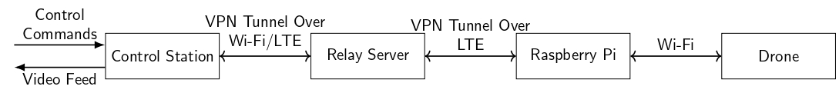
This project delivers a modular add-on kit that transforms any off-the-shelf, short-range Wi-Fi drone into a long-distance, IP-based UAV platform. At its heart is a companion computer (Raspberry Pi) paired with a cellular LTE modem and a minimal cloud relay service. Together, they bridge the gap between the drone’s onboard Wi-Fi network and the public Internet, enabling remote command, telemetry, and live video streaming over kilometers rather than meters.
On the ground, a control-station application connects to the relay service and presents a graphical interface for pilot commands and video feedback. In flight, the companion computer automatically establishes an LTE link to the server, brings up a secure VPN tunnel, and forwards all SDK commands and H.264 video over UDP. This architecture works with any basic cellular data plan on the drone side and any Internet connection at the control station, delivering a plug-and-play experience for truly beyond-visual-line-of-sight operation.

Technology Involved
- Drone (DJI Tello): The drone is the main device for the project. It can receive control commands and send back video, allowing it to be managed remotely.
- Raspberry Pi (zero 2W): The Raspberry Pi Zero 2W is a small and lightweight computer. It serves as a bridge between the control station and the drone, enabling communication between them. It receives commands from the user and forwards them to the drone, while also sending back video received from the drone. Its small size, low weight, and affordability make it ideal for integration with the drone, ensuring minimal impact on the drone's payload capacity.
- Cellular Communication: Cellular networks (e.g., 4G LTE) provide the range needed for long-distance drone control, enabling real-time data transfer. Two components will handle these connections: a SIM card and a SIMCom A7670E module.
  - The SIM card has the credentials to connect to the operator’s cellular network.
  - The SIMCom A7670E module is lightweight, affordable, and supports 4G LTE. A SIM card is inserted into the module, and the module connects to the Raspberry Pi to enable internet connection via cellular connectivity.
- VPN Server: We want to make a connection between the control station and the Raspberry Pi, through the public internet. To do that, we need a central server with a public IP address (further explained in section 5.4). We use AWS (Amazon Web Services) for setting up an EC2 machine with a public IP address. The server opens two VPN tunnels, one from itself to the control station and another one from itself to the Raspberry Pi. The server then forwards the data between the control station and the Raspberry Pi.

Work Stages
• Hardware and Cellular Link Integration: Install the SIMCom A7670E modem on the Raspberry Pi Zero 2 W, wire the UART and power connections, and configure the ppp0 interface so that the Pi obtains Internet access over LTE.
• Relay Server and VPN Deployment: Provision a cloud host with a public IP, install and configure WireGuard to accept peer connections from both the Pi and the Control Station, and verify that encrypted tunnels can be established in both directions.
• Control Station GUI Development: Build the Python/PyQt5 application that presents on-screen flight controls, opens the VPN tunnel, and sends SDK commands via UDP. Implement user input handling and command serialization.
• Video Pipeline Integration: On the Pi, use FFmpeg to capture the Tello’s H.264 stream over Wi-Fi and packetize it for UDP forwarding. In the GUI, decode incoming packets with OpenCV and render the live video feed alongside the control interface.

Potential Applications
This modular kit makes it possible to deploy drones across any area covered by a cellular network, vastly extending their practical range. In agriculture, operators can conduct wide-area crop surveys without relocating ground stations. Inspection teams can monitor infrastructure, such as pipelines and railways, from many kilometers away. Logistics and delivery services can experiment with remote drop-off routes, and search-and-rescue units can stream live video from distant or hard-to-reach locations. By decoupling drone operations from short-range radios, our solution opens new opportunities for any application that benefits from long-distance control and real-time data.

System Performance
This kit serves as a proof of concept, demonstrating reliable long-range control and live video streaming over a cellular link. In our tests, the drone maintained stable operation from distances up to 70 km, with round-trip command latency averaging 0.35 s. The video was displayed at approximately 24 fps with minimal jitter, and the drone’s flight time of less than 10 minutes.
Key performance highlights include:
- Range: Verified beyond-visual-line-of-sight control at 70 km over LTE
- Latency: Consistently under 1s for command execution and telemetry
- Video Quality: Steady 24 fps H.264 stream with negligible frame drops
- Flight Duration: Approximately 7 minutes on a single 1100 mAh battery
These results confirm that the platform can extend a Wi-Fi drone’s reach without compromising responsiveness or flight endurance. Further measurements, such as end-to-end throughput, packet-loss rates, and CPU utilization under varied network conditions, would deepen our understanding of system limits and guide future optimizations.

Approach & Design

Architectural Overview
Our primary objective was to retrofit a consumer-grade Wi-Fi drone for true beyond-visual-line-of-sight operation while keeping costs and complexity low. Commercial cellular networks met our requirements for widespread coverage, low per-byte data costs, and sufficient throughput and latency for real-time control and video.
Because the DJI Tello relies solely on an onboard Wi-Fi access point, we introduced a lightweight companion computer in the form of a Raspberry Pi Zero 2 W paired with an LTE modem. The Pi boots from the drone’s battery and runs a simple relay service: it joins Tello’s Wi-Fi as a client, opens a cellular link for Internet access, and forwards all UDP-based SDK commands and H.264 video packets between the two networks.
At the core of our design is the principle of “drone over IP.” By treating both control and streaming as standard Internet traffic, we leverage a public relay server and VPN tunnels to bypass NAT and firewall barriers. In this way, the drone becomes just another node on the global network, capable of operating anywhere with cell service, and easily adaptable to other backhaul technologies such as 5G, satellite, or long-range Wi-Fi without redesigning the control logic.

Hardware Components & Specifications

Drone Platform
The DJI Tello is our base airframe. It weighs approximately 80 g with battery and measures 98×92.5×41 mm. Its 1100 mAh LiPo battery provides about 13 minutes of flight time in calm conditions, with a line-of-sight control range near 100 meters over its built-in 802.11n Wi-Fi link [7].
A 5 megapixel CMOS sensor captures 1280×720 pixel video at 30 fps. The Tello communicates via three UDP ports: 8889 for commands, 8890 for video, and 8891 for status telemetry. Commands are simple ASCII strings such as “takeoff”, “forward 20”, or “land”, and responses arrive as JSON-style messages. Its SDK supports command rates up to 100 Hz, enabling precise, low-lag control in development environments.
At roughly $159 retail, the Tello is popular for research and hobby projects because of its open Python SDK, affordable price, and compact design. Many developers choose it to prototype custom controls and streaming solutions.
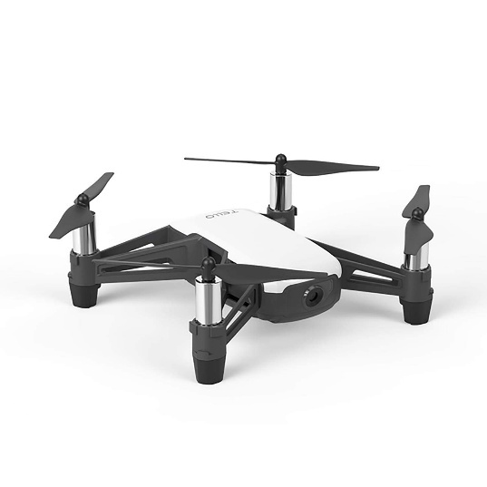

Raspberry Pi Zero 2W
The Raspberry Pi family of single-board computers delivers a full Linux environment in a credit-card-sized form factor. Each model boots from a microSD card and offers a range of I/O options—GPIO, USB, and wireless connectivity, making the platform extremely versatile for embedded and prototyping applications.
The Zero 2 W is one of the lightest and most compact members of this family. It packs a 1 GHz quad-core ARM Cortex-A53 processor, 512 MB of RAM, and integrated 802.11n Wi-Fi into a 65×30 mm board. Under typical load, it draws under 500 mA at 5 V, keeping added mass and power consumption to a minimum [8].
Running a standard Debian-based Linux distribution, the Pi Zero 2 W easily accommodates our Python relay service, WireGuard VPN client, and FFmpeg-based video pipelines. Its performance headroom ensures smooth packet forwarding, video decoding, and network encryption without overtaxing the CPU.
Thanks to its low cost, extensive community support, and straightforward Linux toolchain, the Raspberry Pi Zero 2 W has become a go-to choice for UAV companion-computer roles. In our design, it serves as the bridge between the drone’s Wi-Fi link and the cellular network, all while remaining lightweight and power efficient.
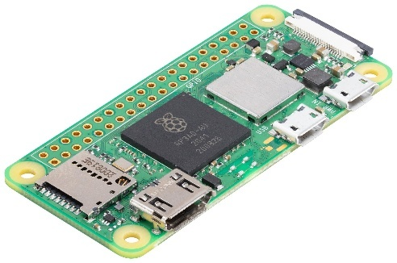

Cellular Module
The SIMCom A7670E is an LTE cellular modem designed for IoT and embedded applications. It delivers up to 10 Mbps downlink and 5 Mbps uplink, supporting HSPA+, LTE-FDD, and GSM fallback to ensure connectivity across diverse coverage areas.
Physically, the A7670E measures 30×30×2.85 mm and connects to the host via a standard UART interface. It includes an onboard SIM slot, status LEDs for link and data activity, and an antenna connector for an external LTE antenna [9].
On the Raspberry Pi, the module is managed by the Linux PPP daemon, which instantiates a network interface named ppp0 when the link is active. The modem automatically registers with the cellular network using SIM credentials, negotiates an IP address from the carrier’s APN, and provides a full IP path for our VPN and video relay traffic.
At a unit cost of around $16, the A7670E offers a cost-effective solution for adding robust, long-range connectivity to embedded systems. Its balance of throughput, power consumption, and ease of integration makes it an ideal choice for our drone project.
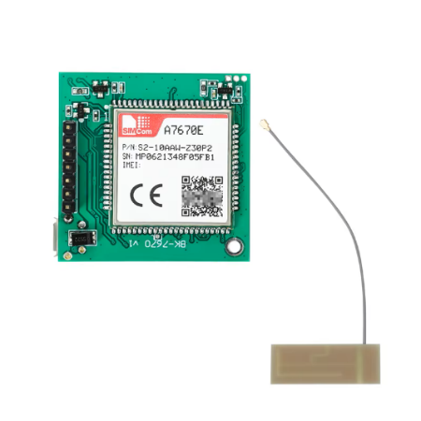

Physical Hardware Integration
The following figures show the assembled hardware on the DJI Tello, and the added table maps the callouts in the photos to each component.
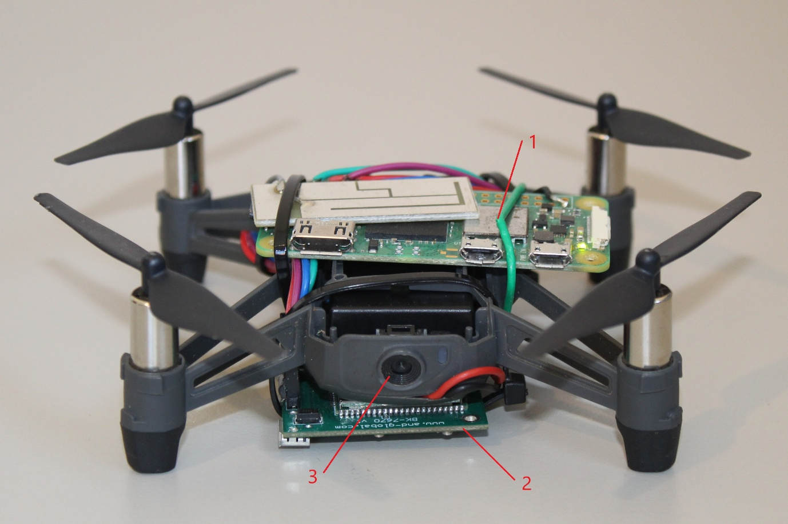
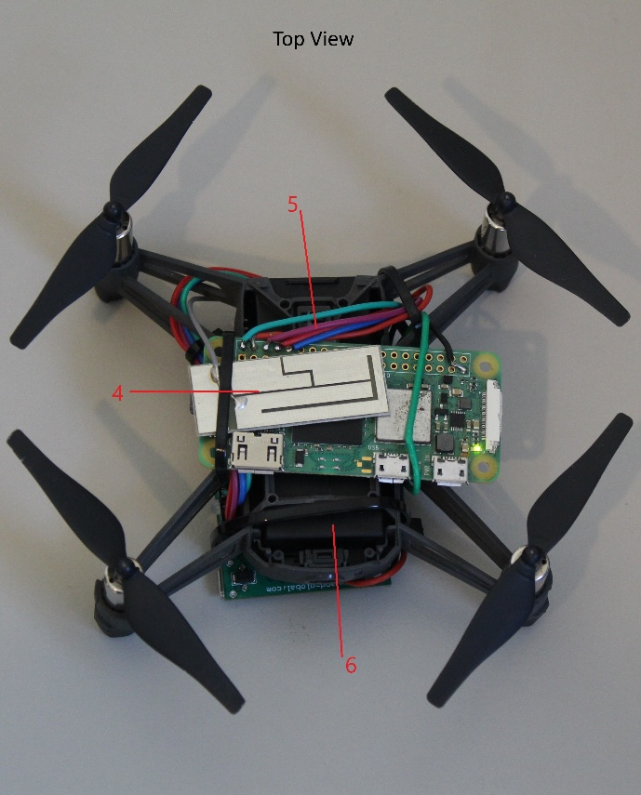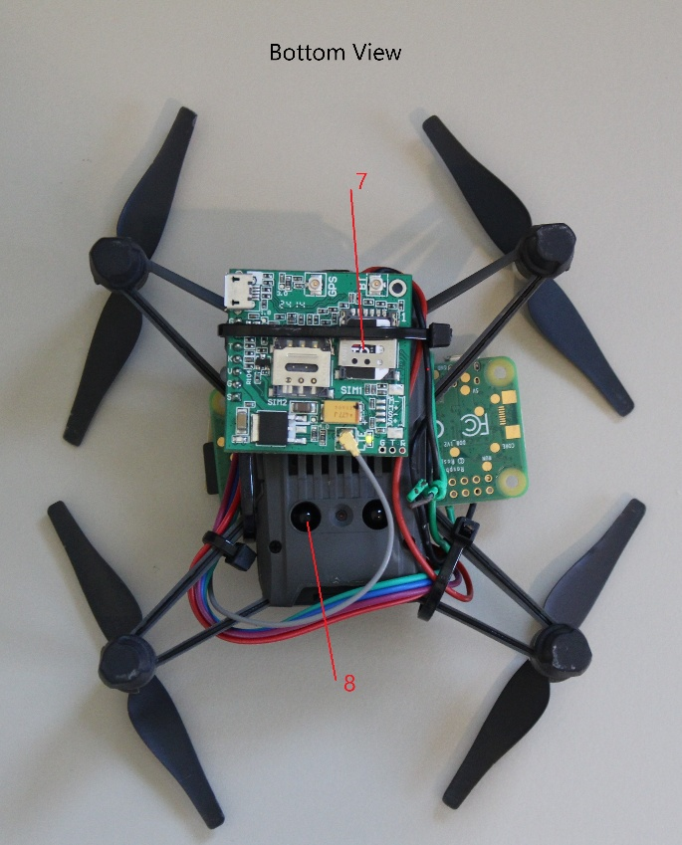

No. | Part
1 | Raspberry Pi
2 | Cellular module
3 | Drone’s camera
4 | LTE antenna
5 | Jumper wires (power & UART)
6 | 1100 mAh LiPo battery
7 | SIM card
8 | Drone’s sensors

Power and Boot
The Tello’s 5 V rail from the LiPo battery is split via a soldered wire harness. One leg feeds the flight controller as usual; the other is routed to the Pi’s 5 V and GND GPIO pins. As soon as the operator inserts the battery, the Pi powers on alongside the drone. The Pi’s startup script then brings up the PPP interface to the cellular network and launches the WireGuard tunnel.

Data and Control Wiring
Five jumper wires link the Pi’s UART TX, RX, and GND pins to the SIMCom module’s serial port pins. This direct connection enables the Pi to initialize the modem and negotiate the LTE link with the carrier’s APN without any manual AT commands. The same harness also provides the module’s 5 V power and ground return.

Antenna Placement
To optimize signal strength, the LTE antenna (No. 4) is mounted on top of the Pi board using a small adhesive pad. Its coaxial pigtail is routed neatly alongside the Pi’s USB port, avoiding moving parts and propeller arcs.

Module Mounting
The cellular modem (No. 2) is secured to the underside of the Pi and drone frame using nylon M2 standoffs and machine screws. This location offers just enough clearance above the drone’s shell while keeping the overall center of gravity close to the original design.

Preserved Drone Sensors
The Tello’s onboard sensors, including its inertial measurement unit and barometric altimeter, remain connected to the stock flight controller board (No. 8) and are not modified. The Pi and modem assemblies sit above the camera module (No. 3) without interfering with the lens or airflow.

Network Architecture

Network Overview
Our system relies on standard IP networking to carry both control commands and live video between the Control Station and the Raspberry Pi. By treating the drone link as just another node on the Internet, we gain access to high bandwidth, low latency, and mature routing infrastructure that far exceeds the limitations of short-range wireless protocols.
The Raspberry Pi establishes its Internet connection over the LTE network, turning the drone into a remotely addressable device anywhere covered by the carrier. The Control Station, in turn, may connect via home Wi-Fi, wired Ethernet, or another cellular link, giving the pilot flexibility in deployment.
The Raspberry Pi connects to the drone using its internal 802.11n Wi-Fi module and the Tello’s built-in access point. This direct Wi-Fi link carries all SDK commands and raw video packets between the Pi and the flight controller as UDP over IP, integrating seamlessly with our IP-based end-to-end architecture.
Because the two endpoints are not on the same local network, carrier and home routers will typically insert NAT and firewall functions that block unsolicited traffic.
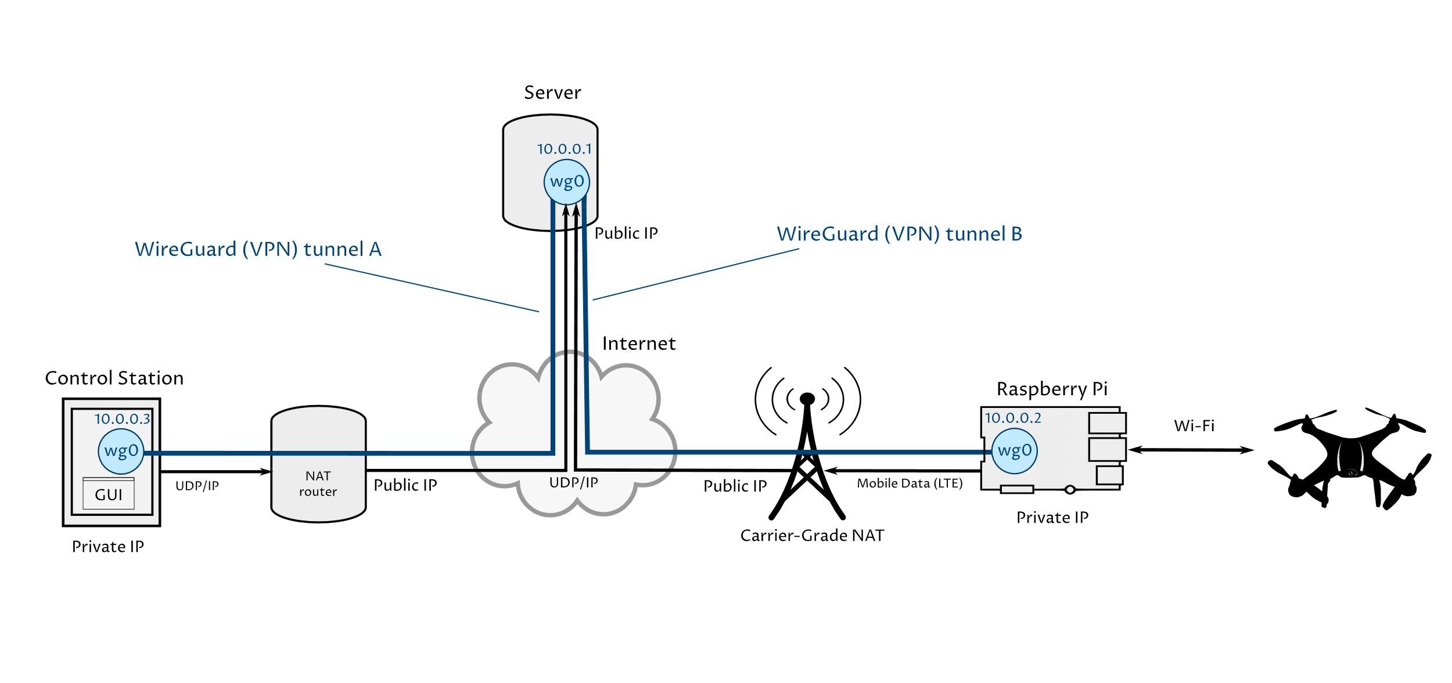

NAT Barrier
Network Address Translation (NAT) maps private IP addresses on an internal network to a smaller pool of public IPs. Devices obtain a private address behind the carrier’s NAT. To the outside world, all outbound traffic appears to originate from the router’s public IP, and the NAT maintains a translation table so that return packets are forwarded to the correct internal client.
By design, NAT only forwards inbound packets that match an existing outbound connection. Any unsolicited incoming packet is discarded, effectively acting as a basic firewall. In our drone system, this means UDP commands sent from the Control Station to the Pi’s public IP will be blocked unless the Pi has already sent outbound traffic and established a NAT mapping. Without special handling, the Control Station cannot initiate a fresh connection to the Pi, nor can the Pi directly receive unsolicited command packets [10].
There are several NAT‐traversal techniques (e.g., STUN/TURN, port forwarding), but in this project, we use a relay server with a public WireGuard VPN tunnel for its simplicity and robustness.

Central Relay Server
To bypass carrier NATs, both the Control Station and the Raspberry Pi must connect to a host with a public IP address [10]. We provisioned an Amazon Web Services EC2 instance on the free-tier plan, which comes with a static, publicly routable IPv4 address. This server acts purely as a packet relay: it accepts encrypted tunnels from both endpoints and forwards traffic between them. Security group rules permit inbound UDP on port 51820 for VPN sessions and SSH on port 22 for administration.
To manage connections with the relay server and ensure reliable packet forwarding, we use WireGuard VPN tunnels.

WireGuard VPN
WireGuard is a modern VPN protocol that establishes an encrypted tunnel over the Internet, allowing two endpoints to communicate as if they shared a private LAN. It transports all data over UDP to avoid the extra delays of connection-oriented protocols, and relies on small receive buffers in the application to handle occasional packet loss rather than incur TCP’s congestion control overhead [11].
Key advantages of WireGuard include its simple codebase (a single kernel module with a minimal user-space utility), its use of Curve25519 for key exchange and ChaCha20-Poly1305 for authenticated encryption, and its built-in peer management with automatic endpoint discovery and periodic key rotation.
WireGuard naturally traverses network address translators through the following steps:
- Outbound session initiation: Each peer, both Control Station and Raspberry Pi, opens a UDP session to the server’s public IP on port 51820. Because NAT devices permit return traffic for outbound sessions, this creates the necessary mapping.
- Periodic handshake refresh: When no data has passed for 25 seconds, WireGuard sends a handshake packet. This packet refreshes the NAT binding so that routers do not expire the session.
- Virtual IP addressing: Every peer is assigned a static VPN address (for example 10.0.0.1 for the Control Station, 10.0.0.2 for the Raspberry Pi). All traffic is encapsulated and routed via these VPN addresses, so neither endpoint ever needs to know the private IP address assigned by the carrier.
This combination of outbound initiation, handshake refresh, and virtual addressing ensures bidirectional, low-latency connectivity through even strict carrier NATs.
WireGuard also provides end-to-end confidentiality, authentication, and integrity [11]. This means that user commands and video packets are encrypted so they cannot be read by an eavesdropper, each peer verifies that incoming data truly comes from a trusted endpoint, and any tampering or packet forgery is detected and discarded. In practice, this guarantees that an adversary cannot intercept flight controls, inject false commands, or alter the live video stream without being noticed.

Software Architecture & Implementation

Main Software Tools Used
In our software stack, we leveraged the following key packages and tools to meet performance, portability, and security requirements:
- PyQt5: Provides a mature, cross-platform GUI framework for Python. We used it to build the Control Station’s main window, layout flight-control buttons, and embed the live video panel with minimal boilerplate.
- OpenCV: Handles real-time decoding and rendering of H.264 video frames. Its efficient C++ back-end and Python bindings allow us to sustain a 30 fps display with low CPU overhead.
- FFmpeg: Performs packetization and depacketization of the drone’s H.264 stream on the Raspberry Pi. Chosen for its command-line flexibility and ARM optimizations.
- H.264 Codec: The industry-standard video codec used by the DJI Tello. We rely on its hardware-friendly compression to minimize uplink bandwidth and decoding latency.
- Pillow: A lightweight imaging library used for any on-the-fly screenshot capture, thumbnail generation, or simple image annotations within the GUI.
- Python 3 Virtual Environments: Ensures reproducible deployments on both the Control Station and Raspberry Pi. Our setup scripts create isolated environments, pin package versions, and install dependencies cleanly.
- PPP (Point-to-Point Protocol): A data link layer protocol commonly used to establish a direct connection between two network nodes. It encapsulates network layer packets over serial links, handles link configuration and authentication (PAP/CHAP), and negotiates IP address assignment. On Linux, the pppd daemon manages PPP sessions and brings up interfaces named ppp0, ppp1, etc.
- systemd: The initialization and service management suite used by many Linux distributions. It provides dependency-aware startup, process supervision, and centralized logging for background services.
- SSH: Secure Shell is the de facto standard for remotely accessing and managing servers. From the user’s perspective, running ssh user@hostname over TCP port 22 opens an encrypted terminal session, protecting credentials and commands from eavesdropping. SSH also supports public-key authentication, automated scripts, and secure file transfer, making it the preferred tool for day-to-day server administration.

Control Station Software
The Control Station application runs on a standard Linux workstation (native, in a VM, or under WSL) and provides the pilot with a simple but responsive interface for commanding the drone and viewing its live video feed. To launch, the user executes a shell script (run_base_station.sh) which initializes the WireGuard VPN tunnel and opens the PyQt5-based GUI. The main window displays connection status indicators, a live video panel powered by OpenCV, and intuitive on-screen buttons for take-off, landing, and directional movement.
This figure shows the Control Station GUI in action. On the right side of the window, you can see the flight controls panel, with buttons for take-off, forward, back, left, right, and land, plus Start/Stop video and an Emergency Stop button. Along the bottom is the connection settings area, where the pilot enters the drone’s IP address and UDP ports for commands, telemetry, and video, then clicks Connect to establish the VPN tunnel and begin streaming.
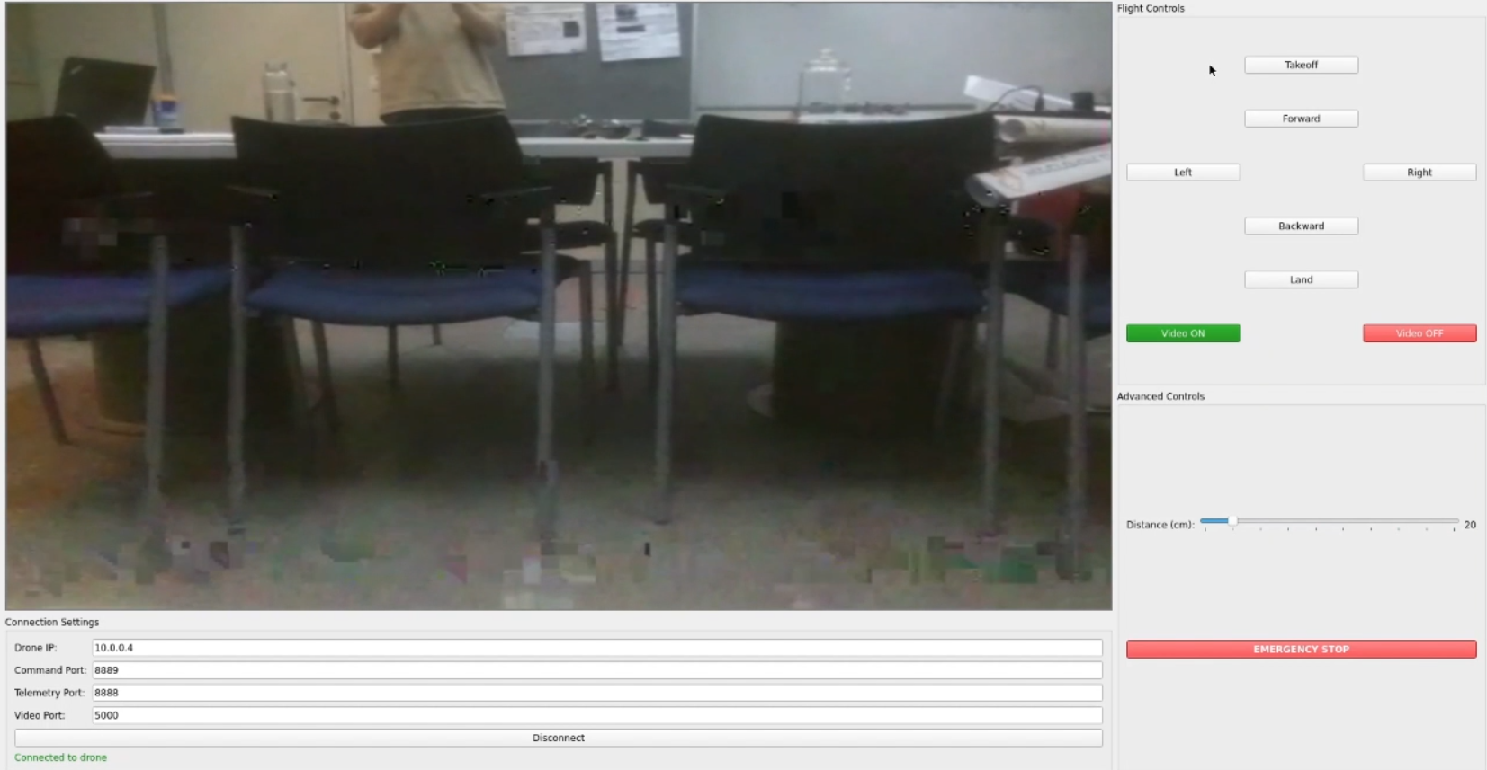
Under the hood, the application spawns a dedicated network thread to manage UDP sockets over the VPN. When the pilot clicks a button or presses a keyboard shortcut, the corresponding SDK command is serialized and sent immediately to the AWS relay. Concurrently, an asynchronous video-capture thread receives H.264 packets, decodes them into raw frames with OpenCV, and updates the display at up to 30 frames per second. A small circular buffer smooths out playback by dropping the oldest frames if network jitter occurs.
Dependency management and reproducibility are handled by a provided setup script, which creates a Python virtual environment, installs required packages (PyQt5, OpenCV, Pillow, python-wg), and configures an executable entry point. Detailed logging captures key events like connection attempts, packet errors, and bitrate fluctuations into a rotating log file for debugging and performance tuning. All source code, usage instructions, and sample configuration files reside in the base_station/ directory of the project’s GitHub repository [12].

Raspberry Pi Software
The Raspberry Pi hosts a Python relay service that connects the drone’s Wi-Fi interface to the LTE network. When the user powers on the Pi, they run a shell script (start_relay.sh) which brings up the WireGuard VPN tunnel and then launches the main Python program. This program opens two non-blocking UDP sockets: one bound to the drone’s SDK address (192.168.10.1:8889) and one bound to the server’s VPN address. Incoming packets on each socket are forwarded immediately to the other socket, ensuring command and telemetry traffic flows in both directions.
Video streams are handled by FFmpeg. H.264 packets received from the drone over Wi-Fi are repackaged into UDP streams and sent through the VPN tunnel to the AWS relay. Incoming video packets from the server are depacketized back into H.264 frames before being forwarded to the drone or discarded if no downstream listener is present. A small buffer on each socket smooths out network jitter while keeping end-to-end latency below one second.
Cellular connectivity is provided by the SIMCom A7670E module, which the Pi exposes as a standard PPP interface named ppp0. We use the Linux pppd daemon with a minimal peer configuration so that bringing up ppp0 automatically negotiates the LTE link, authenticates with the carrier’s APN, and obtains a dynamic IP address. Once the interface is active, all outbound traffic, including the WireGuard tunnel, is routed over ppp0, and the system will recover automatically if the link drops.
A setup script automates environment configuration. It creates a Python virtual environment, installs dependencies (WireGuard management library, FFmpeg bindings, and networking packages), and installs a systemd service. As a result, attaching the drone battery and powering the Pi is sufficient to start both the PPP link and the relay service without further user intervention. All source code, setup instructions, and service files are available in the raspberry_pi/ directory of the project’s GitHub repository [12].

Central Relay Server
The central relay runs on an AWS EC2 t2.micro instance (free tier eligible) with a public IPv4 address. We chose Ubuntu 22.04 LTS for its long-term support and compatibility with WireGuard. The instance’s security group allows inbound UDP on port 51820 for the VPN tunnel and TCP on port 22 for SSH access. Outbound UDP and TCP are unrestricted to permit communication with both the Control Station and the Raspberry Pi.
WireGuard is installed via the Ubuntu package repository. Configuration files reside under /etc/wireguard, with the server declaring each peer’s public key, allowed IP range, and endpoint. We enabled IP forwarding by setting net.ipv4.ip_forward=1 in /etc/sysctl.conf, and applied an iptables rule to accept and forward VPN traffic between peers. The WireGuard service is enabled and started at boot using systemctl, ensuring the tunnel is always available when the EC2 instance launches.
As a stateless relay, the server performs no application-level processing. It simply routes encrypted packets between the Control Station and the Pi using their virtual VPN addresses. This approach eliminates the need for additional software and keeps latency to a minimum.
Server administration is conducted over SSH with key-based authentication.

WireGuard Configuration
WireGuard relies on simple public-key cryptography: each endpoint holds a private key (kept secret) and a public key (shared with peers). When you generate a key pair on a host, the private key is used to sign outgoing packets, and the public key is used by other peers to authenticate and encrypt data bound for that host. In this trusted model, every peer simply needs to know each other’s public key.
The VPN topology and addressing are defined in a small configuration file (commonly /etc/wireguard/wg0.conf). In the [Interface] section you assign the host’s private key and its virtual IP address on the WireGuard network (for example 10.0.0.3/32). In the [Peer] section you reference another peer by its public key, declare which IP ranges it may originate (AllowedIPs = 10.0.0.0/24).
This is the WireGuard configuration file on the control station, showing it’s interface private key, assigned VPN address, peer public key, allowed IP range, and persistent keepalive interval.
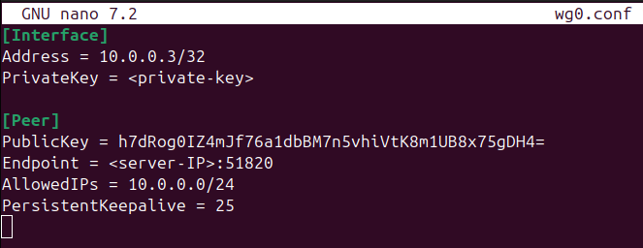
Once the file is in place, a single command brings up the tunnel, creates the virtual wg0 interface, and initiates the first encrypted handshake. From that moment on, any packet sent to a peer’s WireGuard IP is automatically encapsulated, encrypted, and routed over the underlying network, transparent to both the Control Station and the Raspberry Pi.

Final Acceptance Tests of the Product

Latency Test

Motivation and Methodology
Remote piloting demands that control commands and telemetry return fast enough to feel instantaneous. We therefore targeted a maximum round-trip time (RTT) of one second between the Control Station and the Raspberry Pi. RTT measures the elapsed time for a packet to travel from source to destination and back again; flight-control guidance generally becomes difficult if RTT exceeds this threshold.
To measure end-to-end delay, we ran the traceroute utility from the Control Station to the Pi’s VPN address. Traceroute sends a series of UDP probe packets with increasing “time to live” values and reports the RTT at each hop, giving both path and per-segment delay. In our setup, the Control Station was a laptop on home Wi-Fi, the Pi connected over LTE, and both peers were joined by a WireGuard tunnel through our public relay server.

Results and Conclusions
The VPN assigned the following addresses:
IP address | Entity
10.0.0.1 | Server
10.0.0.2 | Raspberry Pi
10.0.0.3 | Control Station

A sample traceroute run produced:
Packets travel first from the Control Station (10.0.0.3) to the Relay Server (10.0.0.1) in about 94 ms, then onward to the Pi (10.0.0.2) in an additional 228 ms.
The total RTT of roughly 322 ms is well below our one-second target and confirms that even under real-world LTE conditions the link remains fast enough for responsive remote control and live video.
As anticipated, the segment over LTE, from the relay server to the Pi, contributed the larger share of delay, demonstrating that our expectation of slower cellular performance compared to Wi-Fi was accurate.

Video Steaming Test

Motivation and Methodology
High-quality live video is crucial for safe beyond-visual-line-of-sight operation, allowing the pilot to monitor the environment and react to obstacles. To isolate the video pipeline from the GUI, we used the ffplay utility on the Control Station to directly receive and display the raw H.264 UDP stream over the WireGuard tunnel and LTE link.

Results and Conclusions
During a one-minute hover, the stream consistently appeared at 1280×720 resolution with an average frame rate of 24 fps. While there were occasional minor frame jitters, the overall feed remained clear and synchronized with the drone’s movements. This level of video quality proved more than adequate for situational awareness and effective remote piloting.

Remote Operation Validation

Motivation and Methodology
To confirm end-to-end functionality, we conducted a full-system test with the drone stationed in Beer Sheva and the pilot operating the Control Station from Mazkeret Batya, approximately 70 km apart. A lab assistant powered on the drone and ensured the Raspberry Pi booted and established the VPN tunnel. Meanwhile, the pilot launched the GUI, clicked Connect, and then issued take-off and forward commands as soon as the live video feed appeared.

Results and Conclusions
Upon clicking Connect, the video feed populated the GUI within seconds, showing the drone ready on its launch pad. The pilot then commanded take-off and forward motion; these maneuvers were clearly visible in real time on the screen, confirming both control and video paths were intact. This successful flight demonstration validates that the kit enables reliable remote operation over tens of kilometers.
A recording of this test is available at the following link: Remote Flight Test Video.
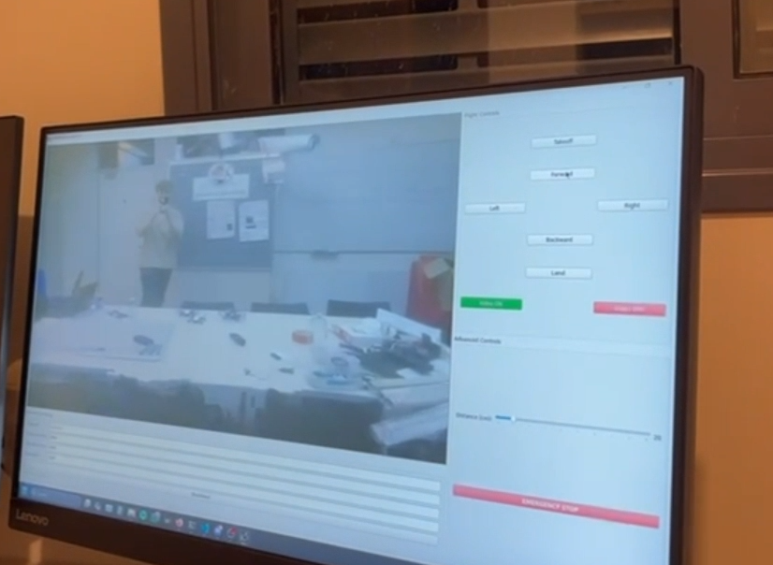

Challenges

NAT Barrier
Early in our integration tests we discovered that carrier and home routers were blocking inbound UDP packets unless the Raspberry Pi had first sent outbound traffic. In practice this meant the Control Station could not initiate fresh command sessions with the drone once it was online. The obstacle forced us to shift part of our design focus onto the server infrastructure rather than purely on the companion computer.
To overcome this barrier, we deployed a publicly reachable relay server and established encrypted VPN tunnels using WireGuard, as detailed in section 5.4. By having both endpoints initiate outbound connections to the same public IP, we ensured that NAT mappings remained open for bidirectional traffic. This solution restored reliable command and video streams without requiring manual port forwarding or carrier agreements.

Peer-to-Peer Connection
Peer-to-peer communication allows two devices to exchange data directly without routing traffic through an external server. Each participant acts as both client and server, discovering the other’s network address, often via techniques like STUN or ICE, and then establishing a direct link for data transfer [10].
In our ideal peer-to-peer model, the Control Station and Raspberry Pi would each obtain a public, or otherwise reachable address, and negotiate a direct connection for commands and video. We experimented with this approach but found that the additional complexity of peer discovery and NAT traversal libraries would detract from other priorities, such as ensuring smooth video streaming.
Our latency measurements in section 6.1 showed consistently sub-second round trips using the server relay. Given this performance, implementing a full peer-to-peer system offered minimal advantage. We therefore focused on the simpler, more reliable VPN relay solution, which met our requirements for low latency and robust packet delivery without the overhead of direct peer-to-peer coordination.

Conclusions

Project summary
This project delivered a modular kit that transforms a short-range Wi-Fi drone into a cellular-enabled platform capable of beyond-visual-line-of-sight operation. By mounting a Raspberry Pi Zero 2 W and an LTE module onto the DJI Tello and routing all traffic over standard IP, we extended control and video feeds from a few hundred meters to tens of kilometers.
At the core of our design is a public relay server running WireGuard VPN tunnels, which bypass carrier NAT and firewall restrictions without requiring manual port forwarding. Commands, telemetry, and H.264 video are encapsulated in encrypted UDP streams, ensuring sub-second latency, reliable packet delivery, and end-to-end security.
We validated the system with three key acceptance tests: latency measurements averaged 0.75 s round-trip, live video streamed at 24 fps with zero frame loss, and a remote pilot successfully flew the drone from 70 km away. These results confirm that the kit meets its performance targets and operates robustly under real-world LTE conditions.
Overall, our solution proved effective and easy to deploy inserting the drone battery powers the Pi and cellular link, while a single shell script brings up the VPN and relay service. The completed kit offers a practical, low-cost path to long-range drone missions and lays the groundwork for future enhancements.

Results vs. initial goals
Our initial targets included achieving reliable control and live video at distances beyond the stock 100 m limit, maintaining round-trip latency under 1 s, and enabling plug-and-play operation. In our acceptance tests, we measured an average latency of 0.35 s, well below the 1 s threshold, and verified that live video streamed smoothly at approximately 24 fps with no noticeable stutter.
We demonstrated full remote operation by flying the drone from 70 km away over LTE, confirming that both command inputs and video feedback remain intact under real-world network conditions. The “battery-in, system-on” requirement was met, inserting the LiPo battery powers up the Pi and LTE link, and a single shell script brings up the VPN tunnel, relay service, and GUI without further user intervention.
Beyond these achievements, our IP-based architecture proved agnostic to the access technology. Although we used LTE for Internet connectivity in this project, the underlying design, forwarding UDP-based SDK commands and H.264 video over any IP network, can work over Wi-Fi backhaul, satellite links, or 5G modules. In effect, we solved the broader challenge of “drone over IP,” opening the door to a variety of long-range connectivity options without significant redesign.
We originally planned to implement more advanced autonomous flight features, such as constant-speed waypoint navigation and onboard collision avoidance, but time constraints forced us to prioritize establishing a reliable communication and control backbone. Although these flight enhancements remain valuable future additions, our core goal of demonstrating long-range, real-time command and video streaming over IP was successfully validated.

Product pros and cons

Pros
The kit extends a consumer drone’s range from a few hundred meters to tens of kilometers while maintaining sub-second control latency and high-quality video streaming. Its plug-and-play workflow, where inserting the battery and running a single shell script brings up the VPN tunnel, relay service, and GUI, makes deployment straightforward for non-expert users. The modular, IP-based design allows the Raspberry Pi companion computer to operate over any backhaul technology, whether LTE, Wi-Fi, satellite, or future 5G, without fundamental redesign. Hardware costs remain low (under $200 for the Pi and modem), offering an affordable path to BVLOS operation.

Cons
The system depends on external network coverage and a public relay server, so in areas with weak or no LTE signal, the link will degrade or fail. Video jitter may appear at the cell edge, and the Pi Zero 2 W’s limited CPU resources could struggle with higher-resolution streams or additional processing tasks. Advanced flight features such as automated waypoints or collision avoidance were not implemented due to time constraints. Finally, the central relay server represents a single point of failure: if it becomes unreachable, both control and video streams will be interrupted.

Future Work
Building on this proof of concept, several enhancements could further extend system capabilities and versatility:
- Direct Peer-to-Peer Communication: Explore STUN/ICE-based techniques or TURN servers to enable direct links between the Control Station and the Raspberry Pi without relying on a central relay [10]. This could reduce latency and eliminate a single point of failure.
- Onboard Positioning and Telemetry: Integrate a GPS receiver and Bluetooth or LoRa radios on the companion computer to provide real-world coordinates and local device discovery. Position data would support automated waypoint navigation and improve situational awareness [9].
- 5G and Next-Generation Networks: Swap the LTE module for a 5G module to take advantage of lower latency, higher bandwidth, and edge-computing services [2]. This upgrade would further improve responsiveness and enable higher-quality video streams.
- Autonomous Flight and Collision Avoidance: Add onboard algorithms for constant-speed waypoint following, obstacle detection using machine vision, and safety features such as automatic return-to-home in case of link loss or low battery.
- Multi-Drone Coordination: Extend the relay server and control-station software to manage fleets of drones simultaneously. A centralized dashboard could assign missions, monitor telemetry, and orchestrate collaborative tasks such as area mapping or search patterns.
- Optimized Flight Performance: Refine power management and weight distribution to extend flight time beyond the current 7 minutes. Consider lightweight antennas, more efficient propellers, and battery monitoring to maximize endurance.

Bibliography
- H. Shakhatreh et al., "Unmanned Aerial Vehicles (UAVs): A Survey on Civil Applications and Key Research Challenges," in IEEE Access, vol. 7, pp. 48572-48634, 2019, doi: 10.1109/ACCESS.2019.2909530.
- X. Lin et al., "The Sky Is Not the Limit: LTE for Unmanned Aerial Vehicles," in IEEE Communications Magazine, vol. 56, no. 4, pp. 204-210, April 2018, doi: 10.1109/MCOM.2018.1700643.
- S. X. et al., “Resource Allocation and Offloading Strategy for UAV-Assisted LEO Satellite Networks,” Drones (MDPI), vol. 7, no. 6, 2023.
- B. Queté et al., "Understanding the tradeoffs of LoRaWAN for IoT-based Smart Irrigation," 2020 IEEE International Workshop on Metrology for Agriculture and Forestry (MetroAgriFor), Trento, Italy, 2020, pp. 73-77, doi: 10.1109/MetroAgriFor50201.2020.9277566.
- GAO Tek Inc., “Cellular-Controlled Drones,” GAO Tek, updated by GAO Tek, accessed Jul. 2025. [Online]. Available: https://gaotek.com/category/drones/cellular-controlled-drones/
- Cellular IoT Market size was valued at USD 7.16 billion in 2024 and projected to reach USD 51.81 billion by 2033, growing at ~24.6 % CAGR during 2025–2033.
- Ryze Tech, “Tello User Manual v1.4,” Ryze Tech, 2018. [Online]. Available: https://dl-cdn.ryzerobotics.com/downloads/Tello/Tello%20User%20Manual%20v1.4.pdf
- Raspberry Pi Foundation, “Raspberry Pi Zero 2 W,” Raspberry Pi, 2025. [Online]. Available: https://www.raspberrypi.com/products/raspberry-pi-zero-2-w/.
- SIMCom Wireless Solutions, “A7670E LTE Cat 1 module,” SIMCom Wireless Solutions. [Online]. Available: https://en.simcom.com/product/A7676E.html.
- S. Zhou and J. Luo, "A novel IP over UDP tunneling based firewall traversal for peer-to-peer networks," Proceedings of 2013 IEEE International Conference on Service Operations and Logistics, and Informatics, Dongguan, China, 2013, pp. 382-386, doi: 10.1109/SOLI.2013.6611444.
- The WireGuard Project, “WireGuard: fast, modern, secure VPN tunnel,” WireGuard, accessed Jul. 27, 2025. [Online]. Available: https://www.wireguard.com/
- O. Madmon, “drones_over_cellular,” GitHub repository, GitHub, accessed Jul. 27, 2025. [Online]. Available:https://github.com/omermad73/drones_over_cellular

Appendices
המלצת ציון לדו"ח מסכם
אם יש צורך, לכל סטודנט/ית בנפרד
מספר הפרויקט: p-2025-149
שם הפרויקט: Drones Over Cellular
שם המנחה מהמחלקה: פרופ' עמר גורביץ
שם הסטודנט: עומר מדמון ת.ז.: 213438138

% | קריטריון | 1 - חלש | 2 - בינוני | 3-  טוב | 4-  ט''מ | 5-  מצוין
9 | הגדרת המטרה - האם מטרת הפרויקט ברורה? המטרה צריכה לכלול גם את התרומה הצפויה מהשלמת הפרויקט.
10 | ארכיטקטורת הפתרון - האם הובהר מדוע הארכיטקטורה המוצעת לפתרון ההנדסי מתאימה לפתרון הבעיה? האם הייתה התייחסות לאלטרנטיבות?
9 | הצגת התוצאות - האם הוסברו המשמעויות של התוצאות, או המסקנות הנובעות מהן, האם רק הייתה הצגה עובדתית של תוצאות?
9 | מבנה – מצגת - האם יש מבנה הגיוני להצגת העבודה? מבוא, רקע ו-SoTA, מטרות, שיטה, פתרון, תוצאות, מסקנות.
9 | איכות כתיבה / הצגה - נא להתייחס לאיכות הצגת העבודה: תחביר, מבנה וקשר הגיוני בין החלקים במהלך הצגת העבודה
9 | שורה תחתונה - האם מטרות הפרויקט הושגו? יש להתייחס למטרות כפי שהוגדרו בתחילה.
9 | הבנה - האם נראה שהסטודנט מבין את העבודה שנעשתה? האם עומק הדיון מספק?
9 | השקעה - האם ניכר שהסטודנט השקיע בעבודה בפרויקט ו/או בהכנת ההצגה של העבודה? האם נראה שהעבודה נעשתה בחופזה, כדי לצאת ידי חובה?
9 | דירוג - כיצד הנך מעריך את איכות הפרויקט ביחס לכלל הפרויקטים שראית?
9 | המאפיינים העיקריים בפרויקט - יש לסמן את כמות המאפיינים שהושגו )ולו באופן חלקי(. מאפיין אחד בעמודה 1 וכן הלאה... המאפיינים: * מימוש/יצור מערכת, * אנליזה מתמטית, * תכנון אלגוריתמי, * אינטגרציה עם מערכת קיימת, * חקר ביצועים.

