Please do your homework using an R script. Homework is NOT collected in this class. However, on the day it is due, you may be asked to share your screen and run some of your code when we discuss this homework in class. This will count towards your participation grade.

1. Create the following network, with the vertices ordered in alphabetical order. Note that this is the same network you started with for question 1 of HW1. Answer the questions without R first, then with R.  
     
   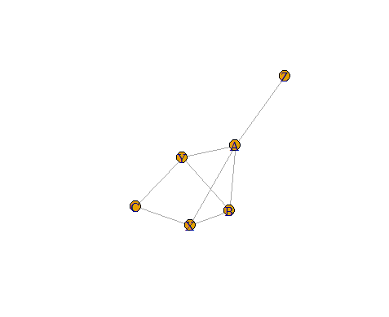
   1. Set the weights for the edges equal to the edge ids and set the edge labels to the same.
   2. Create an induced subgraph $gi$ consisting of the vertices A, B, X, and Y only, and plot it.
   3. Give the (original) graph a name and description of your choice. Also create a “color” attribute for the vertices, choosing whatever colors you like for each vertex. Plot it, using the name as the title of the plot and the description as its subtitle. What happened to the vertices?
   4. Find all the neighbors of A.
   5. Find $d_{Y}$ and $s_{Y}$.
   6. Is B-Y-A-X-B-A-Z a walk, trail, path, circuit, or cycle? What about A-X-B-Y-A? And B-A-Y-C-X-A-B? What is the length of the last one?
   7. Find the distance and the weighted distance between B and Y. Are the paths the same?
   8. Find the diameter of the graph.
   9. Create a table with the strengths between every pair of vertices of the network. Then find the weighted diameter of the graph using this table first, then using the specific R-function.
2. Create the following digraph where the numbers on the edges are the weights.  
     
   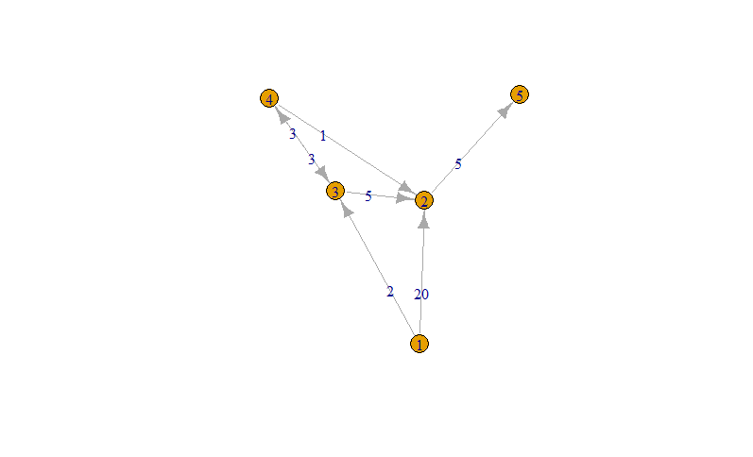  
   1. Find $d_{3}^{in}$ and $s_{3}^{in}$ (guess the meaning of the latter).
   2. Is 3-4-2-3 a directed walk, trail, path, circuit, or cycle? Or none of those?
   3. Is 4 reachable from 2?
   4. Find the (directed) distance from 1 to 2. What is its path?
   5. Find the (directed) weighted distance from 1 to 2. What is its path?
   6. Is this graph weakly, strongly, or not at all connected?
   7. Obtain a table with all directed distances and a table with all weighted directed distances for this graph. What is the longest weighted path?
   8. Can you find the (directed) diameter for this graph?
   9. What is the (directed) weighted diameter?