Please do your homework using an R script. Homework is NOT collected in this class. However, on the day it is due, you may be asked to share your screen and run some of your code when we discuss this homework in class. This will count towards your participation grade.

1. Create the following graph and plot it, making sure that the vertices are larger than usual.  
     
   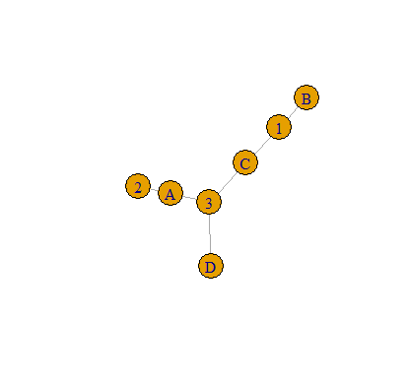  
   1. Turn this into a bipartite network with the numbers as type I and the letters type II. Plot it.
   2. What are $n_{1}$ and $n_{2}$ equal to?
   3. Find the incidence matrix. Make sure you can do this without R, too!
   4. Plot the projection onto the letters. What is the diameter of the projection?
   5. Is the projection onto the numbers acyclic?

1. Load the Lazega lawyer network into R.  
   1. Plot the graph.
   2. Verify that the graph is not connected.
   3. Find the components of this graph. Is there a giant component? If so, how big is it?
2. Create either 3 text files or an excel spreadsheet with 3 sheets. One text file/sheet must contain graph attributes; give your graph a name and at least 1 more graph attribute. One text file/sheet should contain 6 or more vertices with labels and at least one more vertex attribute. The last text file/sheet should contain 6 or more edges with weights and labels and at least one more edge attribute.
   1. Load your text files/excel spreadsheet into 3 data frames in R.
   2. Create a digraph from these three data frames.
   3. Plot your digraph, using appropriate sizes for your vertices and arrow heads.
   4. Is your graph weakly/strongly connected? If not, what vertex combinations stop it from being so? If it is weakly disconnected, determine its weakly connected components. If it is strongly disconnected, determine its strongly connected components.
   5. Plot your digraph again, coloring your vertices depending on which component they are in.
   6. Save your digraph as an R object file (use something.RData) in your data directory.
   7. Remove the graph from your environment, then load it again using the file in your data directory.