Please do your homework using an R script. Homework is NOT collected in this class. However, on the day it is due, you may be asked to share your screen and run some of your code when we discuss this homework in class. This will count towards your participation grade.

1. Create the following graph. Do all the work in R.  
   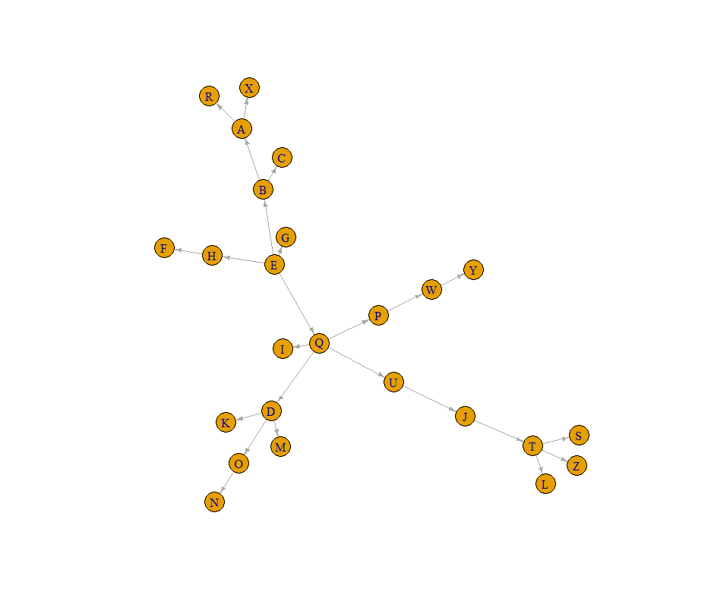  
   1. What kind of graph is this?
   2. Plot it in a better way.
   3. Is Y a descendant of Q?
   4. Find the children of B.
   5. Find all the leaves.
   6. Find the order and size of the graph. What does that tell you?
   7. Find the in-degree distribution of this graph. Can you say something interesting about it? What is its mean in-degree?
   8. Find the out-degree distribution of the graph. Plot it. Can you say something interesting about it? What is its mean out-degree?
   9. Looking at its underlying undirected graph, which vertex has the highest degree?
   10. Again, looking at its underlying undirected graph, which vertex has the highest average neighbor degree? Which are its neighbors?
   11. Create the induced subgraph of vertices D, I, P, Q, U. Call it isg.
   12. What kind of graph is isg?
   13. Is it possible for a vertex in a tree to have two parents? What about a rooted tree?