Please do this quiz using an R script and submit it via Moodle. All questions should be answered using R; you will get no points for doing anything in your head only.

* Make sure your code is well-organized by each question.
* You should always avoid hardcoding. For instance, you should never manually count the length of a vector but should use the length( ) function instead.
* For some problems, a suggested name for the R object you are asked to create is given. It is only a suggestion and you do not have to use the exact name. When a suggested name is not given, you should choose names that are descriptive and concise.

1. Create the following network. Hint: use simplify=F when creating it. Answer all questions using R.

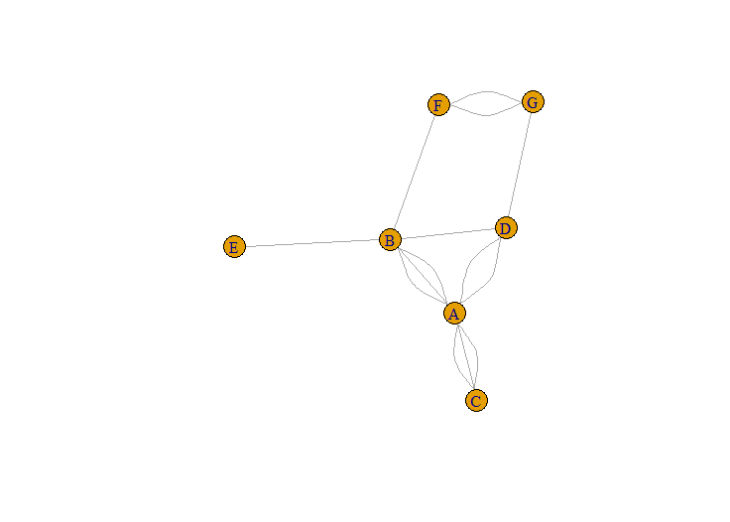

* 1. Find . How many neighbors of order 1 does B have (you may determine the number of neighbors without R)?
  2. Simplify this graph, making sure the weights will indicate the number of edges. Give this graph a different name. You should now have two graphs.
  3. Plot the two graphs side-by-side, but so that the simplified graph displays its weights on the edges.
  4. Find $d_{B}$ as well as $s_{B}$ in the simplified graph. What is the connection with the original graph?

1. Observe the following digraph. Do NOT create it in R and answer all questions without using R. Write the answers in your script using comments.

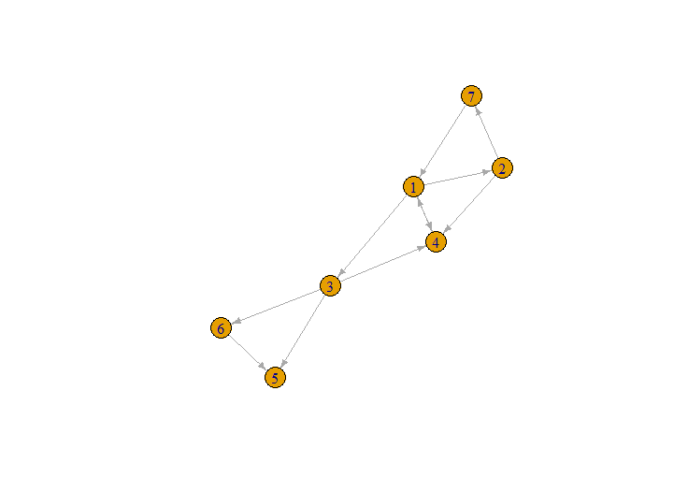

* 1. Find and $d_{3}^{out}$.
  2. Is 1-3-4-1-2-7-1 a directed walk, trail, path, circuit, or cycle? Or none of those? What is its length?
  3. Is this graph weakly connected?
  4. Find out if the induced subgraph containing the vertices 3, 5, and 6 is a DAG. Explain why or why not.