**Flu09 (Memphis Cohort)**

Fulltext link: <https://www.frontiersin.org/articles/10.3389/fimmu.2017.01423/full>

DOI Link: <https://doi.org/10.3389/fimmu.2017.01423>

Case Type can be inferred from Flu09 Viral Loads. Other limited healing possible, but a complete metadata “spine” for the database, covering Age, Sex, and Case Type, would enable multiple analyses.

* Cell quantifications
  + Points are contacts, not primary cases.
  + All time points are at 0 Study Day
  + Cells by Age
    - Bins: ['0-12', '13-18', '18-45', '45+ years']
    - Link: [CellPhenotypes](https://liveutk-my.sharepoint.com/:f:/r/personal/jweave49_uthsc_edu/Documents/VPC/Data/Cohorts/Memphis/CellPhenotypes?csf=1&web=1&e=pD2jTW)
    - Example:

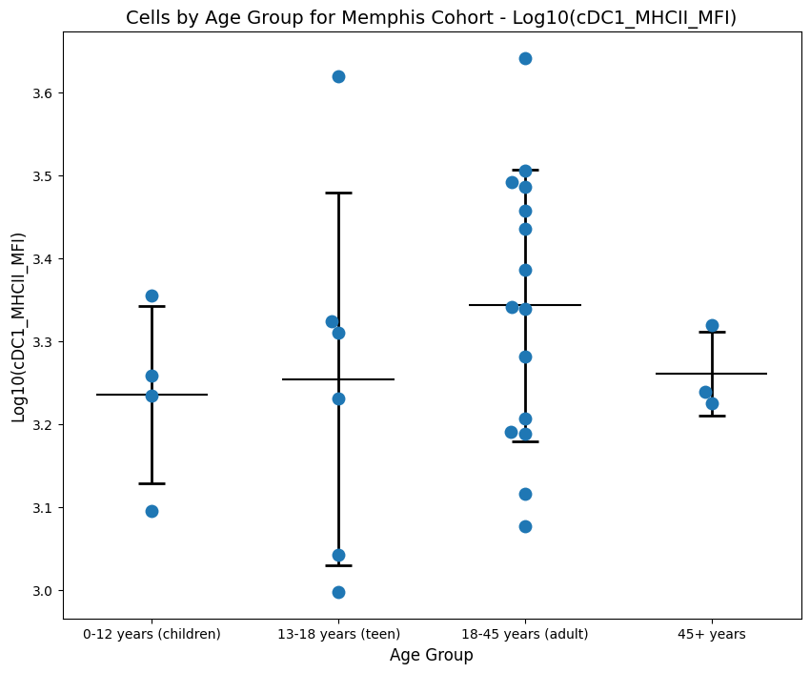

**Gene Expression with Metadata**

* Age (Years), Sex
* Stimulation Conditions (AT, IC, LPS, Pam, Unstimulated)
* No metadata on infection status; Memphis IDs all appear in Uninfected Cytokines database, implying these to be baseline cases only
* Gene Expression by Age Group and Sex
  + Link: [GeneExpression](https://liveutk-my.sharepoint.com/:f:/r/personal/jweave49_uthsc_edu/Documents/VPC/Data/Cohorts/Memphis/GeneExpression?csf=1&web=1&e=C1cVaE)
  + Example:

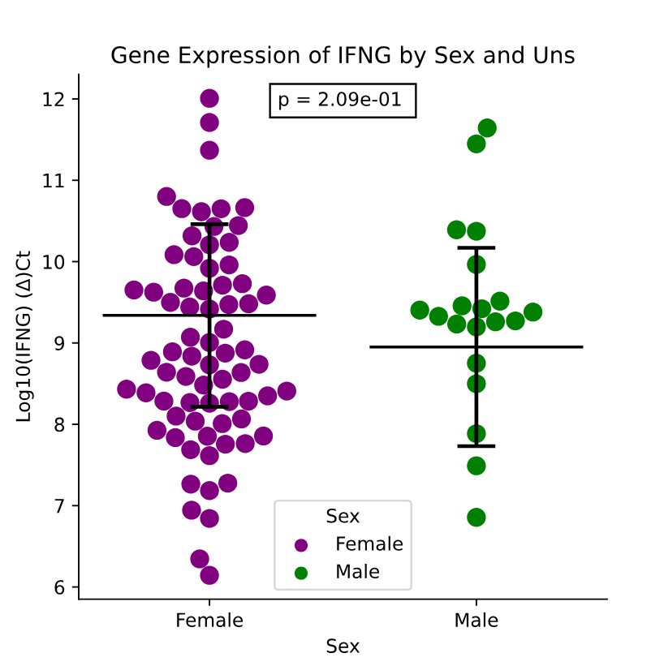

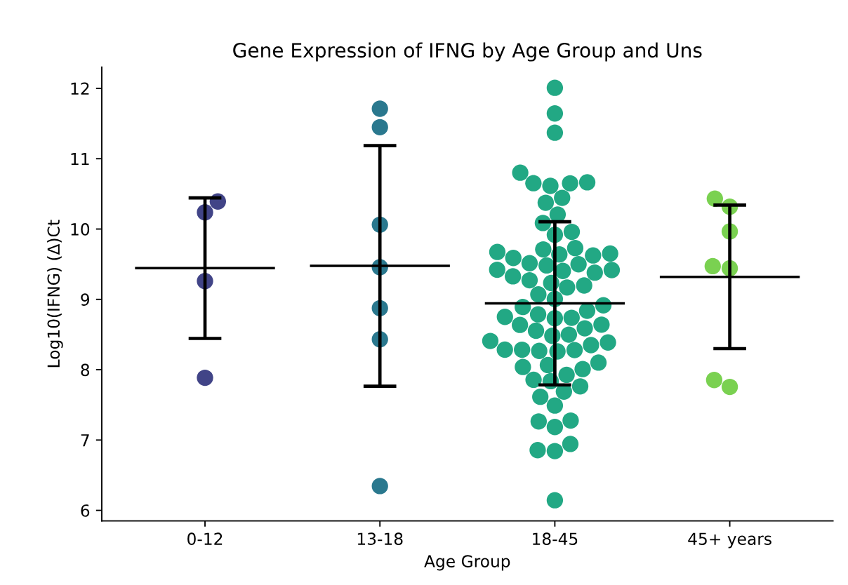

**Dynamic cytokines from nasal wash, plasma** (separate): [Cytokines](https://liveutk-my.sharepoint.com/:f:/r/personal/jweave49_uthsc_edu/Documents/VPC/Data/Cohorts/Memphis/Cytokines?csf=1&web=1&e=jfs8ch)

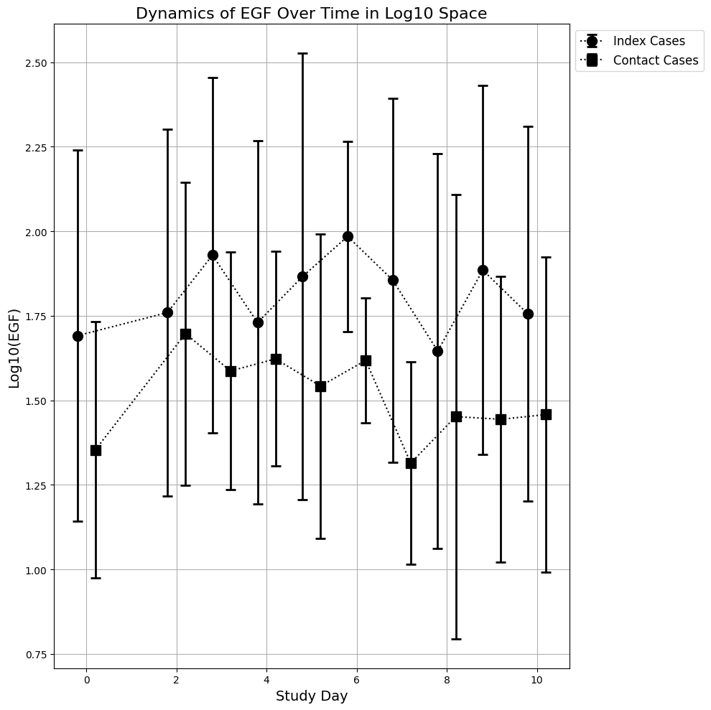

**Study Participants and Design** “Inclusion criteria required that participants meet the clinical case definition of influenza virus infection at the time of enrollment or were asymptomatic household contacts of a participant with confirmed influenza infection. Index cases were asked to provide nasal swabs, nasal lavages, and blood on the day of enrollment (Day 0) and Days 3, 7, 10, and 28, whereas household contacts were asked to provide nasal swabs on Day 0, 3, 7, and 14 and blood and nasal lavages on Days 0 and 28 (Figure 1a). Participants were asked to rank their symptom severity daily according to a visual analog scale. Participant Selection and Characteristics A total of 73 individuals exhibiting influenza-like illness and 126 household contacts were enrolled during the 2009–2010 (aged 3.6 wk to 71 yr) and 2010–2011 (aged 10.5 wk to 56 yr) influenza seasons (Table1). Of the 84 influenza virus–positive participants, 24 suffered from ACIP defined high-risk conditions at enrollment, including 17 individuals with underlying asthma or reactive airway disease (Table2). Our cohort contained 19 individuals who were hospitalized (median duration, 3 d; range, 1–26 d), with four requiring intensive care (median duration, 6 d; range, 2–6 d).”

1. **Quantitative Reverse-Transcriptase Polymerase Chain Reaction** “Molecular viral loads were determined from nasal swabs”
   1. Once metadata is completed, age and sex comparisons of viral load are possible. For now, the three case types are plotted separately: [ViralLoads.svg](https://liveutk-my.sharepoint.com/:u:/r/personal/jweave49_uthsc_edu/Documents/VPC/Data/Cohorts/Memphis/ViralLoads.svg?csf=1&web=1&e=7OcDIP) A graph of lines and points

      Description automatically generated
2. **Microneutralization Assay** “Plasma was tested for antibodies against recently circulating influenza strains by microneutralization assay.”
3. **Detection of Cytokines** “The Luminexx MAP system was used with a MILLIPLEX MAP human cytokine immunoassay for detection of cytokines.”
4. **Flow Cytometry** “1E5 peripheral blood mononuclear cells or nasal lavage cells were stained with a panel of monoclonal antibodies including CD14 (clone M5E2), HLA-DR (clone LN3), and CD16 (clone CB16).”