**Report**

**Run:** Baccam.mlxtran

**Dataset:** Rahil_Best_Virus.csv

**Date:** 05-07-2024

# Tables

Table 1: Estimated population parameters

|  |  |  |  |  |
| --- | --- | --- | --- | --- |
| Parameter | Value | | STOCH. APPROX. | |
| S.E. | R.S.E.(%) |
| Fixed Effects | | | | |
| beta_pop | 0.00000337 | | 0.00000196 | 58.092 |
| k_pop | 4 | |  |  |
| delta_pop | 9.107 | | NaN | NaN |
| p_pop | 0.49 | | 0.274 | 55.865 |
| c_pop | 3.178 | | 1.743 | 54.827 |
| Standard Deviation of the Random Effects | | | | |
|  | Value | C.V.(%) |  | |
| omega_beta | 1.591 | 340.165 | 0.655 | 41.154 |
| omega_delta | 0.804 | 95.384 | 0.523 | 64.994 |
| omega_p | 1.155 | 167.152 | 0.619 | 53.643 |
| omega_c | 0.999 | 131.003 | 0.333 | 33.313 |
| Error Model Parameters | | | | |
| a1 | 0 | | NaN | NaN |
| b1 | 0.925 | | 0.132 | 14.302 |

Table 2: Log-likelihood and Information criteria

|  |  |
| --- | --- |
| CRITERIA | IMPORTANCE SAMPLING |
| -2 x log-likelihood (OFV) | 1042 |
| Akaike Information Criteria (AIC) | 1062 |
| Bayesian Information Criteria (BIC) | 1066.9 |
| Corrected Bayesian Information Criteria (BICc) | 1079.2 |

# Plots

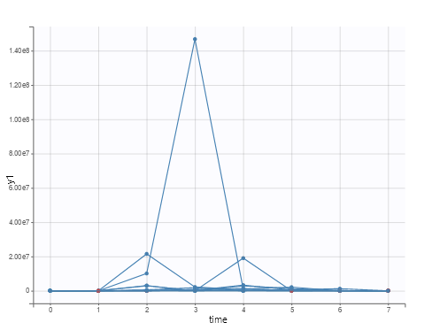

Figure 1: Observed data

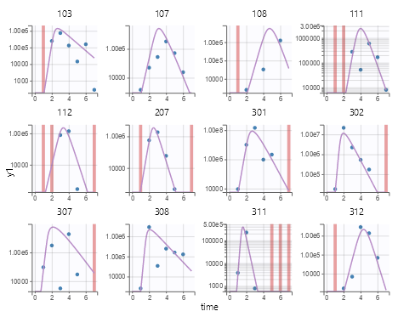

Figure 2: Individual fits

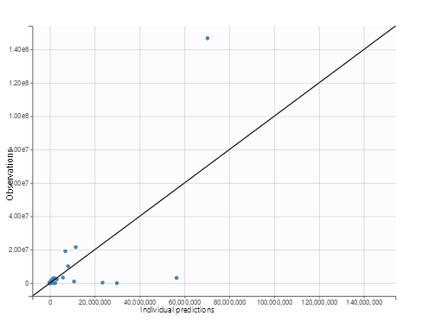

Figure 3: Observations vs predictions

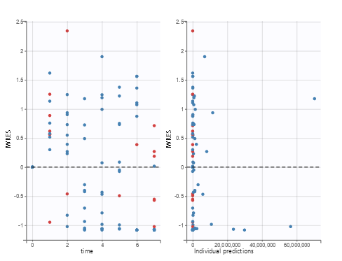

Figure 4: Scatter plot of the residuals

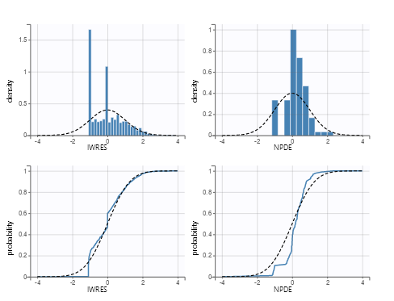

Figure 5: Distribution of the residuals

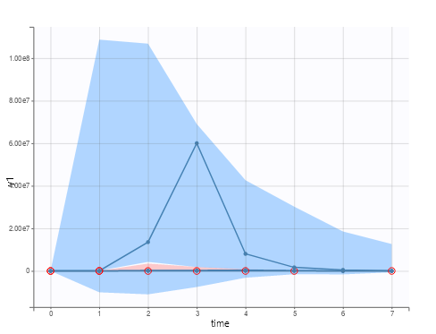

Figure 6: Visual predictive check

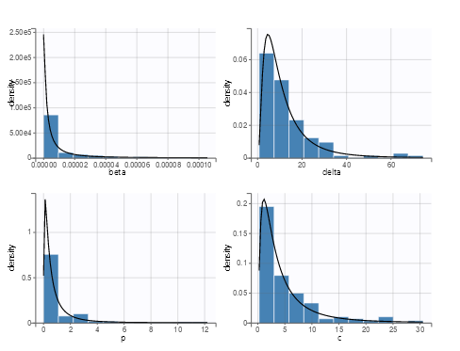

Figure 7: Distribution of the individual parameters

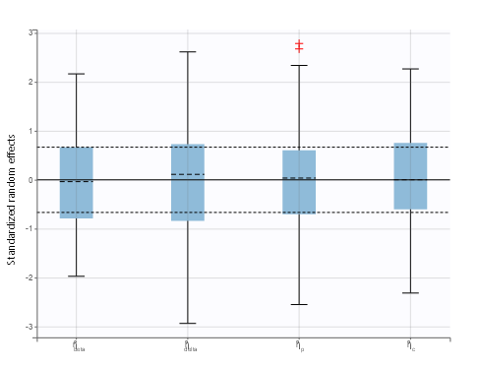

Figure 8: Distribution of the standardized random effects

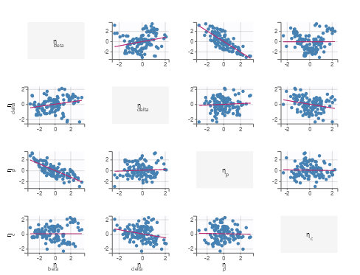

Figure 9: Correlation between random effects

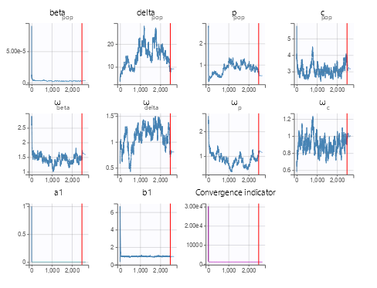

Figure 10: SAEM