**Report**

**Run:** LCT.mlxtran

**Dataset:** LCT_Data.csv

**Date:** 06-19-2024

# Tables

Table 1: Estimated population parameters

|  |  |  |  |
| --- | --- | --- | --- |
| Parameter | Value | STOCH. APPROX. | |
| S.E. | R.S.E.(%) |
| Fixed Effects | | | |
| beta_pop | 0.000176 | 0.0000000898 | 0.0511 |
| k_pop | 4 |  |  |
| p_pop | 0.0311 | NaN | NaN |
| c_pop | 54.62 | NaN | NaN |
| delta_pop | 0.911 | NaN | NaN |
| delta_E_pop | 3.57 | NaN | NaN |
| Kd_pop | 116.455 | NaN | NaN |
| xi_pop | 0.0176 | NaN | NaN |
| d_E_pop | 0.454 | NaN | NaN |
| a_pop | 0.556 | NaN | NaN |
| tau_pop | 1.485 | NaN | NaN |
| Error Model Parameters | | | |
| a1 | 0 | NaN | NaN |
| b1 | 287.066 | 17.701 | 6.166 |
| a2 | 12.195 | 25149.791 | 206234.905 |
| b2 | 2.059 | 0.16 | 7.787 |

Table 2: Log-likelihood and Information criteria

|  |  |
| --- | --- |
| CRITERIA | IMPORTANCE SAMPLING |
| -2 x log-likelihood (OFV) | 6688.1 |
| Akaike Information Criteria (AIC) | 6716.1 |
| Bayesian Information Criteria (BIC) | 6729.3 |
| Corrected Bayesian Information Criteria (BICc) | 6766.9 |

# Plots

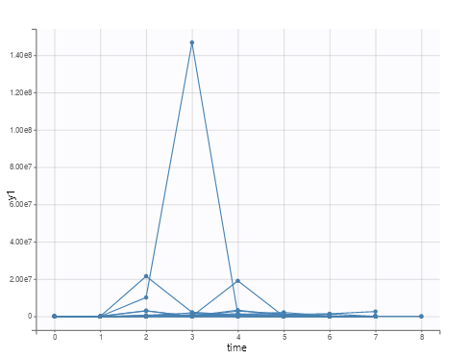

Figure 1: Observed data

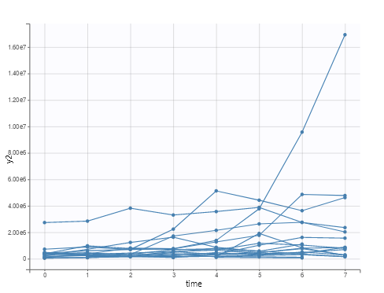

Figure 2: Observed data

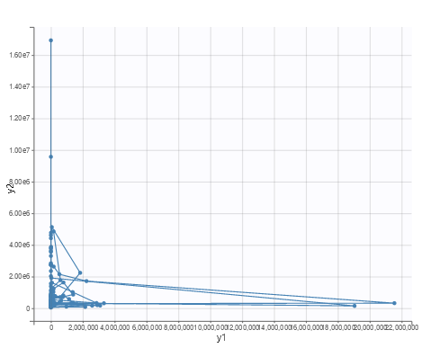

Figure 3: Bivariate data viewer

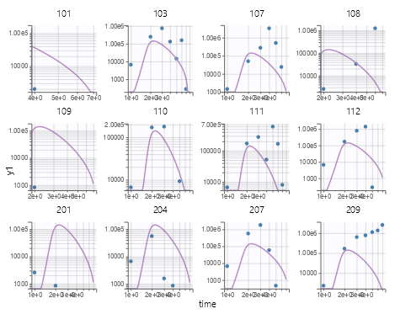

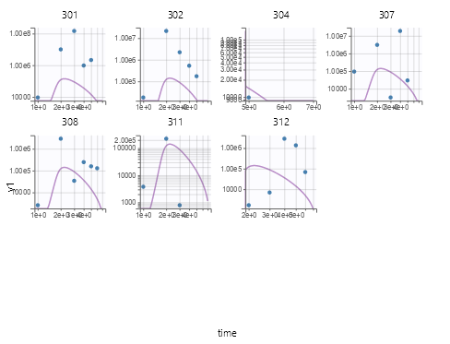

Figure 4: Individual fits

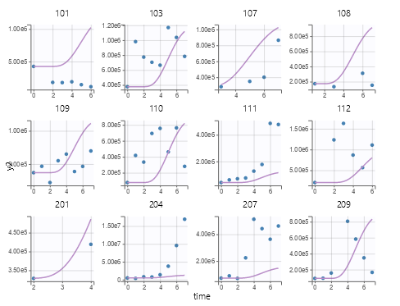

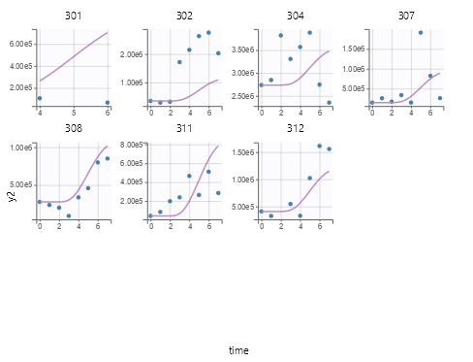

Figure 5: Individual fits

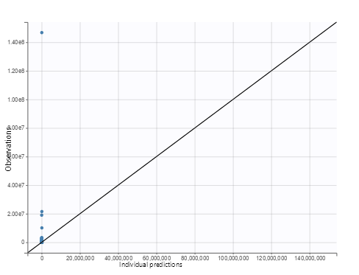

Figure 6: Observations vs predictions

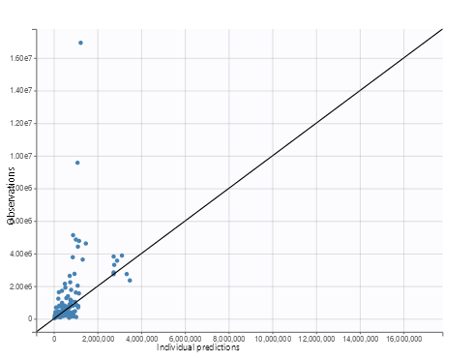

Figure 7: Observations vs predictions

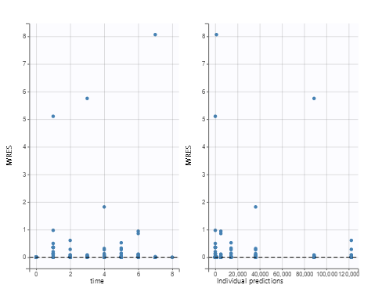

Figure 8: Scatter plot of the residuals

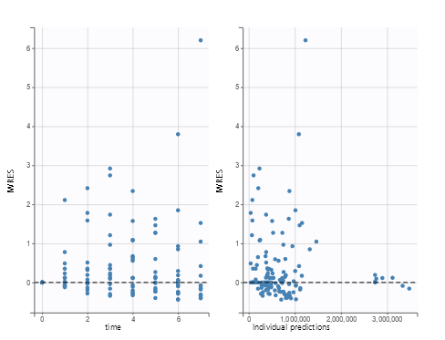

Figure 9: Scatter plot of the residuals

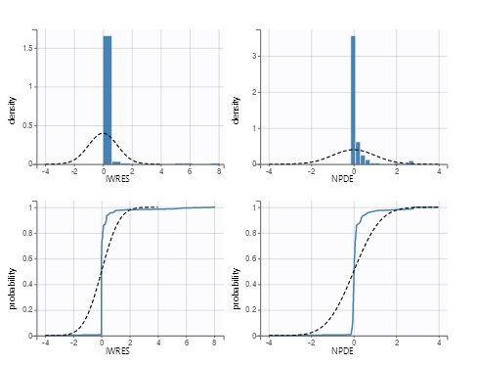

Figure 10: Distribution of the residuals

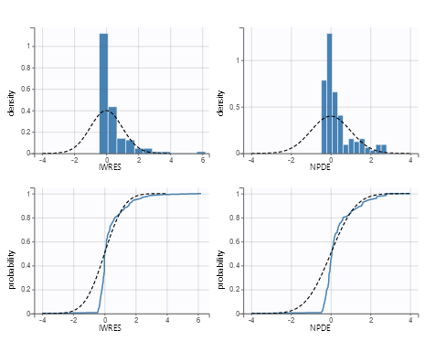

Figure 11: Distribution of the residuals

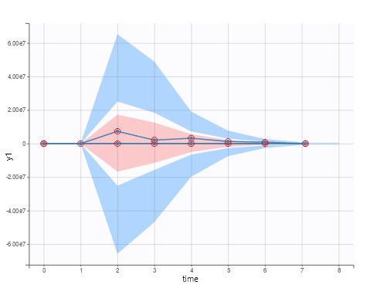

Figure 12: Visual predictive check

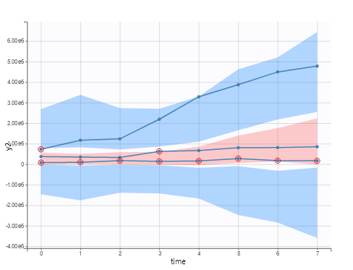

Figure 13: Visual predictive check

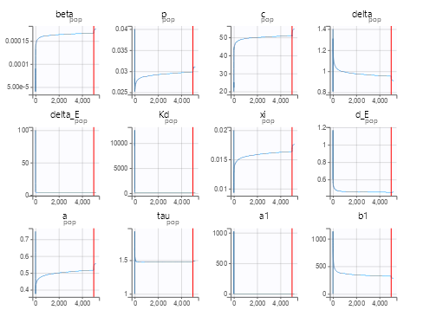

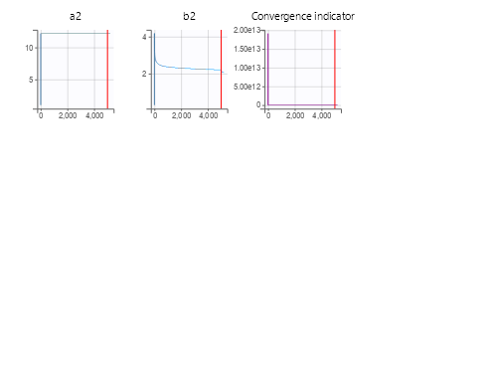

Figure 14: SAEM