**Acoustic Data Chart Documentation**

Version: - 1 Last Updated: - 2025/01/17

**INDEX**

|  |  |  |  |
| --- | --- | --- | --- |
| **Sr No.** | **Content** | **Number of Items** | **Page No.** |
| 1] | Feature List | 4 | 2 |
| 2] | Formulas / Feature Details | 4 | 3 |
| 3] | Planned Changes/Design Modifications (*Priority) | 4 | 7 |
| 4] | Future Enhancements and Feature addition | 2 | 8 |

**CONTEXT**

The Acoustic Data chart allows users to find potentially bad interactions and outliers in a selected time interval. This documentation details out the features in this chart and their working.

**FEATURE LIST**

|  |  |
| --- | --- |
| **Features** | **Last Modified** |
| Statistical Cards |  |
| Global Filters |  |
| Grouped Bar chart |  |
| Stacked Bar chart |  |

**Link for testing: -** [Acoustic Data Chart Dev Region](https://genroute-str-new.apptoapp.net/Acoustic_Chart_Dev/)

**Formulas / Feature Details**

1. Statistical Cards

1. 1st Total interaction card that shows total interactions in given time interval
   1. Should have highest count all the time as compared to all other cards.
   2. Considers null values as well.
   3. This card does not change if we change any acoustic data threshold.
   4. Reset button should work properly and reset everything excluding global filters.
2. 8 Acoustic Data Cards (ADC) with threshold range selector. Does not count null values or interactions.
3. Each acoustic data card + its threshold range selector is completely separate for now and should not affect each other when changed.
4. Changing or setting threshold for a certain ADC should change/filter data only for
   1. That card only.
   2. Tab in Grouped bar chart for that card only.
   3. Tab in Stacked bar chart for that card only.



1. Percentage trend is calculated by current total/ previous total.
   1. Summary tab in downloads preview can be used to verify this data.
2. Line chart data in each card shows daily count i.e. day by day…this should add to up to total count in that card.
3. Global Filters

1. 7 Global filters…applying these should change and affect data everywhere on page…

All components should be compliant with these.

1. Options should be sorted by name i.e. ABC order. And null values marked as NULL. No duplicates
2. Option Gray out is top down for now.
3. After applying filter chips should appear at top of page. This is also top down. Example, closing LOB chip will close all other selected filters/chips.
4. Grouped Bar chart.

1. Following should happen: -
   1. Filter interactions Only by selected Acoustic Tab
   2. Group them by selected group.
   3. Sort these groups by selected Acoustic Tab
2. Download preview for bar chart is for now disabled for upcoming enhancement.
3. The Total count in a group can be verified by applying that group from filters, then it should be equal to respective Acoustic Data.

**

1. Stacked Bar Chart

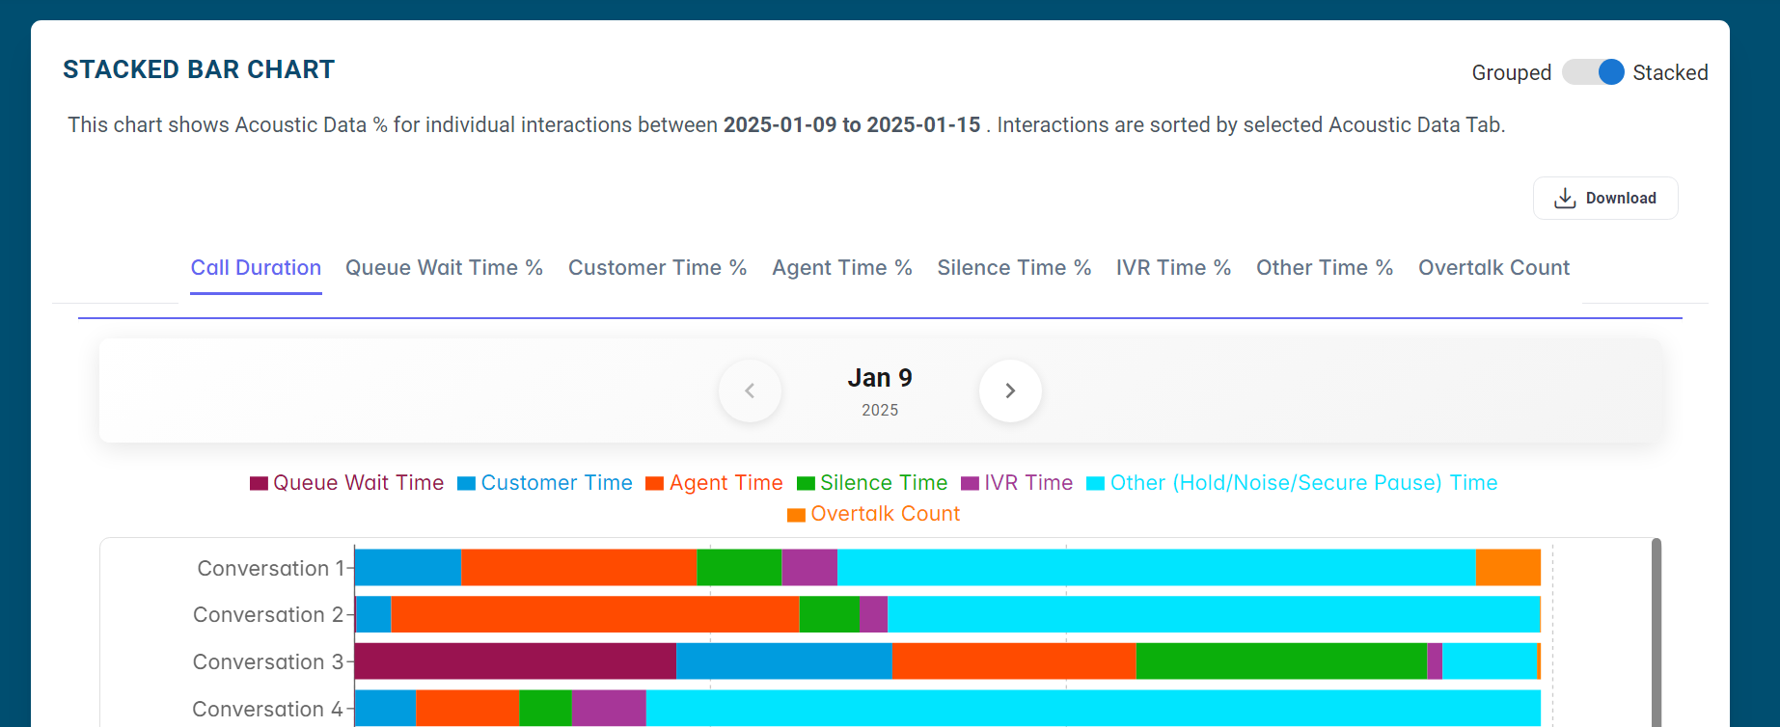

1. Following should happen: -
   1. Has interactions for selected day.
   2. Filter only by selected Acoustic Tab
   3. Sort these groups by selected Acoustic Tab
2. On clicking on a bar, it should redirect to genesys for that particular interaction.
3. On hover it should show correct details for that interaction. Can be verified by visiting and crosschecking with Genesys.
4. Only shows Top 1000 interactions at most for each Acoustic Tab. 10 by default,100 on each page on scroll.
5. Downloads preview: -
   1. Has interaction for all days.
   2. Shows Top 5000 interactions at most for each Acoustic Tab.
   3. Users able to choose which acoustic data tab they want to download as excel format.

**Planned Changes/Design Modifications**

*Sorted by priority as required

1. Download Preview in Grouped Bar Chart
   * Show all conversation details for each individual group item of currently selected group in separate tabs.
   * The conversations in each group item tab are sorted by Selected/Active acoustic data tab.
   * Users being able to download group item of their choice as excel file. All above applies to excel file data as well.
   * Example: - If currently selected acoustic data tab is call duration and group is Agent Name, Download preview will show all conversation details for specific agents sorted by call duration.
2. Pre-Filter modification Grey Out
   * Filter options will grey out dynamically based on selected set of filters.
   * Add Work Teams KVP
   * Add Single/ Multiple Agent interaction choice.
3. Combine Call Duration with other Time % cards including overtalk Count total (7).
   * Examples: - Users able to find Agents (or any group) with call duration greater than 50 minutes and with a Silence time 30% > or < 100% in grouped bar chart.
   * Users able to find all interactions with call duration greater than 50 minutes and with a queue wait time 30% > or < 100% in stacked bar chart.
4. Agent Duration & separate test card: -
   * Add agent Duration…This can be solved in relative mode story (next page).
   * Separate test card to see what count combination of acoustic data brings…this might not be needed if we decide to implement 3rd modification.

**Suggestions & Future Enhancements**

1. Percentages mode/Relative Scoring mode (Update based on further discussions)
   1. Time in % in relative mode and Time in minutes in normal mode.
   2. Relative Line chart in each statistical card.
      1. Selected Threshold count/Total count (y-axis) vs date(x-axis)
      2. Users will be able to see Relative Acoustic Data trend day by day.
   3. Relative Score sorting in Grouped chart.
      1. This mode will allow users to compare groups relatively.
      2. For example, WS FS queues generally has most interaction volume so we might see biased results.
      3. Calculate relative scores for each group i.e.
      4. Count Of Interactions in threshold X 100

Total count of interactions in interval

* + 1. Sort by this score, hover details will still show threshold count and score both.
  1. Relative comparison in stacked bar chart.   
     Example: -

1. When currently sorting by queue wait time % or any other %, brings up.

all calls with highest queue wait %.

1. The Queue wait time % bar (Purple) is biggest for these interactions.
2. Only in queue tab remove this bar so users can see which is the second largest bar or second largest time %.
3. Hover will still show all details.
   1. Add a toggle to switch between relative time + relative score sorting and normal time duration (Minutes) + count-based sorting.
4. Range selection helper chart.
   1. This will help user see in what threshold range do most or least interactions count lie.
   2. Count(y-axis) vs Acoustic data % or Minutes in (x-axis) chart.
   3. Can be update after feedback for initial design; or design for one card to see how it looks.