Pre-Conditions
- Java JDK 8.x
- Tomcat 8.5
- Eclipse Photon. With BuildShip Gradle add on
- Git

Steps
- Git Clone repo JEE-101
  - Edit .gitignore ( /bin/, /build/ )
- Create new Gradle Project in the new directory
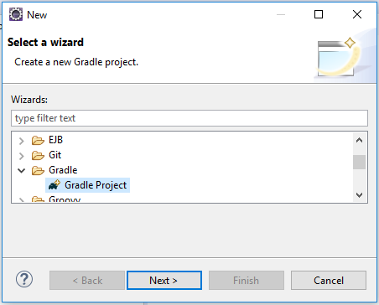
  - Delete gradle project placeholders Library.java and LibraryTest.java
  - Update gradle.build

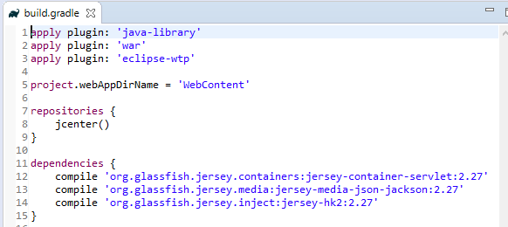
  - Refresh gradle project
  - Move web.xml to WEB-INF

