**OpenCV**

Version 1.0

e-con Systems

4/6/2018

Windows Installation Manual

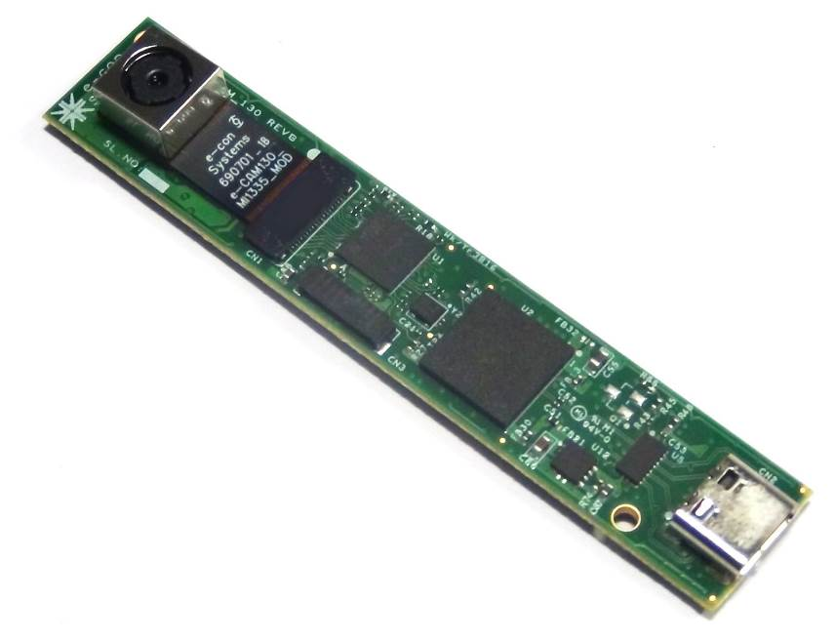



**Disclaimer**

e-con Systems reserves the right to edit/modify this document without any prior intimation of whatsoever.

Contents

Introduction to OpenCV 4

Prerequisites 4

Description 4

Building OpenCV 5

Step 1 - Launching CMake Window 5

Step 2 - Selecting Visual Studio Version 5

Step 3 - Configuring and Generating CMake 6

Step 4 - Replacing Videoio File 8

Step 5 - Building OpenCV in Visual Studio 8

Building Sample Code 9

Troubleshooting 12

Support 13

Introduction to OpenCV

Open Source Computer Vision Library (OpenCV) is an open source computer vision and machine learning software library. OpenCV libraries are used to communicate with Cameras. APIs introduced in the OpenCV can be supported with all e-con Systems cameras.

This document helps you to install OpenCV in Windows and build a sample code to access the camera with OpenCV.

Prerequisites

The prerequisites are as follows:

* Click [here](https://cmake.org/download/) to download CMake.
* Click [here](https://opencv.org/releases.html) to download Sources for OpenCV_v3.3.1.
* Create a Build directory in the OpenCV_v3.3.1.
* Build OpenCV in your PC using Visual Studio

Description

The following steps have been tested on Windows 10. OpenCV must work on any other relatively modern version of Windows OS.

Building OpenCV

OpenCV is a sample command line application used to demonstrate some of the features of the e-con Systems cameras with OpenCV APIs.

The steps to build OpenCV are as follows:

Step 1. Launching CMake Window

Step 2. Selecting Visual Studio Version

Step 3. Configuring and Generating CMake

Step 4. Replacing Videoio File

Step 5. Building OpenCV in Visual Studio

Step 1 - Launching CMake Window

In CMake window, select the OpenCV sources as source folder and OpenCV_v3.3.1/build as build folder and click **Configure** button.

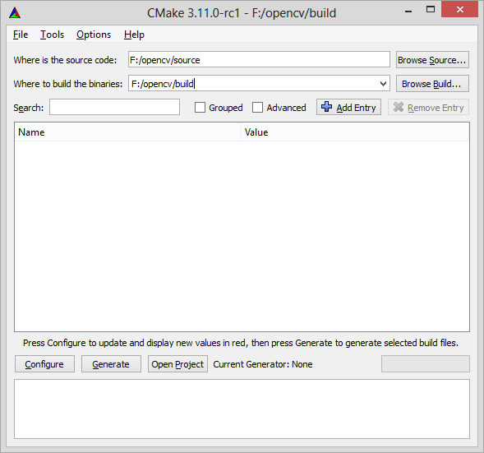

Figure : CMake Source and Build Directory Specification Window

Step 2 - Selecting Visual Studio Version

A window prompting to select Visual Studio version along with x32 and x64 version appears. Select the appropriate options as shown below.

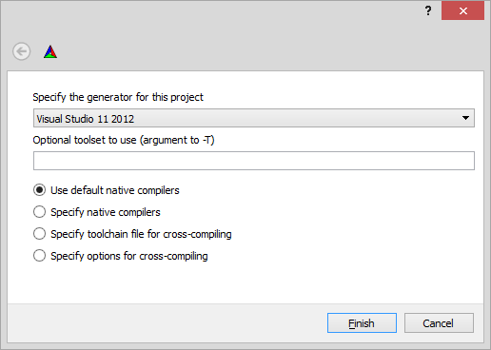

Figure : Selecting Visual Studio Version in CMake

Step 3 - Configuring and Generating CMake

The steps to configure and generate CMake are as follows:

1. Click **Configure** after selecting the Visual Studio.

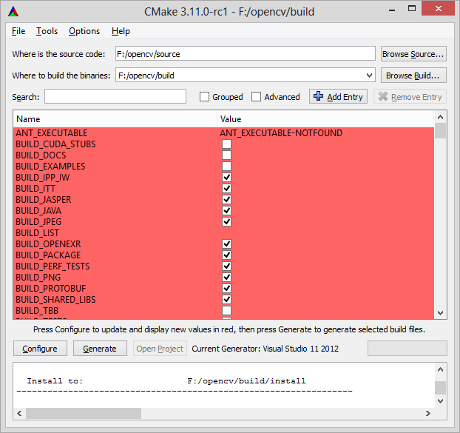

1. Click **Configure** till all red flag goes off.

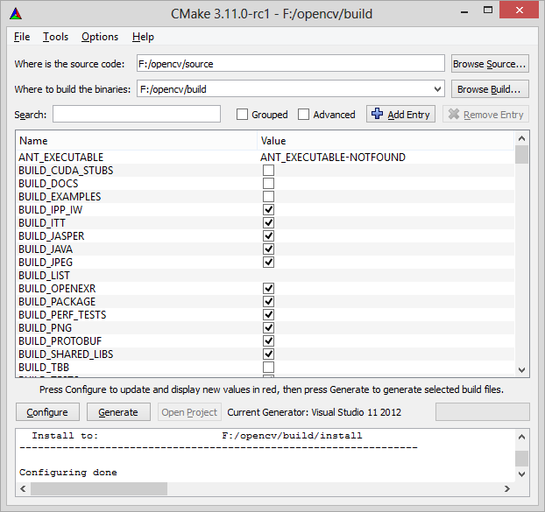

1. Click **Generate** to create Visual Studio solution file in the OpenCV build directory.

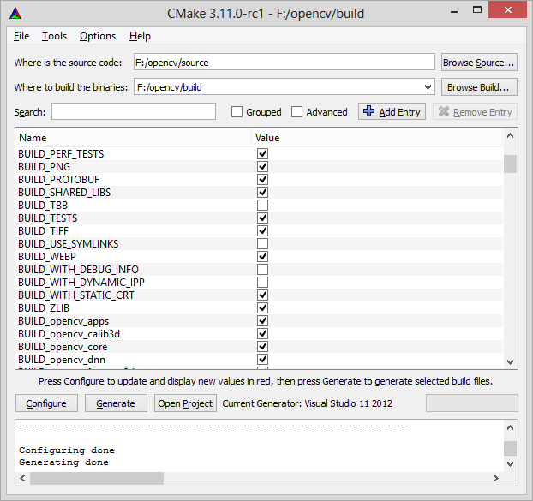

Step 4 - Replacing Videoio File

Replace the **videoio** folder with the folder downloaded from the e-con blog () in **OpenCV_v3.3.1/Sources/modules/** location.

Step 5 - Building OpenCV in Visual Studio

The steps to build OpenCV in Visual Studio are as follows:

1. Run the **OpenCV.sln** found in the build directory of OpenCV using Visual Studio.
2. Add **setupapi.lib** in modules/opencv_videoio properties tab under Linker > Input> Additional Dependencies.
3. Build **CMakeTargets/All Build** and **CMakeTargets/Install** separately in both the Debug/Release Configuration of the Visual Studio.

Building Sample Code

This section describes about how to build the sample code.

The steps to build the sample code are as follows:

1. Create a new console application in Visual Studio. Add the **\*.cpp** file of the application to be built from the blog ().
2. Link the OpenCV header under **C/C++ > General > Additional Include Directories files** from the following:

* OpenCV_v3.3.1/build/install/include
* OpenCV_v3.3.1/build/install/include/opencv
* OpenCV_v3.3.1/build/install/include/opencv2

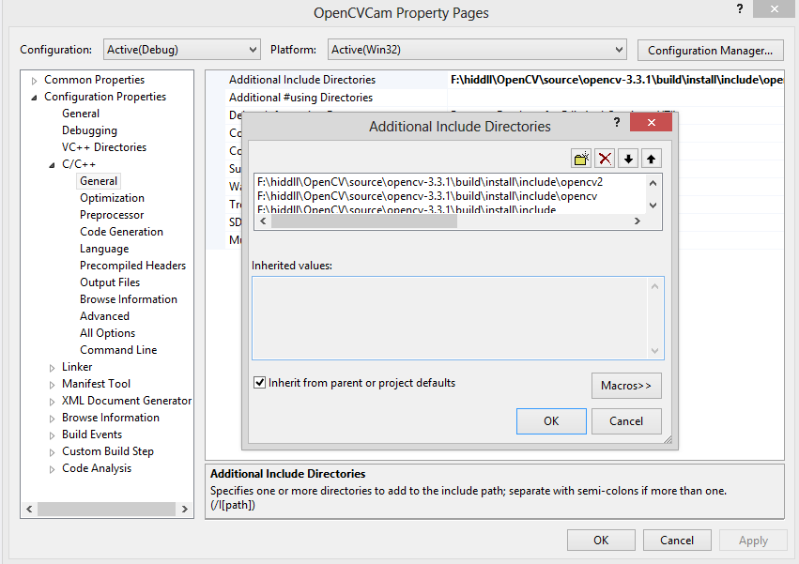

1. Link the library files of OpenCV from the **OpenCV_v3.3.1/build/lib/Release** for configuration type release under **Linker > General > Additional Library Directories**.

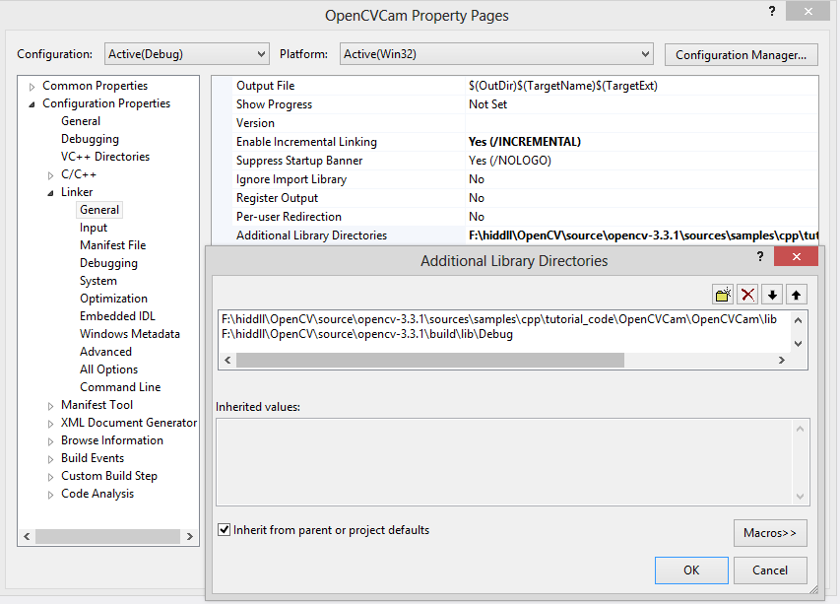

1. List all the library names linked to the project under **Linker > Input > Additional Dependencies** in the Visual Studio Project Property page.

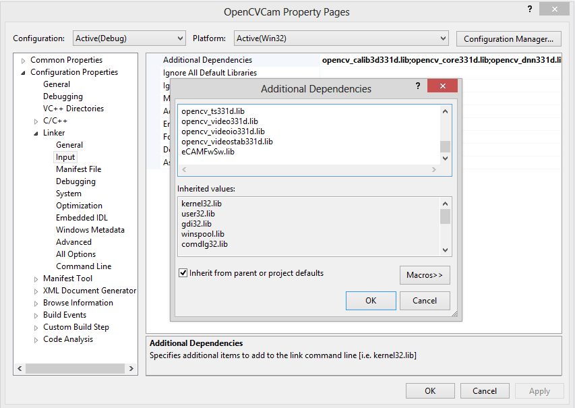

1. Add runtime libraries in the sample application **root** folder from the **OpenCV_v3.3.1/build/bin/Debug** or **OpenCV_v3.3.1/build/bin/Release** based on the configuration of the sample application. The runtime libraries for **release version** are:

* opencv_core331.dll
* opencv_highgui331.dll
* opencv_imgcodecs331.dll
* opencv_imgproc331.dll
* opencv_videoio331.dll
* eCAMFwSw.dll

and the runtime libraries for **Debug version** are:

* opencv_core331d.dll
* opencv_highgui331d.dll
* opencv_imgcodecs331d.dll
* opencv_imgproc331d.dll
* opencv_videoio331d.dll
* eCAMFwSw.dll

Troubleshooting

In this section, you can view the list of commonly occurring issues and their troubleshooting steps.

**Linker issues relating to setupdi* while building.**

Add **setupapi.lib** in the modules/opencv_videoio properties tab under **Linker> Input > Additional dependencies**.

**There is no install folder present in the opencv<version>/build/**

Build the CMakeTargets or **install project** in both Debug and Release configurations.

Support

**Contact Us**

If you need any support on OpenCV sample application, please contact us using the Live Chat option available on our website - <https://www.e-consystems.com/>

**Creating a Ticket**

If you need to create a ticket for any type of issue, please visit the ticketing page on our website - <https://www.e-consystems.com/create-ticket.asp>

**RMA**

To know about our Return Material Authorization (RMA) policy, please visit the RMA Policy page on our website - <https://www.e-consystems.com/RMA-Policy.asp>

**General Product Warranty Terms**

To know about our General Product Warranty Terms, please visit the General Warranty Terms page on our website - <https://www.e-consystems.com/warranty.asp>

Revision History

|  |  |  |  |
| --- | --- | --- | --- |
| Rev | Date | Description | Author |
| 1.0 | 10-April-2018 | Initial Draft | Chandra Sekar. V |
|  |  |  |  |
|  |  |  |  |
|  |  |  |  |
|  |  |  |  |
|  |  |  |  |