**ORIGINAL RESEARCH**

A Descriptive Analysis of Hospital Type and Length of Stay for Ontarians Hospitalized with Schizophrenia Between 2014 and 2021

Andrew Putman1,2, Joyce Mason, PhD3, David Rudoler, PhD1,2

*1Ontario Shores Centre for Mental Health Sciences, Whitby, Ontario, Canada  
2Faculty of Health Sciences, Ontario Tech University, Oshawa, Ontario, Canada*

*3Centre for Addiction and Mental Health, Toronto, Ontario, Canada*

**Corresponding Author**

David Rudoler

[David.Rudoler@ontariotechu.ca](mailto:David.Rudoler@ontariotechu.ca)

905-721-7668 ext. 3186**Abstract  
*Objective:***   
***Method:***   
***Results:***

***Conclusion:***

**MeSH Terms**:

**Introduction**

Variations in care delivery are acceptable and expected when care delivery is being adapted to better facilitate that person’s care goals and needs. However, if the variations are caused by organizational factors like culture, budget constraints, or local resources, they can result in inefficiencies in healthcare resource utilization and variations in health outcomes1,2. Previous research indicates that there is significant variation in the delivery of inpatient services for individuals diagnosed with schizophrenia3–5. Yet, little is known about the organizational factors that may contribute to this variation. By understanding the level of variation in care delivery and the extent to which it is influenced by organizational factors, we can identify opportunities for intervention.

Globally, the lifetime prevalence of schizophrenia is around 1%, affecting approximately 20 million people around the world.6,7 People experiencing schizophrenia-related symptoms typically require intense health care interventions, often including hospital admission.6 Hospitalizations for schizophrenia and other psychotic disorders currently represent one fifth of all mental health hospitalizations in the province of Ontario, Canada.8 Additionally, the total number of Ontarians discharged after hospitalization for psychotic disorders has been increasing on average, rising more than 15% between 2016/2017 (18,402 discharges) and 2020/2021 (21,402 discharges).9 On top of the higher frequency of hospitalizations that people diagnosed with schizophrenia experience, they also typically have longer in-patient length of stays (LOS) than hospitalizations for non-psychotic mental illnesses, both in Canada and globally.3,4,9,10

An additional layer of complexity in interpreting the length of stay for people hospitalized with schizophrenia is the large person-to-person variability of their inpatient LOS.3,4,10 Current literature suggests that some of this variation can be attributed to individual-level factors such as clinical characteristics and socio-economic status,4,6,10,11 but there has been less investigation into variation that is related to hospital-level factors.3,10,12 Chen et al. (2017) have found that mean LOS for schizophrenia in specialized psychiatric hospitals in Ontario was more than quadruple the mean LOS for schizophrenia in general hospitals in Ontario between 2005 and 2015. Chen et al. (2017) created separate models of individual-level factors associated with LOS for each hospital setting and reported significant associations between longer LOS and patient demographic characteristics (e.g., age), psychosocial factors (e.g., marital status), and service history (e.g., number of previous admissions). Their study primarily examined individual-level factors and strictly used data from the Ontario Mental Health Reporting System database (OMHRS), which contains mental health assessments and individual-level information that is not available in other databases like the Discharge Abstract database (DAD).4 This current study found that ≈5% of Ontario hospitalizations for schizophrenia between 2014 and 2021 were reported in the DAD but not OMHRS and an additional ≈6% of schizophrenia hospitalizations had parts of their hospitalization’s LOS reported in the DAD but not in OMHRS. This paper builds on and updates existing research by highlighting the variation in LOS for Ontarians hospitalized with schizophrenia from 2014 to 2021. It specifically focuses on variation at the institutional level by comparing Large Community Hospitals, Specialty Mental Health Hospitals, and Teaching Hospitals

**Methods**

This study used a retrospective cohort design to assess Ontario medical records of persons who have been discharged from an inpatient hospitalization for Schizophrenia between April 1st, 2014, and March 31st, 2022 [fiscal year 2014 through fiscal year 2021].

***Participants***

There were 122,747 hospital discharges with a primary diagnosis of schizophrenia between April 1st, 2014, and March 31st, 2022, in Ontario. This includes instances where an inpatient was not identified as having a primary diagnosis of schizophrenia at the time of admission but were identified as having a primary diagnosis of schizophrenia prior to being discharged from that inpatient stay. Records were then excluded from the study sample if they did not have a valid heath card number (2,499), were a forensic admission (8,407), or were under 18 years of age at the time of admission (3,221). The resulting sample contained 108,620 patient records of discharges from inpatient care that had a primary diagnosis of schizophrenia. Instances of inter-hospital transfer (26,301) were defined as when a person had been discharged from hospital and then admitted to a different hospital with a primary diagnosis of schizophrenia within 48 hours. Sensitivity analysis comparing patients transferred between institutions and those not transferred are presented in *Appendix Tables A1.0 and A1.1.*

***Data Source***

The data was obtained through IntelliHealth Ontario. IntelliHealth is a knowledge repository that is managed by the Ontario Ministry of Health.13 The IntelliHealth portal contains clinical and administrative data collected from various sectors of the Ontario healthcare system. Specifically, this study used information derived from the following databases: the Ontario Mental Health Reporting System database (OMHRS) for information on inpatient mental health hospital stays, the Canadian Institute for Health Information (CIHI) Discharge Abstract database (DAD) for inpatient hospitalizations due to schizophrenia not captured in OMHRS, the Registered Person’s database (RPDB) for demographic information, IntelliHealth’s Population Grouper Reporting (PGR) database for postal-code linked neighbourhood sociodemographic variables, and the Medical Services billing database (MS) for information regarding post-discharge physician follow-up.  
***Primary Variables***

*Acute LOS*: An integer count of the number of days of in which a person required acute inpatient care. Days in which a person is hospitalized are classified as acute care days when their clinicians determine that that person has met the threshold for requiring acute inpatient care.14 The CIHI decision support provides the following guidelines for clinicians determining whether an inpatient’s mental health meets any of the following criteria for acute inpatient care on that day:

* *Suffer[s] from sudden and severe psychiatric symptoms; can include patients who are suicidal, have hallucinations, extreme feelings of anxiety, paranoia or depression.*
* *Progressive acute behavioural or neurological difficulties requiring acute clinical or psychiatric care.*
* *Therapeutic pass to inform clinical readiness for discharge.*14

*ALC LOS:* An integer count of the number of days of in which inpatient is determined to be at an alternate level of care (ALC). Days in which a person is hospitalized are classified as ALC days when their clinicians determine that that person has not met the threshold for requiring acute inpatient care, but are awaiting to be discharged to a more appropriate care setting.14

*Total LOS:* Summation of Acute and ALC inpatient days experienced by a person during a single hospitalization.

*Type of Hospital:* The facility classification of the hospital in which inpatient care was provided. These classifications include Large Community Hospitals (general hospitals with > 100 inpatient beds, not including hospitals that meet other speciality hospital classifications), Specialty Mental Health Hospitals (stand-alone quaternary care hospitals that provide specialized mental health and addiction care), and Teaching Hospital (hospitals that are directly affiliated with a university medical program, not including Specialty Mental Health Hospitals).15–17 Hospitals that had less than of <2% of the hospitalizations in this study’s sample were collapsed into an `All Other` category for analysis [i.e., Amalgamated Hospital, Chronic/Rehabilitation Hospital, Not Stated, Small Hospital, and Specialty Children’s Hospital].

***Patient-Level Variables***

Year of discharge [fiscal], age at admission, and administrative sex were extracted along with the LOS and hospital type variables from OMHRS or DAD. The statistical area classification (SAC), Canadian marginalization index (CAN-Marg), and neighbourhood income quintile of persons in the sample were determined through postal code-linked census data from the PGR database. SACs are Statistics Canada classifications of Canadian census geographic subdivisions into 1 of 3 categories: census metropolitan areas (CMA) – population of >100,000 & >50,000 living in the subdivision’s core; census agglomeration area (CA) – population of >10,000 living in area core [often a municipality adjacent to a CA]; and outside CMA & CA.18,19 The CAN-Marg was developed by St. Micheal Hospital and classifies Canadian geographic area marginalization through assessing housing, material resources, population age, and visible minority populations into quintiles.20

Primary diagnosis of schizophrenia was determined if the person admitted to inpatient care had an ICD-10-CA or DSM-5 primary diagnosis code of F20 [excluding F20.4], F22, F23, F24, F25, F28, F29, or F53.1 (each DSM-5 diagnosis code has a corresponding ICD-10-CA code); or a DSM-IV primary diagnosis code of 295.xx [10, 20, 30, 40, 60, 70, 80, 90 and 295], 297.1, 297.3, 298.8, or 298.9.21 LOS counts include any days that occurred prior to receiving a primary diagnosis of schizophrenia and were from the same hospitalization.

***Statistical Analysis***

Overall descriptive statistics [mean, standard deviation (sd), median, interquartile range (IQR), etc.] of the entire sample related to LOS and the type of hospital that reported each discharge are presented. Coefficient of Variation (CV) for the complete sample and by type of hospital is presented as a standardized measure of how widely each subgroup’s LOS values vary around that group’s mean LOS.22 Then descriptive statistics of individual-level characteristics that have been previously shown to influence in-patient LOS for schizophrenia are presented for the entire sample and disaggregated by type of hospital. The analyses were performed using the *R* statistical computing language version 4.3.1 *Beagle Scouts*23 along with the packages *tidyverse*24 version 2.0.0, *tableone*25 version 0.13.2, and *ggpubr*26 version 0.6.0.

**Results**

Sample (n = 108,620) characteristics are presented in *Table 1*. More than half of the discharges in the sample were reported as being male (59.2%) and the median age of the entire sample was 38 years at the time of admission to hospital with a primary diagnosis of schizophrenia. Two-thirds of all discharges were from large community hospitals (66.7%), with teaching hospitals (19.9%) and speciality mental health hospitals (10.8%) being the only other type of hospital that constituted more than 2% of the hospitalizations in the sample. More than three-quarters of people in the sample (80.6%) lived in census metropolitan areas (CMA), which Statistics Canada defines as an area with at a total population of least 100,000 people and in which at least 50,000 people live in that area’s core [city centre].19 Of the persons discharged with a primary diagnosis of schizophrenia from teaching hospitals in Ontario between 2014 and 2021, 92.3% were identified as living in a CMA. Nearly one-third (33.1%) of the discharges from inpatient care with a primary diagnosis of schizophrenia were persons living in the lowest neighbourhood income quintile whereas 10.7% lived in the highest neighbourhood income quintile.

[Table 1]

The total number of discharges from Ontario hospitals with a primary diagnosis of schizophrenia rose from 12,616 in the 2014 fiscal year to 14,458 in the 2021 fiscal year. The population-standardized rate of discharges for schizophrenia have been broken down by type of hospital and are portrayed in *Figure 1* using discharges per 100,000 Ontarians per fiscal year. The standardized rate of schizophrenia-related discharges from all hospital types in 2021 (108 discharges per 100,000 Ontarians) is higher than in 2014 (93 discharges per 100,000 Ontarians), however this overall growth is not consistent from year to year. The rate of discharges from teaching hospitals steadily increased from 15 discharges per 100,000 Ontarians in 2014 to 24 discharges per 100,000 Ontarians in 2021.

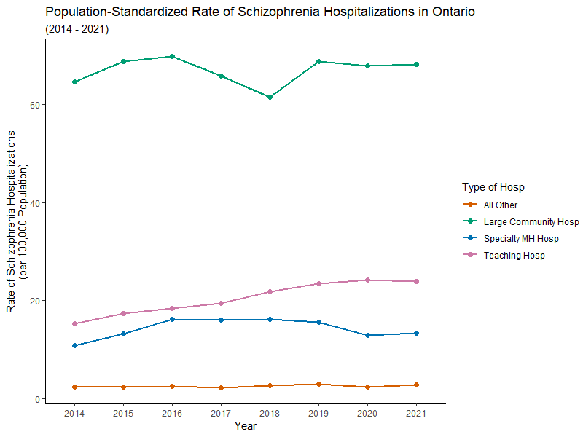*Figure 1: Population-standardized rate of yearly schizophrenia hospitalizations in Ontario by type of hospital (2014-2021)*

*Table 2* further describes the sample in terms of LOS in total and disaggregated by type of hospital. Both mean and SD, and median and IQR have been presented due to the right skew of all LOS variables. The zeros seen in the median and IQR values of ALC LOS days across all hospital sub-types show that more than three quarters of Ontarians hospitalized for schizophrenia in this sample did not spend time in ALC prior to be discharged. The mean acute LOS for all hospital types is right skewed with a minority of discharges having occurred after multiple years of inpatient care. Speciality mental health hospitals had the highest acute LOS average (74.3 days) and median (29 days) of any hospital type and had measures of dispersion (*SD* = ±221.6 days; *IQR* = 61 days) that were nearly double those of the full sample (*SD* = ±117.9 days; *IQR* = 21 days). The coefficient of variation [CV] of acute LOS for the whole sample was 3.78, with large community hospitals having the highest CV (6.08) of any hospital type. The next highest was seen in teaching hospitals (CV = 3.22), followed by specialty MH hospitals (CV = 2.98), and all other hospital types (CV = 2.19).

The mean and standard deviation of acute LOS (164.0 days; ±690.2 days) of persons who lived in a CMA and were hospitalized at large community hospitals was much higher than those who did not live in a CMA (18.6 days; ±120.1 days). Whereas the mean of acute LOS for persons who lived in a CMA (72.8 days) and were hospitalized in a speciality MH was lower than those who did not live in a CMA (85.2 days) and the mean of persons who lived in CMA (35.0 days) and were hospitalized in a teaching hospital were similar to those who did not live in a CMA (36.3 days). Further LOS analyses disaggregated by CMA can be found in *Appendix Tables A2.0 and A3.1*.

[Table 2]

Acute LOS is further examined in *Figure 2* by year and hospital type. The 98.5 days cut off for truncating the LOS range in *Figures 2 & 3’s* left column was determined by calculating the upper Tukey fence [Q3 + 1.5(IQR)] for the full sample and each type of hospital, then selecting the highest of those values to be the upper limit of the truncated scale. *Figure 2* shows that in 2020 and 2021 the width of the IQRs for acute LOS lessened in comparison to 2019 levels for large community hospitals (2019 = 17 days, 2020 & 2021 = 14 days) and teaching hospitals (2019 = 29 days, 2020 = 23 days, 2021 = 24 days); the height of the COVID-19 pandemic in Ontario. The mean and median acute LOS similarly decreased for large community (2019: mean = 21.5 days, median = 14 days; 2020: mean = 19.3 days, median 13 days; 2021: mean = 20.3 days, median = 13 days) and teaching hospitals (2019: mean = 34.6 days, median = 18 days; 2020: mean = 28.1 days, median 15 days; 2021: mean = 33.1 days, median = 15 days) in 2020 and 2021. Speciality mental health hospitals also had a decrease in mean and median LOS in from 2019 (mean = 64.8 days, median = 28 days) to 2020 (mean = 63.3 days, median = 25 days) before rebounding to pre-COVID-19 pandemic levels in 2021 (mean = 71.6 days, median = 30 days). Additional descriptive analyses by cumulative LOS per hospitalization, by type of transfer, and by census-subdivision are presented in *Appendix Tables A1.0, 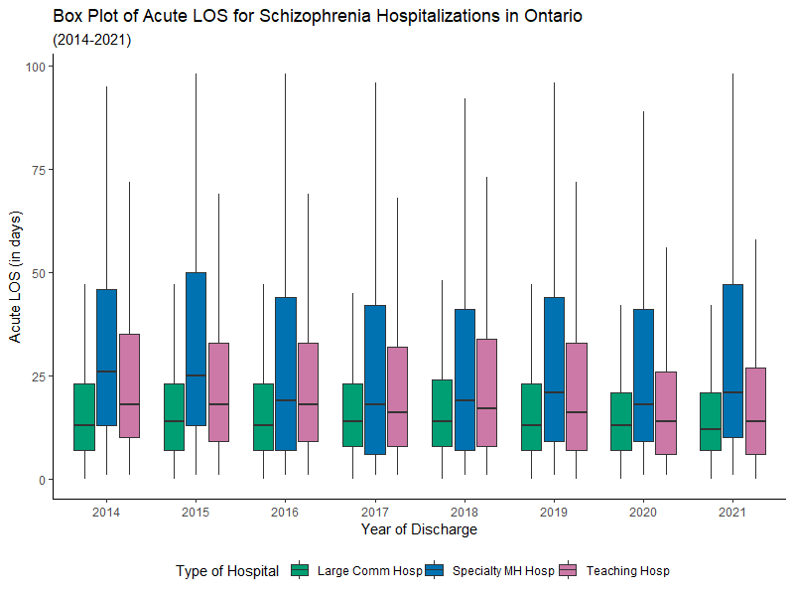A1.1, and A2.0.*

Figure 2: Boxplot of duration of Acute LOS in days for schizophrenia hospitalizations in Ontario between 2014 and 2021

The variation in LOS for Ontarians hospitalized with a primary diagnosis of schizophrenia is visualized in *Figure 3.* The ALC violin plots in *Figure 3* represent the dispersion of ALC LOS among persons who had at least 1 day of ALC during their hospitalization. The distribution of Total LOS disaggregated by type of hospital show that in this sample the large community hospitals and teaching hospitals tended to have Total LOS of less than 25 days with most hospitalizations being 5 days or fewer. Further, Total LOS in teaching hospitals tended to be longer than in large community hospitals over the study period. By comparison, specialty mental health hospitals show a less skewed distribution of Total LOS experienced by persons hospitalized for schizophrenia.

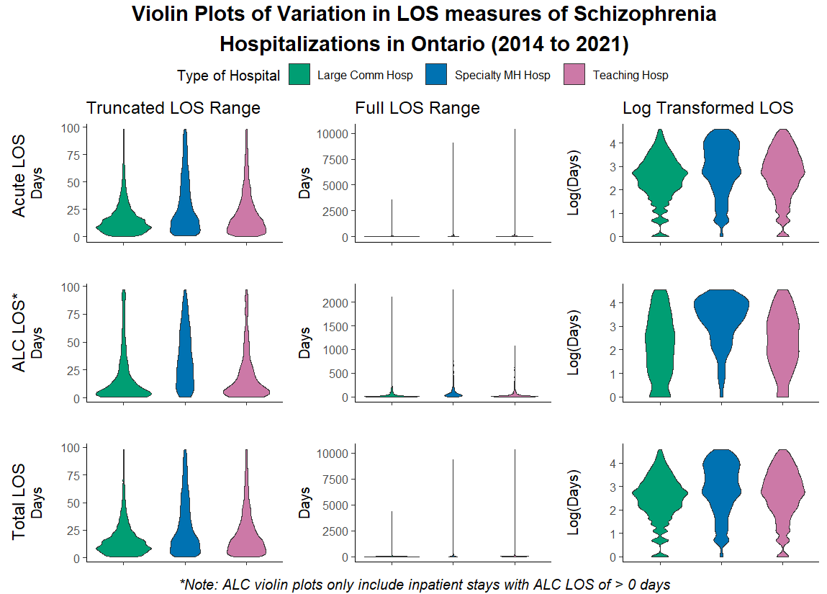

Figure 3: Violin plots of variation in LOS measures of schizophrenia hospitalizations in Ontario (2014-2021)

There were 216 unique Ontario hospitals who reported at least one discharge of an inpatient with a primary diagnosis of schizophrenia between 2014 and 2021. Of those 216 hospitals, 50 hospitals reported 83.3% of all discharges and the top 20 highest reporting hospitals accounted for half (50.2%) of discharges with a primary diagnosis of schizophrenia during the study period.

**Discussion**

This study examined hospital discharges and LOS for individuals in Ontario who were hospitalized with a primary diagnosis of schizophrenia from 2014 to 2021. The rates of schizophrenia-related hospitalizations remained largely stable during the study period, but there was an increase in the rate of hospitalizations in teaching hospitals. The average and median LOS did not show significant changes across all hospital types.

Specialty mental health hospitals had the longest median acute LOS, followed by teaching hospitals, other hospital types, and large community hospitals. This finding is consistent with other studies that have shown higher LOS in specialty mental health hospitals3,5. However, the medians do not reflect the skewed distributions of LOS.

Average acute and total LOS were highest in large community hospitals, which received most schizophrenia-related hospitalizations in Ontario. Large community hospitals in urban areas (census metropolitan areas) had median lengths of stay comparable to specialty mental health hospitals, but their average LOS was more than twice as long as specialty hospitals. The standard deviation of LOS in urban large community hospitals was more than four times the average, and nearly one-quarter of the LOS was attributed to ALC days. The standard deviations of specialty mental health hospitals’ LOS were more than double the average for all hospital types. Chen et al. (2017) found similar results in psychiatric hospitals, but not in psychiatric beds in general hospitals. These differences could be due to the way our data were disaggregated into a greater number of hospital categories, or the way in which episodes of care in hospital were constructed (e.g., exclusion of ALC days, transfers from non-psychiatric hospital beds).

Much of the variation between hospitals could be due to individual-level factors. Indeed, we do see some differences in neighbourhood-level socio-demographics, with a higher proportion of people experiencing schizophrenia related hospitalizations in large community and teaching hospitals living in lower income and more marginalized communities than those in specialty mental health hospitals. However, previous studies have suggested that sociodemographic characteristics are not consistently associated with LOS10, and that the associations vary across jurisdictions27. Although, some characteristics do appear to be more consistently associated with LOS, including housing insecurity4,10,27, social isolation or being unmarried3,4,10,27,28, and symptom severity10,27,29.

On the other hand, several studies have attributed unexplained variation in LOS for individuals with severe mental illness to hospital-level factors5,10,30. Jacobs et al. (2015) found considerable unexplained variation in LOS for individuals with severe mental illness in England. They attributed this variation to unobserved factors at the hospital level, such as management culture and efficiency. Similarly, Lee et al. (2012) observed that hospital-level factors were associated with LOS for severe mental illness based on data collected in Pennsylvania. However, much of the research on LOS for severe mental illness has not specifically focused on the impacts of hospital-level factors. Our results also show considerable variation within and between hospitals, likely pointing to variation due to factors outside of differences in patient characteristics.

Variation due to hospital-level factors may be most amenable to policy and clinical intervention. Variation in care delivery not associated with differences in levels of patient need could be unwarranted variation — variation in care delivery that is not due to patient need or evidence-based practice2. This unwarranted variation could be explained by provider-level factors (e.g., practice style, practice preferences, responses to outcome uncertainty) or practice context and environment (e.g., differences in available resources, differences in local policy and contextual constraints)1,31. As Mercuri et al. (2013) explain, unexplained variation in care delivery is often attributed in the literature to one of these factors, but knowing which of the factors is relevant will warrant difference policy responses. More research is needed to determine the impact of hospital-level factors on the LOS for individuals with schizophrenia. This information can help decision-makers in reducing the variability in LOS for this population.

This analysis has some limitations. Firstly, the administrative data might have miscoded diagnoses, which could result in missed hospitalizations related to schizophrenia and misclassifications among the included cases. Secondly, the health administrative data has limited sociodemographic variables, which may contribute to variations in the length of stay (LOS) and alternate level of care (ALC) across hospitals. This study is descriptive and does not provide information on the proportion of variation that is due to individual, provider, or hospital level factors. Future research should explore alternative methods to account for these differences in patient populations and address the variation in LOS between hospitals. Additionally, our data does not consistently capture information on levels of illness severity, such as treatment refractory schizophrenia, across hospitals. Symptom severity is a known factor associated with LOS in previous studies, and differences across patients could explain the variation in LOS. However, there is no reason to believe that there are significant differences in illness severity between hospitals, especially within hospital types.

Our study has multiple strengths. We provide data on all individuals admitted to hospitals in Ontario with a primary diagnosis of schizophrenia, including those initially hospitalized in non-psychiatric beds. We build on previous research that focuses on individual-level factors by disaggregating schizophrenia-related LOS by hospital type, acute and ALC LOS, and geography. This study serves as a foundation for future investigations into hospital-level factors that influence LOS variation, impacting health system costs, patient health outcomes, and quality of life.

**References**

1. Sutherland K, Levesque J-F. Unwarranted clinical variation in health care: Definitions and proposal of an analytic framework. Journal of Evaluation in Clinical Practice 2020;26(3):687–696.

2. Wennberg JE. Unwarranted variations in healthcare delivery: implications for academic medical centres. BMJ 2002;325(7370):961–964.

3. Cheng P, Wang L, Xu L, et al. Factors Related to the Length of Stay for Patients With Schizophrenia: A Retrospective Study. Front Psychiatry 2022;12818254.

4. Chen S, Collins A, Anderson K, et al. Patient Characteristics, Length of Stay, and Functional Improvement for Schizophrenia Spectrum Disorders: A Population Study of Inpatient Care in Ontario 2005 to 2015. Can J Psychiatry 2017;62(12):854–863.

5. Lee S, Rothbard AB, Noll EL. Length of Inpatient Stay of Persons With Serious Mental Illness: Effects of Hospital and Regional Characteristics. PS 2012;63(9):889–895.

6. Olivares JM, Sermon J, Hemels M, et al. Definitions and drivers of relapse in patients with schizophrenia: a systematic literature review. Annals of General Psychiatry 2013;12(1):32.

7. Pai N, Acar M, Juneja P, et al. Antipsychotic prescribing patterns in Australia: a retrospective analysis. BMC Psychiatry 2022;22(1):110.

8. Canadian Institute for Health Information. Inpatient Hospitalization, Surgery and Newborn Statistics, 2020–2021. Aggregate DataOttawa, ON: Canadian Institute for Health Information;https://www.cihi.ca/sites/default/files/document/dad-hmdb-childbirth-2020-2021-data-tables-en.xlsx (2022, accessed November 15, 2022).

9. Canadian Institute for Health Information. Mental Health and Substance Use Disorder Discharges | CIHI. *Canadian Institute for Health Information*https://www.cihi.ca/en/indicators/mental-health-and-substance-use-disorder-discharges (2022, accessed November 26, 2022).

10. Jacobs R, Gutacker N, Mason A, et al. Determinants of hospital length of stay for people with serious mental illness in England and implications for payment systems: a regression analysis. BMC Health Services Research 2015;15(1):439.

11. Gonçalves-Pinho M, Ribeiro JP, Freitas A. Schizophrenia Related Hospitalizations – a Big Data Analysis of a National Hospitalization Database. Psychiatr Q 2021;92(1):239–248.

12. Chung W, Chang H-S, Oh S-M, et al. Factors associated with long-stay status in patients with schizophrenia: An analysis of national databases covering the entire Korean population. Int J Soc Psychiatry 2013;59(3):207–216.

13. IntelliHealth Ontario. Welcome to IntelliHealth Ontario. *IntelliHealth Ontario*https://intellihealth.moh.gov.on.ca/ (accessed May 23, 2023).

14. Guidelines to Support ALC Designation | CIHIhttps://www.cihi.ca/en/guidelines-to-support-alc-designation (accessed June 27, 2023).

15. Classification of Hospitals. R.R.O. 1990/Reg. 964, Legislative Assembly of Ontario https://www.ontario.ca/laws/regulation/900964 (2001, accessed January 16, 2024).

16. Mental Health Act. R.S.O. 1990/M.7, Legislative Assembly of Ontario https://www.ontario.ca/laws/statute/90m07 (2015, accessed January 16, 2024).

17. Public Hospitals Act. R.S.O. 1990/P.40, Legislative Assembly of Ontario https://www.ontario.ca/laws/statute/90p40 (2023, accessed January 16, 2024).

18. Government of Canada SC. Illustrated Glossary - Census metropolitan area (CMA) and census agglomeration (CA). *Statistics Canada*https://www150.statcan.gc.ca/n1/pub/92-195-x/2021001/geo/cma-rmr/cma-rmr-eng.htm (2017, accessed January 16, 2024).

19. Government of Canada SC. Dictionary, Census of Population, 2021 – Census metropolitan area (CMA) and census agglomeration (CA)https://www12.statcan.gc.ca/census-recensement/2021/ref/dict/az/Definition-eng.cfm?ID=geo009 (2021, accessed September 22, 2023).

20. Van Ingen T, Matheson FI. The 2011 and 2016 iterations of the Ontario Marginalization Index: updates, consistency and a cross-sectional study of health outcome associations. Can J Public Health 2022;113(2):260–271.

21. Kurdyak P, Lin E, Green D, et al. Validation of a Population-Based Algorithm to Detect Chronic Psychotic Illness. Can J Psychiatry 2015;60(8):362–368.

22. Abdi H. Coefficient of variation. Encyclopedia of research design;1(5):.

23. R Core Team. R: A Language and Environment for Statistical Computinghttps://www.R-project.org/ (2023).

24. Wickham H, Averick M, Bryan J, et al. Welcome to the Tidyverse. Journal of Open Source Software 2019;4(43):1686.

25. Yoshida K. tableonehttps://github.com/kaz-yos/tableone (2023, accessed September 27, 2023).

26. Kassambara A. ggpubr: ggplot2 Based Publication Ready Plotshttps://rpkgs.datanovia.com/ggpubr/ (2023, accessed September 27, 2023).

27. Dimitri G, Giacco D, Bauer M, et al. Predictors of length of stay in psychiatric inpatient units: Does their effect vary across countries? European Psychiatry 2018;48(1):6–12.

28. Masters GA, Baldessarini RJ, Öngür D, et al. Factors associated with length of psychiatric hospitalization. Comprehensive Psychiatry 2014;55(3):681–687.

29. Baeza FL, da Rocha NS, Fleck MP. Predictors of length of stay in an acute psychiatric inpatient facility in a general hospital: a prospective study. Braz J Psychiatry 2017;40(1):89–96.

30. Harman JS, Cuffel BJ, Kelleher KJ. Profiling hospitals for length of stay for treatment of psychiatric disorders. The Journal of Behavioral Health Services & Research 2004;31(1):66–74.

31. Mercuri M, Birch S, Gafni A. Using small-area variations to inform health care service planning: what do we ‘need’ to know? Journal of Evaluation in Clinical Practice 2013;19(6):1054–1059.

**Tables**

*Table 1: Overview of Ontario hospitalizations for schizophrenia by type of hospital between 2014 and 2021*

|  |  |  |  |  |  |  |  |
| --- | --- | --- | --- | --- | --- | --- | --- |
|  |  | Type Of Hospital | | | | |  |
|  | **Overall** | ***Large Community*** | ***Specialty MH*** | ***Teaching*** | | ***All Other*** | ***p*** |
| n (%) | 108620 (100) | 72475 (66.7) | 11740 (10.8) | 21675 (19.9) | | 2730 (2.5) | <.001 |
| Year of Discharge (%) |  |  |  |  | |  | <.001 |
| 2014 | 12616 (11.6) | 8716 (12.0) | 1336 (11.4) | 2213 (10.2) | | 351 (12.9) |  |
| 2015 | 12725 (11.7) | 8903 (12.3) | 1297 (11.0) | 2221 (10.2) | | 304 (11.1) |  |
| 2016 | 13318 (12.3) | 9041 (12.5) | 1577 (13.4) | 2397 (11.1) | | 303 (11.1) |  |
| 2017 | 13115 (12.1) | 8814 (12.2) | 1530 (13.0) | 2488 (11.5) | | 283 (10.4) |  |
| 2018 | 13229 (12.2) | 8432 (11.6) | 1602 (13.6) | 2848 (13.1) | | 347 (12.7) |  |
| 2019 | 14618 (13.5) | 9482 (13.1) | 1583 (13.5) | 3159 (14.6) | | 394 (14.4) |  |
| 2020 | 14541 (13.4) | 9600 (13.2) | 1390 (11.8) | 3202 (14.8) | | 349 (12.8) |  |
| 2021 | 14458 (13.3) | 9487 (13.1) | 1425 (12.1) | 3147 (14.5) | | 399 (14.6) |  |
| Age at Admission (median [Q1,Q3]) | 38 [28, 54] | 38 [27, 53] | 38 [27, 54] | 41 [29, 56] | | 41 [29, 58] | <.001 |
| Sex (%) |  |  |  |  | |  | <.001 |
| Female | 44316 (40.8) | 29701 (41.0) | 4464 (38.0) | 8976 (41.4) | | 1175 (43.0) |  |
| Intersex & Unknown | 27 ( 0.0) | 9 ( 0.0) | 8 ( 0.1) | 10 ( 0.0) | | 0 ( 0.0) |  |
| Male | 64277 (59.2) | 42765 (59.0) | 7268 (61.9) | 12689 (58.5) | | 1555 (57.0) |  |
| Census Subdivision SAC (%) | |  |  |  |  | <.001 |
| CA | 10575 ( 9.7) | 9011 (12.4) | 849 ( 7.2) | 550 ( 2.5) | | 165 ( 6.0) |  |
| CMA | 87542 (80.6) | 56537 (78.0) | 10114 (86.1) | 20011 (92.3) | | 880 (32.2) |  |
| Outside CMA & CA | 9303 ( 8.6) | 6179 ( 8.5) | 657 ( 5.6) | 814 ( 3.8) | | 1653 (60.5) |  |
| Unknown | 1200 ( 1.1) | 748 ( 1.0) | 120 ( 1.0) | 300 ( 1.4) | | 32 ( 1.2) |  |
| Canadian Marginalization Index Quantile (%) | | |  |  |  | <0.001 |
| 1 - Least Marginalized | 13959 (12.9) | 8519 (11.8) | 2179 (18.6) | 3075 (14.2) | | 186 ( 6.8) |  |
| 2 | 15435 (14.2) | 10416 (14.4) | 1753 (14.9) | 2861 (13.2) | | 405 (14.8) |  |
| 3 | 18637 (17.2) | 12521 (17.3) | 2075 (17.7) | 3462 (16.0) | | 579 (21.2) |  |
| 4 | 18192 (16.7) | 12527 (17.3) | 1734 (14.8) | 3351 (15.5) | | 580 (21.2) |  |
| 5 - Most Marginalized | 26185 (24.1) | 17543 (24.2) | 2458 (20.9) | 5637 (26.0) | | 547 (20.0) |  |
| Unknown | 16212 (14.9) | 10949 (15.1) | 1541 (13.1) | 3289 (15.2) | | 433 (15.9) |  |
| Neighbourhood Income Quintile (%) | |  |  |  |  | <0.001 |
| 1 – Lowest Income | 36002 (33.1) | 24113 (33.3) | 3357 (28.6) | 7637 (35.2) | | 895 (32.8) |  |
| 2 | 22801 (21.0) | 14875 (20.5) | 2519 (21.5) | 4854 (22.4) | | 553 (20.3) |  |
| 3 | 16878 (15.5) | 11695 (16.1) | 1669 (14.2) | 3123 (14.4) | | 391 (14.3) |  |
| 4 | 16669 (15.3) | 11308 (15.6) | 2220 (18.9) | 2716 (12.5) | | 425 (15.6) |  |
| 5 - Highest Income | 11580 (10.7) | 7464 (10.3) | 1480 (12.6) | 2257 (10.4) | | 379 (13.9) |  |
| Unknown | 4690 ( 4.3) | 3020 ( 4.2) | 495 ( 4.2) | 1088 ( 5.0) | | 87 ( 3.2) |  |

*Abbreviations:* CA, Census Agglomeration; CMA, Census Metropolitan Area

*Table 2: Descriptive summary of LOS of Ontario hospitalizations for schizophrenia between 2014 and 2021 by type of hospital*

|  |  |  |  |  |  |  |
| --- | --- | --- | --- | --- | --- | --- |
|  |  |  | **Type of Hospital** | | | |
|  |  | **Full Sample** | ***Large Community*** | ***Specialty MH*** | ***Teaching*** | ***All Other*** |
|  |  | (n=108620) | (n=72475) | (n=11740) | (n=21675) | (n=2730) |
| Acute LOS | Proportion Acute | 0.930 | 0.756 | 0.920 | 0.946 | 0.954 |
| Mean (sd) | 31.2 (117.9) | 67.8 (412.5) | 74.3 (221.6) | 34.9 (112.3) | 21.7 (47.5) |
| CV | 3.78 | 6.08 | 2.98 | 3.22 | 2.19 |
| Median (IQR) | 15 (21) | 5 (25.75) | 29 (61) | 17 (28) | 14 (17) |
| Min : Max | 0 : 13013 | 0 : 13013 | 1 : 9079 | 0 : 10354 | 0 : 3597 |
| ALC LOS | Proportion ALC | 0.0699 | 0.2440 | 0.0802 | 0.0538 | 0.0459 |
| Mean (sd) | 2.3 (41.2) | 21.9 (183.6) | 6.5 (53.4) | 2.0 (24.6) | 1.1 (22.3) |
| CV | 17.91 | 8.38 | 8.22 | 12.4 | 20.27 |
| Median (IQR) | 0 (0) | 0 (0) | 0 (0) | 0 (0) | 0 (0) |
| Min : Max | 0 : 4328 | 0 : 4328 | 0 : 2265 | 0 : 1080 | 0 : 2110 |
| Total LOS | Proportion Total | 1.000 | 1.000 | 1.000 | 1.000 | 1.000 |
| Mean (sd) | 33.6 (142.6) | 89.7 (555.8) | 80.8 (252.6) | 36.9 (121.8) | 22.8 (58.8) |
| CV | 4.24 | 6.20 | 3.13 | 3.30 | 2.59 |
| Median (IQR) | 15 (21) | 5 (28) | 29 (63) | 18 (29) | 14 (16) |
| Min : Max | 0 : 15847 | 0 : 15847 | 1 : 9370 | 1 : 10354 | 1 : 4381 |