What I used to build this project is the MEAN stack: MongoDB, Express.js, Angular.js, and Node.js.

Suggested IDE: Brackets live preview

After cloning this project from GitHub, you will see three files in [SnS]:

* SnS: for the website itself
* Json-server: for a db.json file and a temporary json-server as the server side to serve up the website and the mobile app
* Ionic: mobile apps built with an Ionic framework

To load it, you need to first set Node.js and npm. Here is the link: <https://nodejs.org/en/>

1. **Setup the environment**

To ensure that the Node.js setup works correctly, use command lines to check on Node and NPM:

node -v

npm -v

I also used some task runners such as Gulp, and frameworks such as Bootstrap and Ionic, which helped me to write the mobile application for mobile devices using my existing HTML code.

1. **Setup json-server**

Currently, to see the demo, you need to use json-server. To set it up, use npm:

npm install json-server -g

1. **View the demo,**

To view the whole demo, first, turn on the json-server, go to the directory of [SnS/json-server] using command line, and then, type

json-server –-watch db.json

You should be able to see something like that:

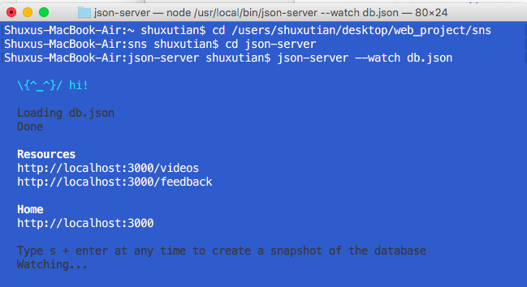

Second, to open the website, just use an IDE (could be Visual Studio I guess. I use Brackets) to open the file index.html and run it using a web browser (probably not IE…). You should be able to see the website.

Third, to view the mobile phone, go to the directory of [SnS/ionic/SnS], and then type

ionic serve --lab

For example:

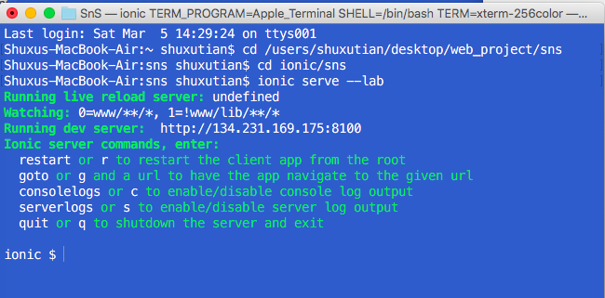

After that, you will see the full demo of this project.