IP v6

# Address Types

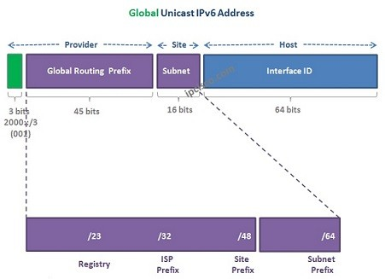  
[**IPv6**](https://ipcisco.com/course/ipv6-course/) has some similar and some different address types than [**IPv4**](https://ipcisco.com/lesson/ip-addressing-ipv4/). There are still unicast addresses in IPv6 world but this time there will be one more Unicast address types. Still multicast addresses are being used but with different addresses.

One additional address type is also in IPv6 world. This is anycast address.

In IPv6, there is no Broadcast Address type.

Some of the concepts like public and private addresses will still remain in IPv6. But with some differences.

Mainly, there are four Address Types in IPv6. These Address Types are:

IPv6 Reserved Addresses

IPv6 Unicast Addresses

IPv6 Multicast Addresses

IPv6 Anycast Addresses

IPv6 Reserved Addresses

These addresses are start with “0000 0000” at first 8 bits. Its prefix is 0::/8 .

For example:

0:0:0:0:0:0:0:0 IPv6 Unspecified Address  
0:0:0:0:0:0:0:1 IPv6 Loopback Address

## IPv6 Unicast Addresses

IPv6 has Unicast address similar to IPv4 Unicast address, but it has also other new unicast addresses. These Unicast address types are:

* IPv6 Global Unicast Address
* [**IPv6 Link-Local Address**](https://ipcisco.com/lesson/ipv6-link-local-address/)
* IPv6 Unique Local Address

Let’s check all these IPv6 Address Types deeply.

0000:0000:0000:0000:0000:0000:0000:0000 /48

0000:0000:0000:X000:0000:0000:0000:0000 /52

0000:0000:0000:XX00:0000:0000:0000:0000 /56

0000:0000:0000:XXX0:0000:0000:0000:0000 /60

0000:0000:0000:XXXX:0000:0000:0000:0000 /64

Global Unicast IPv6 Address

The IPv6 address of Internet. This address type is like IPv4 Public addresses. This is unique on internet like them. But this time, this address space is very big and cover all of the devices that use IP address. Global Unicast IPv6 Address has the prefix 2000::/3.

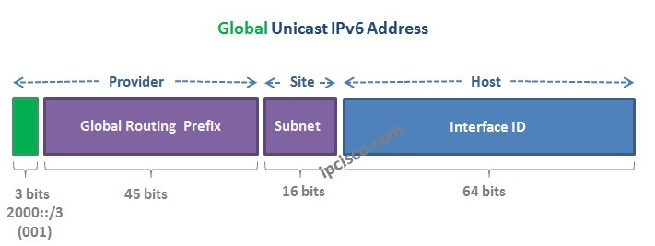

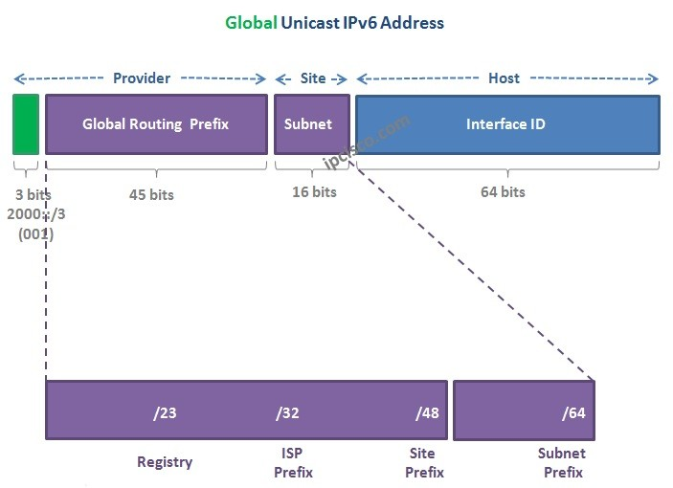

### IPv6 Link-Local Address

Link-Local IPv6 Address is the local address assigned only in a single [**subnet**](https://ipcisco.com/lesson/subnetting-in-ipv6/). They are only used on the same link. This addresses are not routable. They are only used for neighbour discovery and next hop configuration.

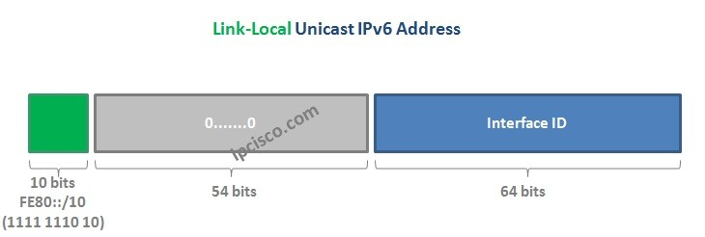

### Unique Local IPv6 Address

Unique Local IPv6 Addresses are like IPv4 Private addresses. They are used on local networks and they can not used on Internet. But with IPv6 NAT you can use Unique Local IPv6 Address on Internet.

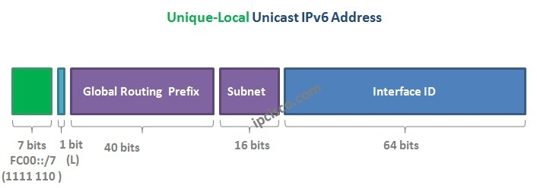

## Anycast Addresses

Anycast addresses are new address type of IPv6. This address is assigned to a set of interfaces that typically belong to the different nodes. Then, when a packet send to the anycast address, teh packet is delivered to the closest node.

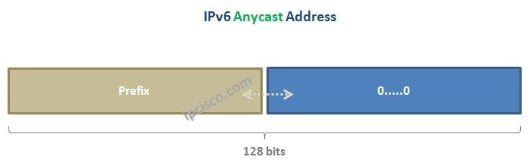

## IPv6 Multicast Addresses

IPv6 Multicast addresses are the addresses that has a prefix of FF00::./8. A packet that sent to a multicast address, is delivered by the interfaces identified by that multicast address.

|  |  |
| --- | --- |
| ff02::1 | all nodes |
| ff02::2 | all routers |
| ff02::5 | all OSPF (Open Shortest Path First) routers |
| ff02::6 | all OSPF DRs (OSPF Designated Routers) |
| ff02::9 | all RIP (Routing Information Protocol) routers |
| ff02::a | all EIGRP (Enhanced Interior Gateway Routing Protocol) routers |
| ff02::d | all PIM (Protocol Independent Multicast) routers |
| ff02::f | UPNP (Universal Plug and Play) devices |
| ff02::11 | all homenet nodes |
| ff02::12 | VRRP (Virtual Router Redundancy Protocol) |
| ff02::16 | all MLDv2-capable routers |
| ff02::1a | all RPL (Routing Protocol for Low-Power and Lossy Networks) routers (used in Internet of Things (IoT) devices) |
| ff02::fb | multicast DNS IPv6 |
| ff02::101 | network time (NTP) |
| ff02::1:2 | all DHCP agents |
| ff02::1:3 | LLMNR (Link-Local Multicast Name Resolution) |
| ff02:0:0:0:0:1:ff00::/104 | solicited node address |
| ff02:0:0:0:0:1-2:ff00::/104 | node information query |
| ff05::1:3 | all DHCP server (site) |
| ff05::101 | all NTP server (site) |

## Subnetting IPv6

