Архитектура вычислительных систем. Лабораторная работа №5. Зенченко Святослав 2МО РБД-2

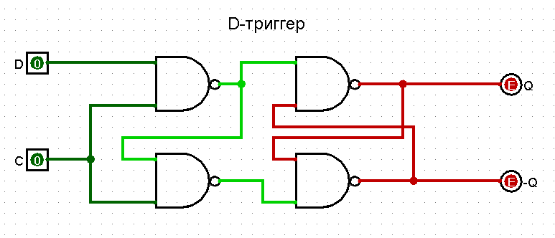

|  |  |  |  |
| --- | --- | --- | --- |
| **D** | **C** | **Q** | **Q̄** |
| 0 | 0 | Qi-1 | Q̄ i-1 |
| 0 | 1 | 0 | 1 |
| 1 | 0 | Qi-1 | Q̄ i-1 |
| 1 | 1 | 1 | 0 |

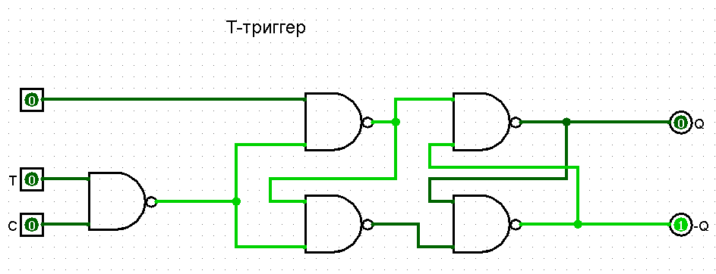

|  |  |  |  |  |
| --- | --- | --- | --- | --- |
| **a** | **T** | **C** | **Q** | **Q̄** |
| 0 | 0 | 0 | 0 | 1 |
| 0 | 0 | 1 | 0 | 1 |
| 0 | 1 | 0 | 0 | 1 |
| 0 | 1 | 1 | Qi-1 | Q̄ i-1 |
| 1 | 0 | 0 | 1 | 0 |
| 1 | 0 | 1 | 1 | 0 |
| 1 | 1 | 0 | 1 | 0 |
| 1 | 1 | 1 | Qi-1 | Q̄ i-1 |

Временная диаграмма для T-триггера

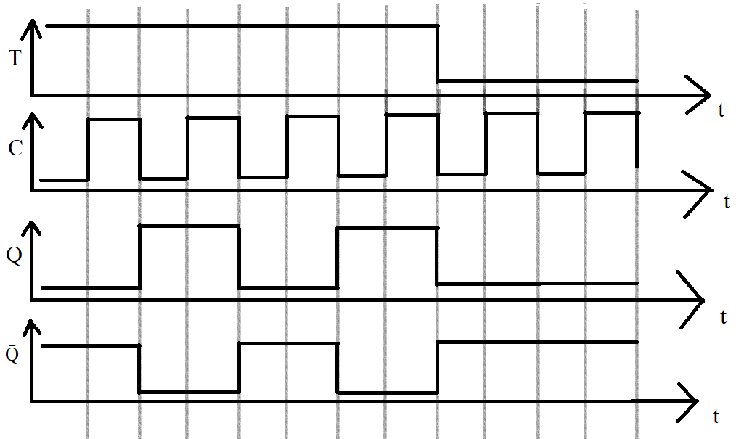

JK-триггер

