Abstract

This study examined technology transfer in the context of non-financial benefits and public policy by exploring a broader conceptualization of technology transfer that included the transfer of knowledge derived from research and development (R&D) activities. Traditional approaches to studying technology transfer have tended to focus only on the transfer of the technology asset as the primary benefit of R&D endeavors. It is argued that the transfer of knowledge is also an important and desirable outcome that is often forgotten or ignored. Several types of regression analyses were conducted using U.S. patent data to understand and explain this aspect of technology transfer and demonstrate the feasibility of using non-financially-based metrics. The study results indicated that the generality of a patent has very strong positive association with the probability and degree to which the knowledge embodied in a patent is transferred while the originality of a patent has a moderate negative association.

Keywords: technology transfer, knowledge transfer, research and development, patent citations

**Introduction**

Improving the transfer of discoveries derived from federally-funded research and development (R&D) to the private sector, so called technology transfer, is arguably a very high public policy priority for the United States of America (U.S. or USA). It was listed as a top priority in the President’s Management Agendas (PMAs) of both the George W. Bush and Donald J. Trump Administrations (Office of Management and Budget [OMB], 2002; OMB, 2018). While the administration of President Barack H. Obama did not issue PMAs, President Obama did issue a presidential memorandum on October 28, 2011 that explicitly focused on technology transfer and commercialization of federal research. In the policy section of this memorandum, he referenced the Startup America initiative which had as one of its objectives “increasing the rate of technology transfer and the economic and societal impact from Federal research and development (R&D) investments” (Daily Comp. Pres. Doc., 2011-October-28). In fact, technology transfer has been a topic of interest to the U.S. federal government since at least the end of World War II (Bush, 1945).

Technology transfer is also a top public policy priority because of the link between national economic prosperity and technological innovation. Solow (1957) estimated that roughly 88 percent of the total increase in real Gross National Product (GNP) was attributable to technological progress. Consequently, it’s important for the U.S. to maintain its technological prowess to continue the way of life that its citizens and residents have come to expect.

From a more pragmatic standpoint, the efficient use of scarce national resources makes technology transfer policy an important issue for examination. In fiscal year 2018, the U.S. federal budget for total R&D was greater than $142.9 billion (American Association for the Advancement of Science [AAAS], 2018a). Although this represented less than 3.7 percent of the government’s $3.9 trillion in total federal outlays (Congressional Budget Office [CBO], 2018), it is not a triviality considering that the amount was greater than the gross domestic product (GDP) of at least 110 countries (United Nations, 2017). Moreover, the U.S. budget deficit for fiscal 2019 was more than $100 billion (U.S. Department of the Treasury, 2018b) and the U.S. total public debt as of October 31, 2018 was more than $21.7 trillion (U.S. Department of the Treasury, 2018a). In this context, making every dollar count is imperative. There are other important, more immediate problems of national interest to which the government could direct monies currently being spent on R&D such as road repairs, alleviating hunger, and addressing issues with inequity in the court system. As Figure 1 shows, federal R&D expenditures was equivalent to roughly 20 percent of the federal budget deficit and exceeded federal spending on transportation, the Supplemental Nutrition Assistance Program (SNAP), and law courts (U.S. Spending, n.d.). As such, it’s important to ensure that technology transfer policy is as optimized as possible.

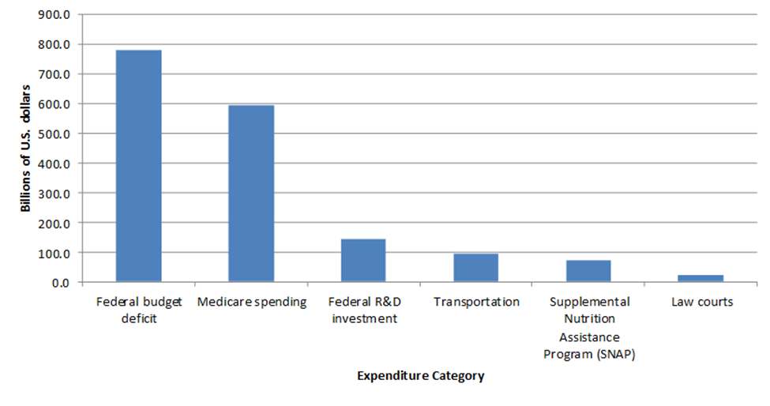Figure 1. Federal Government Expenditures for Fiscal Year 2018

How researchers conceive and operationalize the construct of technology transfer significantly influences how they measure the payoff from R&D. It also influences how policymakers formulate public policy regarding federal R&D funding and technology transfer. It stands to reason that improving construct validity in studies of technology transfer will provide new and useful insights that can illuminate opportunities to increase the benefits that accrue to society from R&D, particularly federally-funded R&D activities. As such, the primary aim of this study was to explore an alternative construct for technology transfer, demonstrate the use of alternative metrics for measuring the payoff from R&D based on such construct, examine the drivers of the technology transfer process in the context of the alternative construct and measures, and consider the public policy implications of any new insights about technology transfer that were produced.

**Materials and Methods**

**Research Questions and Expected Results**

This study filled a gap in the literature by examining technology transfer in the context of non-financial benefits and public policy. How researchers operationalize the construct of technology transfer in studies should reflect the intent of technology transfer policy. While most studies of technology transfer have seemed to operationalize the construct as a financially-motivated exchange of a technology asset however defined, one can make an argument that this does not completely reflect the intent of public policy. The PMAs of the Bush and Trump administrations and the presidential memorandum issued by President Obama (OMB, 2002; OMB, 2018; Daily Comp. Pres. Doc., 2011-October-28) clearly signal that the intent of policy in this area encompasses benefits beyond the development and transfer of technology assets. As such, it’s reasonable to conclude that the intent of technology transfer policy is to maximize all types of benefits derived from R&D efforts funded by the government. Consequently, the transfer of technology assets via financially-based exchanges should not be the only measures used in technology transfer studies or to inform technology transfer policy. There can be other types of benefits derived from R&D such as new knowledge, which the government should also seek to transfer to the private sector when federal funding for R&D is involved. The aim of technology transfer activities is to further the dissemination of research results to benefit the public (Carlsson & Fridh, 2002), which does not necessarily require a financially-based exchange or a technology asset.

The purpose of this study was to investigate issues related to federally-funded R&D and technology transfer that remain unanswered or underexplored. Specifically, this study investigated the following questions:

1. How do we more comprehensively define the benefits produced by R&D?
2. Can patent citations be used to evaluate the transfer of results produced by R&D?
3. What insights can be derived, based on patent citations data, about the factors that are likely to drive the transfer of the results of federally-funded R&D to the private sector to benefit the public?

For the purposes of this study, technology was defined as a manufacture or method that enables one to perform a task that was previously incapable of being done or perform a task in a way that is somehow materially better than was previously possible. Technology transfer was defined more broadly to include both the technology asset and the knowledge associated with or embedded within the technology.

Patents are often an output of R&D activity. For this study, patents allowed by the U.S. Patent and Trademark Office (USPTO) were used as a proxy for technology and its associated knowledge produced from research and development. Citations of patents were used as a proxy for the transfer of the knowledge associated with or embedded within the technology.

In this study, several hypotheses about the factors that are associated with the transfer of new knowledge derived from R&D were posed. One hypothesis was that the number of claims made by a patent and the generality of the patent both have positive associations with the probability that a patent is cited by other patents (i.e., citations received) and the number of citations it receives. It was theorized that opportunities for a patent to be cited by other patents increases with the number of claims the patent contains. It was also theorized that the more general a patent (i.e., the greater the breadth of potential influence of a research discovery across fields) the more opportunities there are for that patent to be cited by other patents across multiple fields. The originality of the patent, which one can think of as a measure of the degree to which a research discovery is novel and independent of anything previous, was also expected to be positively associated with the probability that the patent is cited by other patents and the number of citations received by the patent from other patents. It was speculated that patents with higher levels of originality expand new knowledge to a much greater extent than less original patents and therefore create new opportunities for future discoveries and inventions. The year a patent is allowed was expected to be negatively associated with the number of citations a patent receives from other patents reflecting the truncation effect in the source data as described by Hall, Jaffe & Trajtenberg (2001a). It was also expected that the age of a patent would somehow influence the probability that the patent is cited by other patents and number of citations it receives from other patents. It was theorized that the older a patent is the less relevant it becomes. Machlup (1962) is credited with proposing the concept of the half-life of knowledge, which is the time it takes for half of the knowledge in a field to be rendered irrelevant. Machlup proposed that although patents provide several years of protection and exclusivity (17 years at the time) obsolescence reduces the practical duration of this protection to no more than a few years. After a time, they essentially become non-factors at which point the amount of knowledge transfer that they produce drops to zero for all intents and purposes. This was expected to manifest itself in the backward citation lag.

**Data Sources**

This study used a subset of 2,000 observations taken from patent data obtained from the National Bureau of Economic Research (NBER) website. The source data contained both original and constructed variables. The data file included all utility patents granted by the U.S. Patent and Trademark Office (USPTO) from January 1, 1963 to December 30, 1999. The source file contained data on 2,923,922 patents across 23 variables (Hall, Jaffe, & Trajtenberg, 2001b).

Table 1 details the original USPTO variables of the source data and explanations of their meanings. Table 2 provides information about the constructed variables of the source data and explanations of their meanings.

Table 1

Original USPTO Variables of Source Data

| Variable | Variable Type | Extended Name | Description |
| --- | --- | --- | --- |
| PATENT | Numeric  Nominal | Patent Number | The number assigned to the allowed patent by the USPTO.  Takes on values integer values between 3070801 and 6009554. |
| GYEAR | Numeric  Interval | Grant Year | The year the USPTO allowed the patent.  Takes on integer values between 1963 – 1999. |
| GDATE | Numeric  Interval | Grant Date | The date the USPTO allowed the patent expressed in terms of the number of weeks elapsed since  January 1, 1960.  Takes on integer values between 156 and 2,028. |
| APPYEAR | Numeric  Interval | Application Year | The year the patent application was submitted to the USPTO.  Takes on integer values between 1963 – 1999. |
| COUNTRY | Character  Nominal | Country of First Inventor | The country of citizenship for the first inventor listed on the patent application.  Takes on values of two character string data. |
| POSTATE | Character  Nominal | State of First Inventor (US) | The state of residency for the first inventor listed on the patent application if the country of citizenship is the United States of America.  Takes on values of two character string data. |
| ASSIGNEE | Numeric  Nominal | Assignee Identifier | Unique identifier for the assignee of the patent.  Takes on values from 10950 to 99550. |
| ASSCODE | Numeric  Nominal | Assignee Code | A one character code categorizing the type of assignee.  Takes on values from 1 to 7. |
| CLAIMS | Numeric  Interval | Number of Claims | Number of independent and dependent claims on the patent.  Takes on integer values from 1 to $∞$. |
| NCLASS | Numeric  Nominal | Main Patent Class | A code that categorizes the patent into one of several broad classifications.  Takes on integer values from 1 to 800. |

Table 2

Constructed Variables of Source Data

| Variable | Variable Type | Extended Name | Description |
| --- | --- | --- | --- |
| CAT | Numeric  Nominal | Technological Category | A higher-level classification of the Main Patent Class.  Takes on integer values from 1 to 6.  1 indicates Chemical  2 indicates Computers & Comm.  3 indicates Drugs and Medical  4 indicates Electrical & Electronic  5 indicates Mechanical  6 indicates All Others |
| SUBCAT | Numeric  Nominal | Technological Sub-category | The sub-category of the primary technological category to which the patent is assigned.  Takes on integer values from 1 to 69. |
| CMADE | Numeric  Interval | Number of Citations Made | The number of citations made by the patent.  Takes on integer values from 1 to $∞$. |
| CRECEIVE | Numeric  Interval | No. of Citations Received | The number of citations in other patents that reference the patent.  Takes on integer values from 1 to $∞$. |
| RATIOCIT | Numeric  Ratio | Percent of Citations Made to Patents Granted Since 1963 | The ratio of the number of citations made by all patents granted since 1963 to the total number of citations made by the particular patent.  Takes on continuous values between 0 and 1. |
| GENERAL | Numeric  Ratio | Measure of Generality | A measure of how broad the influence of a patent spans across fields as determined by the number of different fields of all patents that cite the patent of interest.  Calculated as the following:  Generalityi = 1 - $\sum_{j}^{n_{i}}{s_{ij}^{2}}$, where *sij* denotes the percentage of citations received by patent *i* that belong to patent class *j*, out of *ni* patent classes.  Takes on continuous values between 0 and 1. |
| ORIGINAL | Numeric  Ratio | Measure of Originality | A measure of the originality of a patent as determined by the number of different fields for all patents cited by the patent of interest.  Calculated as the following:  Originalityi = 1 - $\sum_{j}^{n_{i}}{s_{ij}^{2}}$, where *sij* denotes the percentage of citations made by patent *i* that belong to patent class *j*, out of *ni* patent classes.  Takes on continuous values between 0 and 1. |
| FWDAPLAG | Numeric  Ratio | Mean Forward Citation Lag | The mean time difference between the application or grant date of the patent and that of the other patents citing this patent.  Takes on continuous values between 0 and 1. |
| BCKGTLAG | Numeric  Ratio | Mean Backward Citation Lag | The mean time difference between the application or grant date of the patent and those of the patents it cites.  Takes on continuous values between 0 and 1. |
| SELFCTUB | Numeric  Ratio | Share of Self-Citations Made – Upper Bound | The number of citations made by the patent to other patents with the same assignee divided by the total number of citations made by all patents with assignee codes.  Takes on continuous values between 0 and 1. |
| SELFCTLB | Numeric  Ratio | Share of Self-Citations Made – Lower Bound | The number of citations made by the patent to other patents with the same assignee divided by the total number of citations made by all patents.  Takes on continuous values between 0 and 1. |
| SECUPBD | Numeric  Ratio | Share of Self-Citations Received – Upper Bound | The number of citations received by the patent from other patents with the same assignee divided by the total number of citations received by all patents with assignee codes.  Takes on continuous values between 0 and 1. |
| SECDLWBD | Numeric  Ratio | Share of Self-Citations Received – Lower Bound | The number of citations received by the patent from other patents with the same assignee divided by the total number of citations received by all patents.  Takes on continuous values between 0 and 1. |

**Data Selection and Modification**

The GYEAR, CLAIMS, CMADE, CRECEIVE, GENERAL, ORIGINAL, FWDAPLAG, and BCKGTLAG variables were used in this study. The APPYEAR variable was not used because patent applications remain unpublished for a certain period during which time the information contained in them is not available to other researchers and inventors. As such the knowledge contained in them cannot be transferred during this time. The SUBCAT variable was eliminated from the data set because including it would have significantly increased the number of cases needed for certain types of regression analyses and would very likely have made the model more complicated than necessary. The SELFCTLB, SELFCTUB, SECDLWBD and SECUPBD variables were also not used in the analysis. An inspection of the data revealed that the value of these variables was either zero or missing for roughly 75 percent of the cases in the sample. All other variables were eliminated from the data because they were unnecessary for the intended analyses.

Table 3 lists the additional variables that were created for the analysis. Additionally, several modifications needed to be made to the source data for the study. In the source data, values for the GENERAL variable were not calculated when the value of the CRECEIVE variable was zero. For the purposes of the study, the GENERAL variable for these cases was imputed with a value of zero meaning that the patent was so specific as to have no influence on other inventions across all fields. Likewise, values for the ORIGINAL variable were not calculated in the source data when the value of the CMADE variable was zero. The ORIGINAL variable was imputed with a value of 1 in these cases meaning that the patent was so original as to be completely independent of anything previous. The FWDAPLAG and BCKGTLAG variables in the source data were undefined for cases in which the value of the CRECEIVE and CMADE variables were zero, respectively. In these cases, the FWDAPLAG and BCKGTLAG variables were imputed with the maximum value for the variable found in the sample to avoid introducing a misleading downward bias.

Table 3

Additional Variables Created for the Analysis

| Variable | Variable Type | Extended Name | Description |
| --- | --- | --- | --- |
| CAT02 | Numerical  Nominal | CAT 02 Indicator | Indicator variable  0 indicates patent not assigned to CAT 02  1 indicates patent assigned to CAT02 |
| CAT03 | Numerical  Nominal | CAT 03 Indicator | Indicator variable  0 indicates patent not assigned to CAT 03  1 indicates patent assigned to CAT03 |
| CAT04 | Numerical  Nominal | CAT 04 Indicator | Indicator variable  0 indicates patent not assigned to CAT 04  1 indicates patent assigned to CAT04 |
| CAT05 | Numerical  Nominal | CAT 05 Indicator | Indicator variable  0 indicates patent not assigned to CAT 05  1 indicates patent assigned to CAT05 |
| CAT06 | Numerical  Nominal | CAT 06 Indicator | Indicator variable  0 indicates patent not assigned to CAT 06  1 indicates patent assigned to CAT06 |
| CRECbinary | Numeric  Nominal | Number of Citations Received | 0 indicates 0 citations  1 indicates 1 or more  Takes on an integer value of 0 or 1. |
| CRECmdnSplt | Numeric  Nominal | Median Citations Received | 0 indicates less than or equal to median  1 indicates greater than median  Takes on an integer value of 0 or 1. |
| CRECordinal | Numeric  Ratio | Ordinal Level of Citations Received | The level of citations in other patents that reference the patent.  1 indicates 1 citation  2 indicates 2 citations  3 indicates 3 citations  4 indicates 4 citations  5 indicates 5 citations  6 indicates 6 citations  7 indicates 7 citations  8 indicates 8 citations  9 indicates 9 citations  10 indicates 10 citations  11 indicates 11 citations  12 indicates 12 citations  13 indicates 13 citations  14 indicates 14 citations  15 indicates 15 or more  Takes on integer values between 0 and 15. |
| CRECEIVEsqrt | Numerical  Ratio | Square Root of CRECEIVE | The square root of the value of the CRECEIVE variable |

**Analysis and Results**

The R programming language was used to analyze the data for this study. To develop a basic familiarity with the data, histograms of each variable were created to visually inspect each variable’s distribution. Quantile-Quantile (QQ) plots were also created to better understand the distribution of each variable. Scatter plots of the CRECEIVE variable against each of the other primary variables of interest were created to visually inspect for evidence of linear relationships. Measures of central tendency were also calculated for each variable. This information revealed that the data for the CRECEIVE variable was highly skewed as was the data for most of the other variables. It appeared that several of the variables might have either positive or negative linear relationships with the CRECEIVE variable but it was not readily apparent from visual inspection.

Table 4 shows a correlation matrix for the variables. None of the variables chosen for the analysis appeared to be strongly correlated with any of the others. Observation counts for each outcome level of each categorical and nominal variable were calculated. For logistic regression analysis, the rule of thumb is that there should be at least 10 observations for the least frequent outcome level of each variable (Peduzzi, Concato, Holford & Feinstein, 1996; Sileshi, 2015). Observations counts confirmed that this condition was satisfied.

Table 4

Correlation Matrix

|  |  |  |  |  |  |  |  |  |  |  |
| --- | --- | --- | --- | --- | --- | --- | --- | --- | --- | --- |
|  | 1 | 2 | 3 | 4 | 5 | 6 | 7 | 8 | 9 | 10 |
| 1. PATENT | 1.0000 |  |  |  |  |  |  |  |  |  |
| 2. GYEAR | 0.9856 | 1.0000 |  |  |  |  |  |  |  |  |
| 3. CRECEIVE | -0.1590 | -0.1495 | 1.0000 |  |  |  |  |  |  |  |
| 4. CAT | -0.0336 | -0.0268 | -0.0956 | 1.0000 |  |  |  |  |  |  |
| 5. CLAIMS | 0.0407 | 0.0402 | 0.1317 | -0.0172 | 1.0000 |  |  |  |  |  |
| 6. CMADE | 0.1023 | 0.0942 | 0.0632 | 0.0402 | 0.1656 | 1.0000 |  |  |  |  |
| 7. GENERAL | -0.1264 | -0.1189 | 0.4175 | -0.1055 | 0.1200 | 0.0882 | 1.0000 |  |  |  |
| 8. ORIGINAL | 0.0803 | 0.0809 | 0.0013 | -0.0607 | 0.0350 | 0.2531 | 0.2147 | 1.0000 |  |  |
| 9. FWDAPLAG | -0.1113 | 0.1052 | -0.1981 | 0.0149 | -0.0833 | -0.0734 | -0.2969 | -0.0092 | 1.0000 |  |
| 10. BCKGTLAG | -0.0113 | -0.0075 | -0.1357 | 0.1761 | -0.0714 | 0.0131 | -0.1064 | 0.2360 | 0.1309 | 1.0000 |

A binomial logistic regression analysis was performed using CRECbinary as the dependent variable and GYEAR, CAT02, CAT03, CAT04, CAT05, CAT06, CLAIMS, CMADE, ORIGINAL, GENERAL, FWDAPLAG, and BCKGTLAG as independent variables. The CAT01 variable was used as the reference category for the indicator variables. The hypothesis for this analysis was that at least one independent variable would be associated with the probability and odds of a patent receiving any citations from other patents. In mathematical terms this can be expressed as follows:

= = Logit-1[]

Logit [] = ln ( =

= Logit-1[)] =

where the null hypothesis was that H0: β0 = β1 …= β12 = 0 and the alternative hypothesis was that Ha: β ≠ 0 for at least one independent variable. Moreover, it was expected that β9 0 indicating a positive association with the ORIGINAL variable and that β10 0 indicating a positive association with the GENERAL variable.

Table 5 shows the results of the binomial regression. The -2 log likelihood (-2LL) was reduced from 1,774.459 to 9.167 producing a $Χ^{2}$ statistic of 1,765.292 for the model. However, none of the coefficients were significant.

Table 5

Binomial Logistic Regression for CRECbinary

|  |  |  |  |  |  |  |  |  |  |  |  |  |  |  |
| --- | --- | --- | --- | --- | --- | --- | --- | --- | --- | --- | --- | --- | --- | --- |
|  | Coefficient Estimate | Std. Error | | Z value | | p value | | Sig. | Exp (Coef) | | | C.I. Lower Exp(Coef) | | C.I. Upper Exp(Coef) |
| Intercept | 18.62 | 4.195(104) | | 0.000 | | 1.000 | |  | 1.222(108) | | | 0.0000 | | Inf |
| GYEAR | 0.31 | 0.880 | | 0.355 | | 0.723 | |  | 1.366 | | | 0.3095 | | 22.7335 |
| CAT02 | 51.87 | 2.259(105) | | 0.000 | | 1.000 | |  | 3.365(1022) | | | 0.0000 | | Inf |
| CAT03 | 57.59 | 3.690(104) | | 0.002 | | 0.999 | |  | 1.023(1025) | | | 0.0000 | | Inf |
| CAT04 | 76.29 | 3.578(104) | | 0.002 | | 0.998 | |  | 1.359(1033) | | | 0.0000 | | Inf |
| CAT05 | 18.54 | 4.344(104) | | 0.000 | | 1.000 | |  | 1.130(108) | | | 0.0000 | | Inf |
| CAT06 | 61.74 | 3.574(104) | | 0.002 | | 0.999 | |  | 6.530(1026) | | | 0.0000 | | Inf |
| CMADE | -0.02 | 0.188 | | -0.105 | | 0.916 | |  | 0.980 | | | 0.5223 | | 1.3160 |
| CLAIMS | -0.02 | 0.174 | | -0.136 | | 0.892 | |  | 0.977 | | | 0.5599 | | 1.2531 |
| ORIGINAL | 2.19 | 4.565 | | 0.480 | | 0.631 | |  | 8.956 | | | 0.0017 | | 2.66(106) |
| GENERAL | 70.98 | 3.623(104) | | 0.002 | | 0.998 | |  | 6.686(1030) | | | 0.0000 | | Inf |
| FWDAPAG | -68.76 | 2.461(103) | | -0.028 | | 0.978 | |  | 1.376(10-30) | | | 0.0000 | | 0.0000 |
| BCKGTLAG | 0.0028 | 0.054 | | 0.052 | | 0.959 | |  | 1.003 | | | 0.8447 | | 1.1269 |
| *** 0.001 ** 0.01 * 0.05 | | | | | | | | | | | | | | |
|  | | | | | | | | | | | | | | |
| -2 log likelihood null | | | 1,744.459 | |  | |  | | |  |  | |  | |
| -2 log likelihood residual | | | 9.167 | |  | |  | | |  |  | |  | |
|  | | |  | |  | |  | | |  |  | |  | |
| McFadden R2 | | | 0.9948 | |  | |  | | |  |  | |  | |
|  | | |  | |  | |  | | |  |  | |  | |

A second binomial logistic regression analysis was performed using CRECmdnSplt as the dependent variable and GYEAR, CAT02, CAT03, CAT04, CAT05, CAT06, CLAIMS, CMADE, ORIGINAL, GENERAL, FWDAPLAG, and BCKGTLAG as independent variables. As before, the CAT01 variable was used as the reference category for the indicator variables. Again, the hypothesis for this analysis was that at least one of the independent variables would be associated with the probability and odds of a patent receiving more than the median number of citations from other patents as expressed by the following:

= Logit-1[)] =

where the alternative hypothesis was that Ha: β ≠ 0 for at least one of the independent variables. As before, it was expected that β9 0 indicating a positive association with the ORIGINAL variable and β10 0 indicating a positive association with the GENERAL variable.

Table 6 shows the results of the second binomial regression analysis. In this case, coefficients for GYEAR, CAT02, CAT03, ORIGINAL, GENERAL, and FWDAPLAG were significant at the 0.001 level. Coefficients for CMADE and BCKGTLAG were significant at the 0.01 level. Coefficients for CAT04 and CLAIMS were significant at the 0.05 level. The coefficients for CAT05 and CAT06 were not significant. The McFadden pseudo-R2 value was 0.295 and the -2LL was decreased from 2,734.8 to 1,927.5 producing a $Χ^{2}$ statistic of 807.3 for the model. Taken in whole, these results suggested that the model fit the data well. Cases in which the patent received more than the median number of citations (i.e., the knowledge contained in the patent was transferred at greater than the median amount) had high predicted probabilities and odds while cases in which the patent received less than the median number of citations had low predicted probabilities and odds.

Table 6

Binomial Logistic Regression for CRECmdnSplt

|  |  |  |  |  |  |  |  |  |  |  |  |  |  |  |
| --- | --- | --- | --- | --- | --- | --- | --- | --- | --- | --- | --- | --- | --- | --- |
|  | Coefficient Estimate | Std. Error | | Z value | | p value | | Sig. | Exp (Coef) | | | C.I. Lower Exp(Coef) | | C.I. Upper Exp(Coef) |
| Intercept | 530.049 | 71.396 | | 7.424 | | 0.0000 | | *** | 1.575(10230) | | | 6.937(10169) | | 2.817(10291) |
| GYEAR | -0.266 | 0.036 | | -7.435 | | 0.0000 | | *** | 0.766 | | | 0.7138 | | 0.8215 |
| CAT02 | 1.002 | 0.223 | | 4.496 | | 0.0000 | | *** | 2.722 | | | 1.7645 | | 4.2277 |
| CAT03 | 0.725 | 0.218 | | 3.323 | | 0.0008 | | *** | 2.065 | | | 1.3482 | | 3.1728 |
| CAT04 | 0.401 | 0.184 | | 2.178 | | 0.0294 | | * | 1.494 | | | 1.0417 | | 2.1464 |
| CAT05 | 0.115 | 0.182 | | 0.634 | | 0.5262 | |  | 1.122 | | | 0.7860 | | 1.6035 |
| CAT06 | 0.350 | 0.186 | | 1.878 | | 0.0603 | |  | 1.418 | | | 0.9856 | | 2.0449 |
| CMADE | 0.024 | 0.007 | | 3.226 | | 0.0013 | | ** | 1.024 | | | 1.0100 | | 1.0402 |
| CLAIMS | 0.015 | 0.006 | | 2.441 | | 0.0146 | | * | 1.015 | | | 1.0030 | | 1.0275 |
| ORIGINAL | -1.101 | 0.221 | | -4.978 | | 0.0000 | | *** | 0.333 | | | 0.2148 | | 0.5114 |
| GENERAL | 4.277 | 0.231 | | 18.487 | | 0.0000 | | *** | 72.030 | | | 46.0593 | | 114.1223 |
| FWDAPAG | -0.199 | 0.027 | | -7.276 | | 0.0000 | | *** | 0.819 | | | 0.7755 | | 0.8635 |
| BCKGTLAG | -0.015 | 0.005 | | -2.999 | | 0.0027 | | ** | 0.986 | | | 0.9761 | | 0.9948 |
| *** 0.001 ** 0.01 * 0.05 | | | | | | | | | | | | | | |
|  | | | | | | | | | | | | | | |
| -2 log likelihood null | | | 2,734.8 | |  | |  | | |  |  | |  | |
| -2 log likelihood residual | | | 1,927.5 | |  | |  | | |  |  | |  | |
|  | | |  | |  | |  | | |  |  | |  | |
| McFadden R2 | | | 0.2952 | |  | |  | | |  |  | |  | |
|  | | |  | |  | |  | | |  |  | |  | |

Several variables had strong associations the odds of a patent receiving more than the median number of citations from other patents. Patents classified as CAT02 and CAT03 were respectively 2.72 and 2.06 times more likely to receive more than the median number of citations than patents classified as CAT01 holding all other variables constant. Although the CLAIMS variable did exhibit a statistically significant positive association, it was very small. The GENERAL variable had a particularly strong association. A patent with a one unit increase in the value of the GENERAL variable was roughly 72 times more likely to receive more than the median number of citations holding all other variables constant. While the positive association was consistent with the expectations, the magnitude of the association was unexpected. Also, somewhat surprising was the negative association between the originality of the patent as measured by the ORIGINAL variable and the odds of the patent receiving more than the median number of citations. This was counter to initial expectations. It’s possible that the more original a patent the more difficult it is for others to conceive applications of the technology in their fields. This may be related to the concept of the adjacent possible described by Johnson (2011), which is the notion that extraordinary change is possible but can only be achieved by progressing through a series of first order combinations of potential knew interactions among current possibilities. A highly original patent may represent a leap to a second order combination or higher. For such a patent to be useful, it may be necessary for the current state of knowledge to expanded over some given amount of time so that first order combinations with the highly original patent become possible.

An ordinal logistic regression analysis was performed using CRECordinal as the dependent variable and GYEAR, CAT02, CAT03, CAT04, CAT05, CAT06, CLAIMS, CMADE, ORIGINAL, GENERAL, FWDAPLAG, and BCKGTLAG as independent variables. The CAT01 variable was used as the reference category for the indicator variables. The hypothesis for this analysis was that at least one independent variable would be associated with the probability and odds of a patent receiving at least a given level of citations from other patents as expressed by the following:

=

= Logit-1[] =

where *j* takes on ordinal values from 1 to 15. The alternative hypothesis was Ha: β ≠ 0 for at least one of the independent variables. Again, it was initially expected that β9 0 indicating a positive association with the ORIGINAL variable and that β10 0 indicating a positive association with the GENERAL variable.

Table 7 shows the results of the ordinal regression analysis. The coefficient for CAT02 was not significant. The coefficients for BCKGTLAG were significant at the 0.05 level while all remaining independent variables were significant at the 0.001 level. The McFadden pseudo-R2 value for the model was 0.189 and the -2LL for the model was decreased from 9,744.127 to 7,904.203 producing a $Χ^{2}$ statistic of 1,839.924 for the model. Taken in whole, these results suggested that the model fit the data well. Cases in which the patent received at least a given level of citations from other patents (i.e., achieved a given level of knowledge transfer) had high predicted probabilities and odds while cases in which the patent did not receive at least a given level of citations from other patents had low predicted probabilities and odds.

Table 7

Ordinal Logistic Regression

|  |  |  |  |  |  |  |  |  |  |  |  |  |  |  |
| --- | --- | --- | --- | --- | --- | --- | --- | --- | --- | --- | --- | --- | --- | --- |
|  | Coefficient Estimate | Std. Error | | t value | | p value | | Sig. | Exp (Coef) | | | C.I. Lower Exp(Coef) | | C.I. Upper Exp(Coef) |
| Variables: |  |  | |  | |  | |  |  | | |  | |  |
| GYEAR | -0.3659 | 0.00010 | | -3,750.527 | | 0.0000 | | *** | 0.694 | | | 0.6935 | | 0.6936 |
| CAT02 | 0.9424 | 0.11150 | | 8.453 | | 0.0000 | | *** | 2.566 | | | 1.8637 | | 3.5377 |
| CAT03 | 0.9285 | 0.10950 | | 8.480 | | 0.0000 | | *** | 2.531 | | | 1.8336 | | 3.4959 |
| CAT04 | 0.4930 | 0.09072 | | 5.435 | | 0.0000 | | *** | 1.637 | | | 1.2525 | | 2.1411 |
| CAT05 | 0.0345 | 0.08924 | | 0.386 | | 0.6995 | |  | 1.035 | | | 0.7950 | | 1.3477 |
| CAT06 | 0.2973 | 0.09029 | | 3.292 | | 0.0010 | | *** | 1.346 | | | 1.0329 | | 1.7550 |
| CMADE | 0.0242 | 0.00501 | | 4.839 | | 0.0000 | | *** | 1.025 | | | 1.0143 | | 1.0350 |
| CLAIMS | 0.0176 | 0.00455 | | 3.865 | | 0.0001 | | *** | 1.018 | | | 1.0087 | | 1.0269 |
| ORIGINAL | -0.8521 | 0.12358 | | -6.895 | | 0.0000 | | *** | 0.427 | | | 0.3132 | | 0.5804 |
| GENERAL | 4.6444 | 0.06795 | | 68.351 | | 0.0000 | | *** | 104.002 | | | 72.4010 | | 150.0701 |
| FWDAPAG | -0.4885 | 0.02004 | | -24.372 | | 0.0000 | | *** | 0.614 | | | 0.5878 | | 0.6397 |
| BCKGTLAG | -0.0067 | 0.00324 | | -2.060 | | 0.0395 | | ** | 0.993 | | | 0.9870 | | 0.9997 |
|  |  |  | |  | |  | |  |  | | |  | |  |
| Intercepts: |  |  | |  | |  | |  |  | | |  | |  |
| 0|1 | -732.991 | 0.00198 | | -369,549.5 | | 0.0000 | | *** | 0.000 | | | 0.000 | | 0.000 |
| 1|2 | -730.923 | 0.10504 | | -6,958.3 | | 0.0000 | | *** | 0.000 | | | 0.000 | | 0.000 |
| 2|3 | -729.860 | 0.11145 | | -6,549.0 | | 0.0000 | | *** | 0.000 | | | 0.000 | | 0.000 |
| 3|4 | -729.079 | 0.11439 | | -6,373.8 | | 0.0000 | | *** | 0.000 | | | 0.000 | | 0.000 |
| 4|5 | -728.525 | 0.11660 | | -6,248.5 | | 0.0000 | | *** | 0.000 | | | 0.000 | | 0.000 |
| 5|6 | -728.049 | 0.11891 | | -6,122.7 | | 0.0000 | | *** | 0.000 | | | 0.000 | | 0.000 |
| 6|7 | -727.700 | 0.12091 | | -6,018.7 | | 0.0000 | | *** | 0.000 | | | 0.000 | | 0.000 |
| 7|8 | -727.412 | 0.12283 | | -5,922.2 | | 0.0000 | | *** | 0.000 | | | 0.000 | | 0.000 |
| 8|9 | -727.149 | 0.12487 | | -5,823.4 | | 0.0000 | | *** | 0.000 | | | 0.000 | | 0.000 |
| 9|10 | -726.933 | 0.12652 | | -5,745.7 | | 0.0000 | | *** | 0.000 | | | 0.000 | | 0.000 |
| 10|11 | -726.699 | 0.12874 | | -5,644.7 | | 0.0000 | | *** | 0.000 | | | 0.000 | | 0.000 |
| 11|12 | -726.499 | 0.13029 | | -5,575.9 | | 0.0000 | | *** | 0.000 | | | 0.000 | | 0.000 |
| 12|13 | -726.323 | 0.13116 | | -5,537.6 | | 0.0000 | | *** | 0.000 | | | 0.000 | | 0.000 |
| 13|14 | -726.188 | 0.13145 | | -5,524.3 | | 0.0000 | | *** | 0.000 | | | 0.000 | | 0.000 |
| 14|15 | -726.030 | 0.13180 | | -5,508.8 | | 0.0000 | | *** | 0.000 | | | 0.000 | | 0.000 |
| *** 0.001 ** 0.01 * 0.05 | | | | | | | | | | | | | | |
|  | | | | | | | | | | | | | | |
| -2 log likelihood null | | | 9,744.1 | |  | |  | | |  |  | |  | |
| -2 log likelihood residual | | | 7,904.2 | |  | |  | | |  |  | |  | |
|  | | |  | |  | |  | | |  |  | |  | |
| McFadden R2 | | | 0.1888 | |  | |  | | |  |  | |  | |
|  | | |  | |  | |  | | |  |  | |  | |

Again, there was a negative association between the ORIGINAL variable and the level of patent citations received. The GENERAL variable had a positive association with the level of patent citations received as expected. Like the results of the binomial logistic regression, the magnitude of the association for the GENERAL variable was very large compared to the other variables. Again, the CLAIMS variable had a statistically significant but small positive association.

A multiple regression analysis was performed using CRECEIVE as the dependent variable and GYEAR, CAT02, CAT03, CAT04, CLAIMS, ORIGINAL, GENERAL, and FWDAPLAG as independent variables. The CAT01 variable was used as the reference category for the indicator variables. These variables were selected based on a review of the adjusted R2 for various regression subsets. For the purposes of the multiple regression analysis, the CRECEIVE variable was treated as continuous because the number of integer values that the variable could take on was theoretically infinite. It was theorized that a positive linear relationship existed between the number of citations a patent received from other patents and the various independent variables selected for the model as represented by the following equation:

*CRECEIVE = β0 + β1(GYEAR) + β2(CAT02) + β3(CAT03) + β4(CAT04) +*

*β5(CLAIMS) + β6(ORIGINAL) + β7(GENERAL) + β8(FWDAPLAG)*

where the alternative hypothesis was Ha: β ≠ 0 for at least one independent variable. Initially, it was expected that β6 0 and β7 0, indicating positive associations with both the ORIGINAL and GENERAL variables.

Table 8 shows the results of the multiple regression analysis. All independent variables were significant at the 0.001 level except for the ORIGINAL variable, which was significant at the 0.01 level. The adjusted R2 value was 0.2342 indicating that the model explained 23.42 percent of the variation in the value of the CRECEIVE variable. Once again, the magnitude of association with the GENERAL variable was considerably larger than all other variables. The ORIGINAL variable had a negative association as it did in the binomial and ordinal logistic regression analyses. The CLAIMS variable again exhibited a very small statistically significant positive association.

Table 8

Multiple Regression Results

|  |  |  |  |  |  |  |  |  |
| --- | --- | --- | --- | --- | --- | --- | --- | --- |
|  | CRECEIVE | | | | CRECEIVEsqrt | | | |
|  | Coefficient Estimate | p-value | Sig. | VIF | Coefficient Estimate | p-value | Sig. | VIF |
| Intercept | 998.65051 | 0.000 | *** |  | 169.336058 | 0.000 | *** |  |
| GYEAR | -0.49997 | 0.000 | *** | 1.0589 | -0.084001 | 0.000 | *** | 1.0458 |
| CAT02 | 3.05106 | 0.000 | *** | 1.0768 | 0.135559 | 0.004 | ** | 1.0617 |
| CAT03 | 3.45773 | 0.000 | *** | 1.0554 | 0.141919 | 0.002 | ** | 1.0434 |
| CAT04 | 1.37359 | 0.000 | *** | 1.0755 | 0.072884 | 0.034 | * | 1.0630 |
| CLAIMS | 0.05989 | 0.000 | *** | 1.0216 | 0.004406 | 0.003 | ** | 1.0135 |
| ORIGINAL | -1.55882 | 0.002 | ** | 1.0728 | -0.249616 | 0.000 | *** | 1.0601 |
| GENERAL | 9.57013 | 0.000 | *** | 1.2192 | 1.473686 | 0.000 | *** | 1.1878 |
| FWDAPAG | -0.21028 | 0.000 | *** | 1.1375 | -0.158777 | 0.000 | *** | 1.1428 |

*** 0.001 ** 0.01 * 0.05

|  |  |  |  |  |  |  |  |
| --- | --- | --- | --- | --- | --- | --- | --- |
|  | Residual SE | DF | Multiple R2 | Adjusted R2 | F-statistic | DF | p-value |
| CRECEIVE | 6.357 | 1,989 | 0.2373 | 0.2342 | 77.4 | 8 & 1,989 | 0.000*** |
| CRECEIVEsqrt | 0.544 | 1,754 | 0.6417 | 0.6401 | 392.7 | 8 & 1,754 | 0.000*** |

*** 0.001 ** 0.01 * 0.05

A check of the assumptions of linear regression suggested that the multiple regression model could be significantly improved. As Figure 2 shows, there appeared to be some heteroscedasticity in the data. Moreover, outliers appeared to be influencing the results.

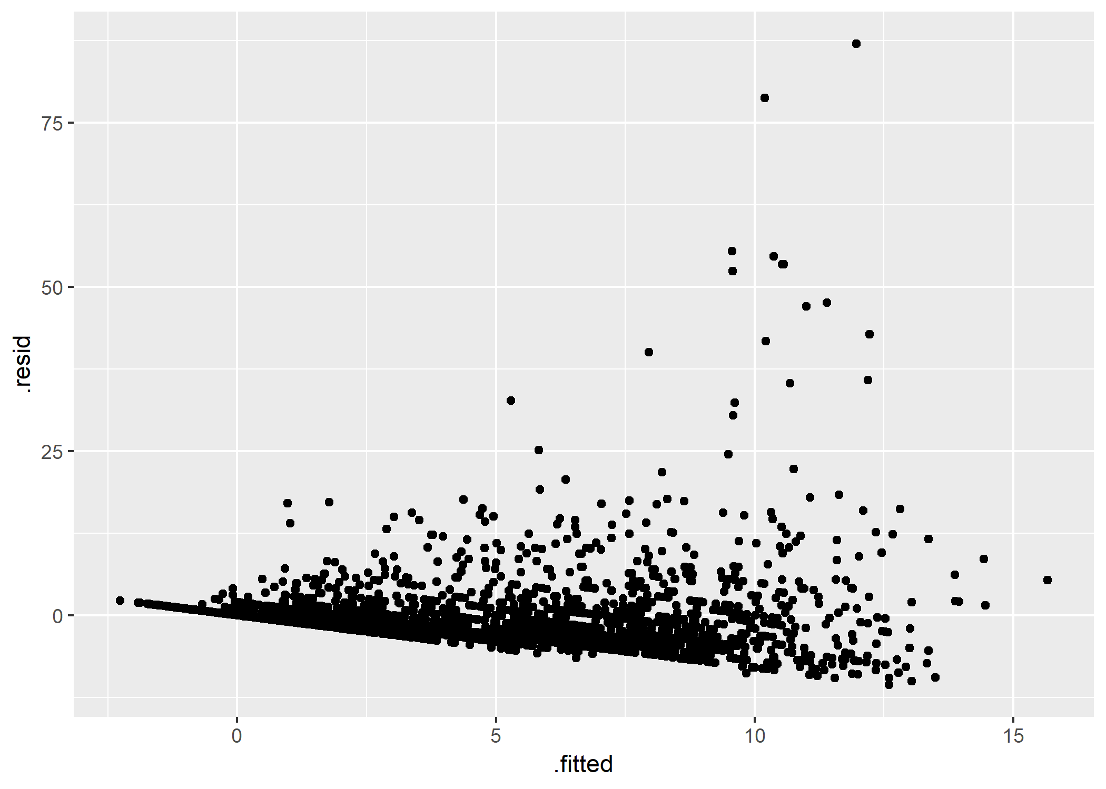

Figure 2. Residuals Plot for Multiple Regression Model Using CRECEIVE

To improve the model, another multiple regression was performed using CRECsqrt as the dependent variable, which is a square root transformation of the CRECEIVE variable. Additionally, cases in which the value of the CRECEIVE variable was equal to or greater than 15 were removed as outliers. As Table 9 shows, all independent variables were significant at the 0.001 level except for the CAT02, CAT03, and CLAIMS variables, which were significant at the 0.01 level and the CAT04 variable, which was significant at the 0.05 level. The adjusted R2 value was 0.6401 indicating that the model explained 64.01 percent of the variation in the value of the CRECsqrt variable. These results indicate that the model fit the data well and resulted in predicted values close to the observed values. The magnitude of association with the GENERAL variable remained considerably larger than all other variables. The ORIGINAL variable had a negative association as before. The CLAIMS variable continued to exhibit a very small statistically significant positive association.

A check of the assumptions of linear regression indicated that applying the transformation to the dependent variable improved the multiple regression model. As Figure 3 shows, the heteroscedasticity in the data appeared to have been greatly reduced.

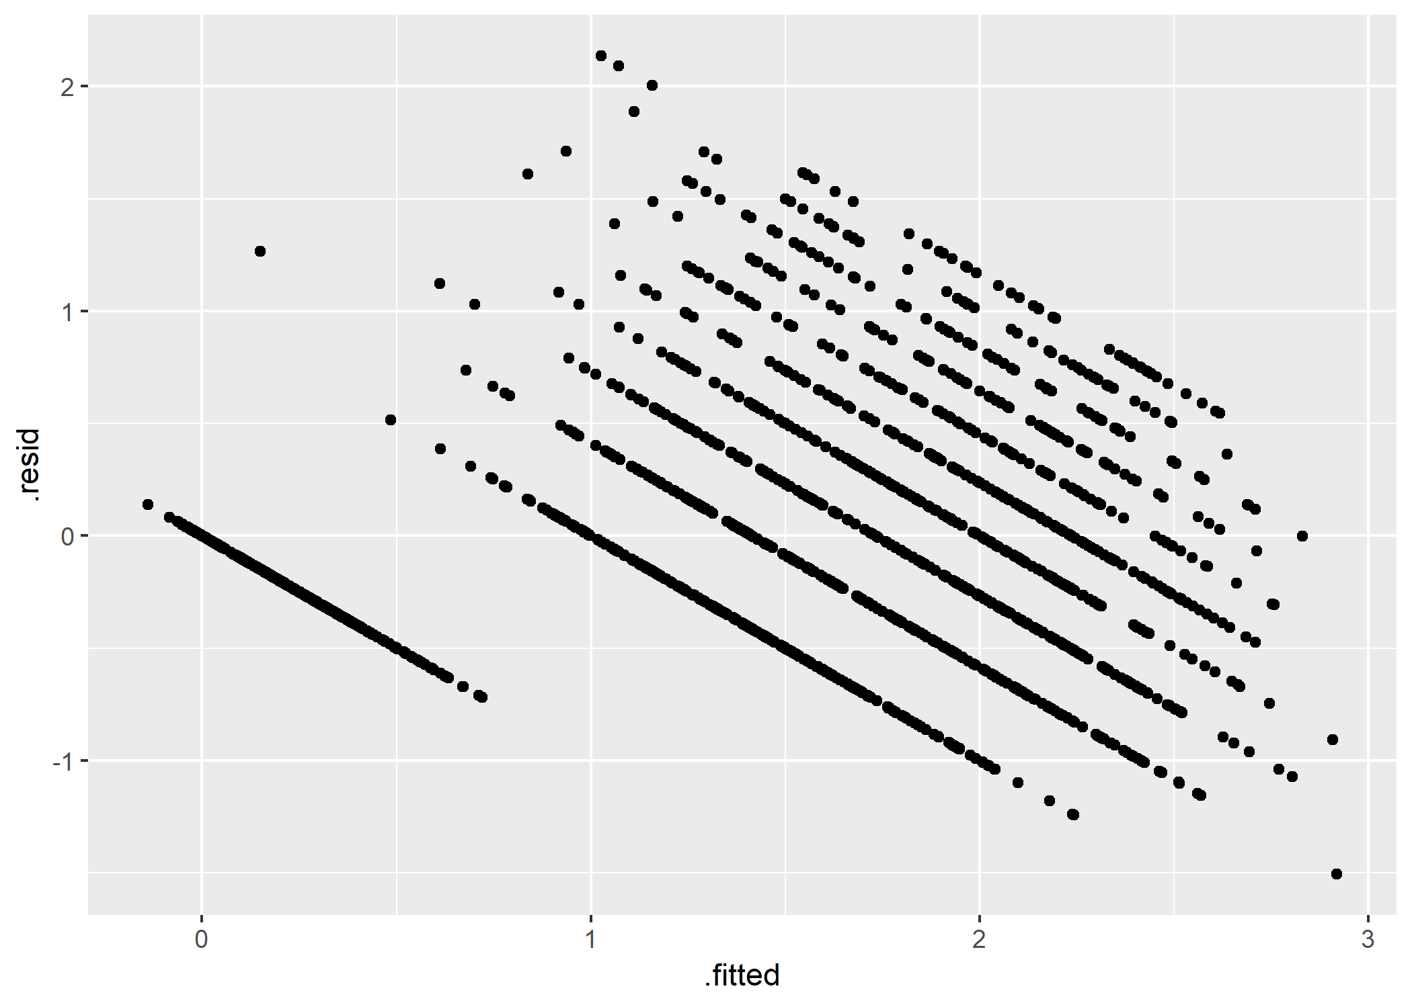Figure 3. Residuals Plot for Multiple Regression Model Using CRECsqrt

The data was not suitable to directly evaluate the hypothesis that older patents become less relevant over time and thus the amount of knowledge transferred from those patents diminishes and becomes a non-factor at some point. However, in the logistic regression analyses the coefficient of the BCKGTLAG variable indicated that higher backward citation lags were associated with lower probabilities and odds of a patent receiving more than the median number of citations from other patents and lower probabilities and odds of receiving at least a given number of citations from other patents. This could mean that patents with high average backward citation lags contain older, less relevant information. Thus, they are likely to be less relevant to current R&D efforts. This seems consistent with the hypothesis. Basic analysis of the source data conducted by Hall, Jaffe, & Trajtenberg (2001) provides some additional insight. Their analysis indicated that on average about 50 percent of a patent’s citations are made to patents that were allowed up to 10 years prior and 75 percent are made to patents that were allowed up to 20 years prior. This suggests that the knowledge contained in a patent becomes obsolete after a given period of time, which is consistent with the concept of obsolescence and the half-life of knowledge attributed to Machlup (1962).

**Discussion**

**Policy Implications**

This study provides information that helps both industry professionals and policymakers better understand the drivers of desirable technology transfer outcomes. It also identifies possible factors that policymakers may want to consider when formulating public policy regarding federal R&D funding and technology transfer.

The study provides support for the notion that the benefits of R&D extend beyond financially-based outcomes and that non-financially-based measures such as knowledge transfer should be considered when evaluating the payoff from federally-funded R&D activities. This may lead policymakers to significantly modify their conceptions of technology transfer and the goals of R&D and technology transfer policies.

The study provides further evidence that measuring knowledge transfer as a benefit of R&D is feasible. This may cause technology transfer professionals and policymakers to modify the metrics used to measure the outcomes and benefits of federally-funded R&D activities.

The results of the study suggest that the generality of knowledge derived from R&D is strongly associated with the odds of the knowledge being transferred and the extent to which the knowledge is transferred. Moreover, the level of originality of knowledge derived from R&D is negatively associated with the odds of the knowledge being transferred and the extent to which the knowledge is transferred. This could have implications for which specific R&D efforts are funded and pursued by researchers and policymakers.

**Limitations and Future Analysis**

This study presents several opportunities for future research. Since this analysis was focused on U.S. patent data for a five-year period from 1990 to 1995, findings based on the data may not be relevant to time frames before or after this period. Moreover, it included patents from all sources. Repeating the analysis with data covering a more recent period, data that isolates patents with lineages that trace back to federally-funded research, and data from other contexts would be useful in evaluating and establishing the generalizability of the results.

The analysis reveals several factors that seem strongly associated with the transfer of knowledge associated with or embedded within a technology. This raises the question of whether these same factors exhibit the same association with other traditional measures of technology transfer such as executed licenses and sponsored research agreements.

There is a truncation effect in the data (Hall, Jaffe & Trajtenberg, 2001). Patents issued in the earliest part of the study period have the potential of receiving citations from other patents over a longer period than patents issued in the latter part of the study period. Examining a subset of data buffered by a longer period on the backside of study period might help to minimize truncation effects. Also, developing new methods for dealing with truncation effects in the data would also be beneficial for analyzing similar kinds of data.

The measures of originality and generality are highly dependent on the specification of classifications, which is somewhat arbitrary and subjective by nature (Hall, Jaffe & Trajtenberg, 2001). Developing less arbitrary, more objective measures of originality and generality would likely improve the analysis and eliminate potential bias in the data and results.

Finally, an interesting and somewhat surprising result of the study was the lack of a strong association that the number of claims made by a patent (i.e., CLAIMS variable) had with the number of citations received by the patent. Claims define what a patent is asserting to be new and novel. As such, one might expect it to be more strongly associated with the number of citations a patent receives from other patents. However, the study results suggested that the number of claims was among the least influential of the factors considered. In current U.S. patent regulations, patents can contain two types of claims – independent and dependent. Independent claims stand alone and do not refer to any other claim. Dependent claims refer to at least one other claim, which can be either independent or dependent (USPTO, 2018). Additionally, patent claims can be broad or narrow. The data did not capture these distinctions. Developing methods to capture and quantify these distinctions may also improve the analysis.

**Conclusion**

This study explored a broader conceptualization of technology transfer that included the transfer of knowledge derived from R&D activities. Traditional approaches to studying technology transfer have tended to focus only on the transfer of technology assets to the private sector through financially-based exchanges as the primary benefit of R&D endeavors. It was argued that technology transfer need not involve financially-based exchanges and that the transfer of the knowledge associated with or embedded within the technology is also an important and desirable outcome that is often forgotten or ignored. Several types of regression analyses were conducted using U.S. patent data to understand and explain this aspect of technology transfer and demonstrate the feasibility of using non-financially-based metrics to assess the benefits of R&D activity. The study results indicated that the generality of a patent, which represents the breadth of influence of a patent across fields, had very strong positive association with the probability and degree to which the knowledge embodied in the patent is transferred as measured by the number of citations a patent receives from other patents. The originality of a patent, which one can think of as a measure of the degree to which the research discovery represented by the patent is novel and independent of anything previous, had a moderate negative association with the probability and degree to which the knowledge embodied in the patent is transferred. These results have implications for how the benefits of R&D are defined and measured, which could influence public policy regarding federal R&D funding and technology transfer.

References

Bush, V. (1945). *Science, the endless frontier*. A report to the President: Washington, U.S. Government printing office, 1945.

Carlsson, B. & Fridh, A.C. (2002). Technology transfer in United States universities. *Journal of Evolutionary Economics, 12*(1/2), 199. doi:10.1007/s00191-002-0105-0

Congressional Budget Office [CBO]. (2018). Historical Budget Data [Data file]. *The Budget and Economic Outlook: 2018 to 2028*. Retrieved from https://www.cbo.gov/about/products/budget-economic-data#2

*Daily Compilation of Presidential Documents*. (2011, October 28). Retrieved from https://www.govinfo.gov/app/collection/CPD/

Hall, B. H., Jaffe, A. B. and Trajtenberg, M. (2001a). "The NBER Patent Citation Data File: Lessons, Insights and Methodological Tools." *NBER Working Paper 8498*. Retrieved from http://www.nber.org/patents/

Hall, B. H., Jaffe, A. B. and Trajtenberg, M. (2001b). Patent data, including constructed variables [data file]. Retrieved September 11, 2018, from http://www.nber.org/patents/

Johnson, S. (2011). *Where good ideas come from: The natural history of innovation*. New York, NY: Penguin.

Machlup, F. (1962). *The production and distribution of knowledge in the United States*. Princeton, NJ: Princeton University Press.

Office of Management and Budget [OMB]. (2002). *The President's Management Agenda*. Retrieved from http://www.dtic.mil/dtic/tr/fulltext/u2/a394421.pdf

Office of Management and Budget [OMB]. (2018). *The President's Management Agenda*. Retrieved from https://www.whitehouse.gov/wp-content/uploads/2018/03/Presidents-Management-Agenda.pdf

Peduzzi, P., Concato, J., Kemper, E., Holford, T. R., & Feinstein, A. R. (1996). A simulation study of the number of events per variable in logistic regression analysis. *Journal of clinical epidemiology*, *49*(12), 1373-1379. Retrieved from http://lib.slu.edu

Sileshi, G. W. (2015). The relative standard error as an easy index for checking the reliability of regression coefficients [Discussion paper]. Retrieved from https://www.researchgate.net/profile/Gudeta_Sileshi2/publication/281371440_The_relative_standard_error_as_an_easy_index_for_checking_the_reliability_of_regression_coefficients/links/55e415b608ae2fac472143ea/The-relative-standard-error-as-an-easy-index-for-checking-the-reliability-of-regression-coefficients.pdf

Solow, R. (1957). Technical Change and the Aggregate Production Function. *The Review of Economics and Statistics,* *39*(3), 312-320. doi:10.2307/1926047

United Nations. (2017). *GDP and its breakdown at current prices in U.S. dollars* [Data file]. Retrieved June 27, 2018, from https://unstats.un.org/unsd/snaama/dnllist.asp

U.S. Department of the Treasury. (2018a). Monthly Statement of the Public Debt of the United States, October 31, 2018. Retrieved from https://www.treasurydirect.gov/govt/reports/pd/mspd/2018/2018_oct.htm

U.S. Department of the Treasury. (2018b). Monthly Treasury Statement: Receipts and Outlays of the United States Government, For Fiscal Year 2019 Through October 31, 2018, and Other Periods. Retrieved from https://www.fiscal.treasury.gov/reports-statements/mts/previous.html

U.S. Patent and Trademark Office [USPTO], U.S. Department of Commerce. (2018). Section 608.01(i) Claims. In *Manual of Patent Examining Procedure* (9th Edition). Retrieved from https://www.uspto.gov/web/offices/pac/mpep/s608.html#d0e44872