List of Figures

Figure 1. Federal Government Expenditures for Fiscal Year 2018

Figure 2. Residuals Plot for Multiple Regression Model Using CRECEIVE

Figure 3. Residuals Plot for Multiple Regression Model Using CRECsqrt

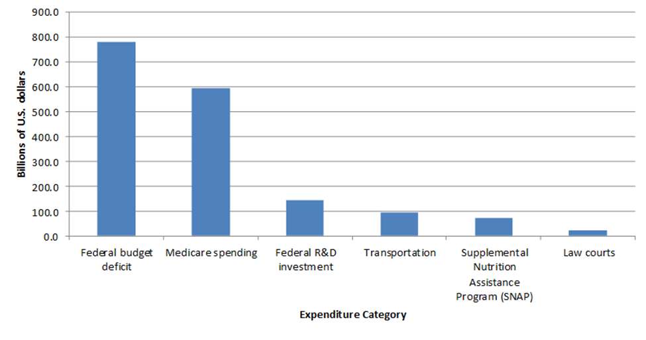Figure 1. Federal Government Expenditures for Fiscal Year 2018

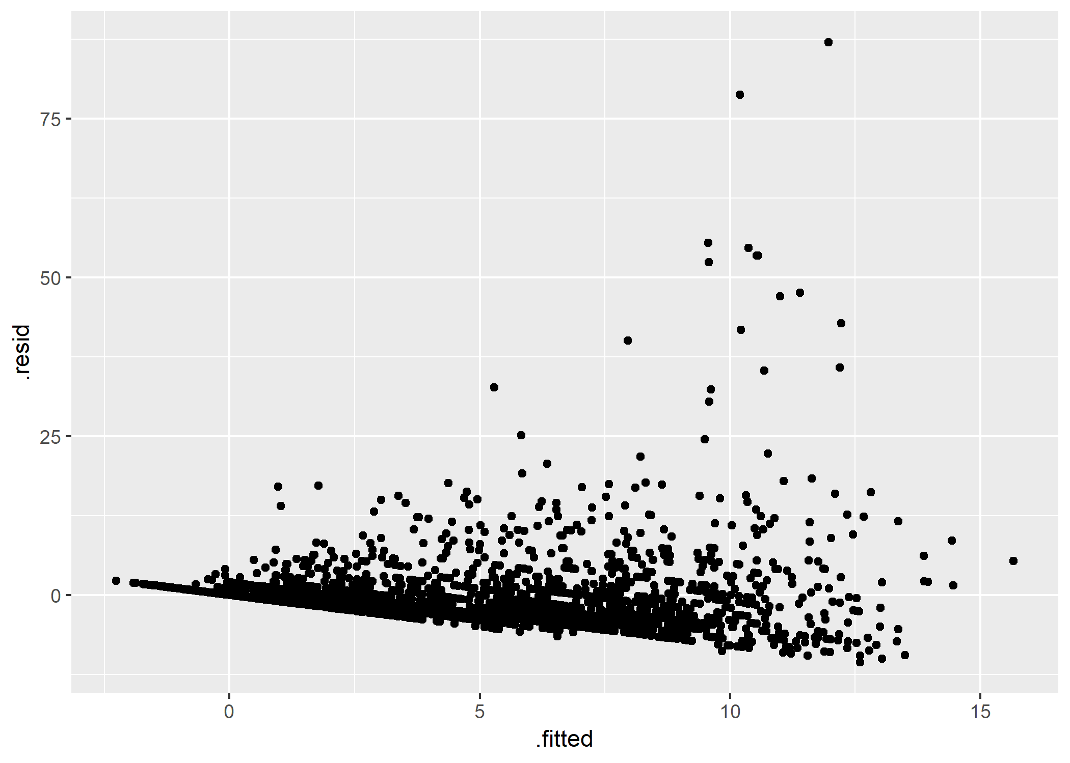

Figure 2. Residuals Plot for Multiple Regression Model Using CRECEIVE

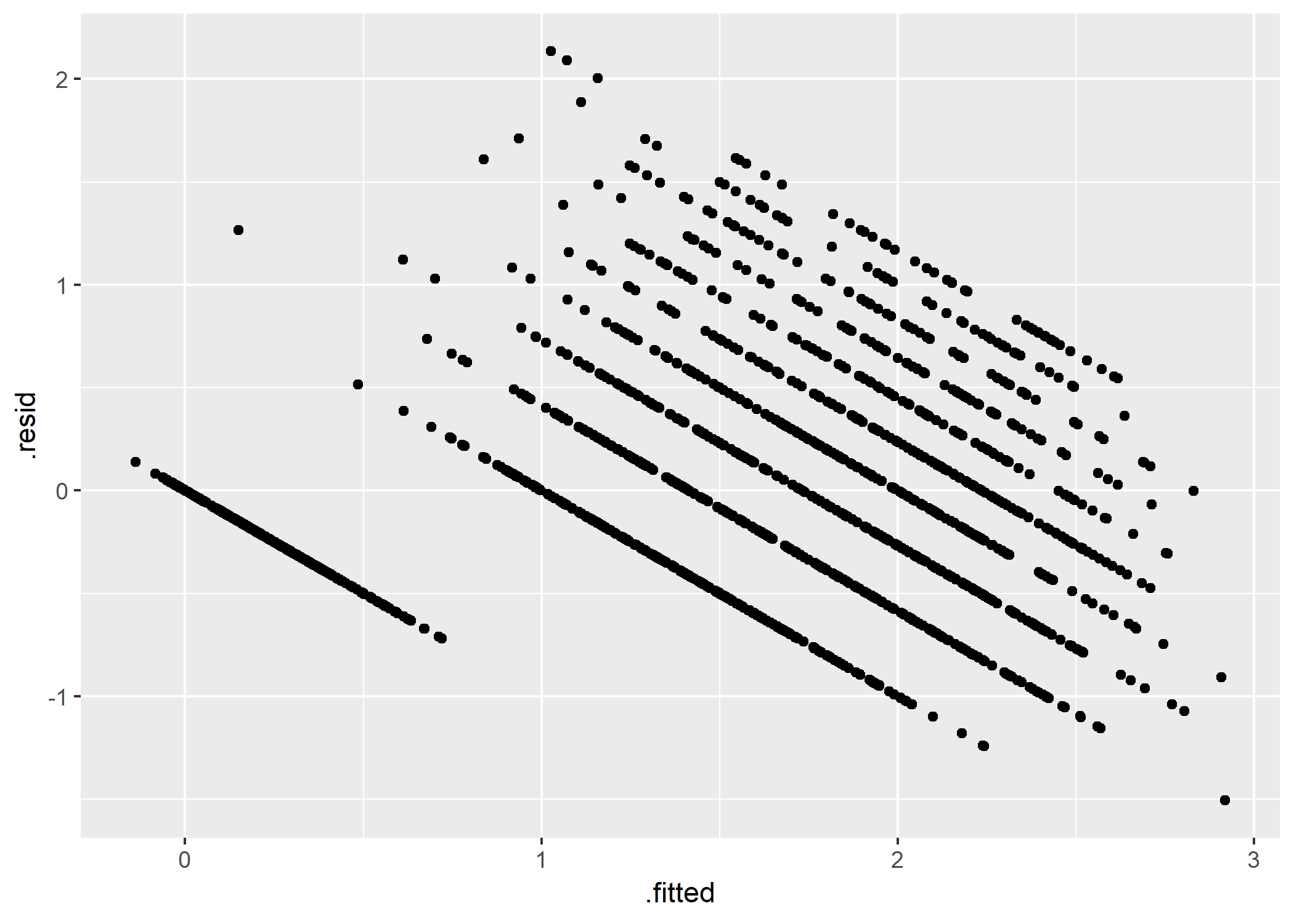Figure 3. Residuals Plot for Multiple Regression Model Using CRECsqrt