Appendix B. R Notebook and Output

**R Notebook: Improving Construct Validity in Studies of Technology Transfer**

Malcolm S. Townes

(July 25, 2019)

**Introduction**

This is an R Notebook for an investigation that explores possibilities for improving construct validity in studies of technology transfer.

**Project Set Up**

The following code chunk enables the R Notebook to integrate seamlessly with the project organization format. This is normally included in the R Notebook to simplify file calls and enable file portability but it has been causing an error. To work around this problem, I’ve embedded the here() function where I enter a file path when necessary.

knitr**::**opts_knit**$set**(root.dir = here**::here**())

**Load Dependencies**

The following code chunk loads package dependencies required to perform the necessary tasks. Basic tasks include importing, reading, wrangling, and cleaning data; selecting a subset of the data; checking for unique observations; analyzing missing data; and performing various types of regression analyses.

**library**(tidyverse) *# loads the basic R packages*  
**library**(here) *# enables file portability*  
**library**(readr) *# functions for reading data*  
**library**(dplyr) *# functions for data wrangling*  
**library**(janitor) *# functions for data cleaning*  
**library**(naniar) *# functions for analyzing missing data*  
**library**(expss) *# functions for calculating on values*  
**library**(ggplot2) *# functions for data visualizations*  
**library**(boot) *# functions for regression analysis*  
**library**(ordinal) *# functions for regression models for ordinal data*  
**library**(MASS) *# functions for ordered logistic or probit regression*  
**library**(broom) *# functions for tidying ordinal logistic regression models*  
**library**(gvlma) *# functions for global validation of linear model assumptions*  
**library**(lmtest) *# functions for testing linear regression models*  
**library**(leaps) *# functions for regression subset selection*  
**library**(car) *# companion to applied regression*  
**library**(aod) *# functions to analyze overdispersed data counts and proportions*  
**library**(pscl) *# contains function for pseudo R2 measures for logistic regression*  
**library**(ResourceSelection) *# contains function for Hosmer-Lemeshow goodness of fit test*

**Load Raw Data**

The following code chunk imports the raw data from the txt file for the NBER data set for the period 1963 to 1999.

DataRaw <- **read.table**(**here**("DataRaw","NBERpatents1963to1999/apat63_99.txt"),   
 sep = ",", header = TRUE, fill = TRUE, dec = ".")

**Subset Data**

The following code chunk creates a subset of the data for the period 1990 through 1995.

DataRaw **%>%** *# subset data*  
 **filter**(GYEAR**>=**1990) **%>%**  
 **filter**(GYEAR**<=**1995) -> DataSubset90to95  
DataSubset90to95 <- **as_tibble**(DataSubset90to95) *# convert data frame to tibble*

**Extract Sample Data**

The following code chunk takes a sample of 2,000 cases from the data subset for the period 1990 through 1995.

**set.seed**(1972)  
Sample90to95 <- **sample**(1**:nrow**(DataSubset90to95), size = 2000,   
 replace = TRUE, prob = NULL)  
Sample90to95 <- DataSubset90to95[Sample90to95,]  
Sample90to95 <- **as_tibble**(Sample90to95)

**Inspect Self-Citation Variables**

**print**(**count_if**(**gt**(0),Sample90to95**$**SELFCTUB))

## [1] 566

**print**(**count_if**(**gt**(0),Sample90to95**$**SELFCTLB))

## [1] 566

**print**(**count_if**(**gt**(0),Sample90to95**$**SECDUPBD))

## [1] 467

**print**(**count_if**(**gt**(0),Sample90to95**$**SECDLWBD))

## [1] 467

**Clean Data 01**

The following code chunk reorganizes the variables and eliminates variables not used in the analysis.

Sample90to95 **%>%**  
 dplyr**::select**(PATENT, GYEAR, CRECEIVE, CAT, CLAIMS, CMADE, GENERAL,   
 ORIGINAL, FWDAPLAG, BCKGTLAG) -> Sample90to95A   
*# Another package also has a `select()` function*

**Inspect Sample Data**

The following code chunk evaluates the data sample to determine if additional data cleaning is necessary. It first checks for missing data for each variable. It then checks for missing data for each variable in each case. Then it checks for duplicate cases with the PATENT variable to determine if that variable can be used as a unique identifier for each case. Finally, it checks for duplicate cases across all variables to ensure that each case is unique.

**miss_var_summary**(Sample90to95A, order = TRUE)

## # A tibble: 10 x 3  
## variable n_miss pct_miss  
## <chr> <int> <dbl>  
## 1 GENERAL 327 16.4  
## 2 FWDAPLAG 327 16.4  
## 3 ORIGINAL 48 2.4  
## 4 BCKGTLAG 34 1.7  
## 5 PATENT 0 0   
## 6 GYEAR 0 0   
## 7 CRECEIVE 0 0   
## 8 CAT 0 0   
## 9 CLAIMS 0 0   
## 10 CMADE 0 0

**miss_case_summary**(Sample90to95A, order = TRUE)

## # A tibble: 2,000 x 3  
## case n_miss pct_miss  
## <int> <int> <dbl>  
## 1 346 4 40  
## 2 516 4 40  
## 3 590 4 40  
## 4 1176 4 40  
## 5 1224 4 40  
## 6 1470 4 40  
## 7 1664 4 40  
## 8 1792 4 40  
## 9 1111 3 30  
## 10 1337 3 30  
## # ... with 1,990 more rows

**get_dupes**(Sample90to95A, PATENT)

## # A tibble: 4 x 11  
## PATENT dupe_count GYEAR CRECEIVE CAT CLAIMS CMADE GENERAL ORIGINAL  
## <int> <int> <int> <int> <int> <int> <int> <dbl> <dbl>  
## 1 4.99e6 2 1991 0 1 15 9 NA 0.370  
## 2 4.99e6 2 1991 0 1 15 9 NA 0.370  
## 3 5.30e6 2 1994 0 1 2 6 NA 0.278  
## 4 5.30e6 2 1994 0 1 2 6 NA 0.278  
## # ... with 2 more variables: FWDAPLAG <dbl>, BCKGTLAG <dbl>

**get_dupes**(Sample90to95A)

## # A tibble: 4 x 11  
## PATENT GYEAR CRECEIVE CAT CLAIMS CMADE GENERAL ORIGINAL FWDAPLAG  
## <int> <int> <int> <int> <int> <int> <dbl> <dbl> <dbl>  
## 1 4.99e6 1991 0 1 15 9 NA 0.370 NA  
## 2 4.99e6 1991 0 1 15 9 NA 0.370 NA  
## 3 5.30e6 1994 0 1 2 6 NA 0.278 NA  
## 4 5.30e6 1994 0 1 2 6 NA 0.278 NA  
## # ... with 2 more variables: BCKGTLAG <dbl>, dupe_count <int>

**Adjust for Missing Data**

The following code chunk modifies cases with missing data, removes duplicate cases, and then evaluates the data sample to determine if additional cleaning is necessary. It first assigns a value of 0 to instances of NA in the data for the GENERAL variable. It then assigns a value of 1 to instances of NA in the data for the ORIGINAL variable. For the FWDAPLAG and BCKGTLAG variables it assigns the maximum value in the data for each variable to instances of missing data. It then removes duplicate cases. The code chunk then checks for missing data for each variable in each case and missing data for each case. Then it checks for duplicate cases with the PATENT variable to determine if that variable can be used as a unique identifier for each case. Finally, it checks for duplicate observations across all variables to ensure that each case is unique.

Sample90to95B <- Sample90to95A  
Sample90to95B**$**GENERAL[**is.na**(x=Sample90to95B**$**GENERAL)] <- 0  
Sample90to95B**$**ORIGINAL[**is.na**(x=Sample90to95B**$**ORIGINAL)] <- 1  
Sample90to95B**$**FWDAPLAG[**is.na**(x=Sample90to95B**$**FWDAPLAG)] <- **max**(Sample90to95B**$**FWDAPLAG, na.rm = TRUE)  
Sample90to95B**$**BCKGTLAG[**is.na**(x=Sample90to95B**$**BCKGTLAG)] <- **max**(Sample90to95B**$**BCKGTLAG, na.rm = TRUE)  
  
Sample90to95B **%>%**  
 **distinct**() -> Sample90to95B  
  
**miss_var_summary**(Sample90to95B, order = TRUE)

## # A tibble: 10 x 3  
## variable n_miss pct_miss  
## <chr> <int> <dbl>  
## 1 PATENT 0 0  
## 2 GYEAR 0 0  
## 3 CRECEIVE 0 0  
## 4 CAT 0 0  
## 5 CLAIMS 0 0  
## 6 CMADE 0 0  
## 7 GENERAL 0 0  
## 8 ORIGINAL 0 0  
## 9 FWDAPLAG 0 0  
## 10 BCKGTLAG 0 0

**miss_case_summary**(Sample90to95B, order = TRUE)

## # A tibble: 1,998 x 3  
## case n_miss pct_miss  
## <int> <int> <dbl>  
## 1 1 0 0  
## 2 2 0 0  
## 3 3 0 0  
## 4 4 0 0  
## 5 5 0 0  
## 6 6 0 0  
## 7 7 0 0  
## 8 8 0 0  
## 9 9 0 0  
## 10 10 0 0  
## # ... with 1,988 more rows

**get_dupes**(Sample90to95B, PATENT)

## # A tibble: 0 x 11  
## # ... with 11 variables: PATENT <int>, dupe_count <int>, GYEAR <int>,  
## # CRECEIVE <int>, CAT <int>, CLAIMS <int>, CMADE <int>, GENERAL <dbl>,  
## # ORIGINAL <dbl>, FWDAPLAG <dbl>, BCKGTLAG <dbl>

**get_dupes**(Sample90to95B)

## # A tibble: 0 x 11  
## # ... with 11 variables: PATENT <int>, GYEAR <int>, CRECEIVE <int>,  
## # CAT <int>, CLAIMS <int>, CMADE <int>, GENERAL <dbl>, ORIGINAL <dbl>,  
## # FWDAPLAG <dbl>, BCKGTLAG <dbl>, dupe_count <int>

**Calculate Measures of Central Tendency**

The following code chunk calculates measures of central tendency in the sample data for each of the variables.

**summary**(Sample90to95B)

## PATENT GYEAR CRECEIVE CAT   
## Min. :4890423 Min. :1990 Min. : 0.000 Min. :1.000   
## 1st Qu.:5034806 1st Qu.:1991 1st Qu.: 1.000 1st Qu.:2.000   
## Median :5185746 Median :1993 Median : 3.000 Median :4.000   
## Mean :5184975 Mean :1993 Mean : 4.952 Mean :3.725   
## 3rd Qu.:5336132 3rd Qu.:1994 3rd Qu.: 6.000 3rd Qu.:5.000   
## Max. :5479597 Max. :1995 Max. :99.000 Max. :6.000   
## CLAIMS CMADE GENERAL ORIGINAL   
## Min. : 1.00 Min. : 0.000 Min. :0.0000 Min. :0.0000   
## 1st Qu.: 6.00 1st Qu.: 4.000 1st Qu.:0.0000 1st Qu.:0.0000   
## Median : 10.00 Median : 7.000 Median :0.0907 Median :0.4444   
## Mean : 12.69 Mean : 8.398 Mean :0.2578 Mean :0.3828   
## 3rd Qu.: 17.00 3rd Qu.: 11.000 3rd Qu.:0.5000 3rd Qu.:0.6250   
## Max. :101.00 Max. :158.000 Max. :0.8800 Max. :1.0000   
## FWDAPLAG BCKGTLAG   
## Min. : 0.000 Min. : 0.00   
## 1st Qu.: 3.000 1st Qu.: 6.50   
## Median : 4.000 Median :10.75   
## Mean : 4.959 Mean :15.13   
## 3rd Qu.: 6.000 3rd Qu.:18.50   
## Max. :10.500 Max. :85.14

**Prepare Histograms**

The following code chunk displays histograms for the variables to enable visual inspection of the data to evaluate whether or not they fit normal distributions. The code chunk generates separate png files for each histogram, which are saved in the Results folder.

**ggplot**() **+**  
 **geom_histogram**(Sample90to95B, mapping = **aes**(GYEAR))

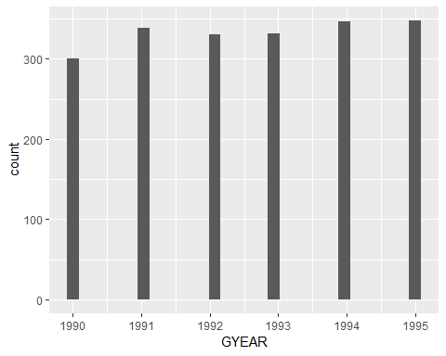

**ggsave**(**here**("results", "histogramGYEAR.png"), dpi = 300)  
**ggsave**(**here**("results", "histogramGYEAR.jpg"), dpi = 300)  
  
**ggplot**() **+**  
 **geom_histogram**(Sample90to95B, mapping = **aes**(CRECEIVE))

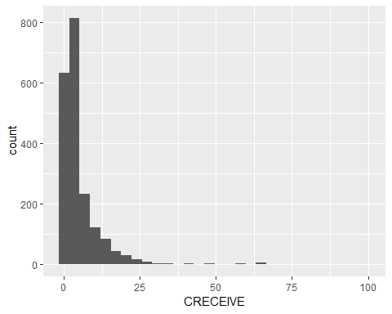

**ggsave**(**here**("Results", "histogramCRECEIVE.png"), dpi = 300)  
**ggsave**(**here**("Results", "histogramCRECEIVE.jpg"), dpi = 300)  
  
**ggplot**() **+**  
 **geom_histogram**(Sample90to95B, mapping = **aes**(CAT))

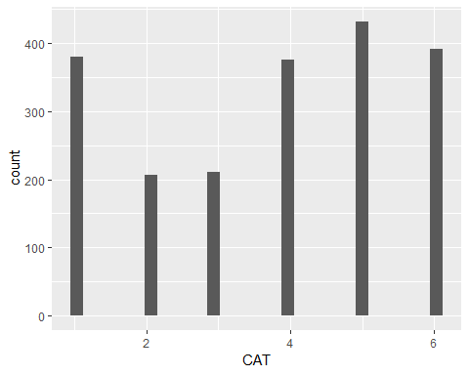

**ggsave**(**here**("Results", "histogramCAT.png"), dpi = 300)  
**ggsave**(**here**("Results", "histogramCAT.jpg"), dpi = 300)  
  
**ggplot**() **+**  
 **geom_histogram**(Sample90to95B, mapping = **aes**(CLAIMS))

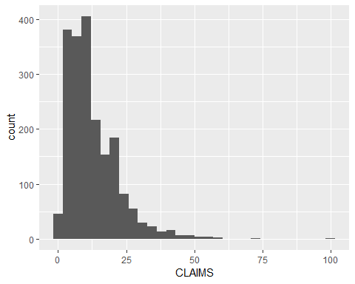

**ggsave**(**here**("Results", "histogramCLAIMS.png"), dpi = 300)  
**ggsave**(**here**("Results", "histogramCLAIMS.jpg"), dpi = 300)  
  
**ggplot**() **+**  
 **geom_histogram**(Sample90to95B, mapping = **aes**(CMADE))

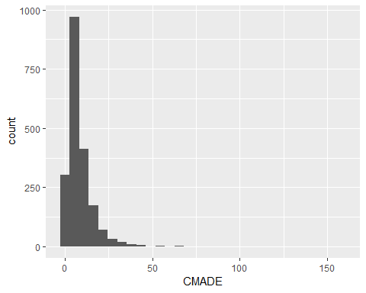

**ggsave**(**here**("Results", "histogramCMADE.png"), dpi = 300)  
**ggsave**(**here**("Results", "histogramCMADE.jpg"), dpi = 300)  
  
**ggplot**() **+**  
 **geom_histogram**(Sample90to95B, mapping = **aes**(GENERAL))

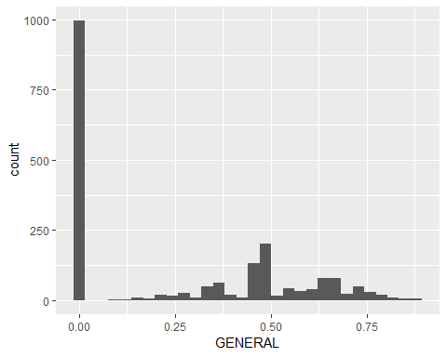

**ggsave**(**here**("Results", "histogramGENERAL.png"), dpi = 300)  
**ggsave**(**here**("Results", "histogramGENERAL.jpg"), dpi = 300)  
  
**ggplot**() **+**  
 **geom_histogram**(Sample90to95B, mapping = **aes**(ORIGINAL))

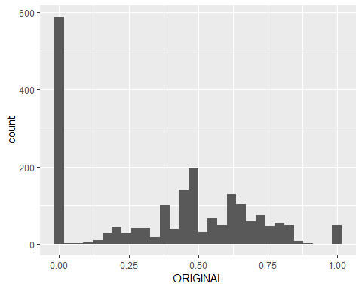

**ggsave**(**here**("Results", "histogramORIGINAL.png"), dpi = 300)  
**ggsave**(**here**("Results", "histogramORIGINAL.jpg"), dpi = 300)  
  
**ggplot**() **+**  
 **geom_histogram**(Sample90to95B, mapping = **aes**(FWDAPLAG))

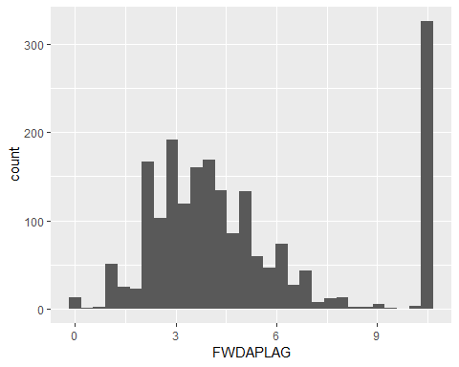

**ggsave**(**here**("Results", "histogramFWDAPLAG.png"), dpi = 300)  
**ggsave**(**here**("Results", "histogramFWDAPLAG.jpg"), dpi = 300)  
  
**ggplot**() **+**  
 **geom_histogram**(Sample90to95B, mapping = **aes**(BCKGTLAG))

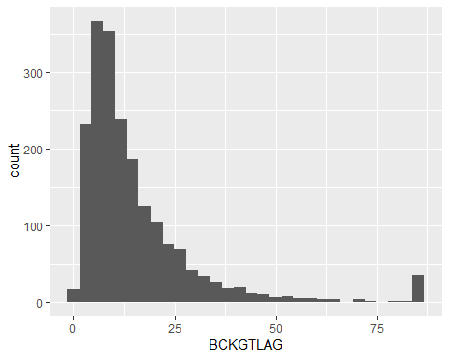

**ggsave**(**here**("Results", "histogramBCKGTLAG.png"), dpi = 300)  
**ggsave**(**here**("Results", "histogramBCKGTLAG.jpg"), dpi = 300)

**Prepare Scatter Plots**

The following code chunk displays scatter plots with CRECEIVE as the dependent variable against each of the the independent variables to visually inspect for linear relationships between the dependent variable and each of the independent variables. The code chunk generates separate png files for each scatter plot, which are saved in the Results folder.

**ggplot**() **+**  
 **geom_point**(Sample90to95B, mapping = **aes**(x = GYEAR, y = CRECEIVE))

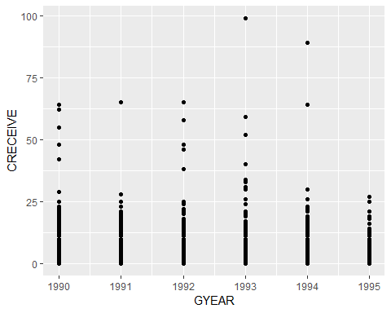

**ggsave**(**here**("results", "scatterCRECEIVEbyGYEAR.png"), dpi = 300)  
**ggsave**(**here**("results", "scatterCRECEIVEbyGYEAR.jpg"), dpi = 300)  
  
**ggplot**() **+**  
 **geom_point**(Sample90to95B, mapping = **aes**(x = CAT, y = CRECEIVE))

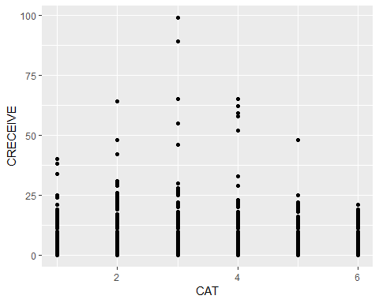

**ggsave**(**here**("results", "scatterCRECEIVEbyCAT.png"), dpi = 300)  
**ggsave**(**here**("results", "scatterCRECEIVEbyCAT.jpg"), dpi = 300)  
  
**ggplot**() **+**  
 **geom_point**(Sample90to95B, mapping = **aes**(x = CLAIMS, y = CRECEIVE))

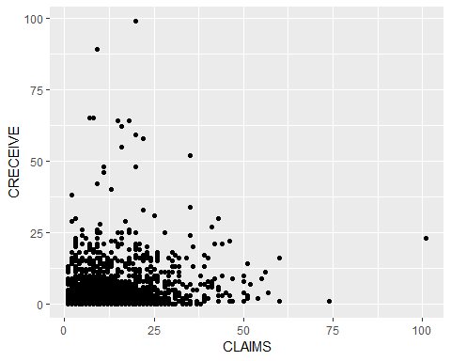

**ggsave**(**here**("results", "scatterCRECEIVEbyCLAIMS.png"), dpi = 300)  
**ggsave**(**here**("results", "scatterCRECEIVEbyCLAIMS.jpg"), dpi = 300)  
  
**ggplot**() **+**  
 **geom_point**(Sample90to95B, mapping = **aes**(x = CMADE, y = CRECEIVE))

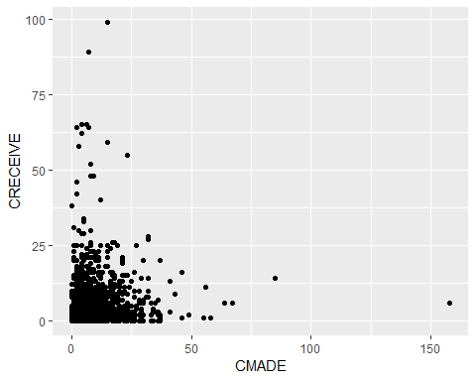

**ggsave**(**here**("results", "scatterCRECEIVEbyCMADE.png"), dpi = 300)  
**ggsave**(**here**("results", "scatterCRECEIVEbyCMADE.jpg"), dpi = 300)  
  
**ggplot**() **+**  
 **geom_point**(Sample90to95B, mapping = **aes**(x = GENERAL, y = CRECEIVE))

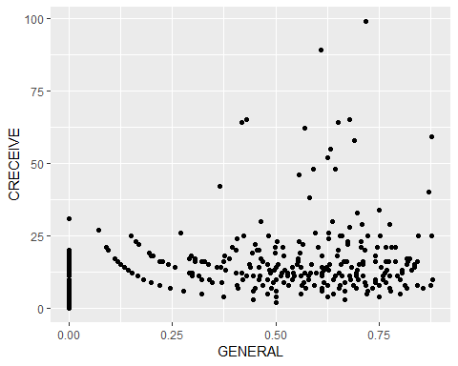

**ggsave**(**here**("results", "scatterCRECEIVEbyGENERAL.png"), dpi = 300)  
**ggsave**(**here**("results", "scatterCRECEIVEbyGENERAL.jpg"), dpi = 300)  
  
**ggplot**() **+**  
 **geom_point**(Sample90to95B, mapping = **aes**(x = ORIGINAL, y = CRECEIVE))

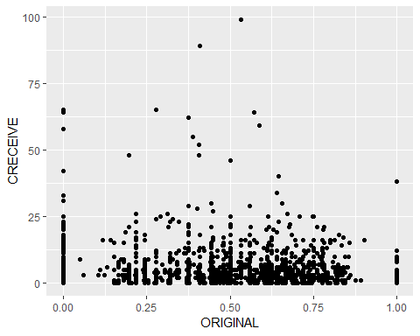

**ggsave**(**here**("results", "scatterCRECEIVEbyORIGINAL.jpg"), dpi = 300)  
**ggsave**(**here**("results", "scatterCRECEIVEbyORIGINAL.jpg"), dpi = 300)  
  
**ggplot**() **+**  
 **geom_point**(Sample90to95B, mapping = **aes**(x = FWDAPLAG, y = CRECEIVE))

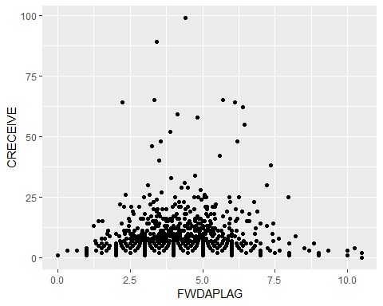

**ggsave**(**here**("results", "scatterCRECEIVEbyFWDAPLAG.png"), dpi = 300)  
**ggsave**(**here**("results", "scatterCRECEIVEbyFWDAPLAG.jpg"), dpi = 300)  
  
**ggplot**() **+**  
 **geom_point**(Sample90to95B, mapping = **aes**(x = BCKGTLAG, y = CRECEIVE))

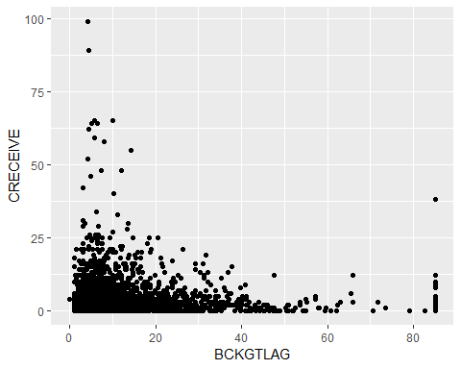

**ggsave**(**here**("results", "scatterCRECEIVEbyBCKGTLAG.png"), dpi = 300)  
**ggsave**(**here**("results", "scatterCRECEIVEbyBCKGTLAG.jpg"), dpi = 300)

**Prepare Q-Q Plots**

The following code chunk displays Quantile-Quantile (Q-Q) plots to check for normal distribution in the data sample for each variable. The code chunk generates separate png files for each Q-Q plot, which are saved in the Results folder.

**ggplot**(Sample90to95B)**+**  
 **aes**(sample = GYEAR)**+**  
 **stat_qq**()**+**  
 **stat_qq_line**()**+**  
 **ggtitle**("GYEAR Q-Q Plot")

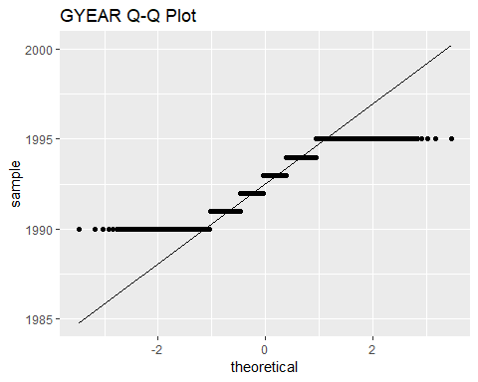

**ggsave**(**here**("Results", "QQplotGYEAR.png"))  
**ggsave**(**here**("Results", "QQplotGYEAR.jpg"))  
  
**ggplot**(Sample90to95B)**+**  
 **aes**(sample = CRECEIVE)**+**  
 **stat_qq**()**+**  
 **stat_qq_line**()**+**  
 **ggtitle**("CRECEIVE Q-Q Plot")

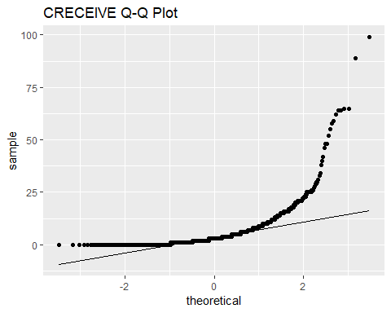

**ggsave**(**here**("Results", "QQplotCRECEIVE.png"))  
**ggsave**(**here**("Results", "QQplotCRECEIVE.jpg"))  
  
**ggplot**(Sample90to95B)**+**  
 **aes**(sample = CLAIMS)**+**  
 **stat_qq**()**+**  
 **stat_qq_line**()**+**  
 **ggtitle**("CLAIMS Q-Q Plot")

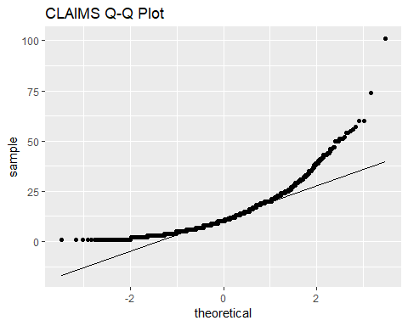

**ggsave**(**here**("Results", "QQplotCLAIMS.png"))  
**ggsave**(**here**("Results", "QQplotCLAIMS.jpg"))  
  
**ggplot**(Sample90to95B)**+**  
 **aes**(sample = CMADE)**+**  
 **stat_qq**()**+**  
 **stat_qq_line**()**+**  
 **ggtitle**("CMADE Q-Q Plot")

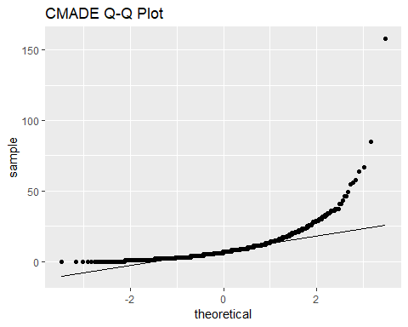

**ggsave**(**here**("Results", "QQplotCMADE.png"))  
**ggsave**(**here**("Results", "QQplotCMADE.jpg"))  
  
**ggplot**(Sample90to95B)**+**  
 **aes**(sample = GENERAL)**+**  
 **stat_qq**()**+**  
 **stat_qq_line**()**+**  
 **ggtitle**("GENERAL Q-Q Plot")

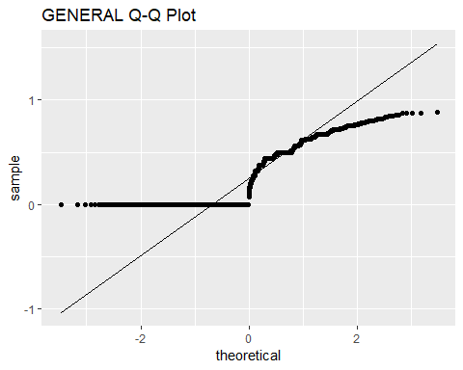

**ggsave**(**here**("Results", "QQplotGENERAL.png"))  
**ggsave**(**here**("Results", "QQplotGENERAL.jpg"))  
  
**ggplot**(Sample90to95B)**+**  
 **aes**(sample = ORIGINAL)**+**  
 **stat_qq**()**+**  
 **stat_qq_line**()**+**  
 **ggtitle**("ORIGINAL Q-Q Plot")

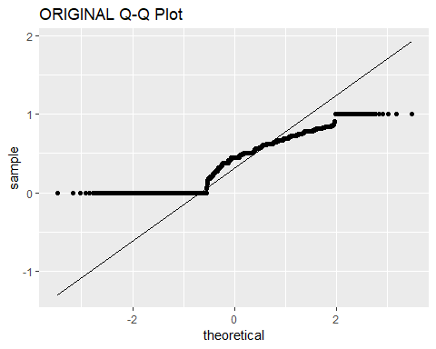

**ggsave**(**here**("Results", "QQplotORIGINAL.png"))  
**ggsave**(**here**("Results", "QQplotORIGINAL.jpg"))  
  
**ggplot**(Sample90to95B)**+**  
 **aes**(sample = FWDAPLAG)**+**  
 **stat_qq**()**+**  
 **stat_qq_line**()**+**  
 **ggtitle**("FWDAPLAG Q-Q Plot")

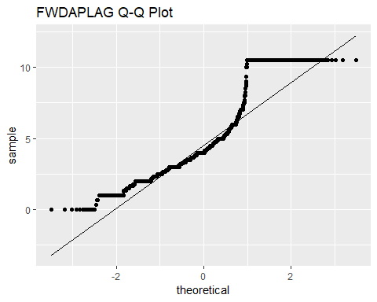

**ggsave**(**here**("Results", "QQplotFWDAPLAG.png"))  
**ggsave**(**here**("Results", "QQplotFWDAPLAG.jpg"))  
  
**ggplot**(Sample90to95B)**+**  
 **aes**(sample = BCKGTLAG)**+**  
 **stat_qq**()**+**  
 **stat_qq_line**()**+**  
 **ggtitle**("BCKGTLAG Q-Q Plot")

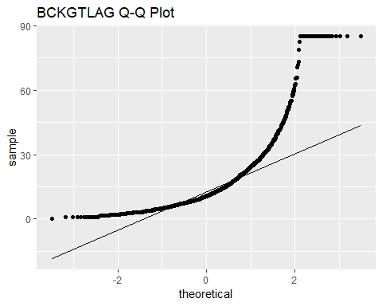

**ggsave**(**here**("Results", "QQplotBCKGTLAG.png"))  
**ggsave**(**here**("Results", "QQplotBCKGTLAG.jpg"))

**Calculate Pairwise Correlation Coefficients**

The following code chunk calculates the pairwise correlation coefficients for all variables in the sample data using the Pearson product-moment correlation function.

Sample90to95corrmatrix <- **cor**(Sample90to95B)  
**print**(Sample90to95corrmatrix)

## PATENT GYEAR CRECEIVE CAT CLAIMS  
## PATENT 1.00000000 0.985635583 -0.159041534 -0.03356222 0.04070183  
## GYEAR 0.98563558 1.000000000 -0.149458127 -0.02684555 0.04029299  
## CRECEIVE -0.15904153 -0.149458127 1.000000000 -0.09560927 0.13170051  
## CAT -0.03356222 -0.026845547 -0.095609270 1.00000000 -0.01724595  
## CLAIMS 0.04070183 0.040292995 0.131700513 -0.01724595 1.00000000  
## CMADE 0.10233427 0.094237930 0.063242195 0.04021272 0.16558795  
## GENERAL -0.12640786 -0.118898816 0.417511656 -0.10545725 0.12005496  
## ORIGINAL 0.08031646 0.080904546 0.001329185 -0.06068721 0.03499034  
## FWDAPLAG -0.11129042 -0.105161070 -0.198067341 0.01490230 -0.08333314  
## BCKGTLAG -0.01126732 -0.007455822 -0.135654022 0.17606285 -0.07141466  
## CMADE GENERAL ORIGINAL FWDAPLAG BCKGTLAG  
## PATENT 0.10233427 -0.12640786 0.080316461 -0.111290419 -0.011267319  
## GYEAR 0.09423793 -0.11889882 0.080904546 -0.105161070 -0.007455822  
## CRECEIVE 0.06324219 0.41751166 0.001329185 -0.198067341 -0.135654022  
## CAT 0.04021272 -0.10545725 -0.060687208 0.014902300 0.176062850  
## CLAIMS 0.16558795 0.12005496 0.034990339 -0.083333140 -0.071414662  
## CMADE 1.00000000 0.08818194 0.253063640 -0.073355840 0.013103136  
## GENERAL 0.08818194 1.00000000 0.214772596 -0.296932164 -0.106377914  
## ORIGINAL 0.25306364 0.21477260 1.000000000 -0.009235051 0.235975356  
## FWDAPLAG -0.07335584 -0.29693216 -0.009235051 1.000000000 0.130915221  
## BCKGTLAG 0.01310314 -0.10637791 0.235975356 0.130915221 1.000000000

**Modify Data 01**

The following code chunk creates additional variables needed for the binary logistic regression, ordinal logistic regression, and multiple regression analyses. It first creates a new variable called CRECbinary that converts the CRECEIVE variable into a dichotomous variable. It then creates a series of dummy variables for the nominal CAT variable to use in multiple regression analysis.

Sample90to95B **%>%**  
 **mutate**(CRECbinary = **ifelse**(CRECEIVE **==** 0, 0, 1)) **%>%**  
 **mutate**(CAT01 = **ifelse**(CAT **==** 1, 1, 0)) **%>%**  
 **mutate**(CAT02 = **ifelse**(CAT **==** 2, 1, 0)) **%>%**  
 **mutate**(CAT03 = **ifelse**(CAT **==** 3, 1, 0)) **%>%**  
 **mutate**(CAT04 = **ifelse**(CAT **==** 4, 1, 0)) **%>%**  
 **mutate**(CAT05 = **ifelse**(CAT **==** 5, 1, 0)) **%>%**  
 **mutate**(CAT06 = **ifelse**(CAT **==** 6, 1, 0)) -> Sample90to95C

**Count Observations 01**

The following code chunk calculates the number of observations for each outcome of each nominal and ordinal variable to determine if the sample size is large enough for logistic regression analysis, which requires at least 10 observations for the least frequent outcome for each variable.

Sample90to95C **%>%**  
 **group_by**(GYEAR) **%>%**  
 **summarize**(**n**())

## # A tibble: 6 x 2  
## GYEAR `n()`  
## <int> <int>  
## 1 1990 301  
## 2 1991 339  
## 3 1992 331  
## 4 1993 332  
## 5 1994 347  
## 6 1995 348

Sample90to95C **%>%**  
 **group_by**(CRECEIVE) **%>%**  
 **summarize**(**n**())

## # A tibble: 48 x 2  
## CRECEIVE `n()`  
## <int> <int>  
## 1 0 325  
## 2 1 307  
## 3 2 265  
## 4 3 234  
## 5 4 172  
## 6 5 142  
## 7 6 98  
## 8 7 73  
## 9 8 60  
## 10 9 44  
## # ... with 38 more rows

Sample90to95C **%>%**  
 **group_by**(CRECbinary) **%>%**  
 **summarize**(**n**())

## # A tibble: 2 x 2  
## CRECbinary `n()`  
## <dbl> <int>  
## 1 0 325  
## 2 1 1673

Sample90to95C **%>%**   
 **group_by**(CAT) **%>%**  
 **summarize**(**n**())

## # A tibble: 6 x 2  
## CAT `n()`  
## <int> <int>  
## 1 1 380  
## 2 2 207  
## 3 3 211  
## 4 4 376  
## 5 5 432  
## 6 6 392

Sample90to95C **%>%**   
 **group_by**(CAT01) **%>%**  
 **summarize**(**n**())

## # A tibble: 2 x 2  
## CAT01 `n()`  
## <dbl> <int>  
## 1 0 1618  
## 2 1 380

Sample90to95C **%>%**   
 **group_by**(CAT02) **%>%**  
 **summarize**(**n**())

## # A tibble: 2 x 2  
## CAT02 `n()`  
## <dbl> <int>  
## 1 0 1791  
## 2 1 207

Sample90to95C **%>%**   
 **group_by**(CAT03) **%>%**  
 **summarize**(**n**())

## # A tibble: 2 x 2  
## CAT03 `n()`  
## <dbl> <int>  
## 1 0 1787  
## 2 1 211

Sample90to95C **%>%**   
 **group_by**(CAT04) **%>%**  
 **summarize**(**n**())

## # A tibble: 2 x 2  
## CAT04 `n()`  
## <dbl> <int>  
## 1 0 1622  
## 2 1 376

Sample90to95C **%>%**   
 **group_by**(CAT05) **%>%**  
 **summarize**(**n**())

## # A tibble: 2 x 2  
## CAT05 `n()`  
## <dbl> <int>  
## 1 0 1566  
## 2 1 432

Sample90to95C **%>%**   
 **group_by**(CAT06) **%>%**  
 **summarize**(**n**())

## # A tibble: 2 x 2  
## CAT06 `n()`  
## <dbl> <int>  
## 1 0 1606  
## 2 1 392

Sample90to95C **%>%**   
 **group_by**(CLAIMS) **%>%**  
 **summarize**(**n**())

## # A tibble: 57 x 2  
## CLAIMS `n()`  
## <int> <int>  
## 1 1 46  
## 2 2 55  
## 3 3 101  
## 4 4 107  
## 5 5 117  
## 6 6 123  
## 7 7 112  
## 8 8 133  
## 9 9 113  
## 10 10 107  
## # ... with 47 more rows

Sample90to95C **%>%**   
 **group_by**(CMADE) **%>%**  
 **summarize**(**n**())

## # A tibble: 49 x 2  
## CMADE `n()`  
## <int> <int>  
## 1 0 34  
## 2 1 108  
## 3 2 159  
## 4 3 182  
## 5 4 179  
## 6 5 175  
## 7 6 152  
## 8 7 151  
## 9 8 131  
## 10 9 118  
## # ... with 39 more rows

**Modify Data 02**

The following code chunk groups cases where the outcome level for CRECEIVE is greater than or equal to 15 citations because most outcome levels above 15 citations do not have enough cases individually for logistic regression analysis, which requires at least 10 cases for the least frequent outcome level of each variable. This was also done to simplify the ordinal logistic regression analysis.

Sample90to95C **%>%**   
 **mutate**(CRECordinal = **ifelse** (CRECEIVE**>=**15,15,CRECEIVE)) -> Sample90to95C  
Sample90to95C <- **as_tibble**(Sample90to95C) *# convert data frame to tibble*

**Count Observations 02**

The following code chunk calculates the number of observations for each outcome level of the new CRECordinal variable.

Sample90to95C **%>%**  
 **group_by**(CRECordinal) **%>%**  
 **summarize**(**n**())

## # A tibble: 16 x 2  
## CRECordinal `n()`  
## <dbl> <int>  
## 1 0 325  
## 2 1 307  
## 3 2 265  
## 4 3 234  
## 5 4 172  
## 6 5 142  
## 7 6 98  
## 8 7 73  
## 9 8 60  
## 10 9 44  
## 11 10 43  
## 12 11 33  
## 13 12 26  
## 14 13 18  
## 15 14 19  
## 16 15 139

**Binary Logistic Regression Analysis**

The following code chunk uses the new dichotomous variable CRECbinary as the dependent variable in a binary logistic regression analysis. It then displays the results. It also calculates the odds ratio, various pseudo R-squared measures, confidence intervals for the coefficients, and Hosmer-Lemeshow goodness of fit test.

logitCRECEIVE <- **glm**(CRECbinary **~** GYEAR **+** **as.factor**(CAT) **+** CMADE **+** CLAIMS **+**   
 ORIGINAL **+** GENERAL **+** FWDAPLAG **+** BCKGTLAG,   
 data = Sample90to95C, family = binomial,   
 na.action = na.omit)  
**summary**(logitCRECEIVE)

##   
## Call:  
## glm(formula = CRECbinary ~ GYEAR + as.factor(CAT) + CMADE + CLAIMS +   
## ORIGINAL + GENERAL + FWDAPLAG + BCKGTLAG, family = binomial,   
## data = Sample90to95C, na.action = na.omit)  
##   
## Deviance Residuals:   
## Min 1Q Median 3Q Max   
## -0.3879 0.0000 0.0000 0.0000 2.6810   
##   
## Coefficients:  
## Estimate Std. Error z value Pr(>|z|)  
## (Intercept) 1.862e+01 4.195e+04 0.000 1.000  
## GYEAR 3.122e-01 8.802e-01 0.355 0.723  
## as.factor(CAT)2 5.187e+01 2.259e+05 0.000 1.000  
## as.factor(CAT)3 5.759e+01 3.690e+04 0.002 0.999  
## as.factor(CAT)4 7.629e+01 3.578e+04 0.002 0.998  
## as.factor(CAT)5 1.854e+01 4.344e+04 0.000 1.000  
## as.factor(CAT)6 6.174e+01 3.574e+04 0.002 0.999  
## CMADE -1.979e-02 1.877e-01 -0.105 0.916  
## CLAIMS -2.364e-02 1.741e-01 -0.136 0.892  
## ORIGINAL 2.192e+00 4.565e+00 0.480 0.631  
## GENERAL 7.098e+01 3.623e+04 0.002 0.998  
## FWDAPLAG -6.876e+01 2.461e+03 -0.028 0.978  
## BCKGTLAG 2.785e-03 5.399e-02 0.052 0.959  
##   
## (Dispersion parameter for binomial family taken to be 1)  
##   
## Null deviance: 1774.459 on 1997 degrees of freedom  
## Residual deviance: 9.167 on 1985 degrees of freedom  
## AIC: 35.167  
##   
## Number of Fisher Scoring iterations: 25

*# Raise e to the coefficients*  
**print**(**exp**(**coef**(logitCRECEIVE)))

## (Intercept) GYEAR as.factor(CAT)2 as.factor(CAT)3   
## 1.222174e+08 1.366461e+00 3.365555e+22 1.023373e+25   
## as.factor(CAT)4 as.factor(CAT)5 as.factor(CAT)6 CMADE   
## 1.358901e+33 1.129561e+08 6.530469e+26 9.804027e-01   
## CLAIMS ORIGINAL GENERAL FWDAPLAG   
## 9.766327e-01 8.956214e+00 6.686125e+30 1.375684e-30   
## BCKGTLAG   
## 1.002789e+00

*# Obtain various pseudo R-squared measures*  
**print**(**pR2**(logitCRECEIVE))

## llh llhNull G2 McFadden r2ML   
## -4.5834781 -887.2297285 1765.2925008 0.9948339 0.5866786   
## r2CU   
## 0.9967854

*# Confidence intervals for the coefficients*  
**print**(**exp**(**confint**(logitCRECEIVE, level = 0.95)))

## 2.5 % 97.5 %  
## (Intercept) 0.000000e+00 Inf  
## GYEAR 3.094650e-01 2.273347e+01  
## as.factor(CAT)2 0.000000e+00 Inf  
## as.factor(CAT)3 0.000000e+00 Inf  
## as.factor(CAT)4 0.000000e+00 Inf  
## as.factor(CAT)5 0.000000e+00 Inf  
## as.factor(CAT)6 0.000000e+00 Inf  
## CMADE 5.223381e-01 1.316047e+00  
## CLAIMS 5.598928e-01 1.253122e+00  
## ORIGINAL 1.719095e-03 2.662451e+06  
## GENERAL 0.000000e+00 Inf  
## FWDAPLAG 3.463248e-228 0.000000e+00  
## BCKGTLAG 8.446546e-01 1.126897e+00

*# Hosmer-Lemeshow Goodness of Fit Test*  
HosLemBinomial <- **hoslem.test**(Sample90to95C**$**CRECbinary,   
 **fitted**(logitCRECEIVE), g=10)  
**print**(HosLemBinomial)

##   
## Hosmer and Lemeshow goodness of fit (GOF) test  
##   
## data: Sample90to95C$CRECbinary, fitted(logitCRECEIVE)  
## X-squared = 1.149e-09, df = 8, p-value = 1

**print**(**cbind**(HosLemBinomial**$**expected, HosLemBinomial**$**observed))

## yhat0 yhat1 y0 y1  
## [2.22e-16,1.25e-10] 200 1.148984e-09 200 0  
## (1.25e-10,1] 125 1.673000e+03 125 1673

**Modify Data 03**

The following code chunk creates a new variable called CRECmdnSplt using a median split of the CRECEIVE values. It then calculates the number of observations for each outcome level of the new variable.

Sample90to95C **%>%**  
 **mutate**(CRECmdnSplt = **ifelse**(CRECEIVE **<=** **median**(CRECEIVE),0,1)) -> Sample90to95C  
  
Sample90to95C **%>%**  
 **group_by**(CRECordinal) **%>%**  
 **summarize**(**n**())

## # A tibble: 16 x 2  
## CRECordinal `n()`  
## <dbl> <int>  
## 1 0 325  
## 2 1 307  
## 3 2 265  
## 4 3 234  
## 5 4 172  
## 6 5 142  
## 7 6 98  
## 8 7 73  
## 9 8 60  
## 10 9 44  
## 11 10 43  
## 12 11 33  
## 13 12 26  
## 14 13 18  
## 15 14 19  
## 16 15 139

**Binomial Logistic Regression 02**

The following code chunk uses the new dichotomous variable CRECmdnSplt as the dependent variable in a binary logistic regression analysis. It then displays the results. It also calculates the odds ratio, various pseudo R-squared measures, confidence intervals for the coefficients, and Hosmer-Lemeshow goodness of fit test.

logitCRECEIVE02 <- **glm**(CRECmdnSplt **~** GYEAR **+** **as.factor**(CAT) **+** CMADE **+** CLAIMS **+**   
 ORIGINAL **+** GENERAL **+** FWDAPLAG **+** BCKGTLAG,   
 data = Sample90to95C, family = binomial,   
 na.action = na.omit)  
**summary**(logitCRECEIVE02)

##   
## Call:  
## glm(formula = CRECmdnSplt ~ GYEAR + as.factor(CAT) + CMADE +   
## CLAIMS + ORIGINAL + GENERAL + FWDAPLAG + BCKGTLAG, family = binomial,   
## data = Sample90to95C, na.action = na.omit)  
##   
## Deviance Residuals:   
## Min 1Q Median 3Q Max   
## -2.4878 -0.7198 -0.2807 0.7900 2.2788   
##   
## Coefficients:  
## Estimate Std. Error z value Pr(>|z|)   
## (Intercept) 530.049130 71.396218 7.424 1.14e-13 ***  
## GYEAR -0.266350 0.035824 -7.435 1.05e-13 ***  
## as.factor(CAT)2 1.001504 0.222754 4.496 6.92e-06 ***  
## as.factor(CAT)3 0.724961 0.218178 3.323 0.000891 ***  
## as.factor(CAT)4 0.401390 0.184315 2.178 0.029425 *   
## as.factor(CAT)5 0.115214 0.181788 0.634 0.526222   
## as.factor(CAT)6 0.349511 0.186079 1.878 0.060342 .   
## CMADE 0.024088 0.007466 3.226 0.001254 **   
## CLAIMS 0.014959 0.006127 2.441 0.014634 *   
## ORIGINAL -1.101033 0.221183 -4.978 6.43e-07 ***  
## GENERAL 4.277086 0.231356 18.487 < 2e-16 ***  
## FWDAPLAG -0.199317 0.027395 -7.276 3.45e-13 ***  
## BCKGTLAG -0.014514 0.004839 -2.999 0.002707 **   
## ---  
## Signif. codes: 0 '***' 0.001 '**' 0.01 '*' 0.05 '.' 0.1 ' ' 1  
##   
## (Dispersion parameter for binomial family taken to be 1)  
##   
## Null deviance: 2734.8 on 1997 degrees of freedom  
## Residual deviance: 1927.5 on 1985 degrees of freedom  
## AIC: 1953.5  
##   
## Number of Fisher Scoring iterations: 5

*# Raise e to the coefficients*  
**print**(**exp**(**coef**(logitCRECEIVE02)))

## (Intercept) GYEAR as.factor(CAT)2 as.factor(CAT)3   
## 1.575478e+230 7.661711e-01 2.722374e+00 2.064650e+00   
## as.factor(CAT)4 as.factor(CAT)5 as.factor(CAT)6 CMADE   
## 1.493900e+00 1.122114e+00 1.418373e+00 1.024380e+00   
## CLAIMS ORIGINAL GENERAL FWDAPLAG   
## 1.015072e+00 3.325274e-01 7.203026e+01 8.192905e-01   
## BCKGTLAG   
## 9.855905e-01

*# Obtain various pseudo R-squared measures*  
**print**(**pR2**(logitCRECEIVE02))

## llh llhNull G2 McFadden r2ML   
## -963.7701190 -1367.4155161 807.2907942 0.2951885 0.3323889   
## r2CU   
## 0.4458102

*# Confidence intervals for the coefficients*  
**print**(**exp**(**confint**(logitCRECEIVE02, level = 0.95)))

## 2.5 % 97.5 %  
## (Intercept) 6.937303e+169 2.816829e+291  
## GYEAR 7.138246e-01 8.215045e-01  
## as.factor(CAT)2 1.764477e+00 4.227735e+00  
## as.factor(CAT)3 1.348257e+00 3.172838e+00  
## as.factor(CAT)4 1.041740e+00 2.146404e+00  
## as.factor(CAT)5 7.859863e-01 1.603493e+00  
## as.factor(CAT)6 9.856086e-01 2.044875e+00  
## CMADE 1.010048e+00 1.040194e+00  
## CLAIMS 1.003048e+00 1.027454e+00  
## ORIGINAL 2.147779e-01 5.113870e-01  
## GENERAL 4.605930e+01 1.141228e+02  
## FWDAPLAG 7.754603e-01 8.634669e-01  
## BCKGTLAG 9.760505e-01 9.947798e-01

*# Hosmer-Lemeshow Goodness of Fit Test*  
*# Null hypothesis: the model is a good fit for the data*  
*# Alternative hypothesis: the model is NOT a good fit for the data*  
HosLemBinomial02 <- **hoslem.test**(Sample90to95C**$**CRECmdnSplt,   
 **fitted**(logitCRECEIVE02), g=10)  
**print**(HosLemBinomial02)

##   
## Hosmer and Lemeshow goodness of fit (GOF) test  
##   
## data: Sample90to95C$CRECmdnSplt, fitted(logitCRECEIVE02)  
## X-squared = 30.913, df = 8, p-value = 0.0001456

**print**(**cbind**(HosLemBinomial02**$**expected, HosLemBinomial02**$**observed))

## yhat0 yhat1 y0 y1  
## [0.00453,0.0533] 193.47787 6.522134 200 0  
## (0.0533,0.119] 182.51013 17.489868 191 9  
## (0.119,0.189] 169.43856 30.561440 172 28  
## (0.189,0.279] 152.73414 46.265862 141 58  
## (0.279,0.414] 132.08743 67.912568 120 80  
## (0.414,0.55] 103.11823 96.881768 86 114  
## (0.55,0.659] 78.16828 120.831722 81 118  
## (0.659,0.75] 58.66664 141.333359 74 126  
## (0.75,0.849] 40.15402 159.845977 44 156  
## (0.849,0.978] 20.64470 179.355303 22 178

**Ordinal Logistic Regression Analysis**

The following code chunk performs an ordinal logistic regression analysis on the data sample using CRECordinal as the dependent variable. It then displays the results. It performs the analysis two different ways for comparison.

*# Ordinal Logistic Regression Results - Method 01*  
CRECEIVEordinal01 <- **clm**(**as.factor**(CRECordinal) **~** GYEAR **+** **as.factor**(CAT) **+**   
 CMADE **+** CLAIMS **+** ORIGINAL **+** GENERAL **+** FWDAPLAG **+**   
 BCKGTLAG, data = Sample90to95C)  
**summary**(CRECEIVEordinal01)

## formula:   
## as.factor(CRECordinal) ~ GYEAR + as.factor(CAT) + CMADE + CLAIMS + ORIGINAL + GENERAL + FWDAPLAG + BCKGTLAG  
## data: Sample90to95C  
##   
## link threshold nobs logLik AIC niter max.grad cond.H   
## logit flexible 1998 -3952.10 7958.20 7(2) 4.51e-07 9.9e+13  
##   
## Coefficients:  
## Estimate Std. Error z value Pr(>|z|)   
## GYEAR -0.365924 0.026953 -13.577 < 2e-16 ***  
## as.factor(CAT)2 0.942450 0.163457 5.766 8.13e-09 ***  
## as.factor(CAT)3 0.928549 0.164576 5.642 1.68e-08 ***  
## as.factor(CAT)4 0.493043 0.136760 3.605 0.000312 ***  
## as.factor(CAT)5 0.034448 0.134614 0.256 0.798027   
## as.factor(CAT)6 0.297271 0.135203 2.199 0.027899 *   
## CMADE 0.024240 0.005091 4.761 1.92e-06 ***  
## CLAIMS 0.017572 0.004548 3.864 0.000112 ***  
## ORIGINAL -0.852045 0.157334 -5.416 6.11e-08 ***  
## GENERAL 4.644408 0.185912 24.982 < 2e-16 ***  
## FWDAPLAG -0.488523 0.021583 -22.634 < 2e-16 ***  
## BCKGTLAG -0.006676 0.003265 -2.044 0.040926 *   
## ---  
## Signif. codes: 0 '***' 0.001 '**' 0.01 '*' 0.05 '.' 0.1 ' ' 1  
##   
## Threshold coefficients:  
## Estimate Std. Error z value  
## 0|1 -733.01 53.75 -13.64  
## 1|2 -730.94 53.73 -13.60  
## 2|3 -729.88 53.73 -13.59  
## 3|4 -729.10 53.73 -13.57  
## 4|5 -728.54 53.72 -13.56  
## 5|6 -728.07 53.72 -13.55  
## 6|7 -727.72 53.72 -13.55  
## 7|8 -727.43 53.72 -13.54  
## 8|9 -727.17 53.72 -13.54  
## 9|10 -726.95 53.72 -13.53  
## 10|11 -726.72 53.72 -13.53  
## 11|12 -726.52 53.72 -13.53  
## 12|13 -726.34 53.72 -13.52  
## 13|14 -726.21 53.72 -13.52  
## 14|15 -726.05 53.71 -13.52

*# Ordinal Logistic Regression Results - Method 02*  
CRECEIVEordinal02 <- **polr**(**as.factor**(CRECordinal) **~** GYEAR **+** **as.factor**(CAT) **+**  
 CMADE **+** CLAIMS **+** ORIGINAL **+** GENERAL **+** FWDAPLAG **+**  
 BCKGTLAG, data = Sample90to95C, Hess = TRUE,   
 model = TRUE, method = "logistic")  
**summary**(CRECEIVEordinal02)

## Call:  
## polr(formula = as.factor(CRECordinal) ~ GYEAR + as.factor(CAT) +   
## CMADE + CLAIMS + ORIGINAL + GENERAL + FWDAPLAG + BCKGTLAG,   
## data = Sample90to95C, Hess = TRUE, model = TRUE, method = "logistic")  
##   
## Coefficients:  
## Value Std. Error t value  
## GYEAR -0.365915 9.756e-05 -3750.5274  
## as.factor(CAT)2 0.942448 1.115e-01 8.4527  
## as.factor(CAT)3 0.928546 1.095e-01 8.4802  
## as.factor(CAT)4 0.493042 9.072e-02 5.4347  
## as.factor(CAT)5 0.034456 8.924e-02 0.3861  
## as.factor(CAT)6 0.297260 9.029e-02 3.2922  
## CMADE 0.024240 5.009e-03 4.8389  
## CLAIMS 0.017572 4.546e-03 3.8649  
## ORIGINAL -0.852066 1.236e-01 -6.8949  
## GENERAL 4.644389 6.795e-02 68.3507  
## FWDAPLAG -0.488513 2.004e-02 -24.3722  
## BCKGTLAG -0.006675 3.241e-03 -2.0599  
##   
## Intercepts:  
## Value Std. Error t value   
## 0|1 -732.9911 0.0020 -369549.4531  
## 1|2 -730.9229 0.1050 -6958.2905  
## 2|3 -729.8599 0.1114 -6549.0132  
## 3|4 -729.0789 0.1144 -6373.8457  
## 4|5 -728.5245 0.1166 -6248.4878  
## 5|6 -728.0492 0.1189 -6122.7410  
## 6|7 -727.6995 0.1209 -6018.6841  
## 7|8 -727.4124 0.1228 -5922.1601  
## 8|9 -727.1485 0.1249 -5823.4243  
## 9|10 -726.9330 0.1265 -5745.7368  
## 10|11 -726.6987 0.1287 -5644.7307  
## 11|12 -726.4988 0.1303 -5575.8923  
## 12|13 -726.3228 0.1312 -5537.6347  
## 13|14 -726.1877 0.1315 -5524.3396  
## 14|15 -726.0301 0.1318 -5508.7824  
##   
## Residual Deviance: 7904.203   
## AIC: 7958.203

*# Calculate P-Values for Coefficients*  
coefsOrdinal <- **coefficients**(**summary**(CRECEIVEordinal02))  
pvalues <- **pt**(**abs**(coefsOrdinal)[,"t value"], df=CRECEIVEordinal02**$**df,lower.tail = FALSE)**\***2  
pval <- **pnorm**(**abs**(coefsOrdinal)[,"t value"],lower.tail = FALSE)**\***2  
coefsOrdinal01 <- **cbind**(coefsOrdinal, "p values (t dist)" = **round**(pvalues, 5))  
coefsOrdinal01 <- **cbind**(coefsOrdinal01, "p values (Normal)" = **round**(pval, 5))  
**print**(coefsOrdinal01)

## Value Std. Error t value p values (t dist)  
## GYEAR -3.659147e-01 9.756353e-05 -3.750527e+03 0.00000  
## as.factor(CAT)2 9.424477e-01 1.114961e-01 8.452738e+00 0.00000  
## as.factor(CAT)3 9.285464e-01 1.094952e-01 8.480247e+00 0.00000  
## as.factor(CAT)4 4.930423e-01 9.072128e-02 5.434693e+00 0.00000  
## as.factor(CAT)5 3.445585e-02 8.923836e-02 3.861103e-01 0.69946  
## as.factor(CAT)6 2.972598e-01 9.029238e-02 3.292191e+00 0.00101  
## CMADE 2.424001e-02 5.009381e-03 4.838924e+00 0.00000  
## CLAIMS 1.757160e-02 4.546481e-03 3.864879e+00 0.00011  
## ORIGINAL -8.520660e-01 1.235786e-01 -6.894933e+00 0.00000  
## GENERAL 4.644389e+00 6.794942e-02 6.835069e+01 0.00000  
## FWDAPLAG -4.885132e-01 2.004388e-02 -2.437219e+01 0.00000  
## BCKGTLAG -6.675213e-03 3.240554e-03 -2.059899e+00 0.03954  
## 0|1 -7.329911e+02 1.983472e-03 -3.695495e+05 0.00000  
## 1|2 -7.309229e+02 1.050435e-01 -6.958291e+03 0.00000  
## 2|3 -7.298599e+02 1.114458e-01 -6.549013e+03 0.00000  
## 3|4 -7.290789e+02 1.143860e-01 -6.373846e+03 0.00000  
## 4|5 -7.285245e+02 1.165921e-01 -6.248488e+03 0.00000  
## 5|6 -7.280492e+02 1.189090e-01 -6.122741e+03 0.00000  
## 6|7 -7.276995e+02 1.209067e-01 -6.018684e+03 0.00000  
## 7|8 -7.274124e+02 1.228289e-01 -5.922160e+03 0.00000  
## 8|9 -7.271485e+02 1.248661e-01 -5.823424e+03 0.00000  
## 9|10 -7.269330e+02 1.265169e-01 -5.745737e+03 0.00000  
## 10|11 -7.266987e+02 1.287393e-01 -5.644731e+03 0.00000  
## 11|12 -7.264988e+02 1.302928e-01 -5.575892e+03 0.00000  
## 12|13 -7.263228e+02 1.311612e-01 -5.537635e+03 0.00000  
## 13|14 -7.261877e+02 1.314524e-01 -5.524340e+03 0.00000  
## 14|15 -7.260301e+02 1.317950e-01 -5.508782e+03 0.00000  
## p values (Normal)  
## GYEAR 0.00000  
## as.factor(CAT)2 0.00000  
## as.factor(CAT)3 0.00000  
## as.factor(CAT)4 0.00000  
## as.factor(CAT)5 0.69942  
## as.factor(CAT)6 0.00099  
## CMADE 0.00000  
## CLAIMS 0.00011  
## ORIGINAL 0.00000  
## GENERAL 0.00000  
## FWDAPLAG 0.00000  
## BCKGTLAG 0.03941  
## 0|1 0.00000  
## 1|2 0.00000  
## 2|3 0.00000  
## 3|4 0.00000  
## 4|5 0.00000  
## 5|6 0.00000  
## 6|7 0.00000  
## 7|8 0.00000  
## 8|9 0.00000  
## 9|10 0.00000  
## 10|11 0.00000  
## 11|12 0.00000  
## 12|13 0.00000  
## 13|14 0.00000  
## 14|15 0.00000

*# Raise e to the coefficients*  
**print**(**exp**(**coef**(CRECEIVEordinal01)))

## 0|1 1|2 2|3 3|4   
## 4.544663e-319 3.595172e-318 1.040850e-317 2.272788e-317   
## 4|5 5|6 6|7 7|8   
## 3.956714e-317 6.364810e-317 9.029007e-317 1.203245e-316   
## 8|9 9|10 10|11 11|12   
## 1.566508e-316 1.943268e-316 2.456352e-316 3.000083e-316   
## 12|13 13|14 14|15 GYEAR   
## 3.577103e-316 4.094518e-316 4.793246e-316 6.935552e-01   
## as.factor(CAT)2 as.factor(CAT)3 as.factor(CAT)4 as.factor(CAT)5   
## 2.566261e+00 2.530835e+00 1.637291e+00 1.035048e+00   
## as.factor(CAT)6 CMADE CLAIMS ORIGINAL   
## 1.346181e+00 1.024536e+00 1.017727e+00 4.265416e-01   
## GENERAL FWDAPLAG BCKGTLAG   
## 1.040018e+02 6.135317e-01 9.933467e-01

*# Obtain various pseudo R-squared measures*  
**print**(**pR2**(CRECEIVEordinal02))

## llh llhNull G2 McFadden r2ML   
## -3952.1016446 -4872.0634922 1839.9236952 0.1888239 0.6018326   
## r2CU   
## 0.6064539

*# Confidence intervals for the coefficients*  
**print**(**exp**(**confint**(CRECEIVEordinal01, level = 0.95)))

## 2.5 % 97.5 %  
## GYEAR 0.6935048 0.6936049  
## as.factor(CAT)2 1.8636582 3.5377111  
## as.factor(CAT)3 1.8335726 3.4958786  
## as.factor(CAT)4 1.2524627 2.1410877  
## as.factor(CAT)5 0.7950133 1.3476907  
## as.factor(CAT)6 1.0329291 1.7550461  
## CMADE 1.0143317 1.0349899  
## CLAIMS 1.0087081 1.0268643  
## ORIGINAL 0.3131889 0.5803639  
## GENERAL 72.4010072 150.0700715  
## FWDAPLAG 0.5877900 0.6396990  
## BCKGTLAG 0.9869618 0.9996843

*# Hosemer-Lemeshow Goodness of Fit Test*  
*# Null hypothesis: the model is a good fit for the data*  
*# Alternative hypothesis: the model is NOT a good fit for the data*  
HosLemOrdinal <- **hoslem.test**(Sample90to95C**$**CRECordinal,  
 **fitted**(CRECEIVEordinal01), g=10)  
**print**(HosLemOrdinal)

##   
## Hosmer and Lemeshow goodness of fit (GOF) test  
##   
## data: Sample90to95C$CRECordinal, fitted(CRECEIVEordinal01)  
## X-squared = 1626200, df = 8, p-value < 2.2e-16

**print**(**cbind**(HosLemOrdinal**$**expected, HosLemOrdinal**$**observed))

## yhat0 yhat1 y0 y1  
## [0.00154,0.032] 196.62033 3.379674 -1711 1911  
## (0.032,0.0542] 191.21231 8.787688 -1419 1619  
## (0.0542,0.0807] 186.71360 13.286396 -998 1198  
## (0.0807,0.112] 179.96381 19.036191 -703 902  
## (0.112,0.137] 175.35476 24.645237 -634 834  
## (0.137,0.187] 167.96449 32.035507 -516 716  
## (0.187,0.258] 155.15712 43.842879 -356 555  
## (0.258,0.444] 131.16791 68.832087 -439 639  
## (0.444,0.732] 87.33144 112.668564 -28 228  
## (0.732,0.956] 31.74051 168.259495 200 0

**Multiple Regression Model Selection**

The following code chunk creates regression subsets using the exhaustive algorithm with CRECEIVE as the dependent variable. It then displays the summary statistics to facilitate selection of the best regression model on which to focus.

CRECregsubsets <- **regsubsets**(CRECEIVE **~** GYEAR **+** **as.factor**(CAT) **+** CMADE **+**   
 CLAIMS **+** ORIGINAL **+** GENERAL **+** FWDAPLAG **+**   
 BCKGTLAG, data = Sample90to95C,   
 nbest = 2, method = "exhaustive")  
**summary**(CRECregsubsets,all.best=FALSE, matrix=TRUE)

## Subset selection object  
## Call: regsubsets.formula(CRECEIVE ~ GYEAR + as.factor(CAT) + CMADE +   
## CLAIMS + ORIGINAL + GENERAL + FWDAPLAG + BCKGTLAG, data = Sample90to95C,   
## nbest = 2, method = "exhaustive")  
## 12 Variables (and intercept)  
## Forced in Forced out  
## GYEAR FALSE FALSE  
## as.factor(CAT)2 FALSE FALSE  
## as.factor(CAT)3 FALSE FALSE  
## as.factor(CAT)4 FALSE FALSE  
## as.factor(CAT)5 FALSE FALSE  
## as.factor(CAT)6 FALSE FALSE  
## CMADE FALSE FALSE  
## CLAIMS FALSE FALSE  
## ORIGINAL FALSE FALSE  
## GENERAL FALSE FALSE  
## FWDAPLAG FALSE FALSE  
## BCKGTLAG FALSE FALSE  
## 2 subsets of each size up to 8  
## Selection Algorithm: exhaustive  
## GYEAR as.factor(CAT)2 as.factor(CAT)3 as.factor(CAT)4  
## 1 ( 1 ) " " " " " " " "   
## 2 ( 1 ) " " " " "*" " "   
## 3 ( 1 ) " " "*" "*" " "   
## 4 ( 1 ) "*" "*" "*" " "   
## 5 ( 1 ) "*" "*" "*" " "   
## 6 ( 1 ) "*" "*" "*" " "   
## 7 ( 1 ) "*" "*" "*" "*"   
## 8 ( 1 ) "*" "*" "*" "*"   
## as.factor(CAT)5 as.factor(CAT)6 CMADE CLAIMS ORIGINAL GENERAL  
## 1 ( 1 ) " " " " " " " " " " "*"   
## 2 ( 1 ) " " " " " " " " " " "*"   
## 3 ( 1 ) " " " " " " " " " " "*"   
## 4 ( 1 ) " " " " " " " " " " "*"   
## 5 ( 1 ) " " " " " " " " " " "*"   
## 6 ( 1 ) " " " " " " "*" " " "*"   
## 7 ( 1 ) " " " " " " "*" " " "*"   
## 8 ( 1 ) " " " " " " "*" "*" "*"   
## FWDAPLAG BCKGTLAG  
## 1 ( 1 ) " " " "   
## 2 ( 1 ) " " " "   
## 3 ( 1 ) " " " "   
## 4 ( 1 ) " " " "   
## 5 ( 1 ) "*" " "   
## 6 ( 1 ) "*" " "   
## 7 ( 1 ) "*" " "   
## 8 ( 1 ) "*" " "

**plot**(CRECregsubsets, scale = "adjr2")

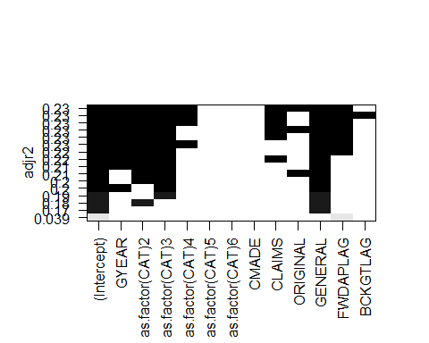

**Multiple Regression Analysis**

The following code chunk performs a multiple regression analysis on the data sample using the selected variables. It then displays the results.

*# Multiple Regression*  
CRECEIVEregression <- **lm**(CRECEIVE **~** GYEAR **+** CAT02 **+** CAT03 **+** CAT04 **+** CLAIMS **+**   
 ORIGINAL **+** GENERAL **+** FWDAPLAG,   
 data = Sample90to95C, na.action = na.omit)  
**summary**(CRECEIVEregression)

##   
## Call:  
## lm(formula = CRECEIVE ~ GYEAR + CAT02 + CAT03 + CAT04 + CLAIMS +   
## ORIGINAL + GENERAL + FWDAPLAG, data = Sample90to95C, na.action = na.omit)  
##   
## Residuals:  
## Min 1Q Median 3Q Max   
## -10.593 -2.956 -0.850 1.035 87.029   
##   
## Coefficients:  
## Estimate Std. Error t value Pr(>|t|)   
## (Intercept) 998.65051 171.81537 5.812 7.16e-09 ***  
## GYEAR -0.49997 0.08621 -5.799 7.73e-09 ***  
## CAT02 3.05106 0.48425 6.301 3.64e-10 ***  
## CAT03 3.45773 0.47537 7.274 5.01e-13 ***  
## CAT04 1.37359 0.37734 3.640 0.000279 ***  
## CLAIMS 0.05989 0.01527 3.921 9.13e-05 ***  
## ORIGINAL -1.55882 0.50028 -3.116 0.001860 **   
## GENERAL 9.57013 0.56144 17.046 < 2e-16 ***  
## FWDAPLAG -0.21028 0.05332 -3.944 8.31e-05 ***  
## ---  
## Signif. codes: 0 '***' 0.001 '**' 0.01 '*' 0.05 '.' 0.1 ' ' 1  
##   
## Residual standard error: 6.357 on 1989 degrees of freedom  
## Multiple R-squared: 0.2373, Adjusted R-squared: 0.2342   
## F-statistic: 77.36 on 8 and 1989 DF, p-value: < 2.2e-16

**Check Linear Regression Assumptions**

The following code chunk performs various checks to determine if the model satisfies the assumptions of linear regression.

*# Global check of linear regression assumptions*  
**par**(mfrow=**c**(2,2))  
**gvlma**(CRECEIVEregression)

##   
## Call:  
## lm(formula = CRECEIVE ~ GYEAR + CAT02 + CAT03 + CAT04 + CLAIMS +   
## ORIGINAL + GENERAL + FWDAPLAG, data = Sample90to95C, na.action = na.omit)  
##   
## Coefficients:  
## (Intercept) GYEAR CAT02 CAT03 CAT04   
## 998.65051 -0.49997 3.05106 3.45773 1.37359   
## CLAIMS ORIGINAL GENERAL FWDAPLAG   
## 0.05989 -1.55882 9.57013 -0.21028   
##   
##   
## ASSESSMENT OF THE LINEAR MODEL ASSUMPTIONS  
## USING THE GLOBAL TEST ON 4 DEGREES-OF-FREEDOM:  
## Level of Significance = 0.05   
##   
## Call:  
## gvlma(x = CRECEIVEregression)   
##   
## Value p-value Decision  
## Global Stat 210438.23 0.000e+00 Assumptions NOT satisfied!  
## Skewness 9785.54 0.000e+00 Assumptions NOT satisfied!  
## Kurtosis 200585.30 0.000e+00 Assumptions NOT satisfied!  
## Link Function 29.73 4.959e-08 Assumptions NOT satisfied!  
## Heteroscedasticity 37.66 8.424e-10 Assumptions NOT satisfied!

*# View residuals*  
**png**(filename = **here**("Results","MultRegres01ModelResidualsPlotA.png"))  
CRECEIVEresid <- **residuals**(CRECEIVEregression)  
**plot**(CRECEIVEresid)  
**dev.off**()

## png   
## 2

**jpeg**(filename = **here**("Results","MultRegres01ModelResidualsPlotA.jpg"))  
CRECEIVEresid <- **residuals**(CRECEIVEregression)  
**plot**(CRECEIVEresid)  
**dev.off**()

## png   
## 2

**ggplot**(CRECEIVEregression)**+**  
 **aes**(x=.fitted, y=.resid)**+**  
 **geom_point**()

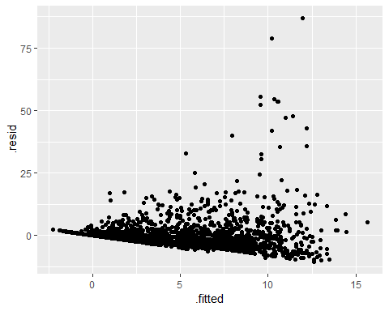

**ggsave**(**here**("Results","MultRegres01ModelResidualsPlotB.png"))  
**ggsave**(**here**("Results","MultRegres01ModelResidualsPlotB.jpg"))  
  
*# Check that mean of residuals equals zero*  
**mean**(CRECEIVEregression**$**residuals)

## [1] -3.595121e-16

*# Check for normality of residuals*  
*# Check for homoscedasticity of residuals or equal variance*  
**png**(filename = **here**("Results", "MultRegres01ModelResidualsDistribution.png"))  
**par**(mfrow=**c**(2,2)) *# set 2 rows and 2 column layout for plot*  
**plot**(CRECEIVEregression)  
**dev.off**()

## png   
## 2

**jpeg**(filename = **here**("Results", "MultRegres01ModelResidualsDistribution.jpg"))  
**par**(mfrow=**c**(2,2)) *# set 2 rows and 2 column layout for plot*  
**plot**(CRECEIVEregression)  
**dev.off**()

## png   
## 2

*# Check for autocorrelation of residuals using Durbin-Watson test*  
*# Null hypothesis: true autocorrelation is zero*  
*# Alternative hypothesis: true autocorrelation is greater than zero*  
AutoCorr <- **dwtest**(CRECEIVEregression)  
**print**(AutoCorr)

##   
## Durbin-Watson test  
##   
## data: CRECEIVEregression  
## DW = 1.9843, p-value = 0.3622  
## alternative hypothesis: true autocorrelation is greater than 0

*# Check that the independent variables and the residuals are uncorrelated*  
CorrGYEAR <- **cor.test**(Sample90to95C**$**GYEAR, CRECEIVEregression**$**residuals)  
**print**(CorrGYEAR)

##   
## Pearson's product-moment correlation  
##   
## data: Sample90to95C$GYEAR and CRECEIVEregression$residuals  
## t = -1.598e-11, df = 1996, p-value = 1  
## alternative hypothesis: true correlation is not equal to 0  
## 95 percent confidence interval:  
## -0.04385287 0.04385287  
## sample estimates:  
## cor   
## -3.576716e-13

CorrCAT <- **cor.test**(Sample90to95C**$**CAT, CRECEIVEregression**$**residuals)  
**print**(CorrCAT)

##   
## Pearson's product-moment correlation  
##   
## data: Sample90to95C$CAT and CRECEIVEregression$residuals  
## t = -0.19801, df = 1996, p-value = 0.8431  
## alternative hypothesis: true correlation is not equal to 0  
## 95 percent confidence interval:  
## -0.04827556 0.03942846  
## sample estimates:  
## cor   
## -0.004432068

CorrCLAIMS <- **cor.test**(Sample90to95C**$**CLAIMS, CRECEIVEregression**$**residuals)  
**print**(CorrCLAIMS)

##   
## Pearson's product-moment correlation  
##   
## data: Sample90to95C$CLAIMS and CRECEIVEregression$residuals  
## t = 1.4501e-17, df = 1996, p-value = 1  
## alternative hypothesis: true correlation is not equal to 0  
## 95 percent confidence interval:  
## -0.04385287 0.04385287  
## sample estimates:  
## cor   
## 3.245828e-19

CorrORIGINAL <- **cor.test**(Sample90to95C**$**ORIGINAL, CRECEIVEregression**$**residuals)  
**print**(CorrORIGINAL)

##   
## Pearson's product-moment correlation  
##   
## data: Sample90to95C$ORIGINAL and CRECEIVEregression$residuals  
## t = 9.1473e-16, df = 1996, p-value = 1  
## alternative hypothesis: true correlation is not equal to 0  
## 95 percent confidence interval:  
## -0.04385287 0.04385287  
## sample estimates:  
## cor   
## 2.047445e-17

CorrGENERAL <- **cor.test**(Sample90to95C**$**GENERAL, CRECEIVEregression**$**residuals)  
**print**(CorrGENERAL)

##   
## Pearson's product-moment correlation  
##   
## data: Sample90to95C$GENERAL and CRECEIVEregression$residuals  
## t = -1.1524e-15, df = 1996, p-value = 1  
## alternative hypothesis: true correlation is not equal to 0  
## 95 percent confidence interval:  
## -0.04385287 0.04385287  
## sample estimates:  
## cor   
## -2.579462e-17

CorrFWDAPLAG <- **cor.test**(Sample90to95C**$**FWDAPLAG, CRECEIVEregression**$**residuals)  
**print**(CorrFWDAPLAG)

##   
## Pearson's product-moment correlation  
##   
## data: Sample90to95C$FWDAPLAG and CRECEIVEregression$residuals  
## t = -3.946e-15, df = 1996, p-value = 1  
## alternative hypothesis: true correlation is not equal to 0  
## 95 percent confidence interval:  
## -0.04385287 0.04385287  
## sample estimates:  
## cor   
## -8.83242e-17

*# Check that the variability in independent variable values is positive*  
varGYEAR <- **var**(Sample90to95C**$**GYEAR)  
**print**(varGYEAR)

## [1] 2.882845

varCAT02 <- **var**(Sample90to95C**$**CAT02)  
**print**(varCAT02)

## [1] 0.0929164

varCAT03 <- **var**(Sample90to95C**$**CAT03)  
**print**(varCAT03)

## [1] 0.09450036

varCAT04 <- **var**(Sample90to95C**$**CAT04)  
**print**(varCAT04)

## [1] 0.1528499

varCAT05 <- **var**(Sample90to95C**$**CAT05)  
**print**(varCAT05)

## [1] 0.1695516

varCAT06 <- **var**(Sample90to95C**$**CAT06)  
**print**(varCAT06)

## [1] 0.1577822

varCLAIMS <- **var**(Sample90to95C**$**CLAIMS)  
**print**(varCLAIMS)

## [1] 88.60728

varCMADE <- **var**(Sample90to95C**$**CMADE)  
**print**(varCMADE)

## [1] 65.00294

varGENERAL <- **var**(Sample90to95C**$**GENERAL)  
**print**(varGENERAL)

## [1] 0.07826721

varORIGINAL <- **var**(Sample90to95C**$**ORIGINAL)  
**print**(varORIGINAL)

## [1] 0.08673389

varFWDAPLAG <- **var**(Sample90to95C**$**FWDAPLAG)  
**print**(varFWDAPLAG)

## [1] 8.095435

varBCKGTLAG <- **var**(Sample90to95C**$**BCKGTLAG)  
**print**(varBCKGTLAG)

## [1] 209.9605

*# Calculate Variance Inflation Factors to check for perfect multicollinearity among the variables*  
VIFregression <- **vif**(CRECEIVEregression)  
**print**(VIFregression)

## GYEAR CAT02 CAT03 CAT04 CLAIMS ORIGINAL GENERAL FWDAPLAG   
## 1.058934 1.076779 1.055360 1.075535 1.021614 1.072760 1.219227 1.137526

**Modify Data 04**

The following code chunk removes cases in which CRECEIVE is greater than or equal to 10 as outliers and applies a transformation to the CRECEIVE variable in an effort to better satisfy the assumptions of linear regression and improve the model.

Sample90to95C **%>%**   
 **filter**(CRECEIVE **<=** 10) **%>%**  
 **mutate**(CRECEIVEsqrt = **sqrt**(CRECEIVE)) -> Sample90to95D

**Q-Q Plots for Transformed Dependent Variable**

The following code chunk creates a Quantile-Quantile (Q-Q) plot for the transformed dependent variable to check for suitability to use in multiple regression analysis.

**ggplot**(Sample90to95D)**+**  
 **aes**(sample = CRECEIVEsqrt)**+**  
 **stat_qq**()**+**  
 **stat_qq_line**()**+**  
 **ggtitle**("CRECEIVEsqrt Q-Q Plot")

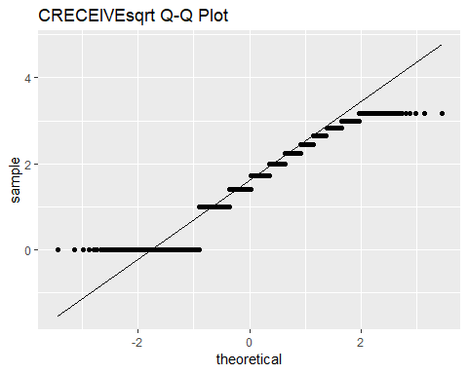

**ggsave**(**here**("Results", "QQplotCRECEIVEsqrt.png"))  
**ggsave**(**here**("Results", "QQplotCRECEIVEsqrt.jpg"))

**Multiple Regression Using Transformed Dependent Variable**

The following code chunk performs a multiple regression analysis using the transformed dependent variable and displays the results.

*# Multiple Regression with Transformed Dependent Variable*  
CRECEIVEregressionTrfm <- **lm**(CRECEIVEsqrt **~** GYEAR **+** CAT02 **+** CAT03 **+** CAT04 **+**   
 CLAIMS **+** ORIGINAL **+** GENERAL **+** FWDAPLAG,   
 data = Sample90to95D, na.action = na.omit)  
**summary**(CRECEIVEregressionTrfm)

##   
## Call:  
## lm(formula = CRECEIVEsqrt ~ GYEAR + CAT02 + CAT03 + CAT04 + CLAIMS +   
## ORIGINAL + GENERAL + FWDAPLAG, data = Sample90to95D, na.action = na.omit)  
##   
## Residuals:  
## Min 1Q Median 3Q Max   
## -1.50502 -0.37531 -0.09773 0.30909 2.13512   
##   
## Coefficients:  
## Estimate Std. Error t value Pr(>|t|)   
## (Intercept) 169.336058 15.585978 10.865 < 2e-16 ***  
## GYEAR -0.084001 0.007821 -10.740 < 2e-16 ***  
## CAT02 0.135559 0.047162 2.874 0.00410 **   
## CAT03 0.141919 0.045456 3.122 0.00182 **   
## CAT04 0.072884 0.034381 2.120 0.03415 *   
## CLAIMS 0.004406 0.001465 3.008 0.00266 **   
## ORIGINAL -0.249616 0.045047 -5.541 3.46e-08 ***  
## GENERAL 1.473686 0.052161 28.253 < 2e-16 ***  
## FWDAPLAG -0.158777 0.004641 -34.214 < 2e-16 ***  
## ---  
## Signif. codes: 0 '***' 0.001 '**' 0.01 '*' 0.05 '.' 0.1 ' ' 1  
##   
## Residual standard error: 0.5442 on 1754 degrees of freedom  
## Multiple R-squared: 0.6417, Adjusted R-squared: 0.6401   
## F-statistic: 392.7 on 8 and 1754 DF, p-value: < 2.2e-16

**Check Linear Regression Assumptions for Transformed Variables**

The following code chunk performs various checks to determine if the model satisfies the assumptions of linear regression.

*# Global check of linear regression assumptions*  
**par**(mfrow=**c**(2,2))  
**gvlma**(CRECEIVEregressionTrfm)

##   
## Call:  
## lm(formula = CRECEIVEsqrt ~ GYEAR + CAT02 + CAT03 + CAT04 + CLAIMS +   
## ORIGINAL + GENERAL + FWDAPLAG, data = Sample90to95D, na.action = na.omit)  
##   
## Coefficients:  
## (Intercept) GYEAR CAT02 CAT03 CAT04   
## 169.336058 -0.084001 0.135559 0.141919 0.072884   
## CLAIMS ORIGINAL GENERAL FWDAPLAG   
## 0.004406 -0.249616 1.473686 -0.158777   
##   
##   
## ASSESSMENT OF THE LINEAR MODEL ASSUMPTIONS  
## USING THE GLOBAL TEST ON 4 DEGREES-OF-FREEDOM:  
## Level of Significance = 0.05   
##   
## Call:  
## gvlma(x = CRECEIVEregressionTrfm)   
##   
## Value p-value Decision  
## Global Stat 362.77778 0.0000000 Assumptions NOT satisfied!  
## Skewness 134.44666 0.0000000 Assumptions NOT satisfied!  
## Kurtosis 13.00083 0.0003114 Assumptions NOT satisfied!  
## Link Function 215.27328 0.0000000 Assumptions NOT satisfied!  
## Heteroscedasticity 0.05701 0.8112811 Assumptions acceptable.

*# View residuals*  
CRECEIVEresidTrfm <- **residuals**(CRECEIVEregressionTrfm)  
**png**(filename = **here**("Results","MultRegresTrfmModelResidualsPlotA.png"))  
**plot**(CRECEIVEresidTrfm)  
**dev.off**()

## png   
## 2

CRECEIVEresidTrfm <- **residuals**(CRECEIVEregressionTrfm)  
**jpeg**(filename = **here**("Results","MultRegresTrfmModelResidualsPlotA.jpg"))  
**plot**(CRECEIVEresidTrfm)  
**dev.off**()

## png   
## 2

**ggplot**(CRECEIVEregressionTrfm)**+**  
 **aes**(x=.fitted, y=.resid)**+**  
 **geom_point**()

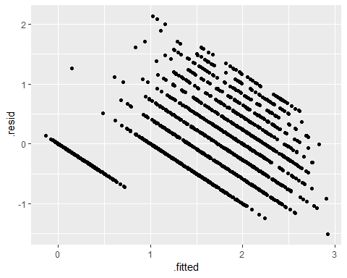

**ggsave**(**here**("Results","MultRegresTrfmModelResidualsPlotB.png"))  
**ggsave**(**here**("Results","MultRegresTrfmModelResidualsPlotB.jpg"))  
  
*# Check that mean of residuals equals zero*  
**mean**(CRECEIVEregressionTrfm**$**residuals)

## [1] -4.023402e-18

*# Check for normality of residuals*  
*# Check for homoscedasticity of residuals or equal variance*  
**png**(filename = **here**("Results", "MultRegresTrfmModelResidualsDistribution.png"))  
**par**(mfrow=**c**(2,2)) *# set 2 rows and 2 column layout for plot*  
**plot**(CRECEIVEregressionTrfm)  
**dev.off**()

## png   
## 2

**jpeg**(filename = **here**("Results", "MultRegresTrfmModelResidualsDistribution.jpg"))  
**par**(mfrow=**c**(2,2)) *# set 2 rows and 2 column layout for plot*  
**plot**(CRECEIVEregressionTrfm)  
**dev.off**()

## png   
## 2

*# Check for autocorrelation of residuals using Durbin-Watson test*  
*# Null hypothesis: true autocorrelation is zero*  
*# Alternative hypothesis: true autocorrelation is greater than zero*  
AutoCorrTrfm <- **dwtest**(CRECEIVEregressionTrfm)  
**print**(AutoCorrTrfm)

##   
## Durbin-Watson test  
##   
## data: CRECEIVEregressionTrfm  
## DW = 2.0548, p-value = 0.8753  
## alternative hypothesis: true autocorrelation is greater than 0

*# Check that the independent variables and the residuals are uncorrelated*  
CorrGYEARtrfm <- **cor.test**(Sample90to95D**$**GYEAR, CRECEIVEregressionTrfm**$**residuals)  
**print**(CorrGYEARtrfm)

##   
## Pearson's product-moment correlation  
##   
## data: Sample90to95D$GYEAR and CRECEIVEregressionTrfm$residuals  
## t = -1.396e-11, df = 1761, p-value = 1  
## alternative hypothesis: true correlation is not equal to 0  
## 95 percent confidence interval:  
## -0.04668485 0.04668485  
## sample estimates:  
## cor   
## -3.326677e-13

CorrCATtrfm <- **cor.test**(Sample90to95D**$**CAT, CRECEIVEregressionTrfm**$**residuals)  
**print**(CorrCATtrfm)

##   
## Pearson's product-moment correlation  
##   
## data: Sample90to95D$CAT and CRECEIVEregressionTrfm$residuals  
## t = 2.0335, df = 1761, p-value = 0.04216  
## alternative hypothesis: true correlation is not equal to 0  
## 95 percent confidence interval:  
## 0.001719017 0.094870465  
## sample estimates:  
## cor   
## 0.04839998

CorrCLAIMStrfm <- **cor.test**(Sample90to95D**$**CLAIMS, CRECEIVEregressionTrfm**$**residuals)  
**print**(CorrCLAIMStrfm)

##   
## Pearson's product-moment correlation  
##   
## data: Sample90to95D$CLAIMS and CRECEIVEregressionTrfm$residuals  
## t = -6.185e-16, df = 1761, p-value = 1  
## alternative hypothesis: true correlation is not equal to 0  
## 95 percent confidence interval:  
## -0.04668485 0.04668485  
## sample estimates:  
## cor   
## -1.473869e-17

CorrORIGINALtrfm <- **cor.test**(Sample90to95D**$**ORIGINAL, CRECEIVEregressionTrfm**$**residuals)  
**print**(CorrORIGINALtrfm)

##   
## Pearson's product-moment correlation  
##   
## data: Sample90to95D$ORIGINAL and CRECEIVEregressionTrfm$residuals  
## t = -6.27e-16, df = 1761, p-value = 1  
## alternative hypothesis: true correlation is not equal to 0  
## 95 percent confidence interval:  
## -0.04668485 0.04668485  
## sample estimates:  
## cor   
## -1.494128e-17

CorrGENERALtrfm <- **cor.test**(Sample90to95D**$**GENERAL, CRECEIVEregressionTrfm**$**residuals)  
**print**(CorrGENERALtrfm)

##   
## Pearson's product-moment correlation  
##   
## data: Sample90to95D$GENERAL and CRECEIVEregressionTrfm$residuals  
## t = 6.7906e-16, df = 1761, p-value = 1  
## alternative hypothesis: true correlation is not equal to 0  
## 95 percent confidence interval:  
## -0.04668485 0.04668485  
## sample estimates:  
## cor   
## 1.61818e-17

CorrFWDAPLAGtrfm <- **cor.test**(Sample90to95D**$**FWDAPLAG, CRECEIVEregressionTrfm**$**residuals)  
**print**(CorrFWDAPLAGtrfm)

##   
## Pearson's product-moment correlation  
##   
## data: Sample90to95D$FWDAPLAG and CRECEIVEregressionTrfm$residuals  
## t = -1.393e-14, df = 1761, p-value = 1  
## alternative hypothesis: true correlation is not equal to 0  
## 95 percent confidence interval:  
## -0.04668485 0.04668485  
## sample estimates:  
## cor   
## -3.319594e-16

*# Check that the variability in independent variable values is positive*  
varGYEARtrfm <- **var**(Sample90to95D**$**GYEAR)  
**print**(varGYEARtrfm)

## [1] 2.873931

varCAT02trfm <- **var**(Sample90to95D**$**CAT02)  
**print**(varCAT02trfm)

## [1] 0.0802342

varCAT03trfm <- **var**(Sample90to95D**$**CAT03)  
**print**(varCAT03trfm)

## [1] 0.08487944

varCAT04trfm <- **var**(Sample90to95D**$**CAT04)  
**print**(varCAT04trfm)

## [1] 0.1511625

varCAT05trfm <- **var**(Sample90to95D**$**CAT05)  
**print**(varCAT05trfm)

## [1] 0.175818

varCAT06trfm <- **var**(Sample90to95D**$**CAT06)  
**print**(varCAT06trfm)

## [1] 0.1655888

varCLAIMStrfm <- **var**(Sample90to95D**$**CLAIMS)  
**print**(varCLAIMStrfm)

## [1] 79.42126

varCMADEtrfm <- **var**(Sample90to95D**$**CMADE)  
**print**(varCMADEtrfm)

## [1] 61.15318

varGENERALtrfm <- **var**(Sample90to95D**$**GENERAL)  
**print**(varGENERALtrfm)

## [1] 0.07338131

varORIGINALtrfm <- **var**(Sample90to95D**$**ORIGINAL)  
**print**(varORIGINALtrfm)

## [1] 0.08781611

varFWDAPLAGtrfm <- **var**(Sample90to95D**$**FWDAPLAG)  
**print**(varFWDAPLAGtrfm)

## [1] 8.919473

varBCKGTLAGtrfm <- **var**(Sample90to95D**$**BCKGTLAG)  
**print**(varBCKGTLAGtrfm)

## [1] 217.1713

*# Calculate Variance Inflaction Factors to check for perfect multicollinearity among the variables*  
VIFregressionTrfm <- **vif**(CRECEIVEregressionTrfm)  
**print**(VIFregressionTrfm)

## GYEAR CAT02 CAT03 CAT04 CLAIMS ORIGINAL GENERAL FWDAPLAG   
## 1.045817 1.061693 1.043375 1.062993 1.013499 1.060122 1.187775 1.142786

**Save Data**

The following code chunk saves the final cleaned and modified data that was used in the analysis.

**write.csv**(Sample90to95C, **here**("DataClean","NBERpatents1963to1999","NBERPatCitSample90to95C.csv"), append = FALSE)  
**write.csv**(Sample90to95D, **here**("DataClean","NBERpatents1963to1999","NBERPatCitSample90to95D.csv"), append = FALSE)