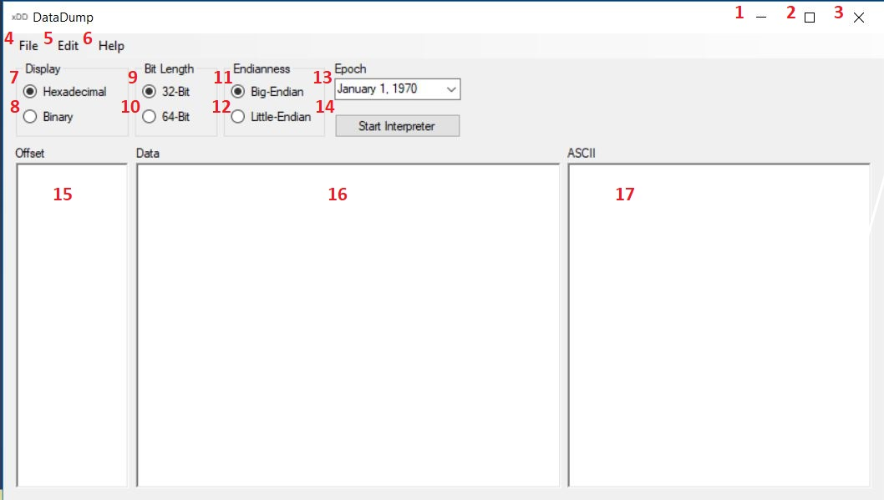

1. Minimizes the window to the task bar.
2. Makes the window full screen. If full screen restores it to a smaller size window.
3. Closes the program.
4. File drop down menu.
5. Edit drop down menu.
6. Help drop down menu.
7. Displays the data in Hexadecimal if selected.
8. Displays the data in Binary if selected.
9. Search using 32-Bit length.
10. Search using 64-Bit length.
11. Search using Big-Endian.
12. Search using Little-Endian.
13. Search starting on this date.
14. Using all the selected information previously described, run the program to convert the file.
15. Display the offset values.
16. Display the data based upon the selected conditions.
17. Display the ASCII representation the data.

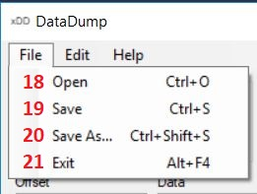

1. To select a file to open in the program.
2. To save a file that has been opened with its results.
3. To rename a file that has been opened with its results.
4. To exit the program.

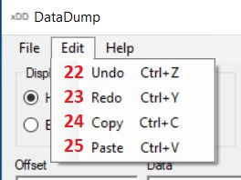

1. Undo the previous change.
2. Redo the previous undo.
3. Copy the selected text.
4. Past copied text.

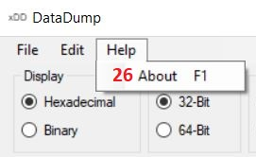

1. About the program.