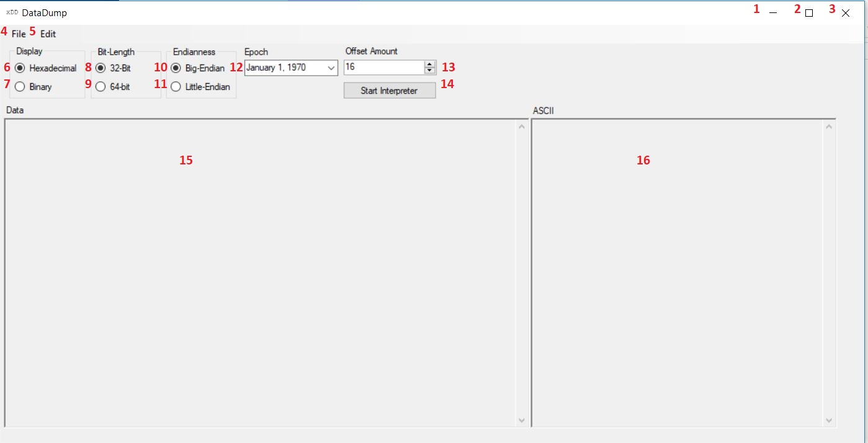

1. Minimizes the window to the task bar.
2. Makes the window full screen. If full screen restores it to a smaller size window.
3. Closes the program.
4. File drop down menu.
5. Edit drop down menu.
6. Displays the data in Hexadecimal if selected.
7. Displays the data in Binary if selected.
8. Search using 32-Bit length.
9. Search using 64-Bit length.
10. Search using Big-Endian.
11. Search using Little-Endian.
12. Search starting on this date.
13. Choose how many characters to display per line in boxes 15 and 16.
14. Using all the selected information previously described, run the program to convert the file.
15. Display the offset values.
16. Display the ASCII representation the data.

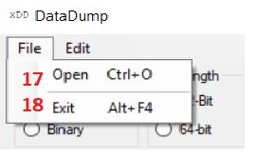

1. To select a file to open in the program.
2. To exit the program.

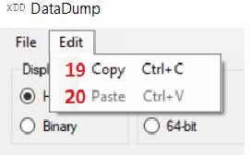

1. Copy the selected text.
2. Past copied text that is on the clipboard.