09)

These are the key points of the cropped image
43.2552,10.6688
39.2179,20.412
14.2005,34.0412
17.6109,68.0674
22.9623,54.4096
18.4315,50.2522

these points in the image1_crop are mapped with the img_1 like this(with BFmatcher)

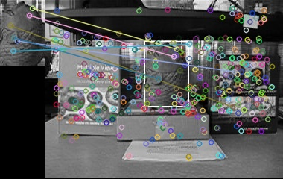

so according to the above drawing we can say that likely position suggested by the feature mapping should be the rectangle drawn area in img_1 at step 4.

10) FLANN based feature matching

Fast Library for approximate nearest neighbors

there are many computer vision algorithms, The most computational expensive part of these algorithms is “searching for the closest matches to high dimensional vectors”.

Ex:
finding the best matches for local image features in large datasets.

Normally we do this matching using brute force matcher. But it is computationally expensive. It takes the descriptor of one feature in first set and is matched with all other features in second set using some distance calculation. And the closest one is returned.

This computational expensive problem is solved by FLANN. It contains collection of algorithms optimized for fast nearest neighbor search in large data sets and for high dimensional features.

There are two approaches
I) Randomized k-d tree algorithm
II) The priority search K-means tree algorithm

The nearest neighbor search problem is used in many other applications.
Ex:
machine learning
document retrieval
data compression
bioinformatics
data analysis

it is possible to define nearest neighbour search problem as follows.

Given a set of points P={p1,p2……..pn} in a vector space X.
thses points must be preprocessed in such a way that given a new query point q ∈
X , finding the points in P that are nearest to q can be performed efficiently.

Through this FLANN approach , automatically algorithm configuration allows a user to achieve high performance in approximate nearest neighbour matching by calling single library routine. The user need only provide an example of the type of dataset that will be used and desired precission, and may optionally specify the importance of minimizing memory or build time rather than just search time. All remaining steps of algorithm selection and parameter optimization are performed automatically.

FLANN contains a collection of algorithms , found to work best for nearest neighbour search and a system for automatically choosing the best algorithm and optimum parameters depending on the dataset.

This approach can speed the matching of high dimensional vectors by up to several orders of magnitude compared to linear search.

References

Marius Muja, David G. Lowe. Fast Approximate Nearest Neighbors with Automatic Algorithm Configuration, 2009

