**班级___8班_____ 学号__2023311803__ 姓名___邢峻源___ 教师签字____________**

**实验日期_______________________________预习成绩_________ 总成绩______________**

**实验名称** 空气中**声速的测量**

1. **实验预习**

相位比较法测量声速实验中，示波器上调出李萨如图形后，改变换能器的间距，连续记录出现正斜率和负斜率直线时接收器的位置（如下图所示），记录了10个位置数据*xi*（*i*=1, 2, 3, ……, 9, 10），所用声波频率为*f*，如下表所示，请用逐差法处理数据，推导出声速*v*的表达式。

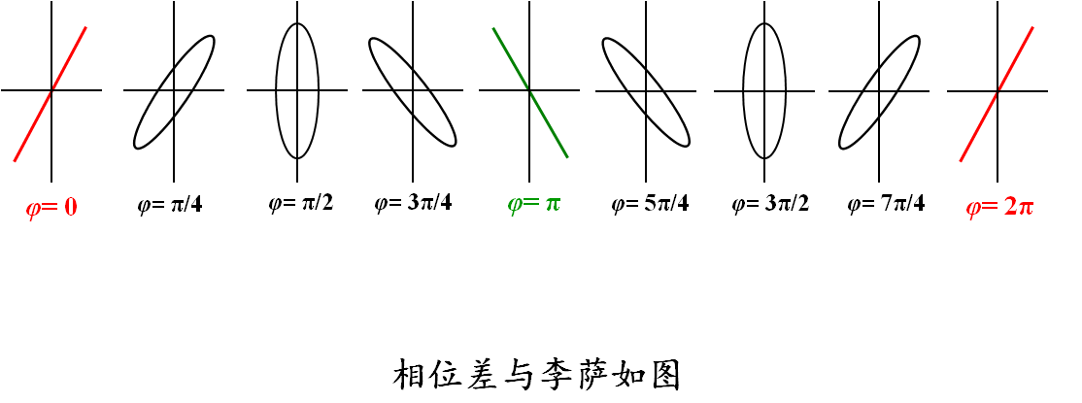

相位比较法测空气中声速，频率*f* =_____

|  |  |  |  |  |  |  |  |  |  |  |
| --- | --- | --- | --- | --- | --- | --- | --- | --- | --- | --- |
| 次数 | 1 | 2 | 3 | 4 | 5 | 6 | 7 | 8 | 9 | 10 |
| *xi* |  |  |  |  |  |  |  |  |  |  |

1. **实验现象及原始数据记录**

极值法（驻波法）测空气中声速，温度*t* =_____oC，频率*f* =_____*kHz*

|  |  |  |  |  |  |  |  |  |  |  |
| --- | --- | --- | --- | --- | --- | --- | --- | --- | --- | --- |
| 次数 | 1 | 2 | 3 | 4 | 5 | 6 | 7 | 8 | 9 | 10 |
| *li* (mm) |  |  |  |  |  |  |  |  |  |  |

相位比较法测空气中声速，温度*t* =_____ oC，频率*f* =_____*kHz*

|  |  |  |  |  |  |  |  |  |  |  |
| --- | --- | --- | --- | --- | --- | --- | --- | --- | --- | --- |
| 次数 | 1 | 2 | 3 | 4 | 5 | 6 | 7 | 8 | 9 | 10 |
| *li* (mm) |  |  |  |  |  |  |  |  |  |  |

**（选做）**波形移动法测空气中声速，温度*t* =_____ oC，频率*f* =_____*kHz*

|  |  |  |  |  |  |  |  |  |  |  |
| --- | --- | --- | --- | --- | --- | --- | --- | --- | --- | --- |
| 次数 | 1 | 2 | 3 | 4 | 5 | 6 | 7 | 8 | 9 | 10 |
| *li* (mm) |  |  |  |  |  |  |  |  |  |  |

时差法测空气中声速，温度*t* =_____ oC

|  |  |  |  |  |  |  |  |  |  |  |
| --- | --- | --- | --- | --- | --- | --- | --- | --- | --- | --- |
| 次数 | 1 | 2 | 3 | 4 | 5 | 6 | 7 | 8 | 9 | 10 |
| *li* (mm) |  |  |  |  |  |  |  |  |  |  |
| *ti* (μs) |  |  |  |  |  |  |  |  |  |  |

**（选做）**时差法测固体中声速，温度*t* =_____ oC

|  |  |  |  |  |  |  |
| --- | --- | --- | --- | --- | --- | --- |
| 次数 | 1 | 2 | 3 | 4 | 5 | 6 |
| 材质 |  |  |  |  |  |  |
| *li* (mm) |  |  |  |  |  |  |
| *ti* (μs) |  |  |  |  |  |  |

|  |  |
| --- | --- |
| **教师** | **姓名** |
| **签字** |  |

1. **数据处理**

【计算以上几种方法测得的声速，计算室温下空气中声速的理论值，分别计算四种方法得到的声速测量值与理论值的相对误差，根据时差法测量数据计算固体介质中的声速**（选做）**，要有详细的计算过程，格式工整】

1. **实验结论及现象分析**

（分析讨论以上几种方法测出的空气中的声速结果为何存在差异，从原理和操作上说明各自的优缺点）

1. **讨论题**
2. 使用驻波法测声速时，为什么示波器上观察到的是正弦波而不是驻波？
3. 用相位比较法测量波长时，为什么用直线而不用椭圆作为S2移动距离的判断数据？
4. 分析一下本实验中哪些因素可以引起测量误差。列出3条主要因素并说明原因。