Hunt The Wumpus
Game description

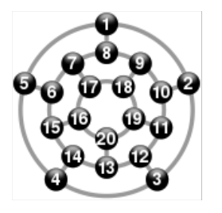
Hunt the Wumpus is a turn-based text adventure with 20 interconnected caves forming a dodecahedron. The player, located in complete darkness, aims to kill the Wumpus using arrows. Caves may have bottomless pits or super bats, and the player receives sensory cues (smell, hear, feel) when moving. Falling into a pit ends the game, entering the Wumpus' cave startles it, possibly causing it to move and kill the player. Shooting arrows involves choosing the number of caves to traverse. If the arrow hits the player, they lose; hitting the Wumpus results in a win. If the arrow misses, the Wumpus may move. Super bats and pits don't affect the Wumpus.
Image 1.1 - Dodecahedron

Resources
1. Hunt The Wumpus description - https://en.wikipedia.org/wiki/Hunt_the_Wumpus
Appendix
Report plan
- Intro
- Task Statement
- Approach
- Code Explanation
- Classes
- Data Structures Used
- Conclusion
- Resources
- Appendix

