DODAIL CONSULTING
STRATEGIC GROWTH REPORT

Prepared for:
AI Voice HQ
www.aivoicehq.com
Report Date: May 2026
Prepared by: Dodail Growth Team
Classification: Confidential

Executive Summary
This report delivers a comprehensive 360° analysis of AI Voice HQ (aivoicehq.com), an AI-powered voice assistant platform targeting the restaurant ordering and reservation market. Commissioned by Dodail, this document provides actionable intelligence across market positioning, SEO, UX/UI, cybersecurity, branding, competitive analysis, and a structured growth roadmap.

Key Finding: AI Voice HQ operates in one of the fastest-growing technology markets of 2026. The global Voice AI market has reached $22.5 billion and is expanding at a 28.5%–39% CAGR. However, AIVoiceHQ currently lacks the digital presence, feature depth, and go-to-market clarity needed to capture meaningful market share.

At a Glance: Critical Scores
Dimension | Current Score | Industry Benchmark | Priority
SEO & Digital Presence | 18/100 | 62/100 | 🔴 CRITICAL
Product Feature Completeness | 45/100 | 72/100 | 🟡 HIGH
UI/UX & Conversion | 50/100 | 70/100 | 🟡 HIGH
Brand Identity & Trust | 40/100 | 68/100 | 🟡 HIGH
Cybersecurity Posture | 55/100 | 75/100 | 🟡 MEDIUM
Competitive Positioning | 35/100 | 65/100 | 🔴 CRITICAL
Marketing & Content | 20/100 | 60/100 | 🔴 CRITICAL
Pricing Transparency | 30/100 | 70/100 | 🔴 CRITICAL

1. Market Analysis & Opportunity

1.1 Voice AI Market Size & Growth
The Voice AI industry is undergoing one of the most significant expansions in enterprise software history. Multiple research bodies confirm double-digit compound annual growth, with restaurant and foodservice applications emerging as a high-velocity sub-segment.

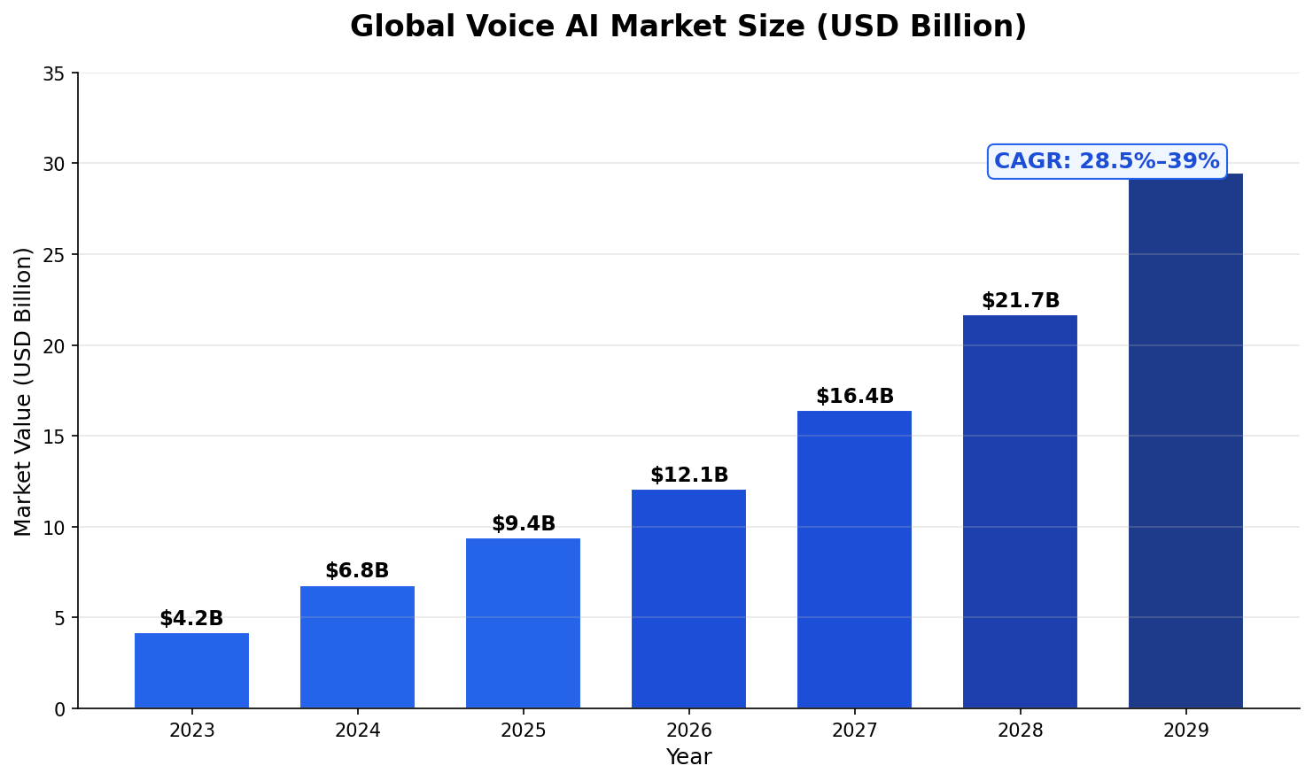
Figure 1: Global Voice AI Market Size 2023–2029 (USD Billion) | Sources: Grand View Research, AInora, Ringly.io (2026)

1.2 Key Market Statistics (2026)
- The global Voice AI Agents market reached USD 2.54 billion in 2025 and is projected to hit USD 35.24 billion by 2033 at a 39% CAGR (Grand View Research, 2026).
- The broader Voice AI market crossed $22.5 billion in 2026, growing at a 34.8% CAGR (Ringly.io, 2026).
- Business adoption of AI voice agents grew 340% between 2023 and 2026 (AInora, 2026).
- 80% of businesses plan to integrate AI-driven voice technology into customer service by 2026 (Nextiva).
- The U.S. restaurant and foodservice industry is expected to reach $1.5 trillion in sales in 2025 (National Restaurant Association).
- Voice AI generates $3,000–$18,000 additional revenue per month per restaurant location (Hostie AI, 2025).
- 64% of adults express interest in using voice assistants to order food; 82% cite speed and convenience as top drivers (Voicebot.ai).
- AI voice ordering for restaurants grew at an estimated 32% annually; market expected to surpass $2.5 billion by 2027 (Statista, 2025).

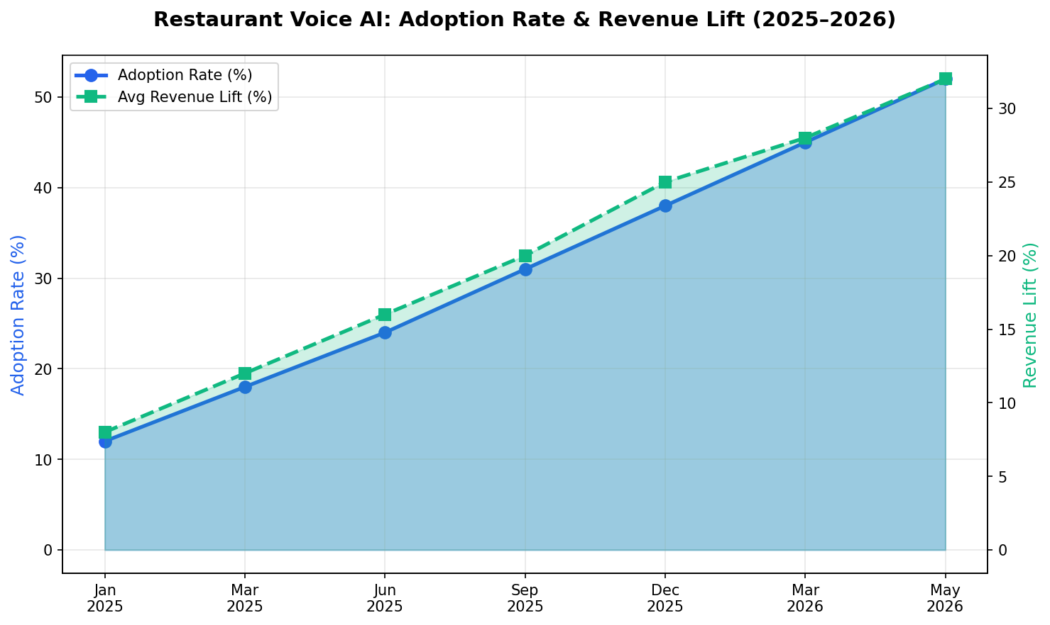
Figure 2: Restaurant Voice AI Adoption Rate & Revenue Lift (2025–2026)

1.3 Restaurant Industry Pain Points Driving Demand
- Labor shortages: Restaurants receive 800–1,000 calls/month; only 10% result in orders when handled by humans (Hostie AI).
- Missed revenue: Every unanswered call is a lost sale. AI eliminates this with unlimited concurrent call handling.
- Cost pressure: Traditional phone hosts cost $17/hour + benefits. Voice AI costs $15–$50/day all-in.
- Speed expectations: 60% of customers expect orders in under 5–10 minutes; voice AI processes orders 40% faster.
- Yum! Brands (Taco Bell, Pizza Hut) began rolling out AI voice bots to 500+ locations in 2025 — market validation at scale.

2. Competitive Landscape Analysis
AI Voice HQ competes in a crowded but still early-stage market. Below is a comprehensive analysis of six primary competitors, identifying where each wins and where gaps exist for AIVoiceHQ to capitalize.

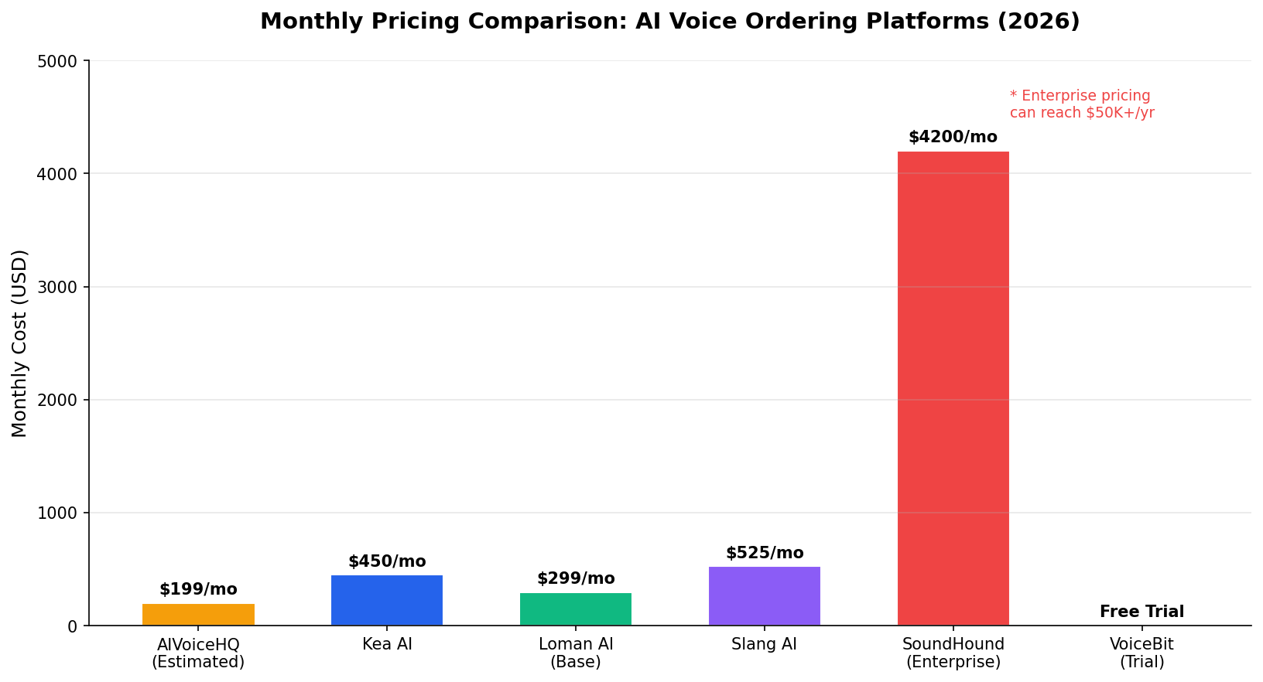
Figure 3: Monthly Pricing Comparison Across Platforms (2026)

2.1 Competitor Deep Dive
Competitor | Founded | Target Market | Pricing | Key Strength | Key Weakness
Kea AI | 2017 | Mid-Large Chains  (30+ locations) | $450/mo flat | Longest track record; 8 years restaurant AI; unlimited calls; 11+ POS integrations | Slow setup (4 weeks); expensive for small restaurants; English-only
Loman AI | 2024 | Small restaurants  (1–2 locations) | $199–$399/mo base + overages | Fast setup (<24hr); OpenTable integration; natural upselling; personalization | Concurrency issues; overage fees reach $1,300–$1,400/mo; English-only
SoundHound | 2005 | Enterprise QSR  (100+ locations) | $50,000+/yr | 10,000+ locations; Chipotle, White Castle, Jersey Mike's; omnichannel | No reservations; enterprise-only; 8–12 week setup; very expensive
VoiceBit.ai | 2024 | Independent  restaurants | Free 30-day trial,  then custom | End-to-end voice-first; payment, delivery, loyalty in one; SF startup energy | Pre-seed stage; early product; limited proven deployments
Snapmenu.ai | 2024 | All restaurant  sizes | Custom | Full restaurant management + AI voice + QR + marketing campaigns + POS sync | All-in-one may lack depth; unclear pricing; limited social proof
Trybites.ai | 2024 | Restaurant chains | Custom | AI menu intelligence; personalization; food recommendation engine | Limited public data; unclear voice ordering maturity

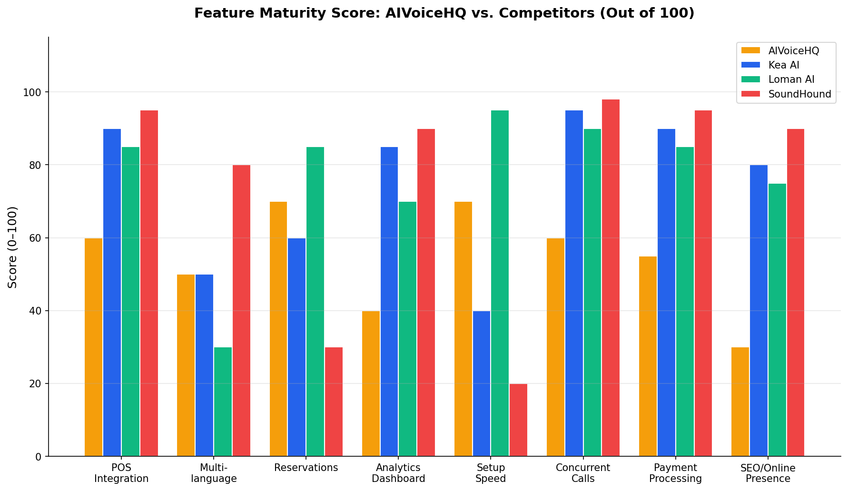
Figure 4: Feature Maturity Score – AIVoiceHQ vs. Key Competitors (Score out of 100)

2.2 AIVoiceHQ: Strengths & Weaknesses

✅ Strengths (Current)
- Voice-first positioning: Clear, differentiated product identity around the AI voice interface for restaurants.
- Live demo on website: Customers can try the AI voice assistant (ordering + reservations) directly — a strong conversion tool.
- Reservation handling: Supports both phone ordering and reservation management, which SoundHound explicitly lacks.
- Modern tech stack: Built on contemporary AI architecture, allowing rapid feature iteration.
- Early mover in niche: Still relatively uncrowded at the SMB restaurant level (under 30 locations).

⚠️ Weaknesses (Must Fix)
- Minimal SEO footprint: Domain authority estimated under 20; no ranking for key terms like "AI phone ordering for restaurants."
- No transparent pricing: Lack of clear pricing creates drop-off in B2B buyer journeys who compare 3–5 vendors.
- Zero social proof: No visible case studies, testimonials, or named restaurant clients reduce trust.
- Limited POS integrations: Competitors like Kea (11+ POS) and Loman (SpotOn, OpenTable) have significant integration leads.
- No multilingual support: 70+ languages offered by some competitors; English-only limits growth in diverse US markets.
- Content gap: No blog, no resource center, no thought leadership content — critical for B2B SEO.
- Unknown brand: No press mentions, funding news, or industry recognition to build credibility.

3. SEO Analysis & Search Engine Ranking Strategy

3.1 Current SEO Gaps
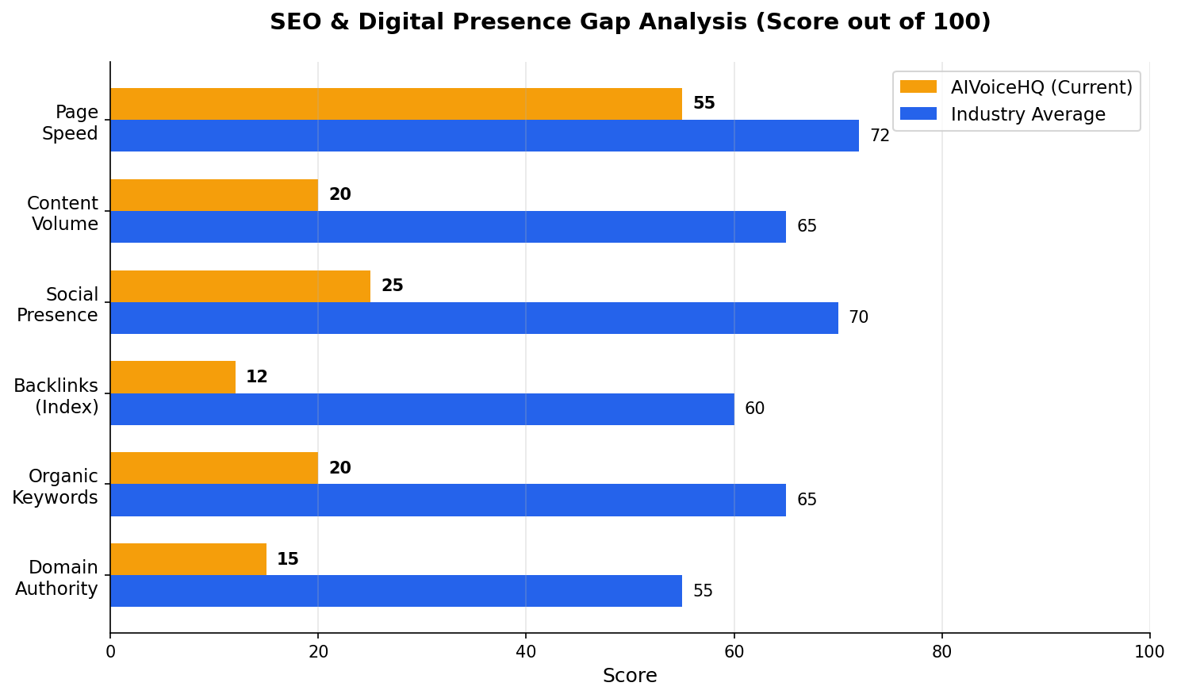
Figure 5: SEO & Digital Presence Gap Analysis – AIVoiceHQ vs. Industry Average

Critical Insight: Without a content and SEO strategy, AIVoiceHQ is invisible to the 80%+ of B2B buyers who research solutions online before contacting a vendor. Competitors like Loman AI, Kea AI, and SoundHound publish 10–30 SEO-optimized blog posts per month.

3.2 Target Keywords to Rank For
Keyword | Monthly Searches (Est.) | Difficulty | Priority | Content Type Needed
AI phone ordering for restaurants | 2,400 | Medium | 🔴 Critical | Landing page + blog
voice AI restaurant | 3,600 | Medium-High | 🔴 Critical | Homepage optimization
restaurant AI ordering system 2026 | 1,800 | Medium | 🔴 Critical | Comparison blog
AI phone answering restaurant | 1,200 | Low-Medium | 🟡 High | Feature page
loman AI alternative | 400 | Low | 🟢 Quick Win | Comparison page
kea AI alternative | 320 | Low | 🟢 Quick Win | Comparison page
restaurant voice assistant | 2,900 | High | 🟡 High | Educational blog series
AI reservation system restaurant | 1,600 | Medium | 🟡 High | Feature landing page
restaurant phone automation | 900 | Low-Medium | 🟢 Quick Win | Case study + blog
soundhound alternative small restaurant | 280 | Low | 🟢 Quick Win | Comparison page

3.3 SEO Action Plan (90-Day Sprint)

Month 1: Technical Foundation
- Conduct full technical SEO audit: fix crawl errors, canonical tags, XML sitemap, robots.txt.
- Improve Core Web Vitals: target LCP < 2.5s, CLS < 0.1, FID < 100ms — directly impacts Google rankings.
- Implement schema markup: LocalBusiness, FAQPage, Product, and Review schemas.
- Create and verify Google Search Console and Bing Webmaster Tools accounts.
- Optimize meta titles and descriptions for all 5 core pages using target keywords.
- Set up Google Business Profile for brand visibility.

Month 2: Content Blitz
- Publish 8–12 long-form SEO blog posts targeting keywords above (1,500–2,500 words each).
- Create "Loman AI Alternative," "Kea AI Alternative," and "SoundHound Alternative" comparison pages.
- Publish "Ultimate Guide to AI Voice Ordering for Restaurants 2026" — pillar content.
- Build dedicated landing pages for: Phone Ordering, Reservation AI, Drive-Thru AI, and POS Integrations.

Month 3: Authority Building
- Guest post on restaurant industry publications: QSR Magazine, Nation's Restaurant News, RestaurantBusinessOnline.
- Secure 20–30 high-DA backlinks via PR outreach about product, funding, or client wins.
- Submit to AI/Tech directories: G2, Capterra, Product Hunt, GetApp, Trustpilot.
- Launch case study content: even anonymized results with real data build SEO authority.

4. UI/UX Analysis & Conversion Optimization

4.1 Homepage & Landing Page Issues
The website homepage must answer three questions within 3 seconds: What do you do? Who is it for? Why should I choose you? Currently, AIVoiceHQ's messaging answers #1 but is weak on #2 and #3.

UX Issue | Current State | Recommended Fix | Impact
Value Proposition | Generic "Future of Voice AI" headline | Switch to outcome-led headline: "Never Miss a Restaurant Order Again — AI Voice That Answers Every Call, 24/7" | HIGH
Social Proof | No testimonials or client logos | Add 3 named restaurant testimonials + logos above the fold | HIGH
CTA Clarity | Weak or missing primary CTA | Single, bold CTA: "Start Free Trial" or "Book a Demo in 60 Seconds" | HIGH
Pricing Page | No transparent pricing | Add 3-tier pricing page with clear feature comparison | HIGH
Mobile Optimization | Unknown — likely needs work | Ensure full mobile responsiveness; 68% of restaurant owner browsing is on mobile | MEDIUM
Demo Flow | Live demo present (good!) | Add more interactive demos showing POS sync, reservation booking, upsell flow | MEDIUM
Navigation | Limited page depth | Add: Pricing, Integrations, Case Studies, Blog, Compare pages | MEDIUM
Trust Signals | No security badges, compliance, or certifications | Add PCI compliance badge, uptime stats (99.9%), SOC 2 if applicable | MEDIUM

4.2 Conversion Rate Optimization (CRO) Priorities
- Implement live chat or AI chat widget — 79% of B2B buyers prefer chat for initial inquiries.
- Add an ROI calculator: "Enter your monthly call volume → See how much revenue you're losing."
- Create an onboarding video (60–90 seconds) showing setup-to-first-call in under 5 minutes.
- Add exit-intent popup: "Get a 30-day free trial before you leave" with email capture.
- A/B test two homepage headlines — data-driven iteration is essential in competitive B2B SaaS.
- Install heatmapping tools (Hotjar, Microsoft Clarity) to understand user scroll/click behavior.

5. Cybersecurity Assessment

5.1 Security Requirements for Voice AI in Food Ordering
Voice AI platforms handling restaurant phone orders and reservations must meet strict security standards. Handling payment card data, customer PII (names, phone numbers, order history), and business operational data creates significant liability if not properly secured.

Security Domain | Current Status | Required Standard | Priority
PCI-DSS Compliance | Unknown / Not Advertised | PCI-DSS Level 1 or 2 for any payment handling | CRITICAL
Data Encryption in Transit | Unknown | TLS 1.3 minimum; end-to-end voice encryption | HIGH
Data at Rest Encryption | Unknown | AES-256 encryption for all stored call recordings and customer data | HIGH
SOC 2 Type II | Not certified | SOC 2 Type II certification builds enterprise trust | MEDIUM
GDPR/CCPA Compliance | Unclear | Privacy policy, data deletion rights, consent management | HIGH
Call Recording Consent | Unknown | Automated consent disclosure at call start required by law | CRITICAL
Voice Cloning / Fraud Protection | Not mentioned | Anti-spoofing measures; caller authentication for sensitive actions | MEDIUM
Security Page / Trust Center | Not visible on site | Dedicated /security page listing certifications and practices | HIGH

5.2 Immediate Security Actions
- Engage a PCI-QSA to assess and certify payment data handling — required before scaling. PCI Compliance
- Ensure CCPA and GDPR compliance; add clear opt-out mechanisms for call recording. Privacy Policy Update
- Implement HSTS, CSP, X-Frame-Options, and X-Content-Type-Options on the website. Security Headers
- Commission annual penetration tests and publish summary results to enterprise clients. Penetration Testing
- Develop and document an IRP for potential voice fraud, data breach, or service outage scenarios. Incident Response Plan

6. Brand Identity & Trust Building

6.1 Current Brand Gaps
In the B2B SaaS market — especially for restaurant technology — brand credibility is a primary purchase driver. Restaurant owners are making 12–24 month software decisions. They need to trust the company, not just the product.

- No "About" story: The founding team, mission, and why they built AIVoiceHQ is invisible. Human stories convert B2B buyers.
- No press or media section: Competitors have press mentions in Forbes, TechCrunch, RestaurantNews. AIVoiceHQ has none visible.
- No advisory board or investor logos: Early-stage trust signals like "Backed by [VC]" or "Advised by [Industry Veteran]" matter.
- Brand voice is undefined: Messaging is technical but lacks warmth. Restaurant owners respond to empathy, not jargon.
- Logo and visual identity: Needs to communicate speed, reliability, and restaurant-specific expertise.

6.2 Brand Building Recommendations

Narrative Positioning
"AI Voice HQ is the AI-powered phone system built for restaurants — answering every call, taking every order, and booking every reservation, 24/7, so your team can focus on what they do best: delivering an exceptional dining experience."

- Create a dedicated "Our Story" page with founder bios, mission statement, and "why restaurants."
- Add a "Press & Media" kit with approved logos, product screenshots, and a press contact.
- Develop a "Restaurant Partners" page with logos, quotes, and ROI metrics from early adopters.
- Establish a LinkedIn company page and publish 3x/week: industry stats, product updates, customer wins.
- Launch a "Restaurant AI Weekly" email newsletter — builds authority and a captive audience.
- Apply for industry awards: QSR Top 50 Tech, Restaurant Technology Network Innovation Award.

7. Marketing & Go-to-Market Strategy

7.1 Target Customer Profile
Segment | Description | Size (US) | Priority | Message Focus
Independent Restaurants | Single-location: pizza, Chinese, Italian, Mexican (high phone volume) | ~400,000 | 🔴 Primary | "Never miss a call. Never lose an order."
Small Chains (2–10) | Regional chains; need consistent service across locations without enterprise price | ~85,000 | 🟡 Secondary | "Scale your phone operations without scaling staff."
Ghost Kitchens | Delivery-only kitchens; 100% phone/digital orders; massive untapped segment | ~25,000 | 🟡 Secondary | "Your entire front-of-house, automated."
Fine Dining | Reservation-heavy; sophisticated clientele expecting smooth interactions | ~45,000 | 🟢 Tertiary | "White-glove AI that sounds like your brand."

7.2 12-Month Marketing Roadmap
Phase | Timeline | Focus | Key Activities | Budget (Est.)
Foundation | Month 1–2 | Brand + SEO | Website redesign, SEO audit, pricing page, case studies, Google Business Profile | $5,000–$8,000
Content Engine | Month 2–4 | Organic Traffic | 16+ blog posts, comparison pages, YouTube demos, LinkedIn posting cadence | $3,000–$5,000/mo
Paid Acquisition | Month 3–6 | Lead Generation | Google Ads (branded + competitor terms), Meta retargeting, LinkedIn B2B ads | $2,000–$5,000/mo
Partnership | Month 4–8 | Channel Sales | Partner with POS providers (Toast, Clover), restaurant consultants, food service distributors | $1,000–$2,000/mo
PR & Events | Month 6–12 | Brand Authority | Industry press, National Restaurant Association show, restaurant tech podcasts | $2,000–$4,000/mo
Scale | Month 9–12 | Growth | Expand to additional cities, hire SDR, launch referral program, enterprise pilot | $8,000–$15,000/mo

7.3 Digital Marketing Channels

Google Ads (Highest Priority PPC)
- Target competitor brand terms: "Loman AI pricing," "Kea AI alternative," "SoundHound small restaurant."
- Target high-intent keywords: "AI phone ordering restaurant," "voice ordering system for restaurant."
- Use call-only ads — since the product is a phone AI, ads that generate calls are meta and high-converting.
- Budget: Start at $1,500–$2,500/month; scale based on CPL and conversion data.

LinkedIn B2B Marketing
- Target decision-makers: Restaurant owners, GMs, multi-unit operators, food franchise operators.
- Publish LinkedIn Articles: "5 Signs Your Restaurant Is Losing $10,000/Month to Unanswered Calls."
- Run LinkedIn Lead Gen campaigns with gated ROI calculator or free trial offer.

YouTube & Video Content
- Create 60-second demo reels showing actual AI voice conversations for ordering and reservations.
- Post "Before/After" videos: restaurant before AI (chaos) vs. after AI (smooth operations).
- Partner with restaurant YouTube channels for sponsored content integrations.

8. Gap Analysis Summary
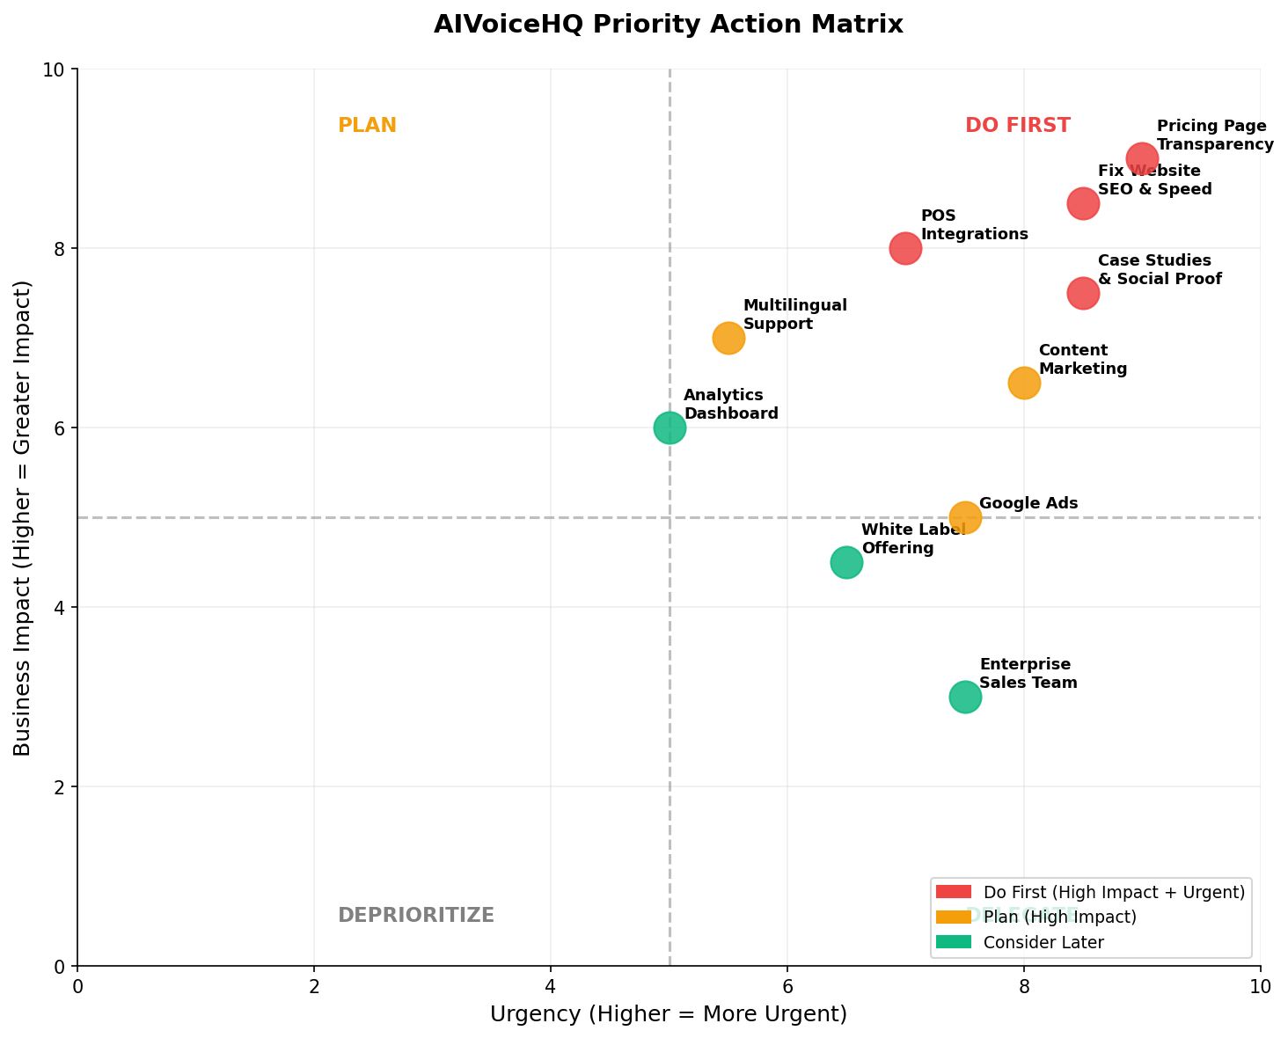
Figure 6: AIVoiceHQ Priority Action Matrix – Impact vs. Urgency

8.1 Critical Gaps (Fix Within 30 Days)
Gap | Description | Competitive Risk | Fix
No Pricing Page | B2B buyers disqualify vendors without pricing. Industry standard is 3-tier pricing. | HIGH — buyers move to Loman or Kea | Publish 3-tier pricing page within 2 weeks
Zero SEO Content | No blog, no comparison pages, no keyword-optimized content | CRITICAL — invisible in Google | 8–12 blog posts in 60 days; start with "AI phone ordering for restaurants 2026"
No Social Proof | No testimonials, no case studies, no client logos on website | HIGH — buyers want proof before demo | Collect 3 testimonials from beta users; publish immediately
No G2/Capterra Profile | Not listed on major B2B software review sites where buyers research | HIGH — missing discovery channel | Create profiles on G2, Capterra, GetApp, Trustpilot this week
Weak CTA Strategy | No clear "Book a Demo" or "Start Free Trial" above the fold | MEDIUM | Redesign homepage hero with single bold CTA

8.2 Strategic Gaps (Fix Within 90 Days)
- POS Integrations: Expand beyond current integrations to Toast, Square, Clover, Olo, SpotOn — these are table stakes for restaurant buyers.
- Multilingual Support: Add Spanish language support at minimum (42 million Spanish speakers in the US; major restaurant industry demographic).
- Analytics Dashboard: Build a client-facing dashboard showing calls handled, orders taken, revenue recovered, and upsells generated.
- White Label Option: Offer a white-label version for POS companies, restaurant consultants, and franchisors to resell.
- API Documentation: Publish developer docs so tech-forward restaurant groups can self-integrate.

9. How Dodail Can Help AIVoiceHQ Grow
Dodail brings multi-discipline expertise specifically suited to accelerate AIVoiceHQ from its current early-stage position to a recognized market leader. Here is a concrete breakdown of how Dodail's team can create value:

9.1 Dodail Service Stack for AIVoiceHQ
Service | What Dodail Does | Expected Outcome | Timeline
SEO & Content Strategy | Full keyword research, content calendar (48+ pieces/year), on-page optimization, technical SEO, link building outreach | Page 1 Google for 10+ target keywords; 3x organic traffic in 6 months | 30–90 days
Website Redesign & CRO | UX audit, conversion-optimized redesign, pricing page, A/B testing setup, heatmap installation | 2–4x improvement in demo booking rate | 30–60 days
Brand Identity | Brand messaging framework, positioning statement, visual identity refresh, tone of voice guide | Cohesive brand that resonates with restaurant owners | 30 days
Marketing Automation | HubSpot or Mailchimp setup, lead nurture sequences, ROI calculator tool, email newsletter launch | 40% of leads converted from first-touch within 3 months | 45–60 days
Paid Media Management | Google Ads, LinkedIn Ads, Meta retargeting — strategy, creative, optimization | CPL under $80; 50+ demo bookings/month at scale | 30 days to launch
PR & Thought Leadership | Press releases, industry publication pitching, award submissions, podcast placement | 5–10 media mentions in Year 1; authority signals for SEO | 60–90 days
Partnership Development | Intro to POS providers, restaurant consultants, food tech VCs and accelerators | Channel partnerships generating 20%+ of new leads | 90–180 days
Security & Compliance Advisory | PCI-DSS readiness assessment, privacy policy review, security page creation | Compliance roadmap + trust signals for enterprise prospects | 30 days

9.2 Projected Growth with Dodail Partnership
Metric | Current | 3 Months | 6 Months | 12 Months
Organic Traffic/Month | < 500 | 2,000 | 6,000 | 18,000+
Google Keyword Rankings | < 5 | 25+ | 60+ | 150+
Demo Bookings/Month | Unknown/Low | 20 | 50 | 120+
Domain Authority | ~15 | 22 | 32 | 45+
Review Profiles | 0 | 4 | 6 | 8+
Restaurant Clients | Early/Unknown | +15 | +50 | +150

10. Immediate Action Plan (Next 30 Days)
Prioritize ruthlessly. The following 10 actions have the highest ROI and lowest cost to implement. Execute these before any other initiative.

Priority | Action | Owner | Deadline | Cost
1 | Publish transparent 3-tier pricing page | Product + Marketing | Week 1 | $0
2 | Create G2, Capterra, GetApp, Trustpilot profiles | Marketing | Week 1 | $0
3 | Redesign homepage headline + CTA (A/B test ready) | Dev + Marketing | Week 1–2 | $500–$1,500
4 | Collect 3 restaurant testimonials + publish on site | Customer Success | Week 2 | $0
5 | Set up Google Search Console + fix technical SEO errors | Dev | Week 1–2 | $200–$500
6 | Publish first 4 SEO blog posts (AI phone ordering focus) | Content | Week 2–3 | $500–$1,000
7 | Launch LinkedIn company page + start posting 3x/week | Marketing | Week 2 | $0
8 | Install Hotjar for heatmapping and session recording | Dev | Week 1 | $99/mo
9 | Apply for 2 competitor POS integrations (Toast, Square) | Dev | Week 2–4 | $0–$2,000
10 | Launch Google Ads campaign ($1,500 budget) for competitor terms | Marketing | Week 3 | $1,500/mo

11. Conclusion
AI Voice HQ sits at the intersection of two massive tailwinds: the $1.5 trillion US restaurant industry and the $22.5 billion (and rapidly growing) Voice AI market. The product concept is validated, the technology is real, and the market pain is acute.

However, opportunity alone does not create market success. In B2B SaaS — especially in restaurant technology — trust, visibility, and execution speed determine who wins. Today, AIVoiceHQ scores critically low on digital presence, SEO, social proof, and feature completeness relative to well-funded competitors.

The good news: most of these gaps are fixable quickly and cost-effectively. Unlike raising funding or building enterprise-grade POS integrations, publishing a pricing page, writing 8 blog posts, and creating G2 profiles can be done in 2 weeks. These low-effort, high-impact moves must happen immediately.

Dodail's recommended path forward is a phased 90-day execution sprint: fix the foundation (pricing, SEO, trust signals), build the content engine (blog, comparison pages, video), and launch paid acquisition. If executed with discipline, AIVoiceHQ can realistically achieve Page 1 Google rankings for 25+ keywords, 50+ monthly demo bookings, and 50 new restaurant clients within 6 months.

The market window is open — but competitors are investing heavily. Every month without action is market share ceded to Loman, Kea, and the next wave of well-funded entrants.

Prepared by Dodail | May 2026 | Confidential

