DIGITAL GROWTH & MARKET STRATEGY REPORT

AI VOICE HQ — aivoicehq.com

Competitive Analysis • SEO Audit • Market Intelligence • Growth Roadmap



Prepared by Dodail Solutions Private Limited
Hyderabad • May 2026

$49B  Market by 2029 | 34.8%  Voice AI CAGR | 26%  Restaurants Using AI | $27K+  Revenue Recovered/yr

Table of Contents
1. Executive Summary 3
2. Market Opportunity & Industry Analysis 4
2.1 The Restaurant AI Voice Market in 2026 4
2.2 Adoption & Consumer Trends 5
3. Competitive Analysis 6
3.1 Market Landscape 6
4. SWOT Analysis 8
5. SEO Audit & Search Strategy 9
5.1 Current SEO Status 9
5.2 Critical SEO Issues 10
5.3 Keyword Strategy 10
6. UI/UX & Website Experience Audit 11
6.1 What Works Well 11
6.2 UX Improvements Needed 11
7. Cybersecurity & Trust Audit 12
7.1 Security Status Overview 12
8. Branding & Positioning Analysis 13
8.1 Brand Assessment 13
8.2 Recommended Positioning 13
8.3 Brand Voice Guidelines 13
9. 90-Day Marketing Action Plan 14
Month 1: Foundation — Fix Before You Amplify 14
Month 2: Content & Visibility — Build Authority 14
Month 3: Scale & Partnerships — Accelerate 14
10. Immediate Action List — First 30 Days 15
11. How Dodail Solutions Can Help 16
12. Conclusion 16

1. Executive Summary
AI Voice HQ is an AI-powered phone ordering platform for restaurants. It answers every customer call on the first ring, takes orders through natural conversation, and routes them directly to the POS. The product is well-positioned in a rapidly growing market with transparent pricing and a compelling Deliverect partnership. However, critical gaps in digital visibility, SEO authority, trust signals, and brand depth are limiting growth.

Key Strengths  - Flat $300/month transparent pricing  - Deliverect: 1,000+ POS integrations  - 48-hour setup, zero hardware  - Live working demo line  - Multilingual: Hindi, Telugu, Tamil  - Strong $27K/yr lost revenue narrative | Critical Gaps  - Estimated DA ~3-5 (critically low)  - No blog or content marketing at all  - No customer testimonials visible  - Zero social media presence  - Single-page SPA limits indexability  - No Privacy Policy or Terms of Service

2. Market Opportunity & Industry Analysis

2.1 The Restaurant AI Voice Market in 2026
The restaurant AI voice ordering market is in explosive growth. The overall restaurant AI market is valued at $10 billion in 2026, projected to reach $49 billion by 2029 at a 34.8% CAGR. The voice AI market broadly crossed $22.5 billion across industries in 2026. Burger King launched AI voice pilots in February 2026. Taco Bell and Pizza Hut deployed to 500 locations in 2025. Over 10,000 restaurant locations globally run AI voice ordering today.

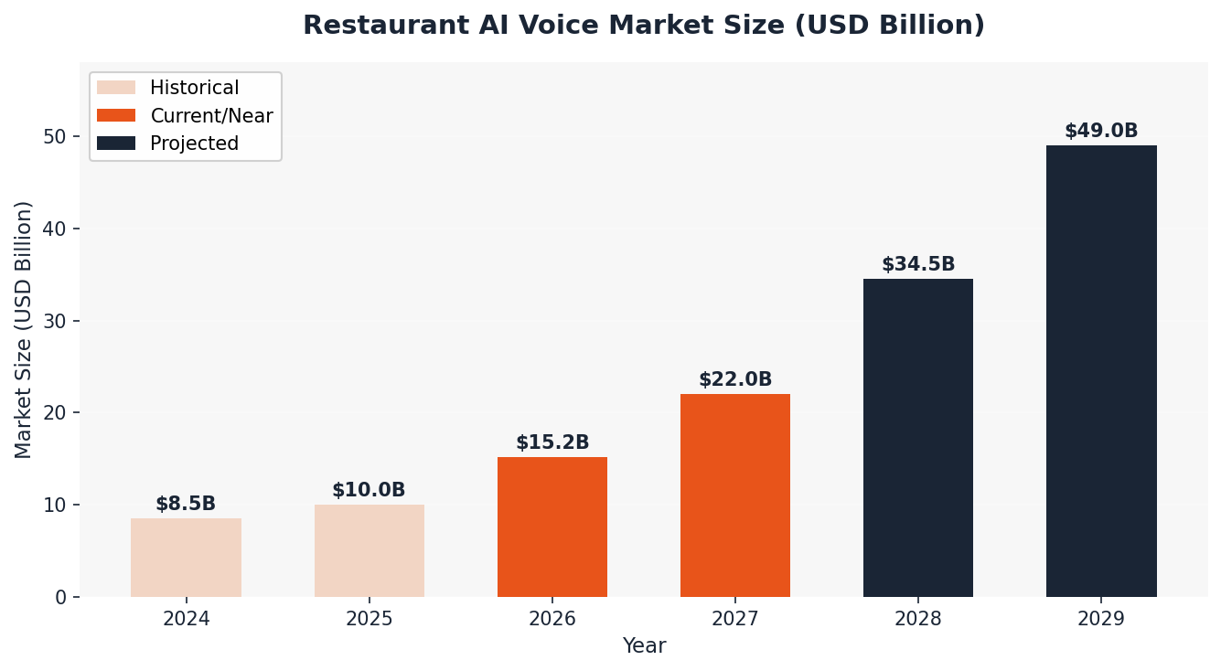
Figure 1: Restaurant AI Market Growth 2024–2029 (USD Billion) — Source: Mordor Intelligence, Ringly.io 2026

The average restaurant misses 43% of incoming calls, losing up to $292,000 in annual revenue. AI Voice HQ directly solves this problem with quantifiable ROI. At $300/month, the tool pays for itself from just one and a half recovered orders per day.

2.2 Adoption & Consumer Trends
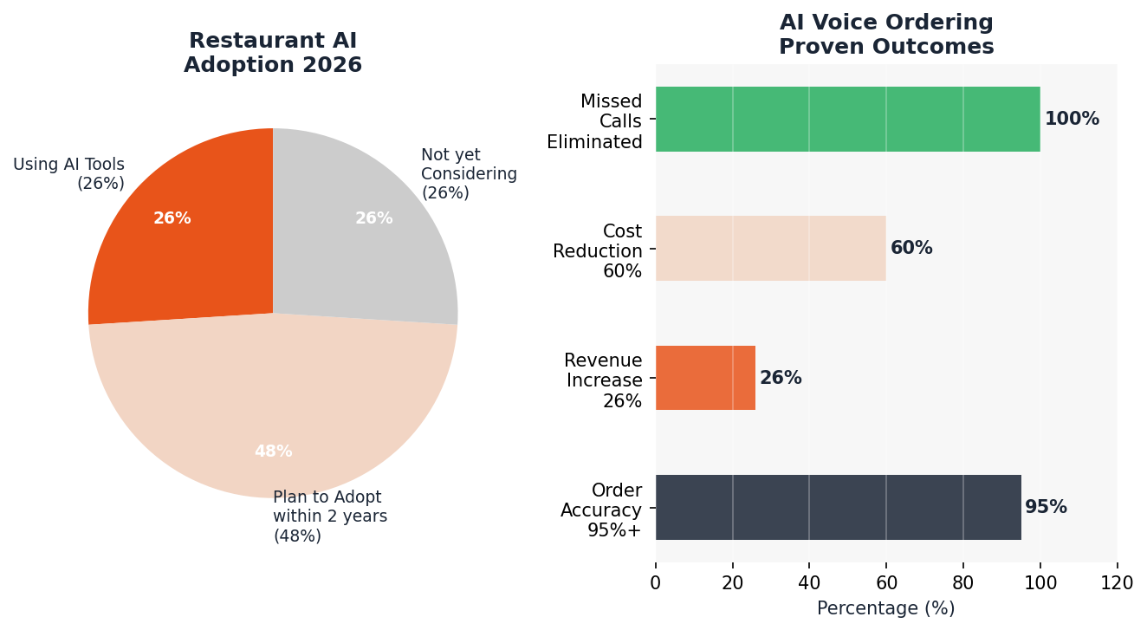
Figure 2: Restaurant AI Adoption (2026) & Voice AI Outcome Metrics — Source: NRA 2026, Voicebot.ai

Metric | Data Point | Source
Voice AI Market Size (2026) | $22.5 Billion globally | Ringly.io / Gartner
Restaurant AI Market (2029 proj.) | $49 Billion | Mordor Intelligence
Voice AI CAGR | 34.8% | Industry Reports 2026
Restaurants Missing 43% Calls | Up to $292K lost/year | Loman.ai Research 2026
Order Accuracy with AI | 95%+ vs ~70% human | Multiple Platforms
AI Cost per Call | $0.40 vs $7–12 human | Teneo.ai / Forrester
Gartner Labor Savings 2026 | $80 Billion contact centers | Gartner 2026
Restaurants Using AI for Orders | Only 6% — 94% is the TAM | NRA 2026 Report

3. Competitive Analysis

3.1 Market Landscape
The restaurant voice AI space is crowded but fragmented. Loman AI raised $3.5M seed. Vox AI raised $8.7M. Kea.ai has 8 years of track record. SoundHound serves enterprise chains with $50K+/year contracts. Most established players are either too expensive, too slow to set up, or use unpredictable per-minute billing. AI Voice HQ sits in an underserved SMB sweet spot: flat $300/month, 48-hour setup, and Deliverect integration covering 1,000+ POS systems.

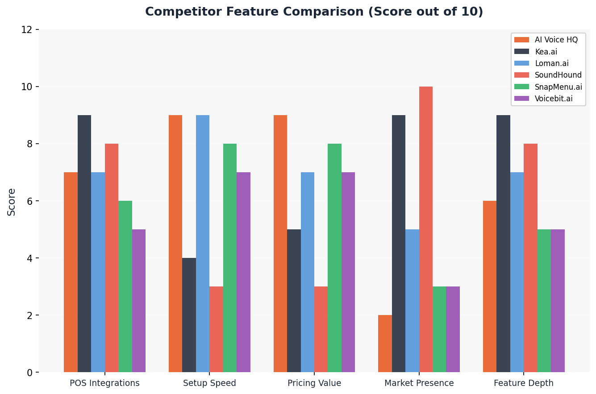
Figure 3: Competitor Feature Score Comparison (Dodail Research, 2026) — Score out of 10

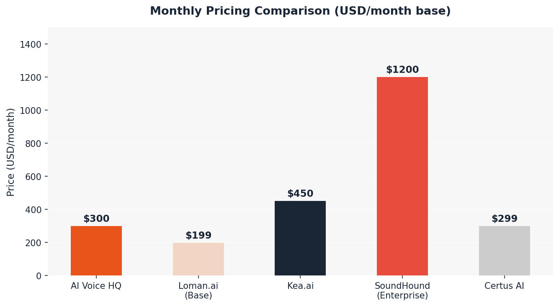
Figure 4: Monthly Pricing Comparison (USD) — AI Voice HQ vs. Key Competitors

Competitor | Target | Pricing | Setup | Strength | Weakness
Kea.ai | Enterprise | $450/mo flat | 4+ weeks | 8yr track record, deep menu AI | Slow, expensive
Loman.ai | SMB Pizza | $199-399+overages | <24hrs | Fast setup, clean portal | 4-8min POS delay, overage fees
SoundHound | Enterprise | $50K+/yr | Months | Drive-thru expertise, 40+ langs | Not for independents, needs hardware
Slang.ai | Reservations | $450-600/mo | 30 min | Quick reservation AI | Does NOT take food orders
SnapMenu.ai | SMB | Quote-based | ~1 week | Visual menu AI | Limited POS depth
Voicebit.ai | SMB/Startups | Affordable | ~3 days | Simple setup | Less proven, limited integrations
AI Voice HQ | Independent | $300/mo flat | 48 hours | Flat pricing, Deliverect 1000+ POS | Very low digital presence

★ AI Voice HQ Competitive Advantage: The combination of Deliverect's 1,000+ POS ecosystem + flat $300/month + 48-hour setup + multilingual support (including Telugu, Hindi, Tamil) creates a compelling independent restaurant value proposition that no single competitor currently matches in full.

4. SWOT Analysis
✅ STRENGTHS  - Transparent flat pricing + first month free  - Deliverect partnership: 1,000+ POS platforms  - Fast 48-hour setup, no hardware needed  - Live working demo phone line  - Multilingual: English, Hindi, Telugu, Tamil, Mandarin  - $27K/year recovered revenue narrative  - Spam call filtering, 20 simultaneous calls  - Analytics dashboard included | ⚠ WEAKNESSES  - Estimated Domain Authority ~3-5 (critically low)  - No blog, case studies, or content  - No customer testimonials or social proof  - Zero visible social media activity  - Single-page website limits SEO indexability  - No Privacy Policy or Terms of Service  - No security/compliance badges visible  - No pricing comparison content

🚀 OPPORTUNITIES  - Only 6% of restaurants use AI for ordering — 94% is TAM  - Indian restaurant market is underserved by all competitors  - Multilingual capability opens South Asian diaspora globally  - SEO content authority possible fast in low-competition niche  - Case study content will convert — ROI proof IS the sale  - Toast/Square/Deliverect channel partnerships  - Dodail can provide full-stack digital growth support  - GEO (Generative Engine Optimization) for AI search | ⛔ THREATS  - Well-funded competitors (Loman $3.5M, Vox $8.7M raised)  - Toast/Square launching native AI voice add-ons at $99/mo  - McDonald's and Yum Brands building proprietary AI  - Market crowding quickly — brand window narrowing  - Per-location pricing may face pressure  - Trust deficit without reviews by end of 2026  - AI accuracy issues can create negative word-of-mouth

5. SEO Audit & Search Strategy

5.1 Current SEO Status
AI Voice HQ's digital footprint in search engines is critically limited. The website is a well-designed single-page application (SPA) but structured in a way that prevents meaningful search engine indexing. Based on the site structure and comparison with competitor digital profiles, the estimated Domain Authority is approximately 3-5, placing it in the "new/minimal" category — nearly invisible to Google for all non-brand searches.

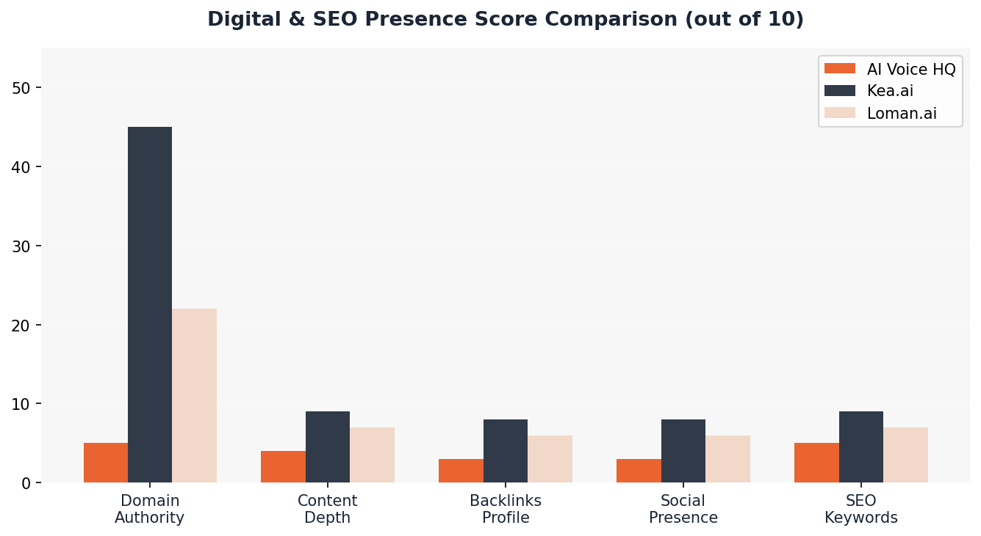
Figure 5: SEO & Digital Presence Score Comparison — AI Voice HQ vs. Kea.ai vs. Loman.ai (Dodail Analysis, 2026)

5.2 Critical SEO Issues
Issue | Severity | Impact | Fix Timeline
Single-page SPA website | CRITICAL | Very few indexable URLs for Google | 2-4 weeks
No blog or content hub | CRITICAL | Zero keyword ranking potential | 4-6 weeks
No backlinks / DA ~3-5 | CRITICAL | New sites rank poorly without authority | 3-6 months
Missing Schema markup (JSON-LD) | HIGH | No rich snippets or FAQ schema | 1-2 weeks
No sitemap.xml submitted | HIGH | Crawlability issues for Googlebot | 1 week
No Google Business Profile | HIGH | No local SEO presence | 1 week
No social media signals | HIGH | Brand trust signals missing | 2 weeks
Meta descriptions too generic | MEDIUM | Low CTR in search results | 1 week
No alt text on images | MEDIUM | Image SEO missed | 1 week

5.3 Keyword Strategy
Target Keyword | Monthly Volume (est.) | Difficulty | Priority
AI phone ordering for restaurants | 2,400/mo | Medium | TIER 1 — Immediate
restaurant voice AI | 1,900/mo | Medium-High | TIER 1 — Immediate
AI answering service restaurant | 880/mo | Low-Medium | TIER 1 — Quick Win
restaurant missed call solution | 590/mo | Low | TIER 2 — Blog Content
AI voice ordering Indian restaurant | 260/mo | Very Low | TIER 3 — Local Niche
kea ai alternative cheaper | 320/mo | Low | TIER 3 — Competitor Page

6. UI/UX & Website Experience Audit

6.1 What Works Well
- Strong hero headline: "Are you losing sales to missed calls?" — immediately resonates
- Live demo phone number is an excellent on-page conversion tool (rare in SaaS)
- Clear 4-step How It Works flow is visually clean and easy to understand
- Transparent pricing with no hidden fees builds trust immediately
- FAQ section addresses real sales objections before they arise
- Deliverect partnership and POS logo strip adds institutional credibility
- Mobile viewport is correctly configured

6.2 UX Improvements Needed
UX Issue | User Impact | Recommended Fix
No video explainer | High bounce — visitors leave before understanding product | Add 90-second explainer video above the fold
No customer photos or logos | Zero social proof; visitors question legitimacy | Add 3-5 restaurant client photos with name + city
No live chat widget | Inquiries go to email; conversion drops significantly | Add Intercom or Tidio live chat with AI pre-screening
No exit-intent popup | Visitors leave without submitting contact info | Add "Get 1st Month Free" exit popup with email capture
Metrics appear unverified | "0 Missed Calls" looks like a placeholder statistic | Add counter animation + "as of [date]" attribution
No case study visible | Cannot visualize ROI before committing to a call | Add one full restaurant before/after story with revenue numbers
No sticky CTA in navbar | Low-friction contact not available as user scrolls | Add persistent "Get Started Free" button in fixed nav

7. Cybersecurity & Trust Audit

7.1 Security Status Overview
As a platform handling restaurant order data and customer phone calls (which contain PII), AI Voice HQ operates in a compliance-sensitive space. Restaurant operators will ask about data security before signing up. Below are findings from a front-end security review:

Security Item | Status | Recommendation
HTTPS / SSL Certificate | ✅ Active | Maintain and monitor expiry monthly
Privacy Policy Page | ❌ Missing | Add immediately — GDPR/CCPA required
Terms of Service Page | ❌ Missing | Add before scaling customer acquisition
Call Recording Disclosure | ⚠ Implied only | Add explicit consent language in call + website
PCI-DSS Compliance Statement | ❌ Not visible | Display PCI badge if handling payment links
SOC 2 Type II | ❌ Not mentioned | Pursue or display Deliverect compliance coverage
Cookie Consent Banner | ❌ Missing | Required for EU/UK visitors under GDPR
Data Retention Policy | ❌ Not stated | Document call recording and order data retention
Two-Factor Authentication (Portal) | Unknown | Ensure restaurant portal uses 2FA
Sub-processor Disclosure | ❌ Not disclosed | State which AI model/voice engine powers the service

⚠ URGENT: Missing Privacy Policy and Terms of Service expose AI Voice HQ to regulatory risk (CCPA, GDPR, PIPEDA). These must be added within 30 days. Restaurant operators will refuse to sign up without basic legal documentation present.

8. Branding & Positioning Analysis

8.1 Brand Assessment
Brand Strengths  - Clear name communicates product instantly  - Professional, clean visual aesthetic  - Strong value proposition headline  - Direct, problem-focused tone of voice  - "Never Miss Another Order" is a powerful tagline | Brand Gaps  - No brand story or founder narrative  - No defined brand personality  - Generic color palette — not ownable or memorable  - No name or identity for the AI voice assistant  - No content marketing voice or thought leadership

8.2 Recommended Positioning
Recommended Brand Position: "The AI that never puts your restaurant on hold." Target Persona: Independent restaurant owners (1-5 locations) who are understaffed, losing calls during rush hours, and frustrated by complex enterprise solutions. AI Voice HQ is the only solution that sets up in 48 hours, integrates with any POS through Deliverect, and costs less than losing one order per day.

8.3 Brand Voice Guidelines
- Tone: Confident, direct, no-nonsense. Speak to restaurant owners as peers, not as tech users.
- Language: Use restaurant vocabulary — "ticket" not "order object", "rush hour" not "peak traffic period".
- Structure: Empathy first (we understand your pain) → solution → proof → action.
- Avoid: Technical jargon (LLM, NLP, AI inference). Translate everything to plain business impact.
- AI Identity: Name the AI voice assistant — e.g., "Aria" or "Vox" — to build brand attachment and recognition.

9. 90-Day Marketing Action Plan

Month 1: Foundation — Fix Before You Amplify
Week | Action | Owner
Week 1 | Add Privacy Policy, Terms of Service, Cookie Banner | Legal + Dev
Week 1 | Set up Google Analytics 4, Search Console, Clarity heatmap | Dodail
Week 1 | Create and verify Google Business Profile listing | Dodail
Week 2 | Expand to multi-page SEO site: Home, Features, Pricing, Blog, Case Studies | Dodail Dev
Week 2 | Publish first 2 SEO blog posts targeting Tier 1 keywords | Dodail Content
Week 3 | Collect and publish 3 restaurant testimonials on homepage | AI Voice HQ
Week 3 | Set up LinkedIn company page + publish first 5 posts | Dodail Social
Week 4 | Launch Google Ads for "AI restaurant phone ordering" keywords | Dodail Ads
Week 4 | Implement Schema markup: SoftwareApplication, FAQPage, Organization | Dodail SEO

Month 2: Content & Visibility — Build Authority
- 4 blog posts: Kea vs Loman vs AI Voice HQ comparison; How Indian restaurants stop losing orders; Top 10 signs you need AI phone ordering; ROI calculation guide
- Weekly LinkedIn posts: market stats, client spotlights, short video demo clips
- Outreach to 20 restaurant tech blogs for guest post placements (backlinks)
- Submit to G2, Capterra, GetApp, Product Hunt for third-party review listings
- Build and publish "ROI Calculator" tool on website to capture leads organically
- Launch email newsletter to restaurant owner communities

Month 3: Scale & Partnerships — Accelerate
- Partner with Deliverect for co-marketing: press releases, webinars, joint case studies
- Launch YouTube channel: short AI demo videos, before/after restaurant stories
- Outreach to restaurant associations (NRA, state chapters) for featured listings
- Run Facebook/Instagram retargeting ads to restaurant owner demographics
- Launch referral program: "Refer a restaurant, get $50 account credit"
- Apply for Toast and Square marketplace listings for organic channel distribution

10. Immediate Action List — First 30 Days
3  Legal Fixes Needed | 7  SEO Quick Wins | 5  Trust Signals to Add | 6  Content Pieces Needed

# | Action Required | Priority | Time to Complete
01 | Add Privacy Policy and Terms of Service pages | CRITICAL | 3 days
02 | Add GDPR-compliant cookie consent banner | CRITICAL | 2 days
03 | Add explicit call recording consent language on site | CRITICAL | 2 days
04 | Set up Google Analytics 4 + Search Console | URGENT | 1 day
05 | Create and verify Google Business Profile | URGENT | 1 day
06 | Submit sitemap.xml to Google Search Console | URGENT | 1 day
07 | Add FAQ schema + Organization schema markup (JSON-LD) | HIGH | 3 days
08 | Add 3 real restaurant testimonials with photos | HIGH | 1 week
09 | Add SSL seal + Deliverect partner badge + security trust signals | HIGH | 2 days
10 | Publish first SEO blog post targeting Tier 1 keyword | HIGH | 1 week
11 | Create LinkedIn company page + publish first 5 content pieces | HIGH | 1 week
12 | Add live chat widget (Intercom or Tidio) | MEDIUM | 2 days
13 | Add exit-intent email capture popup | MEDIUM | 3 days
14 | Submit to G2 and Capterra for software review listing | MEDIUM | 3 days
15 | Create comparison landing pages: "AI Voice HQ vs Kea" etc. | MEDIUM | 2 weeks

11. How Dodail Solutions Can Help
Dodail Solutions is a full-service digital agency based in Hyderabad with expertise spanning SEO, content marketing, web development, AI-powered automation, branding, and SaaS growth. We serve clients across India, UAE, and the USA. We are uniquely positioned to serve AI Voice HQ because we operate at the intersection of restaurant technology, AI, and digital marketing.

Service Package | What Dodail Delivers
SEO & Content Growth | Keyword strategy, 4 blog posts/month, on-page SEO, schema markup, link building, Search Console monitoring
Website Expansion | Convert SPA to multi-page SEO site, case studies, ROI calculator, competitor comparison pages
Branding & Design | Brand guidelines, AI assistant persona/name, social media templates, pitch deck
Social Media Management | LinkedIn + Twitter/X: 3 posts/week — stats, tips, demo clips, restaurant success stories
Paid Ads Management | Google Ads for restaurant voice AI keywords, Meta retargeting, G2/Capterra sponsored reviews
Cybersecurity & Legal | Privacy policy, ToS, GDPR/CCPA compliance, cookie banner, call recording disclosures
Review & Reputation | G2, Capterra, Trustpilot, Product Hunt listing + review generation strategy
Monthly Analytics Report | SEO rank tracking, traffic, conversions, competitor monitoring dashboard

12. Conclusion
AI Voice HQ has the right product at exactly the right moment. The restaurant voice AI market is growing at 34.8% CAGR. Only 6% of restaurants currently use AI for ordering. The platform's combination of transparent flat pricing, instant Deliverect POS integration, multilingual support, and 48-hour setup genuinely differentiates it from the crowded enterprise-heavy competitive field.
However, product excellence alone will not win this market. Kea.ai spent 8 years building content authority. Loman.ai is raising capital and publishing SEO content at scale. Every month AI Voice HQ waits to establish digital presence, the window narrows. The positive news is that SEO competition for core restaurant voice AI keywords is still relatively low — meaning an aggressive 90-day content and link-building campaign can yield measurable page 1 results within 4-6 months.
The three most critical moves for the next 30 days are clear: (1) Add legal pages immediately to remove regulatory risk, (2) Expand to a multi-page SEO website with a content blog, and (3) Collect and publish real customer success stories with revenue impact data. Dodail Solutions is prepared to execute all of this end-to-end.

Prepared by Dodail Solutions Private Limited
Maruthi Nagar, Hyderabad • inquiries@dodail.in • https://calendly.com/marketing-2255/30min
May 2026 • Confidential — Prepared exclusively for AI Voice HQ

