HOW TO CREATE GITHUB ACCOUNT

STEP 1: Open google chrome and search Github.com

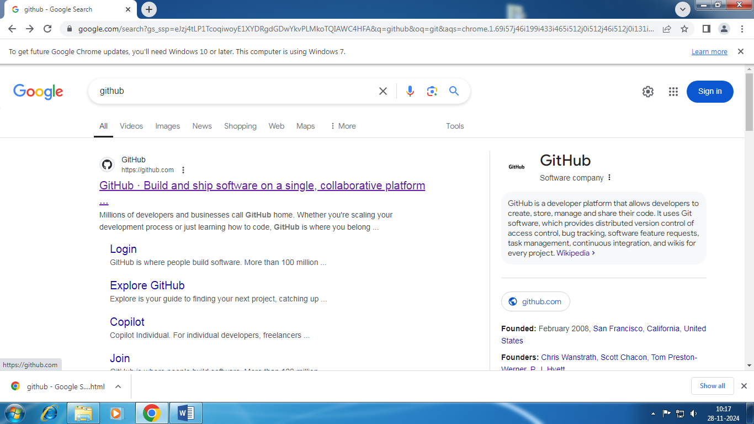

STEP 2: Open 1st link

STEP 3: Signup for Github. And enter your mail and details

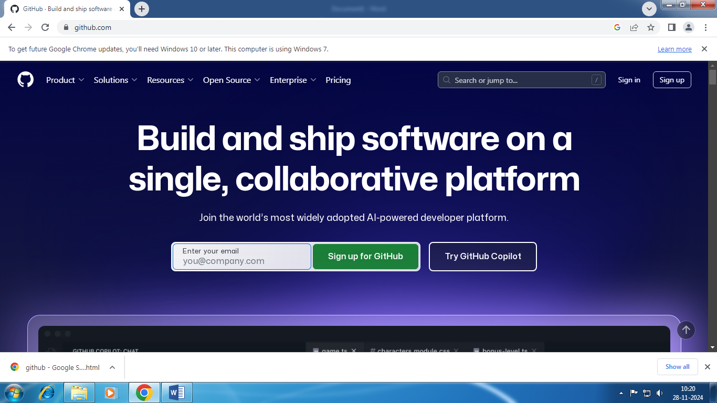

STEP 4: Click on ‘continue’.

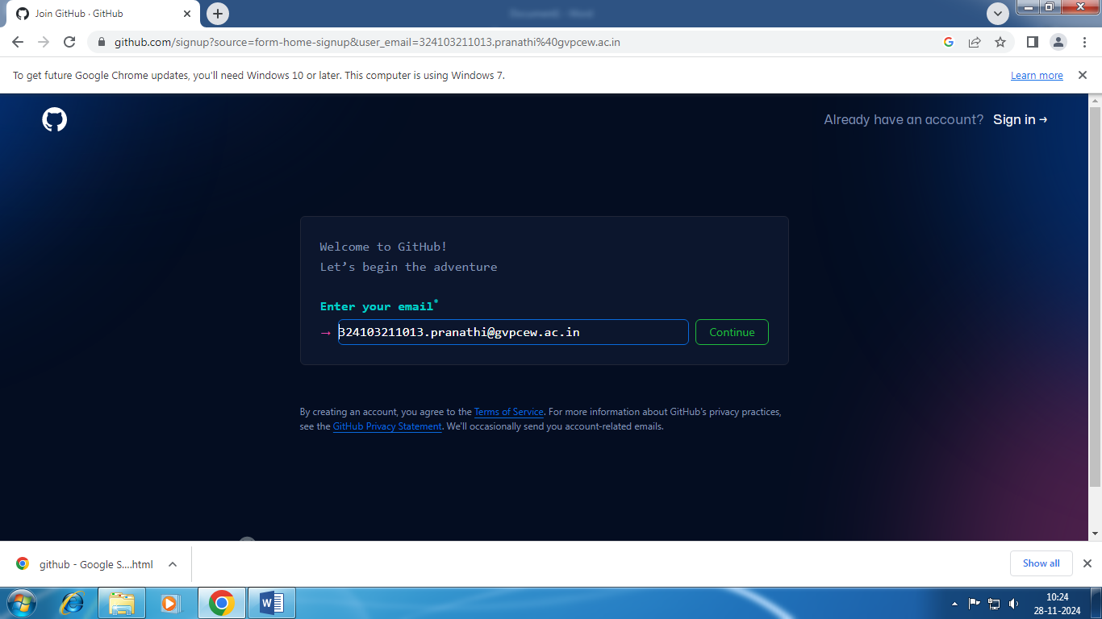

STEP 5: Create a password and user name then click on ‘continue’.

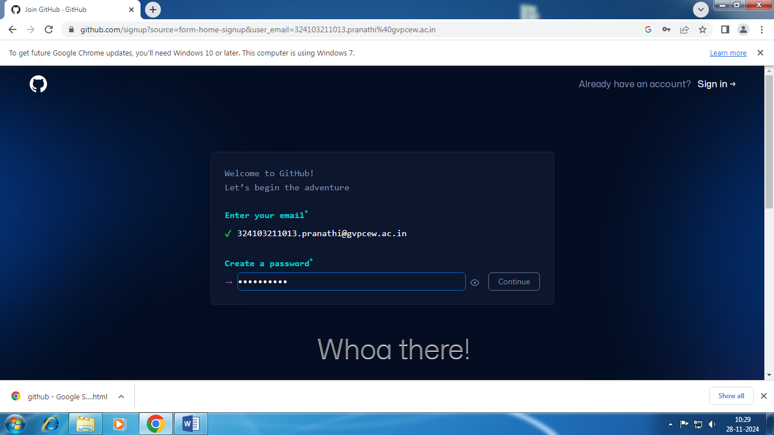

STEP 6: Click on ‘verify your account’.



STEP 7: Do this for verification.

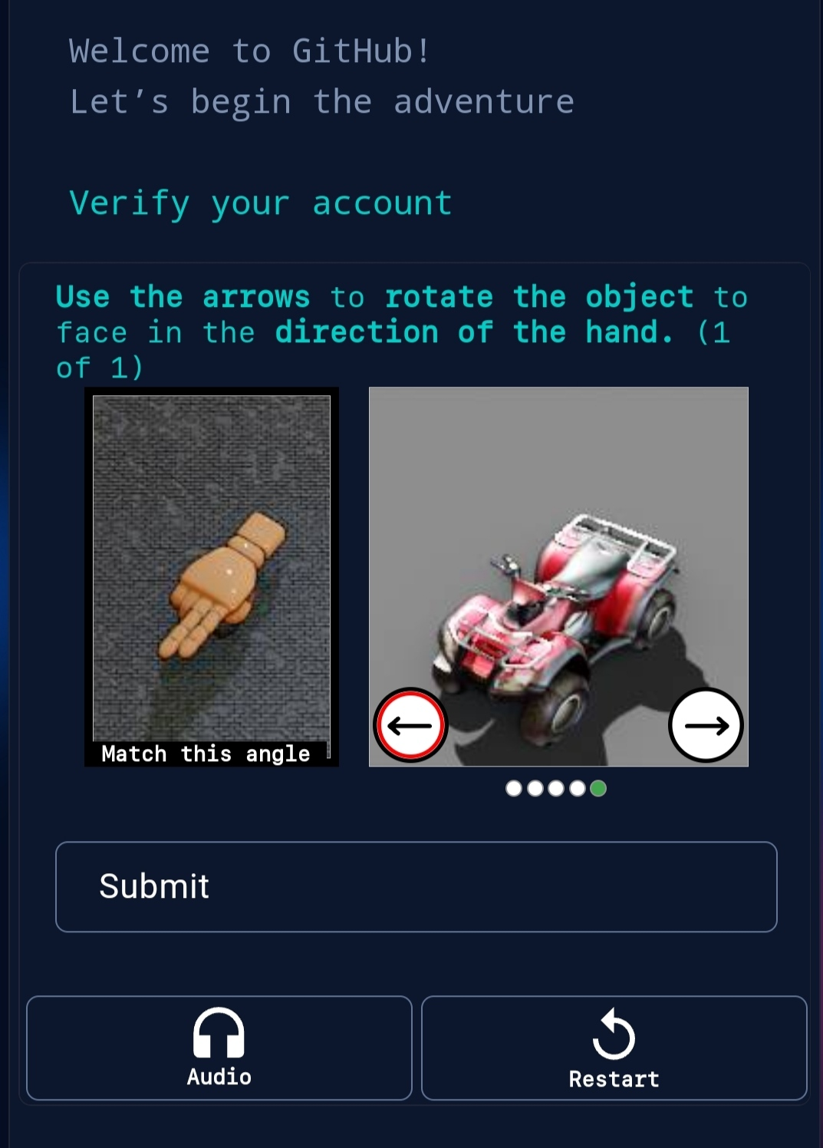

STEP 8: After verification it will send a code to your mail.



STEP 9: After entering the code it will connet to your GitHub account.



STEP 10: It will displays dashboard.

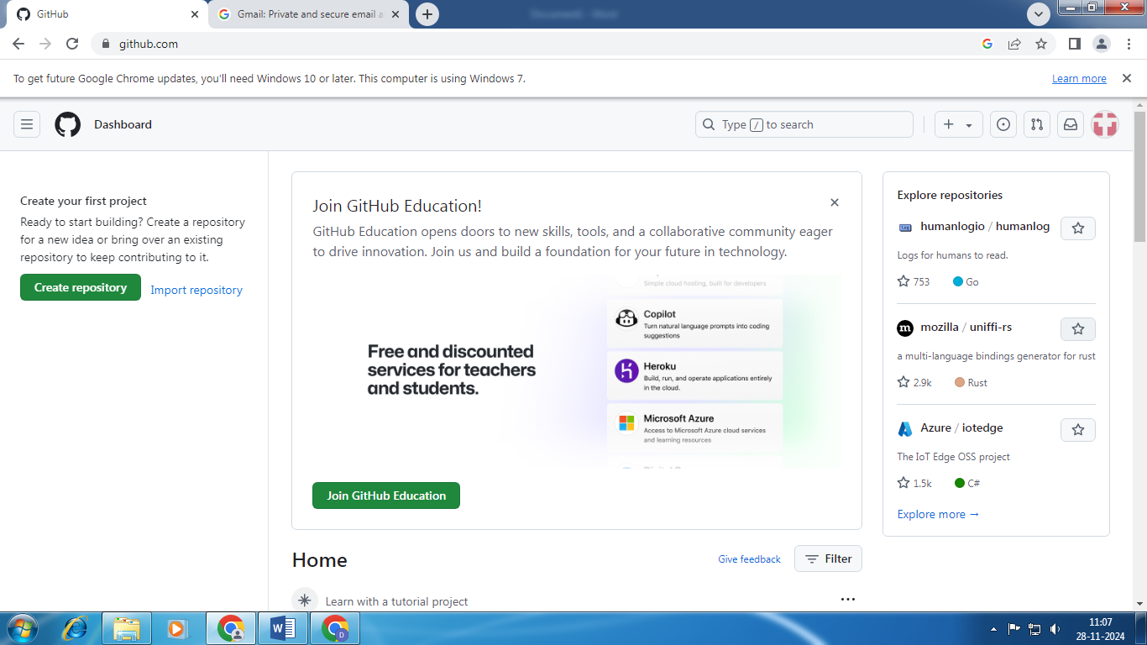

STEP 11: Click on ‘create repository’,and set a repository name and click on continue.

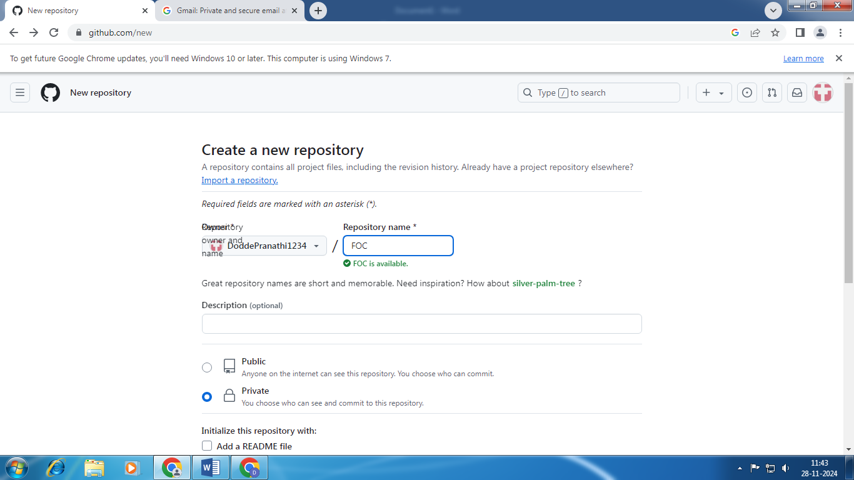

STEP 12:Click on uploading an existing file.

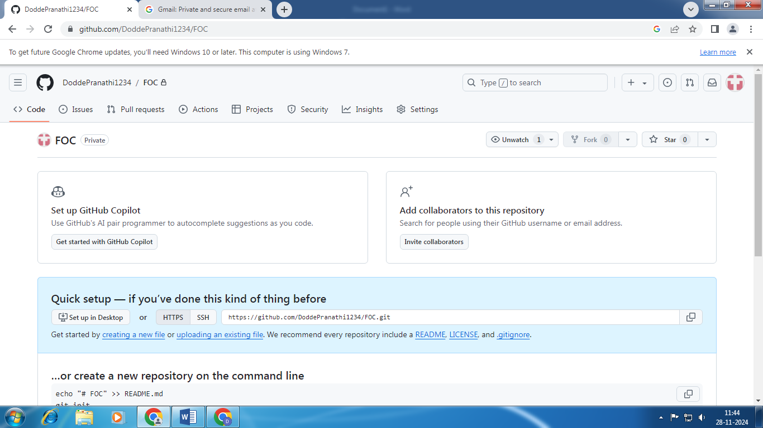

STEP 13: Then click on ‘choose your file’ and select a file.

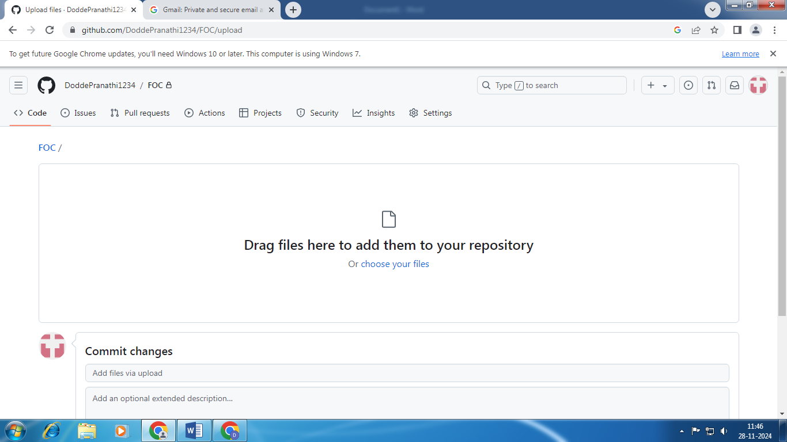

STEP 14: Then click on ‘upload’.

