Step 1
- Netstat: Prints network connections, routing tables and masquerading devices on the current Linux network. It prints open sockets, groups, interfaces, masquerades, and statistics.
To put it in my own words: it lists out all the different devices and networks/IPs it is connected to.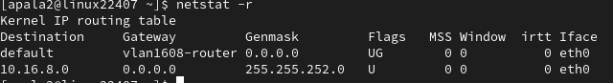
- Ifconfig: Shows/lists all the network interfaces. It is used to set up configurations initially. Users can modify, view or add new interfaces.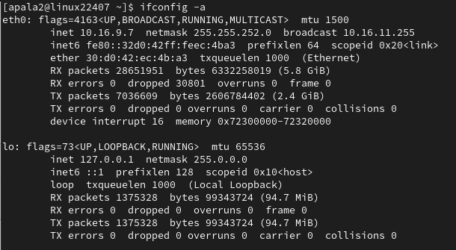

- Hostname: Used to display the systems DNS name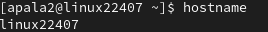
- Ping: Sends an Echo request to another network or device to receive a mandatory response that is in the format of a ICMP header, struct timeinterval. Basically it checks the ability to connect to another dvice or network.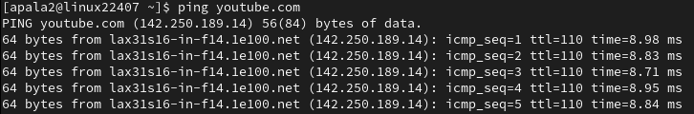
- Traceroute: Tracks the route packets take on the way to their host/destination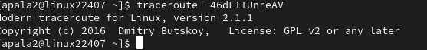
- Telnet: Uses the TELNET protocol to communicate with another host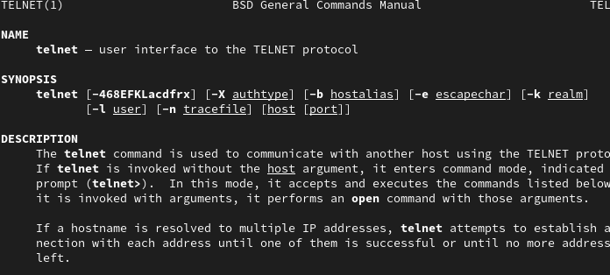
- Host/Dig: It is used to for DNS lookups. It converts domain names to IP address and vice versa.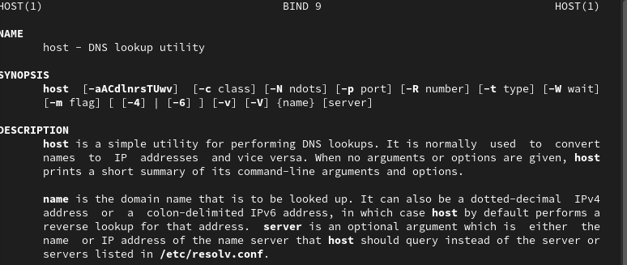
- Route modifies network routing tables so that it can set up static hosts when being configure by ifconfig program.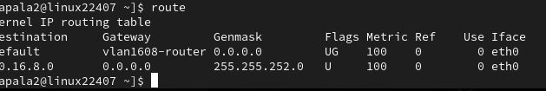
- Arp manipulates kernel network neighbor cache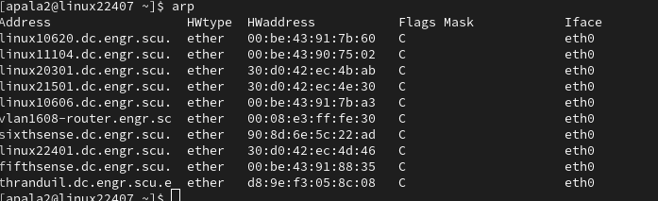

Step 2-Ping Testing
North America-youtube.com

64 bits
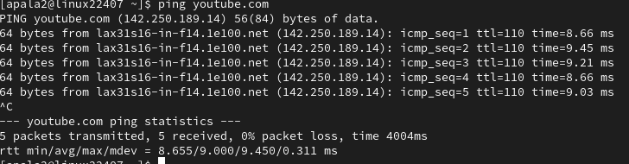
- 0% packet loss
- average RTT time 9.000ms

32 bits
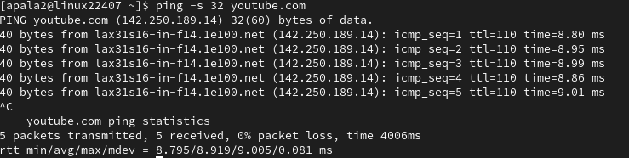
- 0% packet loss
- average RTT time 8.919ms

1048 bits
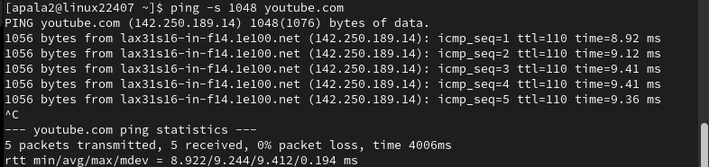
- 0% packet loss
- Average RTT time 9.244 ms

Asia- Youtube.in(India)

64 bits
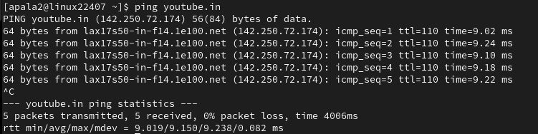
- 0% packet loss
- 9.150ms

32 bits
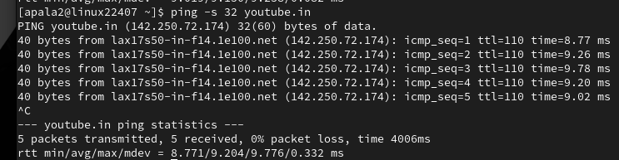
- 0% packet loss
- 9.204

1048 bits
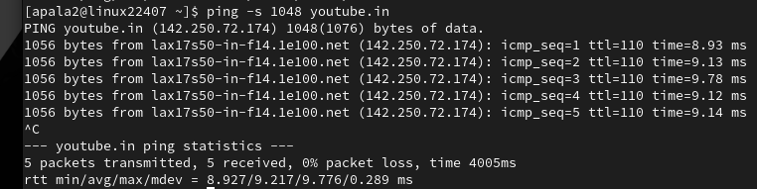
- 0% packet loss
- 9.217 ms

Europe-Youtube.hu(Hungary)

64 bits
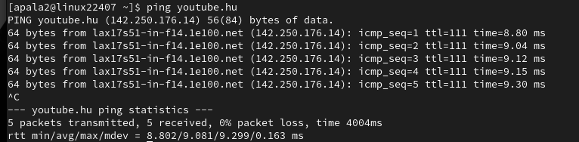
- 0% packet loss
- 9.081ms

32 bits
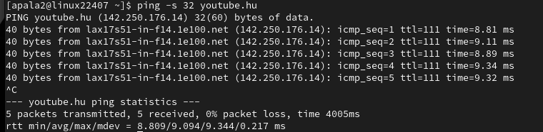
- 0% packet loss
- 9.094ms

1048 bits
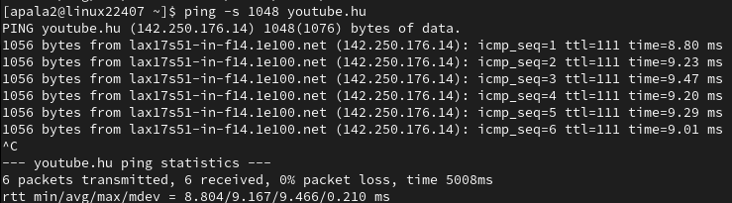
- 0% packet loss
- 9.167ms

Despite being all different countries, the RTT average times are roughly similar. I think this is because since Youtube videos are basically the same regardless of the country(you can view any video from anywhere), it just routes you to the nearest youtube.com server.

If i did a website like toyota, which has different products for different countries, the RTT times would definitely be different.

