f. Analisa Data

1. Entitas dan Atribut :
   1. Pelayan : idpelayan, pass, nama, alamat, notelp
   2. Kasir : idkasir, pass, nama, alamat, notelp
   3. Koki : idkoki, pass, nama, alamat, notelp
   4. Patry : idpantry, pass, nama, alamat, notelp
   5. Cutomer_Services : idcs , pass, nama, alamat, notelp
   6. Pelanggan : idpelanggan, nama, nomeja
   7. Bahan_Baku : kdbahan, nama, tglmasuk, tglexpired, qty,
   8. Menu : kdmenu, nama, jenis, harga,
   9. Pemesanan : kdpemesanan, menupesanan
   10. Pembayaran : kdpembayaran, totalharga
   11. Laporan : kdlaporan, nama
   12. Penyetokkan : kdstok, nama, tglmasuk, tglexpired, qty
   13. KritikSaran : kdkritiksaran, isi
2. Skema Relasi :

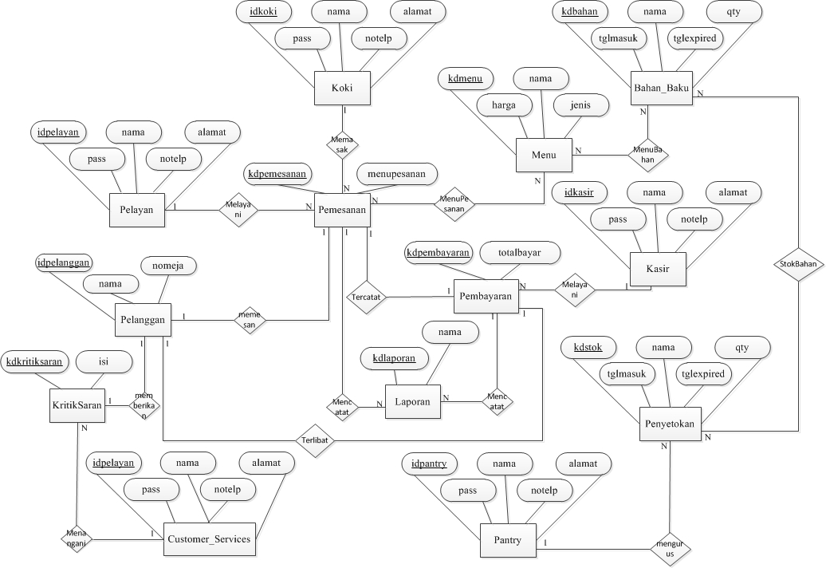

1. Diagram Relasi :

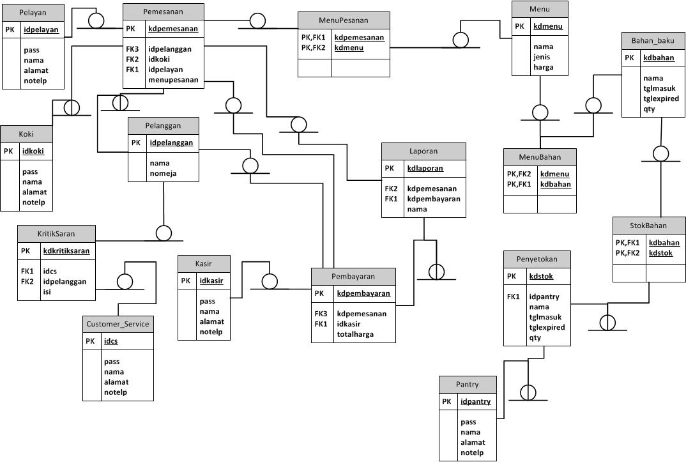

1. Struktur Tabel :
   1. Tabel Pelayan

Nama File : dbrestoran.sql (File MySQL)

Tempat Penyimpanan : Harddisk

|  |  |  |  |  |
| --- | --- | --- | --- | --- |
| Nama Field | Tipe Data | Panjang | Kunci | Keterangan |
| idpelayan | Integer | - | Primary Key | Auto_Increment |
| pass | Varchar | 8 |  | Not Null |
| nama | Varchar | 25 |  | Not Null |
| alamat | Varchar | 35 |  | Not Null |
| notelp | Varchar | 14 |  | Not Null |

* 1. Tabel Kasir

Nama File : dbrestoran.sql (File MySQL)

Tempat Penyimpanan : Harddisk

|  |  |  |  |  |
| --- | --- | --- | --- | --- |
| Nama Field | Tipe Data | Panjang | Kunci | Keterangan |
| idkasir | Integer | - | Primary Key | Auto_Increment |
| pass | Varchar | 8 |  | Not Null |
| nama | Varchar | 25 |  | Not Null |
| alamat | Varchar | 35 |  | Not Null |
| notelp | Varchar | 14 |  | Not Null |

* 1. Tabel Koki

Nama File : dbrestoran.sql (File MySQL)

Tempat Penyimpanan : Harddisk

|  |  |  |  |  |
| --- | --- | --- | --- | --- |
| Nama Field | Tipe Data | Panjang | Kunci | Keterangan |
| idkoki | Integer | - | Primary Key | Auto_Increment |
| pass | Varchar | 8 |  | Not Null |
| nama | Varchar | 25 |  | Not Null |
| alamat | Varchar | 35 |  | Not Null |
| notelp | Varchar | 14 |  | Not Null |

* 1. Tabel Pantry

Nama File : dbrestoran.sql (File MySQL)

Tempat Penyimpanan : Harddisk

|  |  |  |  |  |
| --- | --- | --- | --- | --- |
| Nama Field | Tipe Data | Panjang | Kunci | Keterangan |
| idpantry | Integer | - | Primary Key | Auto_Increment |
| pass | Varchar | 8 |  | Not Null |
| nama | Varchar | 25 |  | Not Null |
| alamat | Varchar | 35 |  | Not Null |
| notelp | Varchar | 14 |  | Not Null |

* 1. Tabel Customer_Services

Nama File : dbrestoran.sql (File MySQL)

Tempat Penyimpanan : Harddisk

|  |  |  |  |  |
| --- | --- | --- | --- | --- |
| Nama Field | Tipe Data | Panjang | Kunci | Keterangan |
| idcs | Integer | - | Primary Key | Auto_Increment |
| pass | Varchar | 8 |  | Not Null |
| nama | Varchar | 25 |  | Not Null |
| alamat | Varchar | 35 |  | Not Null |
| notelp | Varchar | 14 |  | Not Null |

* 1. Tabel Pelanggan

Nama File : dbrestoran.sql (File MySQL)

Tempat Penyimpanan : Harddisk

|  |  |  |  |  |
| --- | --- | --- | --- | --- |
| Nama Field | Tipe Data | Panjang | Kunci | Keterangan |
| idpelayan | Integer | - | Primary Key | Auto_Increment |
| nama | Varchar | 25 |  | Not Null |
| nomeja | Integer | - |  | Not Null |

* 1. Tabel Bahan_Baku

Nama File : dbrestoran.sql (File MySQL)

Tempat Penyimpanan : Harddisk

|  |  |  |  |  |
| --- | --- | --- | --- | --- |
| Nama Field | Tipe Data | Panjang | Kunci | Keterangan |
| kdbahan | Integer | - | Primary Key | Auto_Increment |
| nama | Varchar | 25 |  | Not Null |
| tglmasuk | Date | - |  | Not Null |
| tglexpired | Date | - |  | Not Null |
| qty | Integer | - |  | Not Null |

* 1. Tabel Menu

Nama File : dbrestoran.sql (File MySQL)

Tempat Penyimpanan : Harddisk

|  |  |  |  |  |
| --- | --- | --- | --- | --- |
| Nama Field | Tipe Data | Panjang | Kunci | Keterangan |
| kdmenu | Integer | - | Primary Key | Auto_Increment |
| nama | Varchar | 25 |  | Not Null |
| jenis | Varchar | 20 |  | Not Null |
| harga | Integer | - |  | Not Null |

* 1. Tabel Pemesanan

Nama File : dbrestoran.sql (File MySQL)

Tempat Penyimpanan : Harddisk

|  |  |  |  |  |
| --- | --- | --- | --- | --- |
| Nama Field | Tipe Data | Panjang | Kunci | Keterangan |
| kdpemesanan | Integer | - | Primary Key | Auto_Increment |
| idpelanggan | Integer | - | Foreign Key | Auto_Increment |
| idkoki | Integer | - | Foreign Key | Auto_Increment |
| idpelayan | Varchar | - | Foreign Key | Auto_Increment |
| menupesanan | Varchar | 20 |  | Not Null |

* 1. Tabel Pembayaran

Nama File : dbrestoran.sql (File MySQL)

Tempat Penyimpanan : Harddisk

|  |  |  |  |  |
| --- | --- | --- | --- | --- |
| Nama Field | Tipe Data | Panjang | Kunci | Keterangan |
| kdpembayaran | Integer | - | Primary Key | Auto_Increment |
| kdpemesanan | Integer | - | Foreign Key | Auto_Increment |
| idkasir | Integer | - | Foreign Key | Auto_Increment |
| totalharga | integer | - |  | Not Null |

* 1. Tabel Laporan

Nama File : dbrestoran.sql (File MySQL)

Tempat Penyimpanan : Harddisk

|  |  |  |  |  |
| --- | --- | --- | --- | --- |
| Nama Field | Tipe Data | Panjang | Kunci | Keterangan |
| kdlaporan | Integer | - | Primary Key | Auto_Increment |
| kdpemesanan | Integer | - | Foreign Key | Auto_Increment |
| kdpembayaran | Integer | - | Foreign Key | Auto_Increment |
| nama | Varchar | 25 |  | Not Null |

* 1. Tabel Penyetokkan

Nama File : dbrestoran.sql (File MySQL)

Tempat Penyimpanan : Harddisk

|  |  |  |  |  |
| --- | --- | --- | --- | --- |
| Nama Field | Tipe Data | Panjang | Kunci | Keterangan |
| kdstock | Integer | - | Primary Key | Auto_Increment |
| idpantry | Integer | - | Foreign Key | Auto_Increment |
| nama | Varchar | 25 |  | Not Null |
| tglmasuk | Date | - |  | Not Null |
| tglexpired | Date | - |  | Not Null |
| qty | Integer | - |  | Not Null |

* 1. Tabel KritikSaran

Nama File : dbrestoran.sql (File MySQL)

Tempat Penyimpanan : Harddisk

|  |  |  |  |  |
| --- | --- | --- | --- | --- |
| Nama Field | Tipe Data | Panjang | Kunci | Keterangan |
| kdkritiksaran | Integer | - | Primary Key | Auto_Increment |
| idcs | integer | - | Foreign Key | Auto_Increment |
| idpelanggan | integre | - | Foreign Key | Auto_Increment |
| isi | Varchar | 150 |  | Not Null |

* 1. Tabel MenuBahan

Nama File : dbrestoran.sql (File MySQL)

Tempat Penyimpanan : Harddisk

|  |  |  |  |  |
| --- | --- | --- | --- | --- |
| Nama Field | Tipe Data | Panjang | Kunci | Keterangan |
| kdmenu | Integer | - | Foreign Key | Auto_Increment |
| kdbahan | integer | - | Foreign Key | Auto_Increment |

* 1. Tabel MenuPesanan

Nama File : dbrestoran.sql (File MySQL)

Tempat Penyimpanan : Harddisk

|  |  |  |  |  |
| --- | --- | --- | --- | --- |
| Nama Field | Tipe Data | Panjang | Kunci | Keterangan |
| kdpemesanan | Integer | - | Foreign Key | Auto_Increment |
| kdmenu | integer | - | Foreign Key | Auto_Increment |

* 1. Tabel StokBahan

Nama File : dbrestoran.sql (File MySQL)

Tempat Penyimpanan : Harddisk

|  |  |  |  |  |
| --- | --- | --- | --- | --- |
| Nama Field | Tipe Data | Panjang | Kunci | Keterangan |
| kdbahan | Integer | - | Foreign Key | Auto_Increment |
| kdstok | integer | - | Foreign Key | Auto_Increment |