Software Requirements Specification

Revision History

| **Date** | **Revision** | **Description** | **Author** |
| --- | --- | --- | --- |
| 05/14/22 | 1.0 | Initial Version | Daniel Morales |
|  |  |  |  |
|  |  |  |  |
|  |  |  |  |
|  |  |  |  |
|  |  |  |  |
|  |  |  |  |
|  |  |  |  |
|  |  |  |  |
|  |  |  |  |
|  |  |  |  |
|  |  |  |  |
|  |  |  |  |
|  |  |  |  |
|  |  |  |  |
|  |  |  |  |
|  |  |  |  |
|  |  |  |  |

Table of Contents

**1.** **Purpose 4**

1.1. Scope 4

1.2. Definitions, Acronyms, Abbreviations 4

1.3. References 4

1.4. Overview 6

**2.** **Overall Description 7**

2.1. Product Perspective 7

2.2. Product Architecture 7

2.3. Product Functionality/Features 7

2.4. Constraints 7

2.5. Assumptions and Dependencies 7

**3.** **Specific Requirements 8**

3.1. Functional Requirements 8

3.2. External Interface Requirements 8

3.3. Internal Interface Requirements 8

**4.** **Non-Functional Requirements 9**

4.1. Security and Privacy Requirements 9

4.2. Environmental Requirements 9

4.3. Performance Requirements 9

# Purpose

This document outlines the requirements for the Mine Pump Control System (MPC).

## Scope

Use ip address and port number

UI for server is diff than client

Add names and etc from UI for server for admin and IT

Leveled users (employee, IT, employer, admin, etc)

Separate chat log files (either by room or user) to keep past conversations

Every massage should be time stamped in the GUI and the Old past logs

## Definitions, Acronyms, Abbreviations

None.

## References

Use Case Specification Document – Step 2 in assignment description

UML Use Case Diagrams Document – Step 3 in assignment description

Class Diagrams – Step 5 in assignment description

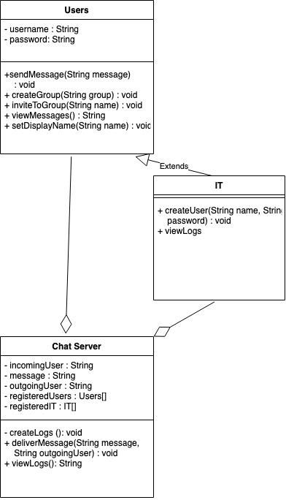

Sequence Diagrams

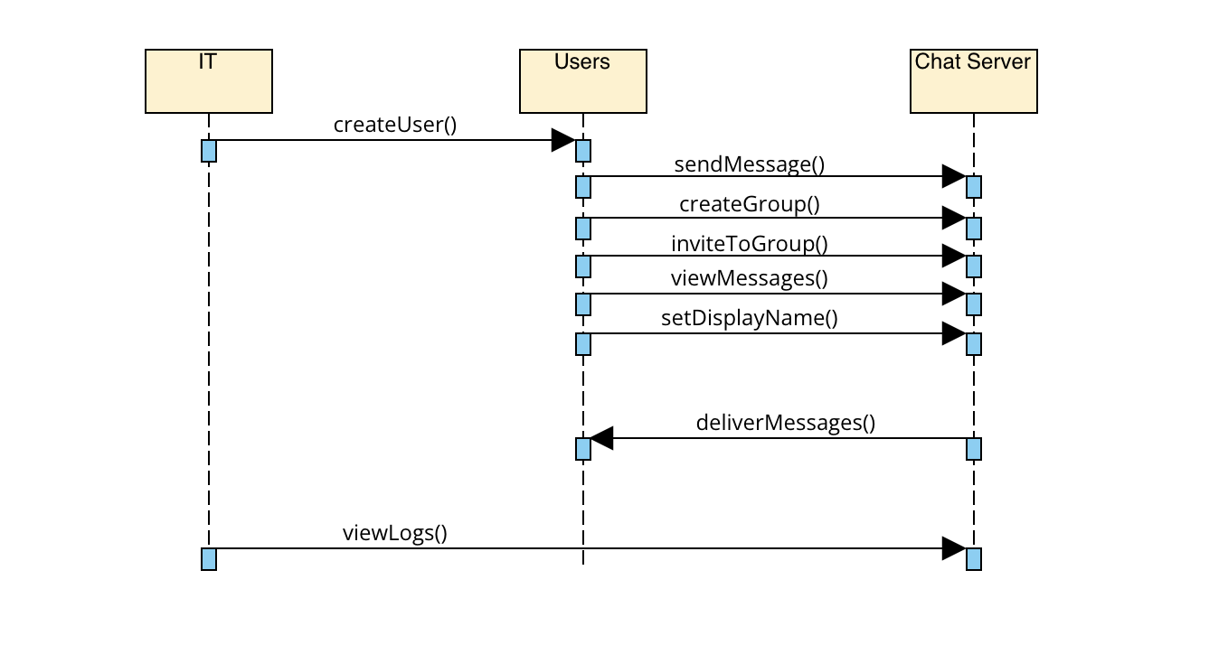

## Overview

The Chat System (CH), is designed for corporate employees to communicate with each other over various facilities.

# Overall Description

## Product Perspective

## Product Architecture

The system will be organized into 3 major modules: the server module, the user module, and the IT module.

## Product Functionality/Features

The high-level features of the system are as follows (see section 3 of this document for more detailed requirements that address these features):

## Constraints

Users may not access it through a web browser.

Only available through company use.

## Assumptions and Dependencies

There are thousands of employees.

The company internet is fast and reliable.

# Specific Requirements

## Functional Requirements

### Common Requirements:

3.1.1.1 All communication must be logged

3.1.1.2 Both private and group communication

### Server Module Requirements:

3.1.2.1 Must be able to handle multiple client requests

3.1.2.2 Must direct messages from client to another client

3.1.2.3 Save messages for when client when offline

### User Module Requirements:

3.1.3.1 Different UI for users

3.1.3.2 Username and password

### IT Module Requirements:

3.1.4.1 Different UI for IT

3.1.4.2 Username and password

3.1.4.3 Can create and delete users

## External Interface Requirements

3.2.1 The system must provide an interface to users so that they can log into a profile.

3.2.2 The system must provide an interface for users to message other users

3.2.3 The system must provide an interface for users to view messages with others users

3.2.4. The system must provide an interface for IT to create other users

## Internal Interface Requirements

3.3.1 The system must process client to server communication.

3.3.2 The system must save logs of messages between clients

# Non-Functional Requirements

## Security and Privacy Requirements

4.2.1 Only users can see their communications with others

4.2.2 Users must be required to log in into their profiles

## Environmental Requirements

4.2.1 System must be java based

4.2.2 Deadline at week 05/02/22

4.2.3 Deadline for phase 1 at 03/02/22

4.2.4 Deadline for phase 2 at 04/03/22

4.2.5 Deadline for phase 3 at 05/04/22

## Performance Requirements