Final Year Project

Using Modern Mapping and Graph techniques to locate missing persons quickly.

Submitted by: Daniel Jameson

T-Number: T00158237

Computing with Software Development

Date Submitted: Date

Github Repository: https://github.com/DogPope/FinalYearProject

*Quick note: Notes, are written in Green*

Table of Contents

Contents

Abstract 3

Introduction 4

Literature Review 5

Search and Rescue Focus Group 5

Current Technologies for Location 5

Graphs and Corresponding Algorithms 5

Tools and Resources 6

Google Elevation API 6

Algorithms 6

References 7

# Chapter 1: Abstract

I’m a programmer. I love abstraction.

# Chapter 1: Introduction

Save this one until last. In basic terms, the purpose of this project is to see how existing technologies can enhance search and rescue missions using a combination of technologies, such as satellite navigation and pathfinding algorithms. In simple terms, this project will use algorithms like Dijkstras, Depth first search and Breadth first search to determine a set of possible routes and priorities in which to search these routes. The main challenge here would be setting these techniques to work over a volatile 3d space, unlike conventional satellite navigation systems, which only deal in 2d areas. Another challenge associated with this would be that there is no single destination or optimal route to reach them. You also have to factor in the number of people in a search party. More people can search more ground at once, multiple people can reach multiple destinations at the same time. This would mean that the route would have to implement multiple routes based on the manpower at their disposal.

This project will have to focus on the possible technologies that could be used to map a 3d space in a cost efficient and effective manner. This field breaks down into various different classes of technology, such as Lidar and Photogrammetry.

The project will seek how best to implement this information and techniques into search and rescue missions and general location services.

Graph theory will then be used to traverse the finished product, and research will be conducted into optimising a possible route or set of routes to try to divide a search parties resources and manpower along a single or multiple routes.

## Chapter 1.1 – Research Questions

The purpose of the research is to determine what kind of technology would be best suited to the task of mountain rescue location.

## Chapter 1.2 – Research Objective

The objective of the research undertaken for this project is to see if modern navigation techniques and tools can enhance search and rescue operations. The topic will take a deep dive into traditional techniques, such as graph algorithms and GPS techniques. It will contrast these techniques with more modern techniques such as I don’t know? I’ll come back to this later.

# Chapter 2: Literature Review

## 2.1 Search and Rescue Focus Group

Slightly generalised, I already know this will focus on mountain terrain, but I have to explain that decision. So more goes in here to explain that. Don’t think I really need this section.

This section concerns my choice of area to focus on. Search and Rescue breaks down into many different specialties and terrain types. The one this report will be focusing on is Mountain Search and Rescue, because, living in an area that is close to two popular mountain ranges, The MacGillycuddy’s Reeks and the Sliabh Mish Mountain range, there is a market for missing persons cases that looks like it may need to be satisfied.

## 2.2 Drawing a Sample Area

The area this project is going to focus on is Carrauntoohil. The mountain, located in the MacGillycuddy Reeks Mountain range, is a formidable area that presents a variety of challenges in the terrain and areas to be assessed. There are lots of jagged rocks, steep inclines and other hazards that may need to be mapped and accounted for when deciding what areas to assess and what kind of weighting may need to be applied in which given circumstance. (Kerry Mountain Rescue, N/A).

The project would have to design a bounding box over the summit of the mountain and assess the number of data points that are needed to gather the associated elevation metrics.

## 2.3 Investigating Modern Navigation Methodology

Currently your existing technologies when it comes to missing person location. Generally speaking, when someone goes missing, it is presumed they did so of their own accord[Citation]. For this reason, it is recommended for this project that the scope be narrowed to finding rescue victims for example. For that reason I need to compile a list of methods by which mountain rescue groups operate.

### 2.3.1 Global Positioning System

Global Positioning System is defined as any system that broadcast navigation pulses to users on earth (Logsdon, 2022). It is a useful system for locating and guiding a given device with the necessary information to make informed decisions with regard to pathfinding.

### 2.3.2 Graphs and Corresponding Algorithms

Pathfinding algorithms will have to be implemented into the project to decide where to search. Luckily, there is no shortage of algorithms to use for this purpose. Dijkstra's algorithm, Breadth first and Depth First will all receive consideration in factoring in which is the likely way to reach people first. There are promising results posted from studies involving these algorithms (Pajaziti Arbnor, 2024). My main area to consider researching here is how existing navigation systems utilise these algorithms and use a similar system for my own project.

There are many types of Graph in computer science, such as weighted and directed graphs. The type of graph used by this project should depend on the type of pathfinding that needs to be done. The terrain of mountains provides a unique challenge in that it provides a third dimension to the proceedings. This will impact pathfinding such that the differences in elevation have to be accounted for more so than if you were designing a standard pathfinding system, such as satellite navigation.

The graph could not be unweighted, for example, as the difference in terrain would be a major factor in its accessibility. Research into standard satellite navigation pathfinding, Google Maps, Waze, etc.

## 2.4 Methods of Assessing Physical Terrain

As time goes on, the options available in terms of assessing geographical data become more varied and more impressive. Even the public now has access to technology such as Unmanned Arial Vehicles (Drones) that allow the user to assess any number of objects or terrain of their choosing. At a wide range of technologies and prices, these options need to be carefully considered for their purpose so that the objective is achieved in the most reasonable manner possible. This section aims to detail some of those technologies to decide the correct tool for the job. (Liyang Xiong, 2022)

### 2.4.1 Photogrammetry

Photogrammetry is the process of using various techniques formulas on photos and similar data to assess a physical object.

Vertical Photogrammetry – The process of vertical photogrammetry involves using a drone to take photos of an area of land. The

Oblique Photogrammetry

Multi-View Photogrammetry

### 2.4.2 Lidar

Light Detection and Ranging(Lidar) describes the process of using lasers to assess distance. It accomplishes this task via assessing the amount of time it takes for the laser to reach its target and return to a sensor. This process is used in a variety of industries and across many product ranges. The automotive industry uses Lidar to navigate roads and other environments, for example.

### 2.4.3 Google Elevation API

Google hosts an API for returning the elevation of any point that is indexed on one of their maps. This information could prove to be useful in assessing the surrounding terrain and provide information to incorporate into the pathfinding route. The API inputs a set of co-ordinates to determine the elevation at that given point. This returns either a JSON or an XML response in Meters. It should be noted that this a paid API, although usage can be forcibly limited. It’s cheap anyway, I don’t think it matters that much. It must be used sparingly, or a free solution could be found. (Google, 2024)

### 2.4.4 – Carrauntoohil Summit

The summit of Carrauntoohil is located at the following co-ordinates: Lat: 51.99904, Long: -9.74324. The task here should be to manufacture a bounding box around this area and calculate the elevation based on the latitude and longitude of the selected point. A bounding box could be broken into several different points to create a 3d space from the given co-ordinates.

# Chapter 3 – Methodology

In the case of this project, the data would not have to be gathered all at once. The data could be collected over the course of months, if necessary. This solution could be coded using a simple for loop using a script language such as Javascript or Python to loop through a 2d array to gather the elevation necessary for the third dimension necessary to create a 3d map. Something like the following: https://stackoverflow.com/questions/1556921/google-map-api-v3-set-bounds-and-center *DO THIS ASAP* to reduce the overall costs of using the API.

## 3.1 Gathering Map Data

The process of gathering map data to use for the project will be handled in this case by designing a bounding box with arbitrary measurements to use as a sample. The geographical area around the summit of Carrauntoohil will serve as the bounding box. An area of 1 kilometre around the summit was arbitrarily chosen. The latitude and longitude can be gathered from the Google Maps service and the elevation can be gathered using a python script. The data structure that is best suited to this purpose is a 2d array that can have the Google Elevation called at each point in the loop. This could be done with basic tools too, like a simple bash script that calls the API using curl requests. As this would be tedious, the preferred choice of language here is Python.

Google has the available information for pricing the API calls on its website. (Google, 2024), pricing section. The relevant information can be found in the figure below.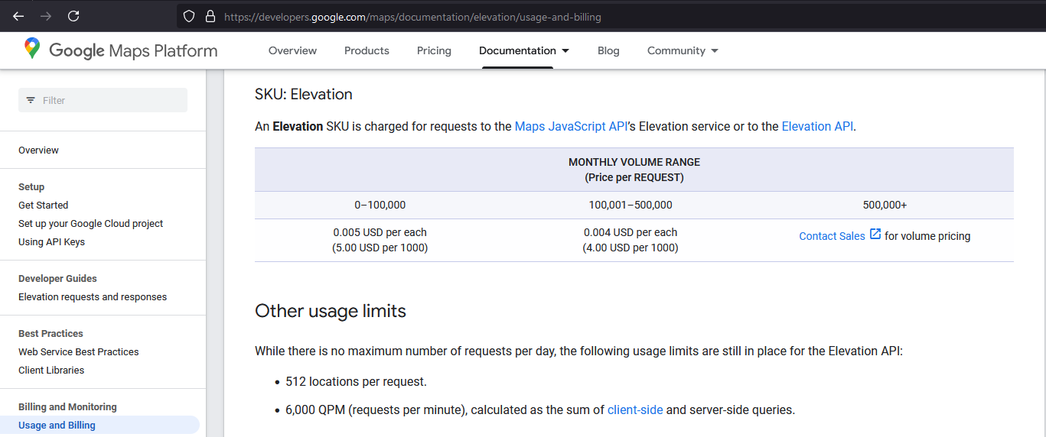

Figure : Google Elevation API Pricing

# Tools and Resources

## Location Finding Technologies

### Algorithms

When considering algorithms to use for pathfinding purposes, there is plenty of documentation on the efficiency of algorithms such as Dijkstra’s and the A* algorithm. The A* algorithm is commonly used in these systems due to its efficiency.*Edit. No it’s not. It is regarded as * There are many options available depending on the users need for priority. Dijkstra’s algorithm is going to prioritise the shortest path, whereas the A star algorithm is going to return a faster route. (Yan, 2022)

# References

Google, 2024. *Elevation API Usage and Billing.* [Online]   
Available at: https://developers.google.com/maps/documentation/elevation/usage-and-billing#pricing-for-product  
[Accessed 13 October 2024].

Google, 2024. *Google Elevation API Documentation.* [Online]   
Available at: https://developers.google.com/maps/documentation/elevation/start  
[Accessed 06 October 2024].

Kerry Mountain Rescue, N/A. *Carrauntoohil Route Descriptions.* [Online]   
Available at: https://kerrymountainrescue.ie/carrauntoohil-route-descriptions  
[Accessed 10 October 2024].

Liyang Xiong, S. L. G. T. J. S., 2022. *Geomorphometry and terrain analysis: data, methods, platforms and applications.* [Online]   
Available at: https://www.sciencedirect.com/science/article/pii/S0012825222002756  
[Accessed 08 October 2024].

Logsdon, T. S., 2022. *Britannica GPS.* [Online]   
Available at: https://www.britannica.com/technology/GPS  
[Accessed 06 October 2024].

Pajaziti Arbnor, B. X. F. A., 2024. *Sciendo, Journal of Mechanical Engineering.* [Online]   
Available at: https://sciendo.com/article/10.2478/scjme-2024-0011  
[Accessed 04 October 2024].

Yan, Y., 2022. *Research Gate.* [Online]   
Available at: https://www.researchgate.net/publication/376719056_Research_on_optimal_path_planning_technology_for_vehicle_positioning_and_navigation_system  
[Accessed 6 October 2024].