İzmir Kâtip Çelebi University
Department of Engineering Sciences
IKC-MH.57
Introduction to High Performance and Parallel Computing
Take-home Final Examination

NAME-SURNAME: Berke DİNÇ
SIGNATURE:
ID: 210402034
DEPARTMENT: Biomedical Engineering

1. (10 Pts) Write a C program calculates the dot product of two vectors
sequentially.
#include <stdio.h>
#include <time.h>

#define VECTOR_SIZE 3

int dotProduct(const int vector1[], const int vector2[]) {
int dotProduct = 0;

for (int i = 0; i < VECTOR_SIZE; i++) {
dotProduct += vector1[i] * vector2[i];
}

return dotProduct;
}

int main() {
int vector1[VECTOR_SIZE];
int vector2[VECTOR_SIZE];

printf("Enter the elements of vector1: ");
for (int i = 0; i < VECTOR_SIZE; i++) {
scanf("%d", &vector1[i]);
}

printf("Enter the elements of vector2: ");
for (int i = 0; i < VECTOR_SIZE; i++) {
scanf("%d", &vector2[i]);
}
clock_t t;
t = clock();
int result = dotProduct(vector1, vector2);
t = clock() - t;
double time_taken = ((double)t)/CLOCKS_PER_SEC;
printf("Dot product: %d\n", result);
printf("took %.10f seconds to execute \n", time_taken);

return 0;
}

2. (30 Pts) Design a parallel version of the same program using MPI
calls.
#include <stdio.h>
#include <mpi.h>

#define VECTOR_SIZE 3

int dotProduct(int vector1[], int vector2[], int start, int end) {
int dotProduct = 0;

for (int i = start; i < end; i++) {
dotProduct += vector1[i] * vector2[i];
}

return dotProduct;
}

int main(int argc, char** argv) {
int rank, size;
int vector1[VECTOR_SIZE];
int vector2[VECTOR_SIZE];
int localDotProduct = 0;
int globalDotProduct = 0;
double start_time , end_time;
MPI_Init(&argc, &argv);
MPI_Comm_rank(MPI_COMM_WORLD, &rank);
MPI_Comm_size(MPI_COMM_WORLD, &size);

if (rank == 0) {
printf("Enter the elements of vector1: ");
for (int i = 0; i < VECTOR_SIZE; i++) {
fflush(stdout);
scanf("%d", &vector1[i]);
}

printf("Enter the elements of vector2: ");
for (int i = 0; i < VECTOR_SIZE; i++) {
fflush(stdout);
scanf("%d", &vector2[i]);
}
}
start_time = MPI_Wtime();
MPI_Bcast(vector1, VECTOR_SIZE, MPI_INT, 0, MPI_COMM_WORLD);
MPI_Bcast(vector2, VECTOR_SIZE, MPI_INT, 0, MPI_COMM_WORLD);

int localStart = rank * VECTOR_SIZE / size;
int localEnd = (rank + 1) * VECTOR_SIZE / size;

localDotProduct = dotProduct(vector1, vector2, localStart, localEnd);

MPI_Reduce(&localDotProduct, &globalDotProduct, 1, MPI_INT, MPI_SUM, 0, MPI_COMM_WORLD);
end_time = MPI_Wtime();
if (rank == 0) {
printf("Dot product: %d\n", globalDotProduct);
printf("time taken:%.10f seconds\n" , end_time - start_time);
}

MPI_Finalize();

return 0;
}

3. (30 Pts) Design a parallel version of the same program using OpenMP
pragmas.
#include <stdio.h>
#include <omp.h>
#define VECTOR_SIZE 3

int dotProduct(int vector1[], int vector2[]) {
int dotProduct = 0;
#pragma omp parallel for reduction(+:dotProduct)
for (int i = 0; i < VECTOR_SIZE; i++) {
dotProduct += vector1[i] * vector2[i];
}

return dotProduct;
}

int main() {
int vector1[VECTOR_SIZE];
int vector2[VECTOR_SIZE];
double start_time , end_time;
printf("Enter the elements of vector1: ");
for (int i = 0; i < VECTOR_SIZE; i++) {
scanf("%d", &vector1[i]);
}

printf("Enter the elements of vector2: ");
for (int i = 0; i < VECTOR_SIZE; i++) {
scanf("%d", &vector2[i]);
}
start_time = omp_get_wtime();
int result = dotProduct(vector1, vector2);
end_time = omp_get_wtime();

printf("Dot product: %d\n", result);
printf("Work took %.10f seconds\n", end_time - start_time);

return 0;
}

4. (30 Pts) Analyze your both parallel programs in the aspects of speed-
up and efficiency.

The calculated one processor c program’s execution time was 0,000002 seconds, for vector values first vector=(10,10,10) for second vector=(20,20,20) was used. According to this execution time I calculated the speed-up factor and efficiency for both openmpi and openmp programs. Table below shows that values.

For easy comparison according to this tables also created graphs for time, speed-up and efficiency. Also the c programs execution time was added to graphs as yellow triangle.

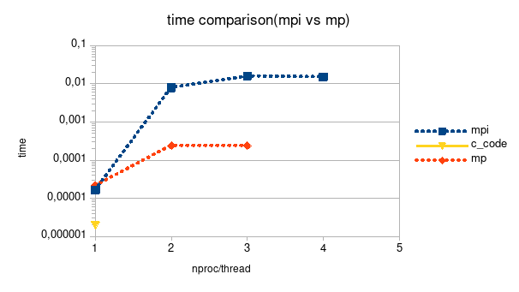

Execution Time:
  - In the MPI implementation, the execution time increases as the number of processors increases.
  - In the MP implementation, the execution time decreases as the number of threads increases.
- Speed Up:
  - The speed up values indicate the performance improvement achieved by using multiple processors/threads compared to a single processor/thread.
  - In the MPI implementation, the speed up values are very small, indicating limited performance improvement.
  - In the MP implementation, the speed up values are generally higher, indicating better performance improvement.
- Efficiency:
  - The efficiency values represent how effectively the system utilizes the available processors/threads.
  - In the MPI implementation, the efficiency values are quite low, indicating inefficient utilization of processors.
  - In the MP implementation, the efficiency values are relatively higher, indicating more efficient utilization of threads.
Overall, the MP implementation with multi-threading shows better performance improvement (higher speed up) and efficiency compared to the MPI implementation with multiple processors. However, pure C code with using only one processor is works way better than parallel versions of the program. Reaseon behind this is spending time at sending data from one processor to another is too much for this simple program. We can’t use parallel programming advantages when working with programs that were has this simplicity.

