**Numerical Analysis Assignment #9**

2020/11/03

2018112749 전현승

Q1. (10pt) Fit cubic splines to the following data with natural end point condition. Utilize the results to estimate the value at $x=1.5$.

|  |  |  |  |  |  |
| --- | --- | --- | --- | --- | --- |
| $$x$$ | 1 | 2 | 3 | 4 | 5 |
| $$y$$ | 0 | 1 | 0 | 1 | 0 |

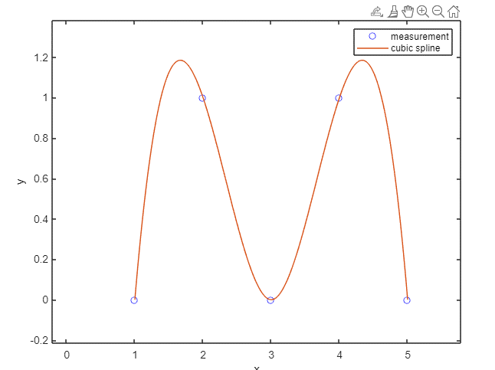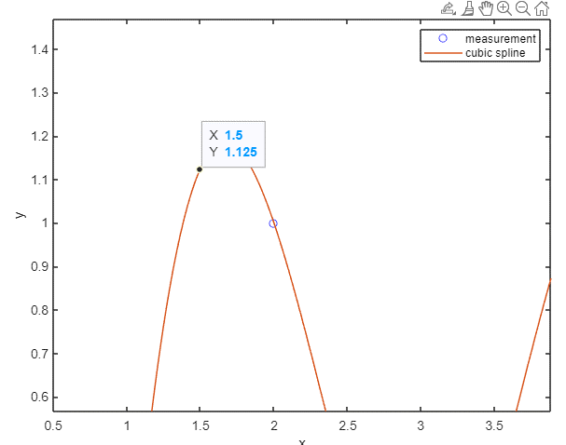

|  |  |
| --- | --- |
| $$x$$ | 1.5 |
| $$y$$ | 1.125 |