DOCNEXUS · HCP & Claims Intelligence

Intern Project Technical Specification
NexusRep — Digital-Twin Video & Audio Sales Reps for Pharma & Medtech Whitespace
Intern / Owner: Swastik
Sponsor: Mahek Chhatrapati — CEO & Co-Founder, DocNexus (mahek@docnexus.ai)
Duration: 10-week internship (compliant MVP for one brand)
Status: Draft v1.0 — for kickoff review

Contents

1. Project Overview & Goals
This project asks Swastik to build NexusRep: a platform that creates AI “digital twins” of sales reps — lifelike video-and-audio agents — that engage healthcare professionals (HCPs) across the country in territories human reps cannot reach. The twins detail a brand the way a rep would, but they only ever speak pre-approved, MLR-cleared content, run 24/7 and nationwide, and hand off to a human the moment a conversation needs one. They are aimed squarely at pharma and medtech “whitespace”: the no-rep and no-see accounts that are growing every year.
The deliverable is a compliant MVP for a single brand, powered by DocNexus claims and HCP intelligence for who to engage and what is relevant. The point is not to build avatar technology from scratch — that is a solved, buy-able layer — but to build the pharma-specific orchestration, compliance, targeting, and analytics that make a digital twin rep safe and effective.

Goals
- Stand up a working digital twin (cloned rep or brand persona) that can hold a real-time, on-label detailing conversation by video and voice.
- Make compliance the architecture, not a feature: the twin physically cannot say anything outside the approved content set, always delivers safety information, and escalates correctly.
- Use DocNexus data to find and prioritize whitespace HCPs and personalize outreach.
- Prove value with an analytics view that shows incremental reach into whitespace plus a clean compliance log.

Learning outcomes for Swastik
- Orchestrating real-time multimodal AI (ASR → LLM → TTS → avatar) from vendor APIs into a coherent product.
- Designing guardrails for a high-stakes regulated domain — retrieval-only answers, refusal, escalation, and full auditability.
- Turning DocNexus claims into a concrete targeting and personalization layer.
- Shipping an end-to-end experience: a creator studio, an HCP-facing call, and an analytics console.
Scope guardrail
One brand, one therapeutic area, one twin (a rep clone is fine), and a fixed approved-content set. Depth on a genuinely compliant, genuinely real-time single experience beats a broad demo that cuts compliance corners. If a corner must be cut, cut breadth — never compliance.

2. The Whitespace Problem & Opportunity
“Whitespace” in pharma/medtech sales means two things: territories with no assigned rep, and offices that refuse rep visits (“no-see” physicians). It is large and growing, which is exactly why a scalable digital rep is compelling.
- Physician access to reps has fallen sharply: roughly half of US physicians now place moderate-to-severe restrictions on rep visits, about half meet with three or fewer companies, and in some specialties nearly a third will see only one.
- In-person access cratered during COVID (to roughly a fifth of prior levels) and rebounded only partway; hybrid engagement is now permanent.
- Industry analyses report that hybrid engagement (in-person plus virtual) can generate close to three times the promotional response of face-to-face alone.
- Non-personal promotion already exists to reach no-see doctors in whitespace where reps cannot visit — but most of it is static email and banners, not a conversation.
NexusRep's wedge is to make whitespace coverage conversational and personal at national scale: a familiar-looking, brand-trained twin that can actually answer an HCP's on-label questions, any time, anywhere, at a fraction of the cost of adding headcount — complementing human reps, not replacing them.
Why DocNexus is uniquely positioned
Most avatar vendors can render a talking head. What they cannot do is tell a brand which 8,000 of 60,000 whitespace HCPs are worth a conversation. DocNexus claims and HCP intelligence supply exactly that — making NexusRep a targeting-plus-engagement product, not just an avatar.

3. Solution — NexusRep Digital Twin Reps
A NexusRep twin is a real-time conversational video-and-audio agent that represents a brand to an HCP. The HCP sees a lifelike person, asks questions by voice or text, and gets answers drawn strictly from approved content, with the brand's detail aids shown on screen and safety information delivered in both audio and on-screen text.

3.1 Two twin modes
Mode | What it is | When to use it
Rep clone | A digital twin of a real, consenting field rep — their actual face and voice, cloned from a couple of minutes of footage | Extend a specific rep's reach into their own whitespace; preserve a familiar relationship for no-see offices
Brand persona | A synthetic, fully MLR-approved brand spokesperson not tied to any individual | Cover territories with no assigned rep at all; national always-on coverage

Build target: the MVP should ship a rep clone (it exercises the harder consent/likeness and voice-cloning path) for one brand, with the brand-persona mode as a configuration variant.

3.2 What the HCP experiences
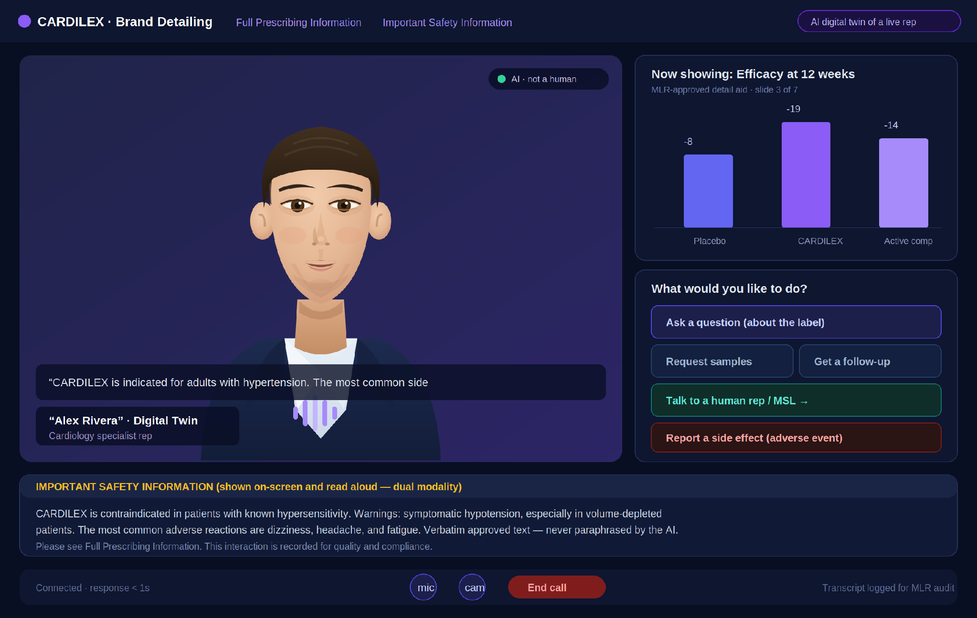
Figure 1. The HCP-facing detailing call. A lifelike twin with live captions and an AI-disclosure badge; an on-screen MLR-approved detail aid; clear actions (ask a question, request samples, talk to a human, report a side effect); and Important Safety Information delivered in dual modality — spoken aloud and shown verbatim on screen.
Four things in that screen are non-negotiable and define the product:
- Honest AI disclosure. The HCP always knows they are talking to an AI twin, not a human.
- Dual-modality safety. Important Safety Information is both read aloud and shown on screen, verbatim — matching how regulators expect risk to be presented clearly, conspicuously, and neutrally.
- A visible human exit. “Talk to a human rep / MSL” is always one tap away.
- An adverse-event path. If the HCP mentions a side effect, the twin captures it and routes it to pharmacovigilance.

4. Technology & Competitive Landscape
Swastik should study these before building. The avatar/voice layer is mature and should be bought; the pharma-specific layer is where DocNexus differentiates.

4.1 Avatar & voice technology (buy this layer)
Vendor | Strength | Relevance to NexusRep
Tavus | Real-time Conversational Video Interface (CVI): digital twin from ~2 min of footage, full-duplex, sub-second latency, vision and tool-calling | Best fit for the live, interactive twin; tool-calling drives on-screen detail aids
HeyGen | Battle-tested avatars at scale, 175+ languages, Interactive Avatar, strong async video | Alternative for the avatar layer; multilingual reach for diverse HCPs
Synthesia | Enterprise avatar library oriented to training/L&D and async video | Useful for pre-recorded modules; less suited to live conversation
D-ID | Real-time streaming avatars for conversational agents | Lightweight real-time alternative
ElevenLabs-class TTS | High-fidelity, low-latency voice cloning | Clones the real rep's voice for the rep-clone mode

4.2 Pharma virtual-rep precedents (study, then beat)
Player | What they do | Lesson for NexusRep
Doceree — RepTwin | An AI virtual pharma brand rep across video, voice and text, embedded in EHRs, journals and brand sites; brand-trained and MLR-ready | Validates the exact concept; our edge is DocNexus claims-driven targeting and transparent grounding
Veeva (CRM / Engage) | The system of record reps already use for digital HCP engagement and e-detailing; tracks content viewed back to CRM | Integrate with it — log twin engagement to the CRM rather than competing with it
“AI-generated reps” (NPP vendors) | Scale coverage cheaply with consistent, approved messaging; complement human reps | Their stated risks — hallucination and off-label drift — are precisely what our guardrails must eliminate

4.3 Build vs. buy
Layer | Decision | Rationale
Avatar rendering + voice clone | Buy (API) | Commodity, capital-intensive, and not our differentiation
Real-time A/V transport | Buy | Use the vendor's WebRTC pipeline
Conversation orchestration + RAG | Build | This is where on-label behavior is enforced
Compliance guardrails + audit | Build | Cannot be outsourced; it is the product's license to operate
Whitespace targeting + analytics | Build (on DocNexus) | Our unique data advantage

5. System Architecture & Core Modules
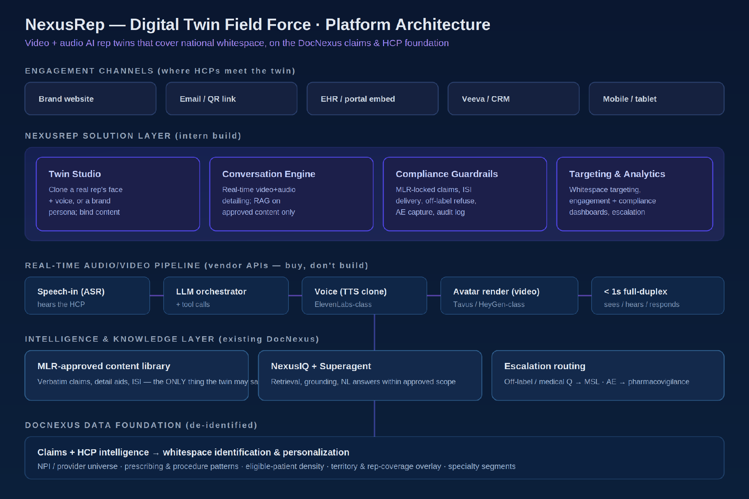
Figure 2. NexusRep architecture. Vendor APIs supply the real-time A/V pipeline; the intern builds the solution layer (studio, conversation engine, guardrails, targeting/analytics) on top of the existing DocNexus knowledge and data foundation.

5.1 Core modules
Module | Description | MVP?
Twin Studio | Create a twin: capture/clone face & voice (with consent), set persona, bind approved content, run MLR sign-off | Yes
Conversation Engine | Real-time video+audio detailing; ASR → LLM orchestrator with retrieval over approved content → TTS → avatar; tool calls to show detail aids | Yes
Compliance Guardrails | Approved-content-only answers, verbatim ISI, off-label refusal, AE capture, full transcript/recording audit log | Yes
Escalation Router | Off-label / medical questions → MSL or medical information; AE → pharmacovigilance; “talk to a human” handoff | Yes
Whitespace Targeting | DocNexus claims → prioritized whitespace HCP list and personalization | Yes
Analytics & Compliance | Reach, engagement funnel, top questions, escalations, AE log | Partial
Channel embeds (EHR/CRM) | Distribute via web, email/QR, EHR portal, Veeva/CRM | Stretch

5.2 How a turn works
- HCP speaks or types a question.
- Speech-to-text transcribes it; an intent/safety classifier checks whether it is in-label, off-label, a medical-information request, or an adverse event.
- If in-label: the orchestrator retrieves the relevant approved answer/claim from the MLR content library (it does not free-generate claims) and composes a response from approved language.
- Text-to-speech voices it and the avatar renders it; a tool call may surface the matching detail-aid slide on screen.
- If off-label / medical / AE: the twin declines to answer beyond the label, says so plainly, and routes per the escalation rules.
- Everything — transcript, content shown, ISI delivery, escalations — is logged for audit.

5.3 The Twin Studio
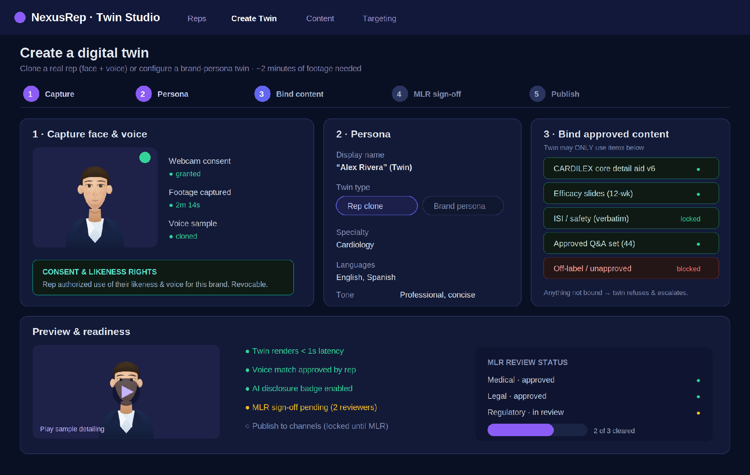
Figure 3. Twin Studio. Capture and clone a consenting rep's face and voice, configure the persona, bind the approved-content set (anything not bound is blocked), and gate publishing behind a Medical/Legal/Regulatory sign-off.

6. Compliance & Regulatory Guardrails
This is the part that makes or breaks the project. Pharma promotional communications are regulated; all promotional material must clear MLR (Medical, Legal, Regulatory) review and present a fair balance of benefit and risk, and the FDA's promotion office (OPDP) actively enforces this across digital channels. AI makes this harder, not easier: language models are very good at producing fluent, plausible, brand-adjacent text — which is exactly how teams drift off approved claims. The design principle is therefore blunt: the twin is a retrieval-and-presentation engine for approved content, not a generator of claims.

6.1 The guardrails
Approved-content-only answers. The twin can only surface claims and answers that exist in the MLR-cleared content library. It never invents or paraphrases a claim. If there is no approved answer, it says it cannot speak to that and escalates.
Verbatim, locked safety language. Important Safety Information and the brief summary are stored and delivered verbatim. The model is never allowed to “make the ISI friendlier” — readable is not the same as reviewable.
Dual-modality risk delivery. Safety information is presented clearly, conspicuously, and neutrally in both audio and on-screen text, and imagery/animation must not distract from it.
Off-label refusal. An intent classifier blocks off-label questions; the twin declines and routes to a Medical Science Liaison or medical information.
Adverse-event capture. Any mention of a side effect is detected, captured, and routed to pharmacovigilance within required timelines.
Honest disclosure & consent. The HCP is told they are speaking with an AI twin; rep clones require documented, revocable likeness/voice consent from the rep.
Full auditability. Every session is transcribed, recorded, and logged — what was asked, what approved content was shown, that ISI was delivered, and any escalation — so MLR and regulators can review.
MLR gating. No twin can be published until Medical, Legal, and Regulatory reviewers sign off in the studio.
The one rule that prevents most failures
If the model would have to write a new sentence that makes a product claim or restates safety language, stop and retrieve approved text instead. Generation is for small talk and navigation; never for claims, efficacy, or safety.

6.2 A note on medtech
Medtech follows the same shape with different specifics: device promotion is governed by its own FDA rules and centers on the cleared/approved intended use rather than a drug label, and twins often add procedural and in-service education. The architecture is identical — approved-content-only, intended-use guardrails, escalation to clinical specialists, and full audit — so the MVP built for a pharma brand generalizes to a device brand by swapping the approved-content set and the guardrail policy.

7. Whitespace Targeting with DocNexus Data
A twin is only as valuable as the conversations it has. DocNexus claims and HCP intelligence decide which whitespace HCPs are worth engaging and what is relevant to them.
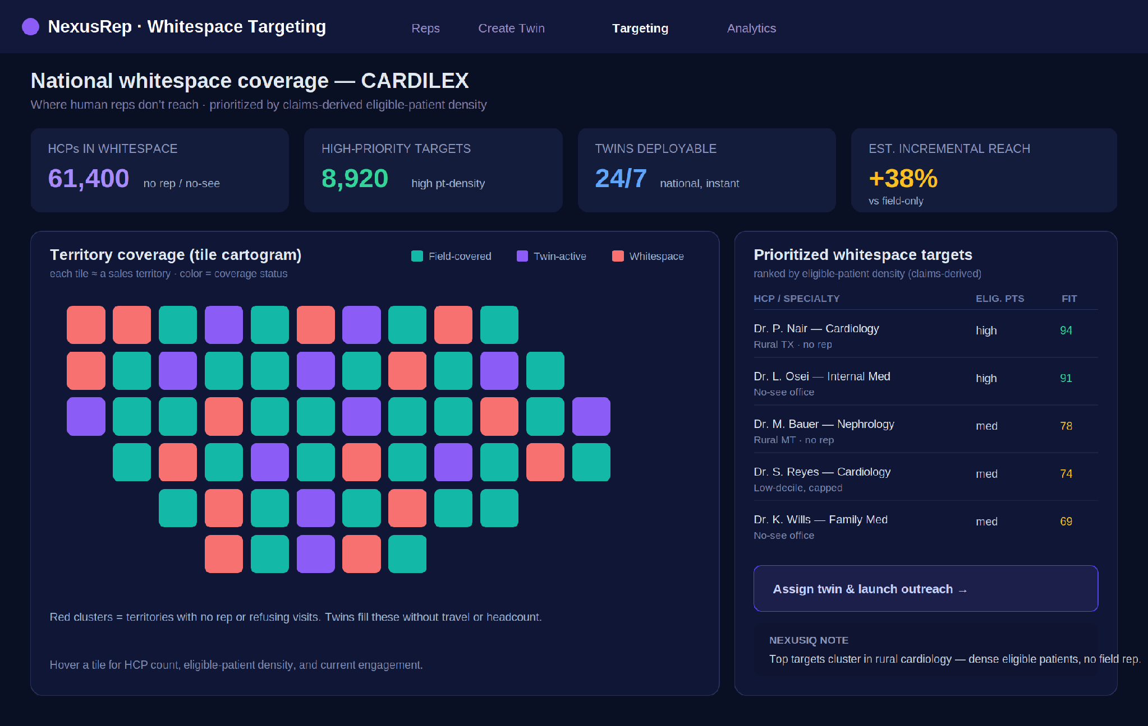
Figure 4. Whitespace targeting console. A territory tile cartogram shows field-covered, twin-active, and whitespace areas; the right panel ranks whitespace HCPs by claims-derived eligible-patient density so twins go where the opportunity is densest.

What the targeting layer needs from claims
- The provider/NPI universe and specialty, to define the addressable HCP set.
- Rep-coverage and access overlay, to isolate the whitespace (no rep + no-see).
- Eligible-patient density (from diagnosis/procedure/prescribing patterns), to rank who is worth a conversation.
- Brand and competitive context, to personalize the opening and the relevant detail aids.
The output is a prioritized target list and a per-HCP personalization brief that seeds the twin's opening — all within approved content.

8. Engagement & Compliance Analytics
Two audiences need proof: commercial teams want reach and engagement into whitespace; compliance teams want a clean, auditable record. One console serves both.
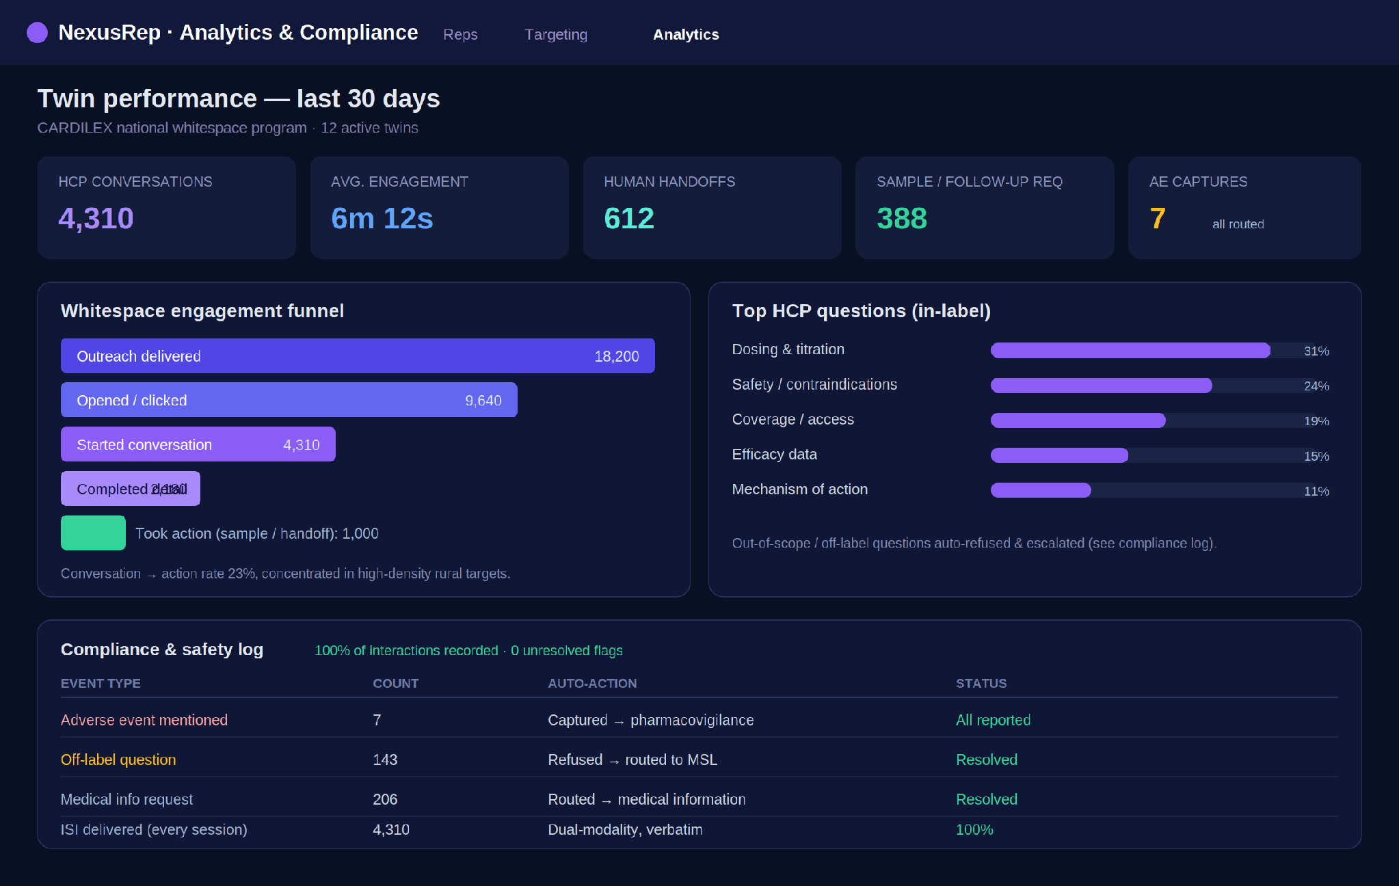
Figure 5. Analytics & compliance console. An engagement funnel into whitespace, the top in-label questions HCPs ask, and a compliance/safety log showing adverse-event captures, off-label refusals, escalations, and 100% verbatim dual-modality ISI delivery.

Metrics that matter
- Incremental reach — HCPs engaged in whitespace that field reps were not reaching.
- Engagement funnel — outreach → conversation → completed detail → action (sample, follow-up, human handoff).
- Question mix — what HCPs ask, to improve approved content.
- Compliance health — % sessions recorded, ISI delivery rate, AE captures all reported, off-label refusals all escalated, zero unresolved flags.

9. Intern Delivery Plan (10 weeks)
Compliance and a single real-time twin come first; targeting and analytics build on them; the final weeks harden and demonstrate.
Week | Focus | Deliverable / milestone
1 | Onboarding + landscape | Teardown of Tavus/HeyGen/Synthesia + Doceree/Veeva; pick A/V + voice vendors
2 | A/V spike | End-to-end real-time talking-twin proof (vendor API) saying a fixed script
3–4 | Conversation engine + RAG | Approved-content library + retrieval-only answering; detail-aid tool calls
5 | Compliance guardrails | Off-label refusal, verbatim ISI dual-modality, AE capture, audit log
6 | Twin Studio + MLR gating | Clone/persona creation, content binding, MLR sign-off workflow — twin MVP demo
7–8 | Whitespace targeting | DocNexus claims → prioritized whitespace list + personalization brief + console
8 | Escalation + handoff | Routing to MSL / medical info / pharmacovigilance; human handoff
9 | Analytics console | Reach, funnel, question mix, compliance log
10 | Integration + hardening | Channel embed (web), CRM engagement logging, latency/quality pass
10 | Demo + handover | Docs, compliance self-audit, final readout to Mahek + team

10. Deliverables & Evaluation Rubric

Deliverables
- A working digital-twin MVP for one brand: Twin Studio, HCP-facing real-time call, targeting console, analytics console.
- A documented compliance layer: approved-content library, guardrail policy, escalation rules, and an audit-log schema.
- A whitespace targeting model built on DocNexus claims.
- A short vendor/competitor teardown and a one-page positioning note.
- Technical README + a final demo (a recorded compliant detailing call).

How the work will be judged
Dimension | Weak | Strong
Compliance | Model free-generates claims; ISI optional | Retrieval-only claims; verbatim dual-modality ISI; full audit
Realtime quality | Laggy, scripted, uncanny | Sub-second, natural, handles interruptions
Escalation | Dead-ends on hard questions | Clean refusal + correct routing every time
Targeting | Random HCP list | Claims-ranked whitespace with real personalization
Usefulness | Tech demo | A brand team would actually deploy it to whitespace

Definition of done
An MLR reviewer could watch a full recorded session and sign off without edits; a brand lead could point at the targeting console and say “these are the right HCPs”; and the twin never, in any session, said a single word that was not approved.

11. Appendix

A. Glossary
Term | Meaning
Whitespace | Territories with no rep + offices that refuse rep visits (“no-see”)
NPP | Non-Personal Promotion — reaching HCPs through non-rep channels
Digital twin | A lifelike video/voice AI replica of a real person (or brand persona)
CVI | Conversational Video Interface — real-time interactive video avatar
ASR / TTS | Automatic speech recognition / text-to-speech
MLR | Medical, Legal, Regulatory review — required before promotional content publishes
OPDP | FDA Office of Prescription Drug Promotion — enforces promotion rules
Fair balance | Required balanced presentation of benefit and risk
ISI | Important Safety Information — the required safety statement
Off-label | Use beyond the approved label — cannot be promoted
AE | Adverse Event — a side effect; must be captured and reported
MSL | Medical Science Liaison — handles scientific/medical questions

B. Non-negotiable principles
- The twin is a presenter of approved content, never a generator of claims.
- Safety information is verbatim and delivered in dual modality, every session.
- Disclose the AI; obtain and honor likeness/voice consent for rep clones.
- Log everything; nothing publishes without MLR sign-off.

C. Reference points reviewed
- Avatar/voice: Tavus (real-time CVI, ~2-min digital twins, sub-second, tool-calling), HeyGen (scale, 175+ languages, Interactive Avatar), Synthesia (async/L&D), D-ID (real-time streaming), ElevenLabs-class voice cloning.
- Pharma virtual reps: Doceree RepTwin (video/voice/text, MLR-ready); Veeva CRM/Engage for digital HCP engagement; industry coverage of AI-generated reps and non-personal promotion to whitespace/no-see HCPs.
- Compliance: MLR review, FDA fair-balance and ISI requirements, OPDP enforcement focus on clear/conspicuous/neutral dual-modality risk presentation, and guidance on AI-generated promotional content drift.

