AttriSense
The Beginner's Guide

Plain-language explainers for every technique in the dashboard.

Version 2 · 2026-05-07

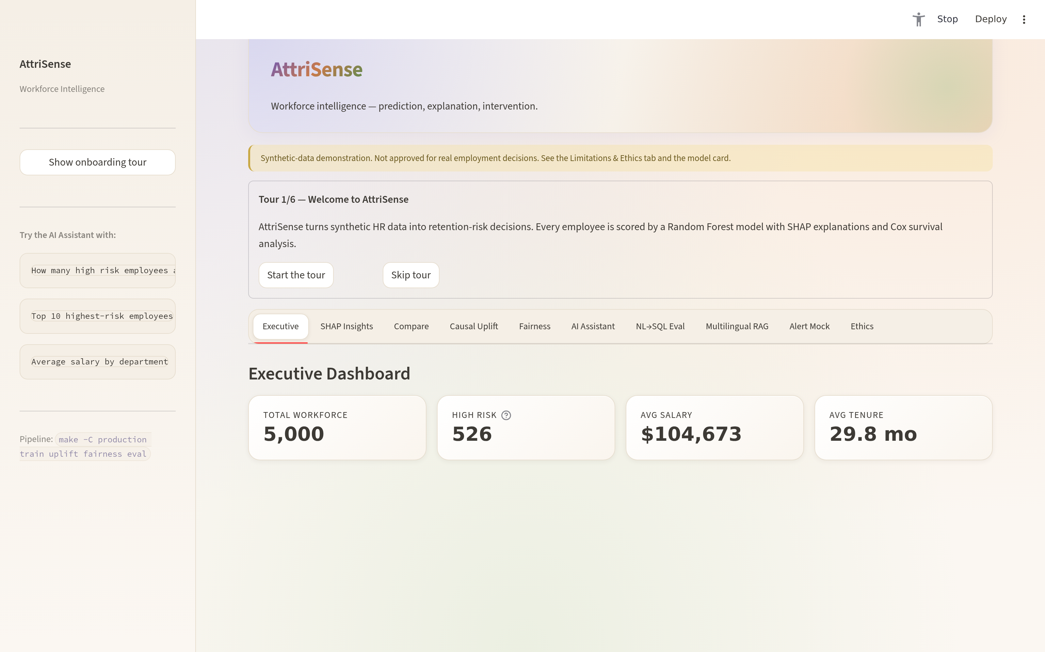

Foreword
AttriSense is a workforce-retention dashboard built around five model modalities — RandomForest with SMOTE, Cox proportional-hazards survival, EconML T-Learner causal uplift, multilingual RAG with provider fallback, and natural-language SQL with a TF-IDF safety net.
This guide is the offline companion to the live docs at docs/learn/. Each chapter starts with the intuition, sketches the math lightly, points to the file in production/src/attrisense/ that implements it, calls out the gotchas that bit us in production, and ends with a one-liner you can paste.
“ If you can read one paragraph, you can read AttriSense. If you can read one chapter, you can ship it.

Contents
An interactive table of contents follows. Open this document in Word and press F9 (or right-click → Update Field) to populate the page numbers. A static index of chapters is also printed below.
Right-click here in Word and choose 'Update Field' to populate the table of contents.

1. Welcome — A friendly tour of every technique used in the AttriSense dashboard.
2. SHAP — Explain Any Prediction — Decompose one prediction into the contribution of each feature.
3. SMOTE — Class Balance — Synthesize minority-class examples — but only on the train fold.
4. Cox PH — Survival Analysis — Model the hazard of leaving over time, not just whether someone leaves.
5. Causal Uplift — T-Learner — Estimate the effect of an intervention per employee, not just the population.
6. Multilingual RAG — Resilient Retrieval — Hybrid index: OpenAI when reachable, hashing-based local fallback otherwise.
7. Fairness — Four-Fifths Rule — Gate every prediction on the EEOC selection-rate ratio.
8. NL→SQL — Text-to-Database — Hybrid pipeline: LLM-first, gold-question TF-IDF fallback.

Chapter 1
Welcome
Key idea · A friendly tour of every technique used in the AttriSense dashboard.

Learn — concepts behind AttriSense
“ Plain-language explainers for every technique used in the dashboard. Read in order, or jump straight to whatever's confusing you.
Tutorial | What you'll learn | Time
SHAP — explain any prediction | Why a model said what it said, on a per-employee basis | 10 min
SMOTE — handle class imbalance | Why oversampling minority classes works (and when it lies) | 8 min
Cox PH — survival analysis | "How long until X happens?" instead of "will X happen?" | 12 min
Causal uplift — T-Learner | The difference between *prediction* and *intervention* | 12 min
RAG — retrieval-augmented generation | Semantic search + LLM, with graceful fallback | 10 min
Fairness — four-fifths rule | EEOC's bright line, what it catches, what it misses | 10 min
NL→SQL — text-to-database | Translating English to SQL safely (read-only, allow-listed) | 8 min
How to read this section
Every tutorial follows the same shape:
- The intuition (why this exists at all)
- The math, lightly (what's actually happening)
- In AttriSense (where the code lives, what it does)
- The gotcha (the thing you'll get wrong on first read)
- Try it (a one-liner you can paste)
If you want to read the production source instead, every tutorial links straight to it.

Chapter 2
SHAP — Explain Any Prediction
Key idea · Decompose one prediction into the contribution of each feature.

SHAP — explain any prediction
“ "The model said this employee is high-risk. Why?" — SHAP answers that question, one employee at a time.
The intuition
Imagine a black-box model that takes 4 inputs and outputs a risk score:
tenure=7, salary=52k, dept=Mfg, mgr_tenure=4 → model → risk = 0.83
SHAP gives you a decomposition:
baseline (avg risk for everyone) = 0.32
+ short tenure (7 months) = +0.21
+ low salary (52k vs 78k median) = +0.18
+ Manufacturing dept = +0.09
+ new manager (4 months) = +0.03
─────────────────────────────────────────────────
final risk for this employee = 0.83
Every contribution sums to the final prediction. Always. That's the only thing SHAP guarantees, and it's why we use it.
The math, lightly
SHAP values come from cooperative game theory (Shapley, 1953). For each feature i:
\phi_i = \sum_{S \subseteq F \setminus \{i\}} \frac{|S|! \, (|F| - |S| - 1)!}{|F|!} \, \big[ f(S \cup \{i\}) - f(S) \big]
Plain English: the average marginal contribution of feature `i` across all possible orderings of the other features.
For tree models (Random Forest, XGBoost), TreeExplainer computes this exactly in polynomial time. For other models there's KernelExplainer (sampled, slower).
In AttriSense
- Where: train_retention_risk_model.py computes SHAP values during training and stores them in the shap_feature_impact table.
- What we store: top-K drivers per employee + a SHAP_Explained flag (only high-risk + a sampled subset get full SHAP, to keep the DB compact).
- Where it surfaces: SHAP Insights tab + Compare tab + driver cards.
The gotcha
SHAP explains the model, not the world. If your model has spurious correlations, SHAP will faithfully explain those spurious correlations. SHAP says "this prediction depended on `salary`" — it does not say "salary causes attrition".
For "what changes if I do X?" → use causal uplift (causal-uplift.md), not SHAP.
Try it
import shap, joblib
import pandas as pd
model = joblib.load("attrisense_model.joblib")
df = pd.read_csv("attrisense_synthetic_hr.csv")
X = df[["tenure_months", "base_salary", "department_code", "manager_tenure_months"]]
explainer = shap.TreeExplainer(model)
shap_values = explainer.shap_values(X.iloc[:5])
print(shap_values) # one row per employee, one column per feature
To visualise:
shap.waterfall_plot(shap.Explanation(
values=shap_values[1][0],
base_values=explainer.expected_value[1],
data=X.iloc[0],
feature_names=X.columns.tolist(),
))
ASCII companion diagram
SHAP Explanation — How a Prediction is Decomposed (ASCII)
==========================================================
Every per-employee prediction sums to:
baseline + sum(feature contributions)
Example for EMP_2417 (final risk = 0.83):
baseline (avg risk for everyone) 0.32 ████████
+ short tenure (7 months) +0.21 █████
+ low salary (52k vs 78k median) +0.18 ████
+ Manufacturing dept +0.09 ██
+ new manager (4 months) +0.03 █
---------------------------------------------------
final risk for this employee 0.83 ████████████████████
Property guaranteed by SHAP:
the bars above always sum to (final - baseline)
What SHAP says:
"this prediction depended on these features"
What SHAP does NOT say:
"these features cause attrition"
For causal questions use the T-Learner uplift module instead.
Visual diagram
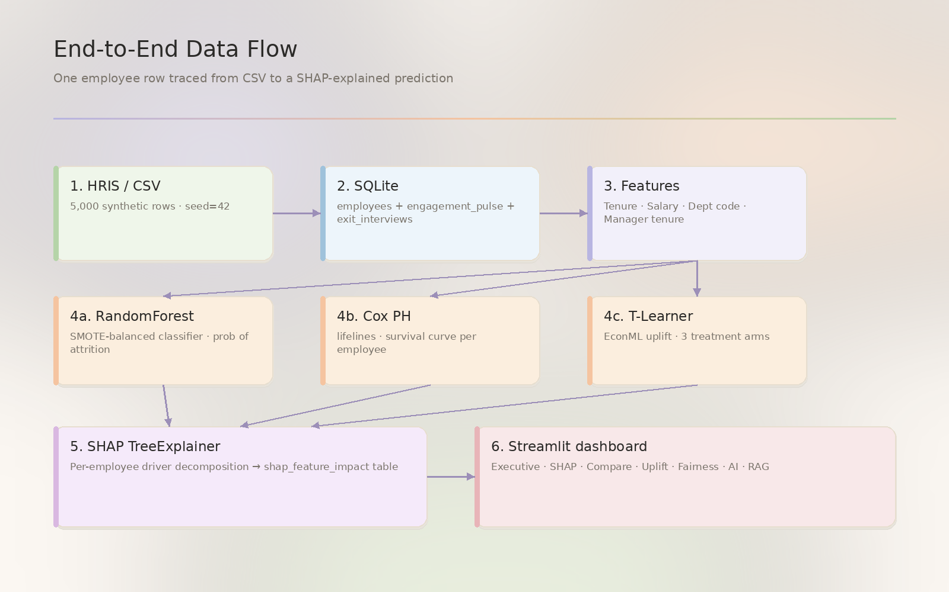
Figure 2. SHAP — Explain Any Prediction — Pixel pastel diagram

Chapter 3
SMOTE — Class Balance
Key idea · Synthesize minority-class examples — but only on the train fold.

SMOTE — synthetic minority oversampling
“ "Only 18% of employees leave. The model just predicts 'stays' for everyone and gets 82% accuracy. Useless." — SMOTE fixes that.
The intuition
Classification models minimise overall error. If 82% of training rows are class 0 and 18% are class 1, the model can score 82% by predicting 0 always — and learn nothing about class 1.
SMOTE (Synthetic Minority Oversampling Technique) synthesises new minority-class examples by interpolating between existing ones, until both classes are balanced.
before: after SMOTE:
class 0: ████████ (4100) class 0: ████████ (4100)
class 1: ██ (900) class 1: ████████ (4100, ~3200 synthetic)
The math, lightly
For each minority sample $x_i$:
- Find its $k$ nearest minority neighbours (default $k = 5$).
- Pick one neighbour $x_j$ at random.
- Generate a synthetic sample $x_{new} = x_i + \lambda \cdot (x_j - x_i)$, with $\lambda \in [0, 1]$ random.
The synthetic sample lies on the line segment between two real minority neighbours. It's not a duplicate — that's the point. Plain duplication overfits; interpolation generalises.
In AttriSense
- Where: train_retention_risk_model.py — imblearn.over_sampling.SMOTE is applied to the training fold only (never to test).
- Order: split → SMOTE → fit. Critically, never SMOTE before splitting, or test-set leakage is guaranteed.
The gotcha
SMOTE can hide a fairness problem. If the minority class is dominated by one demographic group, SMOTE inflates that group's footprint in the training data. The model now appears more accurate but is more biased toward that group's pattern.
Always run the fairness audit after SMOTE, never before.
Also: SMOTE doesn't help calibration. Probabilities from a SMOTE-trained model are systematically too confident for the minority class. If you need calibrated probabilities, run CalibratedClassifierCV after fitting.
Try it
from imblearn.over_sampling import SMOTE
from sklearn.model_selection import train_test_split
X_tr, X_te, y_tr, y_te = train_test_split(X, y, stratify=y, random_state=42)
print("before:", y_tr.value_counts().to_dict())
X_tr_bal, y_tr_bal = SMOTE(random_state=42).fit_resample(X_tr, y_tr)
print("after :", y_tr_bal.value_counts().to_dict())
ASCII companion diagram
SMOTE — Class-Balance Oversampling (ASCII)
============================================
Before SMOTE: After SMOTE:
class 0 ████████ (4100) class 0 ████████ (4100)
class 1 ██ (900) class 1 ████████ (4100)
^^^^^^^^
~3200 of these are SYNTHETIC
How a synthetic point is created:
x_j (real minority neighbour)
o
\
\ x_new = x_i + lambda * (x_j - x_i), lambda in [0,1]
* <-- synthetic
\
\
o
x_i (real minority point)
- x_i is a real minority sample
- x_j is one of x_i's k nearest minority neighbours (default k=5)
- the synthetic point lies on the line segment between them
Order of operations (this matters):
1. split train/test
2. SMOTE on the train fold ONLY
3. fit model
4. evaluate on test (which was never SMOTEd)
If you SMOTE before splitting, you leak synthetic points into test
and your "great" accuracy is a lie.
Visual diagram
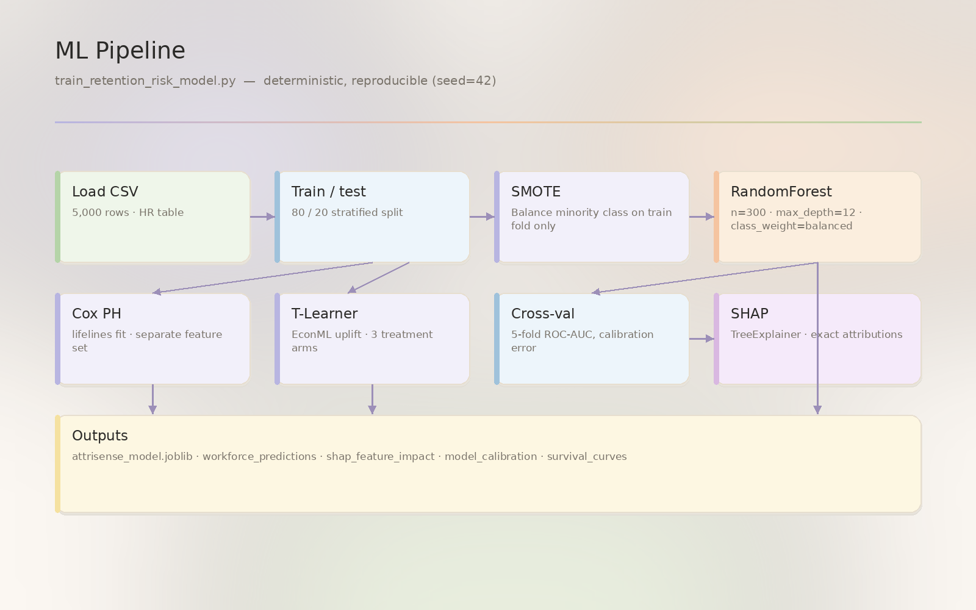
Figure 3. SMOTE — Class Balance — Pixel pastel diagram

Chapter 4
Cox PH — Survival Analysis
Key idea · Model the hazard of leaving over time, not just whether someone leaves.

Cox proportional hazards — survival analysis
“ "Will this employee leave?" is a classification question. "How long until they leave?" is a survival question. Different math, different answer.
The intuition
Survival analysis was invented to answer questions like "how long do patients live after diagnosis?" — where you have:
- An event (death, churn, attrition).
- A time-to-event for some observations.
- Censored observations: people who haven't had the event yet — but might tomorrow.
A classifier throws away the time information. A Cox model uses it.
The math, lightly
The hazard function $h(t)$ is the instantaneous risk of the event at time $t$ given survival up to $t$.
Cox's proportional hazards model:
h(t \mid x) = h_0(t) \cdot \exp(\beta_1 x_1 + \beta_2 x_2 + \dots + \beta_p x_p)
Two parts:
- $h_0(t)$ — a baseline hazard that depends on time but not on features (left non-parametric).
- $\exp(\beta^T x)$ — a multiplier that depends on features but not time.
This is the proportional hazards assumption: hazard ratios between two individuals are constant over time. If feature $x_1$ doubles your hazard at month 1, it doubles your hazard at month 24 too.
In AttriSense
- Library: lifelines (CoxPHFitter).
- Features used (not the same as the classifier — Tenure_Months would be cheating since it is the time variable):
```python
SURVIVAL_FEATURE_COLUMNS = ["Base_Salary", "Dept_Code", "Manager_Tenure_Months"]
```
- Output: per-employee survival curves stored in survival_curves.
- Surfaced as: the survival sparkline on the SHAP Insights tab.
The gotcha
The proportional hazards assumption rarely holds perfectly in workforce data. New hires often have a "honeymoon" hazard pattern that violates PH. Check with lifelines.statistics.proportional_hazard_test and split the model by tenure band if it fails.
Try it
from lifelines import CoxPHFitter
import pandas as pd
df = pd.read_csv("attrisense_synthetic_hr.csv")
df = df.rename(columns={"tenure_months": "T", "voluntary_turnover": "E"})
cph = CoxPHFitter()
cph.fit(df[["T", "E", "base_salary", "manager_tenure_months"]], duration_col="T", event_col="E")
cph.print_summary()
ASCII companion diagram
Cox Proportional Hazards — Survival Analysis (ASCII)
======================================================
A classifier predicts: "will this employee leave? (yes/no)"
A survival model predicts: "how long until this employee leaves?"
Survival curve S(t) = P(still employed at time t)
1.0 |\
| \
| \
S(t)| \____
| \____
| \____
| \____
| \___
0.0 +--------------------------------> time (months)
0 6 12 18 24 30
The Cox model fits per-feature multipliers on a baseline hazard:
h(t | x) = h_0(t) * exp(beta_1*x_1 + beta_2*x_2 + ...)
- h_0(t) baseline hazard (depends on time, not features)
- exp(beta^T x) multiplier (depends on features, not time)
Key assumption: PROPORTIONAL HAZARDS
the multiplier is constant over time
if feature x doubles your hazard at month 1,
it also doubles it at month 24
Validate with lifelines.statistics.proportional_hazard_test
(if it fails, split the model by tenure band)
Features used in AttriSense (NOT including Tenure_Months,
which IS the time variable):
- Base_Salary
- Dept_Code
- Manager_Tenure_Months
Output:
per-employee survival curve stored in `survival_curves` table,
surfaced as the survival sparkline on the SHAP Insights tab.

Chapter 5
Causal Uplift — T-Learner
Key idea · Estimate the effect of an intervention per employee, not just the population.

Causal uplift — T-Learner
“ "Will a 10% raise prevent this employee from leaving?" — a causal question. The Random Forest predicts who's at risk; uplift estimates the effect of an intervention.
The intuition
A predictive model answers P(leave | x). A causal model answers P(leave | x, treatment) − P(leave | x, no treatment) — the uplift of the treatment.
Three concrete treatment arms in AttriSense:
Arm | Cost | Question
5% raise | low | does a small raise reduce the risk?
10% raise | medium | does doubling it reduce the risk twice as much?
Manager change | medium | does a fresh manager reset risk?
For each employee we want the conditional average treatment effect (CATE) — the uplift for this person, not the population.
The math, lightly
A T-Learner (T = "two") fits two separate models:
\mu_0(x) = \mathbb{E}[Y \mid X=x, T=0] \quad \text{(no treatment)}
\mu_1(x) = \mathbb{E}[Y \mid X=x, T=1] \quad \text{(treatment)}
CATE for individual $i$:
\hat\tau(x_i) = \mu_1(x_i) - \mu_0(x_i)
Other learners exist (S-Learner, X-Learner, DR-Learner, DML). T-Learner is the simplest and a fine starting point when you have enough data in both arms.
In AttriSense
- Library: EconML (econml.metalearners.TLearner).
- Where: production/src/attrisense/causal_uplift.py.
- Synthetic treatment data: AttriSense doesn't have observed treatment data, so the demo simulates assignment with a known true effect. This means the causal numbers are illustrative, not real-world calibrated. The same pattern applies once you have real treatment logs.
The gotcha
Causal inference is not predictive accuracy. A model can have great predictive AUC and produce useless CATE estimates if:
- Treatment was not randomly assigned (selection bias)
- Important confounders are unobserved
- Overlap fails (no untreated employees with this $x$, or no treated employees with this $x$)
In real deployments, you must validate causal assumptions before believing the uplift numbers. The dashboard shows uplift; it doesn't validate the assumptions for you.
Try it
from econml.metalearners import TLearner
from sklearn.ensemble import GradientBoostingRegressor
T_learner = TLearner(models=GradientBoostingRegressor())
T_learner.fit(Y=y, T=treatment, X=X)
cate = T_learner.effect(X) # one number per row: the predicted uplift
ASCII companion diagram
Causal Uplift — T-Learner (ASCII)
==================================
Predictive model: P(leave | x)
Causal/uplift model: P(leave | x, treated) - P(leave | x, untreated)
^^^^^^^^^^^^^^^^^^^^^^^^^^^^^^^^^^^^^^^^^^^^^^^^^
conditional average treatment effect (CATE)
T-Learner = "Two" learners:
+-----------------+ +-----------------+
| treated rows | | untreated rows |
| (T=1) | | (T=0) |
+--------+--------+ +--------+--------+
| |
v v
+-----------------+ +-----------------+
| mu_1(x) | | mu_0(x) |
| model fitted | | model fitted |
| on treated | | on untreated |
+--------+--------+ +--------+--------+
| |
+-------------+-------------+
|
v
+-----------------+
| tau(x_i) = |
| mu_1(x_i) - |
| mu_0(x_i) |
+-----------------+
|
v
per-individual uplift estimate
AttriSense treatment arms:
- 5% raise (low cost)
- 10% raise (medium cost)
- manager change (medium cost)
Important: the demo uses SIMULATED treatment (synthetic data has no
real treatment log). The pattern is the same once you have real
historical retention-action data.
Causal assumptions to validate:
- overlap (both treatment arms have data at every x)
- unconfoundedness (no hidden confounder between T and Y)
- SUTVA (one person's treatment doesn't affect another)
The dashboard shows uplift; it does NOT validate these assumptions
for you.

Chapter 6
Multilingual RAG — Resilient Retrieval
Key idea · Hybrid index: OpenAI when reachable, hashing-based local fallback otherwise.

RAG — retrieval-augmented generation
“ "Find me the exit interviews where people complained about compensation, in any language." — RAG turns that into a vector search + LLM combo.
The intuition
A pure LLM can hallucinate. A pure search engine can't summarise. RAG combines them:
1. user query → "compensation issues"
2. embed the query → 1536-dim vector
3. similarity search → top-K most-similar exit interview chunks
4. (optional) feed K → LLM with prompt: "answer using only these chunks"
5. response → answer + citations
The model can only reference what was retrieved. Hallucination shrinks dramatically.
The math, lightly
Embeddings map text to dense vectors:
\text{embed}(\text{"raise was denied"}) = [-0.21, 0.47, \dots, 0.03] \in \mathbb{R}^{1536}
Similarity is cosine:
\text{cos}(a, b) = \frac{a \cdot b}{\|a\| \, \|b\|} \in [-1, 1]
Multilingual embedding models (OpenAI's text-embedding-3-small, multilingual SBERT) place "compensation issues" (EN) and "problemas de compensación" (ES) close together in the same vector space — even though they share zero tokens.
A vector database (FAISS) indexes the corpus once, then answers top_k(query, k=6) in milliseconds.
In AttriSense
- Library: LangChain + FAISS.
- Where: production/src/attrisense/multilingual_rag.py.
- Two-tier embedding:
- Tier 1: OpenAI text-embedding-3-small (1536-dim) — high quality, requires reachable API.
- Tier 2 (fallback): hashing embeddings (256-dim, MD5 + Gaussian) — works fully offline.
- Per-provider FAISS dirs (data/multilingual_index/openai/ vs hashing/) prevent dimension collisions.
- Reachability probe decides which tier to use, mid-query.
The gotcha
Retrieval ≠ truth. RAG only retrieves what's in the corpus. If the corpus is biased, the answers will be biased. If the corpus is sparse, you'll get bad neighbours that look superficially relevant.
Hashing embeddings (the offline fallback) are markedly worse than OpenAI embeddings — they don't understand semantics, only token overlap. The dashboard surfaces the provider field so reviewers can see which tier served their query.
Try it
from attrisense.multilingual_rag import search
results = search("compensation issues", top_k=6)
for r in results:
print(r["language"], r["theme"], round(r["score"], 3), r["text"][:60])
ASCII companion diagram
Multilingual RAG — Resilient Provider Fallback (ASCII)
========================================================
OpenAI-first, hashing-fallback when the API is unreachable
+-----------+ +---------------+
| user |--->| reachability |
| query | | probe |
| EN/ES/HI | | (api.openai) |
+-----------+ +-------+-------+
|
+---------+---------+
| |
reachable firewall/5xx
| |
v v
+----------------+ +-----------------+
| OpenAI | | Hashing |
| embeddings | | embeddings |
| 1536-dim | | 256-dim · MD5 |
+-------+--------+ +--------+--------+
| |
+----------+----------+
|
v
+-------------------+
| FAISS index |
| per-provider dir |
| + cosine similar. |
+-------------------+
Per-provider directories prevent dimension collisions:
data/multilingual_index/openai/ (1536-dim)
data/multilingual_index/hashing/ (256-dim)
Each result row carries a `provider` field so reviewers can see
which backend served the query.
Visual diagram
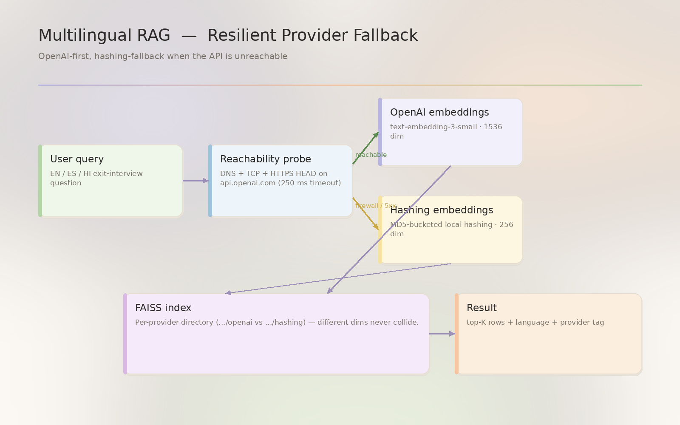
Figure 6. Multilingual RAG — Resilient Retrieval — Pixel pastel diagram

Chapter 7
Fairness — Four-Fifths Rule
Key idea · Gate every prediction on the EEOC selection-rate ratio.

Fairness — the EEOC four-fifths rule
“ A 1978 US Equal Employment Opportunity Commission guideline that's still the legal bright line for adverse impact in hiring and HR decisions.
The intuition
Imagine a model that flags 25% of Engineering employees as high-risk and 50% of Manufacturing employees. Manufacturing is being selected at twice the rate — that's adverse impact on Manufacturing.
The four-fifths rule:
\text{ratio} = \frac{\min_g \text{selection\_rate}(g)}{\max_g \text{selection\_rate}(g)} \geq 0.80
If the smallest group's rate is less than 80% of the largest group's rate, the rule is violated.
In our example: $0.25 / 0.50 = 0.50$ — fail.
Why 80%?
Pragmatic compromise. 100% would be impossibly strict; 50% would let almost anything through. The EEOC picked 80% in 1978 and it's stuck. It's not a statistical threshold — it's a regulatory one.
In AttriSense
- Where: production/src/attrisense/fairness.py.
- Audit dimensions: department (always), manager (extensible), tenure band (extensible).
- Outputs: outputs/fairness_report.json + dashboard banner + audit log row.
- Behaviour on failure: pause downstream alerts for the affected group until retraining + re-audit.
The gotcha
The four-fifths rule only catches selection-rate disparity. It doesn't catch:
- Calibration disparity — the model is right 90% of the time for group A but only 70% for group B. Both groups can have identical selection rates and still be treated unfairly.
- Error-rate disparity — the model has a 10% false-positive rate for one group and 30% for another.
- Intersectional disparity — the rule passes on race and on gender separately but fails on race × gender.
For a real audit you need multiple fairness lenses, plus a decision about which one matters most for your use case. The dashboard's audit is the technical artifact for that conversation; it's not the conversation itself.
Try it
from attrisense.fairness import run_audit
import pandas as pd
import sqlite3
with sqlite3.connect("hr_enterprise.db") as conn:
df = pd.read_sql("SELECT * FROM workforce_predictions", conn)
report = run_audit(df, dimension="department", threshold=0.7, label_col="risk_label")
print(report)
ASCII companion diagram
Fairness Audit — EEOC Four-Fifths Rule (ASCII)
================================================
ratio = min(group selection rate) / max(group selection rate) >= 0.80
+----------------+ +-------------+ +-----------+ +-----------+
| predictions |--->| selection |--->| ratio = |--->| ratio |
| + group_attr | | rate per | | min/max | | >= 0.80? |
| | | group | | | | |
+----------------+ +-------------+ +-----------+ +-----+-----+
|
+-----yes-----+ +-----+-----+
v v v v
+---------------+ +---------------+
| PASS | | FAIL |
| ship | | pause |
| recommend. | | alerts + |
| log audit | | investig. |
+---------------+ +---------------+
Artifacts produced:
- outputs/fairness_report.json
- dashboard banner (green/red)
- audit log entry (who, when, dimension, result)
- pause-state for downstream Slack/Teams alerts
What the rule does NOT catch:
- calibration disparity (right 90% for A, 70% for B)
- error-rate disparity (false-positive rates differ)
- intersectional bias (passes on race AND gender separately,
fails on race x gender)
Visual diagram
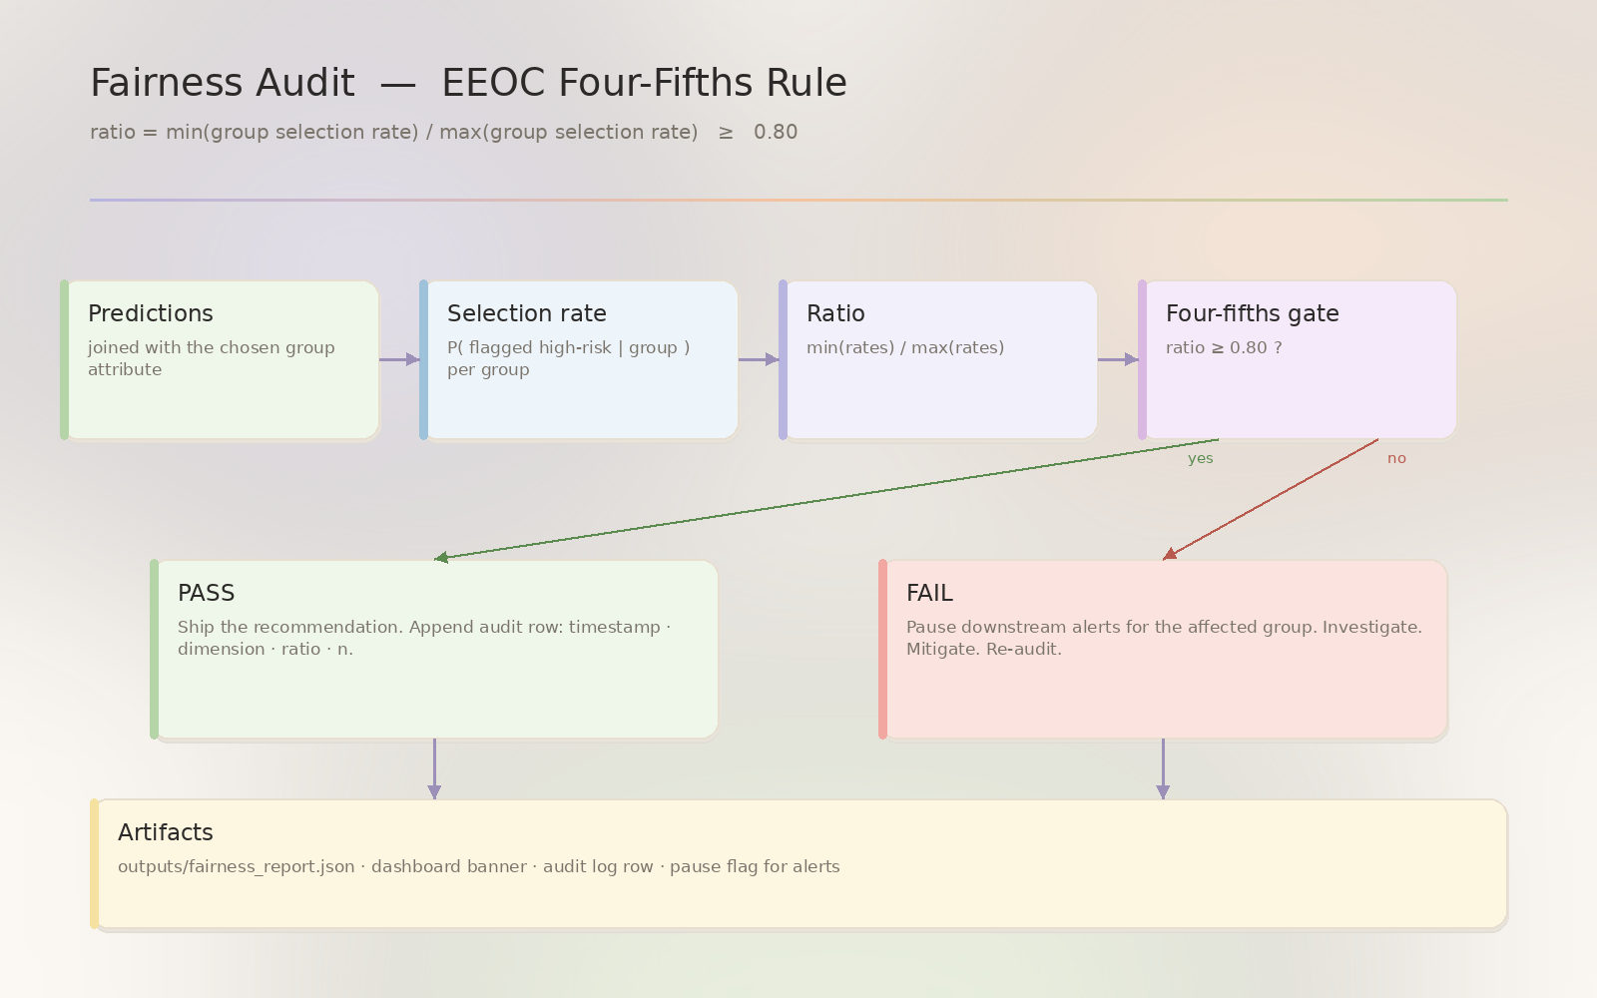
Figure 7. Fairness — Four-Fifths Rule — Pixel pastel diagram

Chapter 8
NL→SQL — Text-to-Database
Key idea · Hybrid pipeline: LLM-first, gold-question TF-IDF fallback.

NL→SQL — text-to-database
“ "Show me the high-risk employees in Manufacturing" → SELECT * FROM workforce_predictions WHERE department='Manufacturing' AND risk_label='High Risk'. Done well, this is delightful. Done poorly, it's a security incident.
The intuition
Three approaches, in order of complexity:
- Gold-question lookup — match the user's question to a hand-crafted list of (question, sql) pairs via TF-IDF or embedding similarity. Zero hallucination, zero LLM cost.
- LLM generation with allow-list — let an LLM produce SQL but reject anything that's not SELECT against an approved table set.
- LLM generation with sandboxed execution — run the SQL in a read-only transaction with row-level limits.
AttriSense uses (1) as fallback and (2) as primary, with (3) as the sandbox for both.
The math, lightly
TF-IDF similarity between user query $q$ and gold question $g$:
\text{sim}(q, g) = \frac{\text{tfidf}(q) \cdot \text{tfidf}(g)}{\|\text{tfidf}(q)\| \, \|\text{tfidf}(g)\|}
Pick the gold question with the highest similarity, return its SQL. If similarity is below a threshold, give up and say "I don't know — try one of these examples".
In AttriSense
- Primary: natural_language_sql.py — LangChain SQL chain over OpenAI.
- Fallback: production/src/attrisense/nl_sql_fallback.py — TF-IDF over the gold-question set.
- Eval: production/src/attrisense/nl_sql_eval.py — 50 gold questions across 4 categories (KPI, group, drill, trend).
- Sandbox:
- SQLite connection opened with PRAGMA query_only=ON.
- SQL allow-list: SELECT only; INSERT/UPDATE/DELETE/DROP/PRAGMA/ATTACH rejected.
- Result row limit (default 200).
The gotcha
LLM-generated SQL is a SQL injection vector if you don't sandbox. Without the read-only PRAGMA + allow-list, a sufficiently creative prompt can DROP TABLE your production database. AttriSense's sandbox is non-negotiable — never disable it.
Also: the LLM will confidently produce SQL that runs but is wrong. Use the eval harness (make eval) on every PR that touches the prompt.
Try it
from attrisense.nl_sql_fallback import answer
result = answer("show high-risk employees in manufacturing")
print(result["sql"]) # the SQL it would run
print(result["confidence"]) # similarity to nearest gold question
print(result["rows"][:5]) # the actual rows
ASCII companion diagram
NL-SQL — Text-to-Database (ASCII)
===================================
Two-tier strategy with sandbox.
+----------------------+
| "show me high risk |
| in manufacturing" |
+----------+-----------+
|
v
+----------------------+ OPENAI_API_KEY set?
| reachability check |---------+
+----------+-----------+ |
| |
reachable not reachable
| |
v v
+-------------------+ +-------------------+
| LangChain SQL | | TF-IDF gold |
| chain over OpenAI | | question fallback |
| | | (50 Q&A pairs) |
+---------+---------+ +---------+---------+
| |
+-----------+-----------+
|
v
+-------------------------+
| SANDBOX |
| - sqlite PRAGMA |
| query_only=ON |
| - allow-list: SELECT |
| only |
| - row limit (200) |
+------------+------------+
|
v
+----------------+
| execute SQL |
| return rows + |
| sql + conf. |
+----------------+
Without the sandbox, an LLM-generated SQL is a SQL-injection vector.
The sandbox is non-negotiable.

Where to go next
- Read the full docs site under docs/ (or mkdocs serve).
- Read the production source under production/src/attrisense/.
- Run the dashboard: streamlit run production/streamlit_app.py.
- Open the model card and fairness policy under docs/ethics/.
- Read the IEEE conference paper at paper/attrisense_ieee.pdf.
Repository layout
Path | Purpose
`production/streamlit_app.py` | The dashboard entry point
`production/src/attrisense/` | Library: theme, identity, fairness, RAG, NL2SQL
`scripts/` | Diagram generator, screenshot capture, beginner-guide builder
`paper/` | IEEE conference paper (LaTeX, PDF, DOCX)
`docs/` | mkdocs site sources, learning chapters, ASCII diagrams
`archive/legacy/` | Older versions kept for reference
Credits
Built by Sharada Dogiparthi. Pixel pastel theme, Aurora-coherent diagrams, and 5-modality model substrate. Pseudonymous Review_ID protects reviewers from identification bias.

