What Open Data Cannot Tell You About Where a Warehouse Will Be Built:
A Pre-Registered Negative Result at Two Geographic Grains
[Author]
[Institution]
[email]

DRAFT — NOT SUBMITTED, NOT PEER REVIEWED. Published in a public repository before submission. Author and affiliation are placeholders. Every figure is traceable to a repository artefact; where the project's reconciliation document docs/NUMBERS.md disagrees with this draft, that document is right.
Abstract—We report a pre-registered attempt to predict the siting of a single large operator's last-mile delivery stations in the United States from free public data, and its failure at both of the geographic grains we tested. The hypothesis, sample, covariate list, baselines, evaluation metrics and numeric success criterion were fixed and hashed before any model was fitted; the resulting MD5 is recorded inside the result artefact and can be re-verified against the sealed document. At metropolitan grain the fitted model beat a zero-parameter “rank metros by households” baseline on out-of-time AUC in 0 of 7 held-out years (pooled AUC 0.7323 against 0.8949; clustered bootstrap difference -0.1628, percentile interval [-0.2011, -0.1313] over 2,000 draws on 935 metro clusters), and was at least as well calibrated as a constant null in only 3 of 7 years. At ZIP-code grain a conditional choice model over 483 within-metro decisions is, on measurement, a single covariate: on the 477-decision covariate-search frame, removing the count of warehousing establishments drops large-metro top-10 lift from 6.22× to 2.68×, and ten of fifteen additional candidate covariates are bit-exact no-ops. We give three supporting measurements. First, a floor on the public-visibility gap: OSHA, the best free source of facility locations, holds a record in only 138 of the 488 US cities where an independent industry census lists a delivery station (28.3%). Second, a diagnosis with a screening rule: across 21 network terms in one run, low within-metro dispersion is sufficient for a covariate to fail (7 of 7 with coefficient of variation below 0.6 land on the parameter boundary) while high dispersion is necessary but not sufficient (9 of 14 above 1.3 are interior), with the 0.6–1.3 band empty. Third, a parcel-level cost model — a Daganzo-style continuous approximation whose depot layer is the operator's 501 address-geocoded delivery stations rather than a solved network, covering 8,037 ZIP-code areas and 57.8% of US households, median 1.1389 per parcel — which does work, and which prices the difference between real and optimal siting: substituting the observed buildings for a 334-depot p-median raises the median 5.2% and more than doubles median line haul, from 4.02 to 9.09 miles. Because cost falls as 1/√(δ), the cheapest places to serve are the densest and the densest are where a warehouse cannot be built — feasibility binds before economics, which is also why a raw warehouse count out-predicts every covariate we fitted. We also release a recovered dataset of 1,904 facilities, 1,420 with opening years, OCR'd from an industry document whose tables are images and validated three ways. The contribution is methodological as much as empirical: pre-registration is rare in applied siting work, and a registered null is a usable result.
Index Terms—pre-registration, negative results, facility location, discrete choice, open data, last-mile logistics, data provenance, reproducibility

I. Introduction
Where a firm puts its next warehouse is a question with public consequences — traffic, air quality, tax abatements, local labour markets — and it is answered privately. A natural hope is that the growing volume of free public data (census demographics, business patterns, environmental screening layers, building permits) is enough to reconstruct the decision from the outside, or at least to warn a community that it is on a short list. This paper reports a sustained attempt to do that for one operator and one facility class — Amazon US small-package delivery stations — and reports that it does not work, at either of the two geographic grains we were able to test.
The result is a null, and nulls are cheap to produce by accident. What makes this one worth reading is the protocol around it. Before any metro-level model was fitted we wrote and froze a pre-registration fixing the question, the sample and its universe, the covariate list and the mechanism that motivated it, both model families, three baselines, the evaluation design, five conditions that would invalidate the test, and a numeric success criterion — together with the paragraph we would publish under each of the two possible outcomes. The document was then hashed:
946f7ef75db69e5278eea409a04c3823
prereg_md5 field, it is checked by continuous integration on every push, and re-hashing the document today still reproduces it — so a reader does not have to take our word for the registration having been fixed in advance; they can verify it in one command. Corrections discovered after the fit were issued as a separate errata document rather than as edits, precisely so that the seal would survive the corrections; one of those corrections runs against the registered hypothesis (Section VII).
*Contributions
1) A pre-registered negative result at two geographic grains. The metro-entry model loses to “rank by households” on out-of-time AUC in 0 of 7 held-out years, under three model forms, in every size tercile, with and without the 2020–21 pandemic build-out, and whether or not the model is allowed to violate its own vintage rule. The ZIP-grain conditional choice model is measurably one variable.
2) A quantified public-visibility gap, reported as a floor. OSHA enforcement records — the best free source of facility addresses — cover 138 of the 488 US cities in which an independent industry census lists a delivery station.
3) A diagnosis of why open data fails here that generalises beyond this operator. Most US public data is published at county grain or coarser. A within-metro conditional choice model cannot use a variable that takes about nine distinct values across two hundred candidate ZIP codes, however important the underlying construct is. We tie this to an asymmetric dispersion regularity and state its limits.
4) A parcel-level cost model that does work, on an observed depot layer. The line-haul term is measured to the operator's 501 real address-geocoded delivery stations rather than to a solved network, which both removes the largest unclassified assumption in the model and prices it: +5.2% on the median and × 2.26 on median line haul. The accompanying finding is that feasibility binds before economics — the cheapest ZIP codes to serve are the densest, and the densest are where a warehouse cannot be built.
5) A recovered dataset. 1,904 facilities, 1,420 with opening years, read out of an industry PDF whose tables are images, with three independent validations run before any row entered a model.
*What this paper is not
It is not a claim that Amazon's siting is unpredictable in principle, nor a causal study of siting, nor a multi-operator generalisation. It is one operator, one facility class, one panel, and a set of measurements about what public data can and cannot support. Section VII is the longest non-results section in the paper for that reason.
II. Related Work
No individual technique in this paper is novel. Every component is a standard method applied to a new dataset; the contribution is the measurement and the protocol, not the machinery.
Facility location. An earlier version of the depot layer solved a p-median problem over candidate nodes; Hakimi's result that an absolute median of a graph always lies at a vertex [1] is what made a discrete candidate set legitimate, and Klose and Drexl [2] survey the model family and its capacitated and multi-stage variants. That solve is retired from the cost path. The depots are now observed, so the relevant use of this literature here is as a benchmark: the p-median is the distance-minimising placement for a given number of sites, and the gap between it and the operator's realised network is a quantity we report rather than a modelling choice we make.
Continuous approximation. The cost model computes distance per stop as a line-haul term shared across a tour of C stops plus a local term scaling as k/√(δ) in stop density δ. This structure is Daganzo's [3]. We must be explicit here: that paper has not been read by the authors of this work. It could not be obtained on the host where the project was built; what was retrieved and read is its abstract (via a bibliographic API), which confirms the object of the paper and, notably, that zone shape is its stated contribution — something our implementation does not represent at all. We therefore cite it for the structure our code implements, and for nothing else. Related, and reported here because it is a defect in our own bibliography that we found rather than inherited: the second “companion” paper our code cited for the numeric constant, DOI 10.1287/trsc.18.3.231, is by Vaughan [5], not Daganzo, spans pp. 231–244 rather than 231–253, and concerns average distances between random points in zones — it contains no tour, no vehicle and no tour-length constant, and supports nothing in our cost model. A third 1984 Daganzo paper, on the length of tours in zones of different shapes [4], is the more likely source of the constant and was not cited by our code at all. The underlying limit theorem is Beardwood, Halton and Hammersley [6]; the most accessible statement of its constant is Larson and Odoni [7], §6.4.8, which we did read in full and which gives K ≈ 0.765 — 34% above the 0.57 our code uses. Section VII states what we do and do not claim about that gap.
Discrete choice. The ZIP-grain model is a conditional logit over within-metro choice sets, in the linear-in-attraction form. Train [8] is the reference throughout, and specifically §3.7.1 (printed p. 61) for the independence-across-observations requirement that killed our survival model, and §3.4 Example 2 for the geographic-aggregation argument that motivates entering covariates as extensive counts.
This operator. Houde, Newberry and Seim [9] estimate a structural model of Amazon's fulfilment-centre network in Econometrica and are the closest prior work; several of our cost primitives are benchmarked against their estimates, and they use the same industry facility census we OCR. Holmes [10] is the methodological ancestor for economies of density in retail network expansion.
Evaluation. We report raw Brier scores and raw top-k counts against a uniform null and never a skill score, following Gneiting and Raftery [11] §2.3 (p. 362), who show skill scores are improper.
Data quality and linkage. The facility panel is assembled by record linkage across OSHA enforcement records, an industry census and a permit trail. The formal model is Fellegi and Sunter [12]; the practical treatment we followed is Winkler [14]. The edit system that accepts or rejects a row, and that supplies our validation rate, is a Fellegi–Holt design [13, 15]. Rahm and Do [16] supply the taxonomy of single- and multi-source problems we used to structure the cleaning stage; Van den Broeck et al. [17] the detect/diagnose/edit discipline.
To our knowledge there is no prior pre-registered study of private facility siting from open data. That absence, rather than any technique here, is what we think this paper occupies.
III. Data
A. Recovering opening dates from an image-only document
The binding constraint on any siting study of this operator is that nobody publishes a dated facility list. MWPVL International, an industry consultancy, publishes a network inventory — the same source used by Houde et al. [9] — but its tables are images. All thirteen were read by OCR. The extraction artefact (mwpvl_extraction.json, run 20260915-195231-c54f) records:
Facilities extracted, 13 tables | 1,904
… with an opening year | 1,420
… with an opening month | 873
… flagged “not confirmed” by the publisher | 44
US small-package delivery stations (eligible class) | 635

The facts are MWPVL's; the contribution is reading them out of images and testing them. Three independent validations were run before any row entered a panel.
1) An OSHA cross-check on all 1,420 dated rows. The edit E_operating_by falsifies a stated opening date if an OSHA inspector recorded the building as already operating before it. 208 rows linked to an OSHA building, 11 were falsified: a 94.71% pass rate (mwpvl_validation.json, 20260915-195247-dbb5). By stated precision: month 160 matched / 9 falsified; year 25 / 2; quarter 23 / 0. The same edit run against the 693-row assembled panel is a different denominator and gives 95.59% — both are current and must not be conflated.
2) Date plausibility, 99.5% = (1,420 - 7)/1,420: two dates precede the start of the delivery-station network, five are beyond plausible.
3) State agreement between the OCR'd state column and the state implied by the geocoded ZIP: 604 of 606 comparable rows agree, 99.67% (613 parsed of 635).
The comparison that makes these numbers mean something is our own failed satellite-dating programme, which produced an estimate for 107 of 107 sites and then failed the first of these tests on 36% of its output: 39 of 107 estimates date construction after the day an inspector found the building already operating, a median of 33 months after. A 94.71% pass rate is not a certificate — an unchecked row is not a passing row — but it is the difference between a method and a guess.
B. The assembled panel
Rows in the expanded facility panel | 693
Buildings (rows surviving E_operating_by) | 687
Distinct address+ZIP pairs | 691
Rows with a numeric opening year | 551
Distinct CBSAs / states | 230 / 50
Latitude–longitude pairs in the panel CSV | 0

The merge that produced it: 635 eligible rows in the extraction, 634 after internal deduplication, 589 added as new panel rows, 40 already present, 5 held for clerical review. A facility-class filter at the panel boundary excludes 1,269 rows of the wrong class; without it, fulfilment centres, Japanese mini-stations and Canadian air hubs would have entered a US delivery-station panel silently.
Three properties of this panel matter downstream and are stated here rather than in a footnote. (i) The correct full sentence is “483 decisions on 687 buildings from 693 rows”; 691 distinct addresses is a fourth number and is not “buildings”. (ii) The panel carries no coordinates, so every distance covariate resolves to a ZCTA centroid; a side geocoding file reaches 72.3% match (501 of 693) and is not joined in. (iii) 142 rows have a non-numeric opening year and the panel deliberately fails its own numeric check rather than dropping the rows or inventing a year.
C. The visibility gap

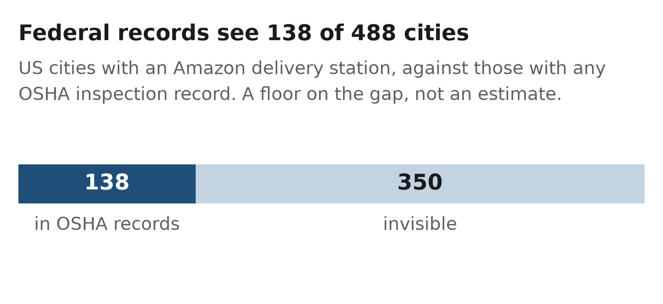
Fig. 1. The public-visibility floor. Of the 488 US cities in which the MWPVL industry census lists an Amazon delivery station, OSHA enforcement records — the best free source of facility addresses — hold an inspection of any Amazon facility class in 138; the other 350 are invisible to OSHA entirely. Both counts are read at build time from outputs/metrics/mwpvl_coverage.json.
Cities where MWPVL lists a delivery station | 488
Cities where OSHA ever inspected any Amazon class | 340
In both lists | 138
MWPVL cities OSHA has never inspected | 350
Share of MWPVL cities OSHA has seen | 28.3%

TABLE I. The visibility gap, as counted. Two independent city lists, not a numerator and a denominator. Source: outputs/metrics/mwpvl_coverage.json.
The best free source of facility addresses in the US is OSHA enforcement data. We measured how much of the network it sees, against the independent MWPVL list (mwpvl_coverage.json). Table I counts it and Fig. 1 draws it.
These are two independent city lists, not a numerator and a denominator. Two qualifications travel with the figure and we state them every time it appears. It is conservative: OSHA's side is unrestricted by facility class, so narrowing it to delivery stations would widen the gap. And it is a floor, not an estimate — a two-list intersection, not capture–recapture — because MWPVL is itself incomplete and says so. A separate three-list capture–recapture exercise, using OpenStreetMap as a third list whose capture mechanism is unrelated to worker grievance so that dependence is measured rather than assumed, puts OSHA coverage of US cities with an Amazon facility at at most 54.0% under a Chapman two-list estimator and at most 37.8% under a Chao lower bound on the population. Those are modelled estimates and a different quantity; the 28.3% is the thing that was counted.
D. Covariates
The choice model's frame joins households, land area, total establishments and the County Business Patterns count of warehousing establishments, at ZCTA grain, over 21,768 ZCTAs. Fifteen further candidates were tested, drawn from the American Community Survey, EPA EJScreen and Census Building Permits Survey. The relevant property of each is not its plausibility but its within-metro variability; Section V-C is about that.
IV. Methods
A. Within-metro conditional choice
Conditional on one station opening in metro m, the probability that candidate ZCTA j is chosen is its share of the metro's total attraction, P_j = A_j / Σk ∈ C_m A_k, with A_j = Σ_c β_c xjc, β_c = (θ_c) > 0, and β_households fixed at 1.0 as numeraire. Entering covariates as extensive counts in a linear attraction is what makes the specification invariant to merging two ZCTAs (Train [8] §3.4, Example 2). Evaluation is by top-k hit rate against the analytic chance rate, stratified by choice-set size, over 50 re-splits with the model refitted inside each repeat. Stratification is not optional: in a metro with 25 or fewer candidates, random guessing already lands in the top ten about two-thirds of the time, so pooled lift is capped by arithmetic and pooling across strata is a Simpson's-paradox trap this project fell into twice.
B. The pre-registered metro-entry model
Unit: CBSA × year, 2018–2025. Universe: all 935 CBSAs in the panel, not only the 195 that ever received a facility — restricting to those would be selection on the outcome and was named in advance as an invalidating condition. Event: at least one delivery station opens in that CBSA in that year. Both a logistic model on the binary event and Poisson / negative binomial models on the count were fitted. Three baselines were fixed in advance: (1) uniform, the no-information floor; (2) rank by households, named in the registration as “the one that matters”; (3) rank by facilities already present, the densification null.
Primary evaluation is out-of-time: fit through year t-1, predict year t, rolled forward. The registered success criterion is explicitly two-clause: H1 is supported only if the model beats the households baseline on AUC in a majority of held-out years and its calibration is at least as good as a constant null in a majority of years. The second clause is where our earlier survival model died, and the registration says why: “ranking without calibration is not prediction”.
Three arms were declared before any fit. prereg_strict enforces a strict vintage gate plus a 90% per-year coverage floor and carries the verdict; vintage_clean waives the coverage floor; vintage_relaxed ignores vintage entirely and is diagnostic only.
C. Cost to serve
For each ZCTA, daily parcels are derived from households and an income-elasticity adjustment; stops from parcels per stop; stop density from land area. Distance per stop is
dstop \;=\; k√(δ) ρ_local \;+\; 2L/C_line haul
with δ stop density per square mile of land, ρ a circuity factor, L great-circle miles to the nearest depot and C stops per tour. Cost per stop is then a per-mile term, a per-hour driver term at 22 mph, a flat service time and a vehicle lease share. Five parameter scenarios are run end to end.
The depots are observed, not solved. L is measured to the nearest of the operator's 501 address-geocoded delivery stations. The facility panel holds 693 rows; 192 carry only a ZCTA-centroid fallback coordinate and are excluded, because a centroid depot sits inside its own catchment by construction and drives that ZCTA's line haul to zero — the single most cost-reducing error available in this model. A ZCTA is costed if its internal point lies within a 15-mile great-circle catchment of some station; the catchment radius is the one this project pre-registered for an unrelated analysis, so reusing it spends no new researcher degree of freedom. Great-circle miles decide the catchment; the miles the model charges pass through ρ exactly as the local term does.
The catchment is a trade of coverage against the regime the approximation is valid in, and it is not chosen for density. A sweep from 5 to 45 miles is monotone in both directions: 5 miles gives a median 588 stops/sq. mi but reaches 21.9% of US households; 45 miles reaches 81.6% at 44 stops/sq. mi. No radius is simultaneously denser than the retired pilot (475 stops/sq. mi) and covers a majority of US households. At 15 miles the costed set is sparser than the pilot — 350 against 475 stops/sq. mi, 866 against 1,075 households/sq. mi — and we report the resulting regime violations rather than absorbing them (Section VII).
Three coverage facts travel with every cost figure in this paper. Twenty of the 501 stations contribute no costed ZCTA. Three hundred and sixteen ZCTAs, 0.83% of catchment households, are dropped for carrying no OEWS driver wage and nothing is imputed. Eight of the 501 stations are announced rather than open.
D. Reporting discipline
Three rules are enforced throughout and are worth stating because they change what the numbers mean.
1) A percentile spread across re-splits is not a confidence interval and not a standard error. Every bracket we report from panel_experiments, gravity_network, metro_entry and refit_expanded is a percentile over re-splits of one fixed decision set; the artefacts carry an explicit spread_is_not_a_standard_error field. Only the metro-clustered bootstrap intervals in this paper are bootstrap intervals.
2) Raw scores, never skill scores [11].
3) Cite the artefact, not the figure. Several headline numbers in this project were invalidated by re-running the code that produced them, and not one of those moves was caused by a parameter change.
V. Results
A. The metro-entry model: H0
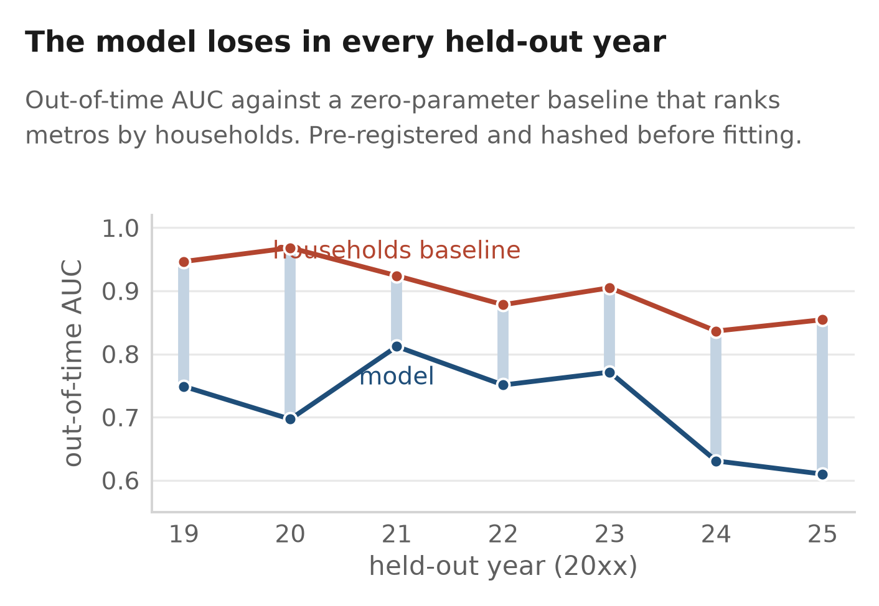
Fig. 2. The pre-registered result, drawn. Out-of-time AUC by held-out year for the verdict arm (prereg_strict, logit) against baseline 2, the zero-parameter rule that ranks metros by household count. The model is the lower line in all seven years and the pale bars are the yearly deficit. Every value is read at build time from outputs/metrics/metro_entry.json.
Year | Events | Model | B1 unif. | B2 h'holds | B3 fac.
2019 | 23 | 0.7487 | 0.5 | 0.9464 | 0.7198
2020 | 49 | 0.6968 | 0.5 | 0.9682 | 0.7600
2021 | 53 | 0.8119 | 0.5 | 0.9239 | 0.7811
2022 | 36 | 0.7509 | 0.5 | 0.8780 | 0.7012
2023 | 31 | 0.7713 | 0.5 | 0.9049 | 0.7934
2024 | 50 | 0.6307 | 0.5 | 0.8363 | 0.6968
2025 | 64 | 0.6098 | 0.5 | 0.8543 | 0.6902
pooled (6,545 rows) | 0.7323 | — | 0.8949 | 0.7325

TABLE II. Out-of-time AUC by held-out year, verdict arm (prereg_strict, logit). 935 metros per year; 306 event metro-years. Source: metro_entry.json, run 20260915-231322-7d21.
Table II is the result and Fig. 2 is the same seven years drawn. Clause 1 of the registered criterion fails 0 of 7; the smallest yearly deficit is 0.112 of AUC (2021) and the largest 0.271 (2020). Clause 2 fails 3 of 7. The verdict is H0 on every arm × form (three arms × logit / Poisson / negative binomial, which agree to within 0.0001 of AUC in every year), and H0 also when 2020–21 are excluded, where it gets slightly worse (0 of 5 and 1 of 5).
We report the pre-registered H0 paragraph without softening, as written before the fit:
Free public data cannot predict siting at any grain tested. The ZIP-level failure is not a resolution problem but a general one: the variables that drive the decision are not public at any resolution.
Four details sharpen this.
The fitted model reproduces a column of integers. Pooled over the seven held-out years, a two-covariate logistic fitted seven times scores AUC 0.7323; baseline 3, the zero-parameter count of facilities already present, scores 0.7325 on the same 6,545 rows. Top-50 totals are 129 against 127.
Stratification strengthens the finding. Terciles of households, fixed across years: model AUC 0.4125 / 0.5666 / 0.6961 against baseline-2 AUC 0.7668 / 0.6827 / 0.8023, on 6 / 27 / 273 events. The pooled AUC of 0.7323 is higher than the model's AUC in every single tier — the textbook aggregation effect, since size both predicts the outcome and defines the strata. Quoted alone, 0.73 would have read as a working model. Note also that in the smallest tercile the model scores 0.4125, which is below the 0.5 of a coin flip: on the six events among the smallest third of metros it is not merely uninformative but actively mis-ordered. Six events is far too few to make anything of that number on its own, and we make nothing of it — but it is the opposite of what a model that had learned a weak signal would look like, and reporting the pooled figure alone would have concealed it.
The uncertainty is not marginal. Metro-clustered bootstrap, 2,000 draws over 935 CBSA clusters: model AUC 0.7319 [0.6876, 0.7706]; model minus households -0.1628 [-0.2011, -0.1313].
Leakage is not what is holding the model up. The diagnostic vintage_relaxed arm — seven covariates including households itself, permitted to see data published after the year it predicts — still loses to ranking on households alone in 6 of 7 years, its single win being +0.0004 of AUC, and loses calibration 7 of 7. The ceiling is the baseline.
The single largest qualification on this run also belongs here, not in a footnote. The registered vintage rule removed 8 of the 12 pre-registered covariates, and two more failed the coverage floor, leaving two. The reason is structural: most of the panel's columns are not time series at all. Mean distinct values per unit across 32 quarters is exactly 1.00 for population, households, income, the two EJScreen columns, both wage series and metro employment — one value, broadcast. The ACS 5-year 2023 file is built from responses collected 2019–2023, so using it to predict 2020 is not a borderline publication-lag call. The Tier-1 mechanism that generated H1 was therefore never testable on this panel. That is a finding about data availability rather than about the hypothesis, and it points at the same conclusion from a different direction: the covariates that might have distinguished one metro from another are published once, late, and without a usable history.
B. ZIP grain: the model is one variable
On the combined arm (483 decisions, 258 in large metros, 193 held out per re-split), the conditional logit's large-metro top-10 lift is 6.2585× over chance. Quintupling the panel from 94 to 483 decisions bought no ranking accuracy and cost none: the same quantity is 6.1804× on original_only (94 decisions) and 6.2903× on combined_plus_network (panel_experiments.json).Four different artefacts in this project publish a “large-metro top-10 lift” on four different frames, with different nulls and different numbers of splits. We name arm, method and artefact every time.
On covariate_search.json's frame (477 decisions, 191 held out, 687 facilities, run 20260915-235210-ff92) the baseline is 6.2157× and the same model without warehousing_establishments is 2.6785×. Removing one column costs 3.54 of 6.22.
Of the fifteen additional covariates tested, ten were exact no-ops — the model was bit-identical with and without them on all 50 re-splits — and the best of the fifteen bought +0.0082 of lift. Two of the fifteen were never independent tests: vehicle_availability_total is equal to households to floating-point precision on all 21,768 ZCTAs (both are ACS occupied housing units), and owner_occupied + renter_occupied = households exactly, so those two rows are one test reported twice. The corrected count is thirteen independent candidates.
Is the ceiling the data or the functional form? A gradient-boosted benchmark answers it. On the 94-decision frame, 38 held out, 50 repeats (gbm_benchmark.json, 20260915-200312-1d51), quoting across_repeats because the artefact carries its own warning that a 10-12 perturbation moves the single-split result by up to 2 of 38: shallow GBM 22.26 hits, an unfitted raw warehouse count 20.96, the conditional logit 20.60 (with the best Brier of all methods, 0.007550), deep GBM 18.76. The flexible learner wins by about 1.3 decisions in 38 and loses on probability quality; 53.5% of its split gain sits on the one covariate. The ceiling is the data.
Does the one working covariate contain its own outcome? The count of warehousing establishments is measured at a CBP vintage chosen off the facility's OSHA-bounded opening year, which can post-date the building. A decisive test forced the vintage behind the facility's stated opening date instead, on the 29 decisions where both exist, all three arms restricted to the same 29 (leakage_decisive.json, 50 paired re-splits): osha_bound 9.24 hits of 12, true_date 8.22, no_covariate 4.48. The covariate retains 3.74/4.76 = 79% of its measured value and still beats the floor on 50 of 50 splits. The per-establishment coefficient is unchanged to within 1.2% once each arm's column mean is divided out, which is what agglomeration looks like rather than what a contaminated regressor looks like. It does not survive cleanly: the test cost 65 of 94 working decisions, the test set is 12 decisions, and the design cannot separate the leak from the staleness that removing it introduces — so +1.02 hits is an upper bound on the leak, not a measurement of it.
C. The dispersion regularity, and its asymmetry

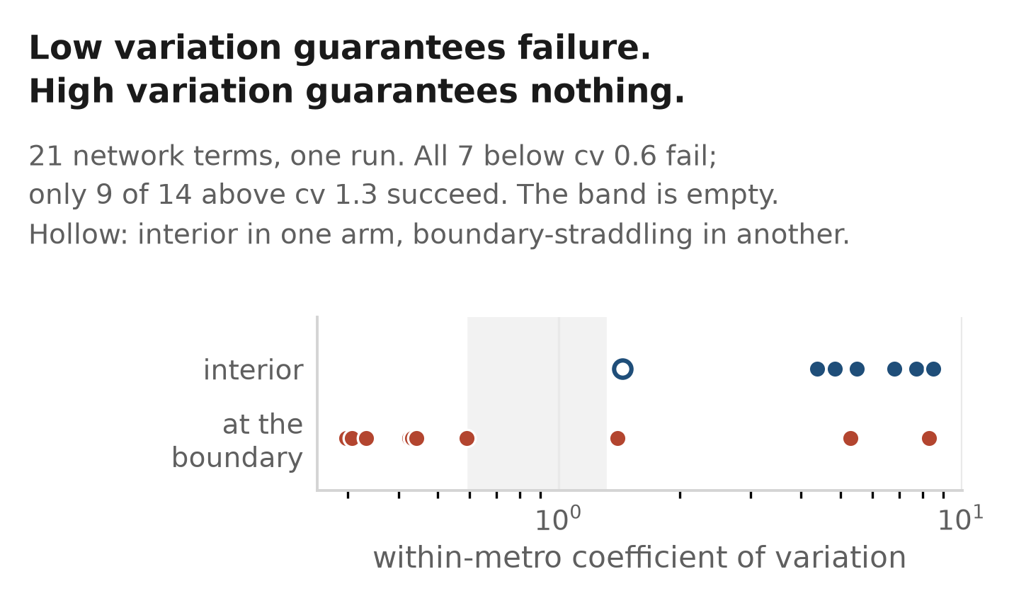
Fig. 3. Why a covariate fails, term by term. Each point is one of the 21 network terms in gravity_network.json (run 20260915-210603-b780), placed by its mean within-metro coefficient of variation and by whether its coefficient is interior or at the boundary in the arm where it is fitted. Every term below cv 0.6 is at the boundary; 9 of the 14 above cv 1.3 are interior; the shaded band holds nothing at all. The hollow marker is fulfilment_proximity, interior in one arm and boundary-straddling in another.
cv band | terms | interior | not interior
< 0.6 | 7 | 0 | 7
0.6–1.3 | 0 | — | —
> 1.3 | 14 | 9 | 5

TABLE III. Within-metro dispersion against coefficient state, all 21 network terms. Low dispersion is sufficient for failure, high dispersion is necessary but not sufficient for success, and nothing was observed in between. Interior/boundary is the re-split percentile rule of the arm in which each term is fitted. Source: gravity_network.json, run 20260915-210603-b780, terms.dispersion at vintage 2030.
A conditional choice model differences away everything constant within a choice set. A covariate's only currency is therefore how much it varies among the 200 candidate ZCTAs of one metro. Measured directly, the mean number of distinct values per large metro is 200 for land area and 193 for households, but 9.2 for the EJScreen and ACS county-grain columns and 8.0/7.9 for the two building-permit columns. Six of eighteen columns offer the model nine distinct values with which to rank two hundred alternatives.
This can be turned into a pre-fitting screen. Over 21 network terms in one run (gravity_network.json, 20260915-210603-b780, terms.dispersion at vintage 2030, 41 large metros of ≥101 candidates, 8,271 candidate ZCTAs), scoring each term's mean within-metro coefficient of variation against its boundary/interior state in the arm where it is fitted gives Table III. Fig. 3 plots the same 21 terms one by one rather than banded.
The rule runs one way. Low within-metro dispersion is sufficient for failure: all 7 terms with cv below 0.6 (range 0.2975–0.5918) land at the coefficient boundary. High dispersion is necessary but not sufficient for success: 9 of the 14 with cv above 1.3 (range 1.3993–8.5046) are interior, and the 5 that are not are all on the sortation side, four of them carrying square footage as mass. An earlier version of this claim, including the version quoted in our own pre-registration, asserted the rule held “21 of 21” in both directions; it does not, and the two-way version was exactly the part that made it sound like a predictor.
Two things raise this above coincidence in the direction it does run. The gravity exponent α is a knob: moving it from 1 to 3 changes nothing about what the covariate measures — still pull from the same facilities — and changes only how sharply it discriminates within a metro. The cv rises from 0.30 to 8.50 and the coefficient walks from the boundary to the interior. And it retrospectively explains the one failure that had no explanation: a count of facilities within 50 miles sits at cv 0.59 and fails at 25, 50 and 100 miles, while a distance to the same facilities works. The radius was never the issue.
Read this as description, not as an estimated relationship. n=21 terms from a single run at a single vintage, and the terms are not independent — each is one of two columns in one of 13 arms fitted over the same 483 decisions. Nothing was observed between cv 0.6 and 1.3, so the finding is silent about intermediate dispersion. We state it as a screening heuristic worth seconds of compute before fitting anything, and no more than that.
D. The cost model works, and says feasibility binds first

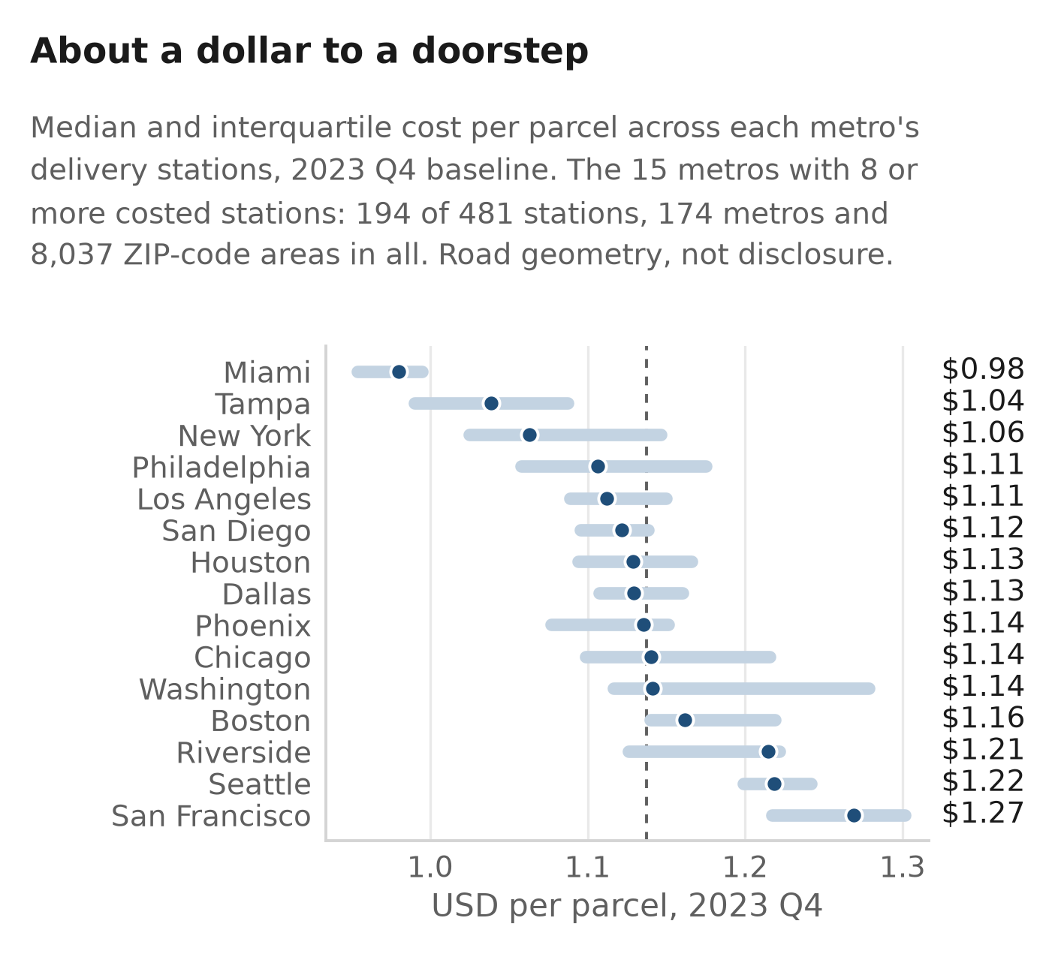
Fig. 4. Median and interquartile cost to deliver one parcel, by metro (2023 Q4 baseline scenario, observed depot layer). Every value is read at build time from outputs/tables/cost_by_station_2023q4_baseline.parquet; nothing in the figure is typed by hand. The 15 metros drawn are those with at least eight costed stations — 194 of the 481 stations, selected by a threshold rather than a rank because eight metros tie at five stations and a “top n” cut would break that tie arbitrarily. The remaining 159 metros are mostly single-station, where an interquartile bar has no content: the median metro-level IQR across all 174 is 0.00.
Median cost per parcel | 1.1389
p10 / p90 | 1.0008 / 1.3445
Pooled cost per parcel | 1.1281
ZCTAs costed | 8,037
Households covered | 74,399,605 (57.8%)
Stations (real / with a costed ZCTA) | 501 / 481
Metros containing a station | 174
Median line haul | 9.09 mi
Total daily parcels | 42,048,849
Total daily cost | 47,434,701
Vans ( Σ van-days ) | 250,291

TABLE IV. The 2023 Q4 baseline cost model on the observed depot layer, over 8,037 ZCTAs and 501 real delivery stations. Source: cost_by_station.json, run_id 20260916-131845-34f1; the per-ZCTA and per-station tables it is computed from ship with the repository.
Table IV summarises the baseline scenario and Fig. 4 shows how it distributes across metros. Across the five parameter scenarios the median moves from -17.2% (dense routing, 0.9431) to +7.7% (congested, 1.2264).
 | solved depots | observed depots
Depots | 334 p-median | 501 real (481 used)
ZCTAs costed | 2,333 | 8,037
Median cost per parcel | 1.0830 | 1.1389
p10 / p90 | 0.9778 / 1.4180 | 1.0008 / 1.3445
Median line haul (mi) | 4.02 | 9.09
Service time share | 66.96% | 59.75%
Vehicle share | 22.93% | 21.63%
Drive-time share | 6.97% | 12.63%
Distance share | 3.14% | 5.98%
Scenario span on median | -17.1/+4.4% | -17.2/+7.7%

TABLE V. What replacing a solved depot network with the observed one costs. The pilot column is a Daganzo model identical in every parameter, differing only in that its depots are a 334-site p-median over ten metros. Source: cost_by_station.json, pilot_comparison.
The level is the least interesting line in Table V. Replacing the solve with the observed network moves the median +5.2%, which is inside the width of a single stress scenario. What moves materially is the composition. Median line haul more than doubles, 4.02 to 9.09 miles, because a real national network is not a distance-minimising one — and because the costed universe is now national rather than ten dense metros. Drive time and distance together rise from 10.1% of a stop to 18.6%. Labour at the door still carries the bill at 59.75%, but the summary this project previously published — that the routing mathematics is decoration — described the solved network and no longer holds. The consequence for this paper is that the parameters now carrying the headline have shifted from service_minutes_per_stop toward avg_speed_mph, circuity and van_mpg, none of which has an external source (Section VII).
A p-median is a lower bound, so the 5.2% is a measurement. The solve minimises demand-weighted distance by construction; the operator's buildings sit where land, labour, zoning and lease terms allowed. The gap between the two is the cost of siting in the world rather than in the objective function, and on this network it is 5.2% of the median parcel and a doubling of line haul. We know of no comparable figure computed on a real US last-mile network from public data.
Feasibility binds before economics, and this is an argument about the cost function rather than a statistic. Cost falls as 1/√(δ). The cheapest ZIPs to serve are therefore the densest, and the densest are precisely where a warehouse cannot physically be built — no parcel, no dock, no zoning, no lease. That is also why a raw warehouse count out-predicts everything else we fitted: the count measures where building is possible, not where delivering is cheap.
A statistic supporting that claim is withdrawn, and the withdrawal is itself a result. Earlier versions of this work reported that of 43 pilot facilities, zero sat in the cheapest decile of their own metro. That test is not identified on the present model and we do not restate it with new digits. Once the depots are the facilities, a ZCTA containing a station has a line haul of approximately zero because the station is inside it; line haul enters as 2L/C and drive-plus-distance is 18.6% of the bill, so the model makes every facility's own ZCTA cheap by construction. Ranked on the published frame, 275 of 476 matched facilities (57.8%) land in the cheapest decile at a median percentile rank of 0.080 — the circularity, measured. Re-pricing every ZCTA against the nearest station outside it does not rescue the test: the mask gives 33 of 476 (6.9%) for the 501 stations but 7 of 43 (16.3%) for the original pilot facilities, below and above the 10% a uniform placement would give. The mask under-corrects in dense metros, where a masked station's neighbour is two miles away (median masked line haul 6.8 miles for the 43 against 10.4 for the 501). A statistic whose sign depends on which facility set draws the counterfactual is not evidence for either sign. The mechanism in the preceding paragraph does not depend on it.
E. Three further programmes, each retired on a measurement
Survival. A ZIP-quarter hazard model was rebuilt on 6.7× the events (812 5,441) with real recovered opening dates. AUC held out by unit moved 0.6894 0.6832, and a constant null was better calibrated in 17 of 17 comparisons (hazard_revival.json; model_better_calibrated_at is an empty list). The retirement was taken on the unit of analysis, not sample size: one opening switches on a median of 39 ZCTAs at the 15-mile catchment (mean 52.4, max 317), which the likelihood counts as 39 independent observations. No radius between 8.3 and 45 miles brings that below 14.
White space. Ranking unserved places by an under-coverage score wins 14 of 108 scored cells (13%), with 0 significant wins for white space against 32 for the household baseline. What it did produce is a densification measurement: at the headline 45-mile radius, 68.7% to 75.9% of 2024–25 delivery-station openings landed inside coverage the pre-2024 network already had (75.9% = 60 of 79 openings with real Census coordinates; 68.7% = 90 of 131 once ZCTA-centroid fallbacks are admitted). That range is across coordinate sets at one radius, not across radii.
Gravity. Replacing distance-to-nearest with summed distance-discounted network pull produces the only specification whose coefficients never hit the boundary, and when both are offered the optimiser keeps gravity and discards distance — a better measurement. It does not resolve to a single scalar against proximity: on large-metro top-10 lift the best fully-interior gravity arm scores 6.2187 against the published proximity baseline's 6.2903 and a no-network floor of 6.2585, but paired over the same 50 re-splits it is +0.0116 on top-1 (42 improved / 4 worsened), +0.0126 on top-5 (44 / 2) and -0.0002 on top-10 (18 / 22), and it wins on Brier. It also costs the specification its aggregation argument: over 43,224 merged ZCTA pairs the merger-invariance error is 0.00 for the extensive-only control and 0.044 median / 0.455 maximum for the network arm. We did not switch.
VI. Discussion
A. Why open data fails here, and where that generalises
The two failures have one diagnosis and it is about publication grain, not about the world.
A within-metro conditional choice model can only use a covariate that varies inside a metro and is not a population proxy. Most free US public data fails one or both. County-grain series — environmental screening, permits, wages — are broadcast down to every ZCTA in the county and arrive at the model as about nine distinct values across two hundred alternatives. A constant cannot rank anything, however large its true effect. This is not a data-quality problem: traffic_proximity is populated on 99.9% of rows. And the remaining ACS columns are collinear with the numeraire by construction — a ZCTA with twice the households has twice the cars, twice the labour force, twice the graduates — so they are not identified. When we re-entered them as per-household rates the collinearity was repaired (within-metro correlation with households falling from +0.982 to +0.112 for labour force, from +0.909 to -0.368 for owner-occupancy) and the lift did not move. The failures were over-determined: the columns were collinear and empty.
Escaping to metro grain was the obvious move, and it is the move the pre-registration bet on: variation that is between counties is, by construction, between metros. The bet lost, and the way it lost is the interesting part. The county-grain covariates could not be used at metro grain either — not because they lack variation there, but because they are published once, late, and without a usable history, so no time-respecting vintage of them exists. The transparency gap therefore has two distinct components: variables published too coarsely to discriminate within a market, and variables published without the temporal depth to predict anything at all. Section III-C's 138-of-488 is a third: the locations themselves are largely unrecorded in public enforcement data.
B. What would actually move this
Our own evidence names the candidates, and they share a shape. The covariates that work are the ones computed as a distance from each candidate rather than looked up against it — because the former are ZCTA-specific by construction and the latter inherit the publisher's grain. The two network-proximity terms are the only new class that ever worked. The best untested idea by the same logic is parcel-level land data (acreage, zoning, van-staging capacity): finer than ZIP and uncorrelated with population, it passes both filters. It is blocked on roughly three thousand county GIS portals, which is an infrastructure problem rather than a modelling one — and that is itself the paper's point.
C. On pre-registration in applied siting work
Writing the registration cost about a day and changed three decisions we would otherwise have made after seeing results. It fixed the households baseline as the bar before we knew the model would clear only the uniform one; it fixed the calibration clause before we knew the model would rank tolerably and calibrate badly; and it wrote the H0 paragraph in advance, which is the main reason this paper reports a null in the language of a finding rather than of an excuse. It also produced three criticisms of itself that only became visible once it met the data — most usefully, that its covariate list should have been checked for distinct-values-per-unit before being fixed, a two-line check. That is an argument for writing one, not against it.
VII. Threats to Validity

A. The panel is one operator, one class, one country
Every result here is Amazon US small-package delivery stations. Nothing licenses extrapolation to other operators, other facility classes or other regulatory regimes. The visibility gap in particular depends on OSHA's inspection selection, which is driven by worker grievance and is therefore not independent of facility age, size or unionisation.
B. The leakage test rests on 29 decisions
The audit of the load-bearing covariate cost 65 of 94 working decisions (69%) and leaves a 12-decision test set, fitting 17 decisions against 3 estimable parameters. Its intersection is also not a random subsample: osha_bound scores 77% here against 54% on the full 94, so these 29 buildings are measurably easier. Fourteen of the 29 stated dates come from an MWPVL table for a different facility class matched on the same street address; restricting to the two delivery-station tables halves the sample to 15 decisions, 6 held out, and the difference disappears into noise. Nothing was corrected: two of the 29 stated dates are later than the OSHA bound for the same building, and are used as stated, because dropping the pairs that disagree in the inconvenient direction is how a leakage test is rigged.
C. The dispersion finding is descriptive and from one run
n=21 non-independent terms — each one of two columns in one of 13 arms fitted over the same 483 decisions — at one vintage, in one artefact. The 0.6–1.3 band is empty, so the finding says nothing about intermediate dispersion. “At the boundary” is also a rule, not a fact: the re-split percentile rule used here calls sortation_proximity “boundary inside the interval”, while a point-estimate rule applied to a 500-replicate clustered bootstrap in a different artefact calls the same column at_boundary: false. Both are current and both are right under their own rule. We name the rule everywhere.
D. One opening switches on a median of 39 ZCTAs
This is why the survival model was retired rather than tuned, and it is worth restating as a threat because the same error is easy to reintroduce. Treating ZIP-quarters as the unit of analysis counts one decision 39 times and makes the standard errors meaningless (Train [8] §3.7.1, printed p. 61). The conditional-choice reframe exists to make each opening exactly one observation. A related caution: 39 is the median catchment size; 13 is the median number of ZCTAs an opening switches on for the first time. Only 39 supports the independence argument.
E. Errata against the pre-registration
Three figures quoted in the registration to motivate the hypothesis were wrong or under-labelled. They are corrected in a separate errata document rather than in the sealed file, because an in-file correction — however honestly flagged — destroys the only check that matters, namely that the document can be shown not to have moved. None of the three touches a pre-registered clause; the verdict is unaffected.
1) The motivating claim that honest nested forward selection came out “0.72 points worse” than adding nothing did not name its stratum, and the magnitude has since settled at -0.62 pp, not -0.72: on the completed 687-facility / 477-decision run the large-metro top-10 hit rate falls 30.473% 29.852% over 50 re-splits (5 wins / 19 ties / 26 losses). Pooled across all choice-set sizes the same comparison goes the other way, +0.36 pp. The motivating argument survives — selection inside the fold bought nothing and cost something in the stratum that matters — but it is stratum-specific and must always be stated as such.
2) The registration quotes the dispersion rule as symmetric and exceptionless, “21 of 21” in both directions. It is neither. The corrected rule is asymmetric (Section V-C), and this correction runs against the registered hypothesis, not in its favour: it weakens the inference that high-dispersion columns would work at metro grain. As it turned out, they did not.
3) The densification range was quoted as 67–77%, mixing radii and coordinate sets. At the headline 45-mile radius the correct range is 68.7–75.9%, varying across coordinate sets only.
The registration also cites three artefacts at paths that have since moved. Those paths were deliberately left wrong, because correcting them would change the file and break the hash.
F. Inference on the expanded panel does not exist
The sandwich, bootstrap and conformal machinery was built and run on the 104-row pilot panel and has not been re-run on the 693-row one. Every bracket this paper quotes from panel_experiments, gravity_network, metro_entry and refit_expanded is therefore a percentile over re-splits of one fixed decision set, and is labelled as such. The project has the better sample and the worse inference on it. Where inference was done properly, it withdrew a claim: a network coefficient interval that excluded the numeraire under re-split percentiles contains it under a metro-clustered bootstrap, a clustered sandwich and an independent sandwich alike.
The depot layer was invented; it is now observed, and the substitution has a price
This subsection used to record a defect and now records its repair and the cost of the repair, because both are measurements.
What the old model assumed. The depot layer was solved. The number of depots in a metro was daily parcels / 40,000 and their positions were a p-median over ZCTA candidate nodes: 334 buildings the operator never chose. Two things made this worse than an ordinary modelling simplification. First, the throughput constant and the placement algorithm entered the line-haul term, which is the only channel by which geography reaches the bill, and parcels_per_depot_per_day was the largest rank mover in the whole model. Second — and this is the transferable part — placement was implemented as an algorithm choice rather than a constant, so it had no entry in any range dictionary, could not be swept, and was therefore structurally invisible to the sensitivity analysis. A sensitivity analysis enumerates the things you called parameters. Depot placement moved the answer further than anything on that list and was not on it. Changing the solver from k-means to p-median alone removed 9.3% of billed parcel-miles and reordered the published ranking (Spearman ρ = 0.888).
What replaced it. The facility panel now carries 501 address-geocoded delivery stations, so the assumption is deleted rather than improved. There is no placement step, no throughput constant and no capacity story: parcels_per_depot_per_day no longer enters the cost path at all, and StationCostModel overrides exactly one method of the Daganzo model — linehaul_miles — so every other parameter is inherited and any difference between the two runs is attributable to the depot layer.
What it cost. The median rises 5.2%, 1.0830 to 1.1389, and median line haul rises from 4.02 to 9.09 miles (Table V). Real siting is less cost-optimal than a p-median solve, and 5.2% is how much less on this network — a finding in its own right, since the p-median is by construction the distance-minimising placement and therefore a lower bound. Part of the doubling is also composition: the costed universe moves from ten dense metros to 57.8% of US households, and the added ring is sparser.
What it did not fix. Three things are now the binding coverage limitations and are stated with the headline throughout: 20 of the 501 stations contribute no costed ZCTA; 316 ZCTAs (0.83% of catchment households) are dropped for carrying no OEWS driver wage, with nothing imputed; and 8 of the 501 are announced rather than open. All 501 are Amazon delivery stations, so “the operator's network” remains one operator and one class. A further 192 of the 693 panel rows are excluded because their only coordinate is a ZCTA centroid, and a centroid depot would drive its own ZCTA's line haul to zero — the exclusion is necessary, and it also means the depot layer is the geocodable 72% of the panel rather than the panel.
G. The composition shift moves which unsourced parameter matters
With a solved network the bill was 66.96% service time and 10.1% driving plus fuel, and the defensible summary was that labour carries the headline while the routing mathematics is decoration. On the observed network driving plus fuel is 18.6%. Service time still dominates at 59.75%, but the sensitivity of the headline has moved toward avg_speed_mph (22), circuity (1.3) and van_mpg (14), none of which is externally sourced, and the scenario span widens accordingly: the congested arm now costs +7.7% where it cost +4.4%. Any reader carrying forward the older summary will under-weight exactly the parameters this model is now most exposed to.
H. A test that stopped being identified when the model improved
We previously reported that zero of 43 facilities sat in the cheapest decile of their own metro. We withdraw the statistic. The reason is structural rather than arithmetic and is worth stating as a threat because the failure mode is general: the test was identified only while the depot layer was wrong. Once depots are the facilities, a ZCTA holding a station has a line haul of about zero because the station is inside it, and drive plus distance is 18.6% of the bill, so the cost model makes every facility's own ZCTA cheap by construction. On the published frame the test inverts to 275 of 476 (57.8%) in the cheapest decile, which measures the circularity and nothing else. A leave-one-out counterfactual — re-pricing every ZCTA against the nearest station outside it — gives 6.9% on the 501 stations and 16.3% on the original 43, straddling the 10% chance rate in opposite directions on the same frame under the same mask. We report both arms rather than the convenient one. The claim the statistic was recruited to support, that feasibility binds before economics, is argued in Section V-D from the 1/√(δ) form of the cost function and from the fact that a raw warehouse count is the only covariate that predicts siting; it does not rest on a decile count.
I. The cost model's central constant is undefended
The local-travel coefficient is set to k=0.57. Of the four sources our code offered for it, one is a different author's paper about a different quantity [5], one is real but unread [3], and two state a value 31–34% higher [6, 7]. Our own docstring derives the term from the Beardwood–Halton–Hammersley setting, in which the constant is a property of the optimum tour and therefore a lower limit — so 0.57 is not admissible under the derivation as printed. If 0.57 is right it is right as a decomposed local-term coefficient, a different object, and we have not reconciled the two. We report this rather than repair it silently because the magnitude makes it invisible downstream: substituting Larson and Odoni's 0.765 moves the median by +1.20%, and deleting the local term entirely moves it by -3.91% while keeping 88 of the cheapest 100 ZCTAs in the cheapest 100. That is precisely the class of error that survives review, and the honest headline is that the cost model's ranking is robust to the constant while its defence is not.
J. The cost model cannot be validated against realised costs
Nobody publishes what it actually costs this operator to deliver a parcel, so no external validation is possible. What we can say is bounded and we say only that: the structure is a published method, five parameter scenarios span -17.2% to +7.7% on the median, the decomposition is internally recomputable from the stored table, and eight of the model's parameters have no external source at all. The depot layer is now observed, which removes one unvalidated input, but observing where the buildings are says nothing about what the operator pays to run them. A Monte Carlo over parameter ranges is not a confidence interval — every range is ours — and one parameter was never sampled at all, so every band it reports is a floor.
K. Validity conditions of the continuous approximation
We apply one constant to all 8,037 ZCTAs as though each were a compact convex routing district. They are not: ZCTAs approximate postal delivery routes, which are by construction long thin things. Daganzo's own abstract states that zone shape is his contribution and that ignoring it during clustering can significantly increase travel distances; our repository holds no shape or compactness measure at all. Separately, 496 of 8,037 ZCTAs (6.17%) generate fewer than the 120 stops a tour assumes, so the vehicle's working area exceeds the zone whose density is being charged, and 136 (1.69%) fall below the n ≥ 15 that Larson and Odoni call adequate. Those ZCTAs carry 0.077% and 0.0035% of catchment households respectively and are already reported as the expensive tail, so the effect on the headline is small. Both fractions rose when the depot layer became real — they were 5.40% and 1.24% on the ten-metro pilot — because the 15-mile station catchment is sparser than the pilot it replaces, 350 against 475 stops/sq. mi. An earlier draft of this paper asserted the opposite, that the catchment was denser at 742 against 475; that comparison put households per square mile against stops per square mile and is withdrawn. No catchment radius we swept is both denser than the pilot and covers a majority of US households, so the radius is a coverage/regime trade and is defended as one.
L. Engineering caveats that bear on the numbers
Stated because they are measured and because omitting them would misrepresent the artefacts. (i) 75 of 138 source modules are unreachable from any test by an AST import-graph traversal seeded from every test file — and every artefact quoted in our results section is written by a module in that list. “661 tests pass” and “the headline artefacts have no test importing their emitter” are both true and must be quoted together. (ii) The 693-row facility panel and its geocoding side file spent most of this project's life excluded from version control by an over-broad ignore rule, existing on a single disk. They are no longer excluded, and they are carried by the published export alongside the two derived tables that let the headline results be reproduced from a clone with no network access and no API keys — but at the time of writing they were still untracked in the working repository rather than committed, which is a weaker statement and the one the evidence supports. An earlier draft of this paragraph claimed they were committed; git ls-files disagreed, and the claim was corrected rather than the check ignored. (iii) One artefact emitter reused a single run_id across successive writes and stamped written_at at the first write, so two materially different versions of covariate_search.json once carried an identical stamp. The cause was a stamping helper that spread its payload after the stamp keys, so an emitter resuming from its own artefact inherited the previous run's identity; it is fixed, but every figure in this paper was read with a payload field checked rather than the stamp trusted. (iv) A retired artefact, lift_by_market_size.json, has no emitter in the tree and an internally contradictory summary field; none of its figures appear in this paper. (v) One pipeline figure in circulation — “13 genuinely new sites” from a labelling programme — is counted by hand, has moved once, and is not reproducible from any artefact; it does not appear in our results.
M. A prior self-audit finding, disclosed
An earlier version of this project's slide deck shipped a decay curve with a 95% confidence band, a significance annotation, and nine hand-typed values, on an outcome variable that does not exist in the project's data. It was caught in self-audit. The rule adopted since is that a figure either reads its values from an artefact at build time or it does not get built, and all four figures in this paper satisfy it: each is drawn by tools/figures/fig_paper.py at the column width it occupies, from values read out of the artefact named in its caption.
VIII. Conclusion
We pre-registered a test of whether free public data can predict where a large last-mile operator puts its next delivery station, fixed the criterion in advance, and failed it: 0 of 7 held-out years against a baseline that ranks metros by household count, under three model forms, in every size tercile, and whether or not the model is allowed to cheat on data vintage. At the finer grain the story is the same in a different shape — a conditional choice model over 483 within-metro decisions that is, on measurement, one covariate, and whose one covariate is a proxy for where building is possible rather than where delivering is cheap.
The diagnosis is the transferable part. A within-metro model can use only covariates that vary within a metro and are not population under another name; most free US public data is published at county grain or is population under another name; and the variables that might distinguish one metro from another are published once, late, and without history. Layered on top is a measured floor on visibility: OSHA holds a record in 138 of the 488 cities where an independent census says a delivery station exists.
Alongside the nulls sits a cost model that does work — 8,037 ZIP-code areas covering 57.8% of US households, an observed depot layer of 501 real delivery stations, 1.1389 median per parcel, a decomposition that says 60% of the bill is a driver standing at a door. Deleting the solved depot network in favour of the buildings the operator actually runs is the largest single improvement in this model's realism and it has a price we can state: +5.2% on the median and a doubling of line haul, 4.02 to 9.09 miles. Real siting is less cost-optimal than a p-median solve, and that is the measurement, not the defect.
It is also the frame for the whole exercise. Cost falls as one over the square root of density, so the places cheapest to serve are the densest, and the densest are the places where a warehouse cannot be built. Feasibility binds before economics, and no amount of public demographic data recovers a constraint that is not published — which is why the one covariate that predicts anything is a count of the warehouses already there.
Availability. Code, artefacts, the sealed pre-registration and its errata, and a per-figure reconciliation document (docs/NUMBERS.md) that re-derives every headline number from an artefact are in the project repository under an MIT licence. The facility panel itself is subject to the source's terms and its provenance is documented row by row.
[1] S. L. Hakimi, “Optimum locations of switching centers and the absolute centers and medians of a graph,” Operations Research, vol. 12, no. 3, pp. 450–459, May–June 1964. [V]
[2] A. Klose and A. Drexl, “Facility location models for distribution system design,” European Journal of Operational Research, vol. 162, no. 1, pp. 4–29, 2005. DOI: 10.1016/j.ejor.2003.10.031. [V]
[3] C. F. Daganzo, “The distance traveled to visit N points with a maximum of C stops per vehicle: An analytic model and an application,” Transportation Science, vol. 18, no. 4, pp. 331–350, 1984. DOI: 10.1287/trsc.18.4.331. [T — not read; abstract only. Cited for the structural decomposition our code implements.]
[4] C. F. Daganzo, “The length of tours in zones of different shapes,” Transportation Research Part B: Methodological, vol. 18, no. 2, pp. 135–145, 1984. DOI: 10.1016/0191-2615(84)90027-4. [T — not read. Listed because it is the more likely source of the local-travel constant and was absent from our own code's citations.]
[5] R. J. Vaughan, “Approximate formulas for average distances associated with zones,” Transportation Science, vol. 18, no. 3, pp. 231–244, 1984. DOI: 10.1287/trsc.18.3.231. [T — listed as a correction: this DOI was cited in our code as a Daganzo companion paper and is not.]
[6] J. Beardwood, J. H. Halton, and J. M. Hammersley, “The shortest path through many points,” Mathematical Proceedings of the Cambridge Philosophical Society, vol. 55, no. 4, pp. 299–327, 1959. [K — volume, issue and pages not confirmed against the document.]
[7] R. C. Larson and A. R. Odoni, Urban Operations Research. Englewood Cliffs, NJ: Prentice-Hall, 1981, §6.4.8. [V — §6.4.8 retrieved and read in full.]
[8] K. E. Train, Discrete Choice Methods with Simulation, 2nd ed. Cambridge, UK: Cambridge University Press, 2009. [V — read in full.]
[9] J.-F. Houde, P. Newberry, and K. Seim, “Nexus tax laws and economies of density in e-commerce: A study of Amazon's fulfillment center network,” Econometrica, vol. 91, no. 1, pp. 147–190, 2023. [V — read in full.]
[10] T. J. Holmes, “The diffusion of Wal-Mart and economies of density,” Econometrica, vol. 79, no. 1, pp. 253–302, 2011. DOI: 10.3982/ECTA7699. [V — read in full.]
[11] T. Gneiting and A. E. Raftery, “Strictly proper scoring rules, prediction, and estimation,” Journal of the American Statistical Association, vol. 102, no. 477, pp. 359–378, 2007. DOI: 10.1198/016214506000001437. [V — read in full; §2.3 at printed p. 362.]
[12] I. P. Fellegi and A. B. Sunter, “A theory for record linkage,” Journal of the American Statistical Association, vol. 64, no. 328, pp. 1183–1210, 1969. [K — details from knowledge; verify before submission.]
[13] I. P. Fellegi and D. Holt, “A systematic approach to automatic edit and imputation,” Journal of the American Statistical Association, vol. 71, no. 353, pp. 17–35, Mar. 1976. [V — read in full including the appendix proofs.]
[14] W. E. Winkler, “The state of record linkage and current research problems,” Statistical Research Report Series RR99/04, Statistical Research Division, U.S. Bureau of the Census, 1999. [V — read in full.]
[15] W. E. Winkler, “State of statistical data editing and current research problems,” Statistical Research Division Research Report RR99-01, U.S. Bureau of the Census, Aug. 1999. [V — read in full.]
[16] E. Rahm and H. H. Do, “Data cleaning: Problems and current approaches,” Bulletin of the IEEE Computer Society Technical Committee on Data Engineering, vol. 23, no. 4, pp. 3–13, Dec. 2000. [V — read in full.]
[17] J. Van den Broeck, S. A. Cunningham, R. Eeckels, and K. Herbst, “Data cleaning: Detecting, diagnosing, and editing data abnormalities,” PLoS Medicine, vol. 2, no. 10, e267, pp. 966–970, Oct. 2005. DOI: 10.1371/journal.pmed.0020267. [V — read in full.]

