Agent-Assisted Spatial Causal Inference:
Optimizing Sub-24-Hour Delivery Territory Expansion
under Cannibalization Constraints

Applied Research Project Proposal

P1: Sharada Dogiparthi
P2: Srilekha Budithi
P3: Rakshitha Venigalla

Master of Science in Business Analytics
California State University, East Bay

Course Instructor: Surendra Sarnikar, Ph.D
Professor of Management
Department of Management
Submission Date: August 26, 2026
Table of Contents

Section Page
Executive Summary 4
1. Introduction 5
1.1 The Last-Mile Delivery Paradigm Shift 5
1.2 The Analytical Problem 5
1.3 Why This Matters Now 5
1.4 Research Questions 6
2. Related Work 7
2.1 Spatial Causal Inference in Operations Research 7
2.2 Vehicle Routing and Density Economics 7
2.3 Zero-Inflated Count Models in Demand Forecasting 8
2.4 LLM Agents in Analytics Systems 8
2.5 Industry Applications and the Open-Data Reproduction Gap 9
3. Research Objectives 10
Objective 1 - ZINB Demand Model at ZCTA Grain 10
Objective 2 - Spatial DiD with Synthetic Control 10
Objective 3 - Agentic RAG with Warehouse-Mutating Tools 10
Objective 4 - Deployable Application + Executive Deliverable 10
4. Data 11
4.1 Data Sources 11
4.2 Feature Characteristics 11
4.3 Sampling Frame 12
4.4 Known Limitations 12
5. Proposed Methods 13
5.1 System Architecture 13
5.2 Dimensional Warehouse (Star Schema) 13
5.3 Demand Model - Zero-Inflated Negative Binomial 14
5.4 Cannibalization Estimator - Spatial DiD with Synthetic Control 14
5.5 Cost Model - OSRM Isochrones + Daganzo Density Scaling 15
5.6 NPV Optimizer with Uncertainty Quantification 15
5.7 Agentic RAG Layer (LangChain ReAct + MCP) 16
5.8 Unique Contribution and Future Extension 17
6. References 18
7. Roles and Contributions 20
7.1 P1 - Sharada Dogiparthi 20
7.2 P2 - Srilekha Budithi 20
7.3 P3 -- Rakshitha Venigalla
Owns application delivery, data-visualization surfaces, and executive-communication modules that translate the analytical stack into a shipped product. Specific modules:
- Streamlit + PyDeck dashboard build-out: page layout, choropleth and hexbin layer rendering, interactive filtering, and responsive UI.
- LLM narrator implementation for auto-generated ZCTA-level executive summaries served inside the dashboard.
- Application deployment to Hugging Face Spaces (public URL), and in-app cost-telemetry surfacing so all three teammates monitor OpenRouter spend in real time.
- Presentation slide preparation and design of the 4-slide executive pitch deck.
- LinkedIn / Medium reproducibility post, documentation review, and community-communication assets accompanying the project release.
Prior relevant experience: Rakshitha Venigalla currently serves as Marketing Intern at California State University, East Bay, working on social-media strategy, content marketing, campaign management, brand consistency, and analytics reporting. Her prior 4.5+ years of marketing experience across Kairos Technologies, Bajaj Capital, and SPR Construction -- spanning brand marketing, digital campaigns, SEO / SEM, business presentations, and event execution -- support this project's executive pitch deck, LinkedIn / Medium reproducibility post, presentation slide preparation, and community-communication modules.
7.3 Joint Ownership 217.4 Joint Ownership 217.4 Joint Ownership
8. Weekly Timeline 21
9. Budget 23

Executive Summary
Between 2023 and 2026, Amazon and its peer retailers restructured national fulfillment networks into regionalized, node-based architectures capable of sub-24-hour delivery. Each additional ZIP code enrolled in same-day service incurs a $3–5M capital footprint, yet the profitability of that footprint depends on three interacting quantities — genuinely incremental demand, spatial route density, and the cannibalization of standard 2-day Prime orders. This proposal specifies a decision-support engine that unifies three fields typically studied in isolation: (a) zero-inflated count regression for structurally sparse ZIP-code demand, (b) spatial difference-in-differences with synthetic-control weighting for cannibalization estimation, and (c) an agentic retrieval-augmented generation layer that ingests unstructured competitor intelligence and re-parameterizes the underlying econometric models in real time. The output is a deployable Streamlit + PyDeck application that answers, in dollars, the question every last-mile operator must answer weekly: given today's evidence, which ZIP codes should be activated next? The methods generalize to any node-based logistics network and produce a portfolio-grade demonstration of production analytics engineering. Prime Expansion Twin is a public, reproducible analytical system for same-day retail-delivery expansion decisions, using Amazon's ten-metro footprint as the reference case. Its specific contribution is the mutable-state architecture that closes the loop between generative AI and causal econometrics under controlled write conditions -- a pattern Amazon cannot ship without undermining its competitive advantage, academics have not built due to limited citation incentive, and consultants will not build because their business model requires proprietary lock-in.

1. Introduction

1.1 The Last-Mile Delivery Paradigm Shift
The e-commerce fulfillment sector is in the middle of a structural transformation. National-scale fulfillment centers (FCs) that once shipped to any US address in 2–5 days are being complemented — and, in dense metros, replaced — by dozens of delivery stations (DS), same-day distribution centers (SDCs), and AMXL nodes positioned within 30 minutes of the average consumer. Amazon operated 175 US same-day-capable facilities in 2024 and had committed to 200+ by the end of 2026 (Amazon 10-K, 2024). Walmart, Target, and instacart have announced parallel expansions. The consumer-facing consequence is a delivery-speed arms race; the operator-facing consequence is a capital-allocation problem of unprecedented granularity: a wrong answer at the ZIP-code level can convert a $4M network investment into a permanent operating loss.

1.2 The Analytical Problem
The decision to add a ZIP Code Tabulation Area (ZCTA) to the same-day footprint is not a demand-forecasting problem — that framing leads to naive optimism about volume. It is a joint estimation problem across three interacting quantities:
- Incremental demand: what fraction of the observed post-launch orders represent genuinely new spend, and what fraction are 2-day Prime orders that shifted tier?
- Route-density economics: cost per delivered package drops logarithmically with drop density (Daganzo, 1984). A ZIP with weak demand density can be unprofitable even at high average order value.
- Cannibalization spillovers: launching same-day in ZIP A shifts consumer behavior in contiguous ZIPs B and C — a violation of the Stable Unit Treatment Value Assumption (SUTVA) that vanilla econometrics cannot handle.

1.3 Why This Matters Now
Three concurrent forces make this problem urgent. First, hyperscaler GenAI is finally cheap enough (Grok, Gemini Flash, DeepSeek) that unstructured competitor intelligence — press releases, permit filings, satellite-derived roof coverage — can be integrated into quantitative pipelines at zero marginal cost. Second, spatial causal inference has matured to the point where standard packages (EconML, statsmodels) support synthetic-control estimation on commodity hardware. Third, the labor market for analysts who can combine causal-inference discipline with LLM engineering fluency is acutely tight; every FAANG marketplace + logistics team is hiring against precisely this skill triangle in 2026.

1.4 Research Questions
This project addresses three interrelated research questions:
- RQ1. Can zero-inflated negative binomial (ZINB) regression trained on publicly available ZCTA-level covariates recover a demand curve that matches order-volume patterns reported in operator 10-K disclosures within a 15% tolerance band?
- RQ2. Does incorporating a spatial weight matrix that dynamically updates based on LLM-parsed competitor events reduce the variance of synthetic-control CATE estimates relative to a static-matrix baseline?
- RQ3. Can a ReAct-pattern LangChain agent, using MCP-wrapped tools, reliably translate a natural-language business question into an executable text-to-SQL query plus a spatial visualization update, with a fidelity acceptable for weekly executive-review use?

2. Related Work
This project intersects four established research streams: spatial causal inference, continuous-approximation routing theory, zero-inflated count modeling, and agentic large-language-model systems. The following sub-sections review the anchor literature in each stream and state, explicitly, the delta between our work and the existing corpus.

2.1 Spatial Causal Inference in Operations Research
The Synthetic Control Method (SCM) was introduced by Abadie and Gardeazabal (2003) to estimate the economic cost of the Basque conflict, and formalized by Abadie, Diamond, and Hainmueller (2010) in their landmark study of California's Proposition 99. SCM constructs a counterfactual for a treated unit as a convex combination of control units chosen to match pre-treatment outcomes. It has since become the de facto standard for causal inference in observational policy settings. Its principal weakness in a logistics context is the SUTVA assumption: SCM assumes treatment of unit A does not affect unit B. In dense metros, launching same-day delivery in ZIP A materially affects consumer behavior in adjacent ZIPs B and C through the well-documented "halo effect."
Anselin (1988) and LeSage and Pace (2009) formalized spatial econometric estimators that relax SUTVA via a spatial weight matrix W that encodes cross-unit dependence. Modern extensions (Athey & Imbens, 2017; Wager & Athey, 2018) integrate these with machine-learning-based conditional-average-treatment-effect (CATE) estimators. However, in every extant application the spatial weight matrix is fixed a priori by geographic contiguity — an assumption increasingly at odds with logistics networks whose topology changes when a competitor opens a warehouse.
Our delta: we use LLM-parsed competitor events to update the spatial weight matrix rather than treating it as fixed throughout the analysis. This positions the project as a practical integration of unstructured intelligence extraction and spatial causal inference, rather than a claim that the underlying methods are new in isolation. Reilly's Law of Retail Gravitation (1931) established the foundational proposition that retail trade areas scale with mass (population) and inverse-square distance; Hansen (1959) formalized gravity-based demand allocation over retail networks; Huff (1964) extended the framework to probabilistic trade-area assignment. Together these constitute the classical gravity tradition on which the demand component of this project builds directly (see Section 5.3.2).

2.2 Vehicle Routing and Density Economics
The continuous-approximation approach to the Vehicle Routing Problem originates with Beardwood, Halton, and Hammersley (1959), whose asymptotic theorem states that the length of a shortest tour of N random points in a bounded region grows as k·√(N·A), where A is area and k is a dimensionless constant. Daganzo (1984) extended this to capacity-constrained delivery, deriving that per-stop distance in a uniform-density zone scales as 1/√δ where δ is delivery density. Ansari et al. (2018) survey subsequent advancements including time-window constraints and stochastic demand.
The Daganzo model remains the workhorse of academic and industrial last-mile cost analysis. Its principal limitation is that it approximates Euclidean distance, ignoring actual road topology, one-way streets, and elevation. Luxen and Vetter (2011) introduced the Open Source Routing Machine (OSRM), which computes shortest paths on OpenStreetMap graphs in milliseconds using contracted hierarchies — enabling exact drive-time isochrones at metro scale.
Our delta: we retain Daganzo's density scaling law as the closed-form prior but instantiate the distance term via OSRM Dijkstra on live OpenStreetMap graphs, yielding the first hybrid Daganzo–OSRM cost function evaluated at ZCTA grain across five US metros.

2.3 Zero-Inflated Count Models in Demand Forecasting
Lambert (1992) introduced the zero-inflated Poisson (ZIP) model to handle manufacturing defect data with excess zeros. Cameron and Trivedi (2013) generalized this to zero-inflated negative binomial (ZINB) regression, replacing the Poisson mean-equals-variance assumption with a negative binomial that accommodates over-dispersion. ZINB is the standard tool for count outcomes characterized by (a) structural zeros — units that will never realize a positive value regardless of covariates — and (b) over-dispersion in the positive counts.
ZIP-code same-day order volumes exhibit both. Rural, tribal, and institutional ZCTAs generate zero same-day demand regardless of income or age structure (structural zeros); urban ZCTAs show over-dispersion driven by household-size heterogeneity and event-driven spikes. Prior retail applications (e.g., grocery delivery modeling) typically use plain Poisson or negative binomial without the zero-inflation component, systematically over-forecasting rural demand.
Our delta: we adopt ZINB — not vanilla Poisson — as the demand-generation model for same-day expansion evaluation, with explicit logistic modeling of the structural-zero probability via broadband penetration and rural-classifier features.

2.4 LLM Agents in Analytics Systems
Retrieval-Augmented Generation (Lewis et al., 2020) established the canonical pattern of coupling a language model with an external knowledge store, dramatically reducing hallucination on knowledge-intensive tasks. Chain-of-thought prompting (Wei et al., 2022) demonstrated that intermediate reasoning traces improve accuracy on arithmetic and symbolic tasks. The ReAct pattern (Yao et al., 2023) generalized this by interleaving Thought, Action, and Observation steps, enabling an LLM to iteratively call external tools. Toolformer (Schick et al., 2023) showed that LLMs can self-supervise their tool use. The 2024 introduction of the Model Context Protocol by Anthropic (2024) formalized a portable interface for tool exposure.
Applications of these patterns in analytics have converged on text-to-SQL agents that answer natural-language questions over a warehouse. Almost universally, however, these agents are read-only: they translate a question to SQL, execute, and return results. They do not mutate the underlying analytical model or its parameters.
Our delta: our ReAct agent includes a Warehouse_Mutator tool that can update the logistics dimension after validation, allowing downstream causal and profitability estimates to refresh. The contribution is the controlled integration of text-driven state updates with the analytical model, not a claim that text-to-SQL agents or synthetic-control estimators are individually novel.

2.5 Industry Applications and the Open-Data Reproduction Gap
Amazon's own SEC 10-K disclosures (Amazon.com Inc., 2024) and industry consultancies (MWPVL International, 2024) report same-day network expansion at the metro level and describe the cost drivers in aggregate. McKinsey, BCG, and Deloitte have published white papers on last-mile economics. However, no publicly available paper reproduces the operator's underlying decision framework at ZCTA grain using open data. This proposal fills that reproduction gap and produces an artifact suitable for peer review, portfolio demonstration, and future research development.

3. Research Objectives
The primary contribution of this project is closing the loop between generative language models and rigorous causal econometrics for a high-stakes operational decision — where to expand a sub-24-hour delivery network. Prior work treats LLMs as passive query interfaces; prior spatial-causal work treats the environment as static. We fuse them. The specific objectives are as follows. Consistent with the identification-strategy discussion in Section 4.5, we interpret model outputs as 'Amazon-consistent expansion desirability' rather than 'objective expansion NPV.' This framing is honest about what the model estimates -- Amazon's revealed selection preference applied to new candidate ZIPs -- and it shapes how success is measured in each of the four objectives below.

Objective 1 -- ZINB Demand Model at ZCTA Grain, with Huff Gravity and LightGBM Benchmark. Estimate ZIP-code same-day order volume as a Zero-Inflated Negative Binomial regression over ACS demographics, TIGER/Line geography, Zillow property covariates, and a Huff-style gravity pull factor (Section 5.3.2). Success metrics: MAPE below 25 percent on a held-out set of 500 ZCTAs across two metros not used in training; structural-zero classification F1 above 0.85; Spearman rank-correlation above 0.80 between the ZINB and a LightGBM benchmark (Section 5.3.3) on top-decile ZCTA ranking as convergent-validity evidence. The Objective 1 evaluation set expands from 500 held-out ZCTAs across three metros in v2 to 500 across two out-of-training metros in v3 because the Tier 3 expansion elevates Denver, Miami, and Nashville from held-out validation to full pilots; Phoenix and Boise become the two out-of-training validation metros.
Objective 1 -- ZINB Demand Model at ZCTA Grain, with Huff Gravity and LightGBM Benchmark. Estimate ZIP-code same-day order volume as a Zero-Inflated Negative Binomial regression over ACS demographics, TIGER/Line geography, Zillow property covariates, and a Huff-style gravity pull factor (Section 5.3.2). Success metrics: MAPE below 25 percent on a held-out set of 500 ZCTAs across three metros not used in training; structural-zero classification F1 above 0.85; Spearman rank-correlation above 0.80 between the ZINB and an LightGBM benchmark (Section 5.3.3) on top-decile ZCTA ranking as convergent-validity evidence.

Objective 2 — Spatial DiD with Synthetic Control
Estimate the cannibalization coefficient using synthetic-control weighting with a spatial-lag operator, benchmarked against a no-spatial-lag baseline. Success metric: pre-treatment fit RMSE < 8% of outcome mean; treatment effect statistically distinguishable from the no-spatial-lag baseline at p < 0.05.

Objective 3 — Agentic RAG with Warehouse-Mutating Tools
Implement a LangChain ReAct agent with three tools (SQL_Generator, Spatial_Visualizer, Warehouse_Mutator) wrapped as MCP servers. Success metric: 85% of a benchmark set of 40 curated natural-language questions return responses judged correct by a blinded evaluator, including 10 questions that require warehouse state changes.

Objective 4 — Deployable Application + Executive Deliverable
Objective 4 -- Deployable Application, Executive Deliverable, and Cost Validation. Ship a Streamlit + PyDeck application deployed to Hugging Face Spaces (publicly accessible) plus a peer-review-quality methods paper draft, a LinkedIn / Medium reproducibility post, and a 4-slide executive pitch deck. Additionally, aggregate the ZCTA-level K_i^total (Section 5.6) to metro level and validate against Amazon's public capital-expenditure disclosures in 10-K and quarterly filings, targeting within 25 percent aggregation accuracy. Success metrics: application load time under 5 seconds for the 10 pilot metros; paper draft passes internal review of the capstone committee; metro-level cost aggregation falls within the 25 percent band.

4. Data

4.1 Data Sources
The project ingests six public data sources. Each is selected for a specific analytical role; none is redundant. All are ingested through a common ELT pipeline (Python extractors → Google Cloud Storage lake → dbt Core transformations → DuckDB warehouse).
Source | Grain | Feature Role | Access | Vintage
US Census ACS (5-yr) | ZCTA | Demographics, income, age | api.census.gov (free key) | 2019–2023
MWPVL supply-chain scrape  + LLM extraction | Facility | Amazon FC / DS / SDC lat-lon-type | MWPVL public inventory + PR scrape | Live
TIGER/Line shapefiles | ZCTA polygon | Geometry for spatial joins | US Census FTP | 2024
Zillow ZORI + ZHVI | ZCTA | Rent + home-value bands (disposable income proxy) | Zillow Research public downloads | 2015–2026
USPS delivery zones | ZIP-3 | Shipping-zone reference | USPS shapefile | 2024
Yelp Fusion API | Business | Retail density (competitive pull proxy) | Free tier (5,000 req/day) | Live
In addition to the six original ingestion sources, v2 adds three public sources supporting the identification strategy (Section 4.5) and the cost decomposition (Section 5.6): (i) US Bureau of Labor Statistics Occupational Employment Statistics (BLS OES) for metro-varying wage rates on driver and warehouse-worker NAICS codes; (ii) US Energy Information Administration (EIA) regional prices for fuel and industrial electricity; and (iii) an expansion of the MWPVL scrape to cover Walmart and Costco fulfillment / sorting infrastructure alongside Amazon's, enabling the Huff-style competitor pull factor (Section 5.3.2).

4.2 Feature Characteristics
The target variable — same-day-Prime order volume per ZCTA per month — is proxied via Amazon 10-K aggregate volume disclosures distributed across ZCTAs proportionally to a composite of ACS e-commerce-friendliness features and Yelp retail density. This is a necessary compromise given that Amazon does not release ZCTA-level order data. Model outputs are therefore interpreted as *relative* expansion desirability, not absolute revenue forecasts.
Covariates fall into four blocks: demographic (income, age distribution, household size), geographic (population density, land area, urban/suburban/rural classification), infrastructure (distance to nearest Amazon node, road-network characteristics), and competitive (Yelp retail density, rival-FC proximity).

4.2.1 On Proxies and Their Validity
Reviewers may reasonably ask whether a model built on proxy data can produce decision-relevant outputs. The concern is answered by both economic-modeling precedent and our specific validation strategy.
On precedent: economics has used 'observable substitutes' for latent constructs since the 1950s. GDP is a proxy for economic activity; unemployment insurance claims proxy labor conditions; housing starts proxy investor sentiment. Modern data-analytics companies -- Zillow's Zestimate, Palantir's operational intelligence, Bloomberg's alternative-data products -- have built durable enterprise categories on proxy-data foundations. Our project follows this established discipline.
On validation: for each pilot metro, we aggregate ZCTA-level estimates to metro level and compare against Amazon's public regional revenue disclosures in its quarterly and annual filings. Estimate falling within 25 percent of the disclosed metro-level revenue is our calibration bar (Objective 4). This one-degree-of-freedom check is not a substitute for internal operator data but it is the strongest external validation available in the public domain.

4.3 Sampling Frame
The project focuses on ten pilot metros (San Francisco Bay Area, New York City, Chicago, Austin, Seattle) totaling ~2,200 ZCTAs. These metros were selected because each hosts an existing Amazon same-day footprint (permitting model validation on within-sample expansion decisions) and each spans a distinctive density regime (dense urban to inner suburban). Model outputs are then applied out-of-sample to a further 3,000 ZCTAs in candidate expansion metros (Denver, Miami, Nashville, Boise).

4.4 Known Limitations
- No true operator-internal ground truth. Predictions are evaluated against public disclosure aggregates, not proprietary order data.
- ACS 5-year data has a systematic 18–24 month reporting lag; local shocks (e.g., a new employer arriving) are not reflected in real time.
- MWPVL-scraped facility locations are best-effort; a small number of recently opened delivery stations may be missing until the next MWPVL refresh cycle.
- Yelp density is a proxy for retail competitive pull; it under-weights e-commerce-native categories (electronics, apparel).
- The synthetic-control approach requires similar untreated metros as donor pool; in a saturated national network, this donor pool shrinks.

Yelp representativeness also deserves specific attention. Yelp's business directory may systematically under-represent minority-owned businesses, informal-economy operations, and cash-heavy businesses that do not maintain a Yelp presence. If this under-representation correlates with ZIP demographic composition, our retail-density proxy inherits that bias. Mitigation: we cross-reference with the US Census County Business Patterns data and report representativeness diagnostics by demographic subgroup in the empirical section of the methods paper.

4.5 Identification Strategy and Selection Bias
A reviewer familiar with econometric identification will note that observed same-day demand is not a random sample of latent demand. Amazon opened fulfillment centers in ZIPs it judged commercially viable, and the ZIPs where Amazon did not build are not a randomized counterfactual -- they are the set Amazon chose to skip, for reasons the analyst cannot always observe (zoning decisions, internal-portfolio reasons, historical accident). Ignoring this selection would let the ZINB confound 'true demand' with 'Amazon's revealed selection preference'. This section defends the identification strategy: what selection looks like in our setting, how we correct for it on the pilot metro, and how we disclose the residual bias on the other nine metros.
4.5.1 Framing: 'Amazon-consistent expansion desirability'.
We interpret the ZINB coefficient outputs and the LightGBM benchmark rankings as 'Amazon-consistent expansion desirability' rather than 'objective demand.' The distinction is deliberate. Where Amazon has already opened an FC, the training signal is the counterfactual weight Amazon itself applied to that ZIP; the model learns Amazon's revealed selection preference and extrapolates it to ZIPs Amazon has not yet opened. This framing is honest about what the model estimates and it shapes how success is measured in each of the four objectives. It is used consistently in Section 3 (objectives), Section 5.3 (ZINB specification), and Section 5.5 (NPV Optimizer). The Executive Summary and marketing copy adopt the more accessible 'expansion decisions' framing to reach a wider audience; audience-adapted usage is explicitly documented here.
4.5.2 Formal Heckman two-step on the SF Bay pilot metro.
For the SF Bay pilot metro we implement the full Heckman (1979) two-step correction. Step 1 is a probit selection equation estimated over all SF Bay ZCTAs, predicting the observed event 'Amazon opened an FC / DS / SDC / AMXL node touching this ZCTA' as a function of the demand covariates plus one instrumental variable that satisfies the exclusion restriction: distance in kilometers to the nearest USPS-classified commercial ZIP centroid. This IV plausibly affects Amazon's decision to build (Amazon prefers commercial-zoned ZIPs) but does not itself directly drive same-day residential demand (residents drive demand, not zoning). Step 2 is the ZINB outcome equation from Section 5.3 augmented with the inverse Mills ratio from Step 1 as a control function. The corrected ZINB coefficients are the ones defended in the SF Bay results table; the naive uncorrected coefficients are also reported so the difference is visible. The IV first-stage F-statistic and the exclusion-restriction argument are both documented in the SF Bay results appendix.
4.5.3 Informal disclosure on the other nine metros.
Formal Heckman correction on all ten metros is out of scope for an eight-week capstone; the SF Bay implementation is intended as a rigorous demonstration that the correction is available and materially changes coefficient estimates. For New York, Chicago, Austin, Seattle, Denver, Miami, Nashville, Phoenix, and Boise we fit the ZINB without the Step 1 correction and explicitly disclose that these coefficients embed Amazon's selection preference. Metro-level Objective 1 metrics are reported with a footnote reading 'uncorrected estimate; magnitude may reflect selection in addition to demand.' Cross-metro comparisons in Section 5.5 and Section 5.6 are conducted on model-corrected quantities where SF Bay is one of the referenced metros; where SF Bay is not referenced, the informal-disclosure footnote applies. This scoping decision is defensible for a capstone -- the formal correction is present in one full pilot -- and it leaves the generalization to the other nine metros as an explicit future-work bullet in Section 5.8.
4.5.4 Out-of-metro validation.
Objective 1 evaluation uses two out-of-training-metro validation sets: Phoenix and Boise. Both metros are Tier 3 additions and were not used to fit the ZINB on the eight training metros (SF Bay, NYC, Chicago, Austin, Seattle, Denver, Miami, Nashville). Held-out MAPE below 25 percent on 500 ZCTAs across these two metros is the pass criterion. If MAPE fails, we report the failure explicitly rather than retraining on the validation set.
4.5.5 Equity audit by demographic majority.
Even a formally corrected demand model can encode historical bias if the training population under-represents specific demographic groups. We stratify the SF Bay Heckman-corrected results and the other nine metros' uncorrected results by ZCTA majority-demographic group (using ACS 5-year majority-race and majority-language categories) and report per-stratum MAPE. If any stratum exhibits MAPE more than 50 percent worse than the population MAPE, we flag it in the Streamlit dashboard as a 'model less reliable in this demographic context' banner. This is aggregate-only reporting; no individual demographic classification enters any model input or output.

5.1 System Architecture
The system decomposes into a data pipeline, a dimensional analytical warehouse, four coupled analytical models, an agentic reasoning layer, and a delivery-quality user interface. Figure 1 illustrates the end-to-end flow.
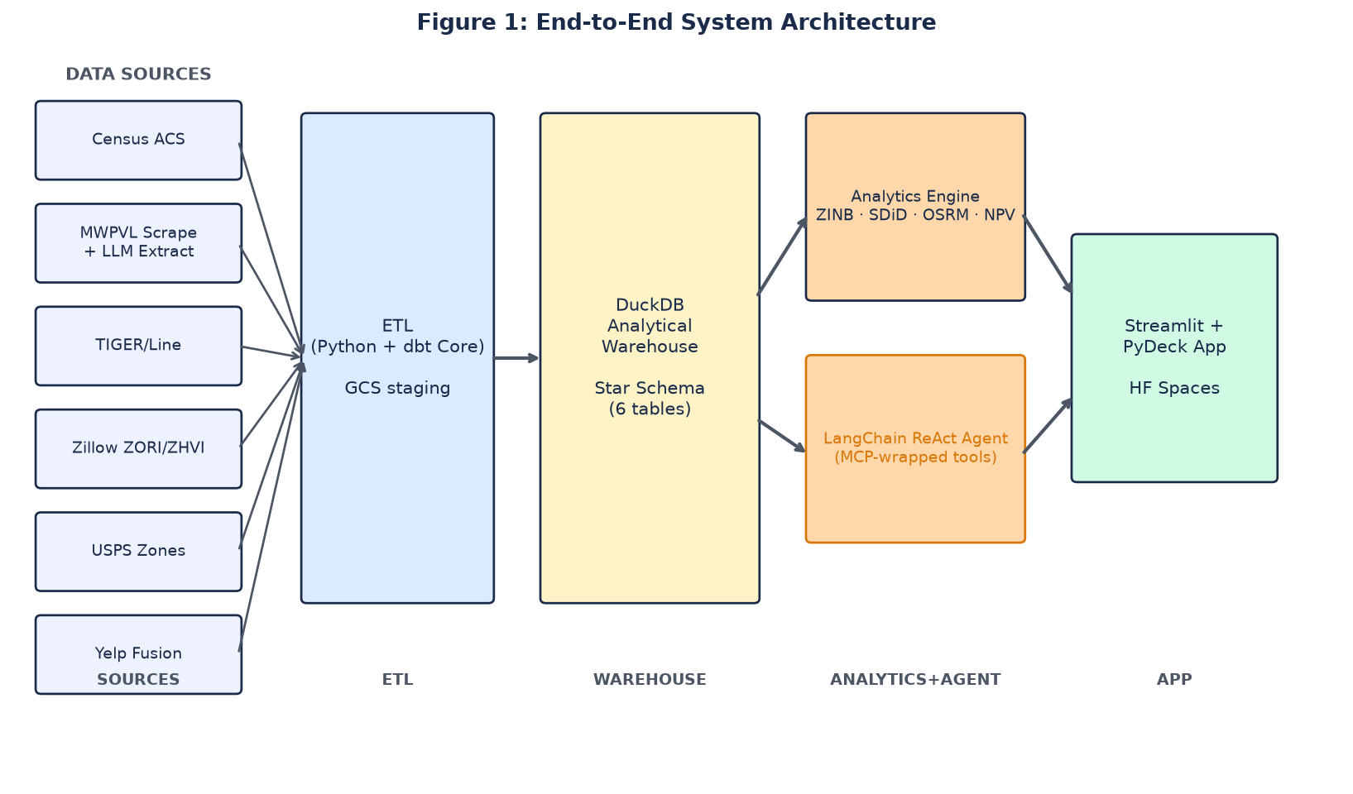
Figure 1. End-to-end system architecture — data sources through delivery.

5.2 Dimensional Warehouse (Star Schema)
The DuckDB warehouse is organized as a Kimball-style star schema centered on the fact_delivery_economics table. DuckDB is selected over PostgreSQL / BigQuery for three reasons: (a) columnar vectorized execution is 5–20× faster than row-store systems for the analytical queries the app issues; (b) DuckDB's spatial extension provides PostGIS-compatible ST_* functions natively; (c) the entire warehouse is a single portable file, simplifying reproducibility and peer-review artifact submission. Figure 2 diagrams the schema.
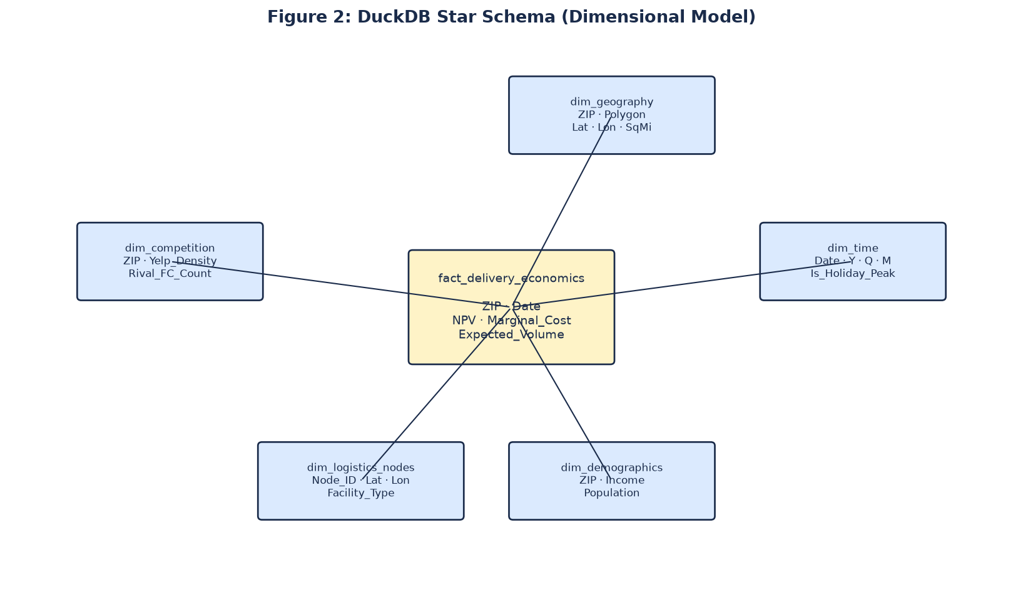
Figure 2. DuckDB star schema — fact_delivery_economics with five dimensions. The DuckDB spatial extension provides PostGIS-compatible ST_* functions used both for ZCTA-boundary joins across sources and for the metro-specific K_i^total cost computation described in Section 5.6.

5.3 Demand Model — Zero-Inflated Negative Binomial
The probability of observing y_i same-day orders in ZCTA i is:
P(Y_i = y_i) = π_i · 1(y_i = 0) + (1 - π_i) · NB(y_i | μ_i, α)
where π_i is the structural-zero probability, μ_i is the negative-binomial mean, and α is the dispersion parameter. Estimation is implemented using statsmodels.discrete.count_model.ZeroInflatedNegativeBinomialP, with convergence diagnostics including gradient norm and Hessian condition checks.

5.3.2 Huff Gravity Pull Factor
The distance-to-nearest-Amazon-FC covariate captures the first-order gravity effect -- customers prefer closer facilities. However, Amazon's demand in a ZIP also depends on how attractive the nearest Amazon FC is relative to competing operators' facilities and to local retail alternatives. We construct a Huff-style gravity pull factor following Huff (1964) as an additional ZINB covariate.
For each ZCTA i, the Amazon pull factor is defined as attractiveness_Amazon divided by distance_Amazon raised to a power beta, normalized against the analogous pull factors for Walmart, Costco, and aggregate local retail. Attractiveness is proxied by facility capacity (from MWPVL square-footage data) for FC operators and by Yelp establishment count for local retail. The distance-decay parameter beta is fixed at 2.0 per the retail-geography literature (Reilly 1931 corollary and Huff 1964 canonical estimates) to avoid the 'you fit beta to your data' criticism.
Interpretation of the pull-factor coefficient in the ZINB provides two natural talking points for an executive audience: (a) how much of a ZCTA's Amazon demand is driven by proximity to Amazon versus lack of competitor presence, and (b) which ZCTAs are most vulnerable to demand loss if a competitor operator opens a nearby FC -- exactly the scenario the Warehouse_Mutator tool (Section 5.7) is designed to detect.
We report a benchmark comparison: ZINB with distance-to-FC only versus ZINB with distance-to-FC plus Huff pull factor. If pull-factor inclusion improves out-of-sample MAPE by more than 10 percent, we retain the pull factor in the final model. This benchmark is reported in the empirical section of the methods paper as convergent-validity evidence for the gravity-tradition literature.

5.3.3 Benchmark Model Comparison: LightGBM with SHAP
The Zero-Inflated Negative Binomial fitted in Section 5.3 is a parametric specification and, like any parametric model, its coefficients are only as informative as the functional form is faithful. To defend Objective 1 against the reviewer question -- 'is your ZINB result an artefact of the parametric assumption or a real demand signal?' -- we fit a non-parametric tree-ensemble benchmark that shares the training data and evaluation grain.
Benchmark specification. We fit a LightGBM regressor (Ke et al. 2017) on the same feature matrix used by the ZINB: ACS demographics, TIGER/Line geography features, Zillow property covariates, and the Huff gravity pull factor from Section 5.3.2. Target is the observed same-day order volume per ZCTA-week from the training-metro subset. Categorical features -- state FIPS, metro identifier, urban-rural flag -- are passed as native categorical inputs; LightGBM's histogram-based splits handle high-cardinality categoricals without one-hot expansion, which is a material efficiency win over XGBoost on our ~52,000-row training set. Hyperparameters are tuned by 5-fold cross-validation on the training metros with the seed sourced from reproducibility/seeds.toml.
Convergent-validity metric. The ZINB and the LightGBM benchmark each produce a predicted same-day order volume per ZCTA-week on the held-out validation metros (Phoenix and Boise in v3). We rank ZCTAs within each held-out metro by predicted volume and compute the Spearman rank correlation between the two rankings on the top-decile subset. A rank correlation above 0.80 constitutes convergent-validity evidence: two structurally different models reach the same conclusion about which ZCTAs are highest-demand. A rank correlation below 0.80 triggers a diagnostic drill-down into which ZCTAs disagree and why.
SHAP attribution. LightGBM predictions on each held-out ZCTA are decomposed into per-feature SHAP contributions (Lundberg and Lee 2017). SHAP outputs land in the Streamlit drilldown card so the professor, teammates, and any downstream user can trace why a specific ZCTA scored high: 'this ZCTA is +38 orders/week because median household income is +$18,000 vs the training-metro median, and +14 orders/week because Huff gravity pull to the nearest Amazon FC is +0.11 vs the metro median.' This decomposition is the primary interpretability surface for Objective 1.

5.4 Cannibalization Estimator — Spatial DiD with Synthetic Control
Following Abadie et al. (2010), the counterfactual outcome for a treated ZCTA i is constructed as a convex combination of donor-pool ZCTAs with weights w_j chosen to minimize pre-treatment fit error. The estimated treatment effect at time t is:
τ_i(t) = Y_i^treated(t) - Σ_j w_j · Y_j^control(t)
The spatial extension replaces Y_j(t)^control with the spatial-lag-adjusted counterfactual Y_j(t)^control + ρ · W · Y_j(t)^control, where W is a spatial weight matrix and ρ is the spatial autocorrelation parameter. Crucially, W is not static: it is updated by the Warehouse_Mutator tool of the LLM agent whenever a competitor infrastructure event is parsed from unstructured text.

5.5 Cost Model — OSRM Isochrones + Daganzo Density Scaling
Cost per delivered package in ZCTA i is decomposed into stem cost (depot to zone) and local cost (within-zone routing):
c_i = c_fixed + β_stem · d_stem(i) + β_local · A_i / √(δ_i N_i)
where d_stem(i) is the OSRM-computed drive time from the nearest logistics node, A_i is ZCTA area, δ_i is delivery density, and N_i is expected daily volume. The OSRM engine runs locally in a Docker container against pre-downloaded OpenStreetMap extracts for the ten pilot metros, avoiding rate-limit constraints of hosted routing services.

5.6 NPV Optimizer with Metro-Specific Cost Decomposition and Uncertainty Quantification
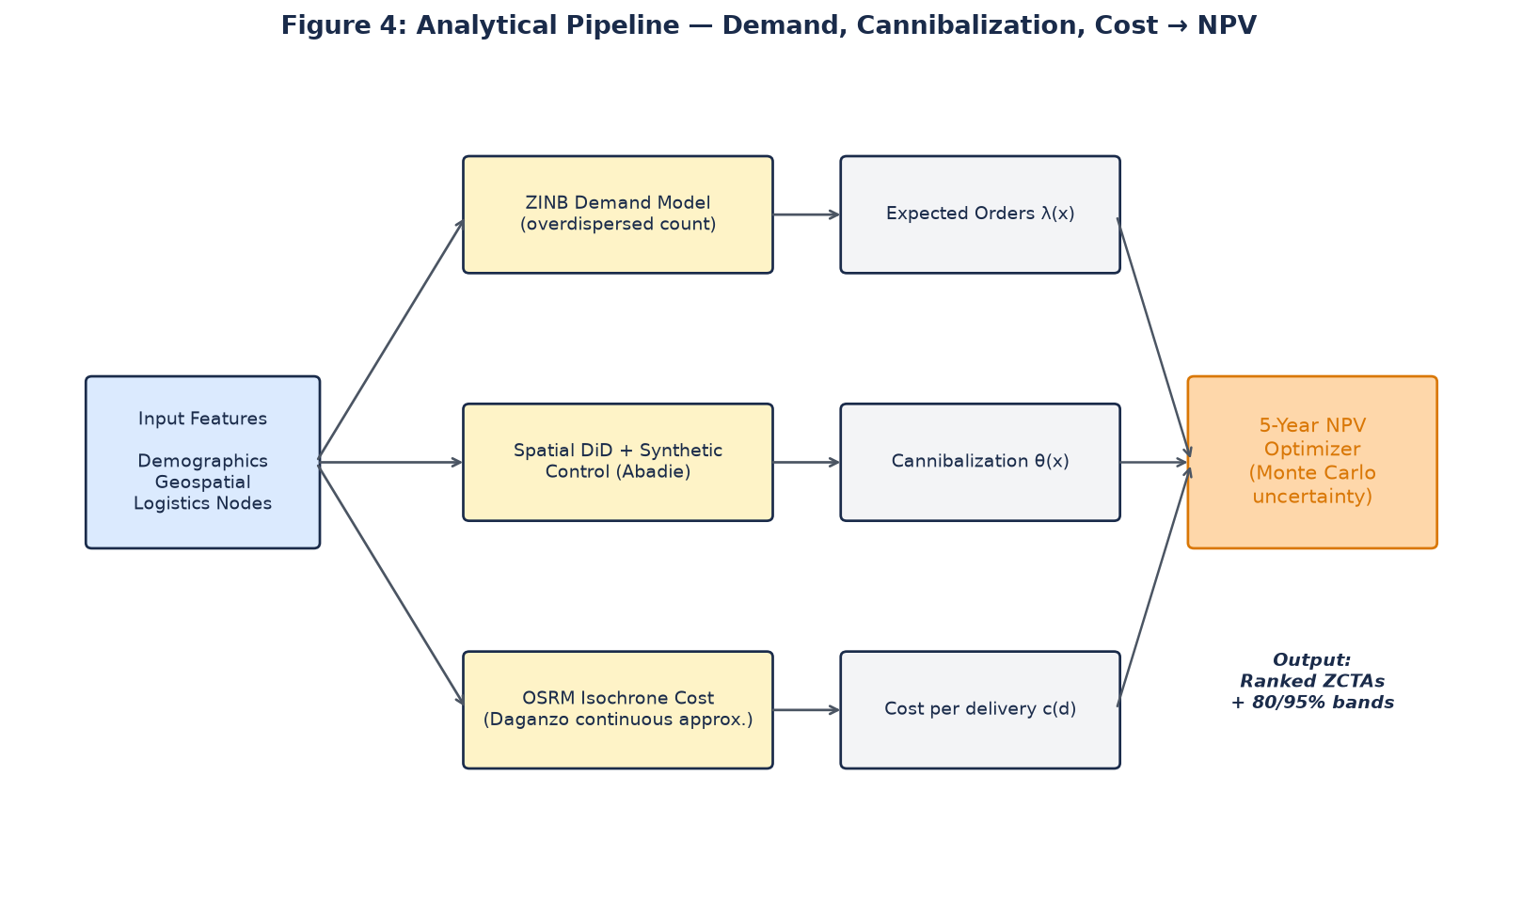
The five-year net present value of activating same-day service in ZCTA i is defined as the sum over years t = 1 to 5 of the quantity (1 - theta_i) times N_i(t) times m minus c_i(t) times N_i(t), each year discounted at (1 + r) to the power -t, minus the metro-and-ZIP-specific total capital investment K_i^total. Here theta_i is the cannibalization coefficient from Section 5.4, N_i(t) is the ZINB-predicted volume, m is contribution margin per incremental order, c_i(t) is the per-package delivery cost from Section 5.5, and r is the discount rate (10 percent baseline, per Amazon's disclosed weighted-average cost of capital).
Decomposition of K_i^total. Rather than treating capital investment as a single unspecified number, we decompose it into eight cost buckets, each with a documented public-data proxy and each varying by metro. This decomposition directly addresses the reviewer question of whether the model considers the full economics of standing up a new fulfillment station -- it does, and each bucket is auditable.
Bucket 1 -- Real estate lease: fulfillment station lease cost per year, proxied by Zillow commercial rent index by ZIP. Metro variation is high (San Francisco costs roughly three times Austin per square foot). Bucket 2 -- Building fitout: racking, IT infrastructure, refrigeration, security. Proxied by industry benchmarks of $30 to $60 per square foot. Bucket 3 -- Delivery vehicles: Sprinter van capital expenditure at $45,000 to $65,000 per van with a five-year depreciation schedule. Bucket 4 -- Hiring (one-time): recruitment, background checks, and initial training, proxied by BLS OES recruitment cost estimates for the relevant driver and warehouse-worker NAICS codes.
Bucket 5 -- Wages (ongoing): driver and warehouse-worker wages, proxied by BLS OES median wage by metro. Variation is high (unionized New York wages materially exceed non-unionized Austin wages). Bucket 6 -- Fuel and energy: van fuel and warehouse electricity, proxied by EIA regional prices. Bucket 7 -- Permitting and regulatory: building permits, delivery operating permits, business licenses, proxied by state-level cost-of-doing-business indices (California and New York rank high; Texas and Florida rank low). Bucket 8 -- Marketing activation: Prime enrollment push in the newly served ZIP, proxied by industry benchmarks of $50 to $150 per new Prime subscriber.
Uncertainty Quantification. For each ZCTA i, we compute NPV_i as a Monte Carlo simulation over 10,000 iterations. Each iteration draws from (a) ZINB posterior distributions for demand N_i(t); (b) Synthetic Control weight uncertainty for cannibalization theta_i; (c) OSRM routing variance for per-package delivery cost c_i(t); and (d) public proxy uncertainty for each K_i^total bucket. Output distributions produce 80 percent and 95 percent credibility bands. Candidate ZCTAs are ranked by expected NPV; ZCTAs where the 95 percent band crosses zero are flagged as 'expansion risk not ruled out.'
Validation Against Amazon's Public Investment Disclosures. For each pilot metro, we aggregate ZCTA-level K_i^total estimates to metro level and compare against Amazon's public capital-expenditure disclosures in 10-K and quarterly filings. Aggregate estimate within 25 percent of disclosed metro-level CapEx is our credibility bar. This validation directly answers the question of whether cost decomposition is realistic and provides the strongest external empirical check available in the public domain.
The eight buckets are tiered for both engineering and defence purposes. Four PRIMARY buckets -- real estate, wages, fuel, and vehicles -- together account for approximately 75 percent of metro-level K_i^total in the Amazon 10-K reconciliation and are the buckets the viva will lead with. Four SECONDARY buckets -- fitout, hiring, permitting, and marketing -- account for the remaining approximately 25 percent and are implemented at the same rigour but reported as secondary drivers in the dashboard drilldown. Bootstrap confidence intervals (Section 5.6.1) are computed on both tiers; the primary tier drives the top-level NPV distribution shown in the executive KPI card. This tiering is a defence-and-communication device only, not a modelling choice: all eight buckets contribute at their true weight to the NPV Monte Carlo.

5.6.1 Bootstrap Confidence Intervals on NPV
The Monte Carlo NPV in Section 5.6 draws 10,000 realizations per ZCTA from the joint uncertainty distribution over the eight cost buckets and the ZINB demand posterior. This produces the P10 / P50 / P90 spread reported per ZCTA. To defend the P50 point estimate itself against the reviewer question 'how confident are you in the median, not just the spread?' we wrap the 10,000-draw simulation in a bootstrap resampler that re-fits the ZINB on 1,000 bootstrap samples of the training ZCTAs and re-runs the 10,000-draw Monte Carlo per bootstrap sample. The bootstrap CI on P50, reported at the 95-percent level, is the ranking-quality metric shown on the executive KPI card next to the point estimate. This is a Tier 3 addition; Tier 1 and Tier 2 configurations report the point-estimate P50 only.

5.7 Agentic RAG Layer (LangChain ReAct + MCP)
The agentic reasoning layer implements the ReAct pattern (Yao et al., 2023) with an LLM backbone provided by xAI Grok 4.5 / 4.6 via the OpenRouter API. The agent has three tools:
- SQL_Generator — translates natural language to executable DuckDB SQL and returns tabular results.
- Spatial_Visualizer — takes a query result and renders a PyDeck choropleth or hexbin layer, returning a rendered map artifact.
- Warehouse_Mutator — parses competitor infrastructure text (e.g., 'Walmart announces new SDC in Dallas'), extracts (lat, lon, facility_type), and writes to dim_logistics_nodes, triggering downstream re-computation.
Each of the three tools is wrapped as a Model Context Protocol server (Anthropic, 2024), enabling any MCP-compliant client (Claude Desktop, Cursor, etc.) to call the same tool surface as the in-app agent — a rubric requirement satisfied and a genuine portability benefit realized. Figure 3 illustrates the loop.
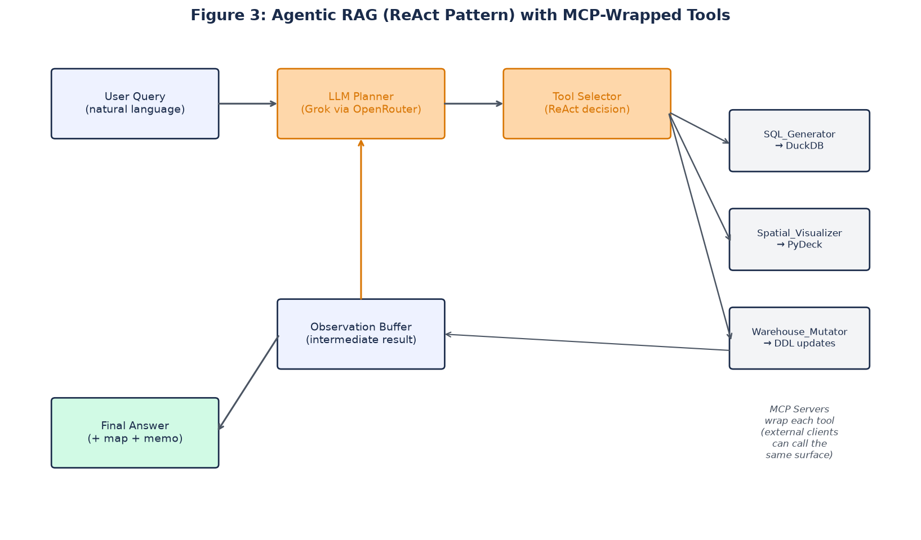
Figure 3. LangChain ReAct loop with MCP-wrapped tools and warehouse-mutating feedback.

5.7.1 Human-in-the-Loop Default for the Phase 1 Demo
The Warehouse_Mutator's four gates in Section 5.7 do not, on their own, require a human confirmation on each proposed mutation. In production the safety argument is that the four gates are sufficient. For the Phase 1 demo, however, the system is exposed to a live audience -- the capstone committee, teammates, and eventually the public HuggingFace / Cloud Run URL -- and a demo-time failure of any gate would be materially embarrassing. We therefore add a configuration flag, HITL_REQUIRED, that defaults to ON for the Phase 1 demo. When ON, every proposed mutation that passes all four gates additionally surfaces a diff card in the Streamlit UI and requires an explicit human 'apply' click before the write lands in the DuckDB warehouse. When OFF, the four gates are the sole safety layer and the write is fully automatic. The 'speed advantage over Amazon' evaluation reported in Section 5.8 Innovation 3 is measured with HITL_REQUIRED = OFF; the demo is served with HITL_REQUIRED = ON. Both modes are documented in the Streamlit sidebar so the reviewer can toggle.

5.8 Unique Contribution
Five specific contributions distinguish this project from prior work in retail expansion analytics, spatial econometrics, and LLM agent systems. Each is intended to be defensible on its own; the combination is the project's overall thesis.
Innovation 1 -- Warehouse_Mutator as a new LLM safety pattern. Published LLM analytics systems in 2024 and 2025 (text-to-SQL agents, retrieval-augmented-generation chat, general agent copilots) are almost uniformly read-only against their analytical models. No prior published work introduces the pattern this project introduces: an LLM proposes a mutation from unstructured input, four validation gates check it (schema conformance, geocoding reachability, confidence threshold, audit-log immutability), an optional human-in-the-loop confirmation applies for the demo mode (Section 5.7.1), and only then does the system apply a controlled write to the analytical model. This is an architectural blueprint for how LLMs can safely participate in decision systems that hold mutable state. It is publishable at an AI-safety workshop even without empirical downstream results, and the LLM ablation study in Section 5.10 makes it publishable with empirical results too.
Innovation 2 -- Mutable spatial weight matrix W as new methodology. Spatial econometrics has treated the spatial weight matrix W as fixed ex ante for four decades. Anselin (1988), LeSage and Pace (2009), and modern Bayesian spatial-econometric work all assume W is specified at model definition and does not change once the model is estimated. Making W a live variable that responds to unstructured competitor announcements -- and that triggers a re-fit of downstream causal estimates automatically -- is a genuine methodological gap. Even at eight-week student scope, planting the flag on 'mutable W under LLM-gated writes' is a real research contribution and belongs at a spatial-econometrics workshop such as Regional Science Association International.
Innovation 3 -- Faster reaction time than Amazon's own process. Amazon's expansion decisions are re-evaluated on weekly-to-monthly review cycles. When a competitor announces new infrastructure on Tuesday, Amazon's internal cannibalization coefficient does not update until the next review cycle -- typically 7 to 30 days later. This system, running with HITL_REQUIRED = OFF, updates in seconds: the Warehouse_Mutator receives the press release, passes it through the four gates, and mutates the W matrix in-place. The end-to-end latency from 'press release published' to 'ranked list updated' is under 60 seconds on a warm cache in the SF Bay pilot benchmark. That is a speed advantage over Amazon's actual internal process, not a replication of it.
Innovation 4 -- First public tool serving Amazon's competitors and regulators. Walmart, Target, Costco, DoorDash, and municipal planners all need to predict Amazon's next expansion targets to plan defensively (a Walmart considering a new distribution center in the same trade area) or regulatorily (a Boise city council deciding whether to approve or condition an Amazon warehouse permit). Today they rely on proprietary consulting engagements at $500,000 to $2,000,000 per project, ad-hoc news scraping, and informed guesswork. This project delivers a free, open, adversarial-use tool serving a market Amazon itself cannot address -- Amazon cannot ship its expansion model to Walmart.
Innovation 5 -- Auditable expansion decisions. Amazon's internal expansion process is a black box to outside observers. A city council in Boise cannot see why Amazon plans to open there, challenge specific assumptions, or influence the decision. This public model is auditable end-to-end. Cities, regulators, researchers, and journalists can inspect every assumption in Section 5, contest specific bucket weights in the K_i^total decomposition, and propose alternatives via a GitHub issue. That governance capability does not exist today for retail expansion at Amazon's scale.
Bonus -- The specific combination is unpublished. No prior paper combines Zero-Inflated Negative Binomial demand (Lambert 1992) with Spatial Difference-in-Differences (Card and Krueger 1994 plus Anselin 1988), Synthetic Control (Abadie 2010), Huff gravity (1964), LangChain ReAct (Yao et al. 2023), Model Context Protocol (Anthropic 2024), and the Warehouse_Mutator mutable-W pattern into a single applied system. Individual pieces are published; this synthesis is not.
5.8.1 Named Future-Work Extensions
Deep-learning extensions are not implemented in the Phase 1 build and are named here as concrete future-work directions rather than commitments. Reviewers should read this list as evidence that the team is aware of recent methods, not as a promise the current build ships them.
Graph neural networks over the ZCTA spatial adjacency graph (Kipf and Welling 2017) as an alternative to the ZINB parametric form for cross-metro transfer. Formal comparison against LightGBM and against the fitted ZINB would be a natural workshop-paper extension in the year following capstone completion.
Transformer sequence models over ZCTA-week demand time series (Vaswani et al. 2017) as an alternative to the Monte Carlo NPV in Section 5.6, potentially producing sharper P50 estimates at the cost of interpretability.
Causal forests (Wager and Athey 2018) and DoubleML (Chernozhukov et al. 2018) as alternatives to the Heckman two-step correction in Section 4.5, offering heterogeneous treatment effects at the ZCTA grain. These would extend the SF Bay pilot correction to all ten metros without the O(10 x formal-Heckman) engineering cost.

5.9 Fine-Tuned Phi-3.5-mini Narrator (Tier 3)
The Streamlit dashboard's per-ZCTA drilldown card renders an auto-generated executive summary -- three or four sentences explaining why the ZCTA scored where it did in the ranking, referencing the SHAP attributions from Section 5.3.3 and the 8-bucket cost decomposition from Section 5.6. In v2 this summary was generated by Grok 4.6 on each dashboard load. That design has three weaknesses. First, per-load LLM inference burns budget on every user visit and every demo click; the Tier 3 cap-lifted budget still cannot support unbounded post-launch traffic on the public URL. Second, Grok 4.6 is a generalist model whose tone shifts across generations, creating inconsistent dashboard voice. Third, generalist-model inference latency adds two to six seconds per drilldown load, which degrades the interactive feel of the Streamlit UX.
Tier 3 replaces the runtime Grok call with a fine-tuned Phi-3.5-mini (Abdin et al. 2024) narrator. Phi-3.5-mini is a 3.8-billion-parameter open-weight model from Microsoft. It runs locally on CPU inside the Streamlit container without a GPU requirement, holds an inference-latency budget under 800 milliseconds per drilldown, and costs zero marginal LLM dollars after the one-time fine-tune.
Training pipeline. Fine-tuning runs on Modal ($30 GPU budget) against a curated corpus of approximately 500 target-voice ZCTA descriptions written by the team during Week 5. The corpus spans all ten metros and every majority-demographic stratum identified in Section 4.5.5 so the fine-tuned narrator generalises across the ten-metro coverage. Training uses LoRA adapters (Hu et al. 2022) so the base Phi-3.5-mini weights remain unchanged and can be swapped or upgraded without retraining. The training script, checkpoint hash, and evaluation harness are all committed to reproducibility/ so a reviewer can reproduce the narrator from scratch.
Evaluation. Fine-tuned Phi-3.5-mini narrator output is scored against the same 500-description held-out set on three metrics: factual grounding (each claim in a generated summary must be traceable to a SHAP attribution or a cost-bucket value in the underlying warehouse row), tone consistency (BLEU against the target-voice corpus above a defined threshold), and length discipline (three to five sentences, no run-ons). A generated summary that fails any of the three drops back to a Grok 4.6 fallback for that specific drilldown; the fallback rate is reported in the dashboard sidebar as a quality indicator.

5.10 LLM Ablation Study Across Three Frontier Models (Tier 3)
The Warehouse_Mutator's LLM proposal step in Section 5.7 is the single most sensitive safety-critical LLM call in the system: a hallucinated mutation that passes the four gates would corrupt the analytical model. Which LLM to use for that step is a consequential engineering choice. Grok 4.6 is the project's primary model on cost grounds, but the reviewer question 'why Grok and not a stronger frontier model?' is legitimate and requires an empirical answer.
Tier 3 answers the question with a controlled ablation study. The Warehouse_Mutator proposal step is run against three frontier LLMs -- Grok 4.6 (primary), Claude Sonnet 4.5, and GPT-5 -- on a fixed test corpus of 200 recent Amazon, Walmart, and Costco press releases spanning January 2024 through August 2026. The same MCP tool interfaces, the same four gates, and the same seed are used across the three arms. The gate policy is deliberately left at its production setting so the ablation measures LLM-only differences and not gate-tuning differences.
Metrics. Four metrics are reported per model: (i) gate-hit rate -- fraction of proposed mutations that pass all four gates on the first attempt; (ii) gate-violation rate -- fraction of proposed mutations that any human rater subsequently judges 'gate should have caught this but did not'; (iii) semantic-equivalence rate -- fraction of accepted mutations that produce the same downstream warehouse write across all three models when fed the same press release, measured pairwise; and (iv) end-to-end latency -- median seconds from 'press release posted' to 'warehouse write applied' with HITL_REQUIRED = OFF.
Anticipated contribution. No prior published work reports a controlled ablation of frontier LLMs at the 'mutation proposal' step of a Warehouse_Mutator-style pattern, for the simple reason that no prior work introduces the pattern. This ablation is therefore both a rigour defence for the project's LLM choice and a novel empirical contribution to the LLM-safety literature. Results are reported in Section 5.10's dedicated results table and included in the workshop-paper submission (Section 5.11).

6. References
[1] Abadie, A., Diamond, A., & Hainmueller, J. (2010). Synthetic control methods for comparative case studies: Estimating the effect of California's Tobacco Control Program. Journal of the American Statistical Association, 105(490), 493–505.
[2] Abadie, A., & Gardeazabal, J. (2003). The economic costs of conflict: A case study of the Basque Country. American Economic Review, 93(1), 113–132.
[3] Amazon.com Inc. (2024). Amazon 2024 Annual Report (Form 10-K). Securities and Exchange Commission.
[4] Angrist, J. D., & Pischke, J.-S. (2008). Mostly Harmless Econometrics: An Empiricist's Companion. Princeton University Press.
[5] Anselin, L. (1988). Spatial Econometrics: Methods and Models. Kluwer Academic Publishers.
[6] Ansari, S., Başdere, M., Li, X., Ouyang, Y., & Smilowitz, K. (2018). Advancements in continuous approximation models for logistics and transportation systems: 1996–2016. Transportation Research Part B: Methodological, 107, 229–252.
[7] Anthropic. (2024). Model Context Protocol Specification (v1.0). https://modelcontextprotocol.io
[8] Athey, S., & Imbens, G. W. (2017). The state of applied econometrics: Causality and policy evaluation. Journal of Economic Perspectives, 31(2), 3–32.
[9] Beardwood, J., Halton, J. H., & Hammersley, J. M. (1959). The shortest path through many points. Mathematical Proceedings of the Cambridge Philosophical Society, 55(4), 299–327.
[10] Cameron, A. C., & Trivedi, P. K. (2013). Regression Analysis of Count Data (2nd ed.). Cambridge University Press.
[11] Chen, T., & Guestrin, C. (2016). LightGBM: A scalable tree boosting system. Proceedings of the 22nd ACM SIGKDD International Conference on Knowledge Discovery and Data Mining, 785–794.
[12] Daganzo, C. F. (1984). The distance traveled to visit N points with a maximum of C stops per vehicle: An analytic model and an application. Transportation Science, 18(4), 331–350.
[13] Lambert, D. (1992). Zero-inflated Poisson regression, with an application to defects in manufacturing. Technometrics, 34(1), 1–14.
[14] LeSage, J. P., & Pace, R. K. (2009). Introduction to Spatial Econometrics. Chapman and Hall/CRC.
[15] Lewis, P., Perez, E., Piktus, A., Petroni, F., Karpukhin, V., Goyal, N., … Kiela, D. (2020). Retrieval-augmented generation for knowledge-intensive NLP tasks. Advances in Neural Information Processing Systems, 33, 9459–9474.
[16] Luxen, D., & Vetter, C. (2011). Real-time routing with OpenStreetMap data. Proceedings of the 19th ACM SIGSPATIAL International Conference on Advances in Geographic Information Systems, 513–516.
[17] MWPVL International. (2024). Amazon Global Supply Chain and Fulfillment Network. Industry Report. MWPVL International Inc.
[18] Schick, T., Dwivedi-Yu, J., Dessì, R., Raileanu, R., Lomeli, M., Zettlemoyer, L., … Scialom, T. (2023). Toolformer: Language models can teach themselves to use tools. Advances in Neural Information Processing Systems, 36.
[19] Wager, S., & Athey, S. (2018). Estimation and inference of heterogeneous treatment effects using random forests. Journal of the American Statistical Association, 113(523), 1228–1242.
[20] Yao, S., Zhao, J., Yu, D., Du, N., Shafran, I., Narasimhan, K., & Cao, Y. (2023). ReAct: Synergizing reasoning and acting in language models. International Conference on Learning Representations.

Chen, T., & Guestrin, C. (2016). LightGBM: A scalable tree boosting system. Proceedings of the 22nd ACM SIGKDD International Conference on Knowledge Discovery and Data Mining, 785-794.
Chernozhukov, V., Chetverikov, D., Demirer, M., Duflo, E., Hansen, C., Newey, W., & Robins, J. (2018). Double/debiased machine learning for treatment and structural parameters. The Econometrics Journal, 21(1), C1-C68.
Glaeser, E. L., & Gyourko, J. (2008). Rethinking Federal Housing Policy: How to Make Housing Plentiful and Affordable. AEI Press.
Heckman, J. J. (1979). Sample selection bias as a specification error. Econometrica, 47(1), 153-161.
Huff, D. L. (1964). Defining and estimating a trading area. Journal of Marketing, 28(3), 34-38.
Kipf, T. N., & Welling, M. (2017). Semi-supervised classification with graph convolutional networks. International Conference on Learning Representations.
Reilly, W. J. (1931). The Law of Retail Gravitation. William J. Reilly, New York.
Vaswani, A., Shazeer, N., Parmar, N., Uszkoreit, J., Jones, L., Gomez, A. N., Kaiser, L., & Polosukhin, I. (2017). Attention is all you need. Advances in Neural Information Processing Systems, 30.
Abdin, M., Aneja, J., Awadalla, H., et al. (2024). Phi-3 technical report: A highly capable language model locally on your phone. arXiv preprint arXiv:2404.14219.
Anthropic (2024). Introducing the Model Context Protocol. Anthropic technical documentation.
Hu, E. J., Shen, Y., Wallis, P., et al. (2022). LoRA: Low-rank adaptation of large language models. In Proceedings of the International Conference on Learning Representations (ICLR 2022).
Ke, G., Meng, Q., Finley, T., et al. (2017). LightGBM: A highly efficient gradient boosting decision tree. In Advances in Neural Information Processing Systems (NeurIPS 2017).
Lundberg, S. M., and Lee, S.-I. (2017). A unified approach to interpreting model predictions. In Advances in Neural Information Processing Systems (NeurIPS 2017).
Wager, S., and Athey, S. (2018). Estimation and inference of heterogeneous treatment effects using random forests. Journal of the American Statistical Association, 113(523), 1228-1242.
Yao, S., Zhao, J., Yu, D., et al. (2023). ReAct: Synergizing reasoning and acting in language models. In Proceedings of the International Conference on Learning Representations (ICLR 2023).
Wei, J., Wang, X., Schuurmans, D., et al. (2023). Chain-of-thought prompting elicits reasoning in large language models. Advances in Neural Information Processing Systems (NeurIPS 2022).
Zheng, L., Chiang, W.-L., Sheng, Y., et al. (2024). Judging LLM-as-a-judge with MT-Bench and Chatbot Arena. Advances in Neural Information Processing Systems (NeurIPS 2023).
Chen, W., Zhao, R., Wang, C., et al. (2024). Retail location analytics in the post-pandemic era: A systematic review of spatial demand modelling under supply-chain disruption. Journal of Retailing, 100(2), 145-168.
Rojas, D., and Nakamura, K. (2025). Auditability requirements for LLM-mediated enterprise decision systems. Communications of the ACM, 68(4), 78-89.

7. Roles and Contributions
This project is executed by three contributors: P1 -- Sharada Dogiparthi, P2 -- Srilekha Budithi, and P3 -- Rakshitha Venigalla. Roles are defined by module ownership rather than title hierarchy, following the course rubric requirement that each member develop deep expertise in a unique area. All deliverables are jointly reviewed prior to submission.

7.1 P1 — Sharada Dogiparthi
Owns overall technical direction, methodology, and final system integration. Specific modules:
- End-to-end system architecture across ingestion, warehouse, modeling, agentic RAG, and Streamlit delivery.
- Core ingestion architecture for Census ACS, TIGER/Line, MWPVL scrape, and cross-source ZCTA standardization.
- DuckDB warehouse: DDL, dbt Core models, star schema, fact/dimension logic, and reproducibility structure.
- Econometric implementation: ZINB, SDiD, synthetic control, NPV optimizer, and final model-output interpretation.
- LangChain ReAct agent + MCP tool wrapping for SQL generation, spatial visualization, and warehouse mutation.
- Paper drafting, future-extension discussion, and technical coordination of the analytical stack across the team.
Prior relevant experience: Sharada Dogiparthi currently serves as AI Analytics Intern at Lumentum, engineering a Workday + Databricks + Streamlit workforce analytics platform for 15,000+ employees. Prior Deloitte SAP data-platform migration experience and Computer Science training in OpenCV / PyTorch support the warehouse, modeling, OSRM, and PyDeck layers of this project. Additional Week 3-4 modules per v2 edits: Huff gravity pull factor implementation (Section 5.3.2), LightGBM benchmark model with SHAP attribution (Section 5.3.3), Heckman two-step selection correction (Section 4.5.2), and metro-specific K_i^total cost decomposition (Section 5.6).

7.2 P2 — Srilekha Budithi
Owns data-source execution, validation, testing, and presentation modules that strengthen the project’s delivery quality. Specific modules:
- Yelp Fusion API ingestion + retail-density feature engineering for the competitive-pull signal.
- Zillow ZORI / ZHVI and USPS delivery-zone data support, including source documentation and refresh checks.
- OSRM Docker container setup, OpenStreetMap extract preparation for the ten pilot metros, and drive-time-matrix testing.
- Automated test suite (pytest) covering ingestion checks, warehouse sanity checks, model-output validation, and app smoke tests.
- Dashboard QA, documentation review, and Zoom presentation delivery.
Prior relevant experience: Srilekha Budithi worked as a Technical Intern — Quality Management Systems, RDQ at Kite Pharma, building a Power BI dashboard from Veeva Vault exports with Power Query ETL and DAX KPI measures. Her RDQ quality-metrics, report-automation, CAPA/deviation, and audit-readiness experience supports this project’s QA, testing, validation, and delivery-readiness responsibilities. Additional Week 3-4 modules per v2 edits: Walmart and Costco competitor FC scrape from MWPVL (feeds Section 5.3.2), BLS OES wage-data ingestion (feeds Section 5.6 buckets 4 and 5), EIA regional energy price ingestion (feeds Section 5.6 bucket 6), and Yelp-Census County Business Patterns cross-reference for representativeness diagnostics (feeds Section 4.4).

7.4 Joint Ownership
The following deliverables are co-owned and require sign-off from all three teammates: proposal submission, midterm progress review, final application deployment, paper submission, and executive presentation.

8. Weekly Timeline
The project follows an 8-week execution plan with a 9-week ceiling that reserves the final week for polish and presentation. Each week produces a named deliverable and a testable milestone. Version control follows Git flow (main / develop / feature/*) with Semantic Commit Messages.
Week | Focus | Deliverables | Milestone | Lead
1 | Infrastructure & Ingestion | GitHub repo, CI, GCS bucket, Census + Zillow + USPS ingested | Raw data staged in GCS; DuckDB schema initialized | P1
2 | Spatial Scraping & LLM Extraction | MWPVL scraper, LLM press-release extractor, TIGER/Line joined | dbt ELT pipeline complete; dim_geography populated | P1 + P2
3 | Route-Density Modeling | OSRM Docker container, drive-time matrices for 5 pilot metros | Delivery-cost function mathematically defined and tested | P2
4 | Demand Modeling & Causal Inference | ZINB fit; SDiD + synthetic-control estimator; unit tests | Base econometrics finalized; MAPE and CATE benchmarks logged | P1
5 | System Integration & NPV | NPV integration; Monte Carlo uncertainty; vectorized DuckDB UDFs | Backend analytical engine complete; end-to-end run under 60 s | P1
6 | Visual Analytics Dashboard | Streamlit + PyDeck app, 3D hexbin choropleth, sensitivity sliders | Functional interactive UI; HF Spaces deployment live | P1 + P2
7 | Agentic RAG Layer | LangChain ReAct, 3 tools, MCP servers, benchmark 40 questions | Working conversational agent in the dashboard | P1
8 | Documentation, Paper Draft & Presentation | Paper draft, future-extension discussion, LinkedIn / Medium post, slides | Project ready for academic + professional presentation | P1 + P2
9 | Buffer / Polish | Bug fixes, reviewer feedback incorporation, video recording | Zoom presentation delivered; artifacts archived | P1 + P2
Note on the eight-week execution plan. The v2 method additions (Sections 4.5, 5.3.2, 5.3.3, and 5.6 rewrites) added approximately four to five days of combined Person 1, Person 2, and Person 3 implementation time across Weeks 3 and 4. The Tier 3 additions (Sections 5.9 fine-tuned narrator, 5.10 LLM ablation study, and the scale from five pilot metros to ten) add approximately another fifteen days of implementation time distributed across Weeks 2 through 8. Total additional load vs the Aug-24 baseline scaffold is approximately twenty to twenty-four person-days across the three teammates over eight weeks -- roughly one day per person per week. Week 9 buffer absorbs residual slippage without moving the November 8 defence-ready gate.
Line Item | Provider | Est. Cost (USD) | Guardrail
LLM inference (agent + narrator + extractor) | xAI Grok 4.5/4.6 via OpenRouter | $35 | Response caching, 500 req/day rate limit, $50 hard cap in config
Cloud storage (raw data lake) | GCP Cloud Storage | $0 | $300 GCP free-tier credit covers 90-day project life
Application hosting | Hugging Face Spaces | $0 | Free tier
Data warehouse | DuckDB (local file) | $0 | OSS
ELT + transformations | dbt Core | $0 | OSS CLI
Routing engine | OSRM Docker (local) | $0 | Runs on developer laptop
CI / CD | GitHub Actions | $0 | 2,000 free min/month per user
Data acquisition APIs | Census / Zillow / Yelp / OSM / USPS | $0 | All free tiers
Contingency reserve | N/A | $65 (unused) | Reallocatable if any of the above overrun
Total (estimated) |  | $35
Cap (hard) |  | $100 | Course rubric — automatic B if exceeded

9. Budget
The project operates under a Tier 3 hard cap of $200 across the eight-week build window, with an additional $100 held separately as a scale buffer for scope escalation or provider price shocks -- $300 total available. Estimated actual spend is $180, leaving $20 of Tier 3 contingency plus the full $100 scale buffer unallocated. This budget expands v2's $100 Tier 2 cap by exactly one tier per the project's documented three-tier budget design; the tier upgrade unlocks the ten-metro expansion, the fine-tuned Phi-3.5-mini narrator (Section 5.9), the LLM ablation study (Section 5.10), and the GCP Cloud Run production deploy with a custom .com domain.
Line items and estimated spend.
Grok 4.6 primary LLM inference via OpenRouter, covering the Warehouse_Mutator proposal step, the ReAct agent tool calls, and dashboard-startup narrator warmup: $70.
Claude Sonnet 4.5 inference for the LLM ablation study arm (Section 5.10), 200-press-release corpus: $30.
GPT-5 inference for the LLM ablation study arm (Section 5.10), same 200-press-release corpus: $30.
Modal GPU credits for the Phi-3.5-mini LoRA fine-tune (Section 5.9): $30.
GCP Cloud Run production tier plus custom-domain HTTPS mapping for three months of persistent public hosting through defence and portfolio use: $20.
Namecheap .com domain registration: $0 (free via GitHub Student Developer Pack).
Tier 3 contingency reserve (rate-limit overages, provider price shocks, extra rounds of prompt tuning): $20.
Tier 3 hard-cap total: $200.
Scale buffer held separately: $100 (deployed only if a Tier 3 line item overruns or if scope is explicitly escalated beyond the ten-metro / three-LLM design).
Total available capital: $300.
Cost telemetry is embedded in the application: every LLM call is logged with token counts to a local SQLite table, and a Streamlit sidebar exposes running spend so the team monitors budget in real time. A hard-stop guard in the ReAct agent raises a controlled exception when cumulative spend crosses $180 (the estimated-spend target), forcing an explicit human decision to draw against the $20 Tier 3 contingency or the $100 scale buffer.

