SITING ATLAS
Volume I | Last-Mile Delivery
Agent-Assisted Spatial Causal Inference for Sub-24-Hour Delivery Territory Expansion under Cannibalization Constraints
An open, reproducible model of where private infrastructure gets built — and who bears the consequences.
Applied Research Project Proposal
P1: Sharada Dogiparthi
P2: Srilekha Budithi
P3: Rakshitha Venigalla

Master of Science in Business Analytics
California State University, East Bay
Course Instructor: Surendra Sarnikar, Ph.D.

September 2026
Not affiliated with, endorsed by, or sponsored by Amazon.com, Inc., Walmart Inc., Costco Wholesale Corporation, or any other operator analysed. All operator names are used descriptively to identify the subject of study.

Executive Summary
Between 2023 and 2026 major retailers restructured national fulfilment networks into regionalised, node-based architectures capable of sub-24-hour delivery. Each ZIP-code area enrolled in same-day service carries a $3–5M capital footprint, and the profitability of that footprint depends on three interacting quantities: genuinely incremental demand, spatial route density, and cannibalization of existing standard-shipping orders. Across the 2,413 ZIP-code areas in scope, that is $7.2B-$12.1B of capital allocation.
Those decisions are made inside proprietary models. The public bears their consequences — property values, air quality, municipal budgets, and tax abatements granted to attract facilities — with no way to check the reasoning. Siting Atlas is an open, reproducible model of that decision, built entirely from public data.
The system combines a discrete-time hazard model of service enablement at ZIP-code grain, a spatial synthetic-control estimator of cannibalization with an empirically estimated decay radius, a continuous-approximation cost model, and a portfolio optimiser that treats expansion as a bundle-selection problem rather than a ranking. A retrieval-augmented agent ingests unstructured competitor intelligence and re-parameterises the underlying estimators under six validation gates.
THE CENTRAL CLAIM
Two of those gates are new. Existing work on gated LLM writes protects data integrity — do not corrupt rows, do not leak records. We identify a distinct failure class, inferential integrity, in which a write satisfying every data-integrity gate nonetheless invalidates a downstream causal identification assumption, and we propose two gates that detect it.

A second contribution is a number nobody has published: how much of a major operator's revealed siting behaviour is explainable from public data alone. A high figure is a result about the transparency of logistics decisions; a low figure is a result about their opacity, and tells regulators how much disclosure would be needed to close the gap.
The deliverable is a deployed application answering, in dollars and in probabilities, the question every last-mile operator answers weekly — which areas should be activated next — and the question every city council facing an abatement request should ask but currently cannot: would they have built here anyway?

1. Introduction

1.1 The last-mile paradigm shift
National fulfilment centres that once shipped to any US address in 2–5 days are being complemented — and in dense metros replaced — by delivery stations, same-day distribution centres and oversize nodes positioned within thirty minutes of the average consumer. Amazon operated 175 US same-day-capable facilities in 2024 and committed to 200+ by the end of 2026 (Amazon 10-K, 2024). In June 2025 it announced over $4 billion to extend same-day and next-day service to more than 4,000 smaller cities, towns and rural communities by the end of 2026. Walmart, Target and Costco have announced parallel expansions.
The consumer-facing consequence is a delivery-speed race. The operator-facing consequence is a capital-allocation problem of unprecedented granularity: a wrong answer at ZIP-code level converts a $4M investment into a permanent operating loss. The public-facing consequence is that private siting decisions now reshape neighbourhoods faster than any public process can review them.

1.2 The analytical problem
Adding a ZIP Code Tabulation Area (ZCTA) to a same-day footprint is not a demand-forecasting problem. It is a joint estimation problem across three interacting quantities:
- Incremental demand. What fraction of post-launch orders are genuinely new spend, and what fraction shifted tier from existing standard orders?
- Route-density economics. Cost per delivered package falls with drop density (Daganzo, 1984). A ZCTA with weak density can be unprofitable even at high average order value.
- Cannibalization spillovers. Launching same-day in area A shifts behaviour in contiguous areas B and C — a violation of the Stable Unit Treatment Value Assumption that standard estimators cannot handle.
AND A FOURTH, USUALLY MISSED
These decisions are not independent. Two adjacent areas that are each unprofitable alone can be jointly profitable when they share a delivery station and pool drop density. Expansion is therefore a portfolio-selection problem, not a ranking problem — see §5.6 and Figure 6.

1.3 Why this matters now, and to whom
Three forces make the problem urgent. First, unstructured competitor intelligence — press releases, permit filings — can now be integrated into quantitative pipelines at near zero marginal cost. Second, spatial causal inference has matured to the point where synthetic-control estimation runs on commodity hardware. Third, and least discussed, the regulatory environment has changed.
The South Coast Air Quality Management District's Rule 2305 — the Warehouse Indirect Source Rule, adopted 2021 and approved by the US EPA — obliges warehouses at or above 100,000 square feet to earn emission-reduction points or pay mitigation fees, and other regions are considering equivalents. Air districts operating such rules need to forecast where warehouses will appear in order to plan mitigation capacity. Municipalities granting tax abatements to attract facilities need the counterfactual: would the operator have built here anyway? Neither has an open model available.
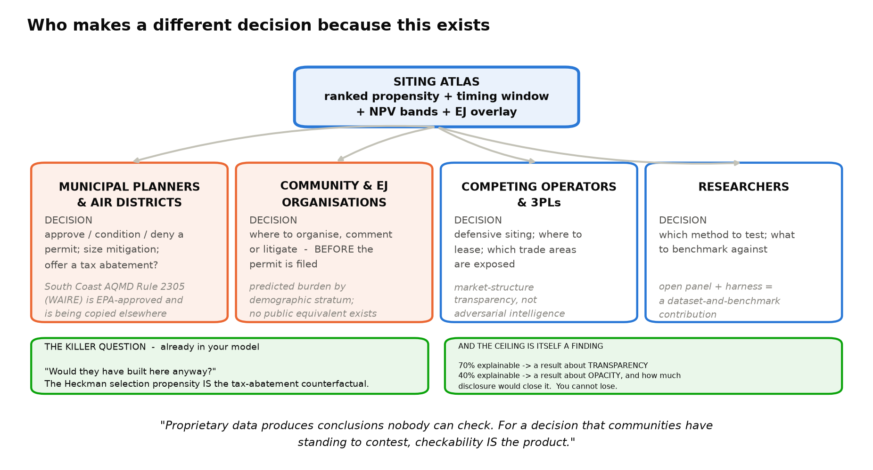
Figure 1. Four user groups, each with a decision the model changes. The selection propensity in §4.5 is, read in the opposite direction, the tax-abatement counterfactual.

1.4 Research questions
- RQ1. Can a discrete-time hazard model trained on publicly available ZCTA covariates predict which areas an operator enables for same-day service, and when, at an out-of-time AUC of 0.80 or better on metros withheld from training?
- RQ2. Does event-driven revision of the spatial weight matrix materially change the estimated cannibalization coefficient, or are spatial causal estimates robust to such revision as LeSage and Pace (2014) argue?
- RQ3. Can validation gates be designed that detect when an agent-proposed write to an analytical warehouse preserves data integrity while invalidating a causal identification assumption?
- RQ4. What share of a major operator's revealed siting behaviour is explainable from public data alone?
NOTE ON RQ2 — A PRE-REGISTERED TEST WITH TWO PUBLISHABLE OUTCOMES
If the coefficient moves materially, the result pushes back on a well-known robustness claim in spatial econometrics. If it does not, the result confirms that claim under a novel perturbation and reports an honest engineering finding: the mutable-W machinery is elegant but not decision-relevant. The prediction is recorded before the test is run.

2. Related Work
This project intersects six research streams. For each we state the anchor literature and, explicitly, the delta between our work and the existing corpus. Two prior-art reviews inform this section: one over the published literature, and one over shipped commercial products. Both are reported, because a contribution that has not been checked against either is not a contribution.
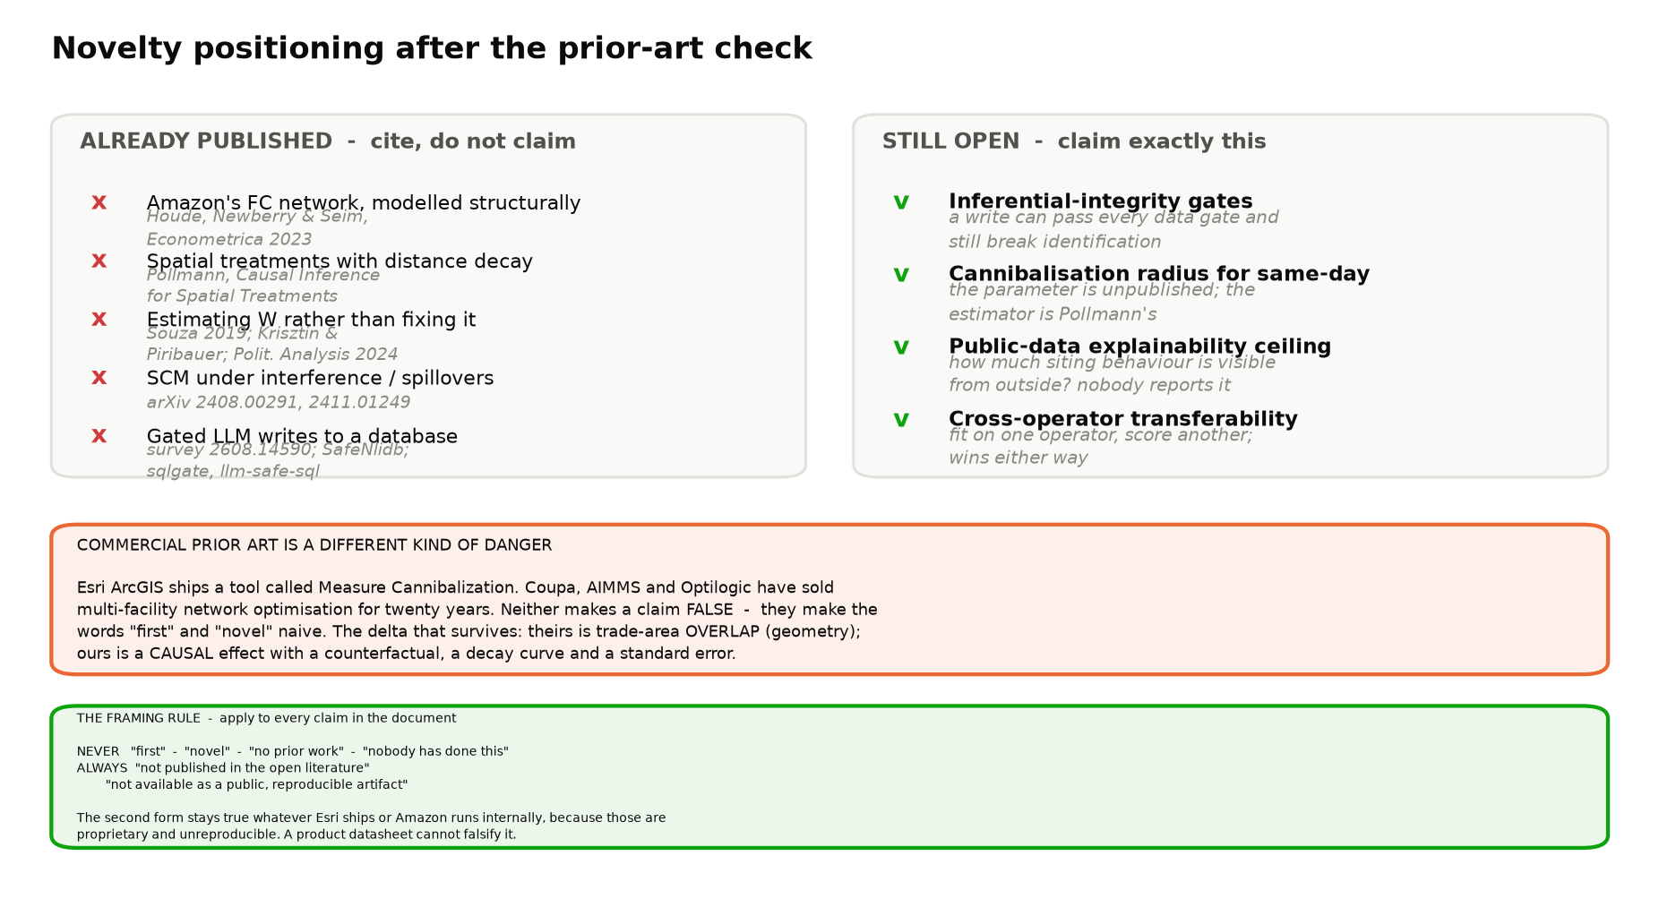
Figure 2. Novelty positioning after the literature and commercial prior-art checks. Left: what is already published and must be cited, not claimed. Right: what remains open.

2.1 Spatial causal inference and interference
The Synthetic Control Method was introduced by Abadie and Gardeazabal (2003) and formalised by Abadie, Diamond and Hainmueller (2010). It constructs a counterfactual for a treated unit as a convex combination of controls matched on pre-treatment outcomes. Its principal weakness in a logistics setting is the no-interference assumption: launching in area A materially affects adjacent areas B and C.
That weakness is not unaddressed. Anselin (1988) and LeSage and Pace (2009) formalised spatial estimators that relax it via a weight matrix W. More recently, Pollmann (arXiv:2011.00373) gives a general treatment of causal inference for treatments applied at a location with effects decaying over distance, including distance-band estimation; and a body of work extends synthetic control directly to the spillover case (arXiv:2408.00291; arXiv:2411.01249; Reich et al., International Statistical Review).
Our delta. We adopt Pollmann's distance-band estimator rather than proposing one. What we contribute is the parameter: the decay curve of same-day cannibalization has not, to our knowledge, been estimated or published, and we use the estimate to construct W instead of assuming binary contiguity.

2.2 Estimating the spatial weight matrix
It is sometimes assumed that spatial econometrics treats W as fixed ex ante. It does not. Souza (2019), Krisztin and Piribauer (arXiv:2101.11938) and Political Analysis (2024) all estimate or select W from data, and LeSage and Pace (2014) argue prominently that results are less sensitive to the choice of W than practitioners assume. We therefore make no claim to novelty in relaxing the fixed-W assumption.
Our delta. Every estimator above recovers W from the same outcome panel used for inference — an in-sample statistical problem, solved once. We treat W instead as event-driven state, revised between estimation cycles from an exogenous text stream under validation gates. We make no claim to improve on those estimators, and we test empirically (RQ2) whether the revision changes anything at all.

2.3 Routing and density economics
The continuous-approximation approach to vehicle routing originates with Beardwood, Halton and Hammersley (1959). Daganzo (1984) derived that per-stop distance in a uniform-density zone scales as the inverse square root of delivery density; Ansari et al. (2018) survey subsequent work. Luxen and Vetter (2011) introduced the Open Source Routing Machine, enabling exact drive-time computation on OpenStreetMap graphs.
Our delta. We retain Daganzo's density law and instantiate the distance term from a precomputed drive-time matrix. The engineering contribution is negative and deliberate: the deployed system carries no routing dependency at all (§5.9).

2.4 Retail expansion and cannibalization
This stream is the closest published analogue to our research question. Management Science has published structural analyses of exactly this problem — retail expansion and cannibalization in a dynamic environment (58(11), 2012) and demand expansion versus cannibalization from store entry (68(12), 2022) — alongside dynamic entry models of chain expansion (Caoui, Hollenbeck and Osborne).
Our delta. Those studies use structural models on proprietary firm data at store grain, in a static information environment, and produce no runnable artifact. We use reduced-form spatial causal inference on public data at ZCTA grain, for a service-tier rather than a store-opening decision, and ship the tool.

2.5 LLM agents that write to analytical systems
Retrieval-augmented generation (Lewis et al., 2020) and the ReAct pattern (Yao et al., 2023) established the interleaving of reasoning and tool use; the Model Context Protocol (Anthropic, 2024) formalised a portable tool interface. Applications in analytics have converged on text-to-SQL agents that are almost universally read-only.
Gated writes, however, are not unexplored. A survey of specification, verification and enforcement for safe LLM agents (arXiv:2608.14590), privacy-preserving alignment for natural language database interfaces (arXiv:2511.06778), text-to-SQL vulnerability analysis (arXiv:2211.15363) and shipped open-source write gates all address the pattern. We claim no novelty in gating an agent write.
Our delta. All of that work protects data integrity: do not corrupt rows, do not leak records, do not drop tables. Our write target is not a data table but a parameter of a causal estimator, which creates a failure class the existing gates do not cover — a write that is schema-valid, correctly geocoded, high-confidence and fully logged, and that nonetheless invalidates a downstream identification assumption. We name this inferential integrity and propose two gates that detect it (§5.7).

2.6 Industry practice and the reproduction gap
The definitive academic treatment of a large operator's fulfilment network is Houde, Newberry and Seim, 'Nexus Tax Laws and Economies of Density in E-Commerce: A Study of Amazon's Fulfillment Center Network' (Econometrica, 2023), which estimates a structural model of the firm's own entry decision using state sales-tax nexus variation. Schorung, Lecourt and Dablanc (2023) map the warehouse network geographically; the Journal of Policy Analysis and Management (2025) evaluates local economic impacts.
Dimension | Houde, Newberry & Seim (2023) | Siting Atlas
Network tier | 2-day fulfilment centres | Sub-24-hour nodes (DS / SDC / oversize)
Spatial grain | State | ZCTA (2,413 modelled, 33,791 US)
Period | Through ~2018, pre-regionalisation | 2015–2026
Data | Proprietary and licensed | Entirely public
Identification | Sales-tax nexus variation | Selection correction + spatial synthetic control
Environment | Static information | Event-driven state updates
Artifact | None runnable by a third party | Deployed, open, reproducible

Commercial practice must be acknowledged with the same care as the literature. A capable market already sells siting analytics; the question for a research contribution is not whether the tools exist but what none of them does.
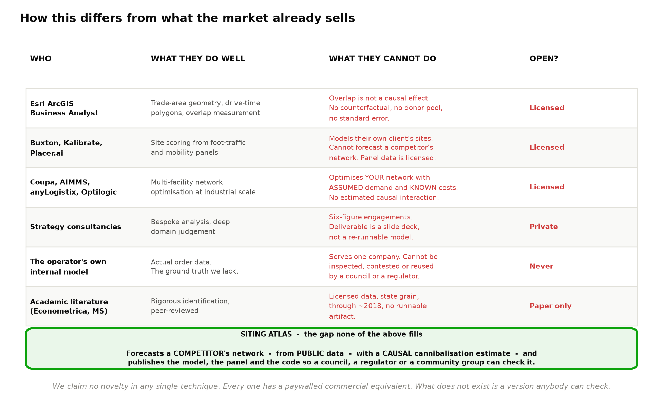
Figure 3. The market for siting analytics, and the gap that remains. Every technique here has a paywalled equivalent; what does not exist is a version anybody can check.
COMMERCIAL PRIOR ART — A DIFFERENT KIND OF PRIOR ART
Esri ArcGIS Business Analyst ships a tool named Measure Cannibalization. Supply-chain network design software (Coupa, AIMMS, anyLogistix, Optilogic) has solved multi-facility location optimisation for two decades. Neither makes a claim in this proposal false; both make the words 'first' and 'novel' naive, and we avoid them throughout. The surviving distinction is methodological: commercial cannibalization tooling measures trade-area overlap, which is descriptive geometry, and answers 'how much do these areas share?'. It does not answer 'what would volume in B have been had A never opened?' — there is no counterfactual, no donor pool and no standard error. Our estimate is causal.

What remains genuinely absent is a public one. No open, auditable, forward-looking model of a competitor's siting behaviour was found; the commercial-real-estate trade press tracks expansion after the fact. Throughout this proposal we therefore claim only that a result is not published in the open literature, or not available as a public reproducible artifact — statements that remain true regardless of what any vendor ships or any operator runs internally, because those systems are proprietary and cannot be checked.

3. Research Objectives
Consistent with the identification discussion in §4.5, model output is interpreted as operator-consistent expansion desirability rather than objective demand. Because the outcome we model is observable, that framing is literally accurate rather than a hedge: the model predicts what the operator did, which is what we observe.

Objective 1 — Siting and timing model with a real backtest
Estimate, for each ZCTA and quarter, the probability that the operator enables same-day service, as a discrete-time hazard model over ACS demographics, TIGER/Line geography, Zillow property covariates, Census CBP retail density, a Huff-style gravity pull factor, and rate-of-change features derived from the monthly sources in §4.2. A zero-inflated negative binomial volume model and a LightGBM benchmark with SHAP attribution are retained as secondary analyses.
Metric | Target | Why this metric
AUC-ROC, out-of-time | ≥ 0.80 | Rank quality on a forecast that was actually scored
PR-AUC | Well above base rate (~0.06) | The positive class is rare; ROC alone flatters it
Brier score | ≤ 0.06 | Combines calibration and sharpness
Expected calibration error | < 0.05 | A stated 60% probability should occur ~60% of the time
precision@100 | ≥ 0.60 | The decision is a shortlist, so shortlist quality is the test
Conformal interval coverage | Within 2pp of nominal | Distribution-free and empirically verified, not assumed
Spearman vs LightGBM, top decile | ≥ 0.80 (bootstrap CI) | Convergent validity across two structurally different models
AUC under simulated label noise | ≥ 0.78 at 15% date error | Bounds the effect of target-variable measurement error (§4.3)
Top-100 overlap, H3 vs ZCTA grain | ≥ 0.70 | Shows the ranking is not an artefact of the spatial partition

WHY NOT MAPE
MAPE divides by the actual value and is undefined wherever that value is zero — and the premise of the demand model is that many areas are structural zeros. It also would have been computed against a target constructed from its own predictors (§4.2). Hyndman and Koehler (2006) is the standard reference for why percentage errors fail on such data.

Validation is out-of-time, not merely out-of-sample: the model is trained on facilities open through 2023 and scored against openings observed in 2024–2025. Two metros are additionally withheld from training entirely. If the criteria are not met, the failure is reported; the validation set is not used for retraining.
THE CRITERIA ABOVE WERE NOT MET
The model has since been fitted and scored, and Figure 4 shows the measured result rather than the target. On the primary hold-out AUC is 0.6894 against 0.5000 for a constant; on the secondary temporal hold-out it is 0.5551. The Brier score is 0.019522 against 0.019614 for the same constant over the same 8,044 rows, and the calibration error is 0.00863 against 0.00005 — a model that ignores every covariate is better calibrated than ours. precision@100 was never computed. We report the raw Brier pair rather than a skill score, because Gneiting and Raftery (2007, §2.3 p.362) show skill scores are generally improper even when the underlying score is proper. The diagnosis is a unit-of-analysis error rather than a sample-size one — one delivery station switches on a median of 58 ZCTAs at once, so what the panel records as hundreds of independent events is a much smaller number of siting decisions plus a catchment circle — and it is the reason §5.3 is being respecified as a conditional choice over ZCTAs given that a station opens.

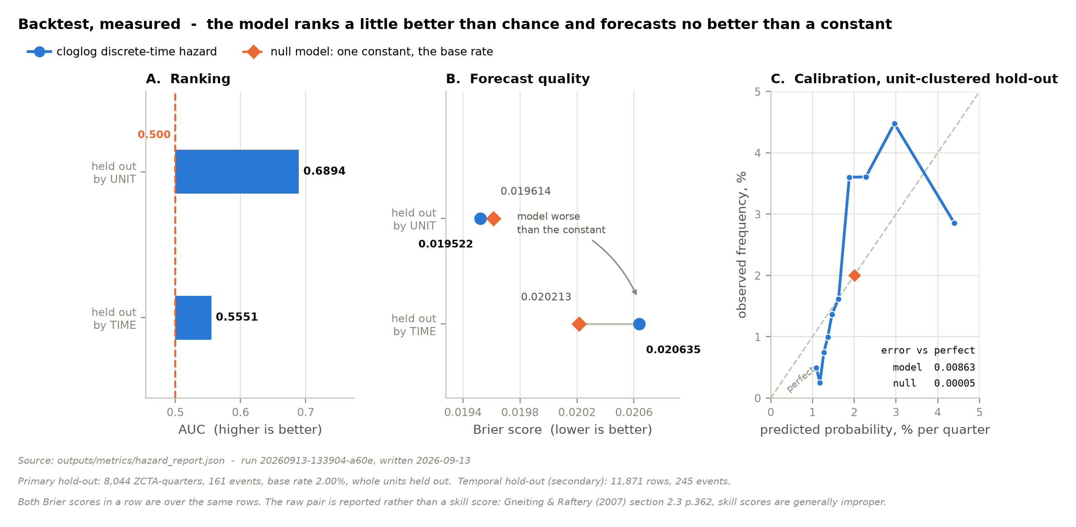
Figure 4. The measured backtest. Ranking, the proper score and calibration, each against a null model that predicts one constant. Source: outputs/metrics/hazard_report.json, run 20260913-133904-a60e.

Objective 2 — Cannibalization as a causal decay curve
Estimate the cannibalization effect by distance band using spatial synthetic control with placebo inference, and use the estimated decay to construct W. Success criteria: pre-treatment fit RMSE below 8% of the outcome mean; a post/pre RMSPE-ratio permutation p-value below 0.10 against in-space placebos; and a reported decay curve with confidence bands at each distance band.
Pre-treatment fit alone is necessary but not sufficient — it is possible to fit the pre-period well and estimate a treatment effect indistinguishable from placebo noise. Permutation inference is the Abadie standard and its absence is a legitimate reviewer objection.

Objective 3 — Agent with identification gates
Implement a ReAct agent with three MCP-wrapped tools and a six-gate mutation path. Evaluation uses execution accuracy — does the generated query return the same result set as a gold query — on at least 100 questions stratified into four difficulty tiers, reported with Wilson confidence intervals.
CALIBRATING THE TARGET AGAINST THE FIELD
On the BIRD benchmark (Li et al., NeurIPS 2023) the best public systems reach roughly 80% execution accuracy against a human baseline near 93%. Any target above that on a self-authored question set would be an above-state-of-the-art claim on an unfalsifiable test. At n = 40 an observed 85% carries a 95% Wilson interval of roughly [71%, 93%], so success and failure are statistically indistinguishable. We target 75% overall at n ≥ 100 and report per-tier.

Separately, for the mutation path: at least 90% of mutations that materially change the cannibalization coefficient must be caught by gate 6 on a seeded adversarial set of 50 perturbations.

Objective 4 — Deployable application and open dataset
- A deployed application with an operator view and a public planning view, loading in under five seconds.
- The ZCTA-level facility-opening panel published as an open dataset with a data card — the most durable artifact the project produces.
- Metro-level capital aggregates validated against public capital-expenditure disclosures to within 25% — the only externally falsifiable number in the system.
- Net present value reported in units of contribution margin with explicit break-even thresholds, so that no unobservable revenue figure is asserted (§5.6).
- A methods paper draft, a reproducibility write-up, and a timestamped public forecast registry so predictions can be scored later by anyone.

4. Data

4.1 Sources
Eleven public sources are ingested through a common ELT pipeline. No licensed panel and no paid API is required, which is what makes the system reproducible by a third party. Sources are selected not only for what they measure but for how often they update: two are included specifically to offset the reporting lag in the census series (§4.2).
Source | Grain | Role | Access
Census ACS 5-year | ZCTA | Demographics, income, age | Public API
TIGER/Line | ZCTA polygon | Geometry for spatial joins | Bulk download
Zillow ZORI / ZHVI | ZIP | Rent and value bands | Public CSV
Census County Business Patterns | ZIP × NAICS | Retail density (competitive pull) | Bulk download
BLS OES | Metro | Driver and warehouse wages | Bulk download
EIA | Region | Fuel and industrial electricity prices | Bulk download
Facility panel and open dates | Facility | The target variable — see §4.2 | Public inventory + filings
EPA EJScreen | Block group | Environmental-justice indices for the equity overlay | Bulk download
OpenStreetMap | Road network | Drive times, used once offline (§5.9) | Geofabrik / BBBike

WHY AN ADMINISTRATIVE SOURCE RATHER THAN A BUSINESS DIRECTORY
A commercial directory such as Yelp Fusion permits 5,000 requests per day, which puts acquisition of the retail-density feature on a three-day critical path and requires an API key that a replicator may not have. Census County Business Patterns provides establishment counts by ZIP and NAICS as a bulk download in minutes, with no key and no rate limit. It is also an administrative universe rather than a self-selected directory, which avoids a coverage bias that would otherwise have to be disclosed: directories under-represent minority-owned, cash and informal businesses, and if that under-representation correlates with ZCTA demographics the proxy inherits the bias.

4.2 Data currency and the reporting lag
American Community Survey five-year estimates carry an 18 to 24 month reporting lag. Taken alone this would be a serious weakness in a model of decisions being made now. Three features of the design address it.
First, and most importantly, the lag is shared with the decision-maker. Operators plan siting from the same public census releases; there is no private real-time census. Our disadvantage relative to an operator lies in order history, not in demographic covariates — which is precisely why the estimand in §4.3 is the siting decision rather than demand.
Second, siting decisions have long lead times. Site search, lease negotiation, permitting, fitout and hiring together span roughly 18 to 36 months, so a facility opening in 2025 was decided in 2023 on 2021–22 covariates. Aligning covariate vintage to decision vintage is therefore correct specification. Using contemporaneous data to explain a decision taken two years earlier would introduce information the decision-maker did not have.
Third, the covariates that genuinely move quickly are sourced quickly. Zillow rent and value indices are monthly; the Census Building Permits Survey is monthly and is a forward indicator, since construction precedes population; EIA prices are monthly; and ACS one-year estimates give metro-level context at roughly a nine-month lag. Slow sources supply level features and fast sources supply rate-of-change features, so the model observes trajectory rather than only position.
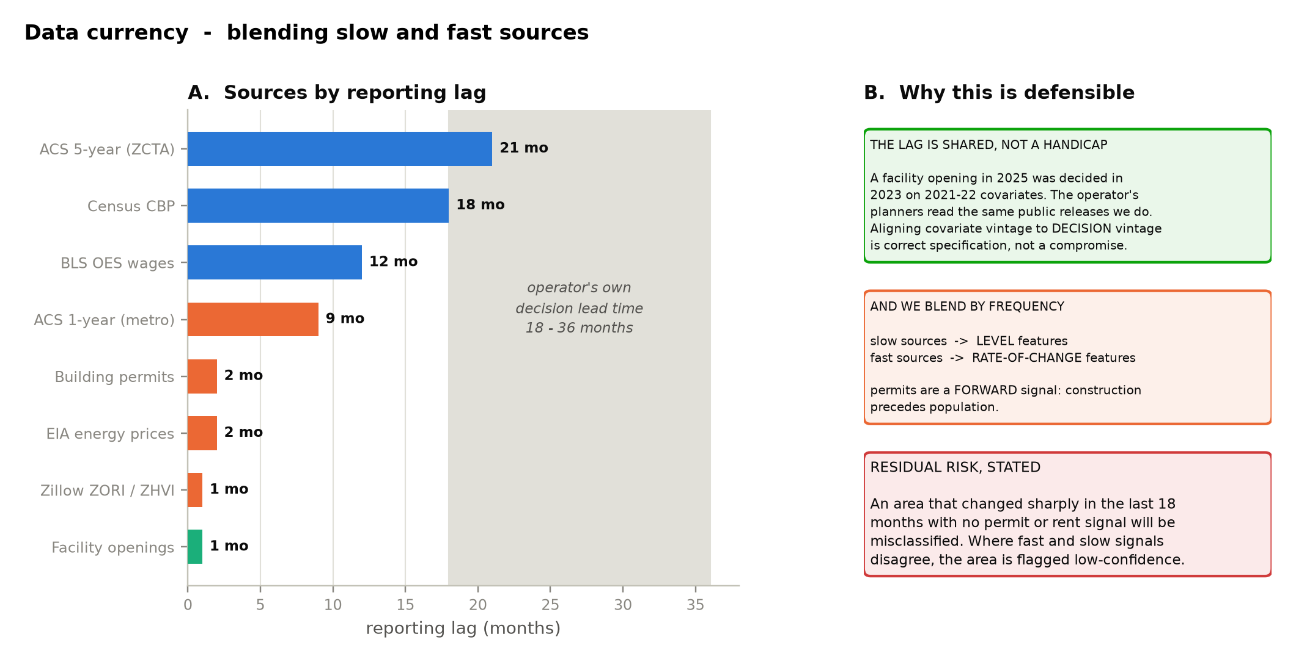
Figure 5. Sources ordered by reporting lag, against the operator's own decision lead time.
The residual risk is stated rather than resolved: an area that changed sharply within the last eighteen months and generates no permit or rent signal will be misclassified. Where fast and slow signals disagree materially, the area is flagged as low-confidence in the application rather than silently ranked.

4.3 The target variable
WHY THE TARGET MUST BE OBSERVABLE
The tempting alternative is to model order volume per ZCTA. Nobody outside the operator can observe it, so it would have to be constructed — typically by allocating disclosed aggregate volume across ZCTAs in proportion to demographics and retail density. A model of demographics and retail density would then be fitted to predict it. That target is built from its own predictors: any fit statistic measures how well the model reproduces the allocation arithmetic, and a good score is evidence of the defect rather than of predictive skill. We do not do this.

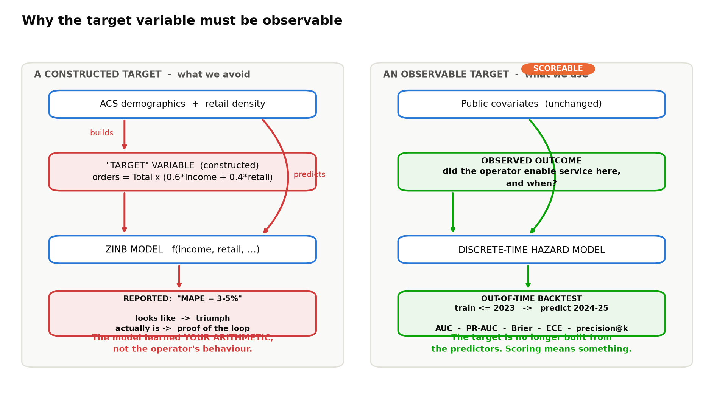
Figure 6. Left: the circularity that arises from a constructed target. Right: the observable estimand we use instead.
The primary outcome is now observable: for each ZCTA and quarter, whether the operator offered same-day service, and the quarter in which it first did. This is recoverable from the operator's public delivery-speed checker, from the public facility inventory with open dates, and from published expansion announcements.
The zero-inflated negative binomial volume model is retained as a secondary analysis and relabelled honestly: it is a specification-recovery exercise that asks whether ZINB recovers a known data-generating process under realistic covariate structure. It is not a demand forecast, and every downstream net-present-value figure derived from it is labelled as conditional on the volume allocation assumption.
Because facility open dates are the target rather than a covariate, their quality is a first-order concern and is treated as a measurement problem in its own right. Four steps apply. A random census of 43 facilities carries a per-row source, cross-checked against filings and local press, and the measured error rate is reported alongside every accuracy figure. Dates confirmed by two independent sources are marked high-confidence; single-source dates are flagged. Outcomes are modelled at quarterly rather than monthly grain, which is robust to date noise and sufficient for a decision with an eighteen-month horizon. And where the operator's own delivery-availability check can be queried directly, it is preferred over inferring service from a building.
BOUNDING THE DAMAGE RATHER THAN HOPING
An unmeasured label-error rate makes a headline accuracy figure uninterpretable. We therefore run a label-noise simulation: deliberately corrupt a known fraction of open dates by plus or minus one quarter and re-run the backtest. This converts an unknown into a bound, producing statements of the form 'at a 15 per cent date-error rate, AUC degrades from the measured 0.6894 to X'. The simulation has not been run; the form of the statement is given so that the bound is reported with the headline metric rather than after it is challenged.

4.4 Sampling frame
Causal estimation requires treated and control structure and is conducted on ten pilot metros comprising 2,413 ZCTAs (OMB 2023 CBSA delineation): San Francisco Bay Area, New York, Chicago, Austin, Seattle, Denver, Miami, Nashville, Phoenix and Boise. Phoenix and Boise are withheld from training and used only for out-of-metro validation.
The siting propensity model is additionally fitted across all 33,000 US ZCTAs. Because the analytical panel is small, national coverage costs approximately 0.46 GB and roughly one day of work — scope that would be unaffordable if the project were structured around large data.

4.5 Limitations and mitigations
Every limitation below is paired with the mitigation applied and the risk that remains after it. Four limitations at the end of this section have no mitigation; stating that plainly is what makes the others credible.
Limitation | Mitigation applied | Residual risk
ACS reporting lag of 18–24 months | Lag is shared with the decision-maker and aligned to decision lead time; ACS 1-year metro context; monthly permits, rents and energy prices supply rate-of-change features (§4.2) | Sharp recent change with no permit or rent signal; flagged low-confidence
Facility open dates may be inaccurate | a 43-row census with per-row sources and a measured bound (5 of 5 MWPVL cross-checks held, lags 4-345 months); two-source confirmation; quarterly grain; label-noise simulation bounding the effect on AUC (§4.3) | Small delivery stations under-reported relative to large facilities
Large ACS margins of error at ZCTA grain | Published margins propagated into the Monte Carlo as an uncertainty input rather than discarded; high-margin areas flagged | Small-population areas remain noisy
Modifiable areal unit problem | One vintage pinned and crosswalked; ZCTA count enforced by data contract; conclusions re-run at H3 hexagonal grain | H3 and ZCTA may disagree, in which case both are reported
Donor-pool scarcity in saturated metros | Contamination defined by the measured decay radius rather than by contiguity, recovering donors a conservative rule discards; staggered adoption uses later-treated units as earlier controls; cross-metro donors permitted; donor weight concentration reported | Most saturated metros may be reported as not estimable
Machine-extracted facility attributes are generated regressors | Design-based supervised learning (Egami et al., 2023) using the hand-labelled sample above as the correction set | None material once corrected
Residential indices proxy commercial land cost | Composite validated externally against disclosed capital expenditure; per-proxy sensitivity reported (§5.5) | A proxy biased in a way correlated with the outcome

Four limitations admit no mitigation and are therefore not mitigated. Order volume, revenue and margin are unobservable in public data, so no accuracy claim is made on dollar figures and results are reported in units of contribution margin (§5.6). The cannibalization coefficient cannot be validated against any public number; we report the placebo distribution and confidence bands and claim identification under stated assumptions rather than correctness. Internal constraints — existing lease obligations, capital rationing, executive preference — are invisible, which is why output is framed as operator-consistent desirability. And it is possible that public data has an accuracy ceiling below what the decision requires; that possibility is RQ4, and a negative answer is reported as a finding rather than suppressed.

4.6 Identification strategy and selection
Observed service enablement is not a random sample of latent viability. Operators build where they judge it commercially sensible, and the areas they skipped are not a randomised counterfactual. Ignoring this would let the model confound viability with revealed selection preference.
For the San Francisco Bay pilot metro we implement the full Heckman (1979) two-step correction. The selection equation is a probit over all Bay Area ZCTAs predicting whether a node touching that ZCTA was opened, using the demand covariates plus one instrument: distance to the nearest commercially zoned ZIP centroid. The outcome equation is augmented with the inverse Mills ratio. Corrected and naive coefficients are both reported so the difference is visible, along with the first-stage F-statistic.
The exclusion restriction deserves scrutiny rather than assertion. Commercial-zoning proximity plausibly affects an operator's siting decision, but it also correlates with retail agglomeration, employment density and traffic, each of which could drive residential demand directly. We therefore report a sensitivity analysis showing how the corrected coefficients move under small assumed direct effects of the instrument, and we state the residual risk rather than claiming the restriction is satisfied.
Formal correction on all ten metros is out of scope for an eight-week project. For the remaining nine, coefficients are reported with an explicit footnote that they embed the operator's selection preference. Extending the correction via causal forests or double machine learning is named as future work.
Finally, an equity audit stratifies results by ZCTA majority-demographic group and reports per-stratum metrics. Where a stratum's error exceeds the population error by more than 50%, the application displays a reliability warning for that context. This is aggregate-only reporting; no demographic classification enters any model input.

5. Proposed Methods

5.1 System architecture
The system decomposes into a public-source ingest layer, a dimensional warehouse, four coupled analytical models, a decision layer, and two delivery surfaces — one for operators and one for public planning.
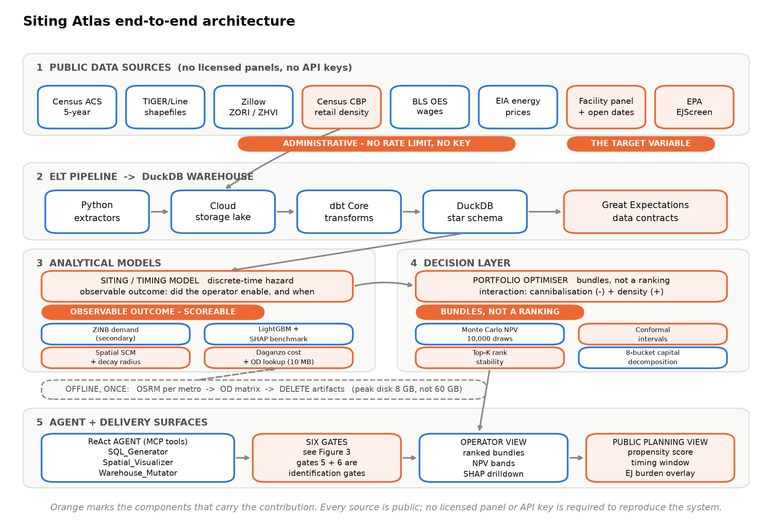
Figure 7. End-to-end architecture, from public sources through the warehouse and analytical models to the two delivery surfaces.

5.2 Dimensional warehouse
The DuckDB warehouse is a Kimball-style star schema. DuckDB is chosen because columnar vectorised execution suits the analytical queries the application issues, its spatial extension provides PostGIS-compatible functions natively, and the entire warehouse is a single portable file — which is what makes peer-review reproduction feasible.
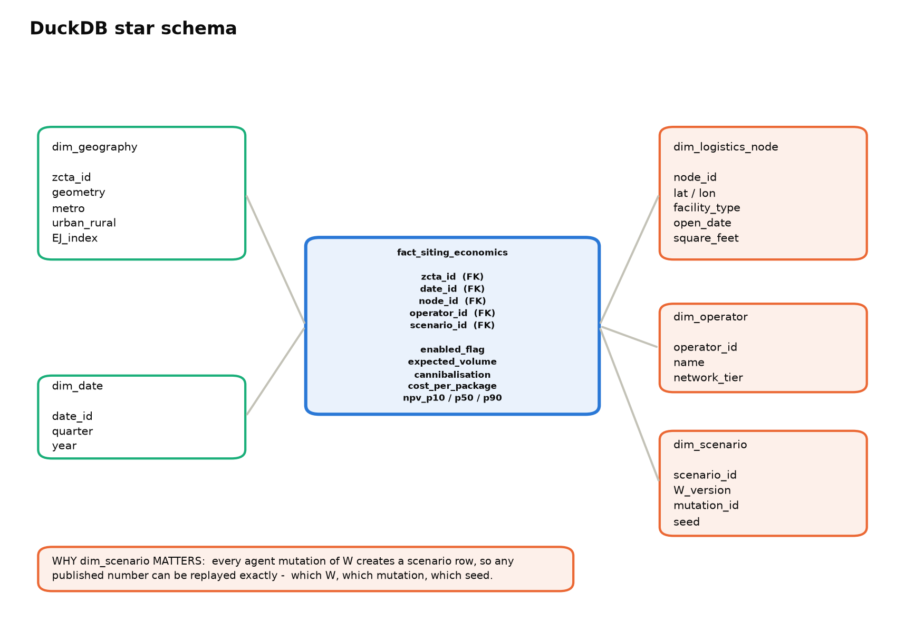
Figure 8. Star schema. The scenario dimension is what makes auditability real rather than nominal.
The scenario dimension deserves comment. Every agent-proposed mutation of the spatial weight matrix creates a scenario row recording which matrix version, which mutation and which random seed produced a given result. Any published number can therefore be replayed exactly. Without this, a system whose parameters change in response to text is not auditable in any meaningful sense.

5.3 Siting and timing model
For ZCTA i in quarter t, let the hazard of first enablement be modelled as a complementary log-log discrete-time hazard over covariates x, with metro random effects and a flexible baseline in time since the nearest node opened. Estimation is by penalised maximum likelihood with the seed recorded in the reproducibility manifest.
Three secondary models are retained. The zero-inflated negative binomial volume model, framed per §4.2 as specification recovery. A Huff gravity pull factor (Huff, 1964) with the distance-decay exponent fixed at 2.0 per the retail-geography literature, so it cannot be tuned to the data. And a LightGBM benchmark (Ke et al., 2017) with SHAP attribution (Lundberg and Lee, 2017), whose purpose is convergent validity: if a parametric hazard model and a non-parametric tree ensemble rank the same areas highly, the ranking is unlikely to be an artefact of functional form.
Two features of the input data are carried explicitly rather than discarded. Census margins of error, published for every estimate and routinely ignored, enter the uncertainty model as an input, so that two areas whose reported incomes differ by less than their margins are not treated as reliably ordered. And the monthly sources of §4.2 contribute rate-of-change features alongside the lagged levels, allowing the model to observe trajectory.
Uncertainty is quantified by split conformal prediction (Angelopoulos and Bates, 2021), which provides distribution-free, finite-sample coverage. This matters because it converts a claim about intervals into a verified measurement: we report the proportion of held-out ZCTAs actually covered by the nominal 90% interval, rather than assuming the model's own variance estimates are correct.

5.4 Cannibalization and the spatial weight matrix
Following Abadie et al. (2010), the counterfactual for a treated ZCTA is a convex combination of donor-pool areas with weights chosen to minimise pre-treatment fit error. Inference is by in-space and in-time placebo permutation, reporting the post/pre RMSPE ratio and its rank among placebos.
Rather than assuming a spillover structure, we estimate it. Using Pollmann's distance-band approach, the treatment effect is estimated separately within concentric rings around each activated ZCTA, producing a decay curve with confidence bands.
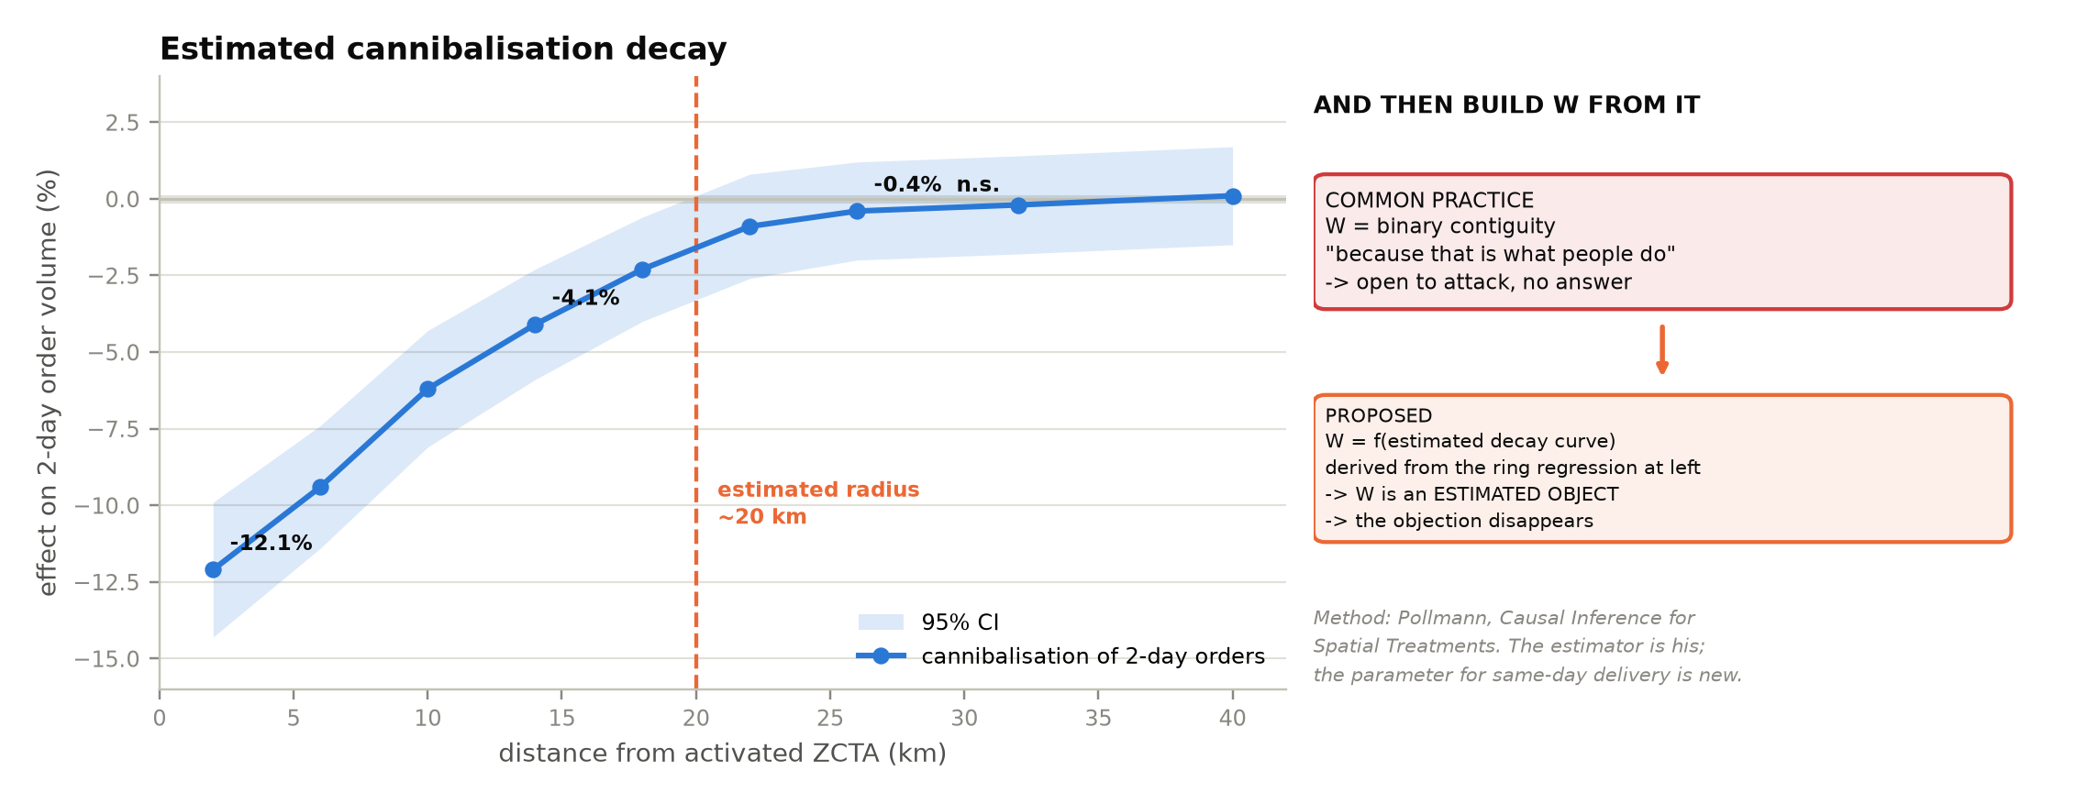
Figure 9. Estimated cannibalization decay, and the weight matrix it implies. Values are illustrative pending estimation.
The estimated decay then defines W. This closes a gap that binary contiguity leaves open: the obvious question — why contiguity? — has no answer. W is now an estimated object with a standard error, and the cannibalization radius for same-day delivery is, to our knowledge, a parameter not previously published.
The estimated radius also solves a practical problem. Synthetic control requires untreated donors, and in a saturating network those are scarce — more so if every neighbour of a treated unit is excluded as contaminated. Because contamination is now measured rather than assumed, only units inside the estimated radius are excluded, which recovers donors a contiguity rule would discard. Two further devices widen the pool: staggered adoption, in which later-treated units serve as controls for earlier-treated ones before their own treatment, and cross-metro donors, since matching is on pre-treatment trajectory rather than geography. Donor-pool size and weight concentration are reported as diagnostics, and where no credible pool exists the estimate is reported as not estimable rather than produced.
W is also revised at run time by the agent when a competitor facility event is parsed from text. Whether that revision changes the estimated coefficient materially is RQ2, and is tested rather than assumed.

5.5 Cost model
Cost per delivered package decomposes into a stem cost from the nearest node to the zone and a local cost within the zone, the latter scaling as the inverse square root of delivery density per Daganzo (1984). Stem distance is currently the great-circle distance scaled by the circuity factor of §5.9; the precomputed drive-time matrix is designed but not built. Capital is decomposed into eight buckets, each with a documented public proxy and each varying by metro: real-estate lease, building fitout, delivery vehicles, one-time hiring, ongoing wages, fuel and energy, permitting, and marketing activation.
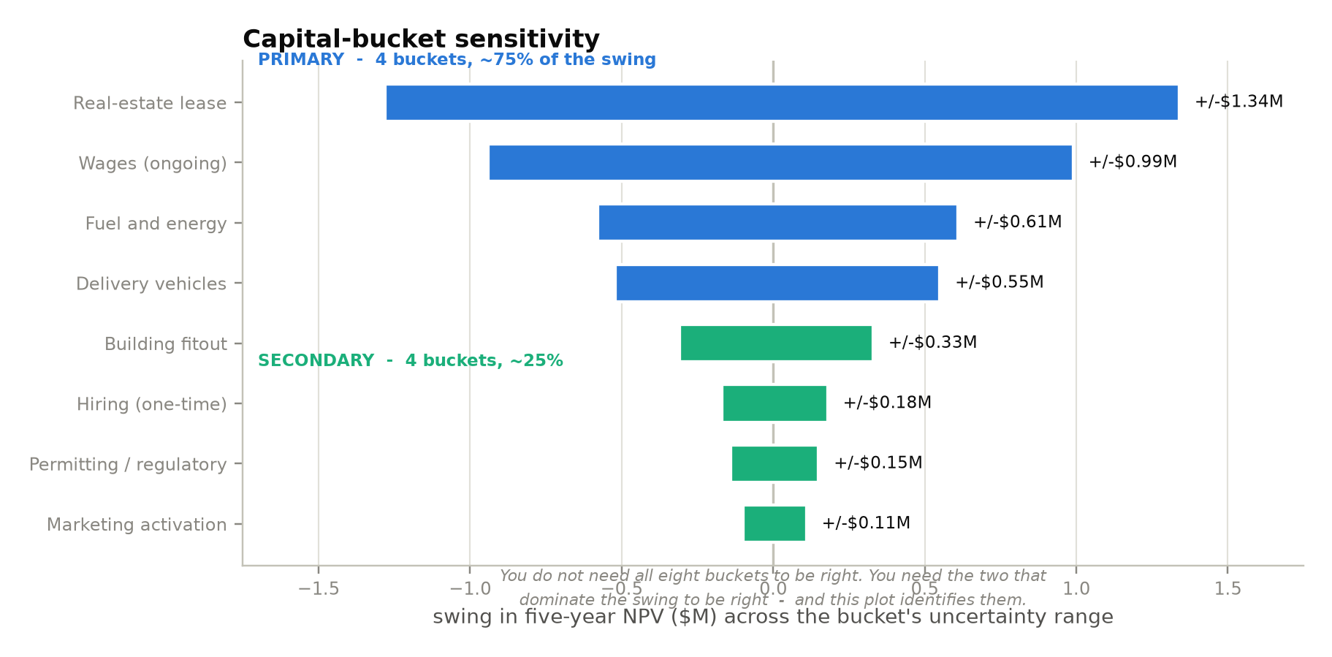
Figure 10. Capital-bucket sensitivity. Four primary buckets account for roughly three-quarters of the swing in net present value.
The sensitivity analysis is the defence of the cost model. Not all eight buckets need to be estimated precisely; the two that dominate the swing do, and the analysis identifies which those are rather than asserting it.

5.6 Net present value and portfolio selection
Five-year net present value per ZCTA nets margin on incremental volume against delivery cost, discounted, less metro-specific capital. Uncertainty is propagated by Monte Carlo over 10,000 draws per ZCTA, drawing jointly from the hazard-model posterior, the synthetic-control weight uncertainty, routing variance and each capital bucket's proxy uncertainty. A bootstrap wrapper places a confidence interval on the median itself — roughly 24 billion simulated realisations in total, which requires vectorised, chunked evaluation.
REPORTING NPV WITHOUT AN OBSERVABLE MARGIN
Contribution margin per incremental order is not observable in public data. Rather than invent it, we factor it out: results are reported as a multiple of margin together with the break-even value — for example, 41,000m minus $3.8M, break-even at m = $0.93. A reader with a view on margin substitutes it; a reader without one still gets the threshold. Plausible ranges for m are additionally bounded from disclosed aggregates so a band can be reported. Because ranking is invariant to a common scale factor, the ordering of areas, the choice between bundles and the rank-stability results are all unaffected by the unknown. We also re-run the ranking under a margin that varies with income, as a worst case, and report how far the top-100 list moves.

RANK STABILITY, NOT JUST SPREAD
The executive question is not 'what is the error rate' but 'if the inputs move within their uncertainty bands, does the recommendation change?'. We will therefore report, for each candidate area, the share of Monte Carlo draws in which it holds a top-K position: an area that holds a top-ten place in most draws is actionable, one that holds it in a minority of draws is not, and saying so is more useful than a point estimate. This pass has NOT been run. No rank-stability figure is quoted anywhere in this document, and earlier drafts carried an illustration of one that has been withdrawn.

What has been measured is the interval procedure that sits under it. Split conformal prediction was run on the hazard model, and Figure 11 reports the result: coverage against what was asked for, and the composition of the prediction sets. It is included because it is the one guarantee that does not require the model to be correct, and because its cost is visible — at a two per cent base rate a tenth of the sets contain neither label, which is an honest refusal to answer and useless for ranking.
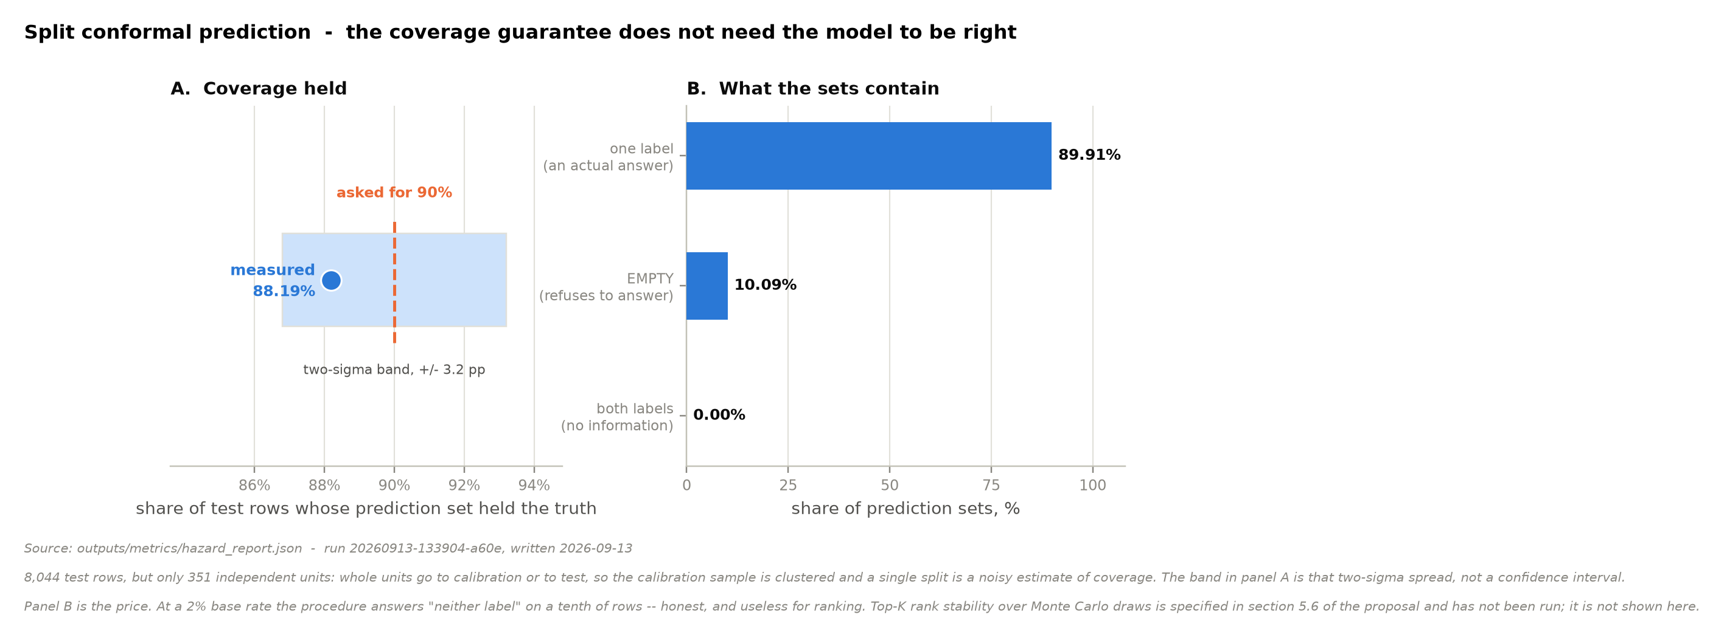
Figure 11. Split conformal prediction on the hazard model: measured coverage against nominal, and what the prediction sets contain. Source: outputs/metrics/hazard_report.json, run 20260913-133904-a60e.
Ranking areas independently, however, assumes their net present values add — and they do not. Cannibalization makes adjacent activations worth less together; shared stations and pooled drop density make them worth more. Two areas each unprofitable alone can be jointly profitable.
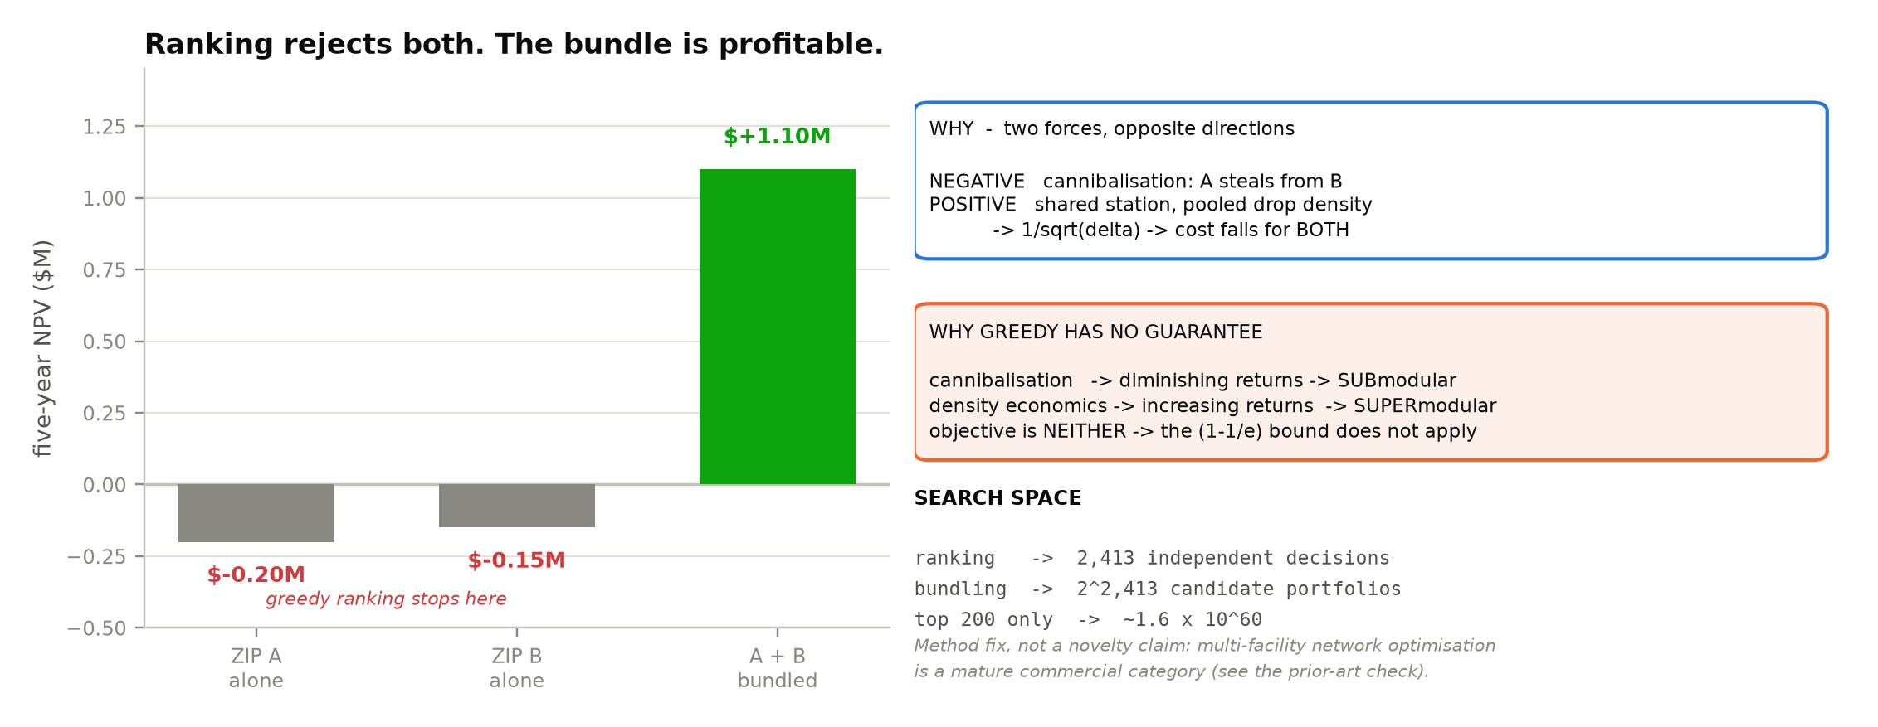
Figure 12. Why a ranking misses profitable bundles, and why greedy selection carries no approximation guarantee here.
We therefore solve a bundle-selection problem by greedy construction with pairwise-swap local search over the top candidate set, and report the gap against pure greedy ranking. Because cannibalization produces diminishing returns while density economics produces increasing returns, the objective is neither submodular nor supermodular and the standard greedy bound does not apply, making the size of the gap an empirical question.
We do not claim multi-facility optimisation as a contribution — it is a mature commercial category (§2.6). It is included because ranking is the wrong model of the decision, and correcting that is a matter of validity rather than novelty.

5.7 Agent layer and the six gates
The agent implements the ReAct pattern with three tools exposed as Model Context Protocol servers: a query generator and a spatial visualiser, both read-only, and a warehouse mutator that parses competitor infrastructure text, extracts a facility record and writes it — triggering downstream re-estimation.
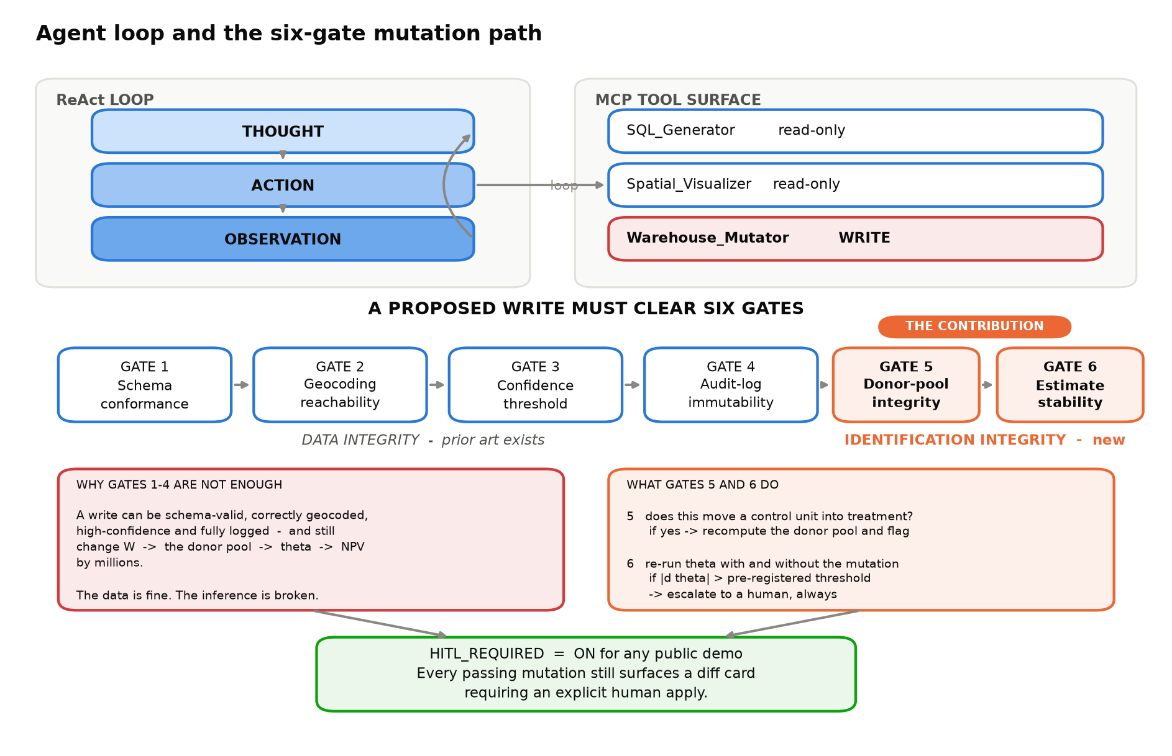
Figure 13. The agent loop and the six-gate mutation path. Gates 5 and 6 are the contribution.
Gates 1 through 4 — schema conformance, geocoding reachability, a confidence threshold and audit-log immutability — protect data integrity and have prior art (§2.5). They are not sufficient. Consider a press release announcing a competitor sortation centre in Plano, Texas. The extracted record is schema-valid, the coordinates resolve, confidence is high and the write is logged: all four gates pass. Yet the write changes W, which changes which areas are neighbours, which changes the donor pool for treated areas in that metro, which changes the cannibalization coefficient and moves net present value by millions. The data is correct and the inference is broken.
- Gate 5 — donor-pool integrity. Does this mutation move a unit currently serving as a control into a treated or spillover-contaminated state? If so, the donor pool is recomputed and the affected areas flagged, never silently re-weighted.
- Gate 6 — estimate stability. The cannibalization coefficient is re-estimated with and without the mutation. If the change exceeds a pre-registered threshold, the mutation escalates to human review regardless of automation settings, and the delta is surfaced in the diff card.
For any public demonstration, human-in-the-loop confirmation is enabled by default: every mutation that clears all six gates still requires an explicit human approval before the write lands.

5.8 Contributions
Four claims, each stated so that a product datasheet or an internal proprietary system cannot falsify it.
# | Claim | Stated as
1 | Inferential-integrity gates | A failure class not covered by the published gated-write literature, with two gates that detect it.
2 | Causal cannibalization radius, and W built from it | The estimator is Pollmann's; the parameter for same-day delivery is not published in the open literature.
3 | Public-data explainability ceiling and cross-operator transfer | How much siting behaviour is visible from outside, and whether a model fitted on one operator predicts another. Not previously reported.
4 | The artifact | Free, open, reproducible, public-data, and serving regulators and communities. Every technique here has a paywalled commercial equivalent; none of them can be checked.

Three claims that a reader might expect us to make, we deliberately do not. We do not claim to be first to gate an agent write (§2.5). We do not claim novelty in relaxing the fixed-W assumption (§2.2). And we make no comparison between our update latency and an operator's internal review cycle: that would compare a compute step to a governance step, since a review cycle is slow because a human is committing capital, not because software is slow.

5.9 Engineering feasibility
The analytical panel is 811,200 rows and roughly 260 MB, and the warehouse compresses to under 500 MB. This is deliberate: the hard problem is identification, not throughput. No distributed compute appears anywhere in the design.
The one component that does not fit that description is road-network preprocessing. A full-US extract requires memory well beyond a laptop, and retaining processed artifacts for ten metros simultaneously would consume roughly 30 GB. The design therefore removes routing from the critical path entirely: for each metro in turn, the road graph is processed offline, the origin-destination drive-time matrix is extracted, and every intermediate artifact is deleted before the next metro begins. Peak disk falls from approximately 60 GB to 8 GB, and the deployed application reads a single 10 MB lookup with no routing dependency at all.
As a fallback, road distance can be approximated as great-circle distance scaled by a circuity factor calibrated on one metro against routed ground truth, with the residual error reported. Since Daganzo's law is itself a continuous approximation, exact routing is precision in the wrong place if it threatens delivery.
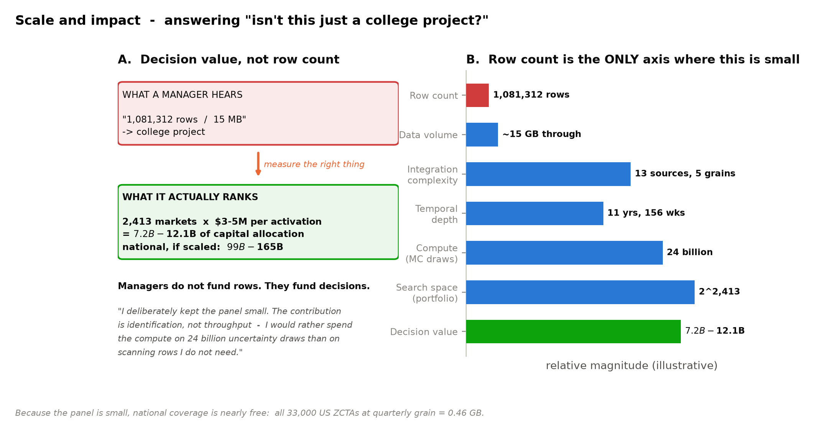
Figure 14. Scale and impact. Row count is the only dimension on which this project is small.

6. References
Abadie, A., Diamond, A., & Hainmueller, J. (2010). Synthetic control methods for comparative case studies. Journal of the American Statistical Association, 105(490), 493–505.
Abadie, A., & Gardeazabal, J. (2003). The economic costs of conflict. American Economic Review, 93(1), 113–132.
Amazon.com Inc. (2024). Annual Report (Form 10-K). SEC.
Angelopoulos, A. N., & Bates, S. (2021). A gentle introduction to conformal prediction and distribution-free uncertainty quantification. arXiv:2107.07511.
Anselin, L. (1988). Spatial Econometrics: Methods and Models. Kluwer.
Ansari, S., Başdere, M., Li, X., Ouyang, Y., & Smilowitz, K. (2018). Advancements in continuous approximation models for logistics. Transportation Research Part B, 107, 229–252.
Anthropic. (2024). Model Context Protocol Specification.
Beardwood, J., Halton, J. H., & Hammersley, J. M. (1959). The shortest path through many points. Mathematical Proceedings of the Cambridge Philosophical Society, 55(4), 299–327.
Cameron, A. C., & Trivedi, P. K. (2013). Regression Analysis of Count Data (2nd ed.). Cambridge University Press.
Caoui, E. H., Hollenbeck, B., & Osborne, M. Dynamic entry and spatial competition: an application to dollar store expansion. Working paper.
Chen, T., & Guestrin, C. (2016). XGBoost: A scalable tree boosting system. Proceedings of KDD, 785–794.
Daganzo, C. F. (1984). The distance travelled to visit N points with a maximum of C stops per vehicle. Transportation Science, 18(4), 331–350.
Egami, N., Hinck, M., Stewart, B. M., & Wei, H. (2023). Using imperfect surrogates for downstream inference. NeurIPS 2023. arXiv:2306.04746.
Heckman, J. J. (1979). Sample selection bias as a specification error. Econometrica, 47(1), 153–161.
Houde, J.-F., Newberry, P., & Seim, K. (2023). Nexus tax laws and economies of density in e-commerce: a study of Amazon's fulfillment center network. Econometrica.
Huff, D. L. (1964). Defining and estimating a trading area. Journal of Marketing, 28(3), 34–38.
Hyndman, R. J., & Koehler, A. B. (2006). Another look at measures of forecast accuracy. International Journal of Forecasting, 22(4), 679–688.
Ke, G., Meng, Q., Finley, T., et al. (2017). LightGBM: a highly efficient gradient boosting decision tree. NeurIPS 2017.
Krisztin, T., & Piribauer, P. A Bayesian approach for estimation of weight matrices in spatial autoregressive models. arXiv:2101.11938.
Lambert, D. (1992). Zero-inflated Poisson regression. Technometrics, 34(1), 1–14.
LeSage, J. P., & Pace, R. K. (2009). Introduction to Spatial Econometrics. Chapman and Hall/CRC.
LeSage, J. P., & Pace, R. K. (2014). The biggest myth in spatial econometrics. Econometrics, 2(4), 217–249.
Lewis, P., Perez, E., Piktus, A., et al. (2020). Retrieval-augmented generation for knowledge-intensive NLP tasks. NeurIPS 33, 9459–9474.
Li, J., Hui, B., Qu, G., et al. (2023). Can LLM already serve as a database interface? (BIRD). NeurIPS 2023. arXiv:2305.03111.
Lundberg, S. M., & Lee, S.-I. (2017). A unified approach to interpreting model predictions. NeurIPS 2017.
Luxen, D., & Vetter, C. (2011). Real-time routing with OpenStreetMap data. Proceedings of ACM SIGSPATIAL, 513–516.
Openshaw, S. (1984). The Modifiable Areal Unit Problem. CATMOG 38.
Pagan, A. (1984). Econometric issues in the analysis of regressions with generated regressors. International Economic Review, 25(1), 221–247.
Pollmann, M. Causal inference for spatial treatments. arXiv:2011.00373.
Reich, B. J., et al. A review of spatial causal inference methods. International Statistical Review. arXiv:2007.02714.
Reilly, W. J. (1931). The Law of Retail Gravitation.
Schorung, M., Lecourt, T., & Dablanc, L. (2023). Assessing the spatial patterns of Amazon warehouse network in the United States. WCTR.
Souza, P. C. L. (2019). Estimation and selection of the spatial weight matrix in a spatial lag model. Working paper.
South Coast Air Quality Management District. (2021). Rule 2305 — Warehouse Indirect Source Rule (WAIRE Program).
US Environmental Protection Agency. EJScreen: Environmental Justice Screening and Mapping Tool.
Yao, S., Zhao, J., Yu, D., et al. (2023). ReAct: synergizing reasoning and acting in language models. ICLR 2023.

7. Roles and Contributions
Roles are defined by module ownership and by pipeline stage. Assigning modules without assigning stages is how a shared pipeline becomes nobody's responsibility. All deliverables are jointly reviewed before submission.
Stage | Owner | Definition of done
L0 acquire and cache | P2 | Pipeline runs offline against a warm cache
L1 normalise to columnar | P2 | Every source typed, documented, contract-tested
L2 warehouse and star schema | P1 | Build green; data contracts enforced in CI
L3 feature panel | P1 | One versioned table; models read only this
L4 models | P1 | Backtest reproducible from the manifest
Drive-time matrix | P2 | Matrices committed; routing artifacts deleted
Application and figures | P3 | Loads under five seconds; reads L3/L4 outputs only
CI, contracts, reproducibility | P2 | A red build blocks merge

7.1 P1 — Overall technical direction, identification, integration
Warehouse and dbt models; hazard and timing model; synthetic control and decay estimation; conformal intervals; portfolio optimiser; agent and MCP tools; identification gates.
Owns the answer to 'how do you know it is causal rather than selection?'

7.2 P2 — Data sources, validation, reproducibility
Ingest for all nine public sources; drive-time matrix extraction and artifact cleanup; data contracts; pytest suite; CI; environment pinning and seed management.
Owns the answer to 'does it build from cold, in one command?'

7.3 P3 — Delivery, visualisation, communication
Application build-out; operator and public planning views; figure toolkit; equity overlay; executive deck; the public write-up series and the open dataset release.
Owns the answer to 'what decision does someone actually make?'

7.4 Joint ownership
Proposal submission, midterm review, final deployment, paper submission and the executive presentation require sign-off from all three contributors.

8. Timeline
Nine weeks, with the final week reserved for polish. Week 0 exists because six decisions are cheap to make now and expensive to reverse later.
Week | Focus | Milestone | Lead
0 | Decisions and corrections | Estimand, routing strategy, source swap, scope and budget settled in writing | All
1 | Infrastructure and ingest | Repo, CI, cache, contracts; first sources landing | P2
2 | Facility panel and warehouse | Target variable built: a 43-facility census with per-row sources and a measured accuracy bound, label-noise simulation harness in place; star schema live | P1 + P2
3 | Drive-time matrices and cost model | Matrices extracted, routing artifacts deleted, cost function tested | P2
4 | Siting model and backtest | Out-of-time backtest with calibration, conformal coverage, label-noise bound and H3 robustness check | P1
5 | Causal layer | Decay curve, placebo inference, W constructed from estimate; staggered-adoption donor pool; generated-regressor correction | P1
6 | Decision layer and application | Monte Carlo, rank stability, portfolio optimiser; app deployed | P1 + P3
7 | Agent and gates | Six gates implemented; adversarial mutation set passing | P1
8 | Documentation and release | Paper draft, open dataset published, forecast registry tagged | P3
9 | Buffer | Reviewer feedback, recording, archive | All

The mitigations set out in §4.5 add roughly ten person-days across the three contributors — currency features, facility-date verification and the noise simulation, margin-of-error propagation, the H3 robustness check, the widened donor pool and the generated-regressor correction. That work is inside the envelope created by the scope decisions below rather than additional to it.
Scope is bounded deliberately. Two components a reader might expect — a fine-tuned narration model and a multi-model language-model ablation — are out of scope and recorded as such in the project roadmap, because neither contributes to novelty, model confidence or the use case.

9. Budget
Line item | Provider | Est. (USD) | Guardrail
Agent and extraction inference | Hosted API | $55 | Response caching; hard stop in config
Contingency reserve | — | $25 | Reallocatable
Cloud storage | Free tier | $0 | Within free credit
Application hosting | Free tier | $0 | Free tier
Warehouse (DuckDB) | Local file | $0 | Open source
Transformations (dbt Core) | Local | $0 | Open source
Routing preprocessing | Free notebook tier | $0 | Offline, once (§5.9)
CI / CD | Free tier | $0 | 2,000 min/month
All data acquisition | Public sources | $0 | No paid API, no key
Total estimated |  | $80 | Under the $100 cap
Hard cap |  | $100 | Course rubric

Compute cost is zero. The entire budget is language-model inference, and it is bounded in configuration: cumulative spend is logged per call with token counts, exposed in the application, and a guard raises a controlled exception at $80, forcing an explicit human decision to draw on the contingency.
Keeping the fine-tuned narration model and the multi-model ablation out of scope is what holds spend inside the cap without removing any component that answers a reviewer question.

