THE BROWN HOOD

DESIGN DOCUMENT

By Doğukan BEKAROĞLU

Introduction 2

Game Summary Pitch 2

Player Experience 3

Platform 4

Development Software 4

Genre 4

Target Audience 4

Concept 4

Gameplay overview 4

Theme Interpretation (Patience is Strength) 5

Primary Mechanics 5

Theme Interpretation 6

Audio 6

Music 6

Sound Effects 7

Game Experience 7

UI 7

Controls 7



## Introduction

### Game Summary Pitch

The Brown Hood is a 2D platform action game featuring various combat and movement mechanics. The player is tasked with collecting a required amount of gold while battling enemies and overcoming environmental hazards. The main objective in each level is to gather enough gold and reach the exit point. The game includes different weapons, attack combos, double jump, dash, and climbing abilities, offering dynamic and responsive gameplay. With increasing difficulty across levels, it challenges the player’s reflexes and strategic thinking.

### Player Experience

The Brown Hood delivers a fluid and diverse gameplay experience that challenges players to act quickly using their reflexes while managing their resources strategically. The game consists of four levels, each designed to progressively develop the player's skills.

* Introductory Level: In this level, the player learns the basic movement mechanics such as walking, jumping, double jumping, climbing, and interacting with the environment. It is designed to help the player get used to the controls and ease into the game.
* Level 1: The player begins collecting weapons and engages in combat with enemies. The main objective is to defeat enemies, gather gold, and use that gold through NPCs like the blacksmith to make purchases and improve their character. The level also introduces simple obstacles that the player must avoid while reaching the exit.
* Level 2: Enemy density increases, and moving hazards are introduced. The player must manage weapons and other resources wisely. This level emphasizes strategic planning and effective resource use.
* Level 3 (Final): The most challenging part of the game. The player faces more complex platforming segments, doors that open through triggers, maze-like areas, and stronger enemies. This level tests not only reflexes but also exploration, navigation, and problem-solving skills.

Each level presents new challenges that require adaptation and skill growth, resulting in a rewarding and evolving gameplay experience that combines action with meaningful progression.

### Platform

The game is optimized for Android devices and has been developed for release on the **Google Play Store**.

### Development Software

* Unity (2D), version **6000.0.45f1** – Game engine and development environment
* C# – Programming language
* DOTween – Tweening library for transitions and fade effects
* Google Mobile Ads SDK – For ad integration
* Unity Asset Store – For visual assets
* Freesound.org – For sound effects (open-source sound library)

### Genre

Single Player, 2D Platformer, Action, Adventure

### Target Audience

Combining fast-paced action with exploration and strategic elements, this game appeals to both casual players who enjoy reflex-based gameplay and more experienced players who seek challenging level design. While the controls are simple and accessible, the game requires careful planning and attention due to enemy diversity and complex platforming structures.  
**Age Rating:** PEGI 7

## Concept

### Gameplay overview

The player controls a character who fights enemies and collects gold. Each level includes varying challenges and obstacles. Using basic movement mechanics like running, jumping, double-jumping, and climbing, the player must navigate through the environment. Weapons and items can be collected within the level and must be used strategically to defeat enemies or bypass hazards. In some levels, instead of direct combat, players must rely on precise timing and resource management. The ultimate goal is to collect the required amount of gold and reach the level exit.

### Level Design

**Entry Level**

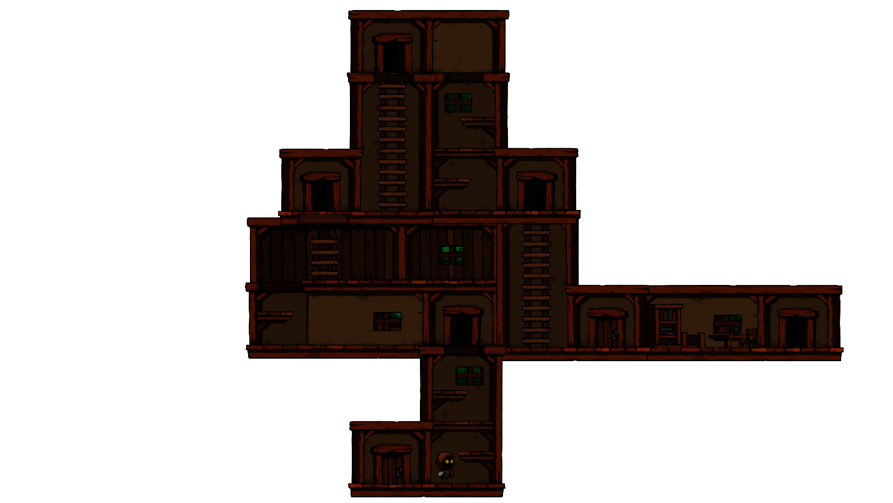

**Level 1**

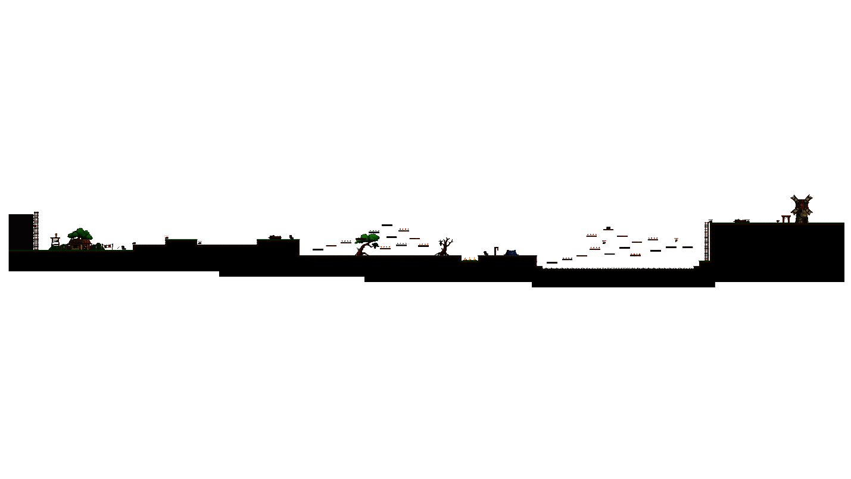

**Level 2**



**Level 3**

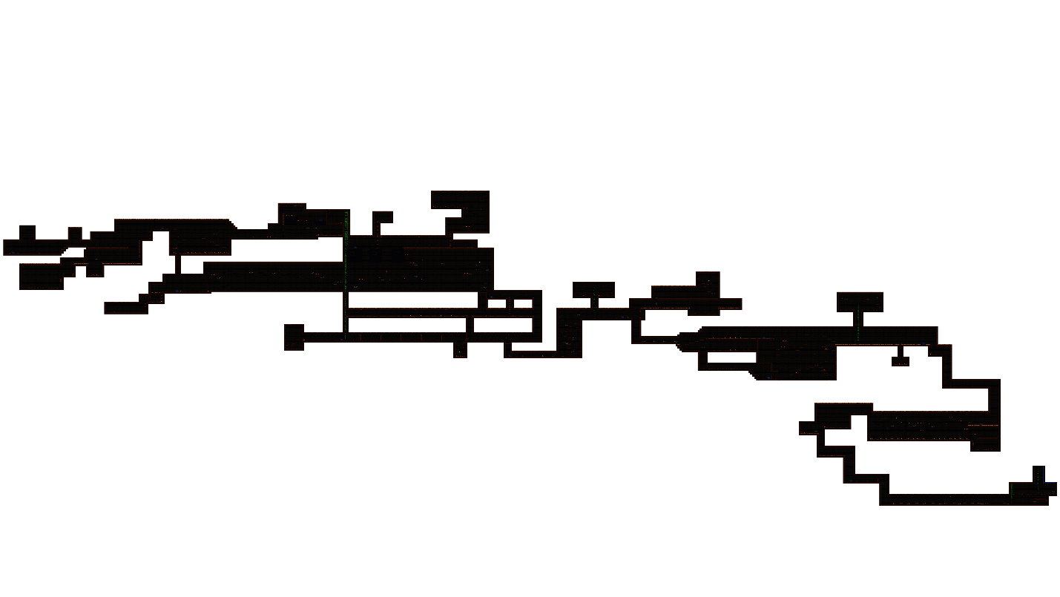

### Theme Interpretation (Patience is Strength)

The theme of “patience” in this game emphasizes the player's ability to learn from death and persistently attempt to overcome levels. Players must learn something new with each death, adjusting their strategy and moving forward with patience. Respawning at nearby checkpoints means players must become more careful and patient with every attempt, constantly revisiting their strategies to overcome the next challenge. The game's difficulty directly correlates with the player's ability to overcome obstacles with patience. Progressing patiently will ultimately lead the player to victory.

### Primary Mechanics

**Movement Mechanics:**

* Move forward
* Move backward
* Jump
* Double jump
* Dash

**Collection Mechanics:**

* Collecting items like coins, arrows, spears, HP

**Damage Mechanics:**

* Taking damage from obstacles
* Taking damage from enemies (spider, bat, pig, bee, etc.)

**Checkpoint Mechanics:**

* Upon death, respawn with half of the remaining health

**Weapon and Attack Mechanics:**

* Sword attacks (three different animations)
* Spear throwing (deals damage and sticks to targets)
* Bow and arrow mechanism

**Enemy AI Mechanics:**

* Spider: Idle, walk, die, deal damage, take damage
* Bat: Idle, fly, die, deal damage, take damage
* Pig: Idle, walk, run, die, attack
* Bee: Idle, fly, deal damage, take damage

**Knockback Feature:**

* Bat, bee, and pig enemies knock the player back when attacked.

**Other Mechanics:**

* Breakable box with gold inside
* Spiked ground (deals damage if the player stands on it)
* Climbing ladders
* Tent Mechanic: The player can buy health or watch ads to restore health.
* Blacksmith market (the player can buy items or earn coins by watching ads)
* Moving Axe: Deals low damage and knocks back enemies when hit.

### Theme Interpretation

While the game predominantly uses brown tones, various other colors have been incorporated throughout different stages of the game. In the early stages, natural greens and lighter tones dominate, while the second and third stages feature more gloomy and darker hues. These color transitions aim to reflect the atmosphere of each level, offering the player a distinct experience. The overall color palette provides the opportunity for players to transition between relaxing and challenging environments.

## Audio

### Music

The game’s music has been sourced from freesound.org. Each level has its own unique music, and as the levels progress, the music speeds up to reflect the increasing difficulty and atmosphere of each stage. The music has been carefully chosen and arranged to enhance the player's experience and align with the game’s theme.

### Sound Effects

The sound effects have also been sourced from **freesound.org**. Sounds such as jumping, taking damage, dealing damage, and breaking boxes were obtained from this platform. Due to the variety of sound types, some effects were modified to better fit the game's theme. Environmental sound effects have been used to provide feedback on the player’s actions and to give weight to the game world.

## Game Experience

### UI

The user interfaces have been designed in a modern and clear way. In harmony with the brown color palette used in the graphics, the UI elements are distinct and user-friendly. The simplicity of the visuals ensures that the game experience remains smooth and intuitive.

### Controls

The controls are tailored for mobile devices, using on-screen buttons. The player controls the character’s movements through the virtual buttons on the screen. This design aims to provide a comfortable gaming experience on mobile devices.