A Causal-Inference Pipeline for Humanities Data
Did the League of Nations’ inaction cause its loss of credibility? — Evening Star, 17 June 1920
Course | Causal Inference and AI — Analyzing Relationships in Humanities Data
Author | 이도권 (Dogwon Lee)
Textbook | Judea Pearl & Dana Mackenzie, The Book of Why (2018)
Track / tools | Track B (design-your-own), pure Python — Step 3 Option B, Step 4 Options B/C, Step 6 Option A/C

Abstract. A single 1920 newspaper article reports that the League of Nations council postponed defending Persia, and the British press immediately declared the League “discredited” and “already dead.” Those are confident rung-two causal claims (inaction → death of the League) resting on zero rung-one evidence. This project carries the whole issue from raw OCR to a causal model through six reproducible steps, then uses an explicit, evidence-linked DAG to show the asserted effect is not identified: the only backdoor path T ← U → O runs through a confounder — post-WWI great-power politics — that the article never measures. The same gap between asserted and identified causation that the worked eugenics example exposes, in a different century.

0. Causal question and approach
Research question. Did the League of Nations’ inaction on Persia’s June 1920 plea for defense cause the collapse of the League’s credibility — the British press’s verdict that it was “discredited” and “already dead”?
The Book of Why frames the task. The Ladder of Causation has three rungs: association (seeing what co-occurs), intervention (what changes if we act), and counterfactual (what would have happened otherwise). The central move of this project is to separate causation asserted by the actors in the text from causation that can actually be identified with a model and evidence. The 1920 journalists speak at rung two — “inaction caused the League’s death” — while supplying no rung-one evidence at all. Making that gap explicit is the point.
The unit of analysis is one article, with time and place metadata (Washington, D.C., 1920-06-17; wire datelines from London, Teheran, Moscow). Temporal ordering matters: the council’s decision precedes the press verdict by a day, which is exactly what tempts a causal reading.

1. Acquire and select the source (Step 1)
Option chosen: C (a different corpus). I used the Library of Congress Chronicling America OCR of the Evening Star, 17 June 1920 (LCCN sn83045462) — 28,060 lines, 32 pages, ~865 KB — instead of the example’s 1925 issue. The issue is dense with explicit causal language (37 occurrences of “because,” 19 of “led to,” plus “owing to,” “due to,” “the cause of”), which makes it a good test bed. I kept the whole issue as the corpus so the discourse-level analytics in Step 6 have material, then zoomed to one article for the focused causal model.

2. Clean and normalize (Step 2)
clean_newspapers.py is rule-based and logs every transformation (outputs/clean_log.txt) so the run is reproducible. The documented rules are:
- strip page markers and running headers (39 lines removed);
- repair line-end word breaks — explicit hyphens join with no space; a long lowercase fragment plus a short lowercase tail across a newline is treated as one broken word; every other single newline becomes a space, so real word boundaries (“men / who”) are preserved rather than fused (“menwho”);
- normalize whitespace and a small map of recurrent OCR artifacts;
- segment the issue into 585 article fragments using ALL-CAPS headline lines as anchors.
Segmentation on 1920s OCR is inherently imperfect — there are no reliable article boundaries — so the heuristic is deliberately simple and its fragment count is logged, making the noise visible rather than hidden. An LLM-cleaning route (Option B) was rejected to avoid hallucinated “corrections” that could silently change a causal claim.

3. Extract entities, events, and causal assertions (Step 3)
Option chosen: B (a transparent classic-NLP pipeline). Extraction is rule-based because every record must stay auditable. Named entities are capitalized multi-token spans, filtered by a stoplist and typed by gazetteer cues (Senator/Professor → Person; org-cue words → Organization; a place gazetteer → Place). Causal assertions are found with a causal-cue lexicon (because, owing to, the cause of, led to, resulted in, in order to, will produce/cause, prevent); each cue carries a direction, a relation type, a polarity, and a confidence proxy. Every assertion is reified as a CausalAssertion node with CAUSE, EFFECT, and EVIDENCE edges pointing to the exact sentence.
The pass yielded 83 causal assertions. Four of them carry the League argument; keeping the supporting quote makes each one auditable:
Cue / relation | Reading | Supporting quote (from the article)
the cause of (causes) | T → O (direct) | “Malice was the cause of discredit being brought upon the league.” — The Times
because (causes) | U → O (structural) | “The league is already dead because it never lived … the men who formed it were militarists and imperialists.” — The Herald
in order to (enables) | N → T (stated reason) | the council delayed “in order to give every opportunity for success of the exchanges … between Teheran and Moscow.”
first practical test (mediator) | T → M → O | supporters expected action as “the first practical test of its power to settle international disputes”; failing it is “one way of killing the league.”
Recall and precision are lower than an LLM would give — the trade-off buys full transparency and reproducibility, which is the right call when the whole point is to audit claims.

4. Build the knowledge graph (Step 4)
Options chosen: B and C. build_graph.py loads the records into a networkx property graph (Option B) — labeled, typed, with no external database — and exports nodes.csv / edges.csv (Option C) plus ekg.graphml, openable in Gephi, yEd, or a Neo4j import. Provenance is first-class: every node ties to its Source via DERIVED_FROM, and every assertion keeps its EVIDENCE mention.
Graph totals:
Node type | Count | Edge relation
Article | 585 | MENTIONS 5,824
Person / Organization / Place | 4,747 / 212 / 100 | DERIVED_FROM 668
Concept | 160 | CAUSE / EFFECT 83 / 83
CausalAssertion / Mention | 83 / 83 | EVIDENCE / SUPPORTED_BY 83 / 83
Total nodes | 5,971 | Total edges 6,824

5. Build the causal model (Step 5)
causal_model.py translates the article’s asserted causal content into a DAG over five variables and adds the confounder the source omits. The DAG is verified acyclic; the figure distinguishes edges asserted in the text (solid blue) from edges added by the analyst (dashed amber).
Var | Meaning | Role
T | League inaction on Persia’s plea | treatment
O | League credibility (“is it dead?”) | outcome
M | Perceived failure of the “first practical test” | mediator (on the path)
N | Teheran–Moscow negotiations underway | stated reason for delay
U | Post-WWI great-power / imperial politics | unobserved confounder
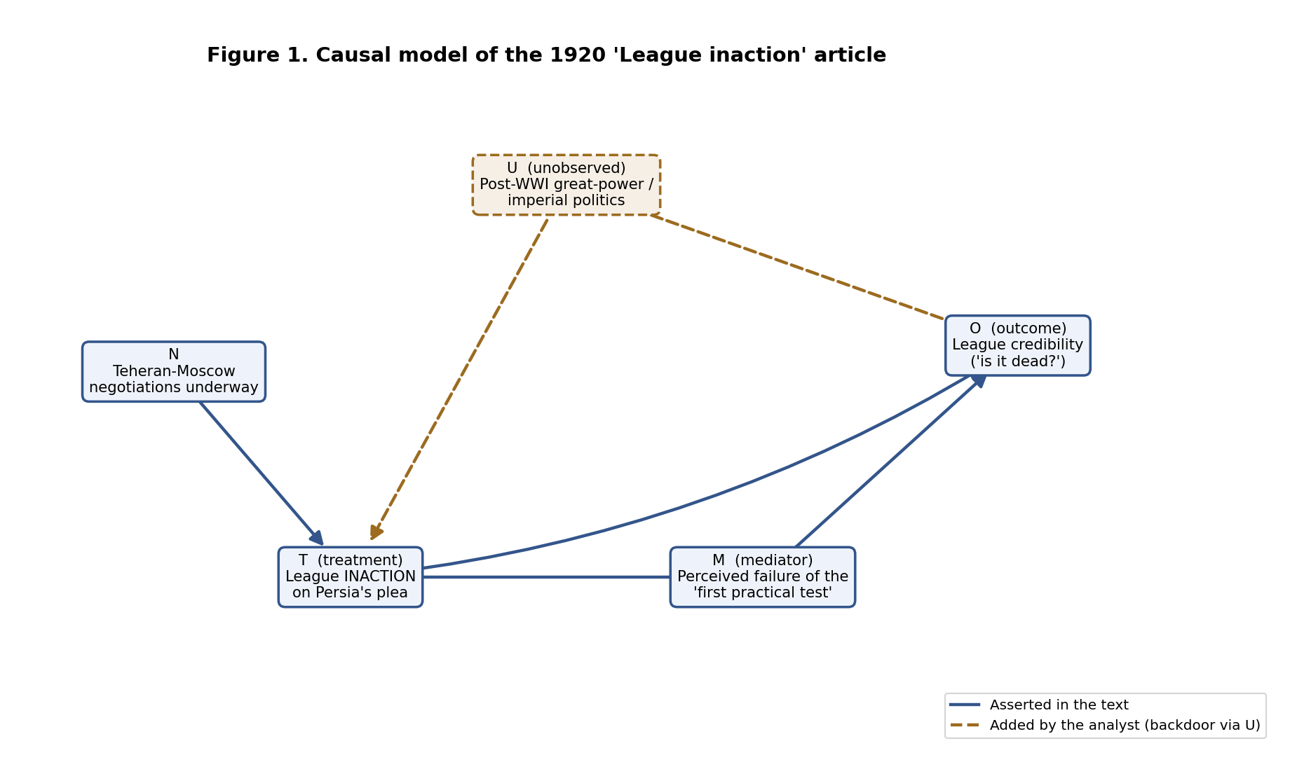
Figure 1. Solid blue = asserted in the text; dashed amber = added by the analyst (the backdoor through U).
Justifying the analyst edges. U → T because the great powers wanted to avoid commitments — Andrew Bonar Law told the Commons the government was “endeavoring to reduce its commitments” — which drives inaction. U → O because the same imperial character is what critics invoke to delegitimize the League (the Herald’s “militarists and imperialists”). So U is a common cause of treatment and outcome, opening a backdoor path. M is correctly a mediator on the T → O path, not a confounder; the model keeps the two apart.

6. Do causal inference (Step 6)
inference.py argues at rungs one and two through graph queries. A causal-motif leaderboard ranks cause-type → effect-type by stated confidence; honestly, the issue’s discourse is dominated by commercial causation (delivery delays “cause” sales), with the political motifs (“… → discredit being brought upon the league”) surfacing below the advertising noise — itself a finding about what 1920 newspaper causal language is mostly for. A hand-rolled d-separation routine then enumerates the backdoor paths between T and O.
Result. There is exactly one backdoor path, T ← U → O, and the minimal adjustment set that would identify T → O is {U}. Because U is never measured in the article — the Herald asserts U → O outright and Bonar Law supplies U → T — the backdoor stays open and the asserted effect is not identified from this source.

Keeping the three apart
Correlation | Asserted causation | Identified effect
Inaction and discredit co-occur, one day apart. | Actors confidently claim inaction CAUSED the discredit (rung two). | None. Identifying T → O needs adjustment for U, which the text omits.
This is the worked example’s payoff in a new setting: a confident historical “because” resting on no rung-one evidence and no identification strategy. What would change the conclusion: a measured time series of the League’s standing around datable decisions, plus a proxy for great-power commitment (U), would permit a backdoor adjustment or a difference-in-differences design around the Persia vote — the quantitative tools this course builds toward.

A quantitative check: what the confounder does to a number
Because the article carries no measurements, the real effect cannot be estimated; but the backdoor criterion can be illustrated numerically. confounding_demo.py simulates 200,000 cases that obey the Step-5 DAG, with no true effect of T on O built in (T ← U → O only). A naive analyst who ignores U — exactly what the press does — recovers a large spurious association; an analyst who adjusts for U recovers the truth.
Quantity | Risk difference E[O|T=1]−E[O|T=0]
True effect built into the data | 0.00
Naive estimate (ignores U) — what the article implies | +0.49 (spurious)
Backdoor-adjusted for U (correct) | −0.00 (recovers truth)
The entire +0.49 “effect” is confounding bias. This is a synthetic illustration, not a claim about real magnitudes — its point is that the press’s confident correlation would be an artifact of the very variable (U) the article never measures, which is exactly why the asserted effect is not identified.

7. Limitations
Rule-based extraction misses implicit causation and mis-segments some OCR; U is a qualitative confounder argued from the text, not a measured variable, so the identification claim is reasoned rather than estimated; and the “credibility” outcome is press rhetoric, not a metric. These limits are stated so the reader knows exactly how far the analysis reaches — which is the discipline the whole pipeline is meant to teach.

Data source and deliverables
Source: Library of Congress, Chronicling America (Evening Star, LCCN sn83045462), 17 June 1920; public domain. Deliverables in the repository: code (src/, run_pipeline.py, notebook.ipynb); knowledge-graph export (outputs/nodes.csv, outputs/edges.csv, outputs/ekg.graphml); causal diagram (figures/causal_dag.png); and this report.

