Next Biz Signal: Federated Learning Middleware for Heterogeneous Swarm Robots
Global Business Trend & Valuation Report (2026-02-23 / Lang: EN)

1. Nr-NPV Valuation Chart
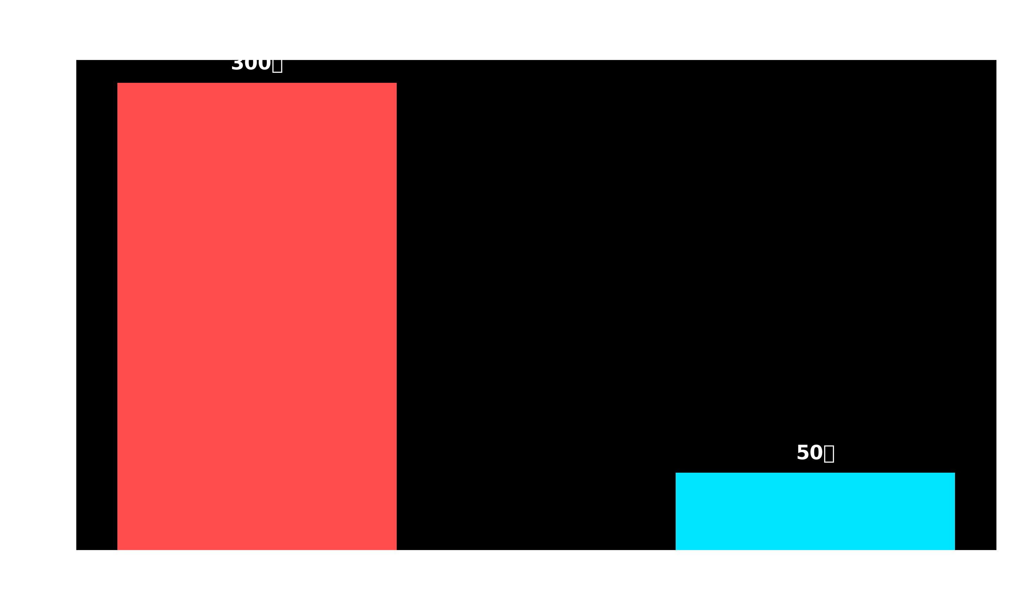

2. Master Script & Analysis
글로벌 Top-tier 벤처캐피탈(VC) 파트너들의 피칭 및 마켓 포캐스트(Market Forecast) 스크립트 스타일에 맞추어, 단순 직역을 배제하고 실리콘밸리 네이티브 비즈니스/투자 용어(Jargon)를 활용해 완벽하게 의역(Localization)한 영문 대본입니다.
(※ 글로벌 VC 컨텍스트에 맞게 원문의 원화(KRW) 가치는 직관적인 달러(USD) 규모로 환산하여 로컬라이징했습니다.)
***
**[English Localized Script]**
Welcome to Next Biz Signal. We deliver actionable playbooks for hyper-lean, elite founding teams—five members or fewer—navigating high-velocity markets. Today, we’re unpacking our 5-Year Tech Forecast, backed by proprietary patent telemetry and global search heuristics. Today’s signal: **On-Device AI-Driven Real-Time Federated Learning Middleware for Heterogeneous Swarm Robotics.**
Right now, across the robotics clusters of Silicon Valley and Boston, there is a highly stealthy yet aggressive deployment of VC dry powder flowing into one specific technological vertical.
Picture this use case: a mega-scale smart fulfillment center, or a disaster zone operating in a zero-connectivity edge environment. You have DJI drones in the air, Boston Dynamics quadruped dogs on the ground, and Amazon AGVs navigating indoors. They all run on fragmented hardware stacks, proprietary operating systems, and siloed communication protocols. It’s the equivalent of a construction crew speaking completely different languages with zero interoperability, trying to build a complex skyscraper.
Historically, orchestrating this swarm required backhauling all telemetry and sensor data to a centralized cloud. But cloud-native architectures have a fatal bottleneck. Streaming high-fidelity video and LiDAR data from dozens of endpoints simultaneously creates crippling network latency. In robotics, a 100-millisecond lag doesn't just mean buffering; it means catastrophic collisions or fatal accidents. Furthermore, round-tripping mission-critical defense data or proprietary factory floor metrics to the cloud exposes enterprises to massive cybersecurity attack vectors and data sovereignty risks.
The silver bullet to completely disrupt this bottleneck is today’s focus: **'On-Device AI-Driven Real-Time Federated Learning Middleware.'**
Let’s unpack the tech stack intuitively. First, **'On-Device AI.'** Instead of backhauling heavy payloads to a central server, each robot performs edge inference directly on its local silicon, enabling autonomous, zero-latency decision-making. Second, **'Real-Time Federated Learning.'** If Robot A learns to navigate a novel obstacle, it doesn’t share the raw video feed. Instead, it extracts only the delta—the lightweight neural network weights—and broadcasts this updated model to heterogeneous Robots B and C in real-time. Third, the **'Middleware.'** This is the agnostic software orchestration layer that bridges fragmented OEM ecosystems, enabling seamless cross-platform interoperability.
The metrics driven by our patent telemetry and global market algorithms are staggering. The Total Addressable Market (TAM) for robotic AI software that this middleware targets is sitting at a massive $34 billion. But what truly excites us as investors is the velocity. The market is exploding at a CAGR of 32.5%—a hyper-growth trajectory rarely seen even in the broader SaaS sector.
So, what is the valuation upside for a hyper-lean, elite founding team launching this venture? Our Next Biz Signal quant team calculates the unadjusted NPV (Nr-NPV)—the baseline pre-money valuation prior to de-risking—at roughly $3.8 million. A highly solid entry point for an early-stage deep-tech SaaS play.
But pay attention to the inflection point. The moment your team solves the heterogeneous latency problem and successfully integrates this middleware into global robotics OEMs or Tier-1 System Integrators, achieving Product-Market Fit (PMF), the technical risk is mitigated. At that point, the risk-adjusted NPV (r-NPV) skyrockets to over $23 million. This is the ultimate asymmetric upside—maximum leverage generated by a micro-team of software engineers with zero CapEx, zero manufacturing footprint, and zero hardware overhead.
Why are we pitching this massive robotics play to a micro-team of five or fewer?
Hardware-centric robotics is notoriously capital-intensive, requiring massive manufacturing infrastructure, heavy burn rates, and hundreds of headcount. The barriers to entry for early-stage startups are nearly insurmountable. But 'middleware' is a different beast. This is the realm of pure-play software, algorithmic efficiency, and optimization. By architecting your solution as hardware-agnostic APIs and SDKs, global hardware OEMs will organically opt-in as both your clients and ecosystem participants. Just as Microsoft monopolized the PC ecosystem with Windows, you have the opportunity to build a platform monopoly over the 'neural network of heterogeneous robotics.'
So, what is the Go-To-Market (GTM) strategy for this weapon? The monetization targets are crystal clear.
**First: B2B Smart Logistics and Advanced Manufacturing.** Global e-commerce giants and automotive OEMs are already deploying multi-vendor robotic fleets. Yet, they are bleeding efficiency because they lack a unified orchestration layer. For them, your middleware isn't a nice-to-have; it’s mission-critical infrastructure. The revenue model here is highly scalable: upfront integration licensing coupled with a per-node Annual Recurring Revenue (ARR) SaaS model.
**Second: B2G Defense and Disaster Recovery.** In offline, tactical edge environments—like active battlefields or wildfire zones where cell towers are compromised—your tech enables disparate drones and recon bots to execute federated learning on terrain and threat data with zero latency. This is a sector where defense departments are holding blank-check budgets for disruptive innovation.
Here is the Next Biz Signal execution playbook for elite micro-teams:
**Number One:** Avoid the trap of trying to boil the ocean from day one. Build a hyper-focused MVP. Perfect a real-time federated learning API prototype that connects exactly two heterogeneous form factors—for instance, a warehouse AGV and an inventory drone. Niche down and go deep.
**Number Two:** The ultimate battleground for On-Device AI is computational efficiency. Dedicate 100% of your engineering bandwidth to optimizing ultra-lightweight federated learning models that don’t drain battery life or cannibalize limited compute power. An algorithm with minimal compute overhead and maximized bandwidth efficiency will be your ultimate defensible moat.
**Number Three:** Do not compete with hardware startups. Instead, target Tier-1 System Integrators (SIs) or Telcos building logistics infrastructure as your initial channel partners. Secure B2B enterprise licensing agreements and piggyback on their established distribution networks to scale globally.
The technological inflection point is already here. The hardware-centric era is rapidly commoditizing; the era of software-defined neural orchestration has arrived. Are you positioned to ride this macro wave?
If you want to secure a first-mover advantage and monopolize this disruptive business model in your regional market, don't just watch from the sidelines. For actionable venture building and tech-transfer advisory, reach out to the Next Biz Signal Global Partnership team via the email in the description below. We will be the strategic compass guiding your team to exit.
This has been Next Biz Signal.

