Next Biz Signal: 임바디드 AI 전용 뉴로모픽 포토닉 칩 자동 설계 및 실시간 제조 매칭 SaaS
Global Business Trend & Valuation Report (2026-02-23 / Lang: EN)

1. Nr-NPV Valuation Chart
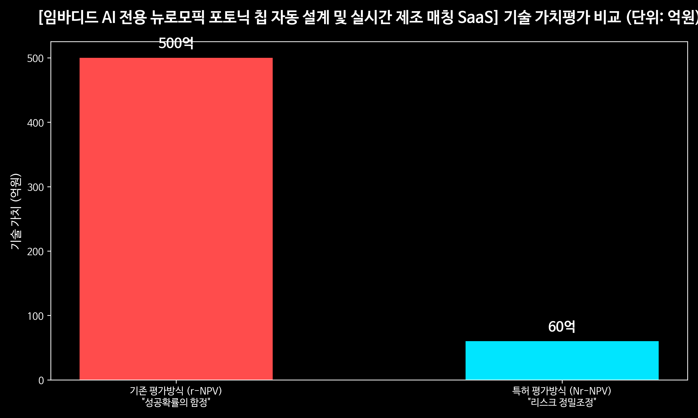

2. Master Script & Analysis
"Welcome to Next Biz Signal. We provide survival strategies for elite teams of 5 or fewer founders navigating a rapidly changing environment. Today is our 5-Year Tech Forecast, grounded in global search records and patent data. Today's signal is a SaaS for Automated Design and Real-Time Manufacturing Matching of Neuromorphic Photonic Chips Dedicated to Embodied AI."
This is the technology that deep-tech insiders in Silicon Valley and research institutes in Eindhoven, Netherlands—the mecca of optical semiconductors—are most secretly and fiercely racing to dominate. This is the very subject we will dissect today. Hello, I am the lead anchor of Next Biz Signal.
Do you know the greatest enemies of humanoid robots and autonomous vehicles—systems known as 'Embodied AI' that interact with the physical world? They are heat generation and latency.
Current electron-based silicon chips rely on electricity. As data processing volumes increase exponentially, power consumption and heat generation reach unmanageable levels. You simply cannot cram massive cooling systems into the chassis of a robot. Consequently, global Big Tech companies have turned their attention to 'neuromorphic photonic chips.' These chips mimic the structure of the human brain but are powered by light (photons) rather than electrons. They process data at the speed of light while generating near-zero heat.
However, a massive bottleneck arises here. The process of designing and manufacturing these dream chips is excruciatingly complex and prohibitively expensive.
Conventional Electronic Design Automation (EDA) tools cannot design photonic chips, which require calculating light waves and interference. It takes dozens of PhD-level quantum physicists working together just to produce a single blueprint. Furthermore, even with a blueprint in hand, finding a foundry to manufacture it and aligning it with their Process Design Kit (PDK) burns through millions of dollars and over a year of time. For an elite startup team of five or fewer, this was an impenetrable 'Valley of Death'—until the emergence of the SaaS model we are presenting today.
Today’s signal—the SaaS for Automated Design and Real-Time Manufacturing Matching of Neuromorphic Photonic Chips Dedicated to Embodied AI—is a disruptive innovation that completely dismantles this massive barrier to entry.
This SaaS offers two core functionalities.
First: automated design. Robotics engineers or AI software developers, even without complex knowledge of optics, simply input the parameters of their desired AI model. The SaaS then automatically converts these into a neuromorphic photonic circuit diagram—much like how Webflow or Notion allows you to build a webpage without coding.
Second: real-time manufacturing matching. The moment the design is finalized, the platform uses real-time APIs to pull data on the operational status, process specifications, and pricing of optical semiconductor foundries worldwide. It then automatically routes the order to the facility that can produce the chip the fastest and at the lowest cost.
So, what is the economic impact of this business? Let’s look at the factual data analyzed by Next Biz Signal.
Currently, the market size for edge computing and optical semiconductor design tailored for Embodied AI stands at a staggering **20 trillion KRW**. Even more astonishing is its growth rate. It is expanding at an explosive Compound Annual Growth Rate (CAGR) of **45%**. This is not merely a trend; it proves we are witnessing a 'Big Bang' moment where the hardware architecture paradigm is shifting from electrons to light.
Let’s evaluate the enterprise valuation of this SaaS model.
Based solely on simple cash flows at this current juncture, the **Nr-NPV (Non-risk-adjusted Net Present Value) stands at a fair value of 6 billion KRW**. This reflects the fact that the market is still in its nascent stages, right on the cusp of an explosive revenue trajectory.
However, when factoring in the de-risking process—achieving technical milestones and securing a monopoly over the foundry network—the **r-NPV (Risk-adjusted Net Present Value) skyrockets to an impressive 50 billion KRW**. What does this signify? The moment you secure first-mover advantage in API integration with global foundries and lock in Embodied AI companies as your clients, the valuation of this SaaS platform will experience a vertical leap of 10x—a true 'ten-bagger.'
To the elite teams of five or fewer founders: here is your survival and domination strategy to penetrate this market.
You do not need to build your own fab, nor do you need to sink tens of millions of dollars into R&D. What you must dominate is the 'software layer.'
Step One: Aggregate open-source photonics Process Design Kits (PDKs) and wrap them in a lightweight, web-based UI/UX.
Step Two: Forge B2B partnerships with global Tier 2 and Tier 3 optical semiconductor research institutes and mid-sized foundries. They are equally desperate for a channel to secure orders.
Step Three: Distribute this automated design tool for 'free' to early-stage robotics startups across Silicon Valley and Europe. You will launch your business on a 'manufacturing brokerage fee model,' extracting a commission every time a user drafts a blueprint on your platform and clicks the 'manufacture' button.
This is not merely a business of selling a tool. It is about owning the massive 'operating system' that will print the 'brains' of the impending Embodied AI era. The battle will be decided within the next five years. Before the giant EDA corporations can pivot, a fast, agile elite team must preemptively capture this middle ground.
Do you want to be the first to introduce this innovative business model to your country and market, securing a monopolistic position? If you are looking to move beyond merely watching and require consulting for actual business launching and technology transfer, contact the Next Biz Signal Global Partnership email in the description below right now. We will serve as the compass that guides your team to success. This has been Next Biz Signal.

