Home Automation System with Raspberry Pi

Introduction
The home automation system is designed to control automatically or remotely the home appliances, such as lights, fans, and so on. To operate the appliances automatically, sensors or inputs are required. The idea is to switch the light on at night and switch it off in the day time, then we need a clock as an input.

System Design
The Raspberry Pi is the main controller to control home appliances via relay connection with GPIO pins. There is a four-channel relay module, which is linked to the appliances (lights, fan, air conditioner, and microwave).
Hardware Implementation
Firstly, select the Raspberry Pi’s GPIO pinouts (BCM: 17,27,22, and 23) and connect to the input pins of a 4-channel relay module. In this project, one incandescent light and three LED lights, instead of household appliances, are used. The relay has 3 terminals: normally open (NO), normally close (NC), and common (COM). In this project, NC and COM are used to connect the appliances in order to have a connection at the initial state. COM of all relays are connected to the Ground (GN), and every NC is linked to the negative pin of LEDs. Continuously, the positive pins of the LEDs go through the resistor and are connected to the supply of 3.3V of Raspberry Pi. For the light, its neutral is connected to GN, and its phase is connected to NC.

Appliance 3
Appliance 1
Raspberry Pi 4B Instead of household appliances,
Relay 4-channel
Appliance 4
Appliance 2

Household Appliances

Wi-Fi

Light ON

Light OFF
Home Assistant
User Command

The System’s Wiring Diagram & Relay Connection

Describe the hardware connection
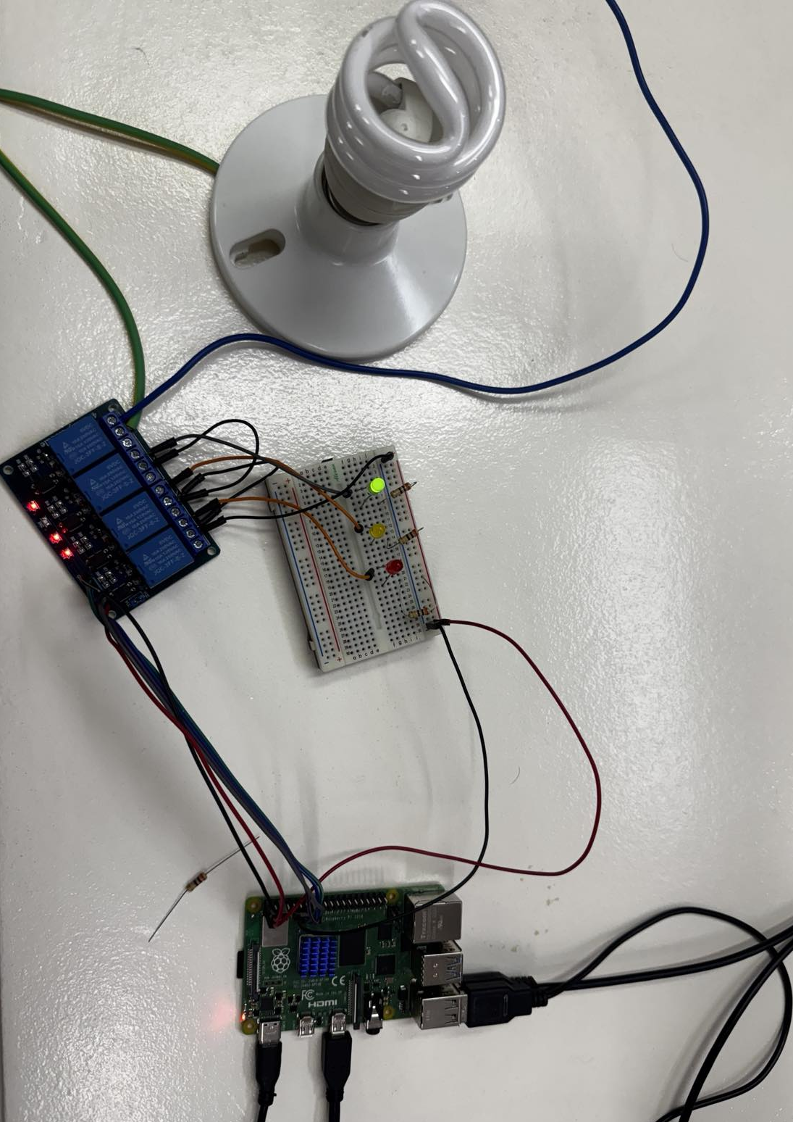
Figure:
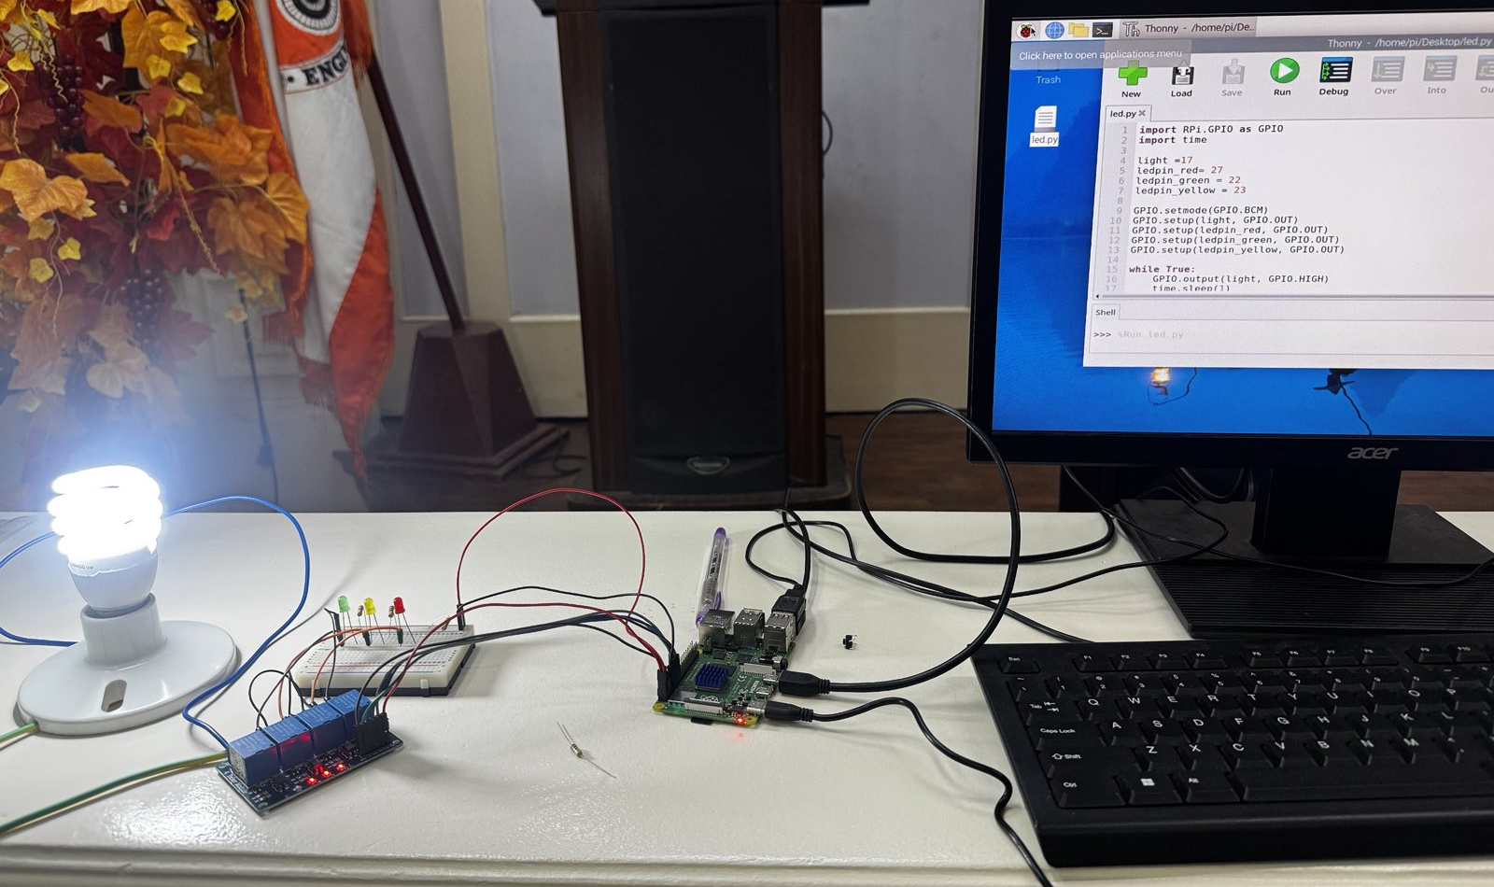
Figure:

Software Development
Explain how the code works
Python code

