**INTRODUCTION TO STATISTICAL CONCEPTS**

**ASSIGNMENT 1A**

**Chapter 1: Introduction**

1. A teacher wishes to know whether the males in his/her class have more conservative attitudes than the females. A questionnaire is distributed assessing attitudes and the males and the females are compared. Is this an example of descriptive or inferential statistics? ([relevant section 1](http://onlinestatbook.com/2/introduction/descriptive.html), [relevant section 2](http://onlinestatbook.com/2/introduction/inferential.html))
   * *The collection of data in the form of a questionnaire is an example of descriptive statistics. However, the process of assessing attitudes using that data is inferential statistics.*
2. If you are told that you scored in the 80th percentile, from just this information would you know exactly what that means and how it was calculated? Explain. ([relevant section](http://onlinestatbook.com/2/introduction/percentiles.html))
   * No, because there are multiple ways to define “percentiles”; the first one being the “lowest score that’s greater than 80% of the scores”, the second one being the “smallest score greater than or equal to 80% of the scores”, and the third one based on ranking. The way statisticians choose to define percentile determines what this number means, and which ranking formula was used, particularly because it relies on integer rank and fractional ranks.
3. Give an example of an independent and a dependent variable. ([relevant section](http://onlinestatbook.com/2/introduction/variables.html))
   * An example of an dependent variable is the price of a house, and examples of independent variable are the location, build, architect, and size.
4. Specify the level of measurement used for the items in Question 6. ([relevant section](http://onlinestatbook.com/2/introduction/levels_of_measurement.html))
   * Rating of the quality of a movie on a 7-point scale – *ordinal scale*
   * Age – *interval scale (because it depends how granularly you want to measure age)*
   * Country you were born in – *nominal scale*
   * Favorite Color – *nominal scale*
   * Time to respond to a question – *ratio scale (since 0 time is meaningful)*
5. The formula for finding each student's test grade (g) from his or her raw score (s) on a test is as follows: g = 16 + 3s Is this a linear transformation? If a student got a raw score of 20, what is his test grade? ([relevant section](http://onlinestatbook.com/2/introduction/linear_transforms.html))
   * Yes, since the data transforms from one measurement scale to another in a linear fashion. The test grade would be g = 16 + 3(20) 🡺 **76**
6. Which of the frequency polygons has a large positive skew? Which has a large negative skew? ([relevant section](http://onlinestatbook.com/2/introduction/distributions.html))

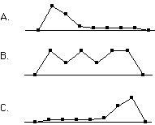

* + *A has a large positive skew*
  + *C has a large negative skew*

**Chapter 2: Graphing Distributions**

1. Name some ways to graph quantitative variables and some ways to graph qualitative variables. ([relevant section](http://onlinestatbook.com/2/graphing_distributions/graphing_qualitative.html) & [relevant section](http://onlinestatbook.com/2/graphing_distributions/intro_quantitative.html))
   * *Some ways to graph qualitative variables include: frequency tables, pie charts, and horizontal and vertical bar charts. Some ways to graph quantitative variables include: stem & leave displays, histograms, frequency polygons, box plots, bar charts, line graphs, and dot plots.*
2. An experiment compared the ability of three groups of participants to remember briefly-presented chess positions. The data are shown below. The numbers represent the total number of pieces correctly remembered from **three** chess positions. Create side-by-side box plots for these three groups. What can you say about the differences between these groups from the box plots?   
   ([relevant section](http://onlinestatbook.com/2/graphing_distributions/boxplots.html))

|  |  |  |
| --- | --- | --- |
| Non-players | Beginners | Tournament players |
| 22.1 | 32.5 | 40.1 |
| 22.3 | 37.1 | 45.6 |
| 26.2 | 39.1 | 51.2 |
| 29.6 | 40.5 | 56.4 |
| 31.7 | 45.5 | 58.1 |
| 33.5 | 51.3 | 71.1 |
| 38.9 | 52.6 | 74.9 |
| 39.7 | 55.7 | 75.9 |
| 43.2 | 55.9 | 80.3 |
| 43.2 | 57.7 | 85.3 |

* *Below are the box plots for these individual groups, generated in R Studio:*

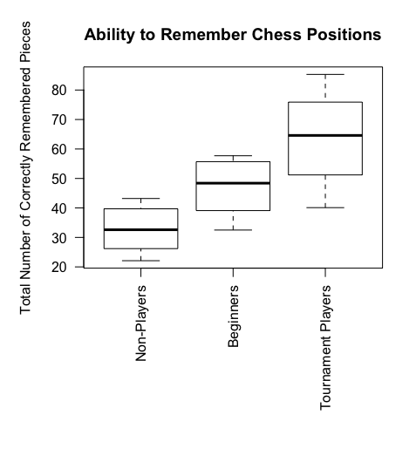

|  |
| --- |
| #STATS bootcamp HW1a, ch2, q3 - create box plots getwd() chess <- read.csv("HW1_ch2_q3.csv", header=TRUE) #it's already a df so no need to convert it again  boxplot(chess,          las = 2,          #par(mar = c(12, 5, 4, 2)),         names = c('Non-Players', 'Beginners', 'Tournament Players'),         main="Ability to Remember Chess Positions",          #xlab="Player Type",          #mtext('Player Type', side = 2, line = 3, cex = 2, font = 3),         ylab="Total Number of Correctly Remembered Pieces") |

* *Based on the box plots above, non-players on average have lower numbers of correctly remembered chess pieces. The beginners on average have higher numbers of correctly remembered chess pieces when compared to non-players, but lower when compared to tournament players. In terms of spread, non-players have scores that are more concentrated near the mean, while tournament players have a wider distribution of scores. The beginners group has a negative skew, which logically makes sense assuming that there are more beginners who are less likely to be able to correctly remember chess pieces in the aforementioned three positions.*

1. In a box plot, what percent of the scores are between the lower and upper hinges? ([relevant section](http://onlinestatbook.com/2/graphing_distributions/boxplots.html))
   * *In a box plot, 50% of the scores are located in between the lower and upper hinges, which represent the 25th and 75th percentiles respectively. (75-25=50)*
2. For the data from the 1977 Stat. and Biom. 200 class for eye color, construct: ([relevant section](http://onlinestatbook.com/2/graphing_distributions/graphing_qualitative.html))
   * pie graph
   * horizontal bar graph
   * vertical bar graph
   * a frequency table with the relative frequency of each eye color

|  |  |
| --- | --- |
| Eye Color | Number of students |
| Brown | 11 |
| Blue | 10 |
| Green | 4 |
| Gray | 1 |

(Question submitted by J. Warren, UNH)

* Pie Graph:

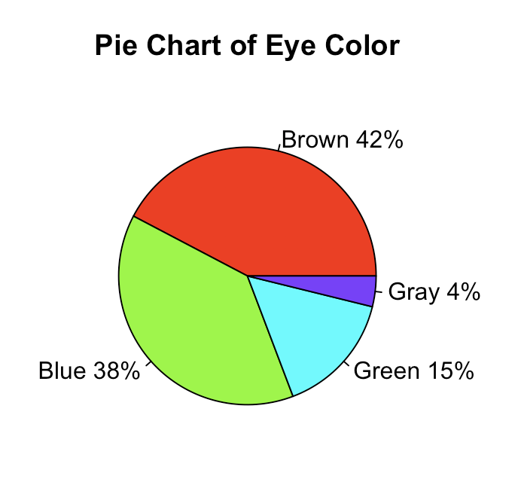

* Horizontal Bar Graph:

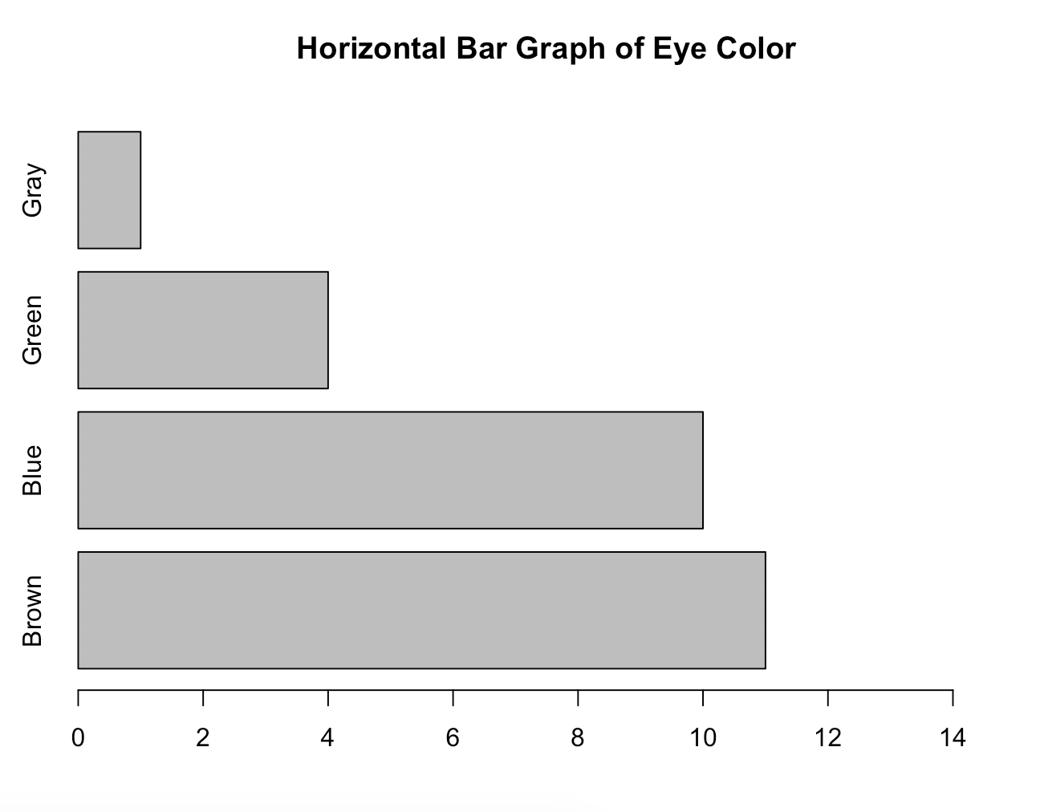

* Vertical Bar Graph:

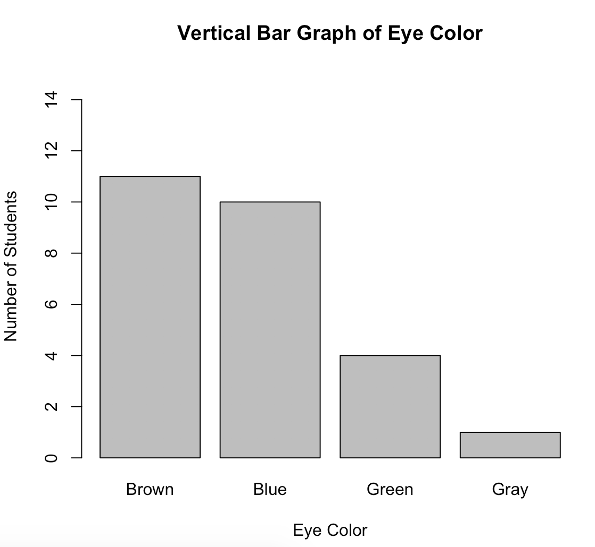

* frequency table with the relative frequency of each eye color

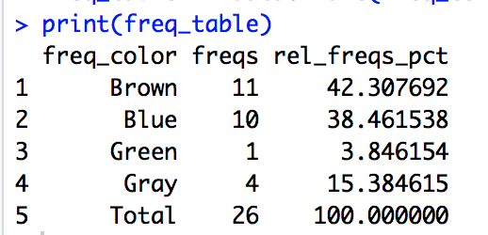

|  |
| --- |
| #STATS bootcamp HW1a, ch2, q7 - create charts color2 = c("Brown", "Blue", "Green", "Gray") numstudents = c(11, 10, 4, 1)  #PIE CHART pie(numstudents, labels = color2, main="Pie Chart of Eye Color") pct <- round(numstudents/sum(numstudents)*100) color2 <- paste(color2, pct) # add percents to labels  color2 <- paste(color2,"%",sep="") # ad % to labels  pie(numstudents, labels = color2, col=rainbow(length(color)),     main="Pie Chart of Eye Color")  #HORIZONTAL BAR GRAPH color3 = c("Brown", "Blue", "Green", "Gray") barplot(numstudents, main="Horizontal Bar Graph of Eye Color", horiz=TRUE,         names.arg=color3, xlim=c(0,15))  #VERTICAL BAR GRAPH barplot(numstudents, main="Vertical Bar Graph of Eye Color",         names.arg=color3, xlab="Eye Color", ylab="Number of Students", ylim=c(0,15))  #FREQ TABLE W REL FREQS freq_color <- c("Brown", "Blue", "Green", "Gray", "Total") freqs <- c(11,10,1,4,26) rel_freqs_pct <- c((11/26)*100, (10/26)*100, (1/26)*100, (4/26)*100, (26/26)*100) freq_table <- data.frame(freq_color,freqs,rel_freqs_pct) # A will be rows, B will be columns  print(freq_table) |

1. Which of the box plots below has a large positive skew? Which has a large negative skew? ([relevant section](http://onlinestatbook.com/2/graphing_distributions/boxplots.html) & [relevant section](http://onlinestatbook.com/2/introduction/distributions.html))   
     
   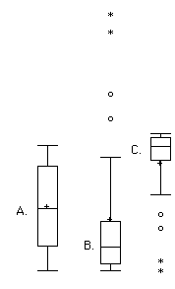
   * *Boxplot B has a large positive skew, given that a lot of its entries are greater than the mean. Box C has a large negative skew.*

**Chapter 3: Summarizing Distributions**

1. Make up a dataset of 12 numbers with a positive skew. Use a statistical program to compute the skew. Is the mean larger than the median as it usually is for distributions with a positive skew? What is the value for skew? ([relevant section](http://onlinestatbook.com/2/summarizing_distributions/shapes.html)& [relevant section](http://onlinestatbook.com/2/summarizing_distributions/comparing_measures.html))
   * *The dataset is as follows: (10, 9, 7, 5, 4, 3, 2, 1, 1, 1, 1, 1)*
   * *The skew of the dataset is 0.8284957*
   * *The mean is 3.75 and the median is 2.5. In positively skewed distributions, as depicted below, the mean is often greater than the median.*

|  |
| --- |
| install.packages("moments")  dataset <- c(10, 9, 7, 5, 4, 3, 2, 1, 1, 1, 1, 1) library(moments) skewness(dataset) library(ggplot2)  qplot(dataset, geom = 'histogram', binwidth=1) + xlab('Scores')  mean(dataset) median(dataset) |

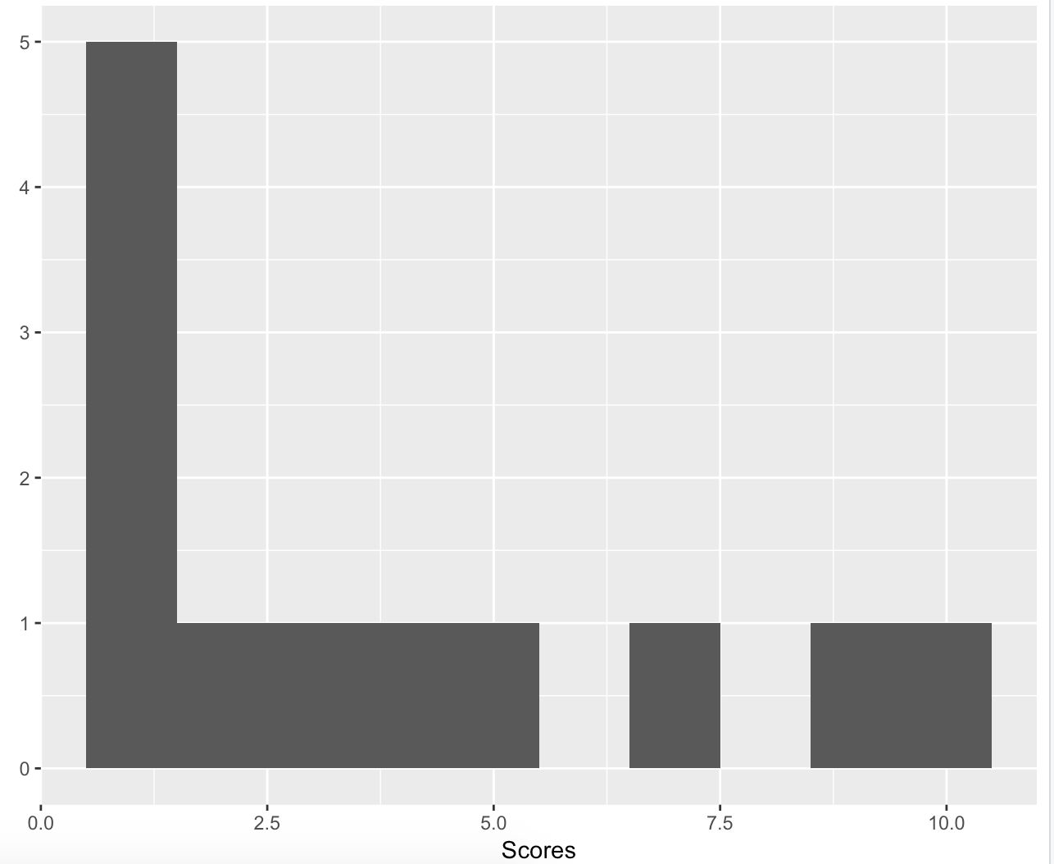

1. Make up three data sets with 5 numbers each that have:
   * (a) the same mean but different standard deviations.
     + *A dataset that would have the same mean but different standard deviations could be a normal distribution, although variably spread out. For example, these two datasets generated in r:*
       1. 3.870773 2.688776 3.630746 2.421281 4.143293 🡪 Mean = 3, SD = 1
       2. 1.7467981 0.8476760 1.7776087 0.4518279 3.5104677 🡪 Mean = 3, SD = 2

|  |
| --- |
| rnorm(5, 3, 1) rnorm(5, 3, 2) |

* + (b) the same mean but different medians.
    - *Through basic trial and error, and example of two datasets that both have a mean of 3 but have different medians (3, and 2.2 respectively) are the following:* 
      1. (1,2,3,4,5)
      2. (0,1.1,2.2,5.5,6.2)

|  |
| --- |
| d1 <- c(1,2,3,4,5) d2 <- c(0,1.1,2.2,5.5,6.2)  mean(d1) mean(d2)  median(d1) median(d2) |

* + (c) the same median but different means.  
    ([relevant section](http://onlinestatbook.com/2/summarizing_distributions/measures.html) & [relevant section](http://onlinestatbook.com/2/summarizing_distributions/variability.html))
    - *Based on brute force method, two datasets that have a median of 1 but different means (1.8 and 4.6 respectively) are the following:* 
      1. (-1,0,1,3,6)
      2. (-2, -1, 1, 5, 20)

|  |
| --- |
| d3 <- c(-1,0,1,3,6) mean(d3) median(d3)  d4 <- c(-2, -1, 1, 5, 20) mean(d4) median(d4) |

1. A sample of 30 distance scores measured in yards has a mean of 7, a variance of 16, and a standard deviation of 4.
   * (a) You want to convert all your distances from yards to feet, so you multiply each score in the sample by 3. What are the new mean, variance, and standard deviation?
     + *The new mean is 7x3 = 21 feet.*
     + *The new variance is 16x3 = 48 feet.*
     + *The new standard deviation is 4x3 = 12 feet*
   * (b) You then decide that you only want to look at the distance past a certain point. Thus, after multiplying the original scores by 3, you decide to subtract 4 feet from each of the scores. Now what are the new mean, variance, and standard deviation? ([relevant section](http://onlinestatbook.com/2/summarizing_distributions/transformations.html))
     + *Subtracting 4 from each of the scores, we get:* 
       1. Mean = 17
       2. Variance = 44
       3. Standard deviation = 8
2. For the test scores in question #6, which measures of variability (range, standard deviation, variance) would be changed if the 22.1 data point had been erroneously recorded as 21.2? ([relevant section](http://onlinestatbook.com/2/summarizing_distributions/variability.html))
   * The test scores given were the following: 15.2, 18.8, 19.3, 19.7, 20.2, 21.8, 22.1, 29.4
     + Range = 14.2
     + SD = 4.067796
     + Var = 16.54696
   * New dataset: 15.2, 18.8, 19.3, 19.7, 20.2, 21.8, **21.2**, 29.4
     + Range = 14.2
     + SD = 4.039448
     + Var = 16.31714
     + Both the SD and Variance change by a little bit. This makes sense given that the error was only 1.0 point. These measures of variability would have probably changed more if the error was much larger, and particularly if it caused that entry to exceed the range.

|  |
| --- |
| d5 <- c(15.2, 18.8, 19.3, 19.7, 20.2, 21.8, 22.1, 29.4) range(d5) 29.4 -15.2 sd(d5) ?sd ?var var(d5)  d6 <- c(15.2, 18.8, 19.3, 19.7, 20.2, 21.8, 21.2, 29.4) range(d6) 29.4-15.2 sd(d6) var(d6) |

1. For the numbers 1, 3, 4, 6, and 12:
   * Find the value (v) for which Σ(X-v)2 is minimized.
     + The mean for this dataset is 5.2, and assuming that we are working with the mean as the main measure of central tendency, below are my analyses.
       1. *This value (v) would be the point where the average squared difference from all other values is minimized****. This value would be at 6,*** *since the average squared deviation from the mean at this point would be 0.64. A back of the envelope shortcut could be looking at the mean of 5.2, since we are dealing with the smallest squared deviation from the mean.*
   * Find the value (v) for which Σ|x-v| is minimized.  
     ([relevant section](http://onlinestatbook.com/2/summarizing_distributions/mean_median_def.html))
     + ***This value would be at 6,*** *since the absolute deviation from the mean would be 0.8 at that point.*

|  |  |  |
| --- | --- | --- |
| **Value** | **Squared Deviation from Mean** | **Absolute Deviation from Mean** |
| 1 | 17.64 | 4.2 |
| 3 | 4.84 | 2.2 |
| 4 | 1.44 | 1.2 |
| **6** | 0.64 | 0.8 |
| 12 | 46.24 | 6.8 |

* + - *Where average absolute deviation from the mean is value – 5.2 ; and the squared deviation from the mean is (absolute deviation)2*

1. An experiment compared the ability of three groups of participants to remember briefly-presented chess positions. The data are shown below. The numbers represent the number of pieces correctly remembered from three chess positions. Compare the performance of each group. Consider spread as well as central tendency. ([relevant section](http://onlinestatbook.com/2/summarizing_distributions/measures.html), [relevant section](http://onlinestatbook.com/2/summarizing_distributions/additional_measures.html) & [relevant section](http://onlinestatbook.com/2/summarizing_distributions/variability.html))

|  |  |  |
| --- | --- | --- |
| Non-players | Beginners | Tournament players |
| 22.1 | 32.5 | 40.1 |
| 22.3 | 37.1 | 45.6 |
| 26.2 | 39.1 | 51.2 |
| 29.6 | 40.5 | 56.4 |
| 31.7 | 45.5 | 58.1 |
| 33.5 | 51.3 | 71.1 |
| 38.9 | 52.6 | 74.9 |
| 39.7 | 55.7 | 75.9 |
| 43.2 | 55.9 | 80.3 |
| 43.2 | 57.7 | 85.3 |

* + *Mean – For non players, the mean was 33.04 correctly identified pieces. For beginners, their mean was at 46.79. For tournament players, they had a mean of 63.89.*
  + *Median – Non players had a median of 32.6. Their median performance was at 48.4 correctly identified pieces. Tournament players had a median score of 64.6.*
  + *Mode – Non players didn’t have a single mode, since values only appeared once. Beginners also didn’t have a single mode, if factoring in the decimal points. Otherwise their mode would have been 55 if we were rounding by integers. Tournament players also didn’t have a single number as a mode, but most of the values were concentrated in 51 to 76.*
  + *Trimmed Mean – Nonplayers had a trimmed mean of 33.04, if we removed 5% from the top and bottom of the dataset. The trimmed mean of beginners was 46.79. The trimmed mean for tournament players is 63.89.*
  + *Range- Nonplayers had a range of 21.1. The range of beginners was 25.2. The range of tournament players’ scores is 45.2.*
  + *Standard Deviation- Nonplayers had a standard deviation of 8.033292. Beginners had a standard deviation of 9.030621. The standard deviation of tournament players is 15.62146.*
  + *Variance – nonplayers had a variance of 64.53378. Beginners had a variance of 81.55211. The variance of tournament players is 244.0299.*
  + Overall, in terms of central tendency, tournament players had the highest average score—with a mean of ~64, compared to beginners (~47) and non players (~33). This makes sense because tournament players probably practice the most and thus are the “most skilled” at remembering the positions the three chess pieces were placed in. In terms of spread, tournament players also had the highest standard deviation at ~16, compared to beginners at ~9 and nonplayers at ~8. This also makes sense, because tournament players probably have scores that have a higher spread than beginners or non players, who are probably playing at similar levels—compared to tournament players who possibly play at various competitive levels.

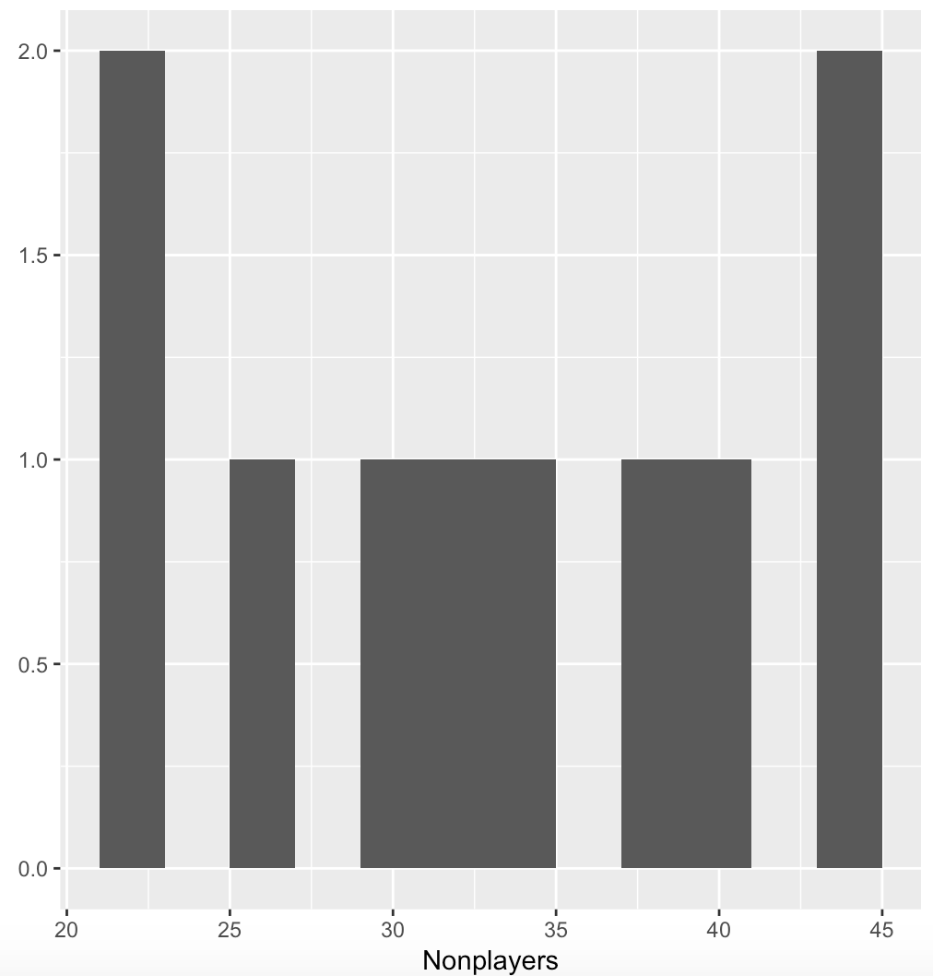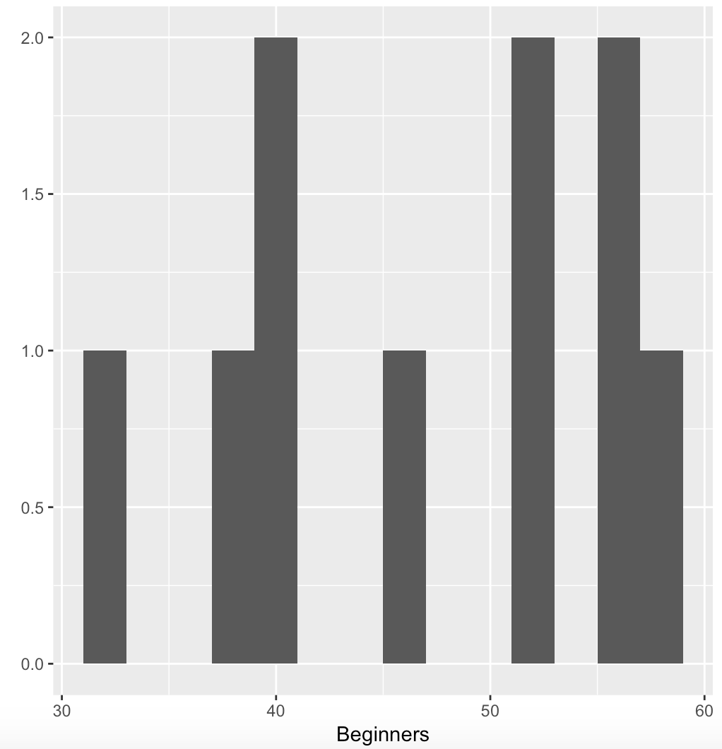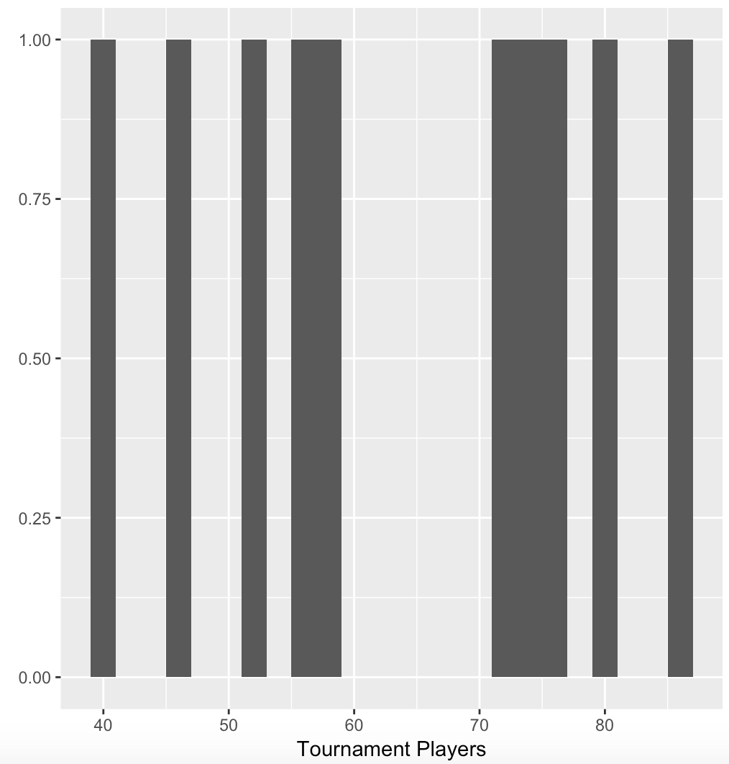

|  |
| --- |
| nonplayers <- c(22.1, 22.3, 26.2, 29.6, 31.7, 33.5, 38.9, 39.7, 43.2, 43.2) mean(nonplayers) median(nonplayers) mode(nonplayers) mean(nonplayers, trim = 0.05) range(nonplayers) 43.2-22.1 sd(nonplayers) var(nonplayers)  qplot(nonplayers, geom = 'histogram', binwidth=2) + xlab('Nonplayers')  beginners <- c(32.5, 37.1, 39.1, 40.5, 45.5, 51.3, 52.6, 55.7, 55.9, 57.7) mean(beginners) median(beginners) mode(beginners) mean(beginners, trim = 0.05) range(beginners) 57.7-32.5 sd(beginners) var(beginners)  qplot(beginners, geom = 'histogram', binwidth=2) + xlab('Beginners')  tournament <- c(40.1, 45.6, 51.2, 56.4, 58.1, 71.1, 74.9, 75.9, 80.3, 85.3) mean(tournament) median(tournament) mode(tournament) mean(tournament, trim = 0.05) range(tournament) 85.3-40.1 sd(tournament) var(tournament) qplot(tournament, geom = 'histogram', binwidth=2) + xlab('Tournament Players') |

1. True/False: The best way to describe a skewed distribution is to report the mean. ([relevant section](http://onlinestatbook.com/2/summarizing_distributions/comparing_measures.html))
   * *False, the best way to describe a skewed distribution (if it is not bimodal) is through the median. A good example is household income, where US Statistics report median household income rather than mean household income. However, if you are looking at a highly skewed distribution, multiple statistics should be reported, since the median alone does not summarize the skewed distribution well, and since the mean summarizes central tendency in terms of the balance scale analysis.*
2. Compare the mean, median, trimean in terms of their sensitivity to extreme scores ([relevant section](http://onlinestatbook.com/2/summarizing_distributions/comparing_measures.html)).
   * *In general, the mean is highly sensitive to extreme scores, particularly compared to the median which is less sensitive to extreme scores. These scores include outliers which can create heavily skewed distributions. In terms of moderately skewed scores, the trimean and trimmed mean often fall between the median and mean, and are often less sensitive to extreme scores than the mean. However, it is important to note that the relationship of these measures of central tendency are highly dependent on the skew of the particular dataset.*
3. A set of numbers is transformed by taking the log base 10 of each number. The mean of the transformed data is 1.65. What is the geometric mean of the untransformed data? ([relevant section](http://onlinestatbook.com/2/summarizing_distributions/additional_measures.html))
   * *The geometric mean is taken by multiplying all the numbers in the dataset then taking the nth root of the product. The antilog of the arithmetic mean can also be used to find the geometric mean. In this case, the antilog of 1.65 is 101.65, or 44.66836.*
4. The histogram is in balance on the fulcrum. What are the mean, median, and mode of the distribution (approximate where necessary)?  
     
   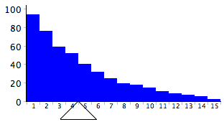
   * *The mean is approximately 4.5, given that that is the point where the fulcrum balances the histogram.*
   * *The mode is in the bin whose average is 1, since it has the most number of entries.*
   * *Since this is a positively skewed distribution, the median is usually less than the mean. It should approximately lay in the bin whose average is 3.*

**Chapter 4: Describing Bivariate Data**

1. Describe the relationship between variables A and C. Think of things these variables could represent in real life. ([relevant section](http://onlinestatbook.com/2/describing_bivariate_data/intro.html))

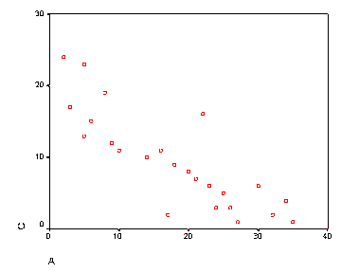

* + *The variables A and C seem to have a negative linear relationship. This means that as A increases, C decreases. One well-known example in economics is the relationship between price and quantity, as described in the demand curve. Assuming that all other factors remain equal, and that consumers behave logically, the higher the price of a good, the less people will demand that good. In other words, the higher the price, the lower the quantity demanded. An image of the demand curve that roughly follows the relationship between A and C is seen below:*
  + 
  + *Another example could be related to snowfall and the number of people driving outside. If snowfall were on the X-axis and the number of people driving outside were on the Y-axis, we can see that as snowfall increases, the number of people who drive outside decrease. This makes sense because it is generally more unsafe to drive outside when there is a lot of snow.*

1. Make up a data set with 10 numbers that has a negative correlation. ([relevant section](http://onlinestatbook.com/2/describing_bivariate_data/pearson.html) & [relevant section](http://onlinestatbook.com/2/describing_bivariate_data/calculation.html))
   * This dataset can be found below, with weekly gym hours and body fat %. I have also added a scatter plot to visualize the relationship.

|  |
| --- |
| ### # Simple Scatterplot weekGymHours = c(40, 36, 35, 34, 28, 20, 25, 15, 10, 5) BodyFat = c(16, 16.5, 16.5, 17, 19, 22, 20, 24, 26, 30)  cor(weekGymHours, BodyFat, method = c("pearson") )  plot(weekGymHours, BodyFat, main="Percent of Body Fat by Number of Hours at the Gym",       xlab="Weekly Gym Hours", ylab="Body Fat %", pch=19) |

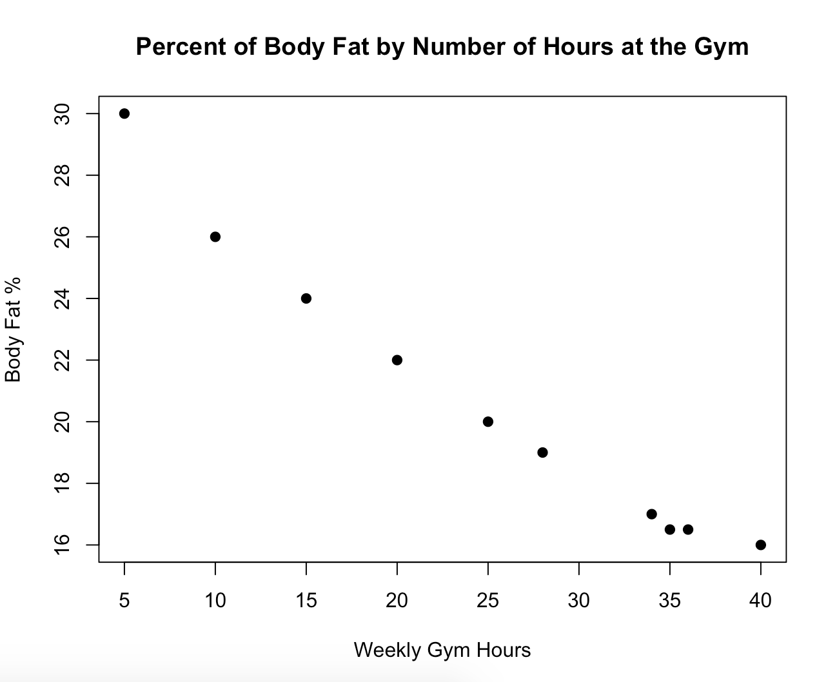

1. Would you expect the correlation between High School GPA and College GPA to be higher when taken from your entire high school class or when taken from only the top 20 students? Why? ([relevant section](http://onlinestatbook.com/2/describing_bivariate_data/restriction_demo.html))
   * *I would expect the correlation between high school GPA and college GPA to be lower when taken from only the top 20 students. The range of GPAs will be restricted when only the upper portion of students are considered, even though individually they may be more likely to attain a higher college GPA.*
2. For this same class, the relationship between the amount of time spent studying and the amount of time spent socializing per week was also examined. It was determined that the more hours they spent studying, the fewer hours they spent socializing. Is this a positive or negative association? ([relevant section](http://onlinestatbook.com/2/describing_bivariate_data/intro.html))
   * *This is a negative correlation, because as the number of hours they socialize increases, the number of hours they study decreases. (This is assuming that these variables are independent, and they’re not socializing simultaneously as studying.)*
3. Students took two parts of a test, each worth 50 points. Part A has a variance of 25, and Part B has a variance of 36. The correlation between the test scores is 0.8.
   * (a) If the teacher adds the grades of the two parts together to form a final test grade, what would the variance of the final test grades be?
     1. *Using the Variance Sum Law II, since we are now dealing with correlated scores, we get a variance of* ***109****. We add the variances to the correlation since we ant to get the variance of the entire final test.*

|  |
| --- |
| ## Variance sum Law II  VARtestA = 25 VARtestB = 36 CORRAB = 0.8 VARSUM = VARtestA + VARtestB + ((2 * CORRAB) * sqrt(VARtestA) * sqrt(VARtestB)) |

* + (b) What would the variance of Part A - Part B be? ([relevant section](http://onlinestatbook.com/2/describing_bivariate_data/variance_sum_law2.html))
    1. *The variance of part a to part b would be computed using the variance sum law II, between to correlated variables. The variance would be* ***13****. Since we want to get Part A – Part B, we subtract the correlation from the variance to get the answer.*

|  |
| --- |
| ## VARIANCE SUM LAW II VARtestA = 25 VARtestB = 36 CORRAB = 0.8 VARSUM = VARtestA + VARtestB - ((2 * CORRAB) * sqrt(VARtestA) * sqrt(VARtestB)) |

1. True/False: It is possible for variables to have r=0 but still have a strong association. ([relevant section](http://onlinestatbook.com/2/describing_bivariate_data/intro.html) & [relevant section](http://onlinestatbook.com/2/describing_bivariate_data/pearson.html))
   * *True—variables an have a strong association but have an r=0. This occurs when the relationship between X and Y is non-linear. (eg parabolic etc)*
2. True/False: After polling a certain group of people, researchers found a 0.5 correlation between the number of car accidents per year and the driver's age. This means that older people get in more accidents. ([relevant section](http://onlinestatbook.com/2/describing_bivariate_data/pearson.html))
   * *False. Correlation is not equivalent to causation. A (somewhat weakly) positive correlation between two variables is not enough to conclude that one causes the other. There could be a number of reasons why this is inaccurate, one of them being that another external variable Z could influence the outcome of the correlation between X and Y—thus being the actual cause of the effect.*
3. True/False: To examine bivariate data graphically, the best choice is two side by side histograms. ([relevant section](http://onlinestatbook.com/2/describing_bivariate_data/intro.html))
   * *False. Often it is more useful to plot bivariate data in a scatter plot, because this type of visualization allows us to examine the relationship between these two variables more clearly.*