**INTRODUCTION TO STATISTICAL CONCEPTS**

**ASSIGNMENT 2B**

**Chapter 5: Probability**

11) **You win a game if you roll a die and get a 2 or a 5. You play this game 60 times.**

**a. What is the probability that you win between 5 and 10 times (inclusive)?**

*Using R, we get: 0.0031*



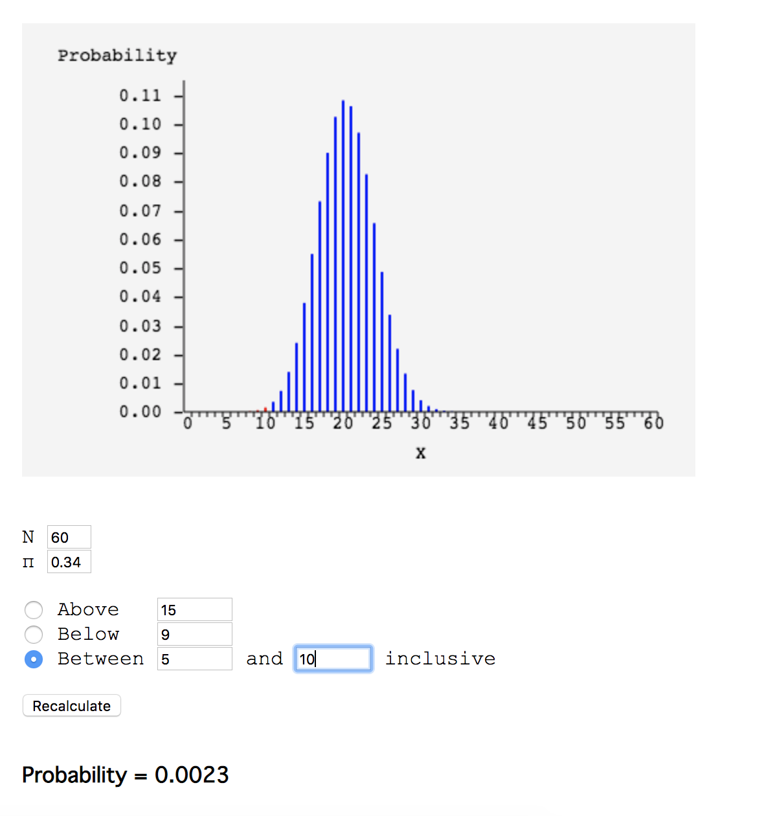

Using the online statistics calculator provided by the textbook, we get 0.0023.

b. **What is the probability that you will win the game at least 15 times?**

or using R.

*Using R, we get 0.937.*

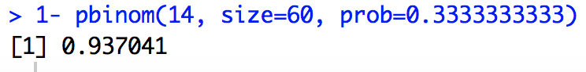

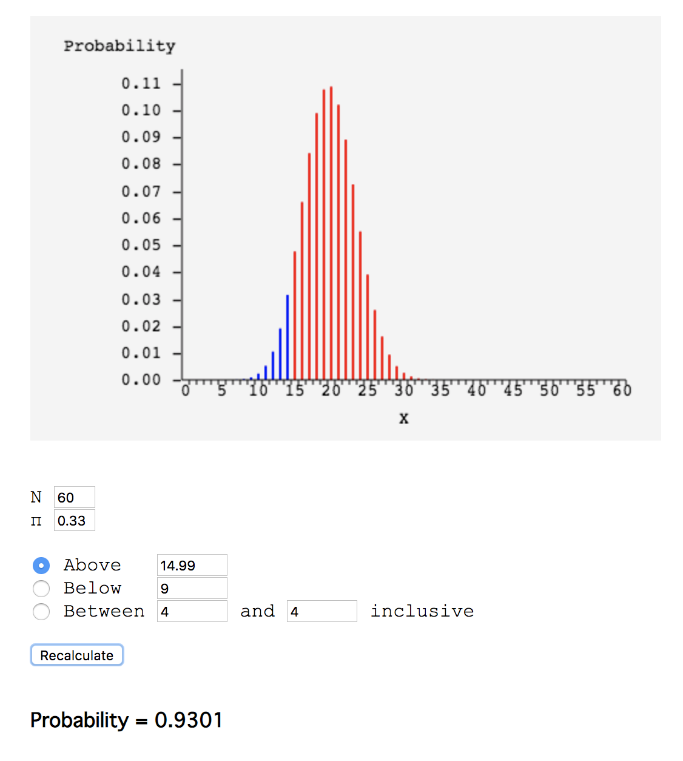

Note that there are some differences between the results in R and using the online calculator, since the online calculator rounds up values.

c. **What is the probability that you will win the game at least 40 times?**

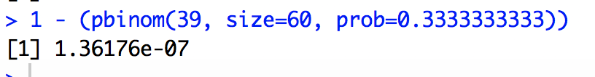

Although we can see below that the values of the distribution don’t extend as far as 40, so we can round this value to 0.

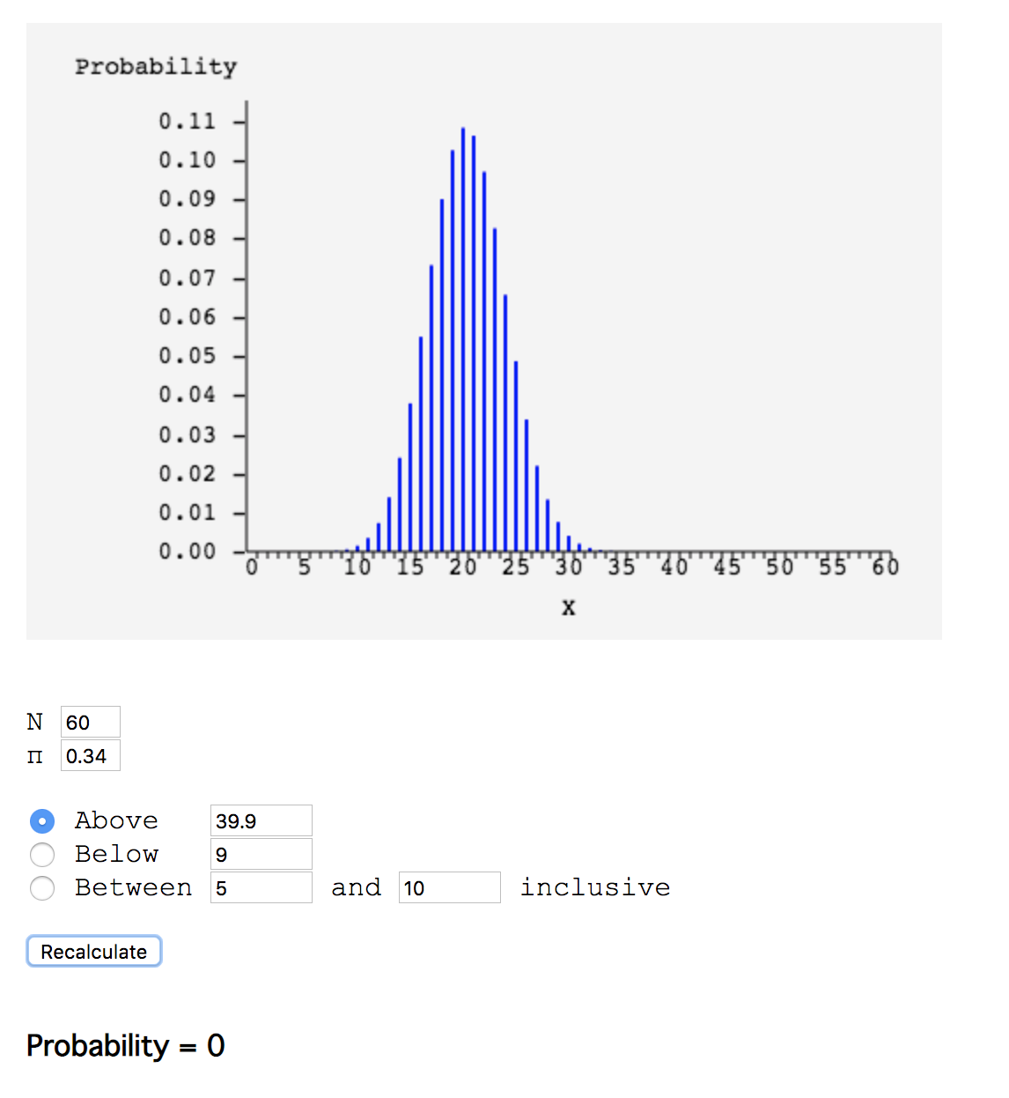

d**. What is the most likely number of wins?**

The most likely number of wins occurs at 20 wins.

We could also just the formula n times p to get 20. Similarly, we could also reach this x by getting the maximum of P(x) with respect to x using derivatives.

Or we could also use:

To get:

**e. What is the probability of obtaining the number of wins in d?   
(**[**relevant section**](http://onlinestatbook.com/2/probability/binomial.html)**)**

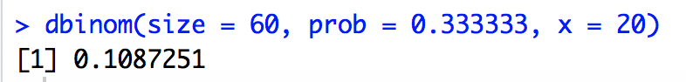

*We find that the probability is 0.108.*

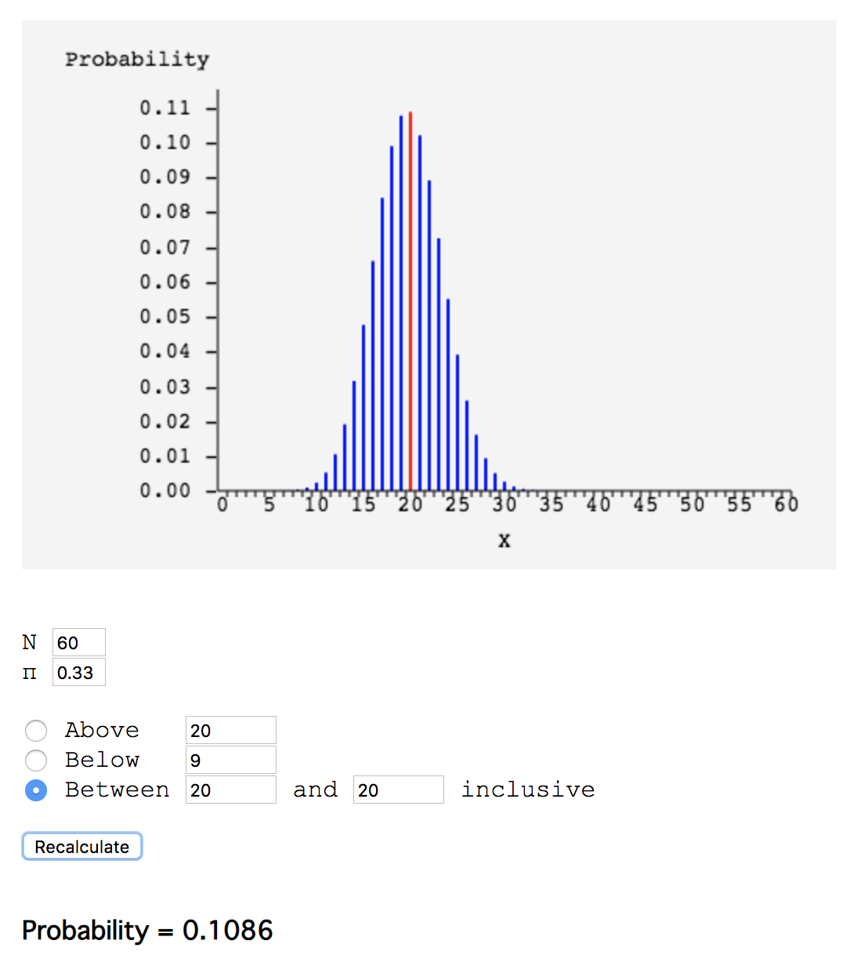

**13) An unfair coin has a probability of coming up heads of 0.65. The coin is flipped 50 times. What is the probability it will come up heads 25 or fewer times? (Give answer to at least 3 decimal places). (**[**relevant section**](http://onlinestatbook.com/2/probability/binomial.html)**)**

Using R, we get 0.021.

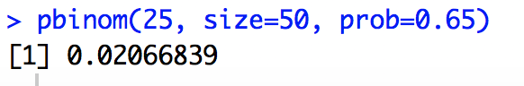

**15) True/False: You are more likely to get a pattern of HTHHHTHTTH than HHHHHHHHTT when you flip a coin 10 times. (**[**relevant section**](http://onlinestatbook.com/2/probability/basic.html)**)**

False, the probability of getting those two patterns is the same—each coin flip is an independent event, and thus does not impact the result of prior or future coin flips.

**Chapter 7: Normal Distribution**

**12) Use the normal distribution to approximate the binomial distribution and find the probability of getting 15 to 18 heads out of 25 flips. Compare this to what you get when you calculate the probability using the binomial distribution. Write your answers out to four decimal places. (**[**relevant section**](http://onlinestatbook.com/2/normal_distribution/normal_approx.html)**&**[**relevant section**](http://onlinestatbook.com/2/normal_distribution/normal_approx_demo.html)**)**

The probability of getting 15 to 18 heads using a normal distribution isn’t too different from the result when using a binomial distribution. They can both be rounded up to 0.20, although using a binomial distribution garners a result about 0.001 higher than that of the normal distribution, as seen below

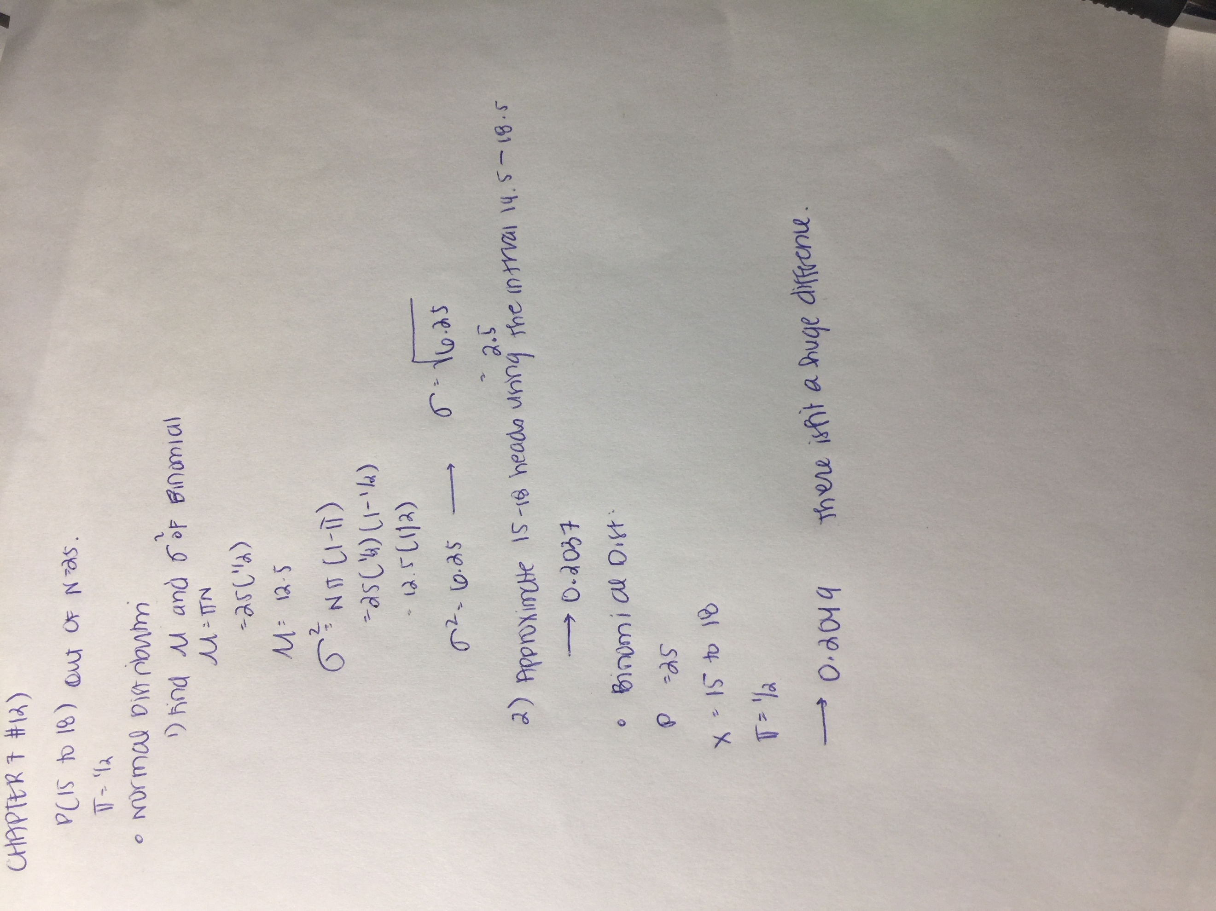

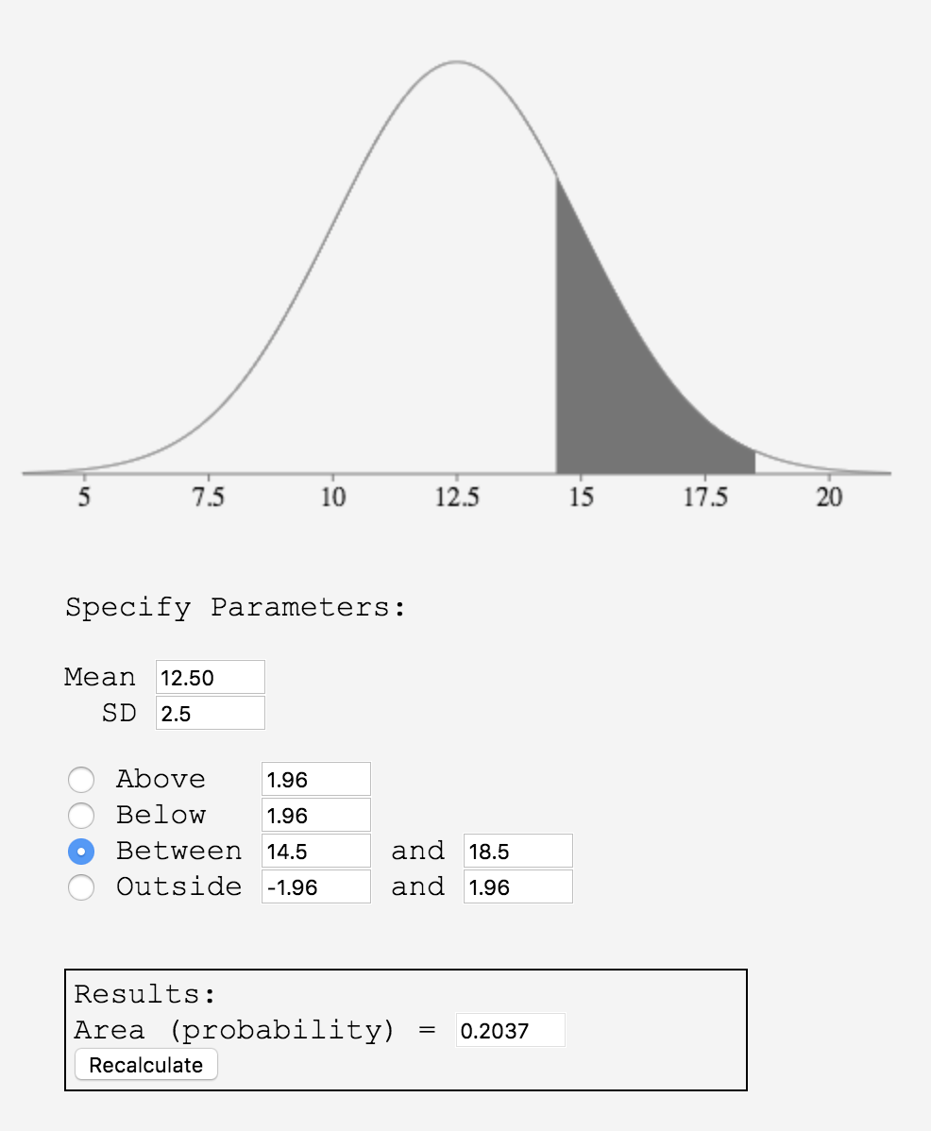 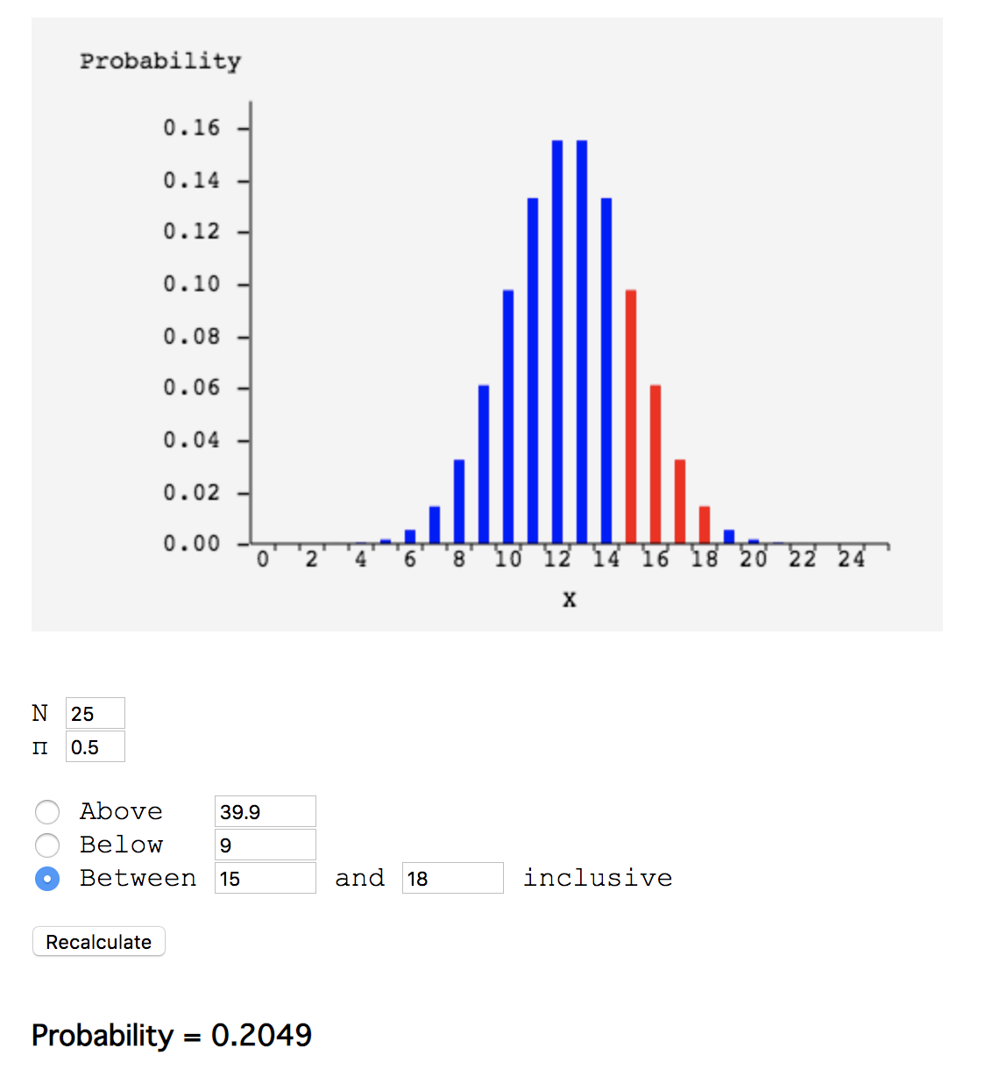

**14) True/false: In a normal distribution, 11.5% of scores are greater than Z = 1.2. (**[**relevant section**](http://onlinestatbook.com/2/normal_distribution/standard_normal.html)**)**

True, as seen using the online calculator provided by the book below:

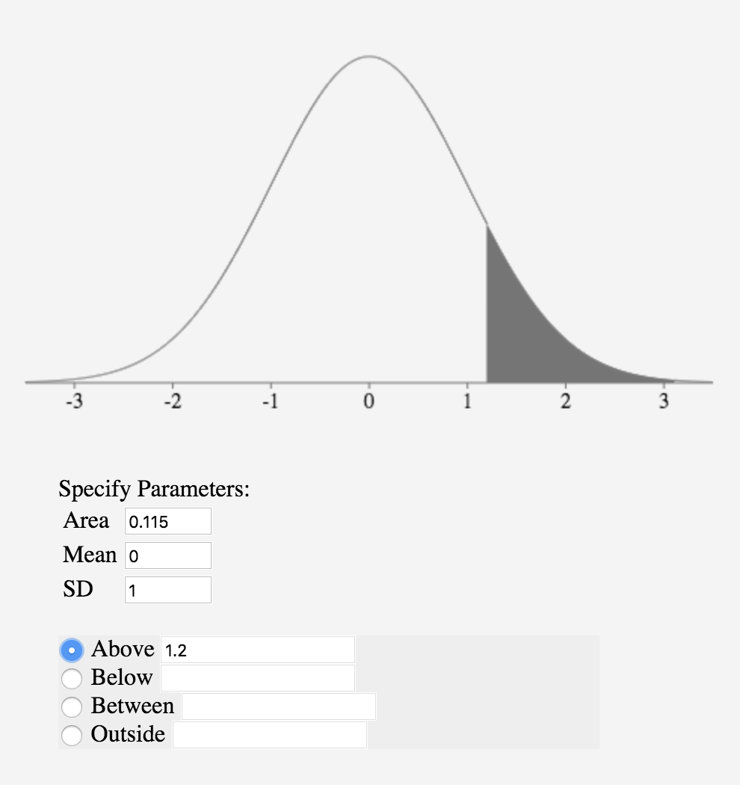

**16) True/false: The larger the π, the better the normal distribution approximates the binomial distribution. (**[**relevant section**](http://onlinestatbook.com/2/normal_distribution/normal_approx.html)**&**[**relevant section**](http://onlinestatbook.com/2/normal_distribution/normal_approx_demo.html)**)**

False, since this approximation is more accurate when pi = 0.05, which makes the binomial more symmetric like the normal distribution. Moreover, it’s the larger the N the better the normal distribution approximates the binomial distribution.

**18) True/false: Abraham de Moivre, a consultant to gamblers, discovered the normal distribution when trying to approximate the binomial distribution to make his computations easier. (**[**relevant section**](http://onlinestatbook.com/2/normal_distribution/history_normal.html)**)**

True, de Moivre “reasoned that if he could find a mathematical expression for this curve, he would be able to solve problems such as finding the probability of 60 or more heads out of 100 coin flips much more easily. This is exactly what he did, and the curve he discovered is now called the normal curve.”

**20) True/false: In the figure below, the red distribution has a larger standard deviation than the blue distribution. (**[**relevant section**](http://onlinestatbook.com/2/normal_distribution/varieties_demo.html)**)**



True, the red curve has a larger standard distribution because it is more widely spread out than the blue distribution. A similar image can be seen outlined below: Evidently, the standard deviation of the red curve is larger than the standard deviation of the blue curve, despite having the same mean.



**22) The following question uses data from the Angry Moods (AM) case study. For this problem, use the Anger Expression (AE) scores.**

**(a) Compute the mean and standard deviation.**   
The mean is 37. The standard deviation is 12.94143.

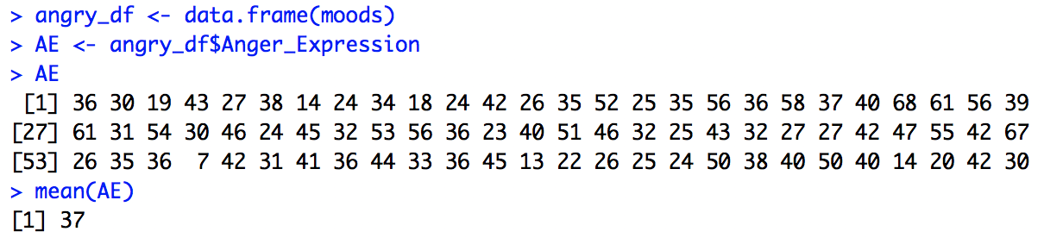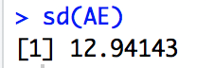

(**b) Then, compute what the 25th, 50th and 75th percentiles would be if the distribution were normal.**

The 25th percentile is 28.27, the 50th percentile is 37, and the 75th percentile is 45.72.

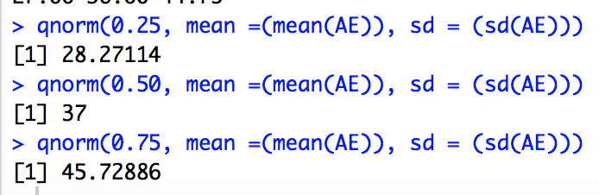

**(c) Compare the estimates to the actual 25th, 50th, and 75th percentiles. (**[**relevant section**](http://onlinestatbook.com/2/normal_distribution/areas_normal.html)**)**

The 25th percentile is 26.75, the 50th is 36, the 75th is 45. ›

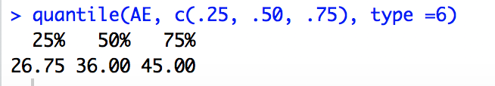

**Chapter 9: Sampling Distributions**

**The following questions use data from the**[**Angry Moods**](http://onlinestatbook.com/2/case_studies/angry_moods.html)**(AM) case study.**

**23) (a) How many men were sampled? (b) How many women were sampled?**

There were 30 men who were sampled, and 48 women.

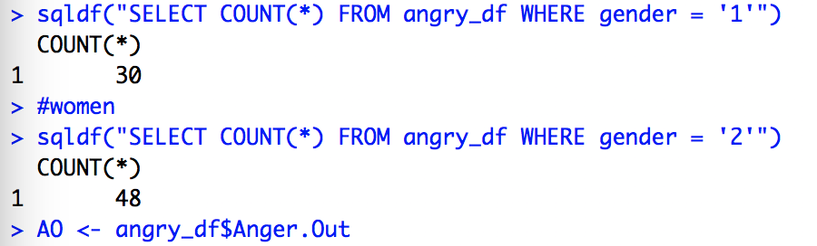

**24) What is the mean difference between men and women on the Anger-Out scores?**

The difference between men and women anger out scores is 0.795833.

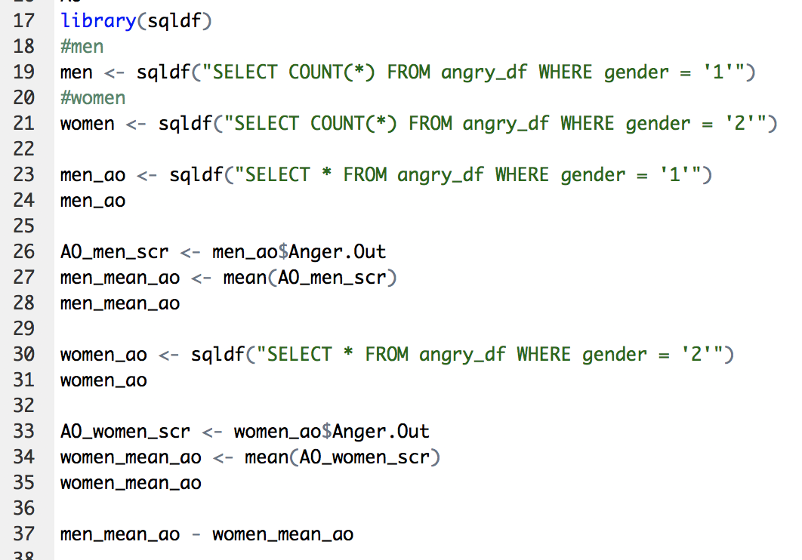

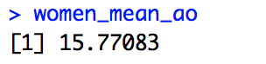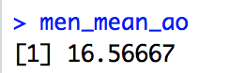

**25) Suppose in the population, the Anger-Out score for men is two points higher than it is for women. The population variances for men and women are both 20. Assume the Anger-Out scores for both genders are normally distributed. Given this information about the population parameters:**

**(a) What is the mean of the sampling distribution of the difference between means? (**[**relevant section**](http://onlinestatbook.com/2/sampling_distributions/samplingdist_diff_means.html)**)**

The mean is 2. In a population, to compute the mean of the sampling distribution of the difference between means, we can use the formula below:

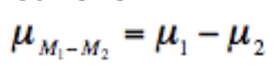

Since we know that , we can then see that

**(b) What is the standard error of the difference between means? (**[**relevant section**](http://onlinestatbook.com/2/sampling_distributions/samplingdist_diff_means.html)**)**

The standard error would be 1.040832999.

To find the standard error of the difference between means, we can use the following formula:

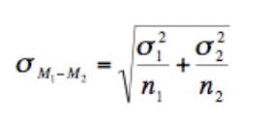

We then get = 1.04083

On R, this looks like



(**c) What is the probability that you would have gotten this mean difference (see #24) or less in your sample? (**[**relevant section**](http://onlinestatbook.com/2/sampling_distributions/samplingdist_diff_means.html)**)**

The probability is 12.3%. This probability of getting the mean difference of 0.795833 can be computed through R using the following code:

