**INTRODUCTION TO STATISTICAL CONCEPTS**

**ASSIGNMENT 3A**

**Chapter 10: Estimation**

**Question 1:**

**When would the mean grade in a class on a final exam be considered a statistic? When would it be considered a parameter? (**[**relevant section)**](http://onlinestatbook.com/2/estimation/intro.html)The mean grade in a class would be considered a statistic when it is used to describe a sample. On the other hand, the mean grade would be considered a parameter when it is used to describe an entire population.

**Question 5: When you construct a 95% confidence interval, what are you 95% confident about? (**[**relevant section)**](http://onlinestatbook.com/2/estimation/confidence.html)

Constructing a 95% confidence interval means that we are 95% sure that the sample will contain the metric we care about. If repeated samples are taken and the 95% confidence interval was computed for each sample, 95% of the intervals would contain the population mean.

**Question 10: The effectiveness of a blood-pressure drug is being investigated. How might an experimenter demonstrate that, on average, the reduction in systolic blood pressure is 20 or more? (**[**relevant section**](http://onlinestatbook.com/2/estimation/mean.html)**&**[**relevant section)**](http://onlinestatbook.com/2/estimation/difference_means.html)

To demonstrate that the reduction in blood pressure is 20 units or more, the investigator can compute the confidence interval between means. For larger populations (usually around n>30), they can use the technique of finding the value of a given Z-score using the standard normal distribution table. For smaller samples (n <30) that have a normally distributed population, they can use the t distribution to obtain confidence levels. Assuming that we have a larger sample size, we can use the standard distribution to estimate the confidence intervals and find the confidence limits:

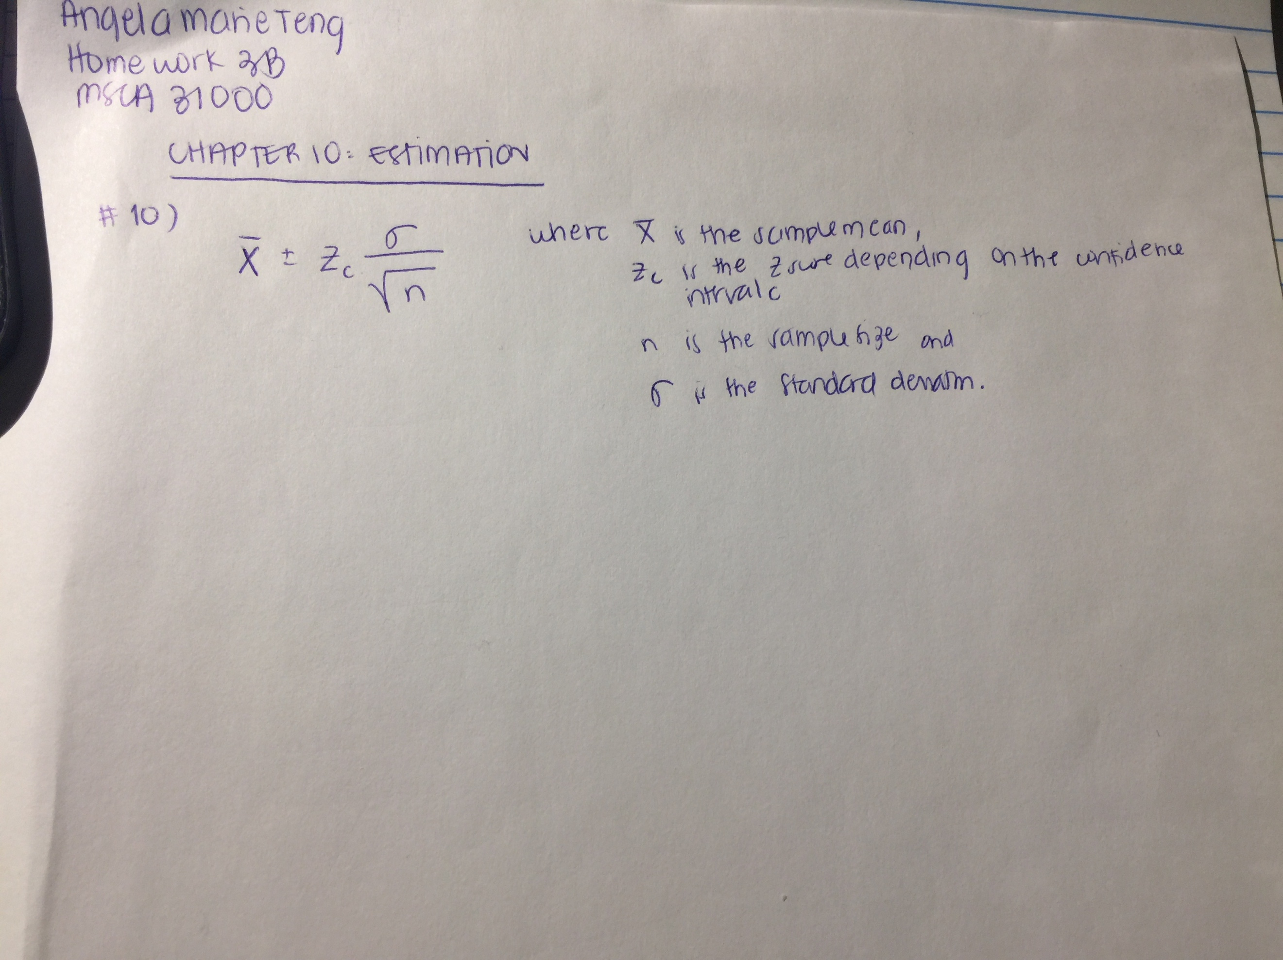

**Question 15: You take a sample of 22 from a population of test scores, and the mean of your sample is 60.**

1. **You know the standard deviation of the population is 10. What is the 99% confidence interval on the population mean.**

The confidence interval is (54.41, 65.48)

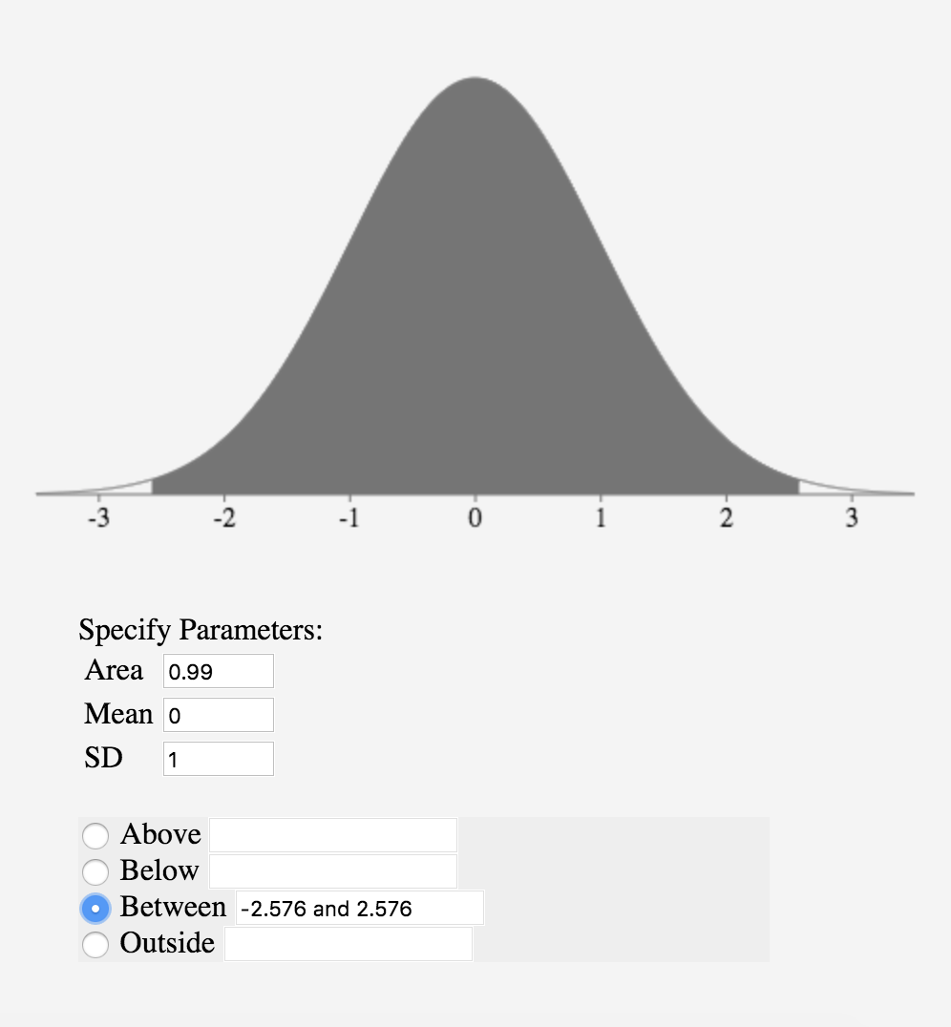

First find the

Then find the standard deviation of the mean =

**(b) Now assume that you do not know the population standard deviation, but the standard deviation in your sample is 10. What is the 99% confidence interval on the mean now? (**[**relevant section)**](http://onlinestatbook.com/2/estimation/mean.html)

The confidence interval is (53.96, 66.03)

Since we don’t know the population standard deviation, we’ll have to use an estimator, as well as the t distribution (even though our sample size is relatively small at 22 < 100)

First find the

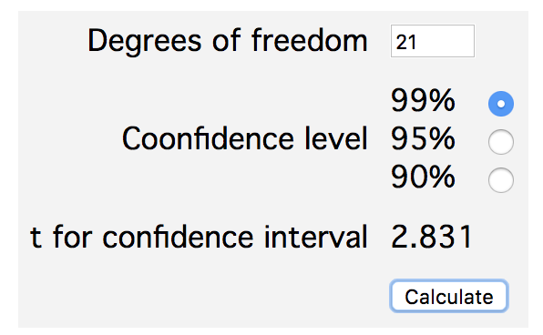

**Question 20: True/false: You have a sample of 9 men and a sample of 8 women. The degrees of freedom for the t value in your confidence interval on the difference between means is 16. (**[**relevant section**](http://onlinestatbook.com/2/estimation/df.html)**&**[**relevant section)**](http://onlinestatbook.com/2/estimation/difference_means.html)

False, since the formula for degrees of freedom is written below, and thus the total number of degrees of freedom would be 15. In particular, the degrees of freedom are the number of independent estimates of variance on which MSE is based. This is equal to where n1 is the sample size of the first group and n2 is the sample size of the second group.

**Chapter 11: Logic of Hypothesis Testing**

**Question 4: State the null hypothesis for:**

1. **An experiment testing whether echinacea decreases the length of colds.**

The null hypothesis always states that the population parameter is equal to the claimed value, so:

H0 = echinacea does not decrease the length of colds; has no effect or increases the length of colds. In other notation, we could write this as:

1. **A correlational study on the relationship between brain size and intelligence.**

H0 = there is no correlation between brain size and intelligence

1. **An investigation of whether a self-proclaimed psychic can predict the outcome of a coin flip.**

H0 = the psychic cannot predict the outcome of a coin flip

**(d) A study comparing a drug with a placebo on the amount of pain relief. (A one-tailed test was used.)**

**(relevant section & relevant section)**

H0 = the effect of the drug will be less than or equal to the effect of the placebo on the amount of pain relief; in other words, the drug is not an effective means of reducing pain. Or possible pain relief = or > drug.

**Question 8: A significance test is performed and p = .20. Why can't the experimenter claim that the probability that the null hypothesis is true is .20? (**[**relevant section**](http://onlinestatbook.com/2/logic_of_hypothesis_testing/intro.html)**,**[**relevant section**](http://onlinestatbook.com/2/logic_of_hypothesis_testing/nonsignificant.html)**&**[**relevant section**](http://onlinestatbook.com/2/logic_of_hypothesis_testing/misconceptions.html)**)**

The experimenter cannot claim that the probability that the null hypothesis is true = 0.20 because the p-values only allow statisticians to reject or fail to reject H0. We cannot accept the claim that the probability of the null being true = 0.2 simply because we have failed to reject that it is false. Like legal trials, the jury can either conclude that someone is guilty or not guilty—but they never conclude innocence. The same can be said for hypothesis testing.

**Question 14: Why is "Ho: "M1 = M2" not a proper null hypothesis? (**[**relevant section**](http://onlinestatbook.com/2/logic_of_hypothesis_testing/intro.html)**)**Although a null hypothesis is sometimes written this way, the null H0 is typically equated to 0, since the direction of the sample mean determines which alternative is adopted. Also, because we should use the proper notation of Greek letters like miu when referring to the population. This null hypothesis is in sample statistics. A null hypothesis should be in population parameters.

**Question 18: You choose an alpha level of .01 and then analyze your data.**

1. **What is the probability that you will make a Type I error given that the null hypothesis is true?**

The probability of making a Type I error is directly affected by the alpha level. The lower the alpha level, the lower the Type 1 error rate. So, the alpha of 0.01 is the probability of a Type 1 error given that the null hypothesis is true—however if it is false, then it’s impossible to make a type I error. Thus, the probability of a Type 1 error, which occurs when a significance test results in the rejection of a true null hypothesis, is 0.01.

1. **What is the probability that you will make a Type I error given that the null hypothesis is false? (**[**relevant section**](http://onlinestatbook.com/2/logic_of_hypothesis_testing/errors.html)**)**

If the null hypothesis is false, then the probability is 0, since a Type 1 can only occur if the null is true.

**Chapter 12: Tests of Means**

**Question 8: Participants threw darts at a target. In one condition, they used their preferred hand; in the other condition, they used their other hand. All subjects performed in both conditions (the order of conditions was counterbalanced). Their scores are shown below.**

|  |  |
| --- | --- |
| Preferred | Non-preferred |
| 12 | 7 |
| 7 | 9 |
| 11 | 8 |
| 13 | 10 |
| 10 | 9 |

1. **Which kind of t-test should be used?**The type of t-test that should be used should be the correlated t-test. Because the same participants are used here, and we don’t have independent groups, we know that they are not independent, since the same person is throwing with their preferred and non-preferred hand. These two outcomes may not be independent, even if the conditions were counterbalanced—so it will be beneficial to use the correlated t-test or the related-pairs t-test. The data is currently organized in pairs, but the variable that is very interesting is the difference in preferred and non-preferred scores.
2. **Calculate the two-tailed t and p values using this t test.**

The t-value is 1.69, and the p-value is 0.166. We can compute this through the following:

Identify the sample statistic for the Preferred and Non-Preferred group. Using R, this looks like:

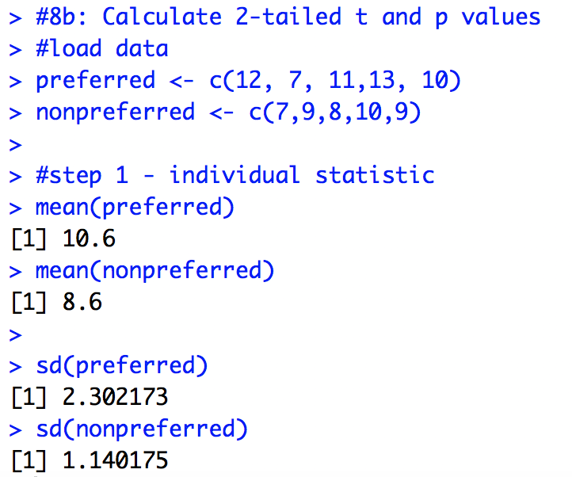

Then we want to find the difference between both means:

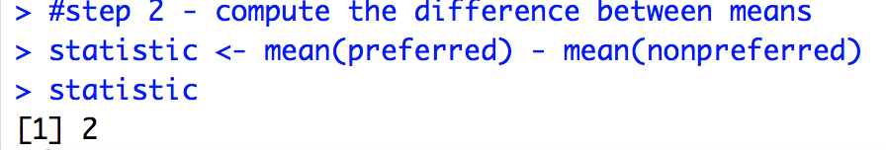

Since the two groups / variables are not independent, find the correlation:

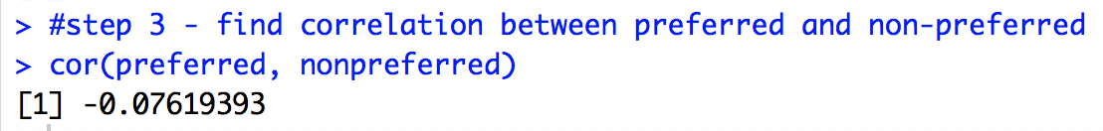

Next, find the standard error using the below formula

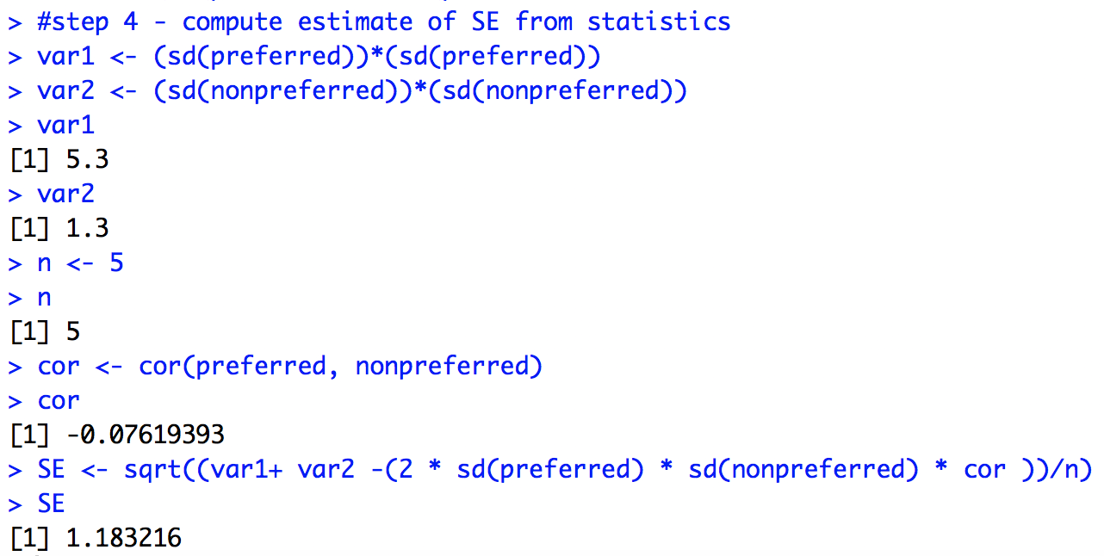

To get the t-statistic and p-value, we need the degrees of freedom:

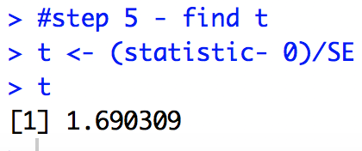

Next we want to find the corresponding p-value to the 2-tailed t-test with a t = 1.6

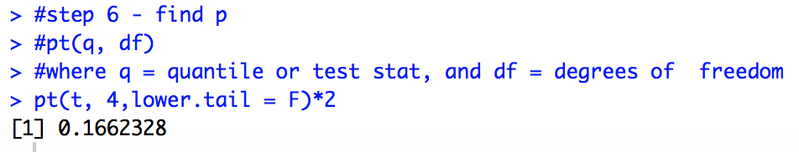

From here, we can tell that the p-value of 0.12 < 0.16 significance level, thus we can reject the null hypothesis.

1. **Calculate the one-tailed t and p values using this t test.**Using the same value of t = 1.69, we can calculate the p-value for a one tailed test to be 0.083:

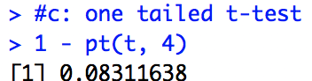

**Question 9: Assume the data in the previous problem were collected using two different groups of subjects: One group used their preferred hand and the other group used their non-preferred hand. Analyze the data and compare the results to those for the previous problem (**[**relevant section**](http://onlinestatbook.com/2/tests_of_means/difference_means.html)**)**

First, we compute the statistic, which is the difference between means. It will be the same as above:



Since our hypothesized value is less than or equal to 0, we do not need to subtract it from the statistic. Next, we will compute the estimate of the SE of the statistic.

We want to use this formula, but need to estimate the variance of each group by averaging the variances of the two samples.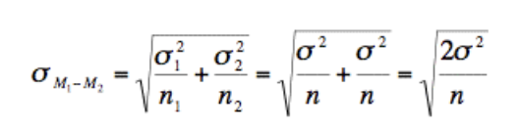

So, our estimate for variance will be computed by the mean squared error:

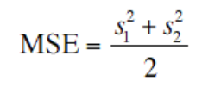

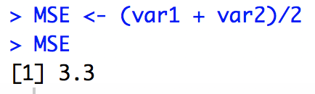

We know that n = 5, so using the formula below, we get:

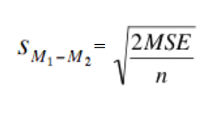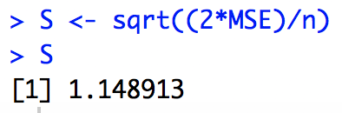

Finally, we want to compute the value of t using the below formula:

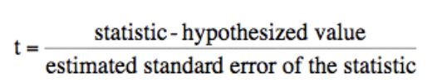

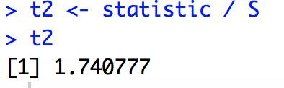

We then compute the degrees of freedom and get 8.

Now, since we have the degrees of freedom we want to compute the p value using this t-statistic. Using a one tailed test, we know that:

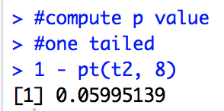

and using a 2-tailed test:

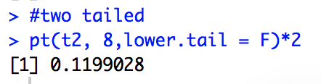

Thus, the results are very similar to those in #9. For the 1-tailed test, there’s a 0.03 difference with the independent groups of subjects having a higher significance. For the 2-tailed test, there’s a 0.05 difference with the two independent groups having a higher p-value.

**Question 11: In an experiment, participants were divided into 4 groups. There were 20 participants in each group, so the degrees of freedom (error) for this study was 80 - 4 = 76. Tukey's HSD test was performed on the data.**

1. **Calculate the p value for each pair based on the Q value given below. You will want to use the**[**Studentized Range Calculator**](http://onlinestatbook.com/2/calculators/studentized_range_dist.html)**.**

|  |  |  |
| --- | --- | --- |
| Comparison of Groups | Q | p-value |
| A - B | 3.4 | 0.0849 |
| A - C | 3.8 | 0.043 |
| A - D | 4.3 | 0.0167 |
| B - C | 1.7 | 0.6274 |
| B - D | 3.9 | 0.0359 |
| C - D | 3.7 | 0.0513 |

**(b) Which differences are significant at the .05 level? (**[**relevant section**](http://onlinestatbook.com/2/tests_of_means/pairwise.html)

|  |  |
| --- | --- |
| Comparison of Groups | Q |
| A - B | 3.4 |
| A - C | 3.8 |
| A - D | 4.3 |
| B - C | 1.7 |
| B - D | 3.9 |
| C - D | 3.7 |

The differences that are significant at the 0.05 level are the comparison of groups: A-C, A-D, and B-D.

**Chapter 13: Power**

**Question 1: Define power in your own words**

Power is the probability of correctly rejecting a false null hypothesis. It is defined as the value of 1 – Beta. In other words, power indicates the probability of *not* making a type II error—or the error of the researcher accepting an incorrect null hypothesis.

**Question 2: List 3 measures one can take to increase the power of an experiment. Explain why your measures result in greater power.**

Three things a researcher can do that can increase the power of an experiment are: increasing the sample size, decreasing the standard deviation, and increasing the significance level. Power is higher when the sample size is larger—because N is usually controlled by the experimenter, increasing this is one way to increase power. This is further outlined by the chart below:

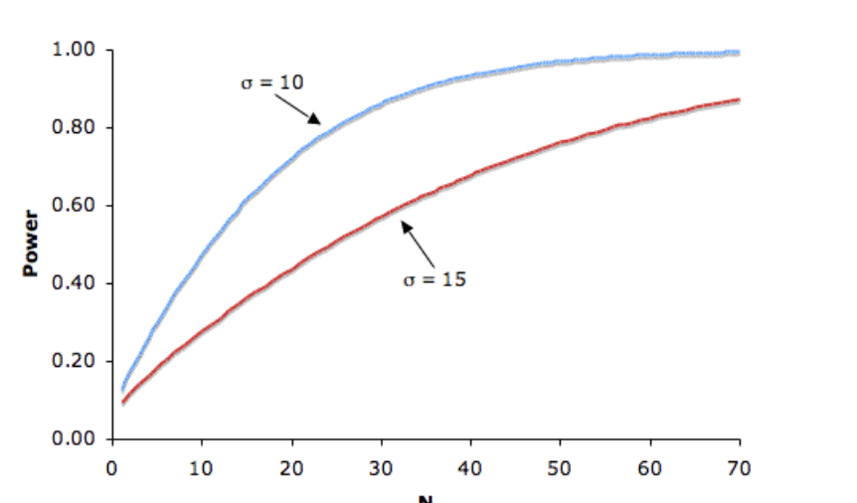

As for standard deviation, (and variance) it has an inverse effect on power. The lower the SD, the higher the power. Moreover, the significance level also affects power. The lower the significance level, the lower the power of the test. By reducing the significance level, the researcher increases the region of acceptance—as a result, they are more likely to reject the null hypothesis when it is false, and thus more likely to make a type II error, and thus decrease power.

**Question 3: Population 1 mean = 36; Population 2 mean = 45. Both Population standard deviations are 10. Sample size (per group) 16. What is the probability that a t test will find a significant difference between means at the 0.05 level? Give results for both one- and two-tailed tests. Hint: the power of a one-tailed test at 0.05 level is the power of a two-tailed test at 0.10.**

The power at the alpha level 0.05 is 0.69. At alpha level 0.10, the power is 0.8. The power is defined as the probability that we can reject a false null, so it represents the probability of finding a significance between means at the 0.05 level using both one and two-tailed tests.

First, we need to find the t-value. Our hypothesis H0 is that H0: M1 = M2, stating that there is no difference between the 2 populations.

To do this, we’ll compute the mean difference between M2 and M1.

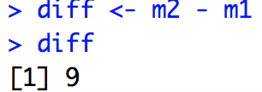

Next, we know that these populations both have SD = 10. Using the formula to find the difference between standard deviations, we see that:



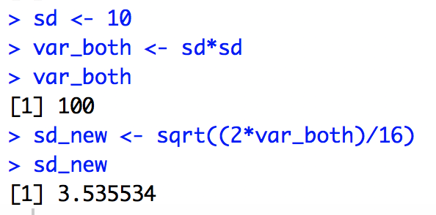

Next, we need to plug in these values into the formula below to find the t-statistic:

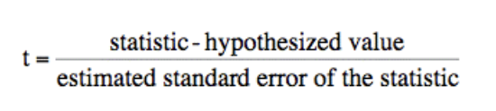

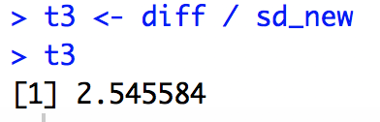

Finding the power at these levels, we can do the following using the online textbook calculator to find the power at 0.05 and 0.10.

