Ministerul Educaţiei al Republicii Moldova

Universitatea Tehnică a Moldovei

Facultatea Calculatoare,Informatică și Microelectronică

**Raport**

Lucrarea de laborator nr.3

La disciplina MIDPS

Efectuat: st.gr. TI-143 Besliu Doina

Verificat :Lect.univ. Cojocaru Svetlana

Chișinău-2016

**Tema:** Version Control Systems si modul de setare a unui server

**Obiective:**

* Realizeaza un simplu GUI Calculator
* Operatiile simple: +,-,*,/,putere,radical,InversareSemn(+/-),operatii cu numere zecimale.
* Divizare proiectului in doua module - Interfata grafica(Modul GUI) si Modulul de baza(Core Module).

### Laboratory Requirements:

* Basic Level (nota 5 || 6):
  + Realizeaza un simplu GUI calculator care suporta functiile de baza: +, -, /, *.
* Normal Level (nota 7 || 8):
  + Realizeaza un simplu GUI calculator care suporta urmatoare functii: +, -, /, *, putere, radical, InversareSemn(+/-).
* Advanced Level (nota 9 || 10):
  + Realizeaza un simplu GUI calculator care suporta urmatoare functii: +, -, /, *, putere, radical, InversareSemn(+/-), operatii cu numere zecimale.
  + Divizare proiectului in doua module - Interfata grafica(Modul GUI) si Modulul de baza(Core Module).

**Implementare task-uri**:

* IDE: Visual Studio 2015
* Limbajul:C#
* Tehnologii: C#

Listingul Programului

using System;

using System.Collections.Generic;

using System.ComponentModel;

using System.Data;

using System.Drawing;

using System.Linq;

using System.Text;

using System.Threading.Tasks;

using System.Windows.Forms;

namespace Calculator

{

public partial class Form1 : Form

{

Double value = 0.0;

String operation = "";

bool operation_pressed = false;

public Form1()

{

InitializeComponent();

}

private void button_Click(object sender, EventArgs e)

{

if ((result.Text == "0")||(operation_pressed))

result.Clear();

operation_pressed = false;

Button b = (Button)sender;

if (b.Text == ",")

{

if((!result.Text.Contains(",")))

result.Text = result.Text + b.Text;

}

else

result.Text = result.Text + b.Text;

}

private void button17_Click(object sender, EventArgs e)

{

result.Text = "0";

}

private void operator_click(object sender, EventArgs e)

{

Button b = (Button)sender;

operation = b.Text;

value = Double.Parse(result.Text);

operation_pressed = true;

equation.Text = value + " " + operation;

}

private void button16_Click(object sender, EventArgs e)

{

equation.Text = "";

switch (operation)

{

case "+":

result.Text = (value + Double.Parse(result.Text)).ToString();

break;

case "-":

result.Text = (value - Double.Parse(result.Text)).ToString();

break;

case "*":

result.Text = (value * Double.Parse(result.Text)).ToString();

break;

case "/":

result.Text = (value / Double.Parse(result.Text)).ToString();

break;

case "x^":

Double x;

Double y;

x = value;

y = Double.Parse(result.Text);

result.Text = ((double)Math.Pow(x, y)).ToString();

break;

case "sqrt":

result.Text = Math.Sqrt(Double.Parse(result.Text)).ToString();

break;

default:

break;

}

// operation_pressed = false;

}

private void button18_Click(object sender, EventArgs e)

{

result.Clear();

value = 0;

equation.Text = "";

result.Text = "0";

}

private void Form1_KeyPress(object sender, KeyPressEventArgs e)

{

switch (e.KeyChar.ToString())

{

case "0":

button15.PerformClick();

break;

case "1":

button1.PerformClick();

break;

case "2":

button2.PerformClick();

break;

case "3":

button3.PerformClick();

break;

case "4":

button4.PerformClick();

break;

case "5":

button5.PerformClick();

break;

case "6":

button6.PerformClick();

break;

case "7":

button7.PerformClick();

break;

case "8":

button8.PerformClick();

break;

case "9":

button9.PerformClick();

break;

case "=":

button16.PerformClick();

break;

case "/":

button10.PerformClick();

break;

case "*":

button11.PerformClick();

break;

case "-":

button12.PerformClick();

break;

case "+":

button13.PerformClick();

break;

case ",":

button14.PerformClick();

break;

default:

break;

}

}

private void button21_Click(object sender, EventArgs e)

{

if ((!result.Text.Contains("-")) && (result.Text == "0"))

{

result.Clear();

result.Text = "-" + result.Text;

}

else

{

result.Text = (-(Double.Parse(result.Text))).ToString();

}

}

}

}

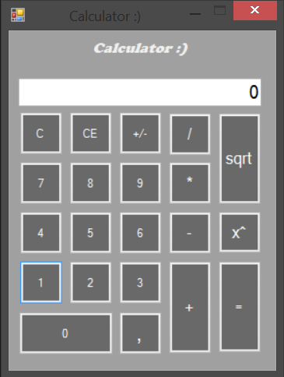 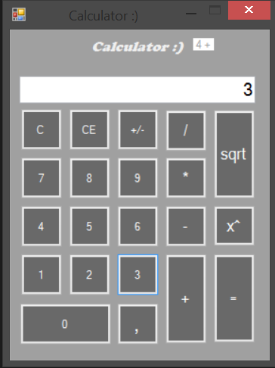 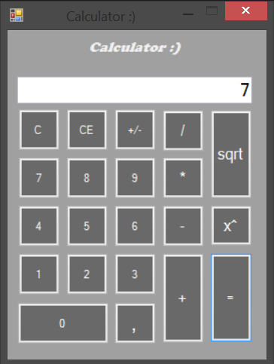

**Concluzie:**

**In aceasta lucrare de laborator am capatat deprinderi practice in lucrul cu limbajul C#, la aplicatia aceasta, am invatat sa creez rapid si comod interfata grafica in limbajul C#.**

**La finisarea laboratorului au fost atinse toate scopurile, a fost realizat un calculator care permite efectuarea atit a operatiilor de baza cu numere zecimale si intregi cit si a unor operatii adaugatoare(ridicarea la putere, rsdacina patrata,etc.).**