MULTI-AGENT EDUCATION SYSTEM

  - Course Name: Agentic AI

Institution Name: Medicaps University – Datagami Skill-Based Course

Student Name(s) & Enrolment Number(s):
Sr no | Student Name | Enrolment Number
1 | Sakshi Jain | EN22CS301845
2 | Sarthak Patel | EN22CS301877
3 | Shreya Mahoday | EN22CS301930
4 | Shreya Thakkar | EN22CS301933
5 | Siya Kusumakar | EN22CS301960

Group Name: 09D8
Project Number: AAI-44
Industry Mentor Name: Ms. Aashruti Shah
University Mentor Name: Prof. Pradeep Baniya
Academic Year: 2026

Table of Contents

- Abstract
- Introduction
- Problem Statement
- Objectives
- System Overview
- High-Level Architecture Diagram
- Activity Diagram
- Sequence Diagram
- Module Explanation
  - multi_agent.py
  - database.py
  - app.py
- Database Workflow
- Testing and Validation
- Advantages
- Limitations
- Future Enhancements
- Screenshots Section
- Conclusion

1. Abstract
The Multi-Agent Education System (EduAI) is an AI-powered collaborative learning platform designed to generate structured educational content through agent specialization and sequential task execution. Unlike traditional single-model AI systems, this platform divides responsibilities among multiple intelligent agents to improve clarity, structure, and task reliability.
The system integrates CrewAI for agent orchestration, Google Gemini 2.5 Flash as the Large Language Model (LLM), SQLite for persistent storage, and Streamlit for an interactive user interface. By combining these technologies, EduAI demonstrates a scalable and modular approach to multi-agent AI system design with memory support.
The system ensures structured note generation, difficulty-level customization, and database-backed caching for performance optimization.

2. Introduction
Artificial Intelligence systems are rapidly evolving from single-response generators to collaborative agent-based architectures. In modern AI system design, multi-agent systems allow different agents to specialize in distinct roles and coordinate to solve complex tasks more efficiently.
This project presents the design and implementation of a Multi-Agent Education System where two AI agents collaborate to generate high-quality educational notes. One agent performs research, while the other structures and formats the content into organized study material.
The system demonstrates key AI architecture concepts such as:
- Agent specialization
- Sequential orchestration
- Persistent memory management
- Conversational UI integration
- Modular software design

3. Problem Statement
Traditional AI-based educational assistants generate responses using a single model without role separation or structured coordination. This often results in unstructured outputs, repetition, or inconsistent formatting.
The problem addressed in this project is to design and implement a collaborative multi-agent education system that:
- Divides tasks among specialized agents
- Enables controlled agent communication
- Stores generated knowledge persistently
- Provides an interactive chat-based learning interface
- Supports customizable difficulty levels
The system must demonstrate real-world multi-agent collaboration using CrewAI.

4. Objectives
The primary objective of this project is to design a modular and scalable multi-agent system for educational content generation.
Specific Objectives:
- Implement specialized AI agents (Researcher & Writer)
- Enable sequential task execution between agents
- Integrate SQLite for persistent memory
- Develop an interactive Streamlit-based UI
- Implement difficulty-level customization
- Demonstrate caching for optimized performance

5. System Overview
The EduAI system consists of four primary components:
- Streamlit Frontend Interface
- Multi-Agent Orchestration Layer (CrewAI)
- Gemini LLM Integration
- SQLite Database Layer
The system follows a sequential multi-agent workflow. When a user enters a topic, the system checks whether the topic already exists in the database. If it exists, the stored content is retrieved. If not, the agents are triggered to generate new structured notes.
This architecture ensures both efficiency and scalability.

6. High-Level Architecture Diagram
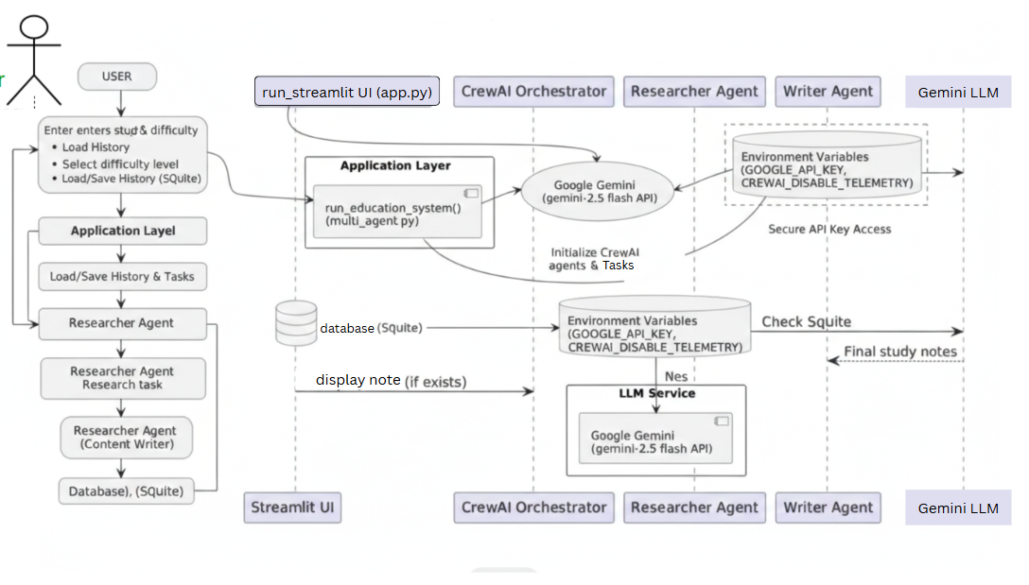
Explanation
The High-Level Architecture diagram represents the structural organization of the EduAI system. It visually demonstrates how user input flows through the system components before generating the final output.

The architecture consists of:
- User Interface (Streamlit) – Handles user interaction
- Application Layer (multi_agent.py) – Controls orchestration
- Agent Layer (CrewAI Agents) – Executes research and writing
- LLM Layer (Gemini API) – Generates language output
- Database Layer (SQLite) – Stores generated notes
Architectural Flow
User → Streamlit UI → Multi-Agent System → Gemini LLM → SQLite Database
The architecture ensures separation of concerns and modular design.

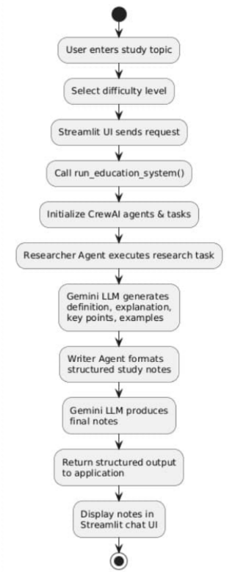
7. Activity Diagram

Explanation
The Activity Diagram represents the operational workflow of the system from start to finish. It models the dynamic behavior of the system during runtime.
The activity flow begins when the user enters a topic. The system then checks whether the topic exists in the database. Based on this condition, the flow branches into two paths:
- Fetch stored content (if topic exists)
- Trigger multi-agent execution (if topic does not exist)
After generation, the content is saved into the database and displayed in the chat interface.
This diagram highlights decision-making logic and sequential execution control.

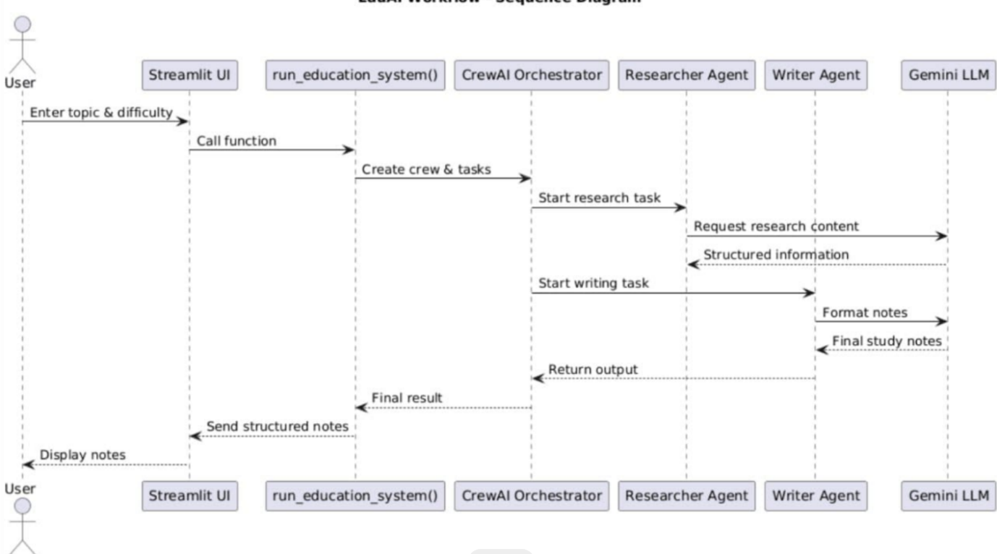
8. Sequence Diagram

Explanation
The Sequence Diagram illustrates the time-ordered interaction between system components.

The participants involved are:
- User
- Streamlit UI
- Multi-Agent System
- Research Agent
- Writer Agent
- Database
The sequence of events:
- User submits topic
- UI sends request to multi-agent system
- System checks database
- If not found → Research Agent executes
- Writer Agent processes research
- System stores result
- UI displays output
This diagram demonstrates inter-agent communication and task delegation clearly.

9. Detailed Module Explanation
9.1 multi_agent.py
This module is the core orchestration engine of the system. It defines agent roles, task structures, and sequential execution logic.
The function run_education_system(topic) controls:
- Database validation
- Agent initialization
- Task creation
- Crew execution
- Result storage

Agents Defined
Agent | Role | Responsibility
Researcher | Information Gathering | Collect definitions, key points, applications
Writer | Content Structuring | Convert research into formatted study notes
The agents are executed using:
process=Process.sequential
This ensures controlled task handoff.

9.2 database.py
This module handles persistent memory using SQLite. The database stores previously generated notes to prevent redundant processing.
Table Schema
Column | Type | Description
id | INTEGER | Primary Key
topic | TEXT | Unique Topic
content | TEXT | Generated Notes
created_at | TIMESTAMP | Time of creation
The use of INSERT OR REPLACE ensures topic uniqueness.

9.3 app.py (Frontend)
The frontend is developed using Streamlit. It provides:
- Chat-based interface
- Sidebar topic history
- Difficulty selection
- Topic reload functionality
Streamlit’s st.chat_message() creates a conversational experience.

10. Database Workflow
The database workflow improves performance by preventing unnecessary agent executions.
Workflow Steps:
- User inputs topic
- System queries database
- If exists → return stored note
- If not → generate using agents
- Store result
This caching mechanism significantly improves efficiency.

11. Testing and Validation
The system is tested using various functional scenarios.
Test Case | Input | Expected Output | Result
New Topic | AI | Generated notes | Pass
Repeated Topic | AI | Fetch from DB | Pass
Difficulty Change | Beginner | Simplified content | Pass
DB View | view_db.py | Records displayed | Pass
All modules function as expected.

12. Advantages
The system provides several architectural and functional advantages:
- Modular agent-based design
- Clear role separation
- Improved output structure
- Reduced redundancy via caching
- Scalable architecture
- Easy future integration of more agents

13. Limitations
Despite its advantages, the system has certain limitations:
- Sequential processing only
- No semantic vector search
- No real-time internet browsing
- Single LLM dependency
- No multi-user authentication

14. Future Enhancements
Future development can include:
- Reviewer Agent for quality validation
- Quiz Generator Agent
- Vector database integration
- Parallel task execution
- Cloud deployment
- Authentication system
- User progress tracking

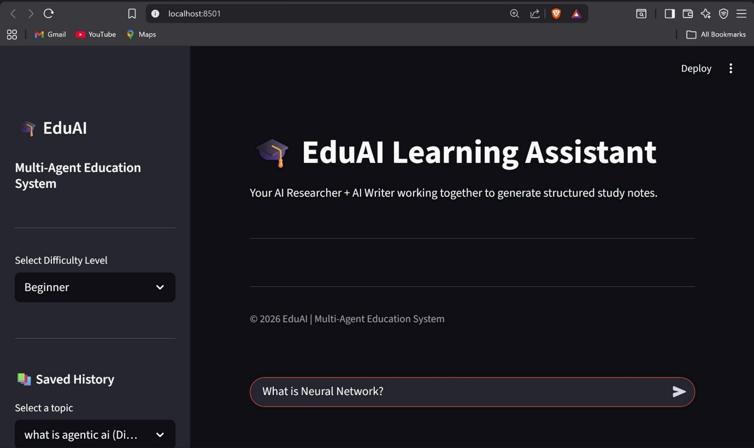
15. Screenshots Section
Fig. EduAI Main Interface

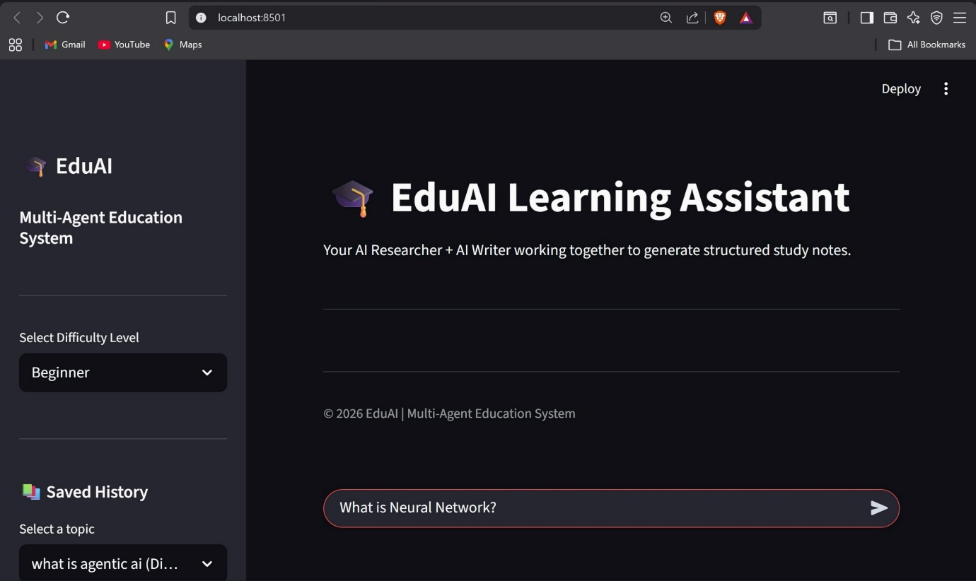
Fig. User Input Section

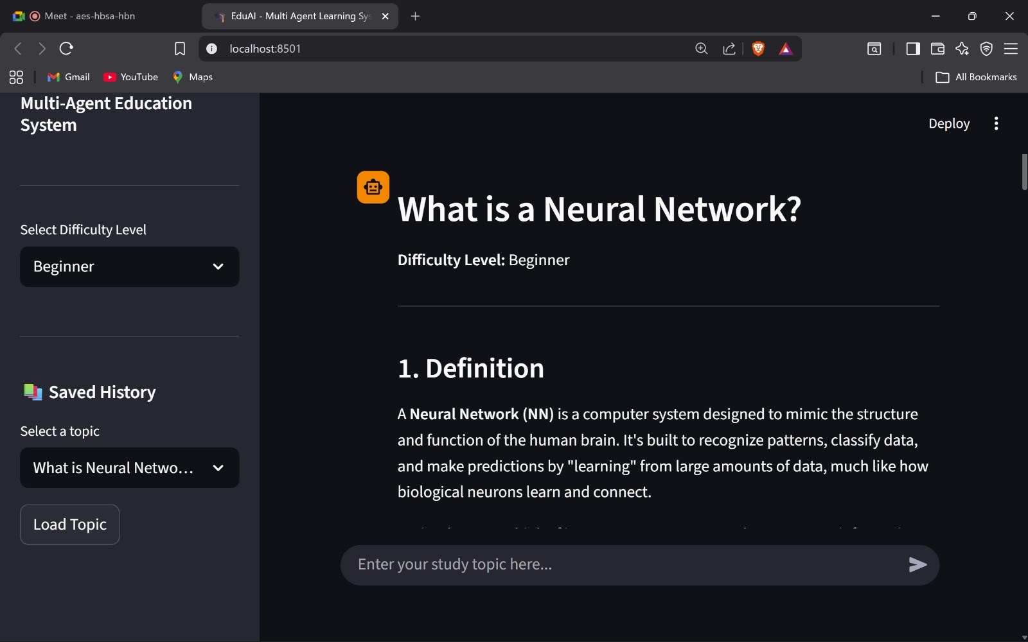
Fig. Generated Output Displayed in the System

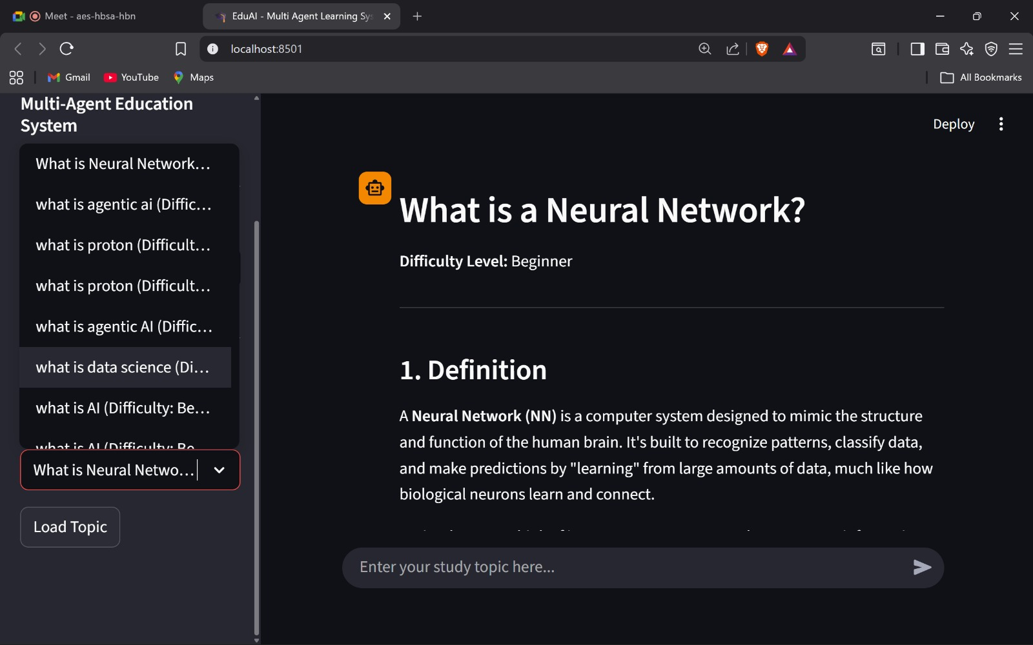
Fig. User Interface Displaying Stored Topics Retrieved from SQLite Database
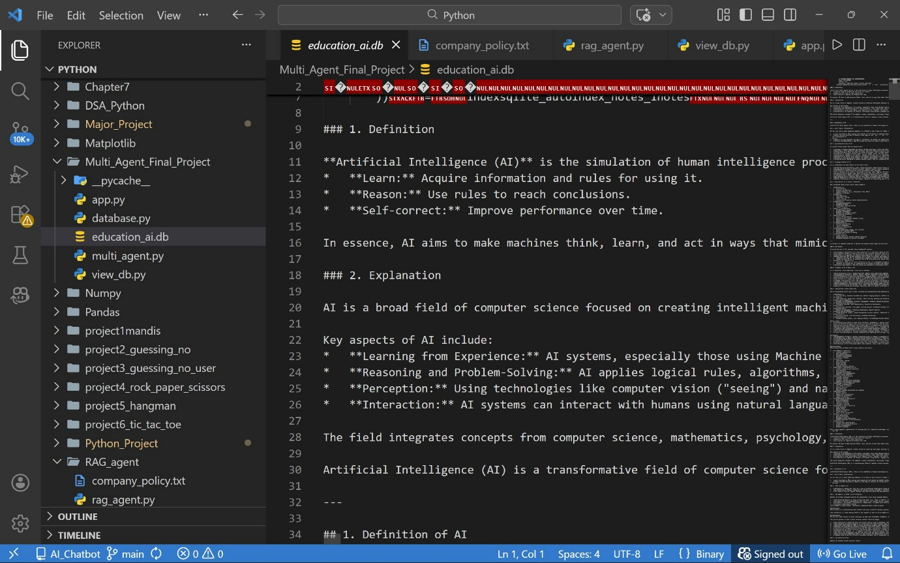
Fig. SQLite Database (education_ai.db) Storing Generated Study Notes

16. Conclusion
The Multi-Agent Education System successfully demonstrates the implementation of collaborative AI agents in an educational context. By integrating CrewAI orchestration, Gemini LLM, and SQLite persistence, the project validates the effectiveness of role-based AI task delegation.
The architecture is modular, scalable, and performance-optimized using caching. This system provides a strong foundation for building advanced AI-powered educational platforms in the future.

