Stroop Effect Experimental R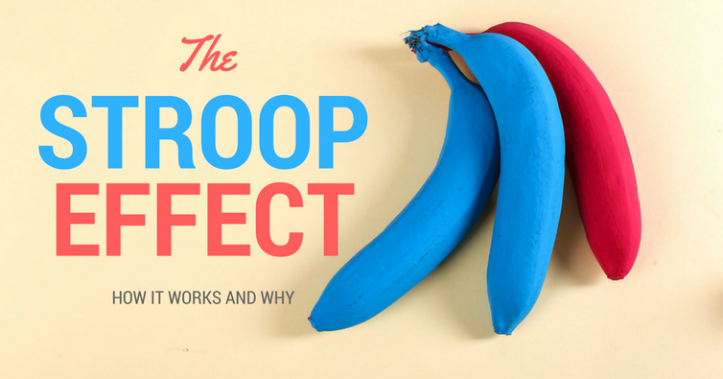eport

Dojo, 郑东佳

Nov 8th, 2017

Background Information

In a Stroop task, participants are presented with a list of words, with each word displayed in a color of ink. The participant’s task is to say out loud the color of the ink in which the word is printed. The task has two conditions: a congruent words condition, and an incongruent words condition. In the congruent words condition, the words being displayed are color words whose names match the colors in which they are printed: for example RED , BLUE. In the incongruent words condition, the words displayed are color words whose names do not match the colors in which they are printed: for example PURPLE, ORANGE. In each case, we measure the time it takes to name the ink colors in equally-­sized lists. Each participant will go through and record a time from each condition.

Experimental Data Sets and Symbols

|  |  |  |  |
| --- | --- | --- | --- |
| x(conditions)  y(time: second) | Congruent | Incongruent | Difference(d):  di=Ii-Ci |
|  | 12.079 | 19.278 | 7.199 |
|  | 16.791 | 18.741 | 1.95 |
|  | 9.564 | 21.214 | 11.65 |
|  | 8.63 | 15.687 | 7.057 |
|  | 14.669 | 22.803 | 8.134 |
|  | 12.238 | 20.878 | 8.64 |
|  | 14.692 | 24.572 | 9.88 |
|  | 8.987 | 17.394 | 8.407 |
|  | 9.401 | 20.762 | 11.361 |
|  | 14.48 | 26.282 | 11.802 |
|  | 22.328 | 24.524 | 2.196 |
|  | 15.298 | 18.644 | 3.346 |
|  | 15.073 | 17.51 | 2.437 |
|  | 16.929 | 20.33 | 3.401 |
|  | 18.2 | 35.255 | 17.055 |
|  | 12.13 | 22.158 | 10.028 |
|  | 18.495 | 25.139 | 6.644 |
|  | 10.639 | 20.429 | 9.79 |
|  | 11.344 | 17.425 | 6.081 |
|  | 12.369 | 34.288 | 21.919 |
|  | 12.944 | 23.894 | 10.95 |
|  | 14.233 | 17.96 | 3.727 |
|  | 19.71 | 22.058 | 2.348 |
|  | 16.004 | 21.157 | 5.153 |
| n |  |  |  |
|  |  |  |  |

**The meaning of Symbols or Equations:**

x: Word Condition - Congruent or Incongruent?

y: The time participants takes to name the ink colors in equally-sized list.

: The mean y value under the condition of Congruent Task.

: The mean y value under the condition of Incongruent Task.

n: The samples’ sizes.

I: Represents the time value from incongruent condition.

C: Represents time value from congruent condition.

d(difference): d represents the difference of the value I and value C.

i: i represents the index

Questions & Answers For Investigation

1. **What is our independent variable? What is our dependent variable?**

Independent variable(x): Word Condition - Congruent or Incongruent?

Dependent variable(y): The time participants takes to name the ink colors in equally-sized list.

**2. What is an appropriate set of hypotheses for this task? What kind of statistical test do you expect to perform? Justify your choices.**

**2.1 An appropriate set of hypotheses:**

**Null-Hypothesis**: It takes longer or equal time to name the colors under the congruent words condition.

**Alternative-Hypothesis**: It takes longer time to name the colors under the incongruent words condition.

(I represents time value from incongruent condition; C represents time value from congruent condition; di represents the difference of these 2 values)

(One-Tailed)

2.2 Kind of statistical test:

**Depedent t-test for Paired Samples(Type: Two Conditions, One-tailed)**

2.3 Justification:

The reasons that I choose dependent t-test for Paired Samples:

a. I choose t-test because I do not know the (the standard deviation of the population) of the population datasets. Meanwhile, the samples’ sizes are not big enough(n < 30) for z-test.

b. The samples given are dependent samples because they are paired measurements for one set of items (that means for the same people but with different measurements); Furthermore, the values in one sample(congruent condition) affect the values in the other sample(incongruent condition). (Checkup from website: [How are dependent and independent samples different?](http://support.minitab.com/en-us/minitab/17/topic-library/basic-statistics-and-graphs/hypothesis-tests/tests-of-means/how-are-dependent-and-independent-samples-different/))

c. I choose the one-tailed test because I believe it takes **longer** time to name the colors under the incongruent words condition. This means that 0.05 is in one tail of the distribution of the test statistic, not in two tail of the distribution. If I choose **two-tailed test**, that means I believe it takes **different** time to name the colors under the incongruent words condition, including both longer time and shorter time, but that’s not what I want.

Assumptions for t-test(Dependent Means): (Checkup from website: [Test Assumptions](http://www.psychology.emory.edu/clinical/bliwise/Tutorials/TOM/meanstests/assump.htm))

|  |
| --- |
| * Interval or ratio scale of measurement (approximately interval) |
| * Random sampling from a defined population |
| * Samples or sets of data used to produce the difference scores are linked in the population through repeated measurement, natural association, or matching |
| * Scores are normally distributed in the population; difference scores are normally distributed |

**3. Report some descriptive statistics regarding this dataset. Include at least one measure of central tendency and at least one measure of variability.**

|  |  |  |
| --- | --- | --- |
| Central Tendency | | |
| conditions | congruent | incongruent |
|  |  |  |
|  | 14.3565 | 21.0175 |

|  |  |  |
| --- | --- | --- |
| Variability | | |
| conditions | congruent | incongruent |
| Q1 : First Quartile | 11.89525 | 18.71675 |
| Q2 : Second Quartile | 14.3565 | 21.0175 |
| Q3 : Third Quartile | 16.20075 | 24.0515 |
| Interquartile Range(IQR) =  Q3 - Q1 | 4.3055 | 5.33475 |
| Upper Outliers = Q3+1.5*IQR | 22.659 | 32.053625 |
| Lower Outliers = Q1-1.5*IQR | 5.437 | 10.714625 |
| Bessel’s Correction(Samples’ Standard Deviation) = | 3.559357958 | 4.797057122 |

**4. Provide one or two visualizations that show the distribution of the sample data. Write one or two sentences noting what you observe about the plot or plots.**

Normal Distribution: (The following graphs are from the [Interactive-Histogram-Website](http://www.shodor.org/interactivate/activities/Histogram/))

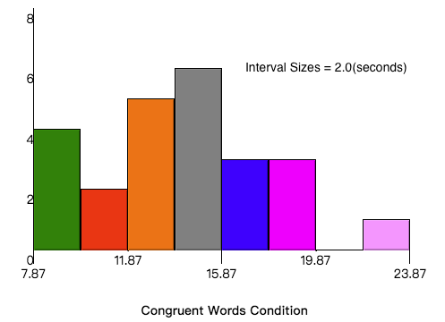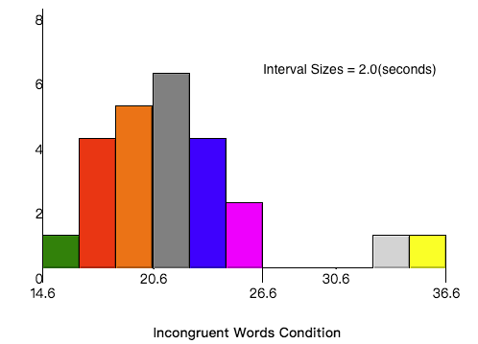

a. IWCD(Incongruent-Words-Condition-Distribution) has a wider range of distribution.

b. CWCD’s(Congruent-Words-Condition-Distribution) median is between 13.87 and 15.87 seconds while the IWCD’s median is between 19.6 and 21.6 seconds.

c. IWCD has more outliers compared with CWCD.

d. CWCD’s mean is generally less than IWCD’s mean.

**5. Now, perform the statistical test and report your results. What is your confidence level and your critical statistic value? Do you reject the null hypothesis or fail to reject it? Come to a conclusion in terms of the experiment task. Did the results match up with your expectations?**

(One-Tailed, 90%CI)

a. Confidence level: 90%CI

b. Calculate the t-statistic：

(df=24-1=23，one-tailed t-critical values at =0.05)

c. I will reject the null hypothesis since the t-statistic(8.02) is bigger than the t-critical(1.714).

d. The result mathes up with my expectations because the alternative hypothesis, which indicates that it takes longer time to name the colors under the incongruent words condition, is statistically significant.

**6. Optional: What do you think is responsible for the effects observed? Can you think of an alternative or similar task that would result in a similar effect? Some research about the problem will be helpful for thinking about these two questions!**

a. I think people’s tendency to associate the words’ meaning with the corresponding colors is responsible for the effects observed. In another word, if people do not know what the words mean, perhaps they will not be influenced by the words’ meaning when saying out the colors.

b. Yes, of course! When asked to say out some kinds of fruites’ species, but the tags of the fruits are actually other species. Then, people may get confused when saying the fruits’ correct species. For example, 🍎(tag: Coconut), 🍌(tag: Apple), 🍉(tag: Banana). It is also a simple experiment for congruent and incongruent test.